SQL

1. select \* from Customers where Country = "Germany";
2. select \* from Customers where CustomerName like "%e";
3. a) insert into Customers (CustomerID, CustomerName, ContactName, Address, City, PostalCode, Country)

values ( "92", "AntipkaSju", "Nastasja Nikolavna", "Raduga duga", "Oblaka", "007", "Nebo");

b) select \* from Customers

c)

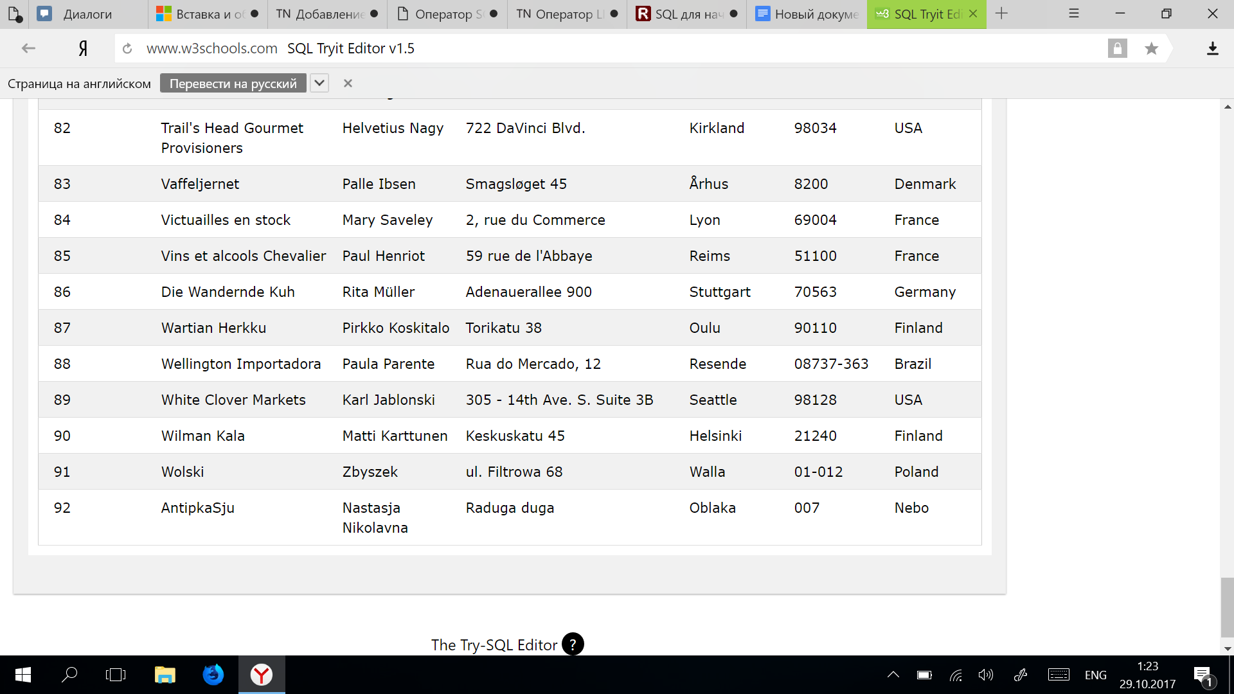

4. a) update Customers

set ContactName = "Antipina Anastasija"

where CustomerID = 92;

b) select \* from Customers

c)

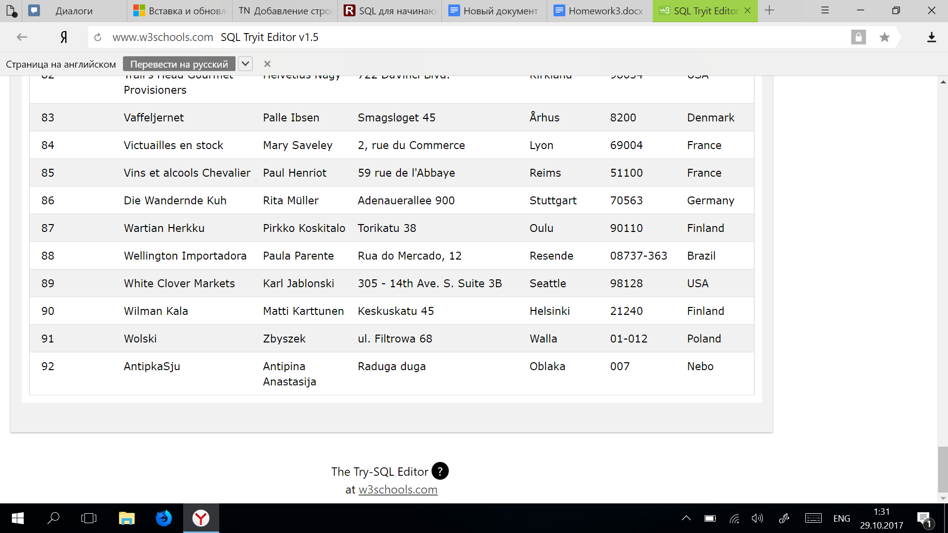

5) delete from Customers where City="Nantes";

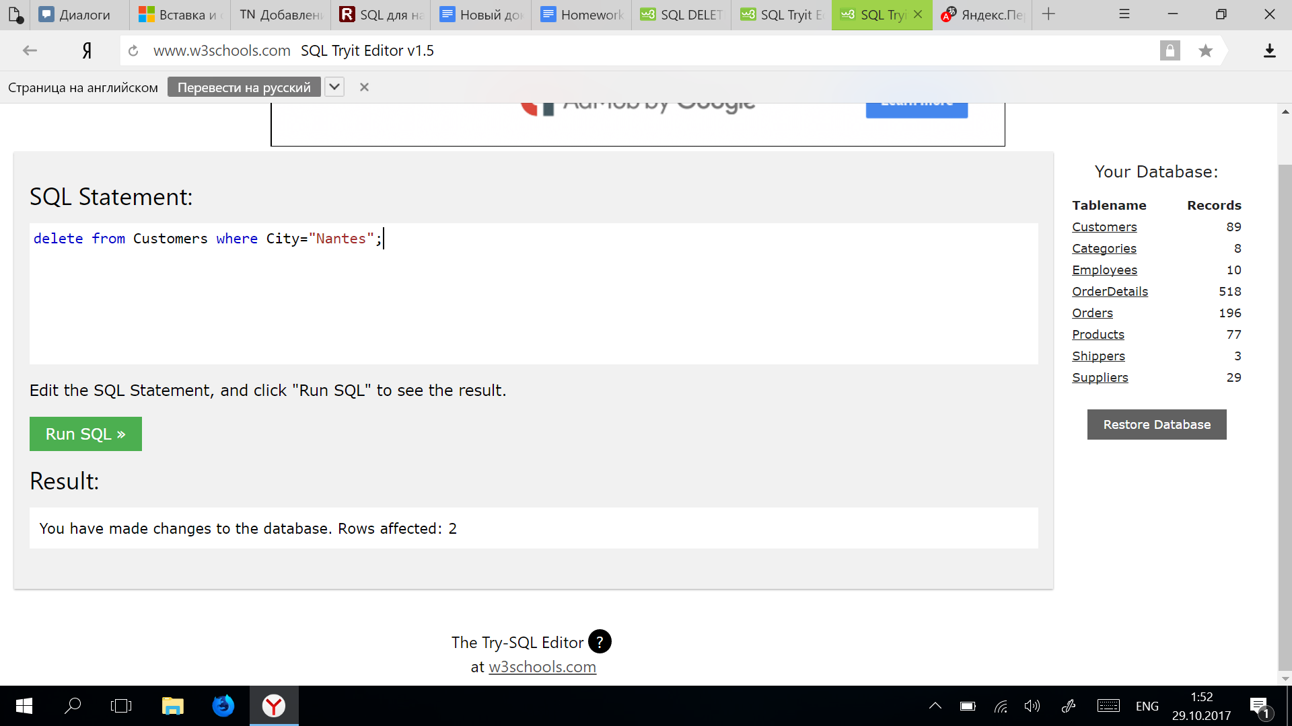

6. select Orders.OrderID, Employees.FirstName

from Orders

inner join Employees on Orders.EmployeeID = Employees.EmployeeID

where FirstName = "Steven";