COSC 4353 – Software Design
Group 1 – Summer 2026
Assignment #2

GitHub Repository Link:

https://github.com/Antiquely3031/COSC4353_SoftwareDesignGroup1_Summer2026/tree/main/Assignment_2_Group_1

Group 1 – Team Contribution Table:

 | Contributions
Patrick Callaghan | Created the Login/Registration screens and “placeholder” authentication of the front end, designed the QS logo, overall color scheme, function animation, and drafted the PDF for submission
Elvis Noel Trujillo Chairez | Created the Administration Dashboard and the Service Management and Queue Management screens, as well as revised PDF for submission
Kevin Chau | Created the User Dashboard, Join Queue, Queue Status, and History screens, as well as revised PDF for submission
Richard Tiamzon | Created the Notifications Dashboard and functionality and revised PDF for submission

Design and Development Methodology:

- Has our methodology changed since Assignment 1

In general, our methodology has not changed since Assignment 1. Our overall structure and functionality have remained in place. We decided to continue with our plans for outside notification (Email and SMS) delivery.

- Why (or why not)?

Thus far, the organization and consequent functionality of the program is relatively straightforward. There were not any issues that immediately laid bare concerns regarding accessibility and usability. It is worth noting that this could change with the next two parts of the project, as development of backend/database components could drastically augment our approach. There is the element of scalability, state management, and bookkeeping that may present problems we have not yet foreseen. Nonetheless, we pressed forward with our original plans.

- How our team divided work for UI/UX and implementation

Work was divided for UI/UX implementation thusly: Patrick designed the logo and established a color scheme. Elvis developed an Administrative Dashboard formatting using the same themes, as did Kevin with the User Dashboard. Richard maintained the same theme as Kevin with his Notifications Dashboard, particularly because it is linked with the User Dashboard. Final themes will be adjusted after functionality has been established on the backend.
The overall layout and structure of each dashboard was left up to each of us with a plan to unify the formatting and structure based on the elements of each student’s work we liked best. Client-side validation and form completion have placeholder functions in place that will be adjusted when there are backend pieces available to attach them. We have set the responsiveness of the interface to adapt to the size of the screen on the device(s) being used.

Front-End Technologies and Responsibilities:
- Given our previous experience with CSS, HTML, and JavaScript, we decided to forgo learning an app-generation platform and build the program from scratch. We realize that scaling the program would likely be better enabled by standard JavaScript frameworks/libraries, but decided to move forward as described.
- All aesthetic designs for user experience have thus far been generated and revised using CSS and Adobe Photoshop.

Screenshots of Front End:

- Login / Registration

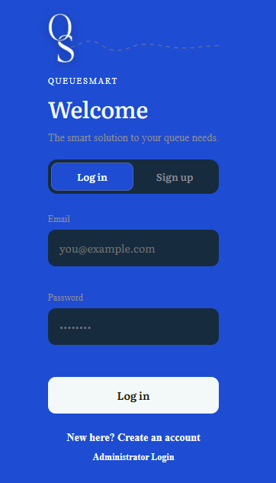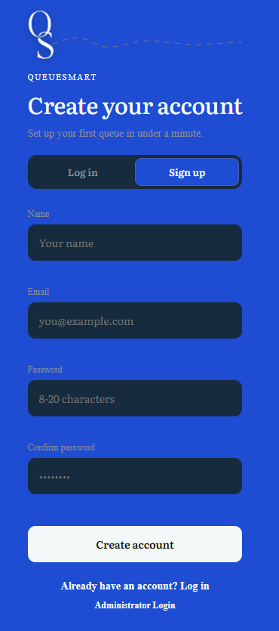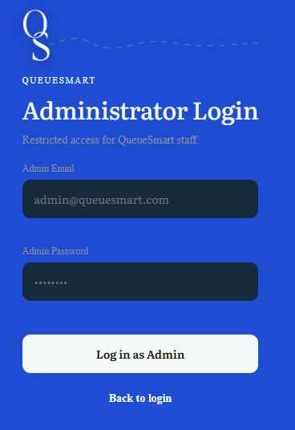

- User Dashboard

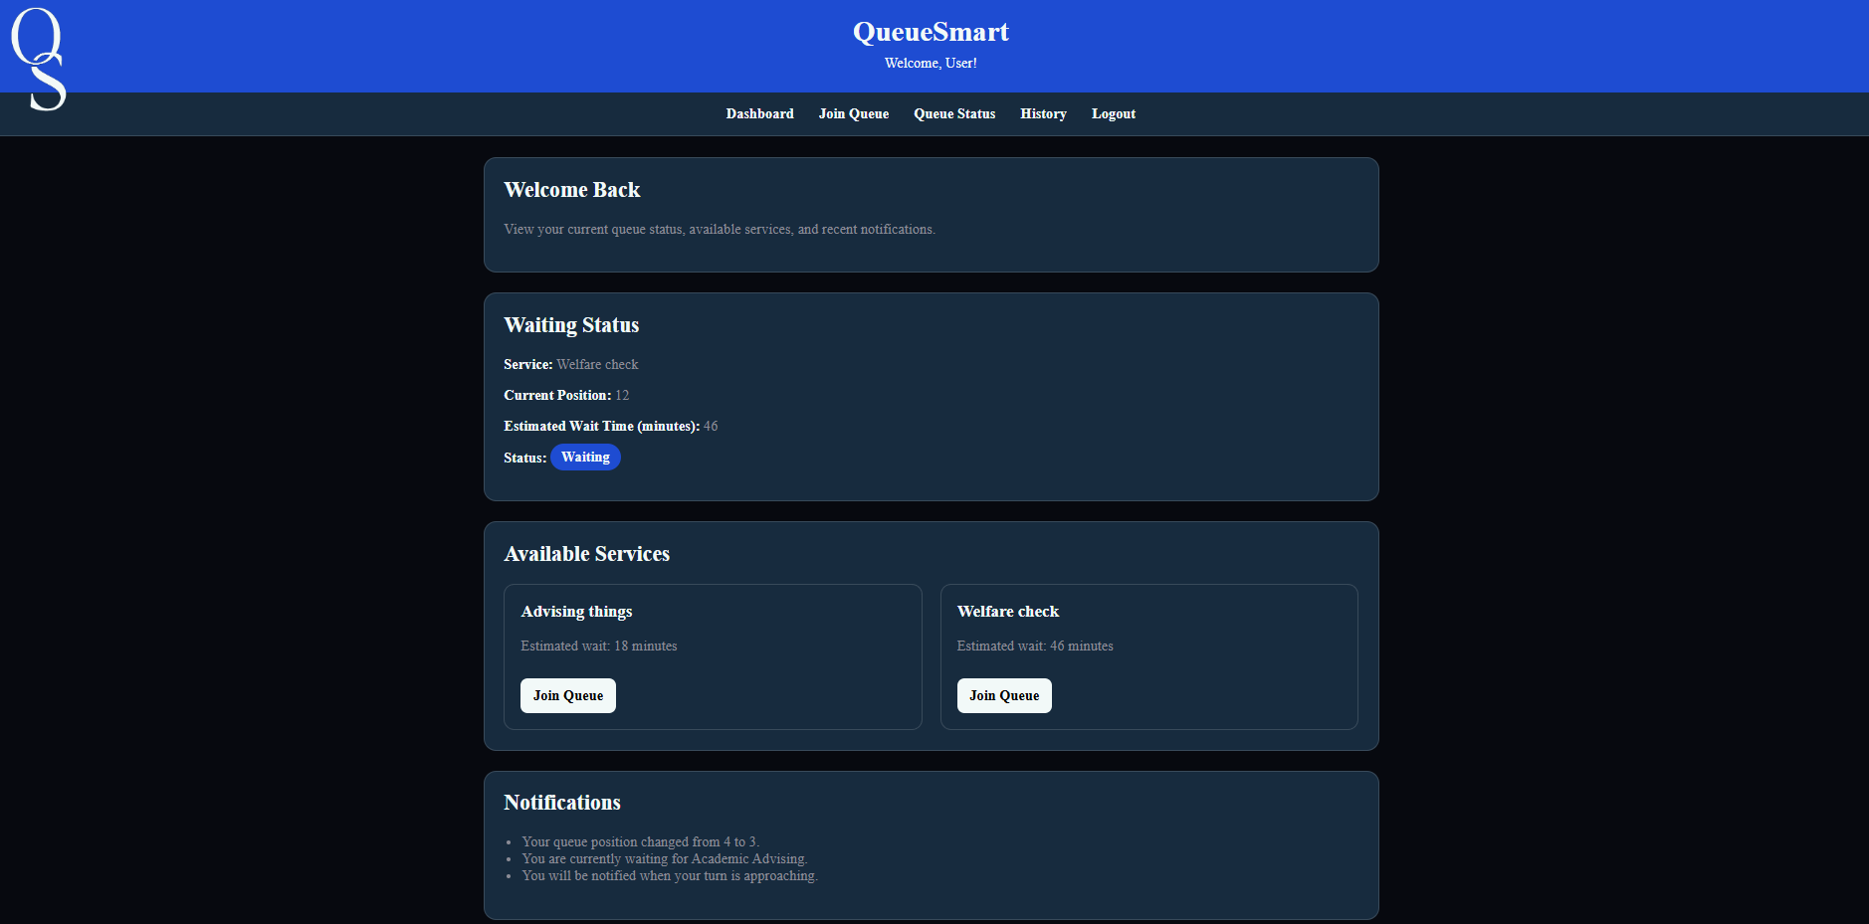

- Join Queue

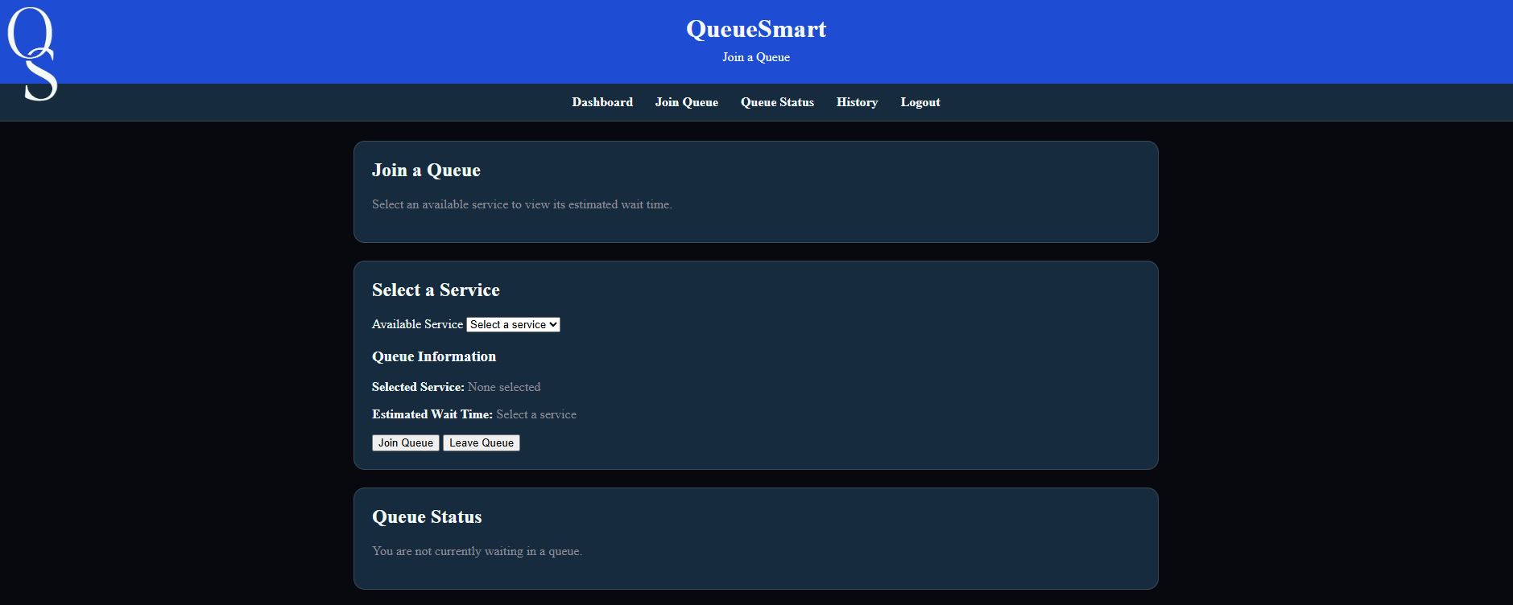

- Admin Dashboard

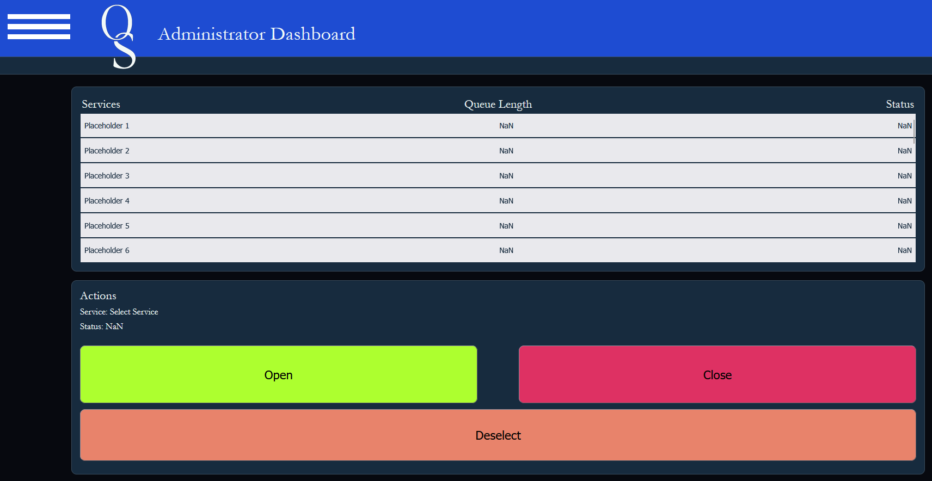

- Service Management

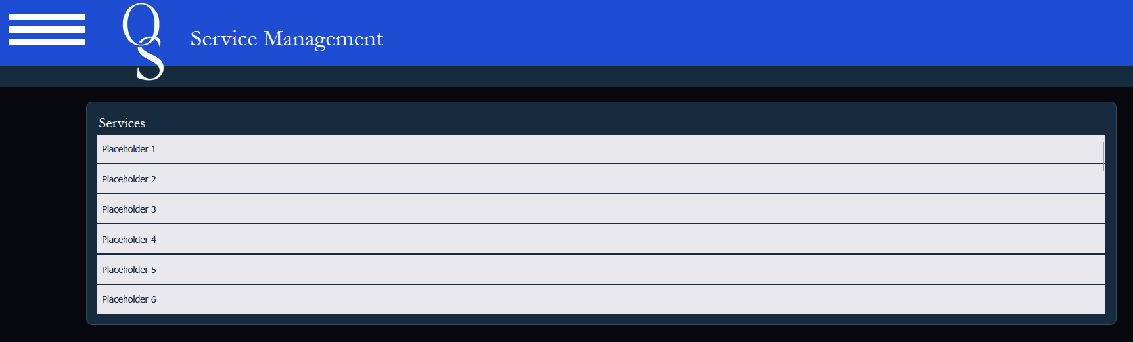

- Queue Management

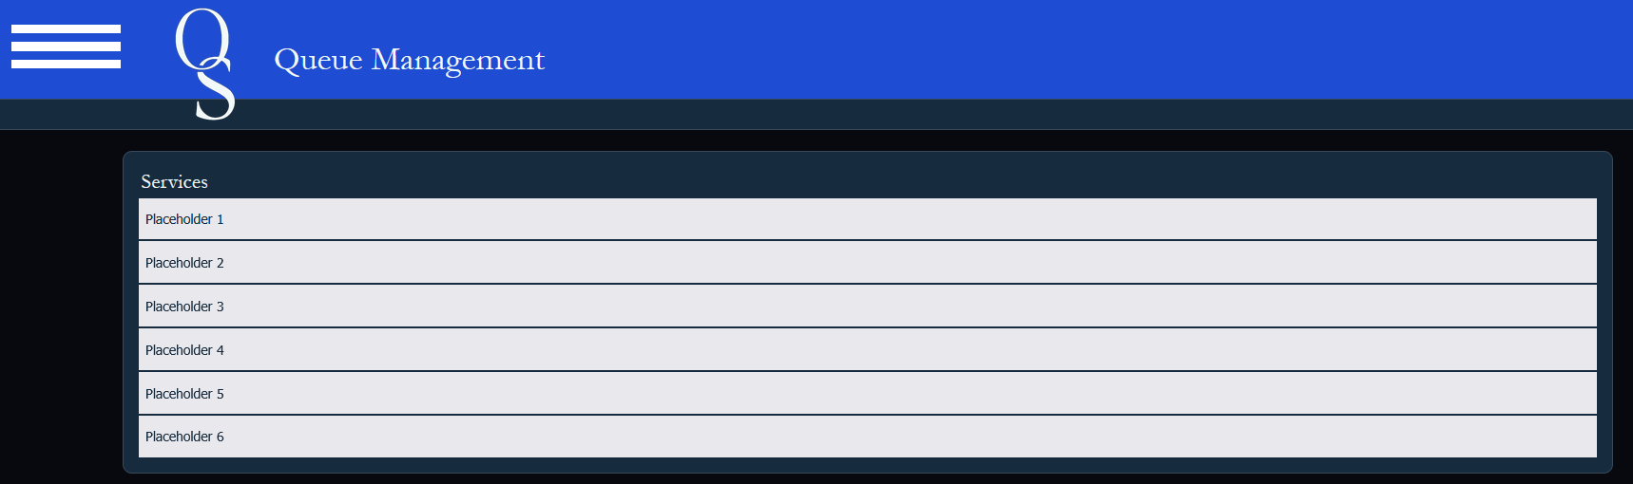

- Notifications

