TeamSpeak 3 G-Key Plugin

Table of Contents
Plugin Installation 2
Tutorial 3
Logitech Gaming Software 3
GamePanel Software (Legacy) 7
Advanced scripting 11
Different commands per device 11
Mouse support 12
Command reference 13
Communication 15
Push-to-talk 15
Voice activation 15
Continuous transmission 15
Mute microphone 16
Mute speakers/headphones 16
Server interaction 17
Away status 17
Globally away status 17
Activate server 18
Channel joining 19
Client kicking 19
Whispering 20
Activating/clearing the whisper list 20
Adding clients to the whisper list 20
Adding channels to the whisper list 21
Replying to whispers 22
Miscellaneous 23
Client muting 23
Master volume 23
Changelog 24

Plugin Installation
- Open and install the package.
Note for 64-bit users: If you are using a 64-bit operating system you will need to use the 64-bit version of TeamSpeak 3.
- Start TeamSpeak 3 and open the “Plugins” dialog (Ctrl+Shift+P).
- Make sure the “G-Key Plugin” is checked.
- Now to configure the G-Keys for usage with the plugin refer to the Tutorial section.

Tutorial
This section will explain how to configure your Logitech software for use with the G-Key plugin, most users should refer to the Logitech Gaming Software tutorial. These are the latest drivers released by Logitech and a lot of devices are supported by it. You should update if you're still using older software.
However if you have a keyboard the old GamePanel software is still supported for now, refer to the GamePanel Software (Legacy) tutorial if you do not wish to update.

Logitech Gaming Software
- Open the Logitech Gaming Software
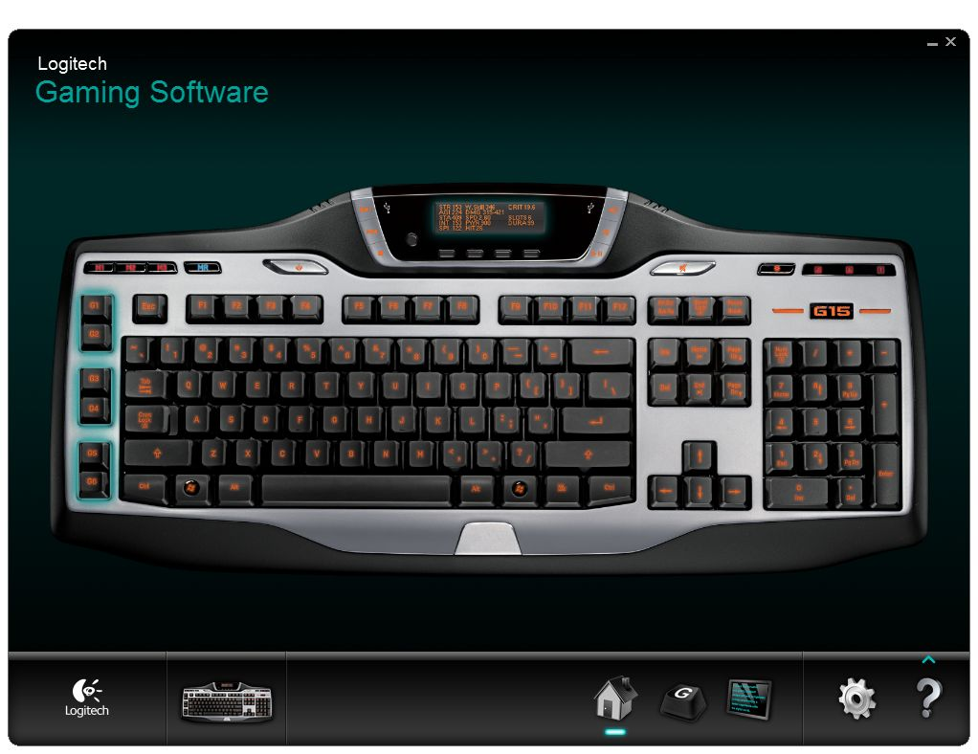

- Open the “Customize G-keys” tab
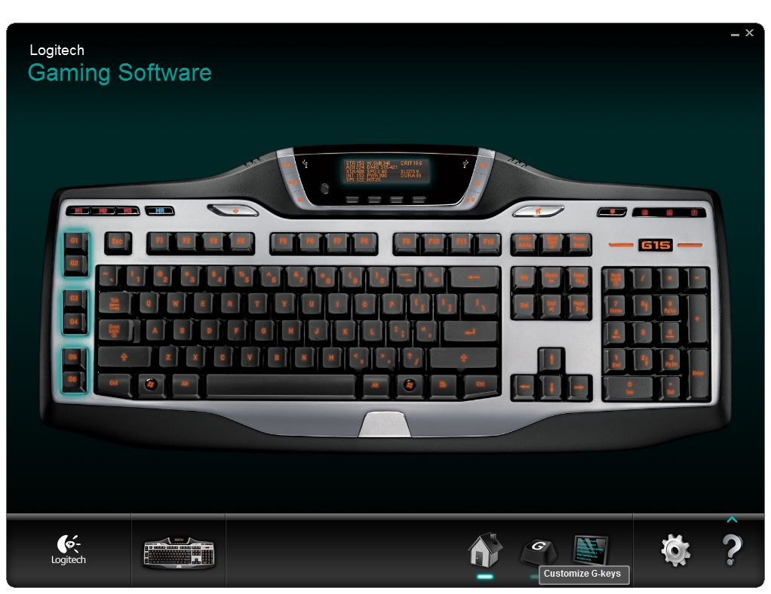

- Open the script for your configuration by right-clicking on the icon.
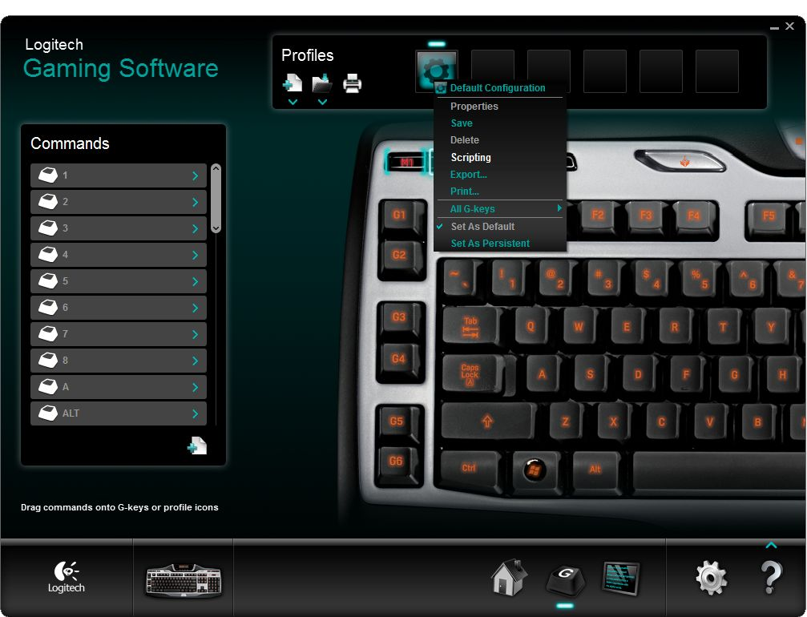

- Now enter the script, the simplest script that only supports push-to-talk is this:
function OnEvent(event, gkey, family)
mkey = GetMKeyState()

if gkey == 3 and mkey == 1 then
if event == "G_PRESSED" then
OutputDebugMessage("TS3_PTT_ACTIVATE")
end
if event == "G_RELEASED" then
OutputDebugMessage("TS3_PTT_DEACTIVATE")
end
end
end

With this script G3 will trigger Push-to-talk regardless of your currently assigned hotkey in TeamSpeak 3.
To change Push-to-talk key you only have to change the following line:
if gkey == 3 and mkey == 1 then
In that line gkey == 3 determines which G-Key activates push-to-talk, for example to change the key to G5 you change it to gkey == 5.
The mkey == 1 part is meant for keyboards that have M-Keys and can be changed in the same way as the G-Key. If you don't have M-Keys or you don't use them you can just leave it at mkey == 1 or remove it.
You have now successfully configured the software to activate Push-To-Talk in TeamSpeak 3.
There are a lot more commands that you can use, refer to the Command reference for a full list of commands.
For advanced scripting examples, refer to the Advanced scripting section.

GamePanel Software (Legacy)
This is a guide for the old keyboard driver, while the plugin still supports this driver for now, it is recommended that you update to the new Logitech Gaming Software.
- Open the Logitech G-series Key Profiler
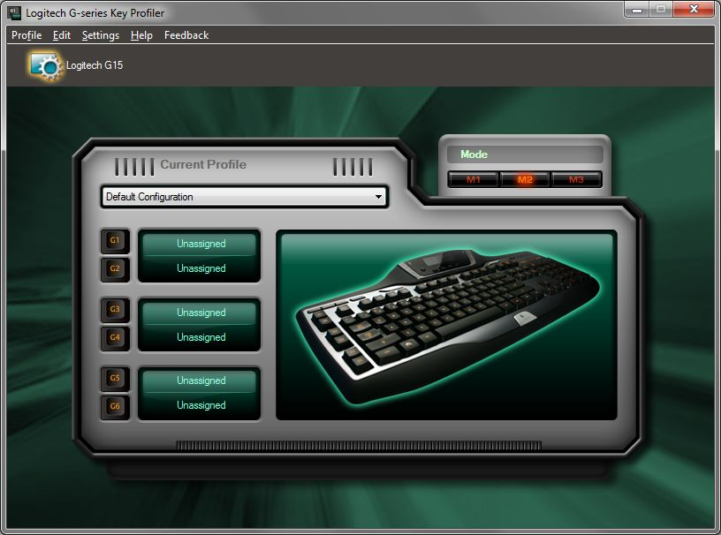

- Assign the G-keys you want to use to control TeamSpeak 3 to “Script”. Note the G-keys and Mode you've set here, as we will need them later.
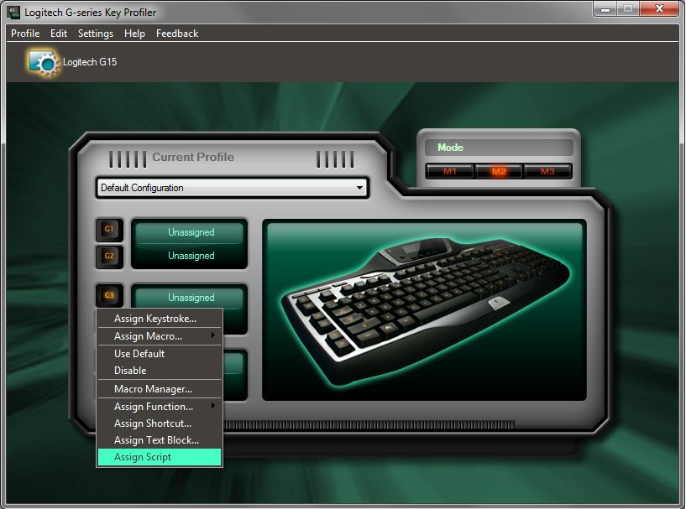

- Open the Script Editor

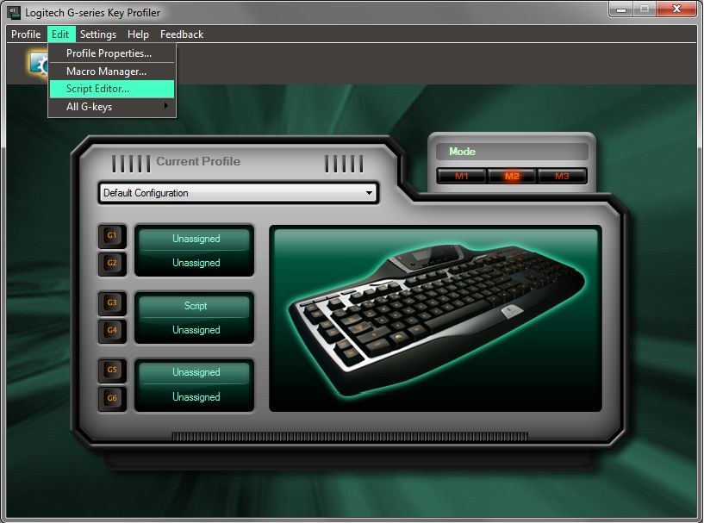

- Now enter the script, the simplest script that only supports push-to-talk is this:
function OnEvent(event, gkey, family)
mkey = GetMKeyState()

if gkey == 3 and mkey == 1 then
if event == "G_PRESSED" then
OutputDebugMessage("TS3_PTT_ACTIVATE")
end
if event == "G_RELEASED" then
OutputDebugMessage("TS3_PTT_DEACTIVATE")
end
end
end

With this script G3 will trigger Push-to-talk regardless of your currently assigned hotkey in TeamSpeak 3.
To change Push-to-talk key you only have to change the following line:
if gkey == 3 and mkey == 1 then
In that line gkey == 3 determines which G-Key activates push-to-talk, for example to change the key to G5 you change it to gkey == 5.
The mkey == 1 part is meant for keyboards that have M-Keys and can be changed in the same way as the G-Key. If you don't have M-Keys or you don't use them you can just leave it at mkey == 1 or remove it.
You have now successfully configured the software to activate Push-To-Talk in TeamSpeak 3.
There are a lot more commands that you can use, refer to the Command reference for a full list of commands.
For advanced scripting examples, refer to the Advanced scripting section.

Advanced scripting
This section contains explanations and example scripts for advanced users. If you just want to use Push-to-talk you should refer to the tutorial above.
All scripts should have the following layout:
function OnEvent(event, gkey, family)
mkey = GetMKeyState()

if gkey == 1 and mkey == 1 then
if event == "G_PRESSED" then
OutputDebugMessage("TS3_PTT_ACTIVATE")
end
if event == "G_RELEASED" then
OutputDebugMessage("TS3_PTT_DEACTIVATE")
end
end
end

You can change gkey == 1 and mkey == 1 to the G-key and M-Key you want to use. Replace the string in OutputDebugMessage with the command you want to execute. The G_PRESSED event should contain the commands you want executed when pressing the key and G_RELEASED the commands on releasing the key. For a full list of commands refer to the Command reference.

Different commands per device
If you use a non-keyboard device with G-Keys like the G930 headset in combination with a keyboard and you want the keys on the headset to activate different commands than the keys on the keyboard use the following variation on the script:
function OnEvent(event, gkey, family)
mkey = GetMKeyState()

-- commands on keyboard
if family == "kb" or family == "lhc" then
if gkey == 1 and mkey == 1 then
if event == "G_PRESSED" then
OutputDebugMessage("TS3_PTT_ACTIVATE")
end
if event == "G_RELEASED" then
OutputDebugMessage("TS3_PTT_DEACTIVATE")
end
end
else -- commands on other devices
if gkey == 2 then
if event == "G_PRESSED" then
OutputDebugMessage("TS3_PTT_ACTIVATE")
end
if event == "G_RELEASED" then
OutputDebugMessage("TS3_PTT_DEACTIVATE")
end
end
end
end

Mouse support
Some Logitech mice with G-Keys like the G300 are supported from the Logitech Gaming Software, but they use slightly different events. If your mouse is supported, use the following variation on the script:

function OnEvent(event, gkey, family)
if gkey == 6 then
if event == "MOUSE_BUTTON_PRESSED" then
OutputDebugMessage("TS3_PTT_ACTIVATE")
end
if event == "MOUSE_BUTTON_RELEASED" then
OutputDebugMessage("TS3_PTT_ACTIVATE")
end
end
end

Command reference
This is a full list of commands supported by the plugin with a description about their function. You can send these commands to the plugin with OutputDebugMessage.
Some commands need a parameter, enter a value for the parameter after the command separated by a space. Values themselves may contain spaces.
Communication
TS3_PTT_ACTIVATE
TS3_PTT_DEACTIVATE
TS3_PTT_TOGGLE
TS3_VAD_ACTIVATE
TS3_VAD_DEACTIVATE
TS3_VAD_TOGGLE
TS3_CT_ACTIVATE
TS3_CT_DEACTIVATE
TS3_CT_TOGGLE
TS3_INPUT_MUTE
TS3_INPUT_UNMUTE
TS3_INPUT_TOGGLE
TS3_OUTPUT_MUTE
TS3_OUTPUT_UNMUTE
TS3_OUTPUT_TOGGLE
Server interaction
TS3_AWAY_ZZZ
TS3_AWAY_NONE
TS3_AWAY_TOGGLE
TS3_ACTIVATE_SERVER
TS3_ACTIVATE_SERVERID
TS3_ACTIVATE_SERVERIP
TS3_ACTIVATE_CURRENT
TS3_SERVER_NEXT
TS3_SERVER_PREV
TS3_JOIN_CHANNEL
TS3_JOIN_CHANNELID
TS3_CHANNEL_NEXT
TS3_CHANNEL_PREV
TS3_KICK_CLIENT
TS3_KICK_CLIENTID
TS3_CHANKICK_CLIENT
TS3_CHANKICK_CLIENTID
TS3_BOOKMARK_CONNECT
Whispering
TS3_WHISPER_ACTIVATE
TS3_WHISPER_DEACTIVATE
TS3_WHISPER_TOGGLE
TS3_WHISPER_CLEAR
TS3_WHISPER_CLIENT
TS3_WHISPER_CLIENTID
TS3_WHISPER_CHANNEL
TS3_WHISPER_CHANNELID
TS3_REPLY_ACTIVATE
TS3_REPLY_DEACTIVATE
TS3_REPLY_TOGGLE
TS3_REPLY_CLEAR
Miscellaneous
TS3_MUTE_CLIENT
TS3_MUTE_CLIENTID
TS3_UNMUTE_CLIENT
TS3_UNMUTE_CLIENTID
TS3_MUTE_TOGGLE_CLIENT
TS3_MUTE_TOGGLE_CLIENTID
TS3_VOLUME_UP
TS3_VOLUME_DOWN
TS3_VOLUME_SET
TS3_PLUGIN_COMMAND

Communication

Push-to-talk
Commands
TS3_PTT_ACTIVATE
TS3_PTT_DEACTIVATE
TS3_PTT_TOGGLE
Description
Turns push-to-talk on/off on the currently active server. The push-to-talk release will be delayed if Push-to-talk Delay is enabled in the Default profile.
Example
Push-to-talk: activate on key press, deactivate on key release.
function OnEvent(event, gkey, family)
mkey = GetMKeyState()
if gkey == 1 and mkey == 1 then
if event == "G_PRESSED" then
OutputDebugMessage("TS3_PTT_ACTIVATE")
end
if event == "G_RELEASED" then
OutputDebugMessage("TS3_PTT_DEACTIVATE")
end
end
end

Voice activation
Commands
TS3_VAD_ACTIVATE
TS3_VAD_DEACTIVATE
TS3_VAD_TOGGLE
Description
Turns voice activation on/off on the currently active server.

Continuous transmission
Commands
TS3_CT_ACTIVATE
TS3_CT_DEACTIVATE
TS3_CT_TOGGLE
Description
Turns continuous transmission on/off on the currently active server.

Mute microphone
Commands
TS3_INPUT_MUTE
TS3_INPUT_UNMUTE
TS3_INPUT_TOGGLE
Description
Turns microphone on/off on the currently active server.
Example
Mute the microphone when G1 is pressed, unmute when G2 is pressed.
function OnEvent(event, gkey, family)
mkey = GetMKeyState()
if gkey == 1 and mkey == 1 then
if event == "G_PRESSED" then
OutputDebugMessage("TS3_INPUT_MUTE")
end
end
if gkey == 2 and mkey == 1 then
if event == "G_PRESSED" then
OutputDebugMessage("TS3_INPUT_UNMUTE")
end
end
end

Mute speakers/headphones
TS3_OUTPUT_MUTE
TS3_OUTPUT_UNMUTE
TS3_OUTPUT_TOGGLE
Description
Turns speakers/headphones on/off on the currently active server.

Server interaction

Away status
Commands
TS3_AWAY_ZZZ <Message>
TS3_AWAY_NONE
TS3_AWAY_TOGGLE <Message>
Description
Turns away status on current servers on/off with an optional message.
Example
Toggle away status with the away message “Studying”.
function OnEvent(event, gkey, family)
mkey = GetMKeyState()
if gkey == 2 and mkey == 1 then
if event == "G_PRESSED" then
OutputDebugMessage("TS3_AWAY_TOGGLE Studying")
end
end
end

Globally away status
Commands
TS3_GLOBALAWAY_ZZZ <Message>
TS3_GLOBALAWAY_NONE
TS3_GLOBALAWAY_TOGGLE <Message>
Description
Turns away status on all connected servers on/off with an optional message.

Activate server
Commands
TS3_ACTIVATE_SERVER <Server Name>
TS3_ACTIVATE_SERVERID <Unique ID>
TS3_ACTIVATE_SERVERIP <IP Address>
TS3_ACTIVATE_CURRENT
TS3_SERVER_NEXT
TS3_SERVER_PREV
Description
The active server determines where all voice input will be transmitted to and where all commands will be executed. You can change the active server based on Server Name, Unique ID or IP Address. You can also switch to the next/previous server or set the server tab currently opened in the interface as the active server.
Example
Set the server named MyServer as the currently active server.
function OnEvent(event, gkey, family)
mkey = GetMKeyState()
if gkey == 1 and mkey == 1 then
if event == "G_PRESSED" then
OutputDebugMessage("TS3_ACTIVATE_SERVER MyServer")
end
end
end

Channel joining
Commands
TS3_JOIN_CHANNEL <Name/Path>
TS3_JOIN_CHANNELID <Channel ID>
TS3_CHANNEL_NEXT
TS3_CHANNEL_PREV
Description
Join a channel based on Name/Path or Channel ID, you can also join the next/previous channel in the channel list. The complete channel path is not necessary but allows you to be more specific and is described as follows:
Parent-channel/Sub-channel
The Channel ID is only viewable if you have installed the extended info theme and is located next to the channel name.

Client kicking
TS3_KICK_CLIENT <Nickname>
TS3_KICK_CLIENTID <Unique ID>
TS3_CHANKICK_CLIENT <Nickname>
TS3_CHANKICK_CLIENTID <Unique ID>
Description
Allows you to kick a client out of the server or channel based on Nickname of Unique ID. The Unique ID is only viewable if you have installed the extended info theme and is located beneath the nickname.
Example
Kick the client nicknamed “Annoyance”.
function OnEvent(event, gkey, family)
mkey = GetMKeyState()
if gkey == 1 and mkey == 1 then
if event == "G_PRESSED" then
OutputDebugMessage("TS3_KICK_CLIENT Annoyance")
end
end
end

Whispering

Activating/clearing the whisper list
Commands
TS3_WHISPER_ACTIVATE
TS3_WHISPER_DEACTIVATE
TS3_WHISPER_TOGGLE
TS3_WHISPER_CLEAR
Description
Activates/clears the current whisper list. The whisper list is set per server and is not remembered between sessions, but this is not a problem since you can save the whisper list in the script.

Adding clients to the whisper list
Commands
TS3_WHISPER_CLIENT <Nickname>
TS3_WHISPER_CLIENTID <Unique ID>
Description
Add a client to the current whisper list based on Nickname or Unique ID. The Unique ID is only viewable if you have installed the extended info theme and is located beneath the nickname.
Example
Push-to-whisper: Set and activate the whisper list and push-to-talk when pressed, clear the whisper list and push-to-talk when released.
function OnEvent(event, gkey, family)
mkey = GetMKeyState()

if gkey == 1 and mkey == 1 then
if event == "G_PRESSED" then
OutputDebugMessage("TS3_WHISPER_CLIENT Bob")
OutputDebugMessage("TS3_WHISPER_CLIENT Sarah")
OutputDebugMessage("TS3_WHISPER_ACTIVATE")
OutputDebugMessage("TS3_PTT_ACTIVATE")
end
if event == "G_RELEASED" then
OutputDebugMessage("TS3_PTT_DEACTIVATE")
OutputDebugMessage("TS3_WHISPER_CLEAR")
end
end
end

Adding channels to the whisper list
Commands
TS3_WHISPER_CHANNEL <Name/Path>
TS3_WHISPER_CHANNELID <Channel ID>
Description
Add a channel to the current whisper list based on Name/Path or Channel ID. The complete channel path is not necessary but allows you to be more specific and is described as follows:
Parent-channel/Sub-channel
The Channel ID is only viewable if you have installed the extended info theme and is located next to the channel name.
Example
Push-to-whisper: Set and activate the whisper list and push-to-talk when pressed, clear the whisper list and push-to-talk when released.
function OnEvent(event, gkey, family)
mkey = GetMKeyState()

if gkey == 1 and mkey == 1 then
if event == "G_PRESSED" then
OutputDebugMessage("TS3_WHISPER_CHANNEL Channel 1")
OutputDebugMessage("TS3_WHISPER_ACTIVATE")
OutputDebugMessage("TS3_PTT_ACTIVATE")
end
if event == "G_RELEASED" then
OutputDebugMessage("TS3_PTT_DEACTIVATE")
OutputDebugMessage("TS3_WHISPER_CLEAR")
end
end
end

Replying to whispers
Commands
TS3_REPLY_ACTIVATE
TS3_REPLY_DEACTIVATE
TS3_REPLY_TOGGLE
TS3_REPLY_CLEAR
Description
Activates/clears the current reply list. This is a special whisper list set per server that remembers the clients that have recently whispered to you, it is not remembered between sessions.
Example
Push-to-reply: Activate the reply list and push-to-talk when pressed, clear the reply list and push-to-talk when released.
function OnEvent(event, gkey, family)
mkey = GetMKeyState()

if gkey == 1 and mkey == 1 then
if event == "G_PRESSED" then
OutputDebugMessage("TS3_REPLY_ACTIVATE")
OutputDebugMessage("TS3_PTT_ACTIVATE")
end
if event == "G_RELEASED" then
OutputDebugMessage("TS3_PTT_DEACTIVATE")
OutputDebugMessage("TS3_REPLY_CLEAR")
end
end
end

Connect to bookmark
Commands
TS3_BOOKMARK_CONNECT <Label>
Description
Allows you to connect to a bookmarked server by specifying the label of the bookmark.

Miscellaneous

Client muting
Commands
TS3_MUTE_CLIENT <Nickname>
TS3_MUTE_CLIENTID <Unique ID>
TS3_UNMUTE_CLIENT <Nickname>
TS3_UNMUTE_CLIENTID <Unique ID>
TS3_MUTE_TOGGLE_CLIENT <Nickname>
TS3_MUTE_TOGGLE_CLIENTID <Unique ID>
Description
Allows you to mute a client based on Nickname or Unique ID. The Unique ID is only viewable if you have installed the extended info theme and is located beneath the nickname.

Master volume
Commands
TS3_VOLUME_UP <Amount>
TS3_VOLUME_DOWN <Amount>
TS3_VOLUME_SET <Value>
Description
Changes the master output volume, you can increment/decrement it with an optionally specified amount (default 1) or you can set it to a desired value. The key press is not repeated so you will have to press the key multiple times if you want to increase the volume further.
Due to a technical limitation the change in volume is not displayed in the interface.

Plugin commands
Commands
TS3_PLUGIN_COMMAND <command>
Description
Allows you to send a command to other enabled TeamSpeak3 plugins as you would from the console. The slash (/) prefix may be omitted.
Example
Test Plugin: Instruct the Test Plugin to join the channel with channel ID 1.
function OnEvent(event, gkey, family)
mkey = GetMKeyState()

if gkey == 1 and mkey == 1 then
if event == "G_PRESSED" then
OutputDebugMessage("TS3_PLUGIN_COMMAND /test join 1")
end
end
end

Changelog
Version 0.6.2 (poqdavid)
- Updated to API 21
Version 0.6.1
- Updated to API 20
Version 0.6.0
- Added new commands:
  - TS3_BOOKMARK_CONNECT
  - TS3_PLUGIN_COMMAND
Version 0.5.8
- Fixed default capture profile not being detected properly.
Version 0.5.7
- Updated to API 19
- Added support for the new TeamSpeak 3 settings database
- The ReadMe can now be opened by pressing the Settings button
Version 0.5.6
- Completed documentation, included ReadMe with plugin.
- Allow away status message to be set
- Allow away status to be set per-server
- Renamed plugin command to /gkey
- Added new commands:
  - TS3_GLOBAL_AWAY_ZZZ
  - TS3_GLOBAL_AWAY_NONE
  - TS3_GLOBAL_AWAY_TOGGLE
  - TS3_ACTIVATE_SERVERIP
Version 0.5.5
- Updated to API 18
Version 0.5.4
- Updated to API 17
Version 0.5.3
- Fixed two occurrences of incorrect connection status checking
- Added new command:
  - TS3_ACTIVATE_CURRENT
Version 0.5.2
- Switching servers no longer clears whisper list
- Added functionality to reply to whispers
- Fixed numerous bugs and problems from the previous beta release
- Added new commands:
  - TS3_ACTIVATE_NEXT
  - TS3_ACTIVATE_PREV
  - TS3_CHANNEL_NEXT
  - TS3_CHANNEL_PREV
  - TS3_REPLY_ACTIVATE
  - TS3_REPLY_DEACTIVATE
  - TS3_REPLY_TOGGLE
  - TS3_REPLY_CLEAR
  - TS3_VOLUME_UP
  - TS3_VOLUME_DOWN
  - TS3_VOLUME_SET
  - TS3_VAD_ACTIVATE
  - TS3_VAD_DEACTIVATE
  - TS3_VAD_TOGGLE
  - TS3_CT_ACTIVATE
  - TS3_CT_DEACTIVATE
  - TS3_CT_TOGGLE
- Renamed commands:
  - TS3_JOIN_CHAN to TS3_CHANNEL_JOIN
  - TS3_JOIN_CHANID to TS3_CHANNEL_JOINID
  - TS3_WHISPER_ADD_CLIENT to TS3_WHISPER_CLIENT
  - TS3_WHISPER_ADD_CLIENTID to TS3_WHISPER_CLIENTID
  - TS3_WHISPER_ADD_CHAN to TS3_WHISPER_CHANNEL
  - TS3_WHISPER_ADD_CHANID to TS3_WHISPER_CHANNELID
Version 0.5.1
- Added new commands:
  - TS3_ACTIVATE_SERVER
  - TS3_ACTIVATE_SERVERID
  - TS3_JOIN_CHAN
  - TS3_JOIN_CHANID
  - TS3_WHISPER_ACTIVATE
  - TS3_WHISPER_DEACTIVATE
  - TS3_WHISPER_TOGGLE
  - TS3_WHISPER_CLEAR
  - TS3_WHISPER_ADD_CLIENT
  - TS3_WHISPER_ADD_CLIENTID
  - TS3_WHISPER_ADD_CHAN
  - TS3_WHISPER_ADD_CHANID
  - TS3_MUTE_CLIENT
  - TS3_MUTE_CLIENTID
  - TS3_UNMUTE_CLIENT
  - TS3_UNMUTE_CLIENTID
  - TS3_MUTE_TOGGLE_CLIENT
  - TS3_MUTE_TOGGLE_CLIENTID
  - TS3_KICK_CLIENT
  - TS3_KICK_CLIENTID
  - TS3_CHANKICK_CLIENT
  - TS3_CHANKICK_CLIENTID
Version 0.5.0
- Added support for PTT delay
Version 0.4.4
- Updated API version
Version 0.4.3
- Updated API version
- Removed support for the old G930 plugin system.
Version 0.4.2
- Updated API version
- More log messages
- Added package installer support
Version 0.4.1
- Updated API version
- Added log messages
Version 0.4
- Added support for the Logitech G930 Headset
- Added support for Continues Transmission (No longer cuts it off)
- Added support for Push-To-Talk in combination with Voice Activation
Version 0.3
- Fixed a crash while activating Push-to-talk when the client hasn't joined any server yet
Version 0.2
- Changed the way debug messages are caught
- Beta release
Version 0.1
- Internal development release

