Running the Image Scrapper project in my local pycharm workspace.

While running the application the chrome browser gets opened and searched the images as ‘Kamala Harris’.

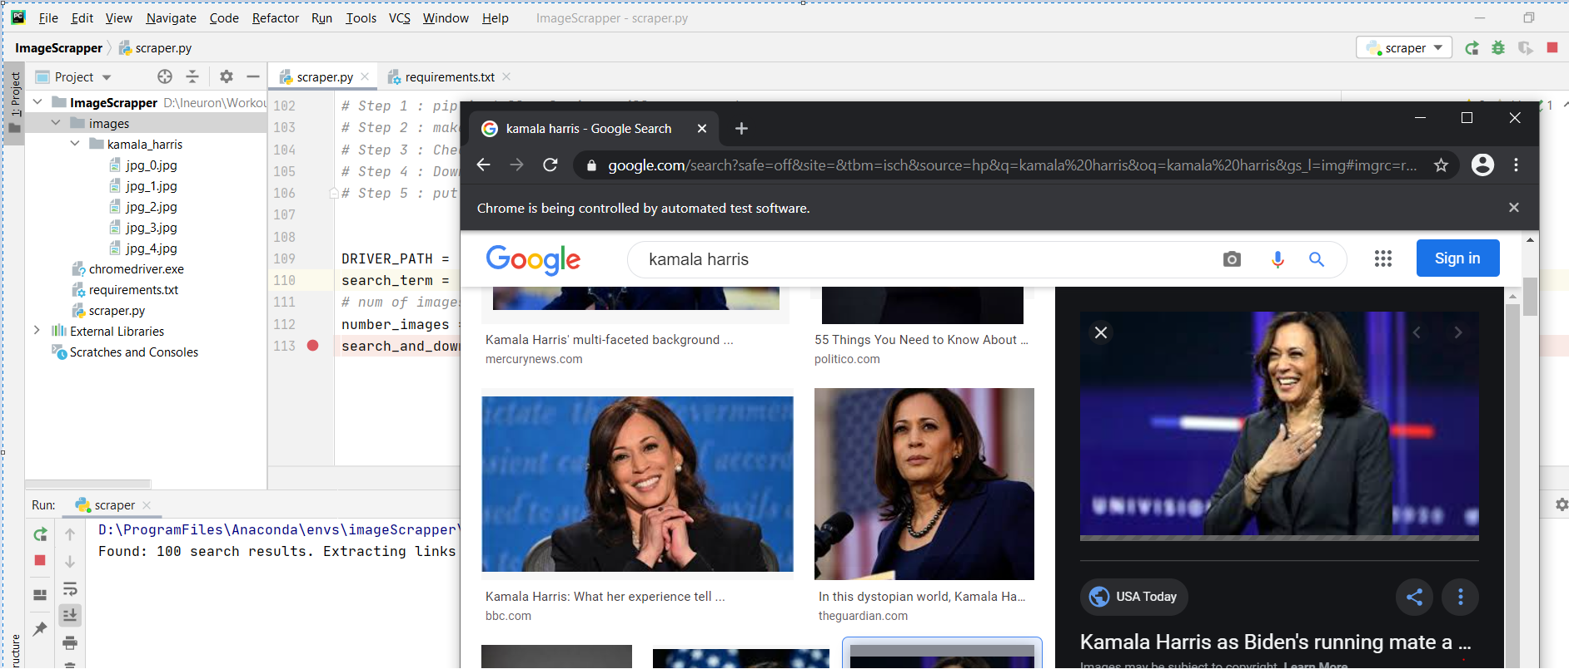

From the IDE, terminal able to see the log of saving the 5 images in my directory

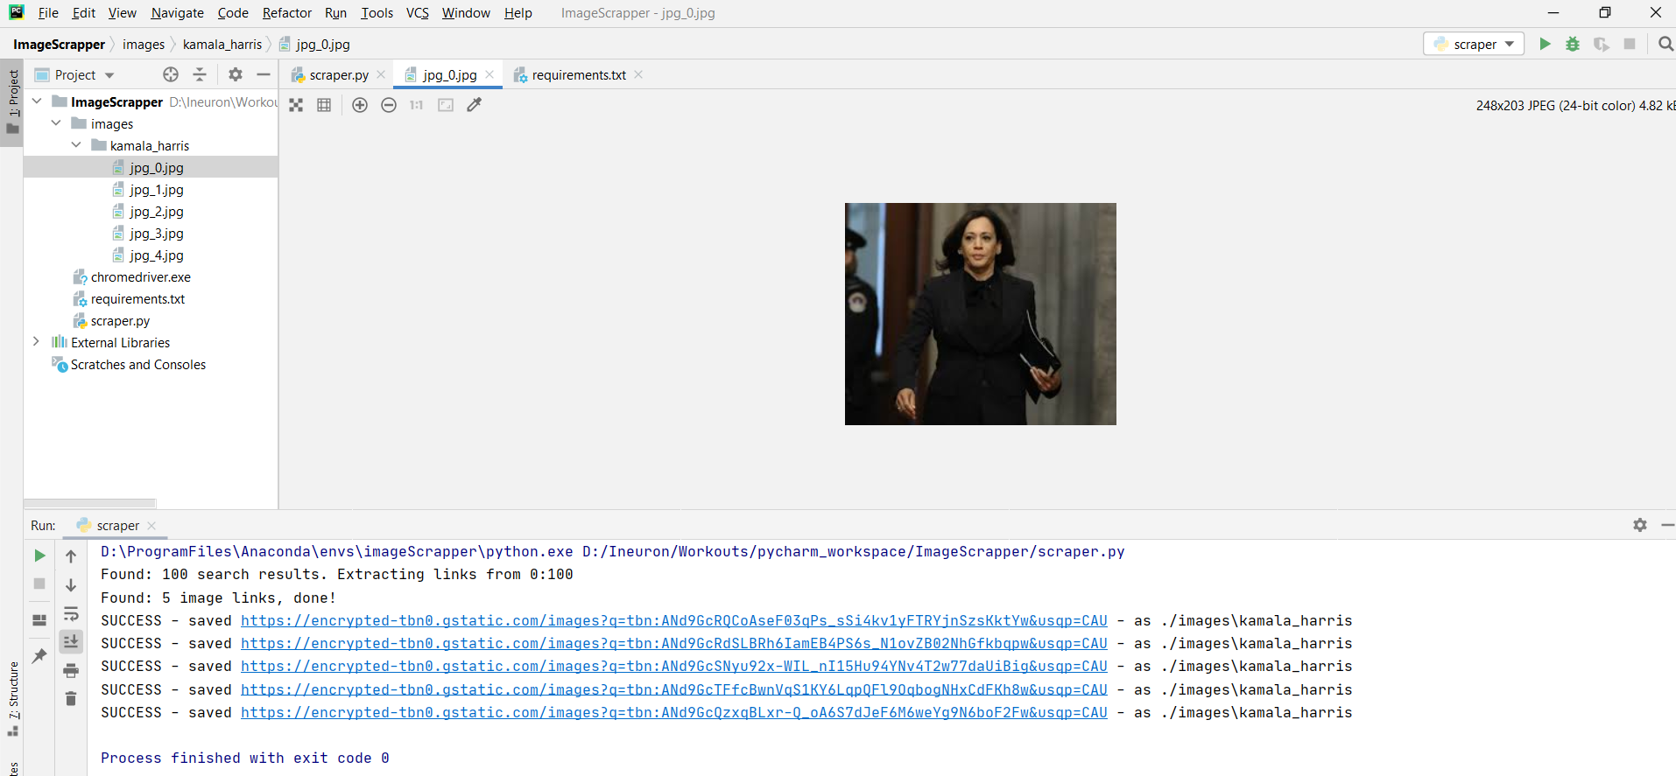

Opening the images from the directory created as ‘Kamala Harris’

