DSA0503 - Query Processing for Data Science
Activity

Name : Anto Chriswin G
Register Number : 192324093
Date : 25/07/2026
Github link :

Activity using SQLite Database:
1. Create the Department Table (Parent Table) with attributes Department_ID
INTEGER PRIMARY KEY, Department_Name TEXT
2. Create the Student Table (Child Table) with the following attributes:
Student_ID INTEGER PRIMARY KEY,
Name TEXT,
Age INTEGER,
Department_ID INTEGER,
CGPA REAL,
FOREIGN KEY (Department_ID) REFERENCES Department(Department_ID)
3.Display students from CSE department.
4.Count students in each department.
5. Update the foreign key. For eg., change the department of a student
6. Delete a department
7. Display the student’s name, student’s department and CGPA if the student’s CGPA is
greater than 8.

1. Create the Department Table (Parent Table) with attributes Department_ID
INTEGER PRIMARY KEY, Department_Name TEXT
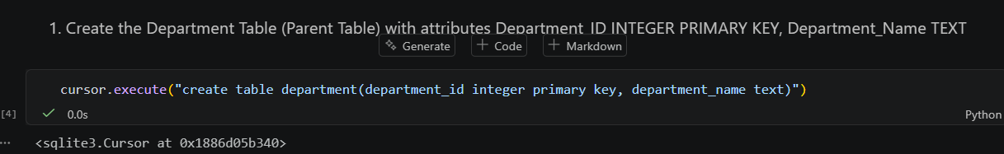

2. Create the Student Table (Child Table) with the following attributes:
Student_ID INTEGER PRIMARY KEY,Name TEXT,Age INTEGER, Department_ID INTEGER, CGPA REAL, FOREIGN KEY (Department_ID) REFERENCES Department(Department_ID)

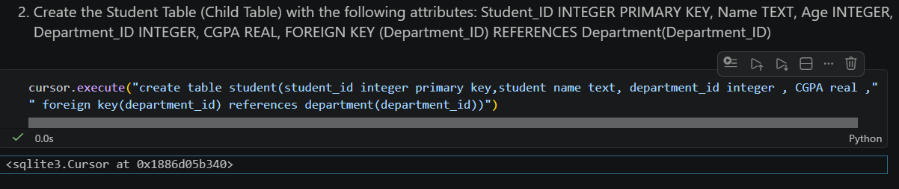

3.Display students from CSE department.
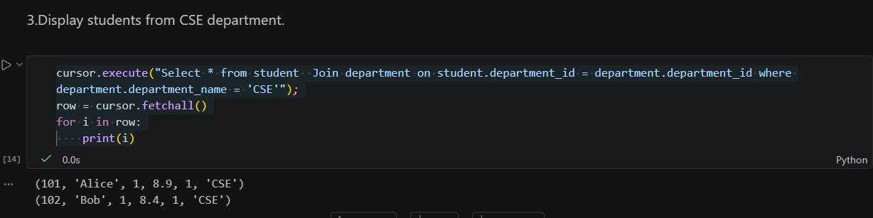

4.Count students in each department.
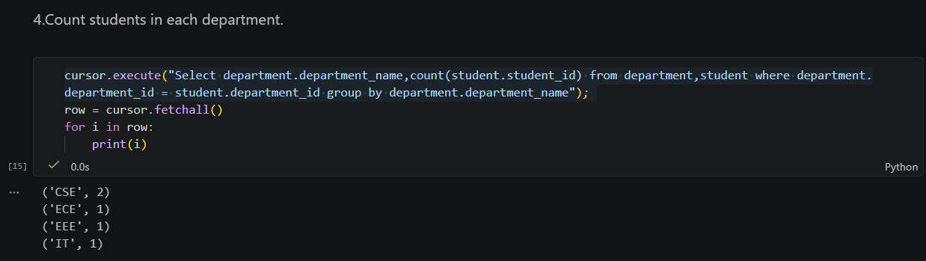

5. Update the foreign key. For eg., change the department of a student
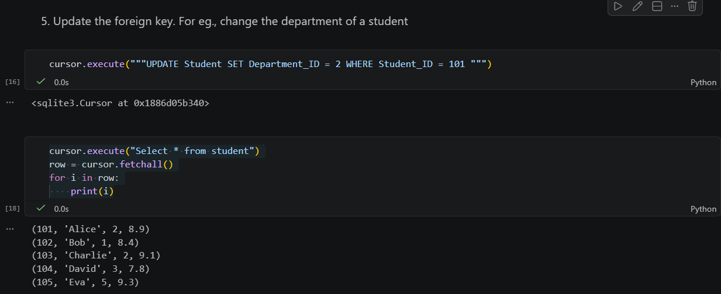

6. Delete a department
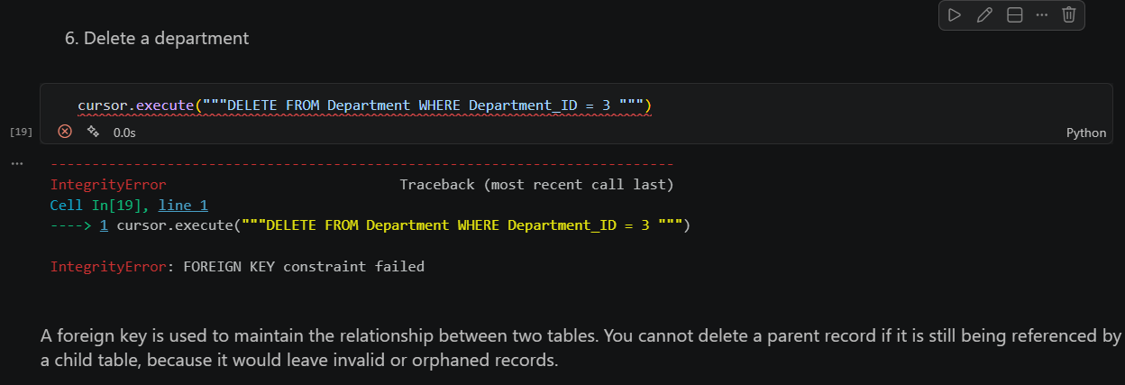

7. Display the student’s name, student’s department and CGPA if the student’s CGPA is
greater than 8.
