DSA0503 - Query Processing for Data Science
Activity

Name : Anto Chriswin G
Register Number : 192324093
Date : 27/07/2026

1 ) Employee and Department Database Design (10 Marks)
A company wants to store employee information and department details in an SQLite database. Design two related tables, Department and Employee, by identifying appropriate primary and foreign keys. Write a Python program to connect to the database, create both tables, insert sample data into each table, and display the employee name along with the corresponding department name using an SQL JOIN query.
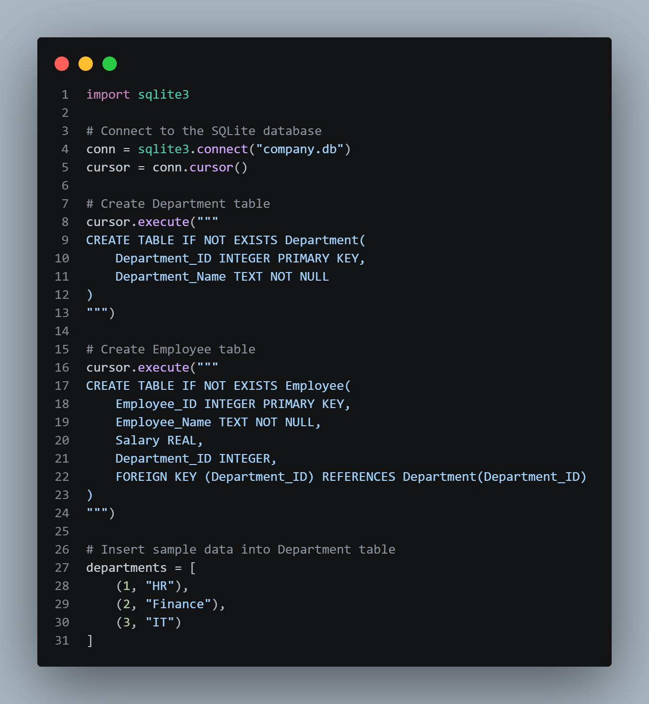
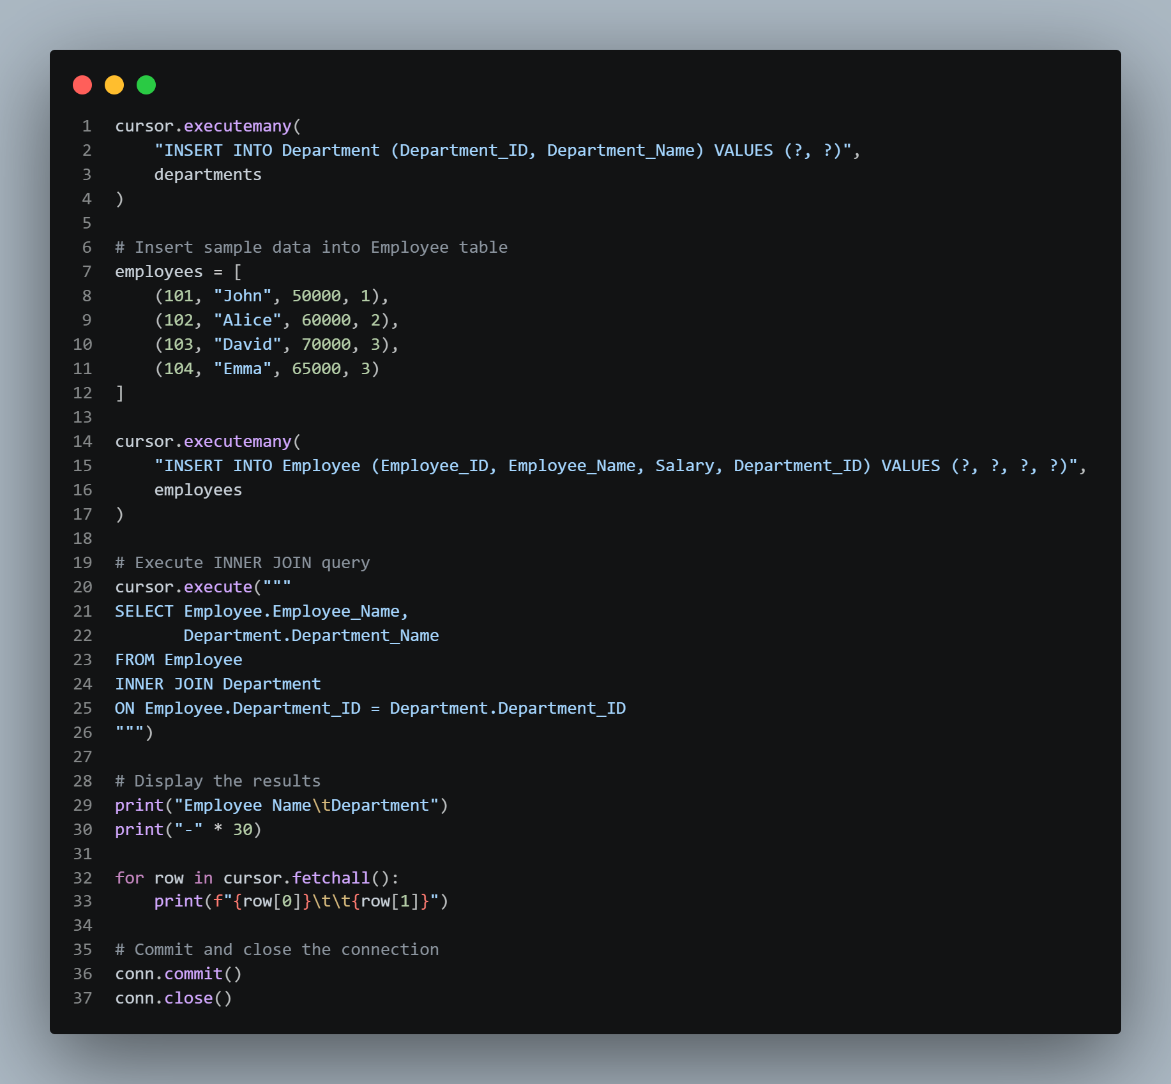

Output :
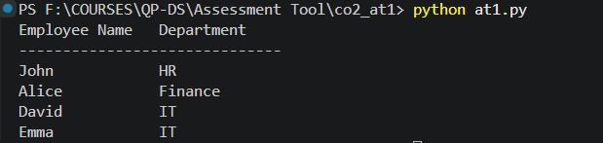

2) Banking Customer Database (10 Marks)
A bank wants to maintain customer account details in MySQL. Design an Account table with appropriate constraints. Write a Python program to connect to the database, create the table, insert customer account records, update the account balance after a transaction, and retrieve the account information.
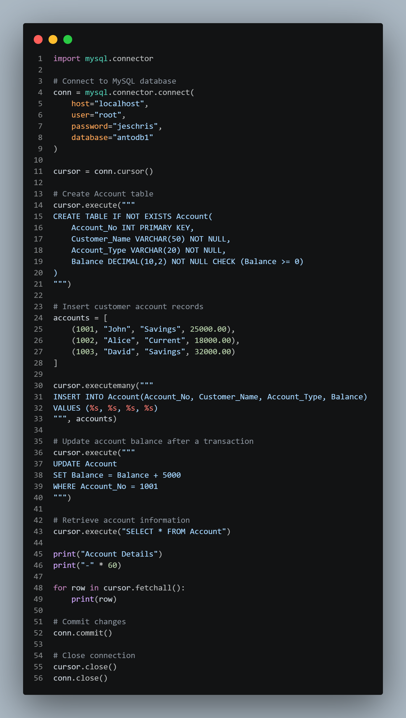
Output :
