**AdminApp/models.py**

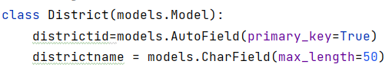

**Python manage.py makemigrations**

**Python manage.py migrate**

**Project --- urls.py**

path('',include('GuestApp.Guesturls')),  
path('AdminApp/',include('AdminApp.adminurls')),

**AdminApp/adminurls.py**

urlpatterns = [

path('adminhome/',views.adminhome,name='adminhome'),

path('district/',views.district,name='district'),

]

**AdminApp/views.py**

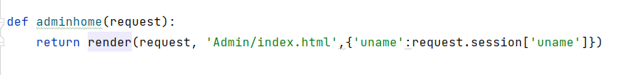

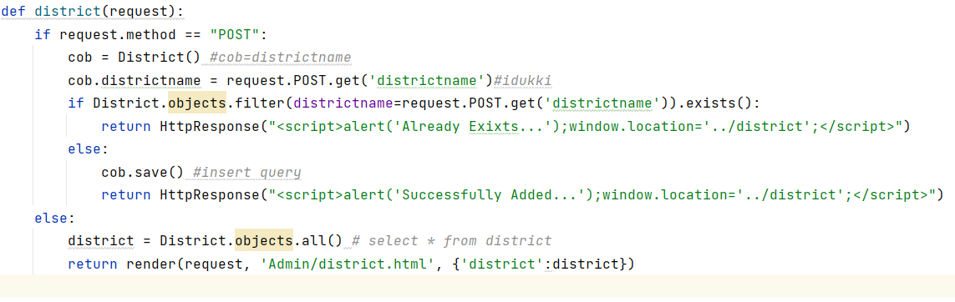

**Templates/Admin/district.html**

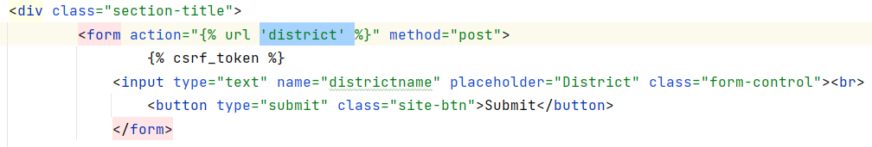

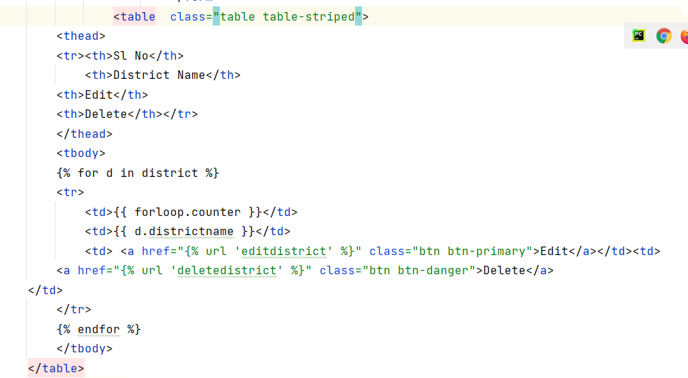

**AdminApp/adminurls.py**

path('editdistrict/<id>/',views.editdistrict,name='editdistrict'),  
path('deletedistrict/<id>/',views.deletedistrict,name='deletedistrict'),

**AdminApp/views.py**

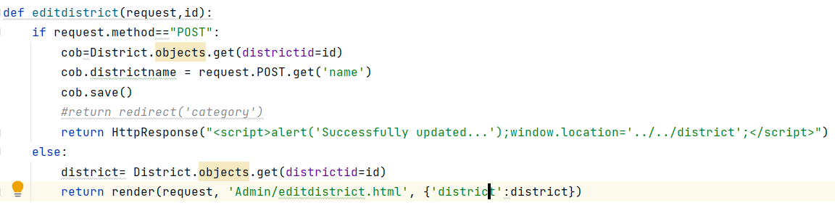

**Templates/Admin/editdistrict.html**

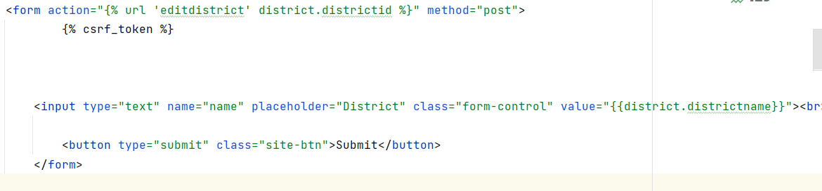

**AdminApp/views.py**

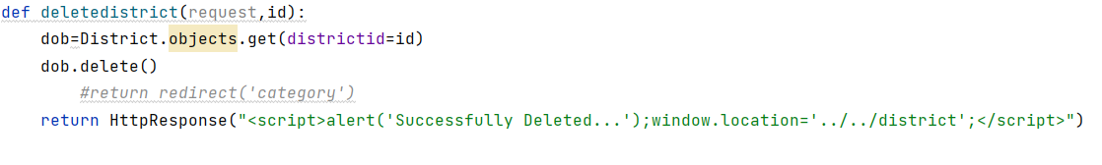

**Location District Dropdown**

