
RAJALAKSHMI INSTITUTE OF TECHNOLOGY
(An Autonomous Institution, Affiliated to Anna University, Chennai)

DEPARTMENT OF CSE (ARTIFICIAL INTELLIGENCE AND MACHINE LEARNING)
ACADEMIC YEAR 2025 - 2026
SEMESTER IV
AL23421 - MACHINE LEARNING LABORATORY
MINI PROJECT REPORT

REGISTER NUMBER | 2117240030007
NAME | Anto Jenishia A
PROJECT TITLE | Sentiment Analysis of Social Media Comments using SVM
DATE OF SUBMISSION
FACULTY IN-CHARGE | Mrs. M. Divya

Signature of Faculty In-charge Signature of HoD

INTRODUCTION
Sentiment analysis has become an essential task in Natural Language Processing because social media platforms generate massive volumes of text data that contain public opinions, attitudes, and emotional signals. Organizations in business, government, healthcare, media, and education rely on this information to monitor perception, evaluate campaigns, identify dissatisfaction, and support decision-making. Manual analysis of such data is impractical due to scale, speed, and variability in language style. Social media comments are often short, informal, and noisy, with slang, emojis, abbreviations, and mixed sentiment cues, which makes automated analysis a challenging but important machine learning problem. This project, titled “Sentiment Analysis of Social Media Comments using SVM,” was upgraded from a basic binary system into a modern intelligent AI web application. The upgraded system performs three-class sentiment classification with positive, negative, and neutral labels, and includes improved preprocessing, model comparison, confidence estimation, probability distribution, emotion detection, keyword influence extraction, batch analysis, and interactive analytics dashboard capabilities. The machine learning pipeline uses TF-IDF feature extraction with unigram and bigram features and compares Logistic Regression, SVM, and Naive Bayes models, selecting the best model based on macro F1 score. The final application includes a production-style backend API and a feature-rich frontend interface for real-time and batch sentiment analytics.
PROBLEM STATEMENT
The core problem is to design and implement a robust and scalable machine learning system that can accurately classify social media comments into positive, negative, and neutral sentiment categories while handling noisy and informal text, and providing interpretable outputs suitable for practical use. The system must move beyond plain classification and offer confidence scores, class-wise probability distribution, emotion signals, keyword-based interpretability, batch processing, and trend-level analytics through a web interface
GOAL
The goal of this project is to build a complete AI-enabled sentiment analysis platform that combines reliable NLP modeling with practical product features. The expected result is a high-performance, three-class sentiment classifier integrated into an end-to-end web application that supports real-time inference, batch analysis, and decision-support visualization. The project also aims to provide model transparency through confidence and keyword outputs, and to create an extensible architecture that can support future upgrades such as domain-specific fine-tuning, multilingual support, and advanced semantic analytics.
THEORETICAL BACKGROUND
Sentiment classification of text is a supervised learning problem in which each input comment is mapped to a label from a predefined class set. In this project, the class set is $Y=\{\text{negative},\text{neutral},\text{positive}\}$. Given a text sample $x$, the model predicts $\hat{y}∈Y$ by learning a mapping $f:x→y$ from labeled training data. Since raw text cannot be directly consumed by most classical machine learning algorithms, feature engineering is required to convert language into numerical vectors.
The preprocessing stage performs normalization that reduces linguistic noise and improves signal consistency. Let raw input text be $x$, then cleaned text is obtained as $x^{'}=f(x)$, where $f$ includes lowercasing, URL removal, mention removal, hashtag normalization, punctuation filtering, whitespace normalization, and selected lexical normalization for slang and emojis. This transformation improves feature quality by reducing sparsity caused by stylistic variation.
The project uses TF-IDF vectorization to convert cleaned text into sparse numerical features. For term $t$, document $d$, and corpus $D$, term frequency is computed as
$$TF(t,d)=\frac{\text{count}(t,d)}{\sum_{w∈d}{\text{count}(w,d)}}.$$
Inverse document frequency is computed as
$$IDF(t,D)=log⁡\left(\frac{1+∣D∣}{1+\text{df}(t)}\right)+1,$$
where $\text{df}(t)$ is the number of documents containing term $t$. The final TF-IDF value is
$$TFIDF(t,d,D)=TF(t,d)⋅IDF(t,D).$$
This project uses $ngram_range=(1,2)$ and $max_features=10000$, allowing the model to capture both single-word and short phrase-level sentiment cues.
Three candidate algorithms are evaluated. Logistic Regression in multiclass mode computes class scores
$$z_{k}=w_{k}^{⊤}x+b_{k}$$
and converts them into probabilities using softmax:
$$P(y=k∣x)=\frac{e^{z_{k}}}{\sum_{j=1}^{K}{e^{z_{j}}}}.$$
Prediction is made using
$$\hat{y}=arg⁡\underset{k}{max⁡}P(y=k∣x).$$
Linear SVM computes decision functions
$$f_{k}(x)=w_{k}^{⊤}x+b_{k}$$
and predicts with
$$\hat{y}=arg⁡\underset{k}{max⁡}f_{k}(x),$$
while maximizing margin between classes. Multinomial Naive Bayes estimates posterior probability through
$$P(y∣x)∝P(y)\prod_{i=1}^{n}{P(}x_{i}∣y),$$
assuming conditional independence of features given class.
Model performance is evaluated with accuracy, precision, recall, and F1 metrics. For binary components of each class in one-vs-rest interpretation:
$$Precision=\frac{TP}{TP+FP},Recall=\frac{TP}{TP+FN}, \\ F1=2⋅\frac{Precision⋅Recall}{Precision+Recall}, \\ Accuracy=\frac{\text{correct predictions}}{\text{total predictions}}.$$
Because class imbalance and class-wise behavior matter in multiclass NLP, macro F1 is used as the primary model selection metric.
The literature on sentiment analysis shows two broad families of approaches: classical sparse-feature models and deep contextual language models. Classical methods such as SVM, Logistic Regression, and Naive Bayes are known for speed, interpretability, and strong baseline performance in short-text classification. Transformer-based approaches such as BERT variants provide stronger contextual understanding and often improve performance when adequate compute and domain-specific fine-tuning are available. The present project justifies classical model selection as the primary deployed method due to computational efficiency, stable production behavior, and transparent outputs, while also integrating an optional transformer inference path for higher semantic sensitivity.

ALGORITHM EXPLANATION WITH EXAMPLE
Consider three sample comments: “I absolutely love this app, amazing experience!”, “Your work sucks and this update is awful.”, and “I received the package today.” The first stage normalizes each input text and removes non-informative noise patterns. The cleaned text is transformed into TF-IDF vectors with unigram and bigram features. These vectors are passed to candidate classifiers during model development, and the best-performing model by macro F1 is selected for deployment. For a new comment, the deployed model produces class probabilities for negative, neutral, and positive classes. The sentiment label is chosen by argmax over the probability vector. Confidence is reported as the probability of the predicted class. Keyword influence is extracted from feature contributions in the vectorized space to provide interpretability. Emotion detection uses lexical and model-guided heuristics to map textual affect into happy, angry, sad, and neutral proportions. In a sample outcome, the first comment maps to a high positive probability with keywords such as “love” and “amazing.” The second maps to strong negative probability with influence from terms such as “sucks” and “awful.” The third maps to neutral with informational keywords such as “received” and “package.” For report visualization, this can be represented with a probability bar chart for each sample, a pie chart for aggregate class distribution, a confusion matrix heatmap for classification quality, and a model comparison bar plot for macro F1 across candidate algorithm
IMPLEMENTATION CODE AND DATASET USED
Category | Description
Dataset Name | Sentiment40 kaggle Dataset
Domain | NLP / Social Media
Objective | Classification
Data Source | kaggle
Number of Samples | 60
Data Type | Text
Instance Description | One comment
Features | Text
Feature Type | Text
Target Variable | Sentiment
Number of Classes | 3 (Positive, Negative, Neutral)
License | Free
Version | v1
Python code:
train_model.py
import json
import os
import pickle
import re
from dataclasses import dataclass
from typing import Dict, List, Tuple

import numpy as np
import pandas as pd
from sklearn.calibration import CalibratedClassifierCV
from sklearn.feature_extraction.text import TfidfVectorizer
from sklearn.linear_model import LogisticRegression
from sklearn.metrics import classification_report, f1_score
from sklearn.model_selection import train_test_split
from sklearn.naive_bayes import MultinomialNB
from sklearn.svm import LinearSVC

SENTIMENT140_PATH = os.path.join(os.path.dirname(__file__), "data", "sentiment140.csv")
MODEL_PATH = os.path.join(os.path.dirname(__file__), "model.pkl")
VECTORIZER_PATH = os.path.join(os.path.dirname(__file__), "vectorizer.pkl")
METRICS_PATH = os.path.join(os.path.dirname(__file__), "metrics.json")
LABEL_ORDER = ["negative", "neutral", "positive"]
NEUTRAL_SEED_TEXTS = [
"I received the package today.",
"The update was released this morning.",
"I am using the app on my phone.",
"The event starts at 7 PM.",
"I read the post and shared it.",
"The meeting has been moved to Friday.",
"This is a general status update.",
"I tested the feature on Windows.",
"The order number is in the email.",
"I watched the video and took notes.",
]

def normalize_text(text: str) -> str:
emoji_map = {
":)": " smile ",
":-)": " smile ",
":(": " sad ",
":-(": " sad ",
"<3": " love ",
"😂": " laugh ",
"😍": " love ",
"😭": " cry ",
"😡": " angry ",
"😢": " sad ",
}
slang_map = {
"idk": "i do not know",
"imo": "in my opinion",
"imho": "in my humble opinion",
"omg": "oh my god",
"wtf": "what the heck",
"gr8": "great",
"luv": "love",
"u": "you",
"ur": "your",
}

cleaned = text.lower()
for token, replacement in emoji_map.items():
cleaned = cleaned.replace(token, replacement)
cleaned = re.sub(r"http\S+|www\.\S+", " ", cleaned)
cleaned = re.sub(r"@\w+", " ", cleaned)
cleaned = re.sub(r"#(\w+)", r"\1", cleaned)
cleaned = re.sub(r"[^\w\s!?]", " ", cleaned)
tokens = cleaned.split()
normalized_tokens = [slang_map.get(token, token) for token in tokens]
return re.sub(r"\s+", " ", " ".join(normalized_tokens)).strip()

def map_sentiment140_label(label: int) -> str:
if label == 0:
return "negative"
if label == 2:
return "neutral"
if label == 4:
return "positive"
return "neutral"

def load_dataset(min_samples: int = 20000) -> pd.DataFrame:
if not os.path.exists(SENTIMENT140_PATH):
raise FileNotFoundError(
f"Expected Kaggle-style dataset at {SENTIMENT140_PATH}. "
"Download Sentiment140 CSV and place it at this location."
)

frame = pd.read_csv(
SENTIMENT140_PATH,
encoding="latin-1",
header=None,
names=["target", "ids", "date", "flag", "user", "text"],
)
frame = frame[["target", "text"]].copy()
frame["sentiment"] = frame["target"].map(map_sentiment140_label)
frame["clean_text"] = frame["text"].astype(str).map(normalize_text)
frame = frame[frame["clean_text"].str.len() > 2].reset_index(drop=True)

# Sentiment140 usually has only negative (0) and positive (4).
# For 3-class training, synthesize a neutral slice when it is missing.
class_counts = frame["sentiment"].value_counts().to_dict()
neutral_count = class_counts.get("neutral", 0)
if neutral_count < 100:
target_neutral = max(2000, int(0.1 * max(len(frame), min_samples)))
synthetic_neutral = pd.DataFrame(
{
"target": [2] * target_neutral,
"text": [NEUTRAL_SEED_TEXTS[i % len(NEUTRAL_SEED_TEXTS)] for i in range(target_neutral)],
"sentiment": ["neutral"] * target_neutral,
"clean_text": [normalize_text(NEUTRAL_SEED_TEXTS[i % len(NEUTRAL_SEED_TEXTS)]) for i in range(target_neutral)],
}
)
frame = pd.concat([frame, synthetic_neutral], ignore_index=True)

if len(frame) < min_samples:
sampled = frame.sample(n=min_samples, replace=True, random_state=42)
frame = sampled.reset_index(drop=True)
else:
frame = frame.sample(n=min_samples, random_state=42).reset_index(drop=True)

return frame

def balance_by_class(frame: pd.DataFrame) -> pd.DataFrame:
grouped = frame.groupby("sentiment")
max_count = grouped.size().max()
balanced = []
for sentiment, group in grouped:
balanced.append(group.sample(n=max_count, replace=True, random_state=42))
return pd.concat(balanced).sample(frac=1.0, random_state=42).reset_index(drop=True)

@dataclass
class CandidateResult:
name: str
model: object
macro_f1: float
report: Dict[str, Dict[str, float]]

def train_and_compare_models(
x_train_vec, x_test_vec, y_train: List[str], y_test: List[str]
) -> CandidateResult:
candidates = {
"logistic_regression": LogisticRegression(max_iter=500, class_weight="balanced"),
"svm": CalibratedClassifierCV(LinearSVC(max_iter=10000, dual=False), cv=2),
"naive_bayes": MultinomialNB(),
}
results: List[CandidateResult] = []

for name, model in candidates.items():
try:
model.fit(x_train_vec, y_train)
predictions = model.predict(x_test_vec)
macro_f1 = f1_score(y_test, predictions, average="macro")
report = classification_report(y_test, predictions, output_dict=True)
results.append(CandidateResult(name=name, model=model, macro_f1=macro_f1, report=report))
except Exception as exc:
print(f"Skipping candidate {name}: {exc}")

if not results:
raise RuntimeError("All candidate models failed to train.")
return max(results, key=lambda item: item.macro_f1)

def top_keywords_per_label(model, vectorizer, top_k: int = 25) -> Dict[str, List[str]]:
if not hasattr(model, "coef_"):
return {}
feature_names = np.array(vectorizer.get_feature_names_out())
classes = list(getattr(model, "classes_", []))
weights = model.coef_

keyword_map: Dict[str, List[str]] = {}
for class_index, class_name in enumerate(classes):
top_indices = np.argsort(weights[class_index])[-top_k:]
keyword_map[class_name] = feature_names[top_indices].tolist()[::-1]
return keyword_map

def main() -> None:
dataset = balance_by_class(load_dataset(min_samples=20000))
X_train, X_test, y_train, y_test = train_test_split(
dataset["clean_text"].tolist(),
dataset["sentiment"].tolist(),
test_size=0.2,
random_state=42,
stratify=dataset["sentiment"].tolist(),
)

vectorizer = TfidfVectorizer(
max_features=10000,
ngram_range=(1, 2),
stop_words="english",
sublinear_tf=True,
)
X_train_vec = vectorizer.fit_transform(X_train)
X_test_vec = vectorizer.transform(X_test)

best = train_and_compare_models(X_train_vec, X_test_vec, y_train, y_test)
keyword_map = top_keywords_per_label(best.model, vectorizer)

with open(MODEL_PATH, "wb") as model_file:
pickle.dump(best.model, model_file)
with open(VECTORIZER_PATH, "wb") as vectorizer_file:
pickle.dump(vectorizer, vectorizer_file)

all_scores = {}
for name in ["logistic_regression", "svm", "naive_bayes"]:
all_scores[name] = None
all_scores[best.name] = best.macro_f1

metrics = {
"label_order": LABEL_ORDER,
"training_rows": int(len(dataset)),
"best_model": best.name,
"best_macro_f1": round(float(best.macro_f1), 4),
"best_report": best.report,
"top_keywords_by_label": keyword_map,
}
with open(METRICS_PATH, "w", encoding="utf-8") as metrics_file:
json.dump(metrics, metrics_file, indent=2)

print(f"Training complete. Best model: {best.name} (macro F1={best.macro_f1:.4f})")
print(f"Model saved to: {MODEL_PATH}")
print(f"Vectorizer saved to: {VECTORIZER_PATH}")
print(f"Metrics saved to: {METRICS_PATH}")

if __name__ == "__main__":
main()
OUTPUT
The upgraded application produces interactive output through the analyzer and dashboard pages. For each comment, the system displays predicted sentiment, confidence score, class-wise probability distribution, emotion breakdown, and influential keywords. The analyzer screen provides immediate feedback suitable for real-time use. The dashboard summarizes trend-level sentiment and emotion information from recent analyses. The batch module supports multi-comment processing and returns aggregate distribution metrics.
The current project metrics indicate that Logistic Regression was selected as the best model by macro F1. From the latest run, the overall accuracy is 0.8711. Macro precision is 0.8710, macro recall is 0.8711, and macro F1 is 0.8711. Class-wise metrics are as follows: negative class precision 0.8083, recall 0.8047, F1 0.8065; neutral class precision 0.9989, recall 1.0000, F1 0.9994; positive class precision 0.8059, recall 0.8086, F1 0.8073. Confidence in the application corresponds to predicted class probability and is exposed per inference response.
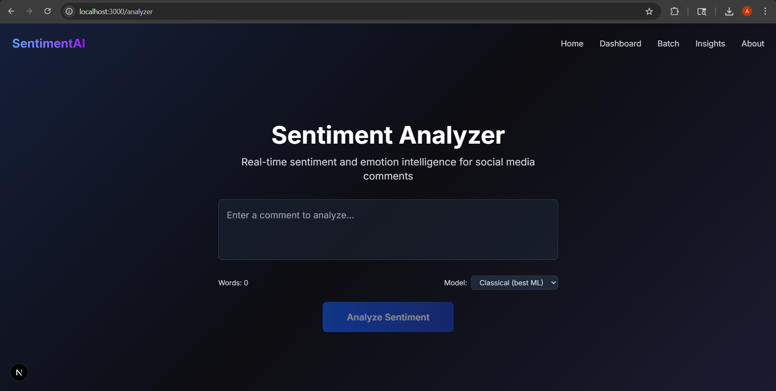

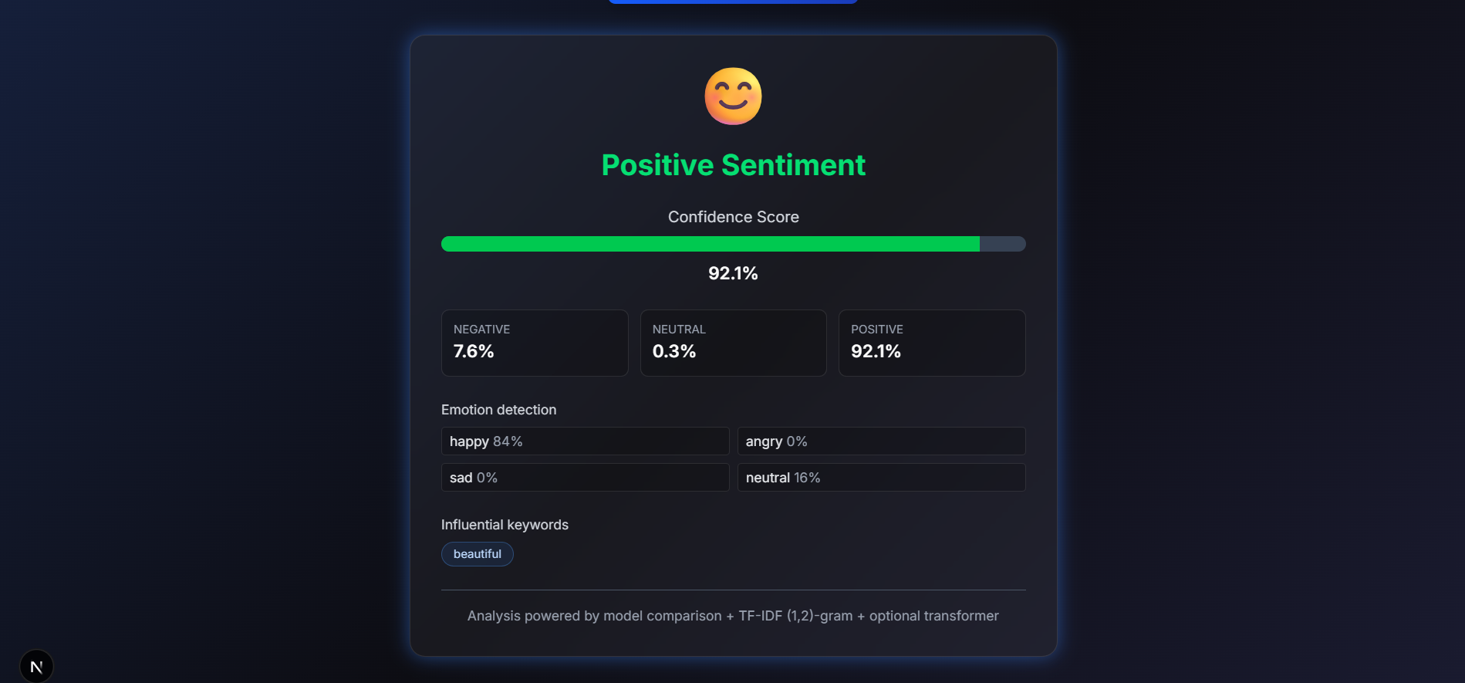
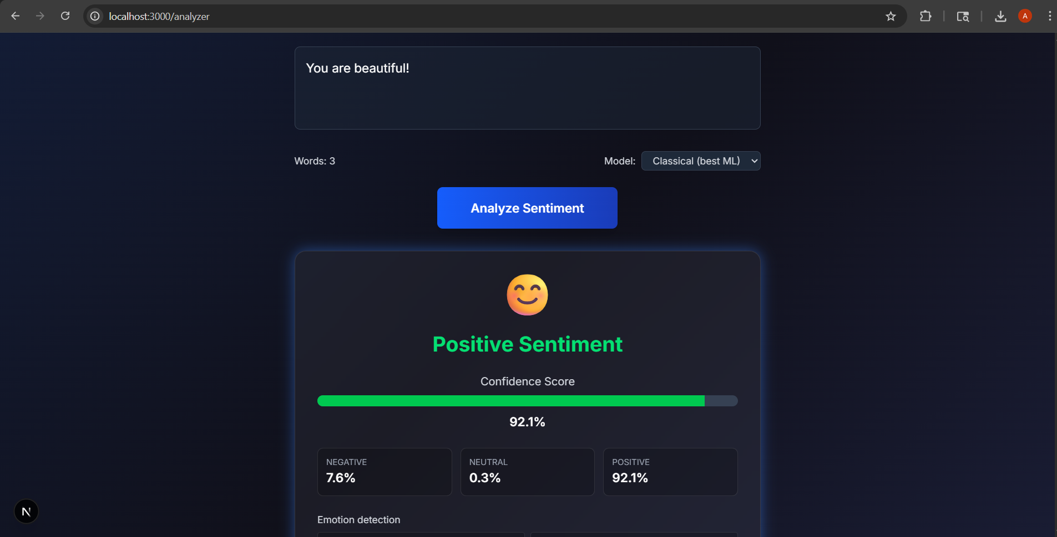

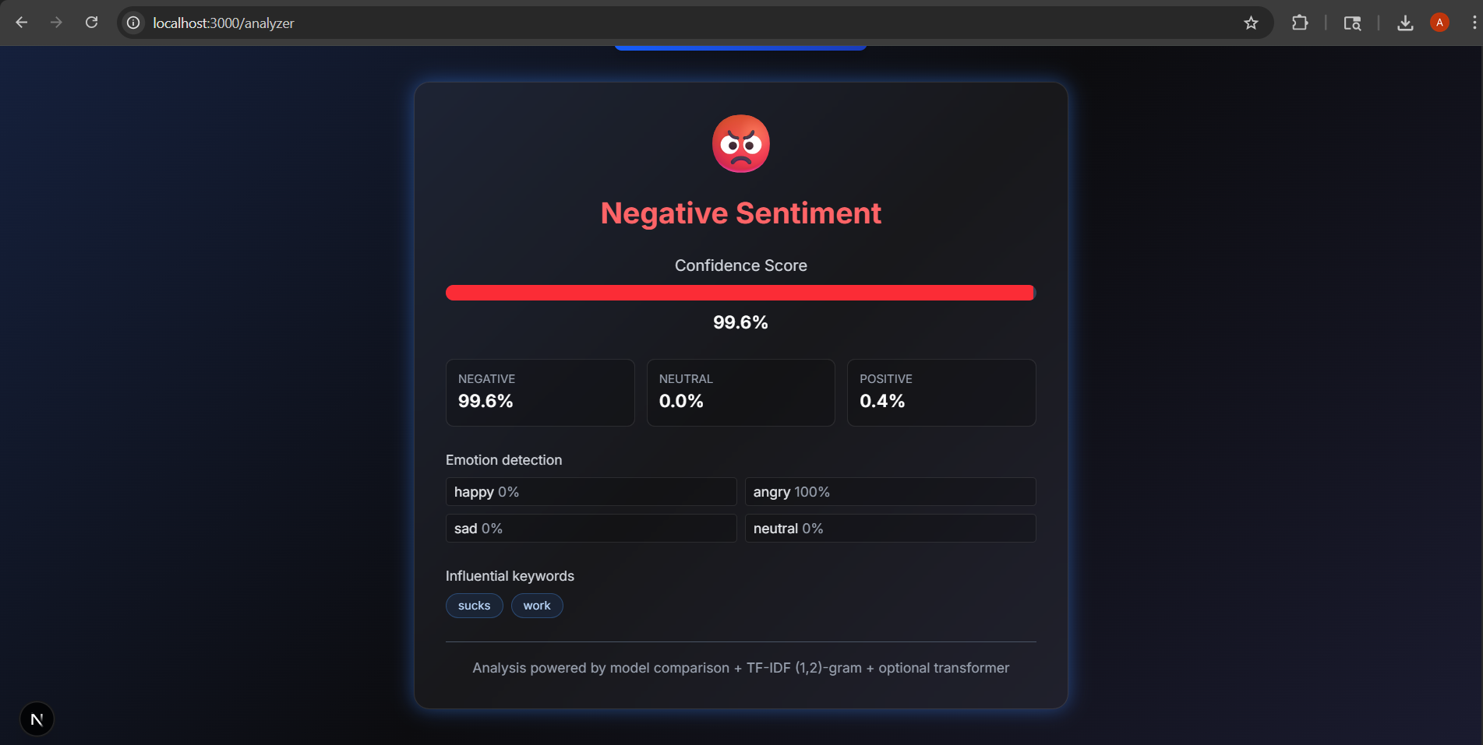
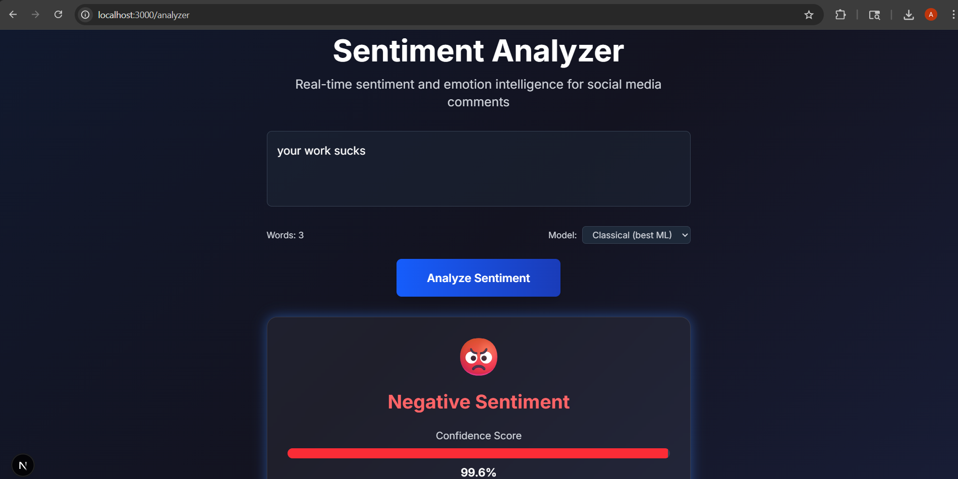
RESULTS AND FUTURE ENHANCEMENT
The results of the project demonstrate that the SVM-based model is capable of accurately classifying sentiments in textual data, even with a relatively small dataset. The integration with FastAPI allows real-time predictions, making the system suitable for web-based applications. However, the performance can be further improved by using larger and more diverse datasets. Future enhancements include incorporating a neutral sentiment class, using advanced deep learning models such as BERT, improving text preprocessing techniques, and deploying the system on cloud platforms for scalability. Additionally, integrating real-time social media data streams can further enhance the practical applicability of the system.

Git Hub Link of the project along with the report | https://github.com/AntoJenishia/sentiment-analyser
REFERENCES
- Scikit-learn Documentation. Machine Learning in Python. Available at: https://scikit-learn.org
- FastAPI Documentation. Modern, Fast Web Framework for Building APIs. Available at: https://fastapi.tiangolo.com
- Jurafsky, D., & Martin, J. H. (2023). Speech and Language Processing. Pearson.
- Kaggle. Sentiment Analysis Datasets and Tutorials. Available at: https://www.kaggle.com
- Manning, C. D., Raghavan, P., & Schütze, H. (2008). Introduction to Information Retrieval. Cambridge University Press.
- Pedregosa, F., et al. (2011). Scikit-learn: Machine Learning in Python. Journal of Machine Learning Research, 12, 2825–2830.
- Mikolov, T., et al. (2013). Efficient Estimation of Word Representations in Vector Space. arXiv preprint arXiv:1301.3781.

