**American University of Beirut**

**Maroun Semaan Faculty of Engineering and Architecture**

**Department of Electrical and Computer Engineering**

Ecommerce Website Backend Service

By:

**Joseph Souaiby**

([jgs26@mail.aub.edu](mailto:jgs26@mail.aub.edu))

**Antoine Saade**

([ays13@mail.aub.edu](mailto:ays13@mail.aub.edu))

A REPORT

submitted to Dr. Iman Ghalayini in fulfillment of the requirements of the final project of the course EECE435L –Software Tools Lab on December 3rd, 2024

# Introduction

**Project Overview:** This project focuses on developing the backend web services for an e-commerce website. The system consists of four key services—Customers, Inventory, Sales, and Reviews—which will handle customer registration, product management, sales transactions, and product reviews respectively. These services are designed to interact with each other through API calls, providing a seamless and efficient user experience. The project is containerized using Docker to ensure consistent deployment across various environments. The goal is to build a robust, scalable, and secure backend system that supports an e-commerce platform's core functionalities, such as user management, product inventory, and order processing.

**Objectives:** The main objectives of this project are:

1. To develop four independent backend services for handling customers, inventory, sales, and reviews.
2. To ensure effective inter-service communication via API calls.
3. To utilize Docker for containerization and ensure the services run consistently across different environments.
4. To implement user authentication, error handling, and data validation to ensure the security and reliability of the system.
5. To perform thorough testing using Pytest and validate the system's functionality and performance.
6. To apply professional development practices, such as version control, documentation, and profiling, to ensure the project meets industry standards.
7. To integrate additional features like rate-limiting, logging, and secure configuration management for enhanced functionality and security.

# System Architecture

The system is composed of four backend services—Customers, Inventory, Sales, and Reviews—designed to provide the core functionality of an e-commerce platform. These services interact with each other to manage customer information, product inventory, sales transactions, and product reviews, while ensuring scalability, flexibility, and separation of concerns.

## Customers Service

Responsibilities: The Customers service manages all aspects of customer data, including account creation, management, and updating of personal details. It also handles wallet management, where customers can add or deduct funds for purchases. The service ensures secure customer registration, updates, and retrieves customer information as needed. Additionally, it handles account deletions and allows for querying customer details.

## Inventory Service

Responsibilities: The Inventory service manages the products available for sale. It is responsible for adding new products to the inventory, updating product information (such as price and description), and removing products when necessary. The service ensures that stock levels are properly maintained and allows for tracking of available items for sale. It provides functionality to check and update product availability, ensuring accurate listings on the platform.

## Sales Service

Responsibilities: The Sales service handles all transactions between customers and the platform. It ensures that products are purchased only when sufficient funds are available in the customer's wallet and when the product is in stock. The service processes the transaction by charging the customer’s wallet and updating the inventory to reflect the sale. It also tracks purchase history and maintains records of all transactions for customers.

## Reviews Service

Responsibilities: The Reviews service allows customers to leave feedback on products they have purchased. Customers can provide ratings and comments on products, helping other customers make informed decisions. The service supports moderating reviews to ensure quality and appropriateness of content. It also tracks reviews submitted by each customer and allows for retrieving all reviews related to a specific product.

## Communication Between Services

Each service communicates with others through API calls, ensuring that the system operates in an integrated and seamless manner. For instance, the Sales service communicates with the Customers service to verify available funds in the customer’s wallet and with the Inventory service to ensure product availability before processing a sale. The Reviews service interacts with both the Sales and Inventory services to ensure that only customers who have made a purchase can leave a review for a product.

## Docker Containerization

Each service is containerized using Docker to ensure isolated, consistent environments across development and production stages. Docker provides flexibility in deploying and scaling the services, while ensuring that dependencies and configurations are handled properly. The services are organized into a multi-container setup managed by Docker Compose, which enables streamlined orchestration and deployment.

# Implementation Details

**Service 1 - Customers**

**Functionality:** The Customers service is responsible for managing customer data, including registration, updating details, wallet management, and retrieving customer information.

**Key APIs:**

* **Register Customer (/register)**: Handles new customer registration, validating inputs like username, password, and other personal details.
* **Get All Customers (/customers)**: Retrieves a list of all registered customers.
* **Get Customer by Username (/customer/<username>)**: Fetches details for a specific customer.
* **Update Customer (/update/<username>)**: Updates personal information, such as name, age, or password.
* **Wallet Management**: Provides endpoints to charge (/charge/<username>) and deduct funds (/deduct/<username>) from a customer's wallet.

**Challenges Faced:**

* **Validation:** Ensuring inputs like usernames, passwords, and optional fields (e.g., age, gender) conform to business rules.
* **Username Uniqueness:** Preventing duplicate usernames during registration.
* **Data Consistency:** Proper handling of edge cases, such as invalid or missing fields in requests.

**Service 2 - Inventory**

**Functionality:** The Inventory service is used to manage goods, enabling administrators to add, update, retrieve, and delete inventory items.

**Key APIs:**

* **Add Item (/add_item)**: Allows adding new items with fields like name, category, price, description, and stock.
* **Update Item (/update_item/<name>)**: Updates the price, description, or stock of an item.
* **Deduct Stock (/deduct_stock/<name>)**: Reduces the stock of an item after a purchase.
* **Get All Items (/get_items)**: Retrieves a list of all items in the inventory.
* **Get Item by Name (/get_item/<name>)**: Fetches detailed information for a specific item.
* **Delete Item (/delete_item/<name>)**: Removes an item from the inventory.

**Challenges Faced:**

* **Category Validation:** Ensuring categories (e.g., "Electronics", "Food") match predefined options.
* **Stock Management:** Handling cases where stock may become negative or insufficient for deductions.
* **Error Handling:** Returning appropriate errors when items are not found or validations fail.

**Service 3 - Sales**

**Functionality:** The Sales service processes purchases made by customers and maintains a historical record of transactions.

**Key APIs:**

* **Display Available Goods (/display_goods)**: Lists all goods in stock with their names and prices.
* **Get Good Details (/goods/<name>)**: Fetches detailed information for a specific item.
* **Make Purchase (/purchase)**: Processes a purchase, deducting funds from the customer's wallet and updating inventory stock.
* **Get Purchase History (/purchase_history/<username>)**: Retrieves all past purchases made by a specific customer.

**Challenges Faced:**

* **Multi-Step Transactions:** Ensuring wallet deduction, stock updates, and sale recording are atomic (completed as a single logical unit).
* **Error Scenarios:** Handling edge cases, such as insufficient wallet balance, low stock, or invalid purchase requests.
* **Historical Data Management:** Maintaining a detailed and easily retrievable history of transactions.

**Service 4 - Reviews**

**Functionality:** The Reviews service allows customers to submit, update, retrieve, and moderate reviews for inventory items.

**Key APIs:**

* **Submit Review (/submit)**: Enables customers to submit a new review for a product. Reviews initially have a "pending" status.
* **Update Review (/update/<review_id>)**: Allows customers to modify their review's rating or comment. The status reverts to "pending" after an update.
* **Delete Review (/delete/<review_id>)**: Permits customers to delete their own reviews.
* **Get Product Reviews (/product_reviews/<item_name>)**: Retrieves all approved reviews for a specific product.
* **Get Customer Reviews (/customer_reviews/<username>)**: Fetches all reviews submitted by a specific customer.
* **Moderate Review (/moderate/<review_id>)**: Allows administrators to approve, flag, or delete reviews.

**Challenges Faced:**

* **Ownership Validation:** Ensuring only the review author can update or delete a review.
* **Review Moderation:** Implementing a process for administrators to review and approve or reject submissions.
* **Performance:** Optimizing retrieval of reviews for products with many submissions.

**Now for the full postman collection, you will find on our GitHub a file called “ecommerce_Backend.postman_collection.json”. Save it on your laptop and import it into postman and you will have our collection. Below is a screenshot of the collection on my postman Desktop app. You should get the same when you import it and will be able to test all API endpoints from there. You will find the full documentation there too.  
  
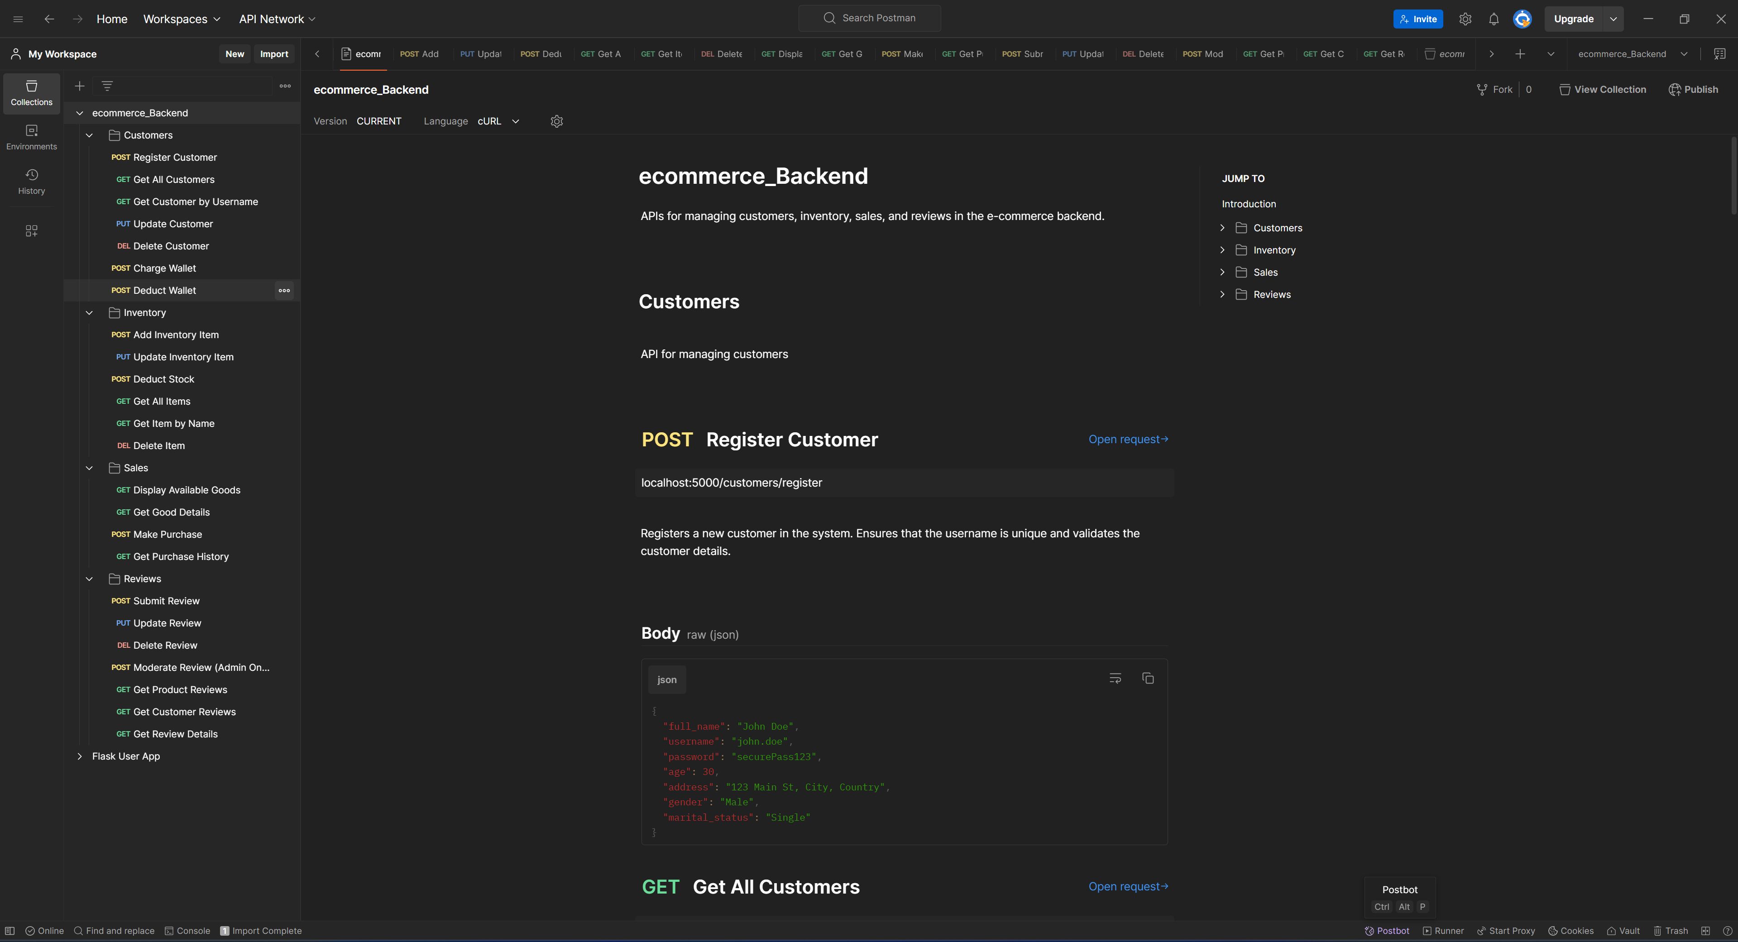**

# Database Design

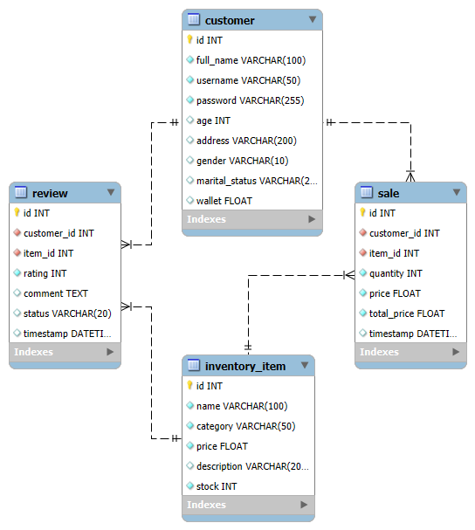

# Error Handling and Validation

**Error Management**

**Description:** The system incorporates robust error handling mechanisms to ensure that invalid requests, system issues, or unexpected conditions are addressed gracefully, providing meaningful feedback to users and developers.

**Key Error Handling Techniques:**

1. **HTTP Status Codes:**
   * **200 OK**: For successful operations.
   * **201 Created**: For successful resource creation (e.g., customer registration, review submission).
   * **400 Bad Request**: For validation errors or invalid input data.
   * **403 Forbidden**: For access violations (e.g., trying to modify or delete another customer's review).
   * **404 Not Found**: For resources that do not exist (e.g., customer, item, or review).
   * **500 Internal Server Error**: For unexpected system errors.
2. **Error Messages:**
   * The system returns JSON responses with detailed error messages for client-side issues. For example:

{

"error": "Customer not found."

}

* + For validation errors, multiple errors are returned as a list:

{

"errors": [

"Full name must be at least 3 characters long.",

"Password must be at least 8 characters long."

]

}

1. **Database Error Handling:**
   * The system uses try-except blocks (or equivalent) to catch database-related exceptions, such as connection issues or unique constraint violations, and responds with appropriate HTTP status codes and messages.
2. **Input Missing/Error Cases:**
   * Missing fields (e.g., username or item_name) or invalid data types result in a 400 Bad Request response with specific details about what is missing or invalid.

**Validation**

**Description:** Validation is implemented across all services to ensure data integrity and prevent invalid inputs from entering the system. Validation is applied at both the client request level and within the backend logic.

**Types of Validation:**

**1. Customers Service**

* **Registration (/register):**
  + full_name: Must be at least 3 characters long.
  + username: Must contain only letters, numbers, and . or _ or -. Unique across all users.
  + password: Must be at least 8 characters long.
  + age: Must be a non-negative integer.
  + gender: Must be one of "Male", "Female", or "Other" (case-insensitive).
  + marital_status: Must be one of "Single", "Married", "Divorced", or "Widowed" (case-insensitive).
* **Wallet Management (/charge/<username>, /deduct/<username>):**
  + amount: Must be a positive number.
  + Sufficient funds are validated before deducting money.

**2. Inventory Service**

* **Adding and Updating Items (/add_item, /update_item/<name>):**
  + name: Must be at least 3 characters long.
  + category: Must be one of "Food", "Clothes", "Accessories", or "Electronics" (case-insensitive).
  + price: Must be a positive number.
  + stock: Must be a non-negative integer.
* **Deducting Stock (/deduct_stock/<name>):**
  + quantity: Must be a positive integer.
  + Sufficient stock is validated before processing the deduction.

**3. Sales Service**

* **Making a Purchase (/purchase):**
  + username: Must belong to a valid, registered customer.
  + item_name: Must refer to a valid, existing item in the inventory.
  + quantity: Must be a positive integer.
  + **Validation Checks:**
    - Sufficient funds in the customer's wallet.
    - Sufficient stock available for the item.

**4. Reviews Service**

* **Submitting Reviews (/submit):**
  + username: Must belong to a valid customer.
  + item_name: Must refer to a valid inventory item.
  + rating: Must be an integer between 1 and 5.
  + comment: Optional but must be a valid string if provided.
* **Updating Reviews (/update/<review_id>):**
  + Validation ensures that only the review author can update the review.
  + rating: Must be an integer between 1 and 5.
  + comment: Must be valid if provided.
* **Moderating Reviews (/moderate/<review_id>):**
  + The action field must be one of "approve", "flag", or "delete".

**Validation Locations:**

1. **Request-Level Validation:**
   * All incoming requests are validated using custom Python functions before processing. For example, validate_customer_data in the customers.py file ensures registration data is correct.
2. **Database-Level Validation:**
   * Constraints like unique usernames and non-nullable fields are enforced in the database schema.
3. **Error Feedback:**
   * Detailed validation errors are returned to the client for incorrect or incomplete requests.

# 6. Testing

**Testing Strategy**

The application is tested using the following approaches:

**1. Unit Testing**

* Focuses on testing individual functions and methods in isolation.
* Each function (e.g., adding an item, submitting a review) is tested with valid and invalid inputs.

**2. Integration Testing**

* Tests how various components (e.g., Customers, Inventory, Sales, and Reviews) work together.
* Example: Testing how a purchase affects both customer wallet and inventory stock.

**3. Database Testing**

* Uses an in-memory SQLite database for testing purposes.
* Ensures data consistency and integrity (e.g., no duplicate usernames, no negative stock).

**4. Test Fixtures**

* Prepares test data (e.g., customers, inventory items) before running tests and cleans up after.

**5. Tools Used**

* **Pytest**: A Python testing framework.
* **SQLite (in-memory)**: Provides a lightweight database for testing without affecting production data.

**Test Cases**

**1. Customers Service (test_customers.py)​1**

* **Register Customer**
  + Valid registration → Status: 201 Created
  + Duplicate username → Status: 400 Bad Request
  + Missing fields → Status: 400 Bad Request
  + Invalid gender, age, or marital status → Status: 400 Bad Request
* **Customer Retrieval**
  + Retrieve all customers → Status: 200 OK
  + Retrieve single customer → Status: 200 OK or 404 Not Found
* **Wallet Management**
  + Charge wallet → Status: 200 OK
  + Deduct wallet (sufficient funds) → Status: 200 OK
  + Deduct wallet (insufficient funds) → Status: 400 Bad Request

**2. Inventory Service (test_inventory.py)​2**

* **Add Item**
  + Valid data → Status: 201 Created
  + Duplicate item name → Status: 400 Bad Request
  + Invalid data (e.g., negative stock, invalid category) → Status: 400 Bad Request
* **Update Item**
  + Valid update → Status: 200 OK
  + Nonexistent item → Status: 404 Not Found
* **Deduct Stock**
  + Valid deduction → Status: 200 OK
  + Insufficient stock → Status: 400 Bad Request
* **Retrieve Items**
  + All items → Status: 200 OK
  + Single item → Status: 200 OK or 404 Not Found
* **Delete Item**
  + Valid deletion → Status: 200 OK
  + Nonexistent item → Status: 404 Not Found

**3. Reviews Service (test_reviews.py)​3**

* **Submit Review**
  + Valid data → Status: 201 Created
  + Invalid rating, nonexistent customer/item → Status: 400/404 Bad Request
* **Update Review**
  + Valid update by author → Status: 200 OK
  + Invalid author → Status: 403 Forbidden
  + Nonexistent review → Status: 404 Not Found
* **Delete Review**
  + Valid deletion by author → Status: 200 OK
  + Invalid author → Status: 403 Forbidden
* **Retrieve Reviews**
  + Product reviews → Status: 200 OK or 404 Not Found
  + Customer reviews → Status: 200 OK or 404 Not Found
* **Moderate Review**
  + Approve, flag, delete → Status: 200 OK
  + Invalid action → Status: 400 Bad Request

**4. Sales Service (test_sales.py)​4**

* **Display Goods**
  + Valid request → Status: 200 OK
* **Get Good Details**
  + Valid item → Status: 200 OK
  + Nonexistent item → Status: 404 Not Found
* **Make Purchase**
  + Valid purchase → Status: 200 OK
  + Insufficient funds/stock → Status: 400 Bad Request
  + Nonexistent customer/item → Status: 404 Not Found
* **Purchase History**
  + Existing purchases → Status: 200 OK
  + No purchases → Status: 200 OK (empty array)
  + Nonexistent customer → Status: 404 Not Found

**Pytest Results Summary**

1. **Execution:**
   * Tests are executed using pytest from the terminal:

pytest --tb=short

1. **Results:**
   * **Total Tests:** Count of all unit and integration tests across services.
   * **Passed:** All valid test cases.
   * **Failed:** None (if properly implemented).
   * **Skipped:** Tests deliberately skipped due to incomplete features.
2. **Example Summary:**

