20. Jubilee National Competition “Young Talents” 2018

**Subject:**

**Blumber**

**Аuthor:**

Antoan Biser Georgiev  
MSHS “St. Kliment Ohridski” – Montana  
X grade

Email: antoangeorgiev@yahoo.com

**Supervisor:**

Krasimir Asenov  
Teacher  
MSHS “St. Kliment Ohridski” – Montana

Email: asenow@gmail.com

**Scientific consultant:**

Assoc. Prof. Zlatogor Minchev

Institute of ICT/ Institute of Mathematics & Informatics

Bulgarian Academy of Sciences

E-mail: [zlatogor@abv.bg](mailto:zlatogor@abv.bg)

Contents

**SUMMARY** 3

**THINGS YOU SHOULD KNOW BEFORE USING BLUMBER:** 4

**THE ADVANTAGES OF THE PROJECT:** 5

**SOURCES:** 5

**HAND RECOGNITION** 6

**INTERFACE** 7

**CONCLUSION** 9

**FUTURE PLANS** 9

**OTHER SOURCES** 10

# **SUMMARY**

One of the most visible examples of fast technological development in recent years are mobile devices and, above all, smartphones. Camera capabilities are no exception to this process. Its goal – capturing images - expands to gain a new role: creating a bridge between the physical and digital world. This is a new way that can lead to abstract rendering of objects and a more visceral sense of real life and physicality.

What does all this mean? This means the camera gives you the opportunity to improve your world. Make it different, even though only digital.

"Blumber" is a game where the main engine is the user. The high level of user-device interaction and the ability to use mimics make the app unique. Using camera capabilities, you are able to reach a closer to the physical, digital world.

# **THINGS YOU SHOULD KNOW BEFORE USING BLUMBER:**

1. The app is compatible with all Android devices with API Level 24+ (Android 7.0)

2. Before you start the application, you must manually allow the camera use

3. Due to a bug from Vuforia in the latest update, the app can run relatively slowly on certain devices. Bug fix is ​​expected as soon as possible.

4. In order to prevent overloading and to make the game more difficult, bananas can be cut a second after their appearance

5. Hand recognition is based on many factors, one of which is coincidence in color. When matched, the hand can be scanned incorrectly! At "blumberfront.apk" you can test only the hand-tracking created using OpenCVForUnity

# **THE ADVANTAGES OF THE PROJECT:**

|  |  |  |  |
| --- | --- | --- | --- |
|  | Fruit Ninja | Ninja Slice Fruit | Blumber |
| Availability |  |  |  |
| Independence from Internet |  |  |  |
| Achievements |  |  |  |
| AdFree |  |  |  |
| Interactive |  |  |  |

One of Blumber's goals is to be massively played. The key to this is the independence from the Internet, which ensures trouble-free play by users all over the world.

Another benefit is the completely free content and lack of ads.

Google Play Services integration is forthcoming to build charts and achievements.

The high-level interaction between user–device makes the app unique.

# **SOURCES:**

The application is created with Unity, validated to the latest standards.

C # is used for the code part of the game. The hand tracker was created using OpenCVForUnity. Vuforia was also used, and the graphic elements were made using Photoshop.

# **HAND RECOGNITION**

The hand recognition is a long and complicated process that was created with OpenCVForUnity. By clicking on the screen, the fingers are identified and labeled in blumberfront.apk with pink dots. Then it passes through the color matching process. The hand is surrounded by a polygon, from which an upper left and a lower right corner are extracted and based on their coordinates, they get compared with the coordinates of the bananas. When matched, the banana is cut (an appropriate animation is yet to be integrated).

The coordinates of the pink dots are displayed in the MatOfPoint format without the possibility of converting to another unit.

This made it possible to find the diagonals of the random figure that were displayed on the screen:

Imgproc.rectangle(rgbaMat, boundRect.tl(), boundRect.br(), CONTOUR_COLOR_WHITE, 2, 8, 0); //mnogougulnik

Imgproc.circle(rgbaMat, boundRect.tl() , 6, new Scalar(0, 255, 0, 255), -1); //goren lqv ugul

Imgproc.circle(rgbaMat, boundRect.br() , 6, new Scalar(0, 255, 0, 255), -1);// dolen desen ugul

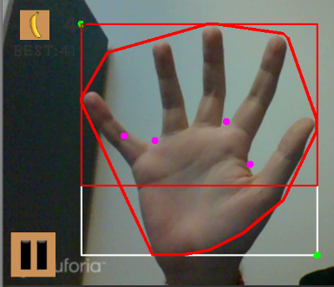

In order for the hand to be recognized, the user must click on the screen once, indicating its relative position.

# **INTERFACE**

<https://www.dropbox.com/s/om8a5gxvndq8gtg/video-1520374187.mp4?dl=0>

This video demonstrates the functionality and general look of the game.

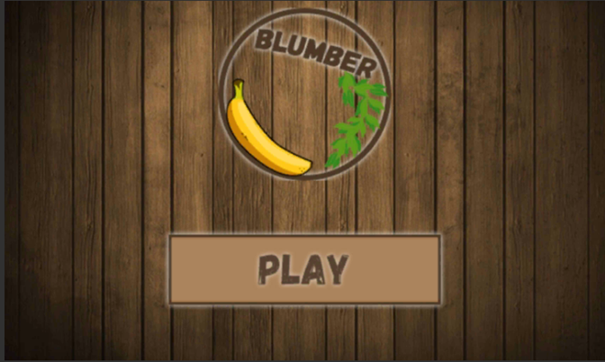

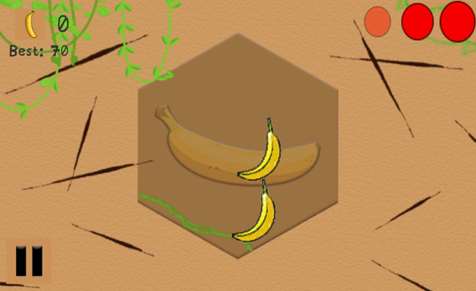

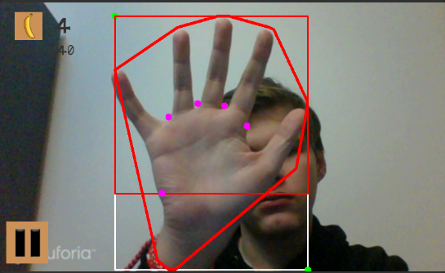

(in background)

# **CONCLUSION**

Blumber is an interesting, innovative and different application. Designed to entertain, it demonstrates the capabilities of each smartphone's camera. The innovative in the project remarks Blumber and makes it a future serious competitor.

# **FUTURE PLANS**

1. Optimize and improve the hand tracker
2. Improved interface
3. Reduce the size of the game
4. Ranking
5. Achievements
6. Shop
7. Multi-criteria evaluation of the game
8. Improve the complexity of the game menu
9. Upload the app on Google Play

# 

# **OTHER SOURCES**

Due to the specificity of the project, various sources were used. I consulted with:

* Krasimir Asenov
* Assoc. Prof. Zlatogor Minchev
* Konstantin Delchev
* Family, friends
* Unity Help & Examples documentation
* Briar Lee Mitchell – Game Design Essentials
* OpenCVForUnity
* http://www.math.com/