**Flowering abandance data Zackenberg**

Note by A. Becker-Scarpitta, Nov 2021

All scripts are open access: <https://github.com/AntoineBeckerScarpitta/Zackenberg_Flowering>

All info on field collection:

Biobasis, Zackenberg, 2019, section 1.1 & 1.2 (PDF attached)

# Final dataset: dim=751 rows, 7 cols

* Site: Zackenberg
* Year: 1996 to 2018
* Species: (x6 with Salix male and female, see detail below) CAS, DRY, PAP, SAX, SIL, SAL_male , SAL_female
* Plot: (x28), Cas1, Cas2, Cas3, Cas4, Dry1, Dry2, Dry3, Dry4, Dry5, Dry6, Pap1, Pap2, Pap3, Pap4, Sax1, Sax2, Sax3, Sil1, Sil2, Sil3, Sil4, Sal1, Sal2, Sal3, Sal4, Sal5, Sal6, Sal7
* Plot_size: range from 1 to 300 m2
* TotalFlower: total number of flowers recorded on the plot for a given year.
* Flow_m2: flower density per plot= TotalFlower/Plot_size

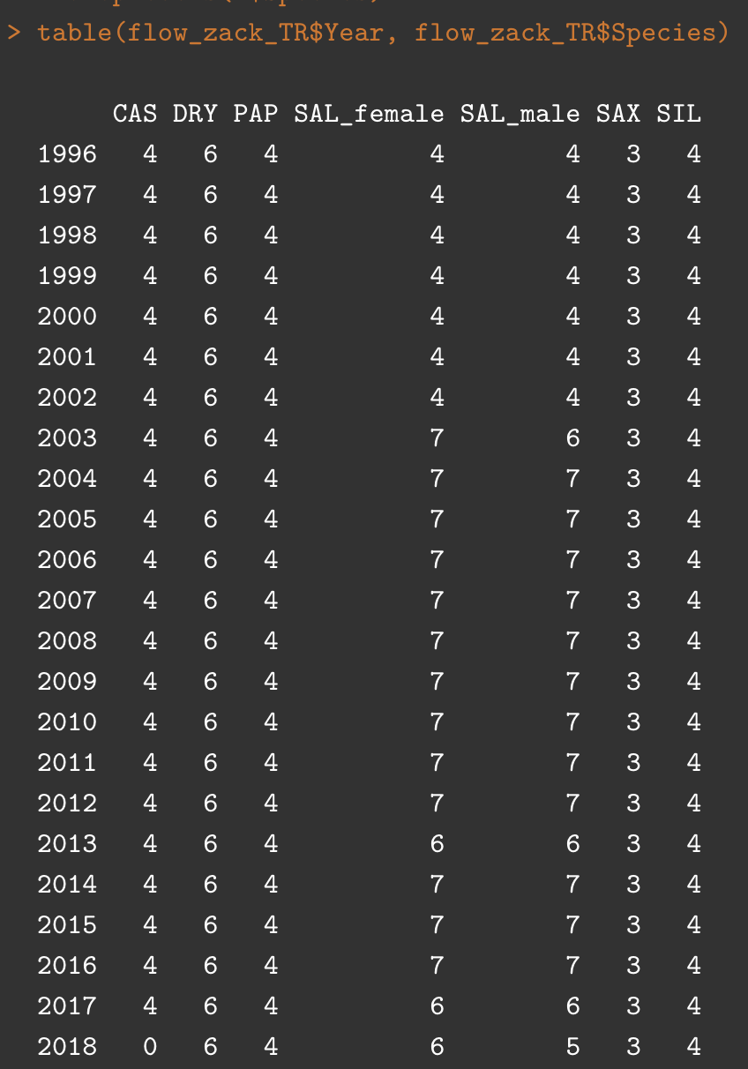

Table 1: Time series design (number of plots) for each species every year. Zackenberg (total duration 23 years): CAS=*Cassiope tetragona*, SAX=*Saxifraga oppositifolia*, SAL=*Salix arctica*, SIL=*Silene acaulis*, DRY=*Dryas integrifolia/octopetala*, PAP=*Papaver radicatum*.

# Material and Methods

**Data set**

The flower abundance data have been extracted from *The Greenland Ecosystem Monitoring (GEM) Database* (<https://data.g-e-m.dk>), an open-access long-term monitoring program on ecosystems and climate change effects in the Arctic.  The data consist of annual plot-level time series of the total number of flowers measures at the peak of the growing season for eight plant species. At Zackenberg, six plant species have been surveyed for over 23 years since 1996. Table 1 gives the temporal study design with the number of plot surveys for each species for the two sites.

**Sampling methods**

A sampling unit is operationally defined as the annual total number of reproductive structures (i.e. flowers & buds) of all individuals of a given species occurring in each plot.

The total number of flowers is used as a proxy for the maximum annual productivity. Once a year at the peak of flowering, each plot was divided into four identical sections: A, B, C, D, each subsection was visit the same day to quantify the total number of flowering structures. Subplots have been lumped at the plot level, since the count of some subplots might be very low, the number of plots surveyed every year for each species is given in Table 1.

Flowering structures include *flower buds*, defined as all flowers not yet open, not sexed for *Salix*; *flowers*, reproductive structure open to insects; and *senescent flowers*, flowers which have already dropped all petals or with all petals almost or fully faded or brown. No or little confusion, if possible, with flowers from preceding years, since older stems are always dry and stiff, while new stems are soft and flesh (Zackenberg BioBasis Manuals). The time of the survey varied between species, plot, and years depending on climatic conditions.

For *Salix* species, the total flower number was recorded separately for males and females in each plot. Important to note that *Salix* flowers are defined as catkins and not individual flowers *per se*. Since *buds* are unsexed flowers, we then divided them into male/female based on the average long-term observed sex ratio of the *Salix* flowers for each plot independently.

**Response variables**

To control for differences in plot area and very small records, we calculated flower density per plot for each species, by pooling the total number of flowers recorded in each section (A, B, C, D) surveyed every year and dividing this sum by plot area.

**Explanatory variables**

The snowmelt day at the plot level has been estimated by linear models. The DOY is the predicted day where plots have to reach 50% of the snow cover. Negative values and extreme value have been converted into NA, meaning the plot never reach 50% snow cover. All values higher than 360 has been removed.

# Technical change made in the dataset in R

# delete K, W, plots + cas5, cas6, dry7, dry8 as half has no data

# correct Species name i.e. Sil , Si with SIL

# SELECT "TOTALCOUNT" of the original dataset (from GEM)

# REPLACE Section = A-D, A-B with A

# CALCUL the total flower per plot per year (sum of all sections)

# CALCUL the flower density by dividing the TotalFlower by Plot_size

# SPLIT Date into Year, Month, Day

**# For SALIX:**

# select TOTALCOUNT, remove -9999, sum at plot level and

# select only Total Male, Female and Buds

# Buds were divided following the SexRatioat the plot level for all years (=Total_Male/Total_Female) AND NOT DIVIDED 50/50