Image statistics and trait creativity jointly shape visual pareidolia
[Authors] · Manuscript draft, PNAS format
Abstract. Pareidolia, the perception of meaningful objects in ambiguous patterns, has recently been linked to creativity as a marker of divergent perception. Yet this relationship has not been examined at scale in a way that disentangles the contribution of image properties from that of the observer’s creativity. Moreover, no study has systematically examined the perceptual content of unconstrained pareidolia using generated fractal images. Here, we collected 580 online sessions in which participants viewed 30 fractal-noise patches spanning three controlled fractal-dimension levels (FD ≈ 1.3, 1.5, 1.7) and freely typed every percept that came to mind, before and after completing the Divergent Association Task (DAT; Olson et al., 2021) as a stable measure of trait creativity. A subset opted in to webcam-based eye tracking. Across 18,500 unique percept reports we show that (i) image complexity systematically reshapes both what people see, shifting the modal percept from anthropomorphic figures at low complexity to animals at intermediate complexity and to textural descriptions at high complexity, and how they explore the image; (ii) trait creativity predicts a small but reliable bias away from human and toward animal percepts, higher semantic diversity at intermediate complexity, and a measurable preference for specific embodied or unusual categories. This study positions pareidolia as a scalable paradigm for probing the perceptual dimensions of creative cognition, suggesting that divergent thinking may be linked to divergent perception through the semantic diversity of meanings that observers extract from ambiguous visual forms.

Significance Statement. Visual pareidolia, seeing faces and figures in clouds or rocks, is a ubiquitous demonstration that perception is constructed jointly from the image and from the observer. Existing studies typically test one or the other in small samples. Here we vary the statistical complexity of fractal-noise stimuli at three controlled levels and combine free verbal report from approximately 580 online participants with a canonical measure of trait creativity and optional webcam eye tracking. The dual manipulation shows that image complexity controls the modal percept on a humans-to-animals-to-texture continuum, while individual creativity shifts which percepts are reported rather than how many, refining what divergent-thinking traits contribute to ambiguous visual perception.

INTRODUCTION
Pareidolia, the perception of meaningful figures in unstructured visual input, sits at the intersection of bottom-up image statistics and top-down inference. Bayesian and predictive-coding accounts hold that perception integrates noisy sensory evidence with internal priors (Friston, 2010; Summerfield and de Lange, 2014; de Lange et al., 2018), and pareidolia is a textbook case in which the prior dominates: observers report faces in toast, animals in clouds, and figures in rocks. Neuroimaging of face-pareidolia confirms that illusory faces engage face-selective cortex, initially with the same temporal signature as real faces before rapidly transitioning to that of ordinary objects (Liu et al., 2014; Wardle et al., 2020); the phenomenon is not unique to humans, with rhesus monkeys also showing spontaneous face-pareidolia responses to object stimuli (Taubert et al., 2017). Far less is known about the constructive side of the process: which meanings the observer actually extracts when the image affords many, and how that depends jointly on stimulus statistics and observer disposition.
A converging line of evidence links the constructive side of pareidolia to creativity. The classical associative account of creative thinking (Mednick, 1962) holds that creative individuals have flatter associative hierarchies, retrieving more remote concepts when prompted; modern work has formalised this idea using semantic-network structure and computational measures of semantic distance (Kenett et al., 2014; Beaty and Johnson, 2021), and the Divergent Association Task (DAT) provides a brief, language-based, test-retest reliable index of this property by asking participants to name ten words that are as different as possible (Olson et al., 2021). Bellemare-Pepin et al. (2022) extended this principle from cognition to perception, showing in a sample of 50 participants that high-creative observers spontaneously report more, more diverse, and faster pareidolic percepts from cloud-like fractal images than low-creative observers. Bellemare-Pepin and Jerbi (2024) articulated this finding as divergent perception, a perceptual counterpart to divergent thinking in which flexibility in extracting meaning from ambiguous sensory input is hypothesised to be a generalised cognitive trait. Independently, individual differences in face pareidolia have been linked to schizotypy, paranormal belief, and broader anomalous perceptual experience (Riekki et al., 2013; Zhou and Meng, 2020; Salge et al., 2021), and to the vividness of voluntary mental imagery (Pearson, 2019; Salge et al., 2021), suggesting that pareidolia indexes a stable readout dimension of the visual system.
Three obstacles have limited the scale at which these claims can be tested. First, most adjacent pareidolia studies use binary face/no-face decisions or low-trial paradigms with samples of dozens (Liu et al., 2014; Riekki et al., 2013; Zhou and Meng, 2020; Salge et al., 2021; Wardle et al., 2020), making it difficult to disentangle image-side and observer-side contributions within the same design. Second, the natural medium of pareidolia, free verbal report, has historically been hard to score at scale; modern sentence embeddings (Pennington et al., 2014; Reimers and Gurevych, 2019), density-based clustering (Campello et al., 2013) and non-linear dimensionality reduction (McInnes et al., 2018) make this tractable. Third, the stimulus side has been dominated by curated face-like images. Fractal-noise stimuli replace this curation with a single controlled parameter, the fractal dimension (FD), which sets the slope of the amplitude spectrum and the local structure of the resulting image (Field, 1987; Knill et al., 1990; Spehar et al., 2016); humans show systematic perceptual and aesthetic responses across the FD range, peaking around FD ≈ 1.3 to 1.5 (Spehar et al., 2016). Browser-based experimentation (de Leeuw, 2015) and webcam eye tracking (Papoutsaki et al., 2016) then make it possible to assemble a controlled image-by-observer factorial design at hundreds of participants.
Here we extend the Bellemare-Pepin (2022) paradigm to a much larger scale and a richer dependent variable. Approximately 580 online participants each viewed 30 fractal-noise patches drawn from a 300-image bank at three calibrated fractal-dimension levels (FD ≈ 1.3, 1.5, 1.7; labelled FD12, FD14, FD16 by generation target), freely typed every percept that came to mind, completed the DAT both before and after the pareidolia task, and (when opted in) had their gaze recorded with WebGazer. We ask four questions on the same participants. First, does image complexity reshape the amount, the semantic content, and the inter-observer consensus of pareidolia? Second, does trait creativity shift the kind of percept reported beyond its amount? Third, does completing the pareidolia task itself perturb DAT, or is the link between DAT and pareidolia trait-driven? Fourth, does successful pareidolia leave a measurable signature in eye movements?

RESULTS

Image complexity controls the amount of pareidolia.
We first asked whether the image’s statistical structure modulates how readily participants extract a percept. As complexity rose from FD12 to FD16, the average number of single words submitted per trial decreased monotonically from 1.69 to 1.56 (Friedman χ² = 46.5, P = 7.9 × 10⁻¹¹; Fig. 1), and the parallel decrease in the number of free-text descriptions per trial was equally robust (P = 6.7 × 10⁻¹⁰). The within-subject median semantic spread of percepts at each FD, a participant-level index of how semantically scattered the answers were on stimuli of a given complexity, also decreased slightly but reliably (P = 0.02). Mean reaction time did not differ by FD (P = 0.17). FD therefore acts as a behavioural manipulation that biases observers toward fewer and progressively more uniform percepts.
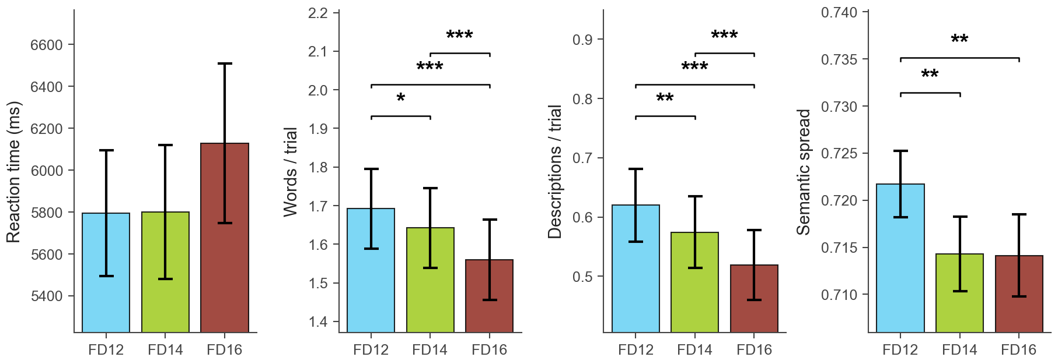
Fig. 1. Image complexity reduces the amount of pareidolia. Within-subject mean ± 95% CI by FD level for reaction time, single words per trial, descriptions per trial, and the within-subject median semantic spread of percepts. Brackets denote significant pair-wise Wilcoxon signed-rank contrasts.

Image complexity reshapes the content of pareidolia.
The drop in amount was accompanied by a striking shift in semantic content. We assigned every unique percept word to one of fifteen seed-based semantic buckets (face, body-part, person, mammal, bird, fish-aquatic, insect-bug, reptile, creature, object, landscape, weather, abstract, food, action) by nearest seed-centroid in BERT space (Materials and Methods), with a hard-reject list preventing high-frequency objects (e.g., hat, cross, hammer, gun) and actions (e.g., kiss, dancing) from leaking into the human or animal categories. Three highly significant within-subject FD effects emerged on what participants named (Fig. 2). The proportion of percepts falling in human-related categories (face, body-part, person) dropped monotonically from 33% at FD12 to 25% at FD16 (χ² = 73.3, P = 1.3 × 10⁻¹⁵); the animal share (mammal, bird, fish, insect, reptile) rose from 25% to a peak of 32% at FD14 (P = 1.2 × 10⁻⁷); and the animal-minus-human bias index inverted sign across the FD axis, from clearly human dominated at FD12 (−0.16) to mildly animal dominated at FD16 (+0.09; P = 6.8 × 10⁻¹³).
At the image rather than the participant level, the same complexity gradient produced a parallel rise in inter-observer disagreement. The Shannon entropy of the percept-word distribution per stimulus rose from a median of 5.90 bits at FD12 to 6.05 bits at FD16 (Kruskal-Wallis P = 0.014; Fig. 2, rightmost panel), indicating that high-complexity images do not converge on a canonical answer the way low-complexity images do. The lexical shift is visible in the most distinctive words per FD: FD12 percepts are dominated by discrete, often anthropomorphic figures (vase, handshake, elbow, horn, pregnant, ape, cave); FD14 by mammalian and small-animal labels (ox, warthog, bunnies, salamander, llama, mice, rooster); FD16 by texture and atmosphere descriptors (canopy, stars, fuzzy, marble, rain, scatter, noise, swamp). The progression from figural to animal to textural is also visible spatially in a t-SNE projection of every unique percept word coloured by majority FD level (Fig. 3b): FD12 words concentrate in face and person regions, FD14 in the central animal cloud, and FD16 spreads into the abstract and textural periphery.
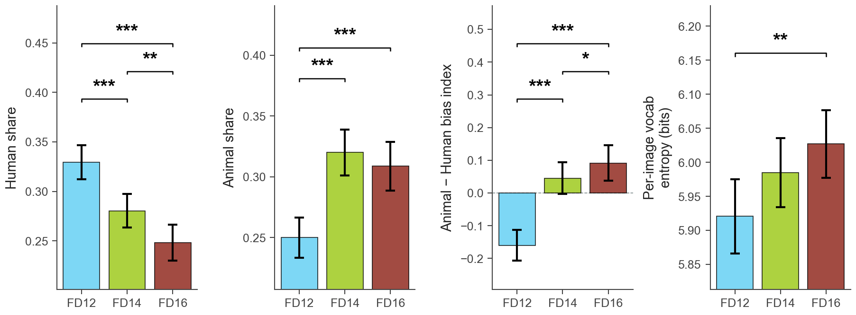
Fig. 2. Image complexity reshapes the content of pareidolia. Within-subject mean ± 95% CI per FD of the human share, animal share, and animal-minus-human bias index (panels 1 to 3, bars), together with the per-image vocabulary entropy of percept distributions (rightmost panel, bar = mean across the ten images per FD). Brackets denote significant pair-wise contrasts (Wilcoxon for the participant-level metrics, Mann-Whitney U for the image-level panel).
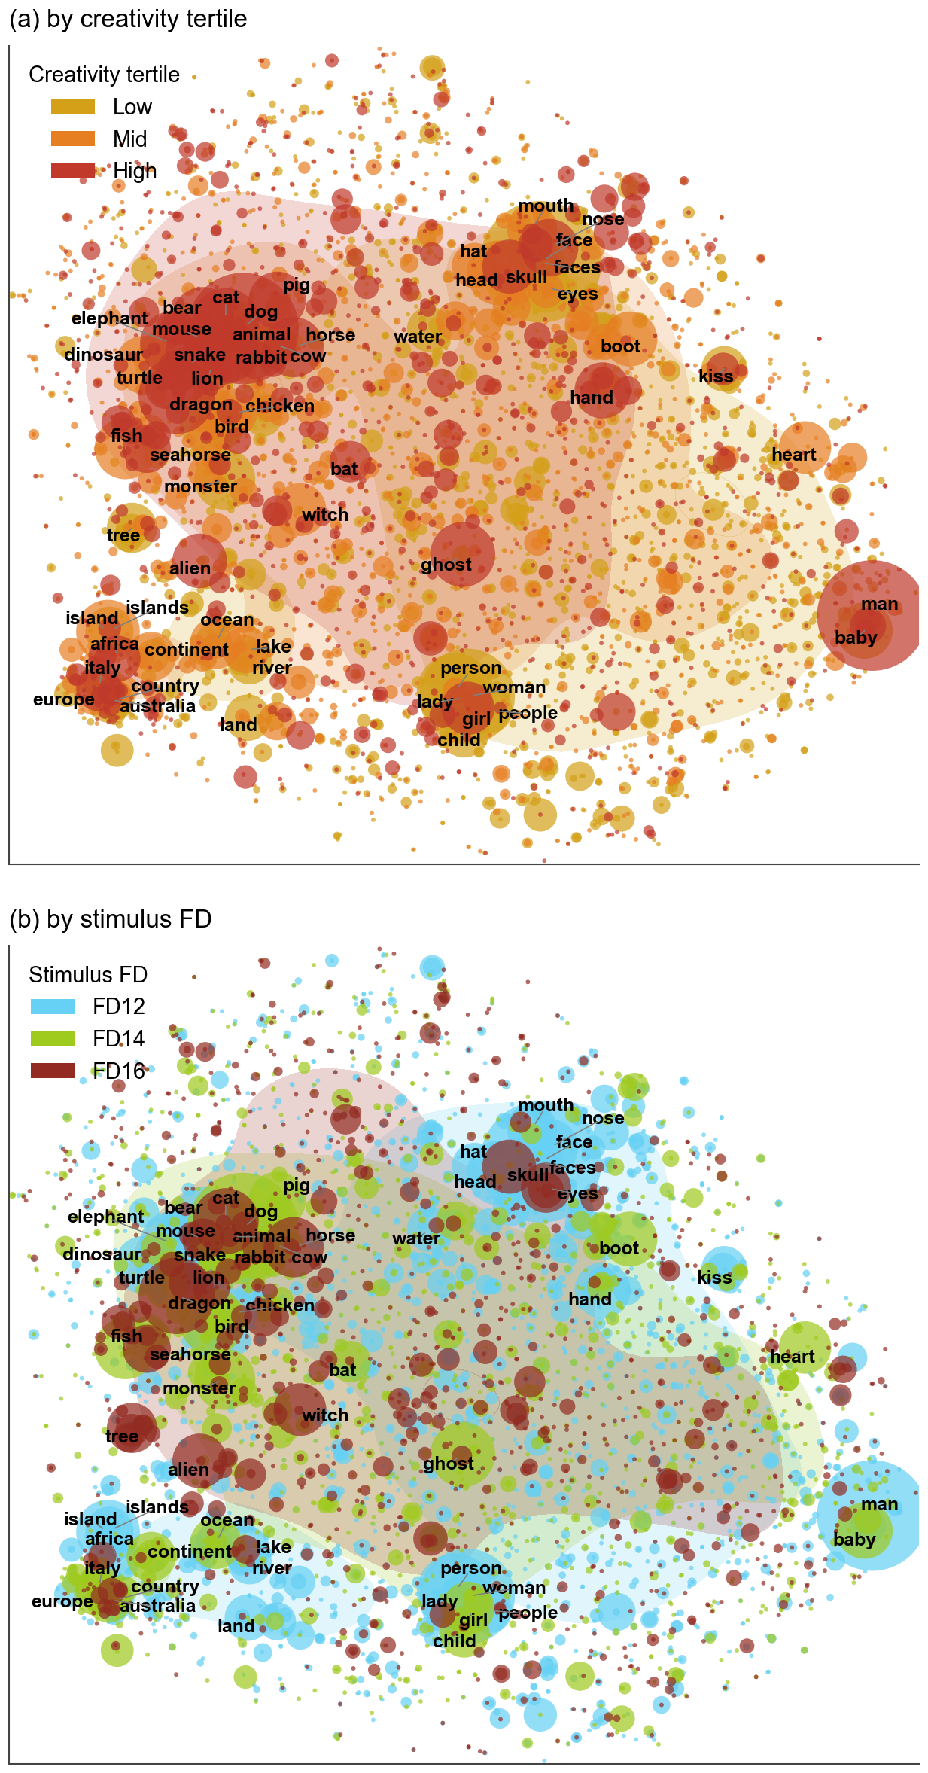
Fig. 3. Semantic territory of collective pareidolia. Shared t-SNE projection (cosine, perplexity = 30) of every unique percept word (n = 4,361); dot size scales with corpus frequency; KDE contours per group. (a) coloured by majority creativity tertile (sequential warm palette, amber = low, dark red = high DAT). (b) coloured by majority FD level at which the word was produced. Both panels share the same projection.

Observers largely disagree on what they see, but agreement decreases with complexity.
Beyond the group-level shifts in modal percept, we asked how much individual observers actually converge on the same answer for the same image. For every stimulus (300 images, approximately 50 observers each) we computed two complementary inter-observer agreement metrics: the modal-word share, defined as the proportion of all percept words on that image that equal the single most common word, and the mean cross-observer cosine similarity, defined as the mean BERT cosine similarity between two randomly sampled percept words from different participants on the same image (the literal same word yields 1.0; close synonyms yield ~0.6 to 0.8; unrelated words yield ~0.1). Both metrics agree that consensus is low in absolute terms: on average the single most common word accounts for only 7% of all percepts (best image: 27%; worst image: 4%), and the mean cross-observer cosine similarity sits around 0.29 (Fig. 4). Pareidolia, at this resolution, is mostly an idiosyncratic act. The small but reliable consensus core that does exist is modulated by image complexity: low-FD images elicit higher agreement than high-FD images on both metrics (Kruskal-Wallis on mean cosine P = 0.004; on modal share P = 4 × 10⁻⁵), with monotonic decreases across FD12 → FD14 → FD16. A complementary per-(image, DAT-tertile) analysis paired across the 300 images found no detectable effect of observer creativity on per-image consensus (Friedman P = 0.70 on mean cosine, P = 0.22 on vocabulary entropy), indicating that the ambiguity of an image is a property of the image itself rather than of the creativity profile of its observers.
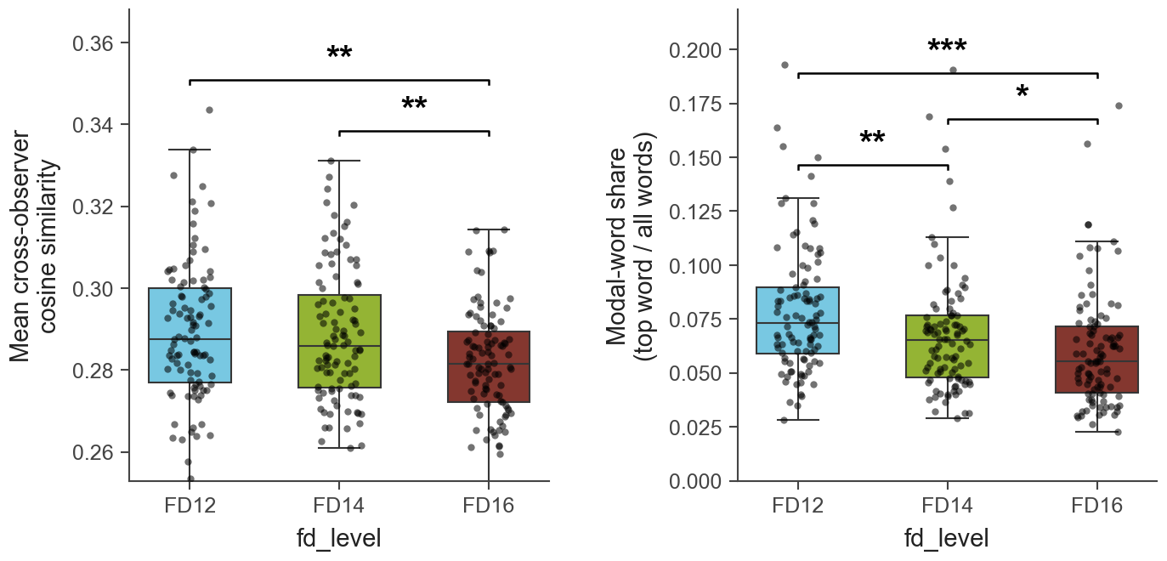
Fig. 4. Inter-observer agreement decreases with image complexity. Per-image inter-observer agreement summarised across 300 stimuli (100 per FD level). (a) Mean cross-observer cosine similarity between two randomly sampled percept embeddings from different participants on the same image. (b) Modal-word share: fraction of all percept words on the image that equal the single most common word. Box-and-whisker plots show the distribution across the 100 images per FD level; dots are individual images. Brackets denote significant pair-wise Mann-Whitney U contrasts.

Test-retest reliability of DAT is preserved across the task.
Among the n = 507 participants who completed both DAT timepoints (Fig. 5), pre- and post-task scores were positively but moderately correlated (Pearson r = 0.19, P = 1.2 × 10⁻⁵), with no detectable group-level shift (Wilcoxon signed-rank W = 6.1 × 10⁴, P = 0.99; mean Δ = −0.02, SD = 4.4). The link between DAT and pareidolia reported below replicates consistently with the pre-task score and weakens substantially when the post-task score is substituted in, consistent with this link capturing a stable trait-level property of the observer rather than a transient state shift induced by the pareidolia task.
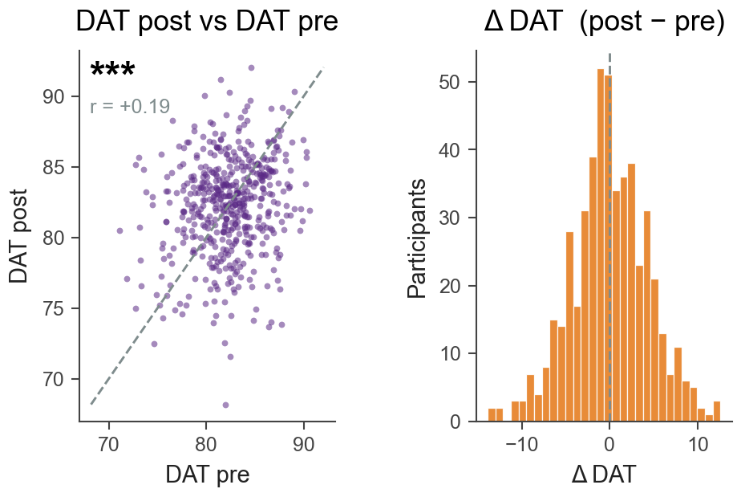
Fig. 5. Pre vs post DAT scores. Left: GloVe-scored DAT post vs DAT pre, n = 507. Right: distribution of the participant-level delta (post minus pre).

Trait creativity does not predict more or faster pareidolia.
Across six general behavioural metrics (fraction of trials completed, single words per trial, descriptions per trial, mean reaction time, total unique words across the experiment, and mean corpus rarity of a participant’s words), only one survived bivariate ±3 SD outlier trimming as significantly related to DAT, and in the opposite direction to a “more is more” account: high-creativity participants completed slightly fewer trials than low-creativity participants (r = −0.10, P = 0.03; Fig. 6). Words per trial and reaction time were both null. Creativity, in this dataset, therefore does not manifest as producing more or faster pareidolia.
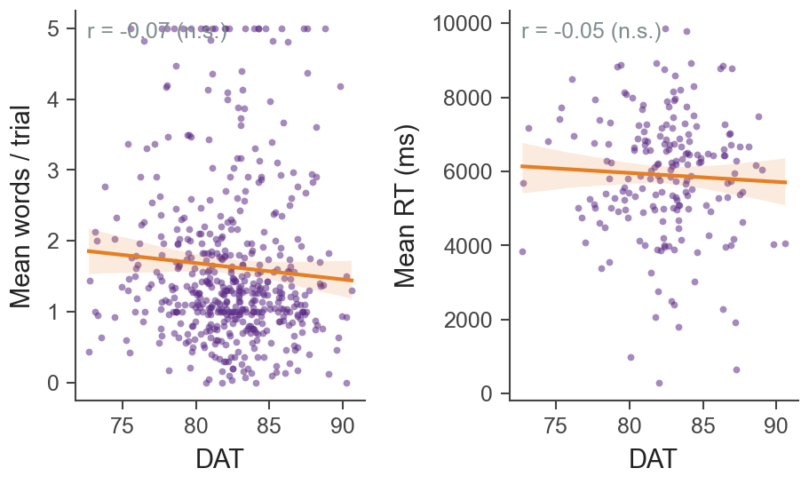
Fig. 6. Creativity is not associated with more or faster pareidolia. DAT vs mean words per trial (left) and DAT vs mean reaction time (right). The number of percepts extracted per trial and the time taken to extract them do not covary with creativity.

Creativity predicts greater perceptual diversity, concentrated at intermediate complexity.
The within-subject median pair-wise cosine distance of a participant’s percept embeddings, a participant-level measure of how semantically scattered the percepts are, was positively correlated with DAT (r = +0.14, P = 0.001; n = 500; Fig. 7, left), reproducing a previously reported relationship between divergent thinking and lexical diversity in a perceptual task. Splitting the analysis by FD revealed that the effect concentrates at the middle complexity level (Fig. 7, right): r = +0.17 (P = 2.7 × 10⁻⁴) at FD14, r = +0.09 (P = 0.04) at FD12, and essentially null at FD16 (r ≈ 0, P = 0.93). Intermediate complexity therefore appears to be the regime in which divergent-thinking ability has the greatest expressive room.
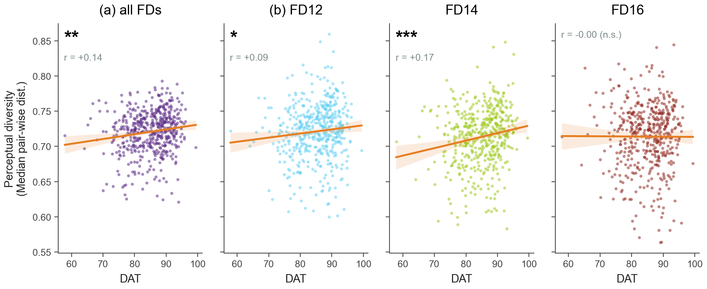
Fig. 7. Creativity predicts perceptual diversity, especially at intermediate complexity. (left) pooled across all FD levels (one point per participant). (right) the same analysis split by FD: the relationship concentrates at FD14, the middle complexity level.

Creativity biases pareidolia from humans toward animals.
The same fifteen-bucket taxonomy pinpointed where the link between DAT and diversity comes from. The per-participant share of percepts falling in human categories (face + body-part + person) was negatively associated with DAT (r = −0.14, P = 0.003), while the animal share was numerically higher in high-creativity participants but did not reach significance on its own (r = +0.08, P = 0.10; Fig. 8). Combining the two into an animal-minus-human bias index produced the cleanest creativity effect we observed (r = +0.12, P = 0.006; Spearman ρ = +0.14, P = 0.001). High-creativity participants therefore do not extract more pareidolic percepts overall. Rather, they shift the kind of percept they extract, away from canonical human and face responses and toward animal ones.
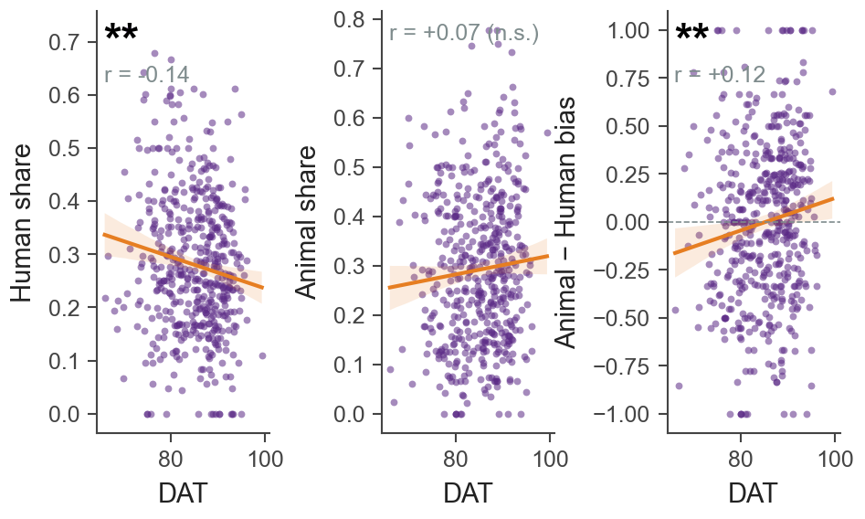
Fig. 8. Creativity tilts the percept distribution away from humans and toward animals.

Unsupervised clusters separate low- and high-creativity profiles.
The human-vs-animal contrast captures one axis along which creativity restructures percepts, but the seed-based taxonomy is deliberately narrow. To examine the full preference landscape we re-derived categories de novo by clustering all percept words that occurred at least three times in the corpus (Materials and Methods). HDBSCAN yielded 32 interpretable clusters plus a small noise group (22% of words); about a third of clusters had a 95% bootstrap CI on the log-odds (high vs low tertile) preference that excluded zero (Fig. 9b).
High-creativity participants were over-represented in clusters of specific, embodied, or unusual percepts: mushroom / apple / clover / carrot; gremlin / ogre / gargoyle / ghoul; blood / stomach / kidney / vomit; fish / seahorse / crab / whale; bat / vase / ball / cob; hand / finger / fist / hands; witch / cartoon / demon / angel. Low-creativity participants were over-represented in clusters of abstract or texture-like percepts: plus / separation / two / open; water / spill / mess / pipe; ink / paint / painting / book; ocean / lake / river / sea; land / mountain / cliff; fire / explosion / death; hammer / hole / splatter / dots. The semantic-map view (Fig. 9a) makes the structure of the contrast explicit: the two preference profiles occupy non-overlapping regions of BERT space, with the creature, viscera, and specific-object region on the upper side and the landscape, texture, and abstract region on the lower side. Together with the bias-index result above, this argues that the creativity effect on pareidolia is best characterised not as seeing more but as seeing different things.
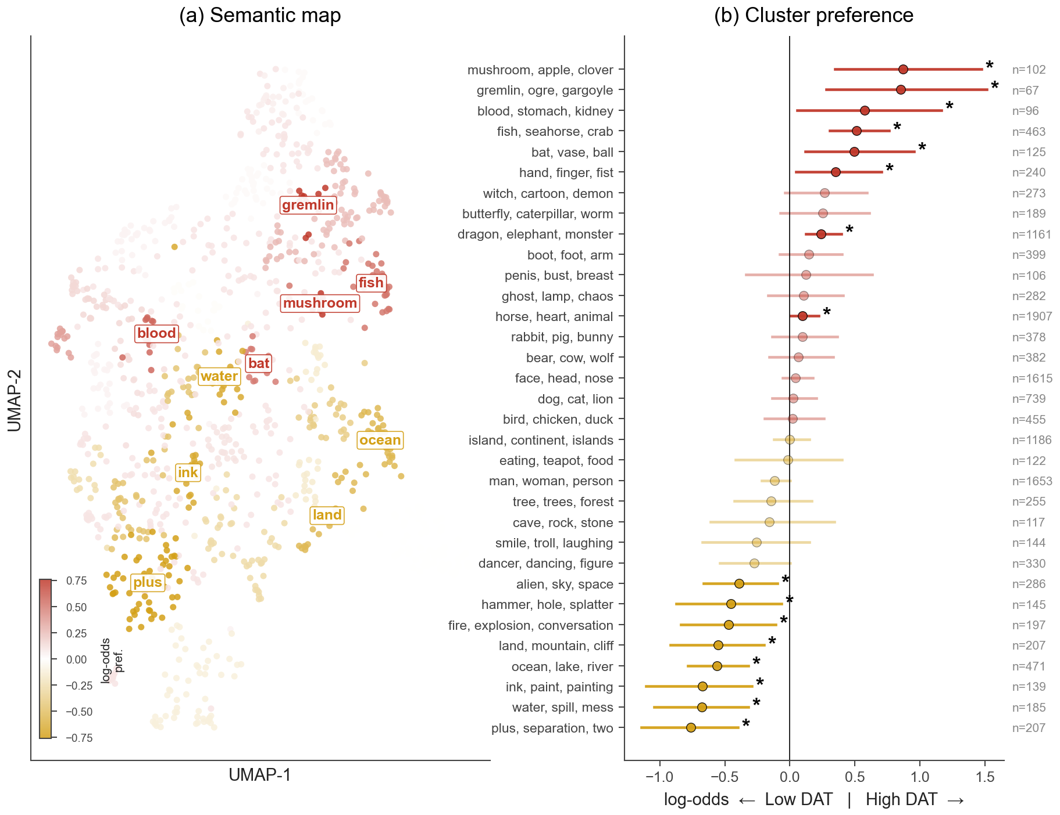
Fig. 9. Percept clusters preferred by low vs high creativity. (a) 2D UMAP projection of every percept word with at least 3 corpus occurrences, coloured by the log-odds preference of its HDBSCAN cluster (red = preferred by high-creativity participants, amber = preferred by low-creativity). Labels mark the top six clusters on each side at their UMAP centroid. (b) Forest plot of all 32 retained clusters, log-odds (high/low) with bootstrap 95% CI; stars mark clusters whose CI excludes zero. Numbers on the right are word occurrences per cluster.

The same pipeline reveals a complementary FD preference axis.
Repurposing the clustering with stimulus FD level as the contrast variable (FD16 vs FD12 instead of high vs low DAT) shows partly overlapping but distinct preference geometries (Fig. 10). High-FD images are over-represented in clusters of tree / forest, butterfly / caterpillar / worm, alien / sky / space, fish / seahorse / crab, witch / demon / angel, and ghost / lamp / chaos, whereas low-FD images dominate clusters of cave / rock / stones, blood / stomach / kidney, boot / foot / arm, bat / vase / ball, and land / mountain / cliff. Creativity drives a humans-to-animals shift along one axis of the BERT space; image complexity drives a body-parts-to-atmospheric-creatures shift along another. The two manipulations therefore probe partly independent dimensions of the same percept landscape.
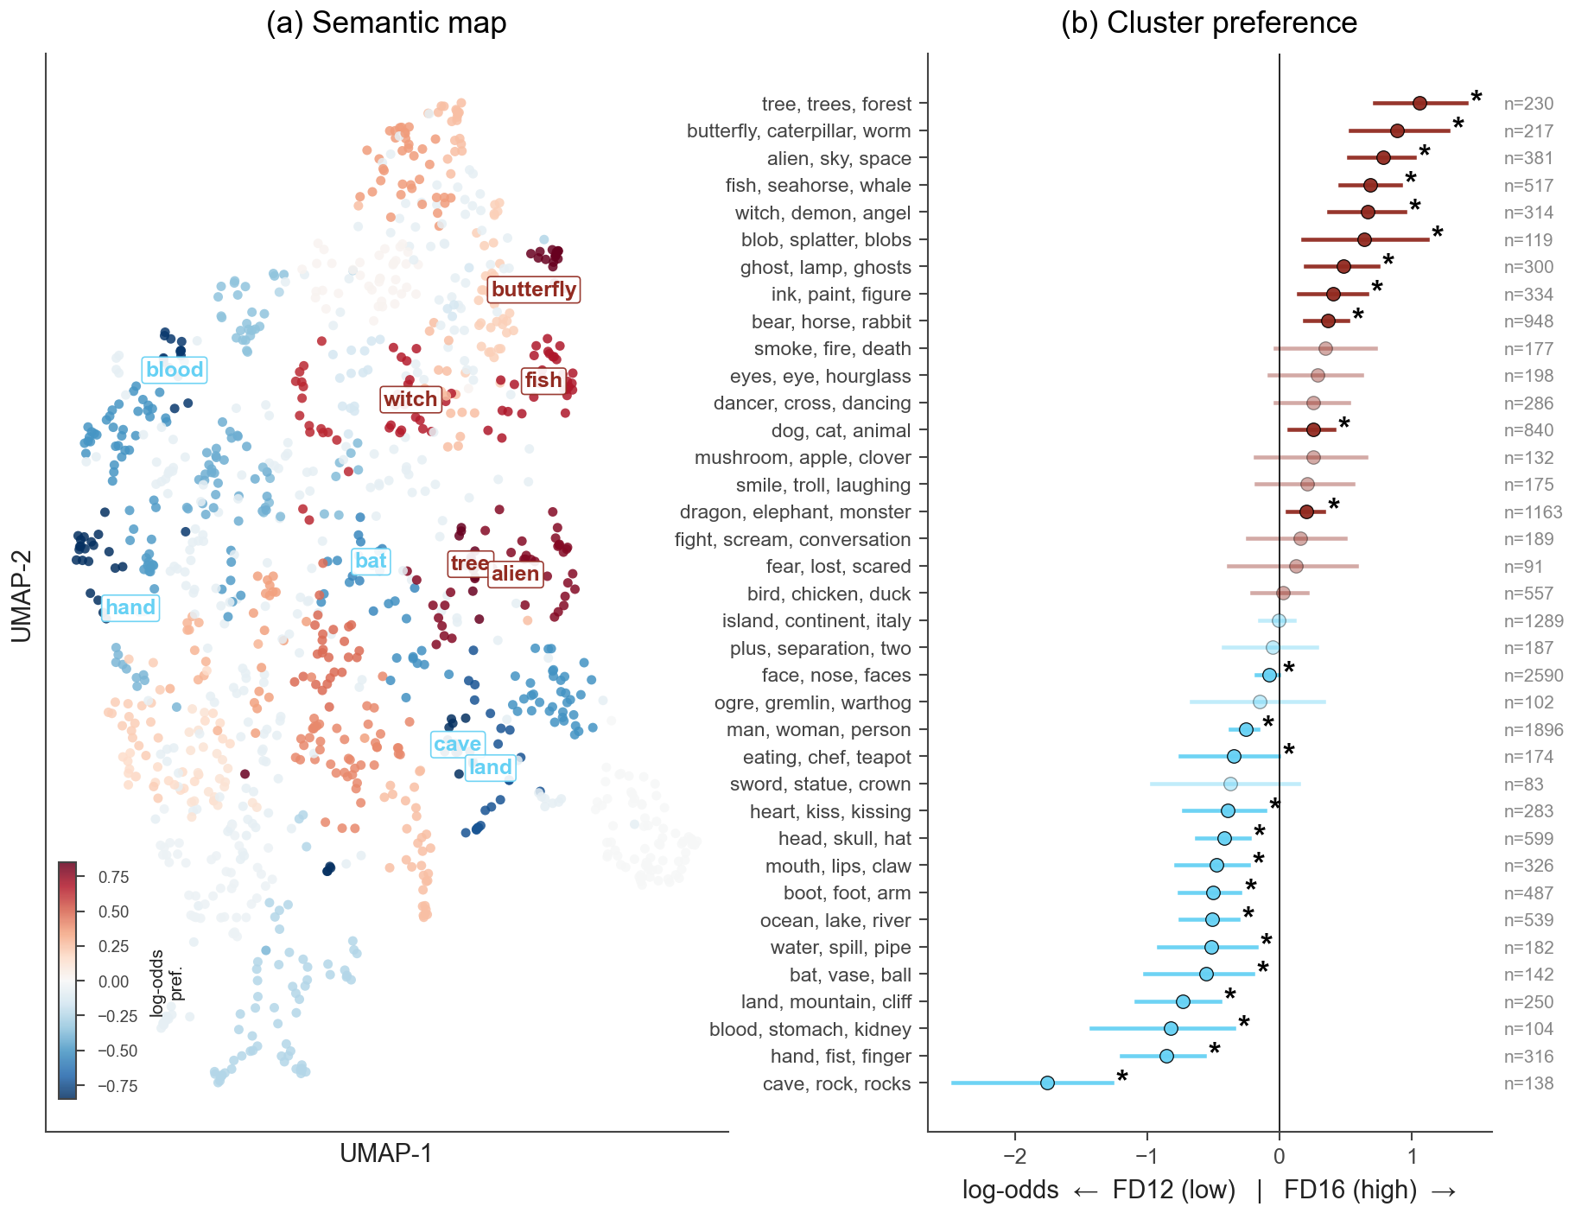
Fig. 10. Percept clusters preferred by low vs high stimulus FD. Same clustering pipeline as Fig. 9; the contrast variable is FD16 versus FD12. (a) Semantic map coloured by log-odds preference (blue = FD12, red = FD16). (b) Forest plot of clusters, log-odds (FD16/FD12) with bootstrap 95% CI; stars mark clusters whose CI excludes zero.

Gaze signatures of successful pareidolia.
For the 247 participants who opted in to webcam-based gaze recording and produced trials that survived the WebGazer tracking-failure check (Materials and Methods), we computed six gaze metrics per trial spanning fixation structure (count, mean duration), scanpath length, and three spatial-concentration measures (gaze entropy in bits, Gini coefficient of the 2D gaze histogram, and recurrence rate of nearby fixations). We contrasted these metrics along three independent axes: trials on which the participant did vs did not report a pareidolic percept, stimulus FD level, and continuous DAT score (Fig. 11).
Within the 105 participants who had at least two trials of each kind, trials in which the participant submitted at least one word (“pareidolia”) differed from no-word trials on three of the six metrics, all in the same direction: more fixations per trial (9.0 vs 9.4, Wilcoxon P = 0.045); lower 2D gaze entropy (3.76 vs 3.71 bits, P = 0.037); and a higher Gini concentration of the gaze distribution (0.868 vs 0.872, P = 0.047). Fixation duration, scanpath length, and recurrence rate did not differ. Successful pareidolia is therefore accompanied by a small but reliable shift toward more fixations clustered in a smaller region, consistent with the participant having found something specific in the noise that they are inspecting.
Within-subject FD effects emerged on scanpath length (P = 0.006; monotonic decrease from FD12 to FD16) and, marginally, on fixation duration (P = 0.06; longer fixations at FD16). The other four metrics were not modulated by FD. As image complexity rises, participants therefore move their eyes less and dwell on a few central locations for longer, consistent with the behavioural and content-level FD effects in Figs. 1 and 2. None of the six metrics correlated reliably with DAT score (|r| < 0.07 for all six; all P > 0.30). Together with the behavioural-engagement null reported above, this argues that creativity does not change how people look at the stimulus, only what they extract from it.
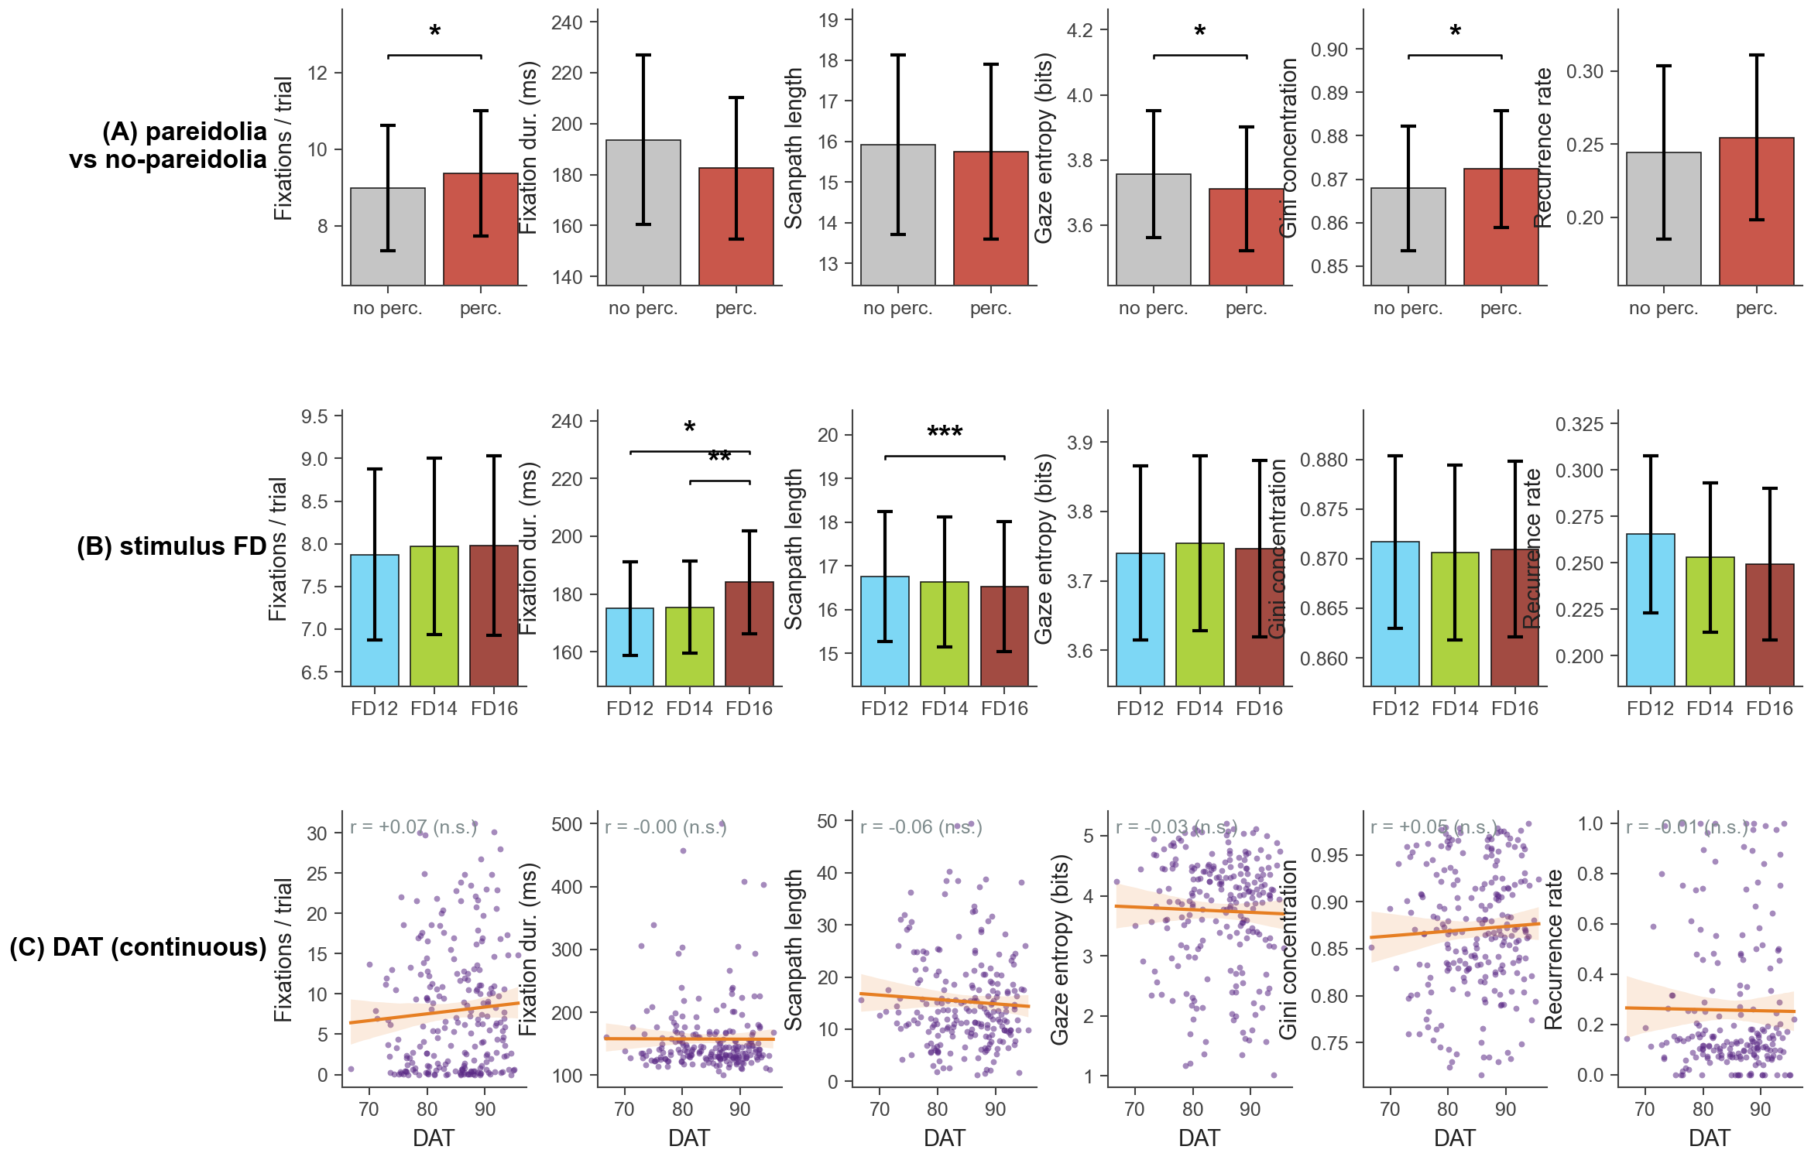
Fig. 11. Eye-tracking metrics across three contrasts. Rows: (A) pareidolia vs no-pareidolia trials (within-subject Wilcoxon, n = 105 participants with at least 2 trials of each kind); (B) stimulus FD level (within-subject Friedman plus pair-wise Wilcoxon, n = 226); (C) continuous DAT score (between-subject Pearson, n = 198 to 227 depending on the metric, ±3 SD bivariate trim). Columns: six gaze metrics mixing classical (fixation count, fixation duration, scanpath length, gaze entropy) and recent measures (Gini concentration of the 2D gaze histogram, RQA-style recurrence rate of nearby fixations). Brackets mark significant pair-wise contrasts; small in-axis text on row C reports the Pearson r.

DISCUSSION
Three findings emerge consistently across analyses. First, the statistical complexity of the noise determines the modal pareidolic percept on a human-to-animal-to-texture continuum, with the between-image variability of percepts growing as complexity rises. Second, trait creativity, as indexed by the DAT, does not modify how much pareidolia an observer produces but shifts which categories the observer favours, away from canonical human and face percepts and toward animals, viscera, and specific embodied objects. Third, both manipulations leave converging gaze signatures: successful pareidolia is accompanied by more concentrated fixations, and rising image complexity tightens the scan pattern, while creativity has no detectable gaze signature.
The asymmetry between the rich content effects of creativity and its null behavioural and oculomotor effects is informative. It suggests that what divergent-thinking measures track in this paradigm is not a bias toward sensitivity (more percepts, faster percepts) but a bias toward unusual readout of an otherwise comparable extraction process. A practical consequence is that pareidolia tasks designed to maximise individual differences should score the kind of percept rather than its presence or its count. A second consequence is that mid-complexity stimuli (FD14 in our parameterisation) are the regime in which observer-driven variability is most expressible.
The pre versus post DAT result, near-zero mean shift but moderate test-retest correlation, supports the interpretation of DAT as a stable trait rather than a state, and suggests that completing approximately 15 minutes of pareidolia does not measurably alter divergent-thinking ability. The strong attenuation of links between post-task DAT and pareidolia, alongside the preserved links to pre-task DAT, further supports a trait reading.
Several limitations should be noted. Webcam eye tracking, although adequate for the coarse-grained contrasts reported here, lacks the precision to resolve fixation-level effects within the image; the moderate-strength gaze effects we report are unlikely to be overestimates. The semantic categorisation rests on contemporary sentence embeddings and inherits whatever biases those embeddings carry; we mitigated this by combining a seed-based taxonomy with an unsupervised HDBSCAN view, and the two views agreed on the principal contrasts. Finally, the design samples three discrete FD levels rather than a continuum; a finer sweep would test the monotonicity claims more strictly.

MATERIALS AND METHODS

Participants.
Participants were recruited online via [recruitment platform]; all gave informed consent in accordance with the [ethics committee] guidelines. The full session was completed by N = 579 English-speaking adults (the “main cohort”), comprising a demographic form, the 10-word Divergent Association Task (Olson et al., 2021) as a baseline measure of trait creativity (DAT pre), an optional 9-point WebGazer calibration and validation routine, 30 pareidolia trials with free-response word entry, a repeated DAT (DAT post; n = 507 provided a scoreable response), and a closing feedback questionnaire. The main cohort analysed below is defined as the intersection of (i) English as primary language, (ii) feedback supplied, and (iii) at least one valid pareidolia trial. Sessions whose stored DAT word list duplicated one of the previous two log entries were removed.

Stimuli.
The stimulus set comprised 30 greyscale fractal-noise images, ten at each of three fractal-dimension levels labelled FD12, FD14, FD16 by their generation target. Each image was synthesised by filtering 2D Gaussian noise so that its amplitude spectrum followed a 1/fβ profile prior to inverse Fourier transform; higher FD produces finer-grained spatial detail and lower local autocorrelation. The realised fractal dimension of every generated image was estimated empirically with the standard 2D box-counting method (Liebovitch and Toth, 1989); across the 30 images the mean ± SD per nominal level was FD12: 1.27 ± 0.012, FD14: 1.49 ± 0.016, FD16: 1.67 ± 0.011 (100 images per level were generated and the 10 closest to each target were retained). For readability we refer to the three conditions throughout the manuscript as FD ≈ 1.3, 1.5, and 1.7. Each participant saw all 30 images in a fully randomised order, each rendered centred on a white viewport with max-width: 55%.

Pareidolia task.
A pareidolia trial began with a 500 ms central fixation cross, followed by the stimulus image presented for up to 30 s, terminated early if the participant pressed the spacebar to advance. Immediately after stimulus offset a free-text response screen appeared with five short-answer slots labelled “Single words” and five longer slots labelled “Descriptions (optional)”; participants were instructed to write every distinct percept that the image evoked. When eye tracking had been enabled at session start, raw (x, y, t) gaze samples were captured throughout image presentation via the WebGazer browser-side extension to jsPsych.

Percept word preprocessing.
Each typed entry was lowercased and whitespace-stripped. To minimise contamination by non-percept entries we kept only entries matching the regular expression ^[A-Za-z]+$ (single alphabetic tokens without spaces, digits, or punctuation) and additionally removed the catch-all stopwords nothing, nothingness, black, white, map, cloud, clouds. Sentence-level descriptions were excluded from semantic analyses to avoid mixing single-word and multi-word vector representations, which occupy systematically different regions of embedding space. All semantic computations use 384-dimensional sentence-transformer embeddings (all-MiniLM-L6-v2) of every unique surviving percept word (n_{words} = 4,361).

Divergent Association Task (DAT) scoring.
Both DAT pre and DAT post were scored with the canonical Olson et al. (2021) procedure. Each set of 10 candidate words was lowercased and restricted to alphabetic forms; the first seven words with a GloVe 840B 300-d vector were retained, and the DAT score was defined as 100 × mean(d_{ij}), where d_{ij} is the cosine distance between every pair of those seven vectors. Sessions producing fewer than seven valid lookups yielded no DAT score and were excluded from any analysis using that timepoint. DAT scores in main-text analyses refer to the baseline (pre) score unless explicitly noted.

Eye-tracking preprocessing.
The online WebGazer calibration sweep provides a dense set of gaze samples spanning most of the viewport. For each session, we estimated the usable gaze extent as the 1st-to-99th-percentile box of these calibration samples and used it to rescale all subsequent gaze data into the unit square [0, 1], eliminating cross-session differences in screen size and browser viewport. The stimulus region of interest (ROI) was approximated as a per-session rectangle centred on the recorded stimulus position with half-width 0.275 (half of the 55% CSS rule) and half-height 0.275 · W/H, where W/H is the session’s viewport aspect ratio. Trials whose normalised gaze trace formed a near-perfect line, defined as |corr(x, y)| > 0.97 together with span > 0.6 on both axes, a signature of the WebGazer face-mesh tracker failing onto a screen edge, were flagged as tracking failures and dropped (530 of 5,660 trials, 9.4%). Fixations were detected with a dispersion-threshold (I-DT) algorithm using a dispersion bound of 0.05 in normalised coordinates and a minimum duration of 100 ms.

Per-participant and per-image semantic metrics.
For every participant and every FD level we computed (i) the semantic spread of percepts as the median pair-wise cosine distance over their unique word embeddings, and (ii) the vocabulary surprisal as the mean −log p over the corpus frequency of each word. To examine the kind of percept rather than its amount, we assigned every unique word to one of fifteen semantic categories (face, body-part, person, mammal, bird, fish-aquatic, insect-bug, reptile, creature, object, landscape, weather, abstract, food, action) by nearest seed-centroid in BERT space (minimum cosine ≥ 0.30, otherwise “other”). Seed lists were hand-curated and audited against the highest-frequency words in the corpus; an explicit hard-reject list prevents a small number of items that are close to a human or animal centroid in embedding space but are clearly not (objects: hat, cross, hammer, gun, ball, bat, vase; actions: kiss, kissing, dancing, dance, hugging; landscape: sea, lake, ocean, river) from being assigned to those categories; such items are routed to their best non human/animal centroid instead. For each (participant, FD) we summarised the percept distribution as the human share (face + body-part + person), the animal share (mammal + bird + fish + insect + reptile), and the animal-minus-human bias index (A − H) / (A + H), ranging from −1 (entirely human) to +1 (entirely animal). At the image level we computed the Shannon entropy of the percept-word distribution elicited by each stimulus, as a measure of inter-observer consensus.

Unsupervised clustering of percepts.
To complement the seed-based taxonomy with an unsupervised view, we clustered every percept word that appeared at least three times in the corpus (n = 1,110 words). The BERT embeddings were L2 normalised, reduced to 10 dimensions with UMAP (cosine metric, n_neighbors = 15, min_dist = 0), and clustered with HDBSCAN (min_cluster_size = 12, cluster_selection_method = EOM). The procedure produced 32 interpretable clusters plus a noise group (22% of words). Each cluster was labelled by its top four log-odds most distinctive words, i.e., the words whose probability inside the cluster most exceeds their probability outside it.

Statistical analyses.
Within-subject effects of FD were tested with Friedman’s χ² followed by pair-wise Wilcoxon signed-rank contrasts; only contrasts significant at P < 0.05 are annotated on the figures (brackets with asterisks). Between-subject DAT effects were tested with Pearson’s r (reported in the main figures) and Spearman’s ρ (reported in the companion CSV tables). Before every correlation we trimmed bivariate outliers at ±3 SD on both the dependent metric and the DAT score; no other transformations were applied. For the cluster-preference forest plot, 95% bootstrap CIs (2,000 binomial resamples per cluster) were computed on the log-odds of the (high/low) tertile share. Statistics are reported as r with significance markers (*P < 0.05, **P < 0.01, ***P < 0.001); exact P values and Spearman counterparts are given in the supplementary data tables. Analyses were performed in Python 3.10 using pandas, numpy, scipy.stats, sentence-transformers, umap-learn, and hdbscan; reproducible scripts and CSV outputs are available at [URL].

