|  |
| --- |
| Pierre Mouli Castillo – Antoine Cremel  25/11/2018 |

|  |
| --- |
| ECE Paris |
| Software Engineering with the UML |
| Mini project |

1. **Use case diagram**
   1. 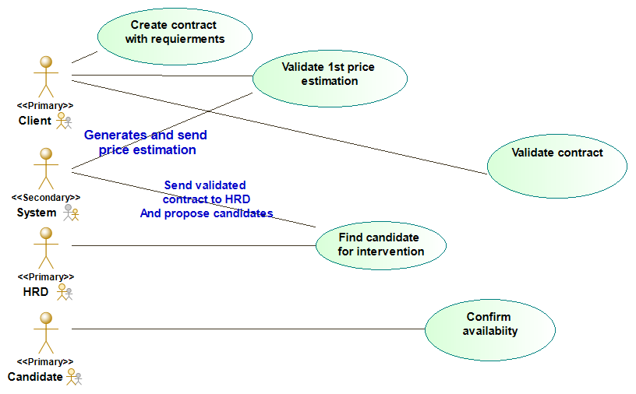Diagram
   2. Detailed description
      1. UC1: Create contract with requirements  
         Description: Allows the client to open ask for a contract and provide the requirements he needs  
         prerequisites: None  
         Result: System is informed with all the information necessary about the contract and the interventions
         1. Client upload contract
         2. Client add new intervention
         3. Client indicate skill level wanted for the intervention
         4. Client indicate dates availability for the intervention
         5. Back to 2. until client has indicate all interventions he needs.
         6. System generates price estimation and send it to client
      2. UC2: Validate 1st price estimation  
         Description: The client validates the price evaluation given by the system according to the requirements he provided  
         prerequisites: UC1 completed  
         Result: HRD gets the information about all the contract, and is proposed a list of candidates to fulfill the interventions
         1. If the client is satisfied, he validates estimation
         2. System send contract to HRD
         3. System propose candidates to HRD based on intervention’s requirements
         4. If client isn’t satisfied, the system asks for cancelation (end of UC) or update of contract (back to UC1)
      3. UC3: Find candidate for intervention  
         Description: HRD select a candidate for each intervention according to the client requirement (skill and date), then contact the candidate to confirm his availability  
         prerequisites: UC1 and UC2   
         Result: For each interventions a candidate is contacted, and the system is waiting for confirmation
         1. For each intervention of the contract HRD choses a candidate among the list proposed by the system
         2. Once a candidate is chosen, he is contacted to confirm his availability
         3. If there are not enough candidates for the contract, the contract is cancelled, end of UC
      4. UC4: Confirm availability  
         Description: The candidate confirms his availability for an intervention on a chosen date  
         prerequisites: UC1, UC2 and UC3  
         Result: The intervention is confirmed to HRD
         1. Candidate confirm if there are available for the intervention within a business day
         2. System send a list of all the candidate that confirmed back to HRD
         3. When candidates are available for every intervention the client is informed of the dates of each intervention and a new price estimation is created.
         4. If there is not a candidate available for each intervention, the contract is canceled, end of UC.
      5. UC5: Validate contract  
         Description: The client is satisfied with the   
         prerequisites: UC1, UC2, UC3 for every candidate, and the creation of a new price estimation by the system based on which candidate are booked for the interventions  
         Result: The contract is finally confirmed
         1. If the client is satisfied with the new contractual information, he must validate the contract within 2 business days, end of UC.
         2. If client doesn’t validate the contract or he doesn’t respond in time, the contract is cancelled, end of UC.
         3. The system will update the calendar of candidates, so they don’t appear in the list for another intervention on the same date
2. **Class diagram**
   1. 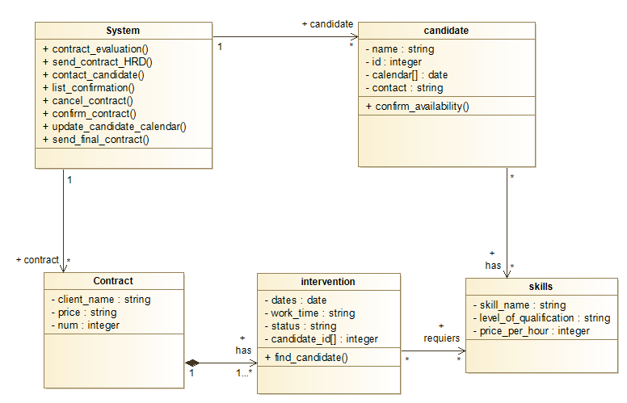Diagram
   2. Detailed description
      1. System
         1. conctract_evaluation()  
            The system calculate a price estimation based on the clients requirements and creates a Contract class, with the interventions required (date, skill, skill level).
         2. find_candidate()

When an intervention is created, it will find all matching candidates in skill_name, level_of_qualifiaction, then add it to the list of candidat_id[], and change the status attribute to “waiting_approval”. If there is none matching, then its “no_match”

* + - 1. send_contract_HRD()  
         If client accept the first evaluation the system will send the contract to HRD. The system check if all interventions status attribute is either “waiting_approval”, “booked” or “waiting_confimation”. If there is a “no_match” status, then no candidates are available for the interventions. The system can cancel_contract()
      2. list_confirmation()  
         When HRD has approved all the candidates, the system use contact_candidate() for each intervention according to its status attribute and update it to “waiting_confirmation”
      3. confirm_availability()  
         When a candidate deny his availability, the system use find_candidate() for the concerned interventions and the use send_contract_HRD() in order to fin replacement if one exists. If the candidate confirms then status attributes is updated to “booked”
      4. send_final_contract ()  
         When all the status of the interventions are “booked” then the system send the new contract to the client with the new price.
      5. confirm_contract()  
         If the client confirm the contract is validate, and status of all interventions become “ongoing”
      6. update_candidate_calendar()  
         This allows the system to update the calendar of each candidate, so they can’t pe proposed on the booked date anymore, this happens when the client confirm_contract()
      7. cancel_contract()  
         cancel the contract, happens if the client reject the price of if there is no candidate available for an intervention

1. Sequence diagram
   1. 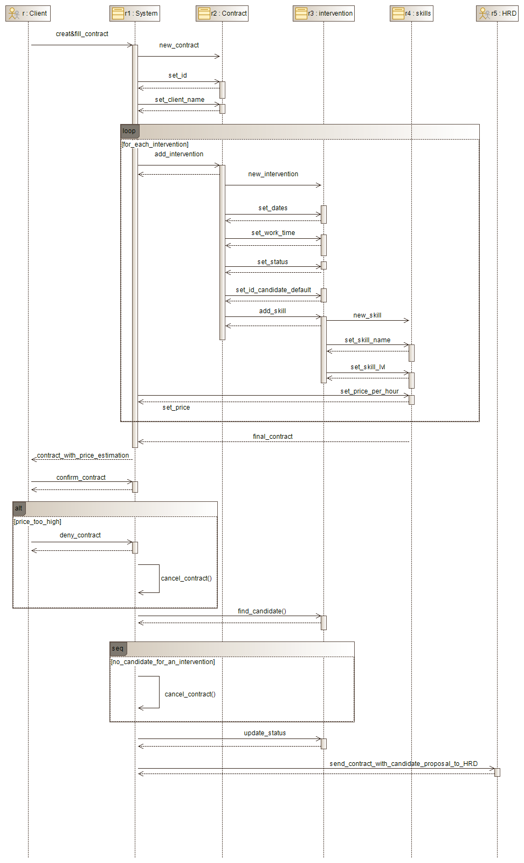 Diagram UC1 & UC2

NB: I noticed I have the wrong signals link, in this version. For link going from left to right it should be asynchronous signals

* 1. 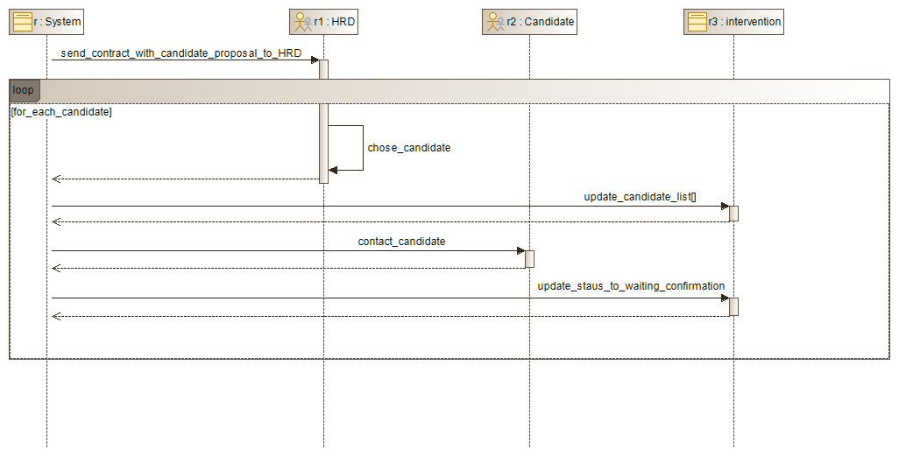Diagram UC3
  2. 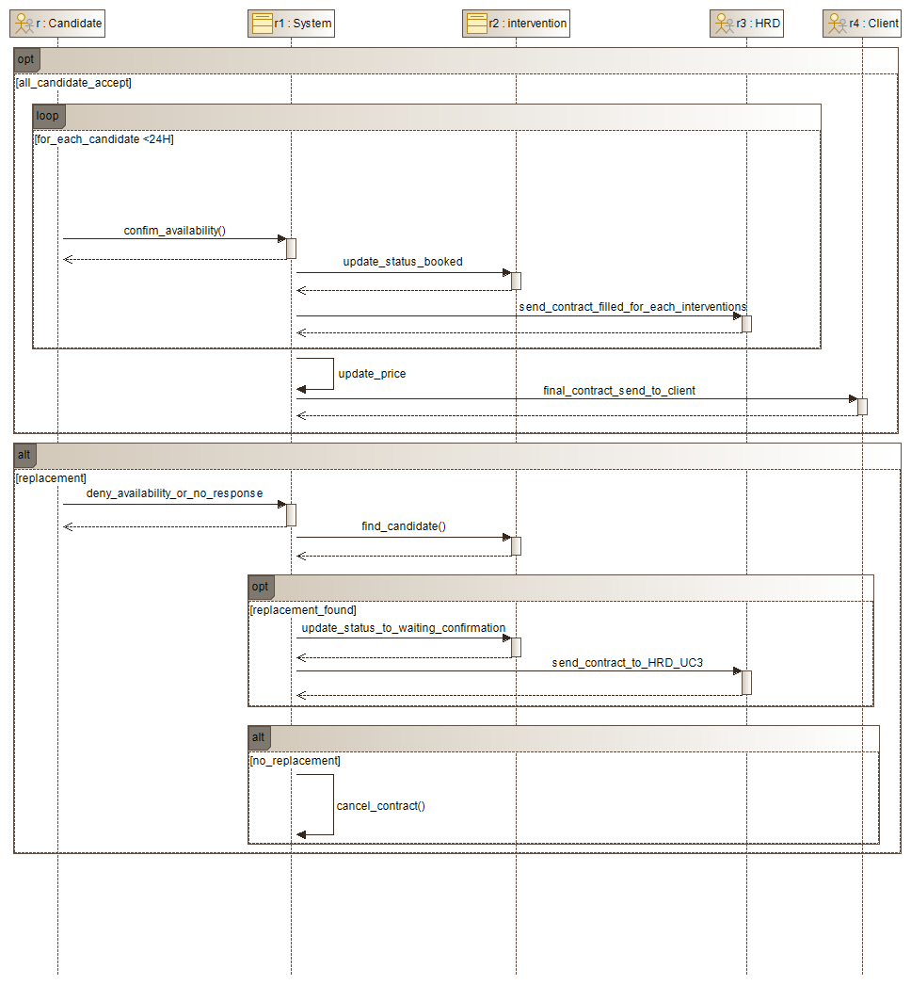Diagram UC4
  3. 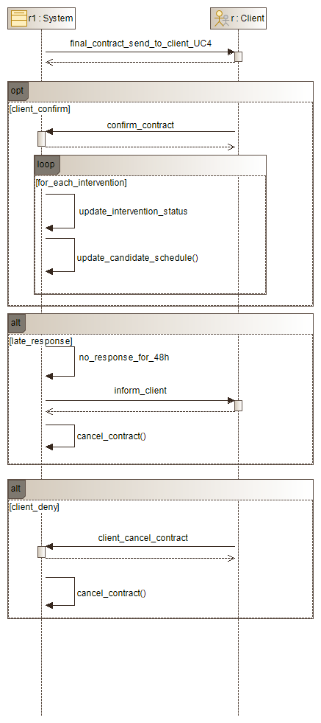Diagram UC5

1. Sequence diagram
   1. 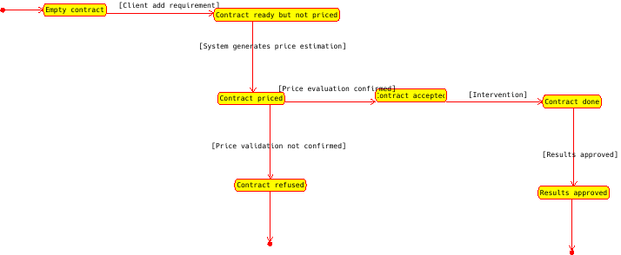Contract
   2. 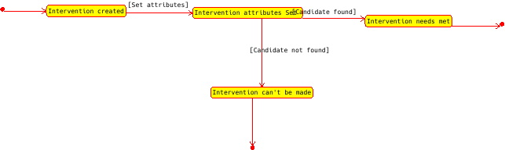Intervention
   3. 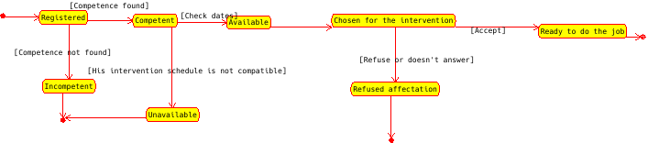Candidate