# Template for Project Report WDD

## Group: ____O____

Team member (id and name, Github link):

23524103, Christian Joseph, https://github.com/ChristianJ123ABC

Team member (id and name, Github link): ________

Team member (id and name, Github link): ________

## Links:

Deployed: https://main.d1y5p5m0kvgkwc.amplifyapp.com/

If video report, video link: ________

# **For those doing the written report:**

## Screen shots of Wireframes:

## Screen shot of sitemap

## Screen shot of Mood board:

## Coding done by team member 1:

**HTML**

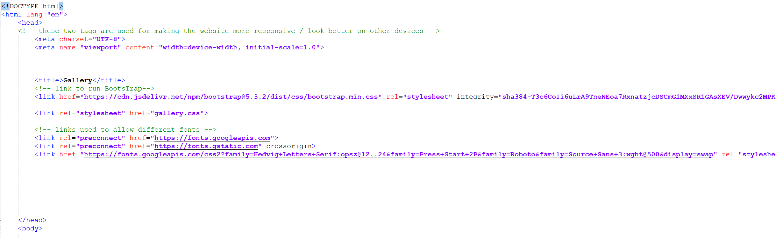

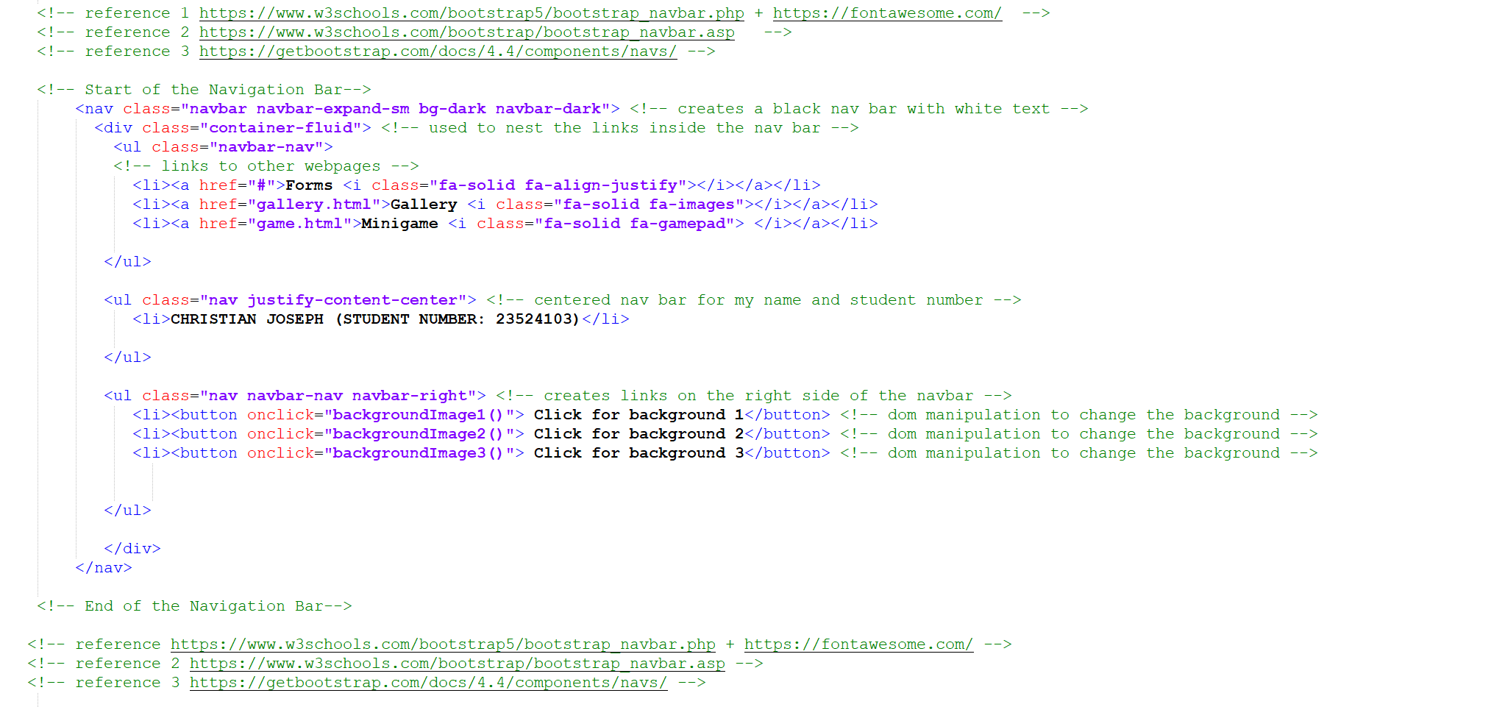





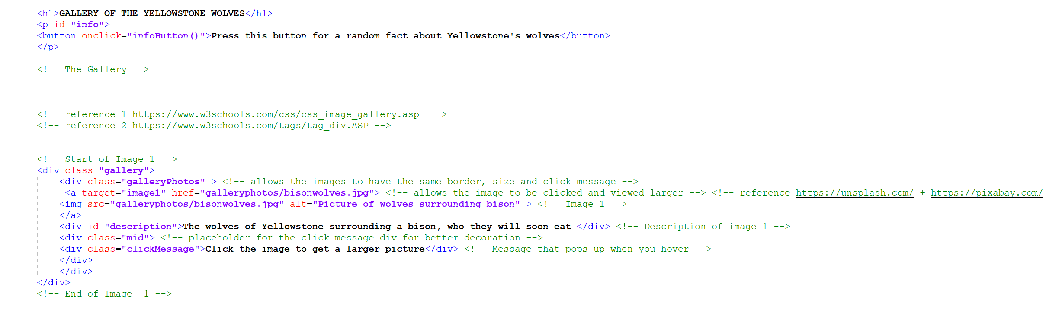

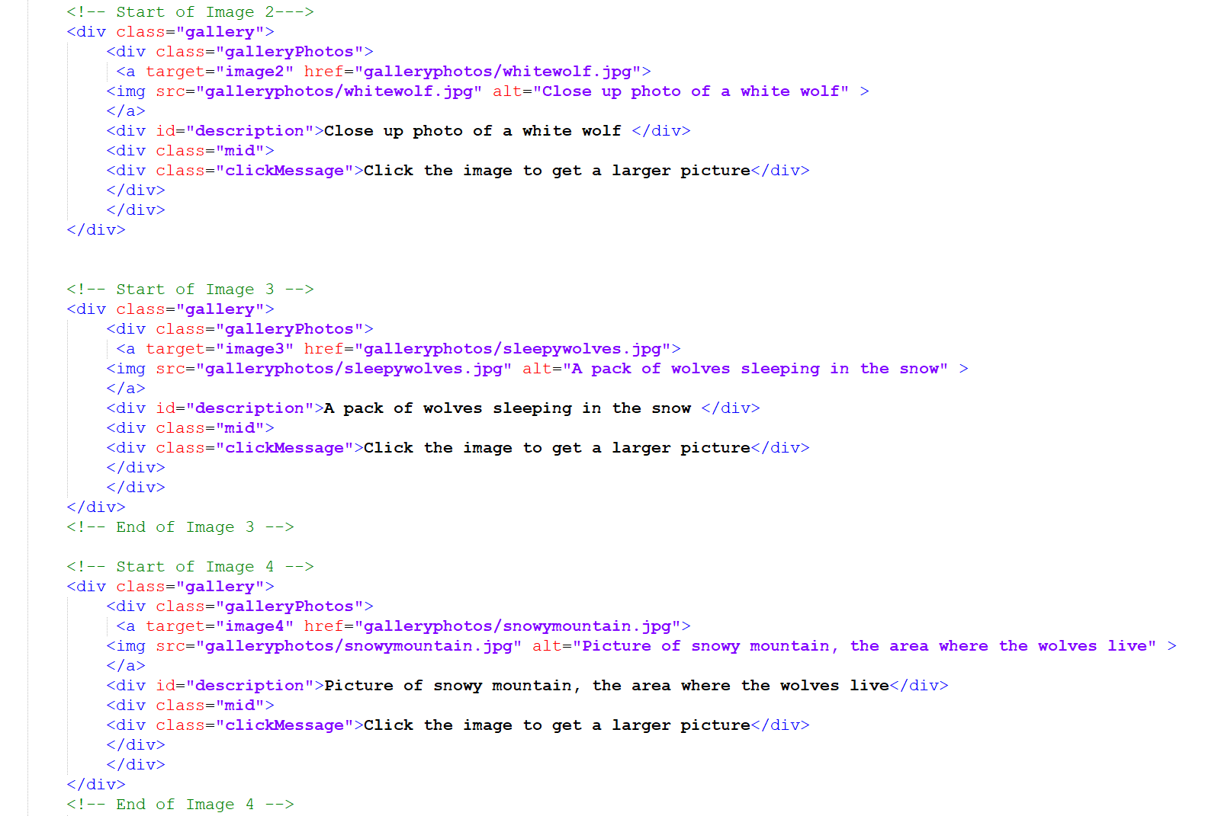

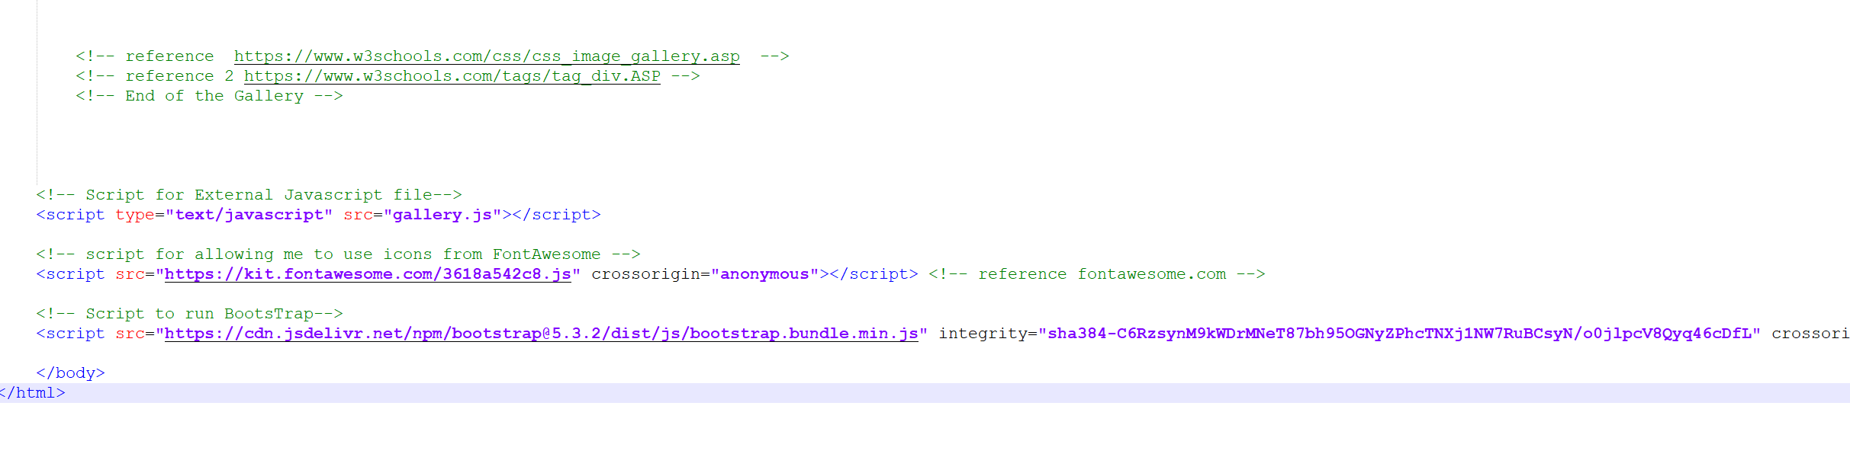

**CSS:**

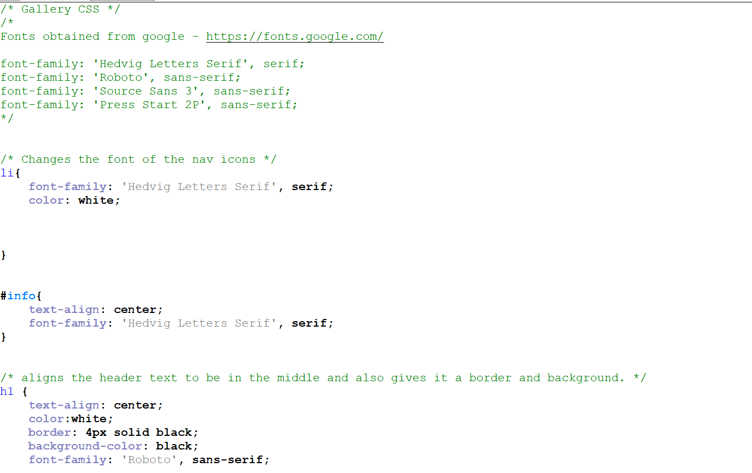

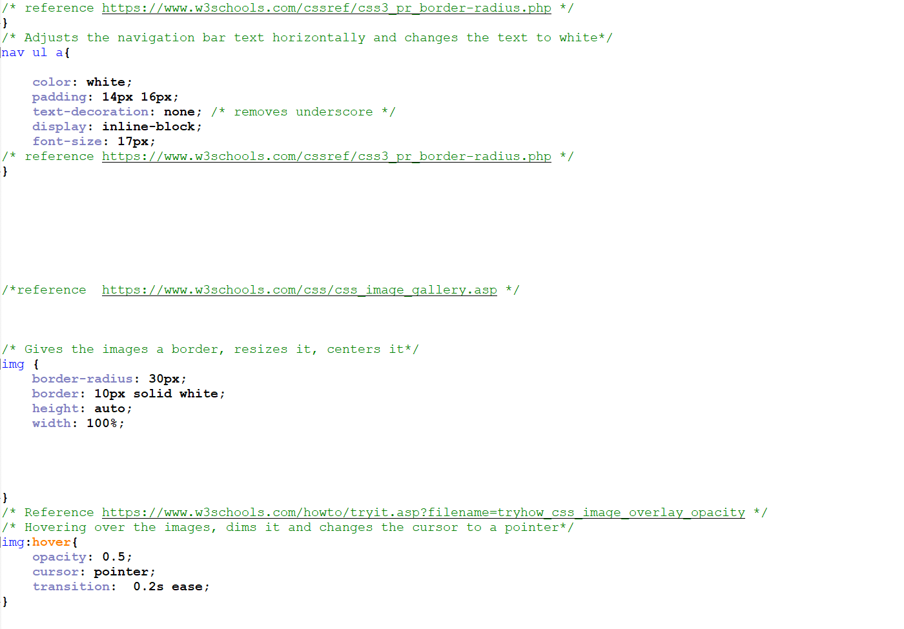

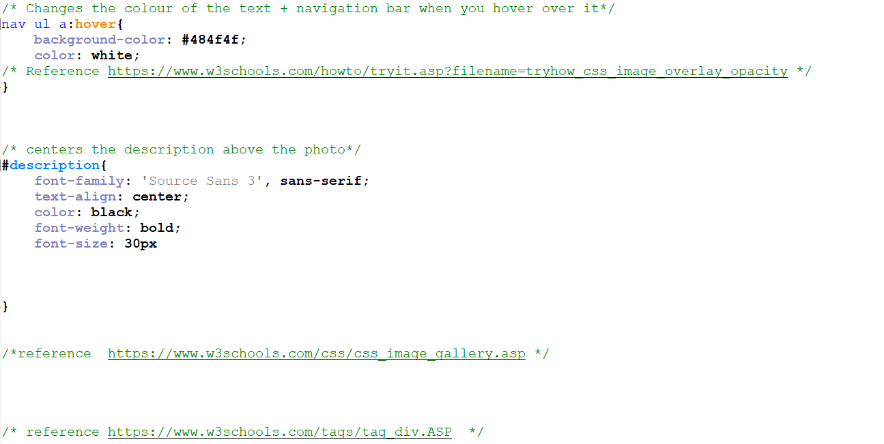

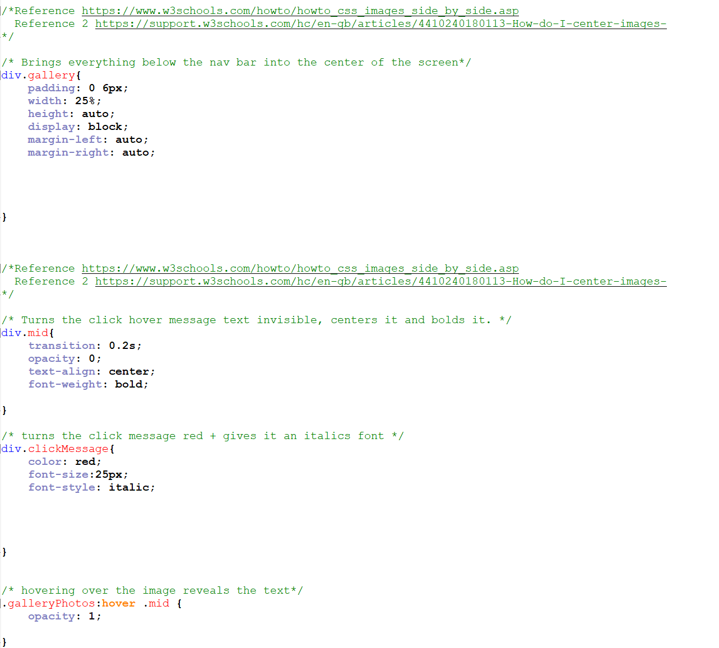

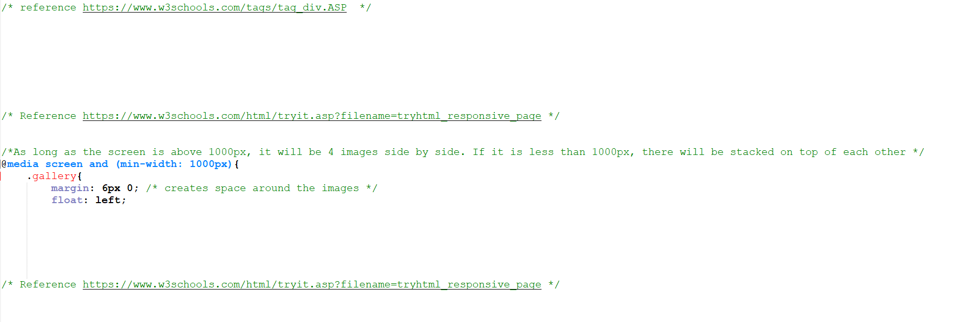

**JAVASCRIPT:**

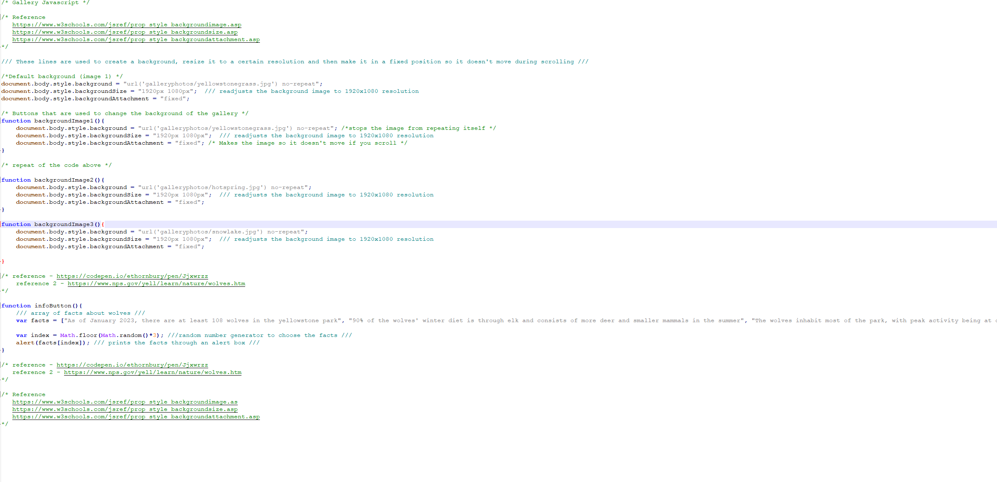

## Coding done by team member 2:

## Coding done by team member 3:

## Testing documented here:

HTML validation

Create a table to show testing of menu links and JS, responsiveness

Deployment – speed test

## Document the optimization of your images:

I ran all of the images through <https://tinypng.com/>, which optimised them and made them smaller so that they could load faster. I then ran them through <https://www.img2go.com/resize-image>, so that I could put the gallery images to the same size, so they are equal.

## Document the planning (excel/other)