Antoine Gaton

Professor Rida Moustafa

Foundations of Big Data Analytics:

CS356

16 June 2024

***Unit 1 - Individual Project***

* ***Section #1:*** *“Hello World!”Script Output*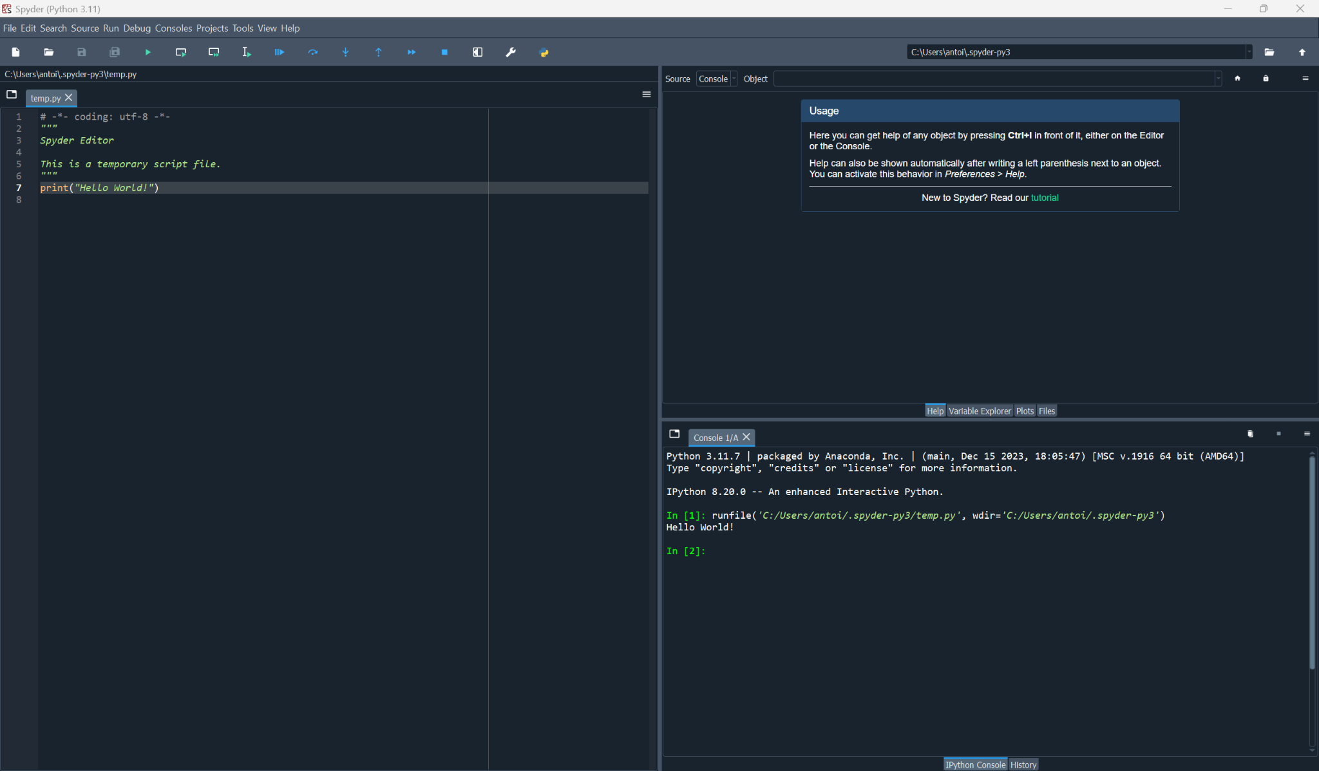
* ***Section #2:*** *Parse Data Script Output* 