Antoine Gaton

Professor Tonia Canada

Linux Programming: CS227

2 June 2024

***Unit 5 - Individual Project***

* ***Script#1:*** *Environment Configuration plus File Management*

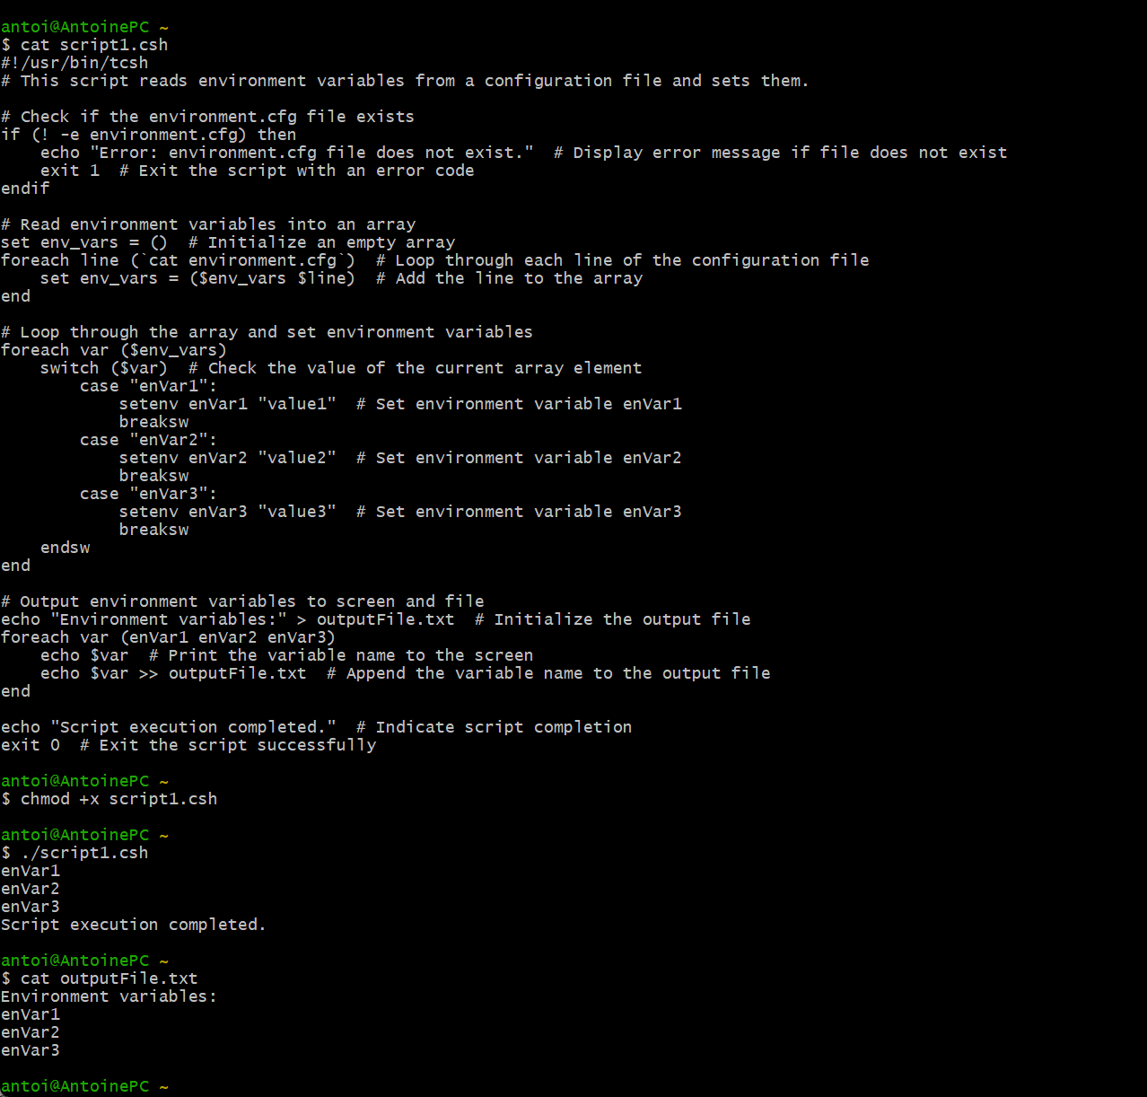

* ***Script#2:*** *Creating Functions*

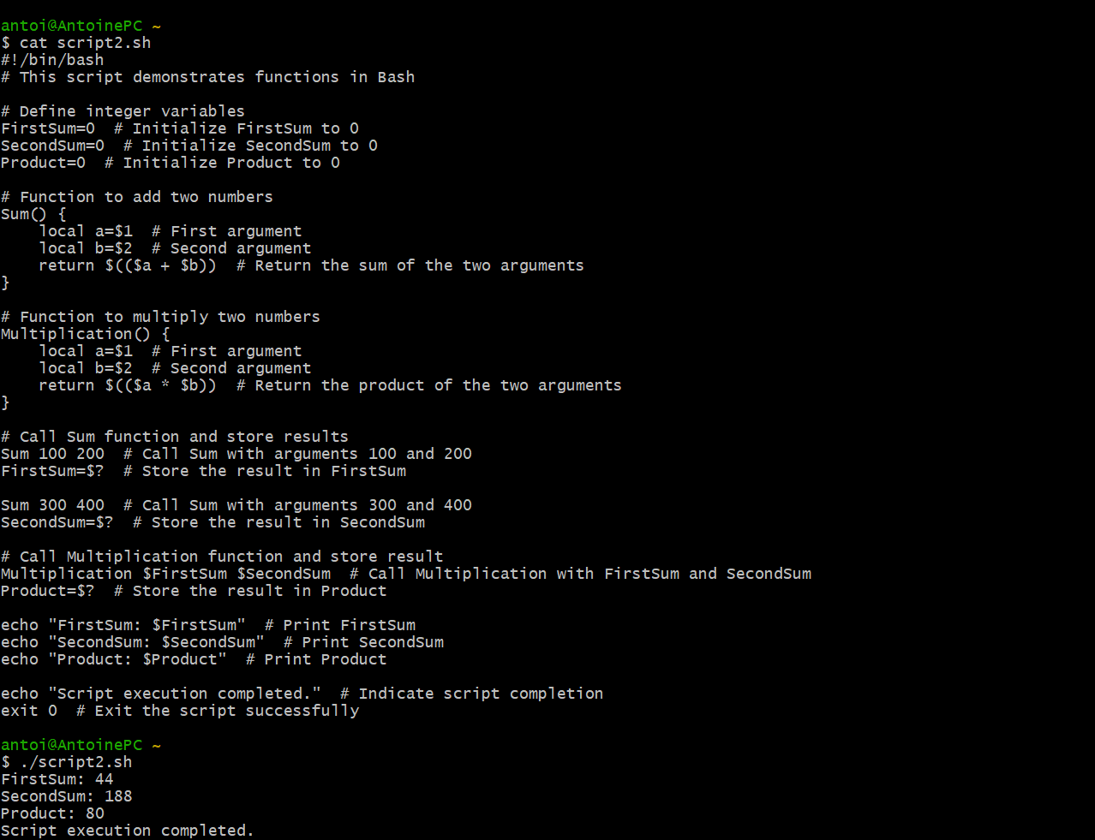

* ***Script#3:*** *Application Process Control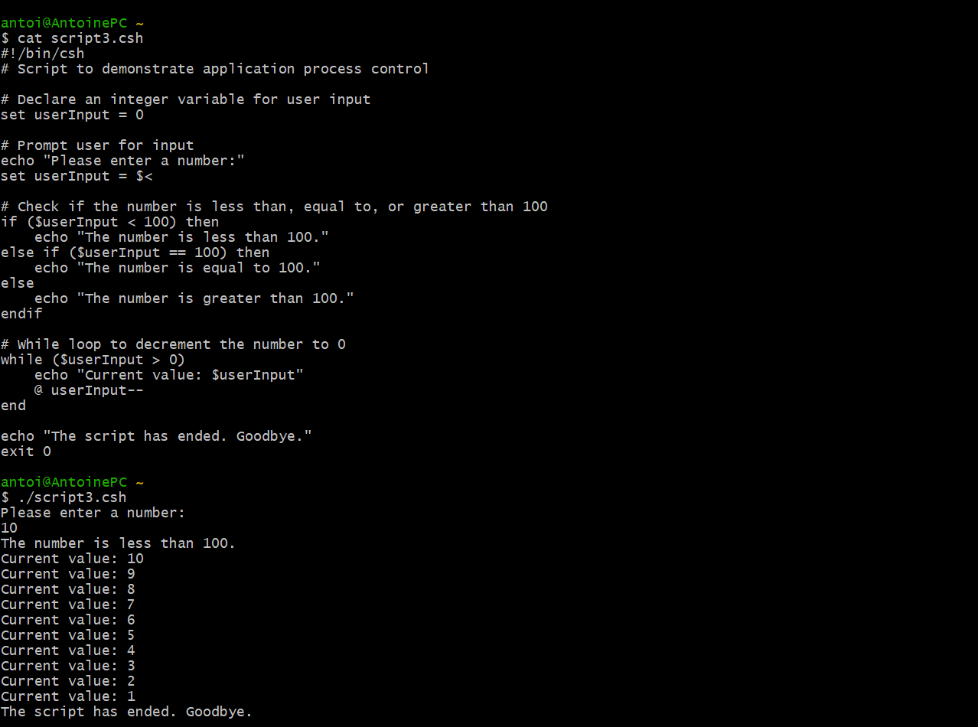*
* ***Summarization***
  + In Script 1, I learned how to handle file existence checks and set environment variables based on configuration files. Script 2 provided me with insight into defining and using functions to perform operations and return values in Bash scripts. Through Script 3, I understood how to use sequential, conditional, and iterative constructs to control the flow of a script and handle user input effectively.