Antoine Gaton

Professor Abbas Yousefi

NoSQL Databases: CS378

12 April 2024

***Unit 2 - Individual Project***

* *Part 1*
  + *Extract only the first 5 records to insert it into MongoDB.*

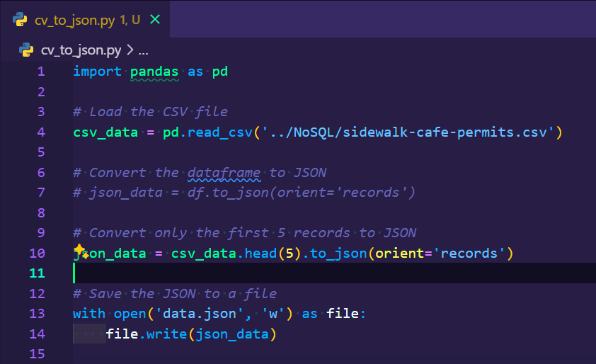

* + *Create the collection in MongoDB.*

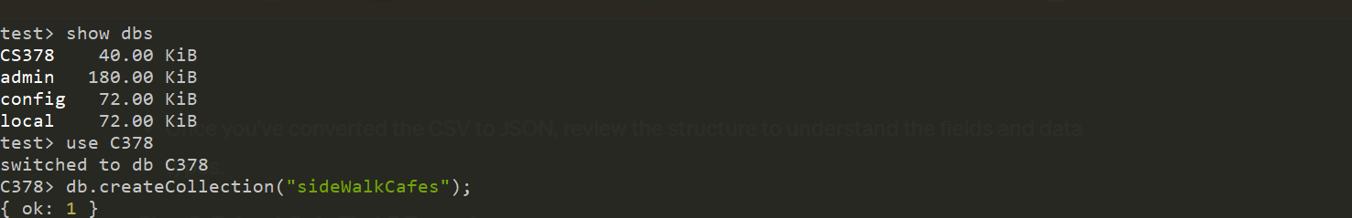

* + *Insert multiple documents using the insertMany method.*

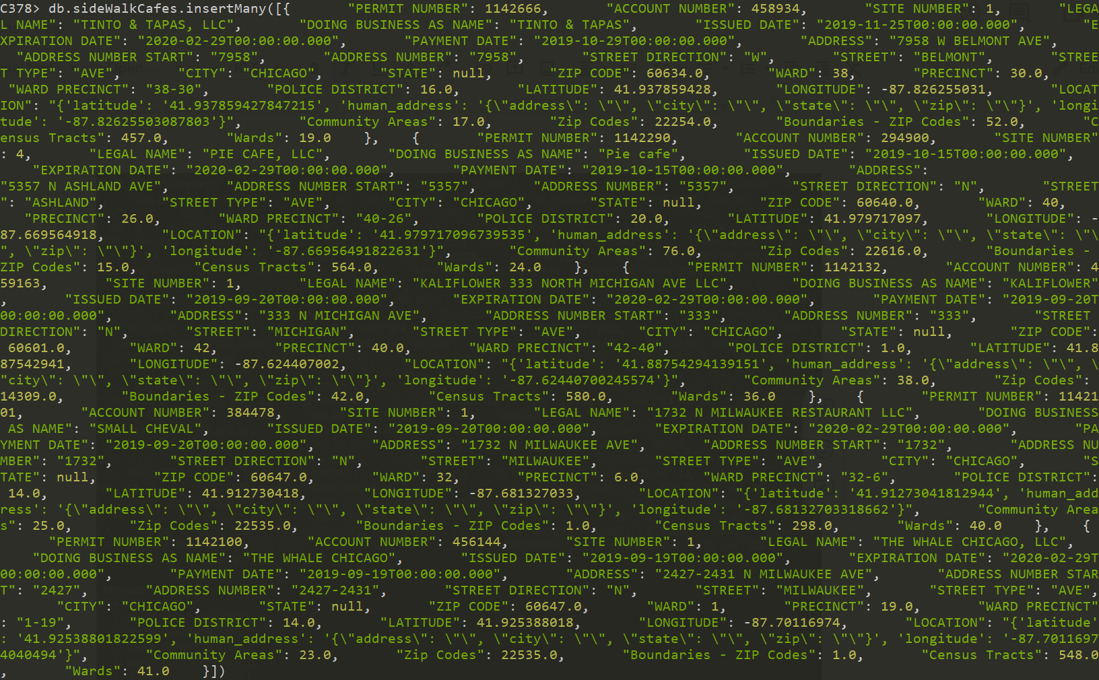

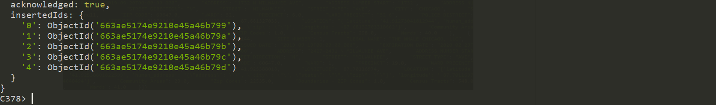

* + *Write a query to retrieve the number of documents stored in the collection.*

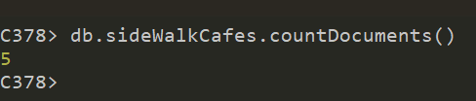

* *Part 2*
  + *Extract only the first 5 records to insert it into MongoDB.*

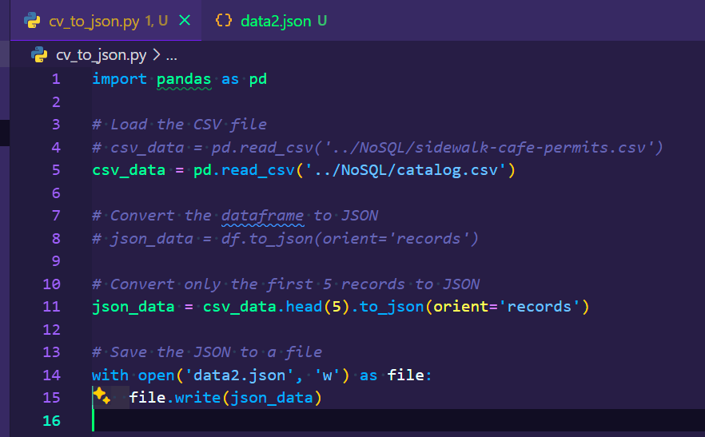

* + *Create the collection in MongoDB*

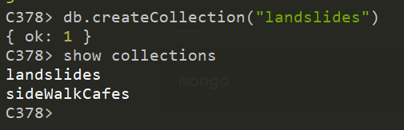

* + *Insert the 5 rows copied into your MongoDB collection*

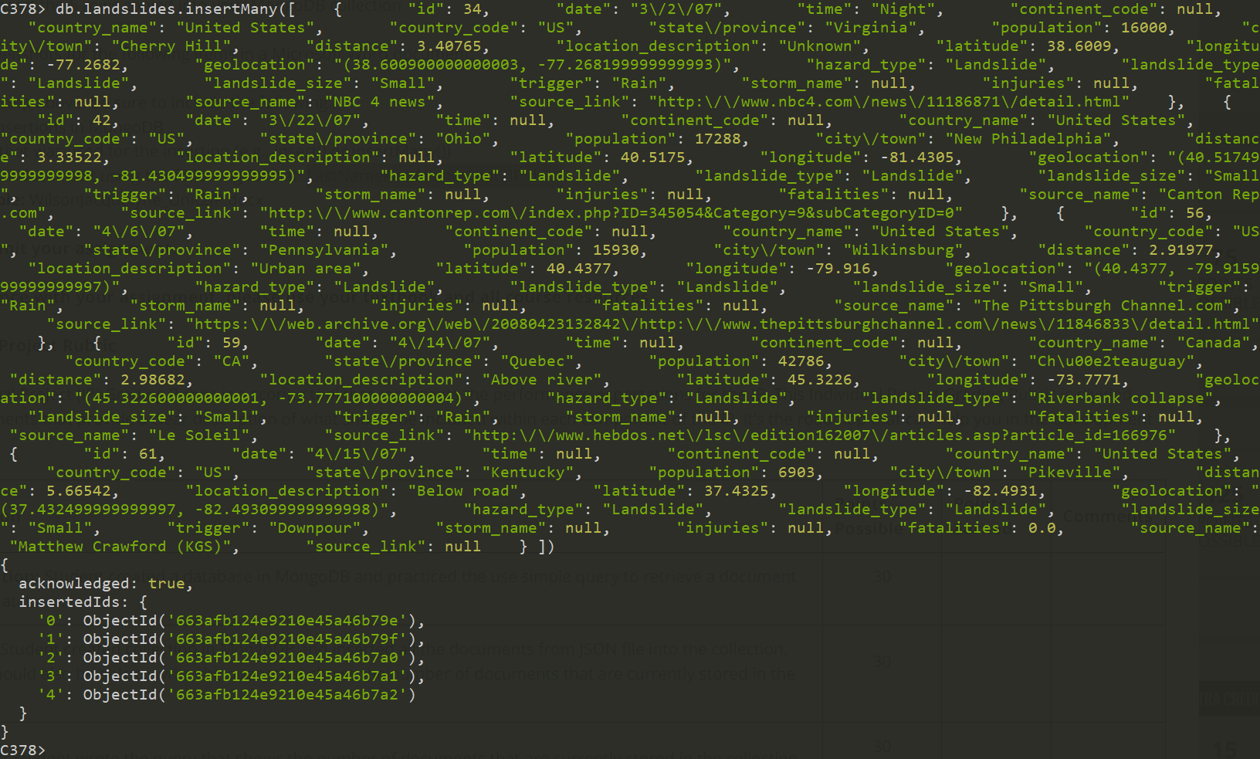

* *Part 3*
  + Validating everything done in MongoCompass

