Antoine Gaton

Professor Abbas Yousefi

NoSQL Databases: CS378

19 April 2024

***Unit 3 - Individual Project***

* ***Part 1***
  + *Create the collection in MongoDB using the script:*

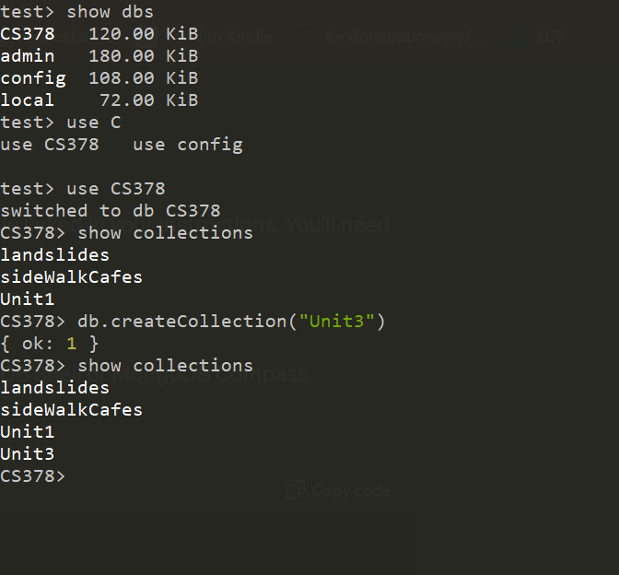

* + *Use the mongoimport() method to import the entire JSON document into the collection:*

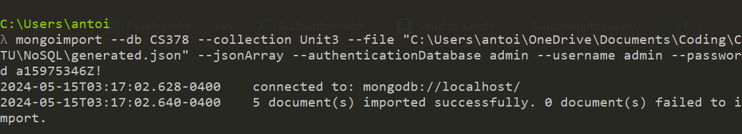

* + *Generate a single record from the* [*JSON generator*](https://www.json-generator.com/)*, and insert the document into the existing collection using the script:*

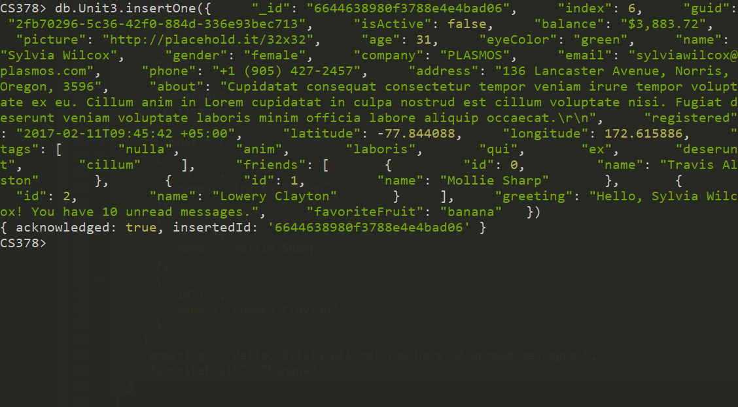

* + *Note the _id of the first document. Update the name to Tim Allen for the _id of the first document in your collection:*

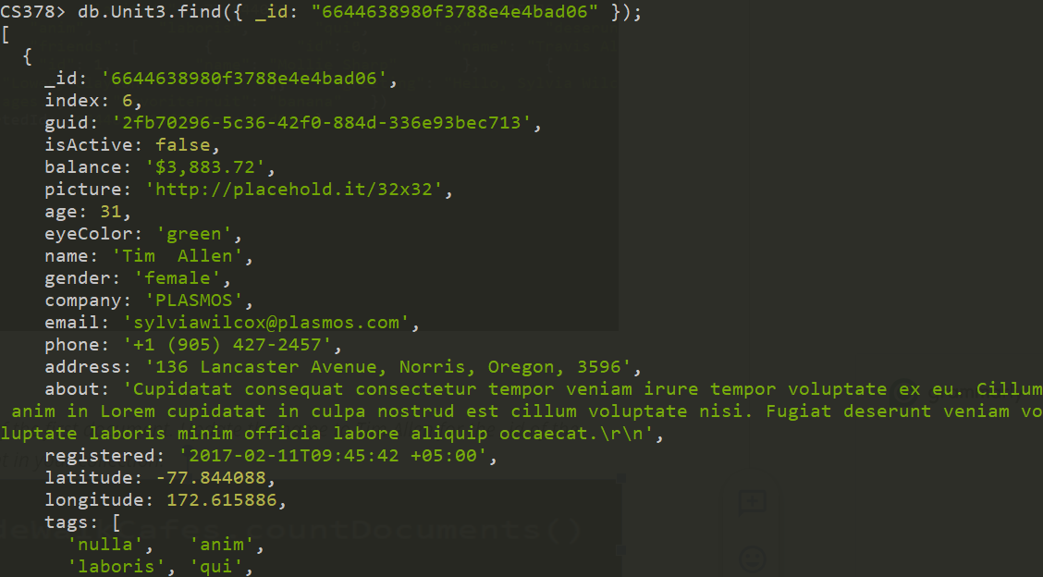

* + *Note the _id of the first document. Update the name to Tim Allen for the _id of the first document in your collection:*

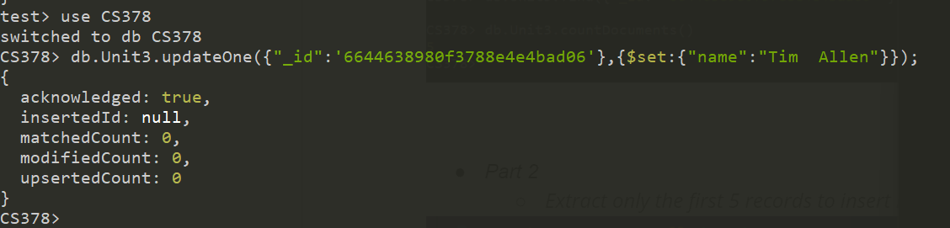

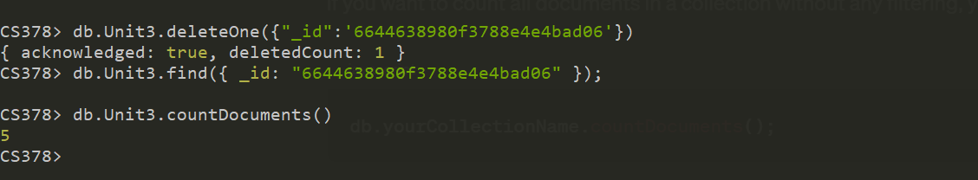

* ***Part 2***
  + *Determine the additional indexes. Apply indexes to the MongoDB collection:*

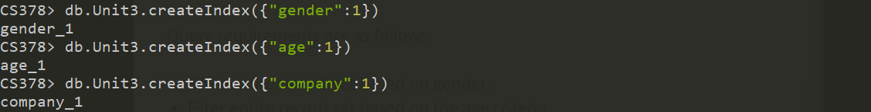

* + *Write a query to extract all of the records if age is 32:*

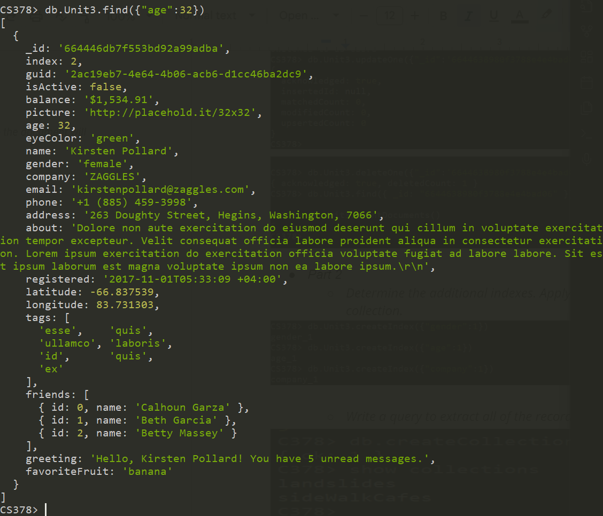

* + *Extract all records where gender is male:*

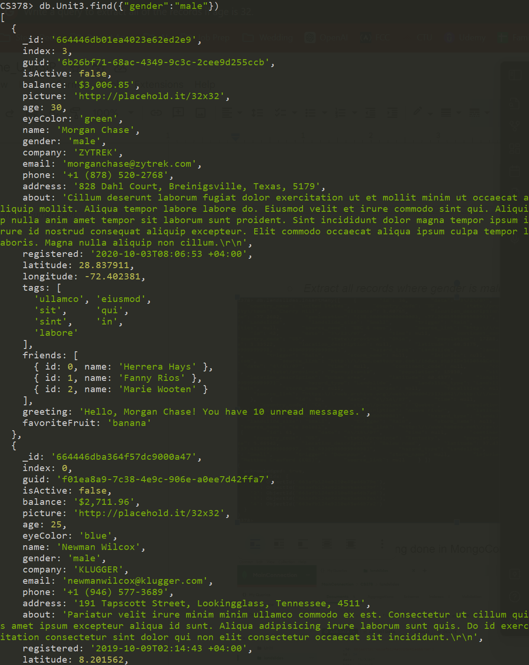

* + *Extract all records from the company "PERMADYNE" with proof of count for every index:*

