Antoine Gaton

Professor Abbas Yousefi

NoSQL Databases: CS378

26 May 2024

***Unit 4 - Individual Project***

* ***Part 1***
  + *Setting Up MongoDB Cluster in MongoDB Atlas*

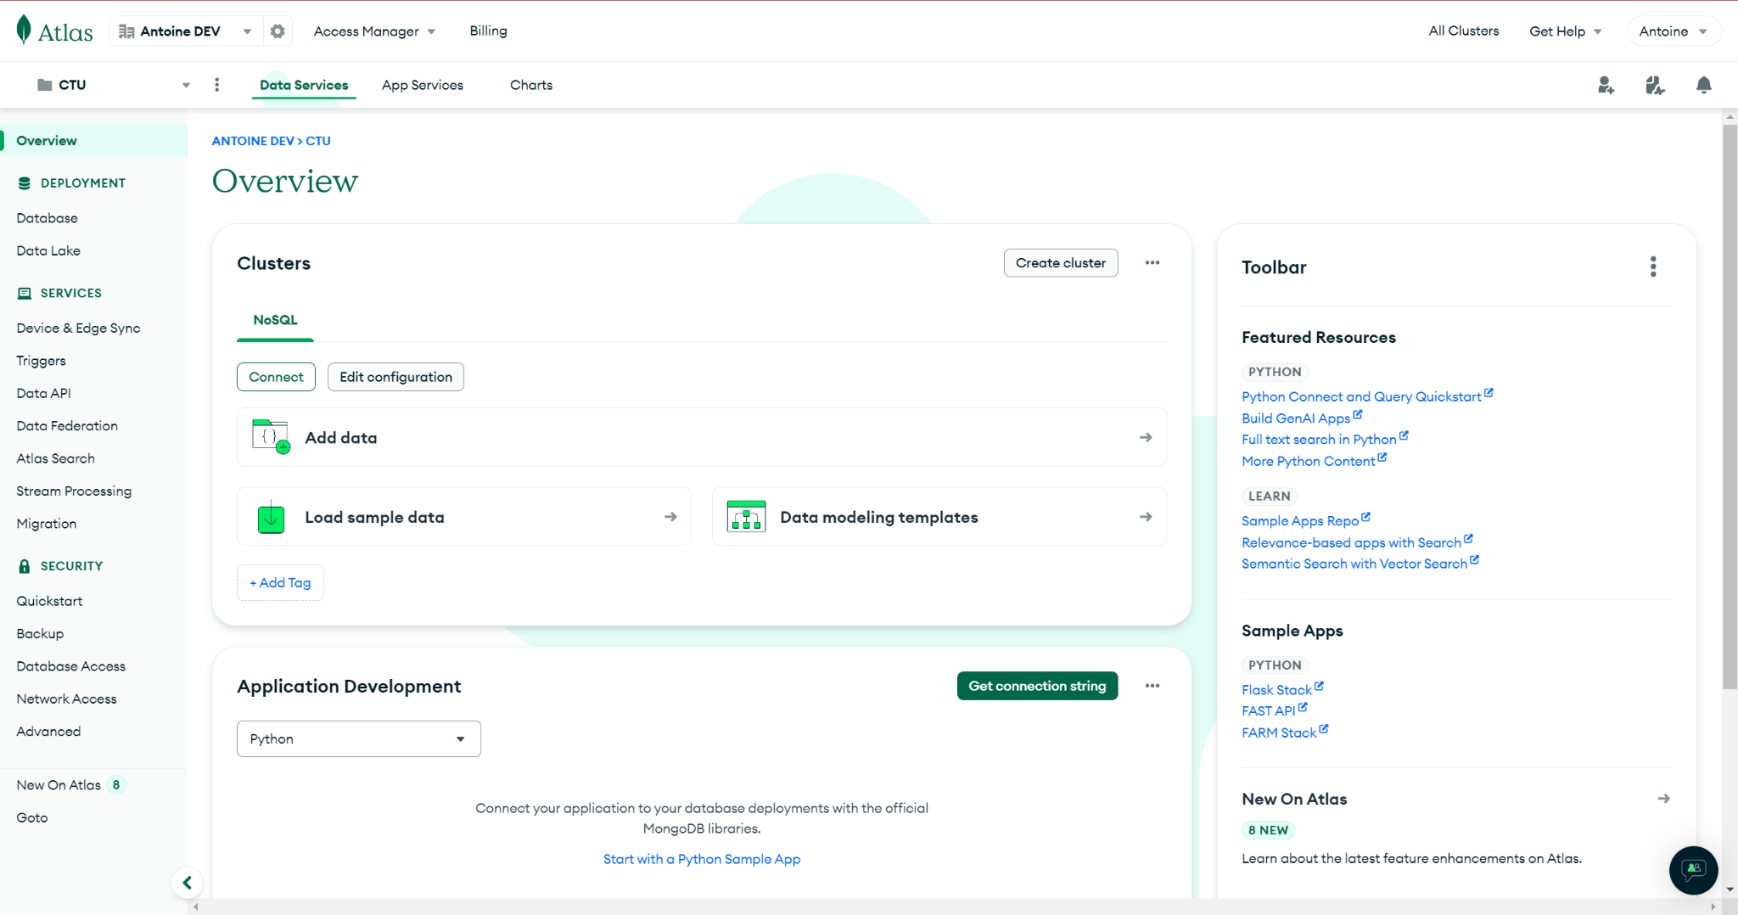

* ***Part 2***
  + *Create the collection in your MongoDB Atlas cluster*

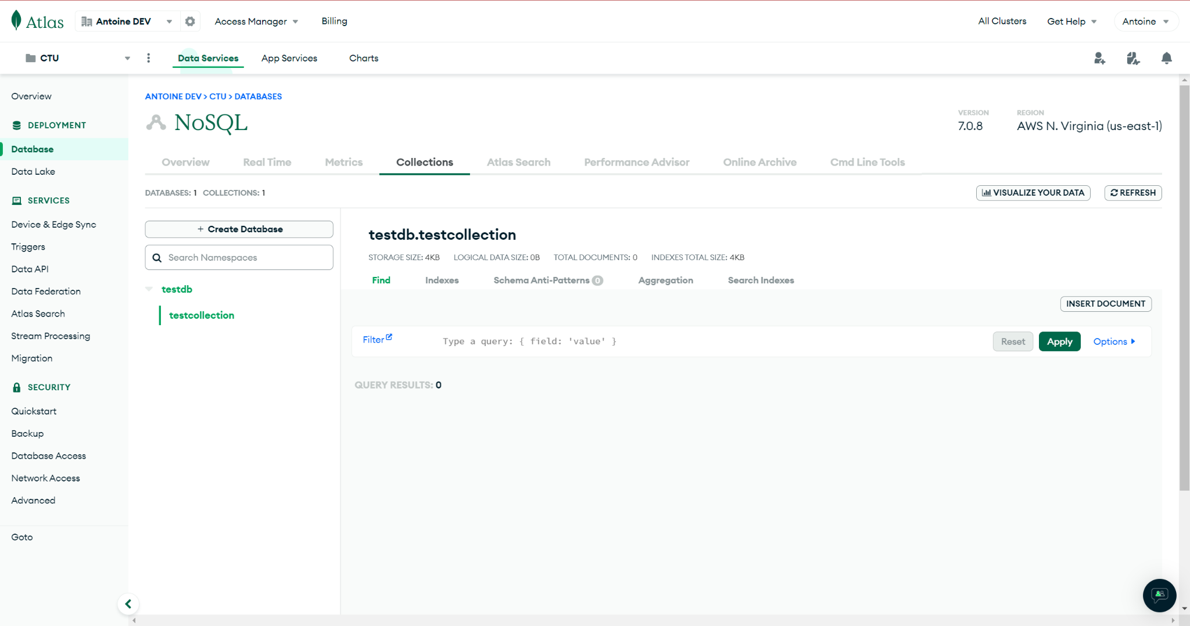

* + *Use mongoimport to import the JSON document*

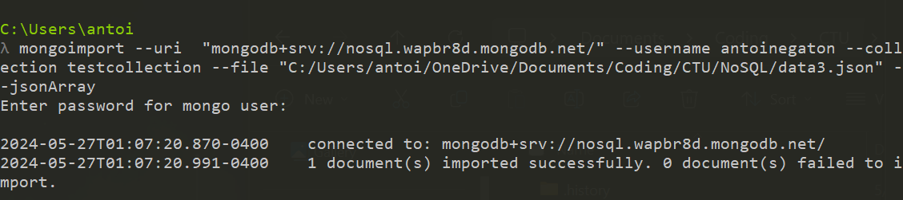

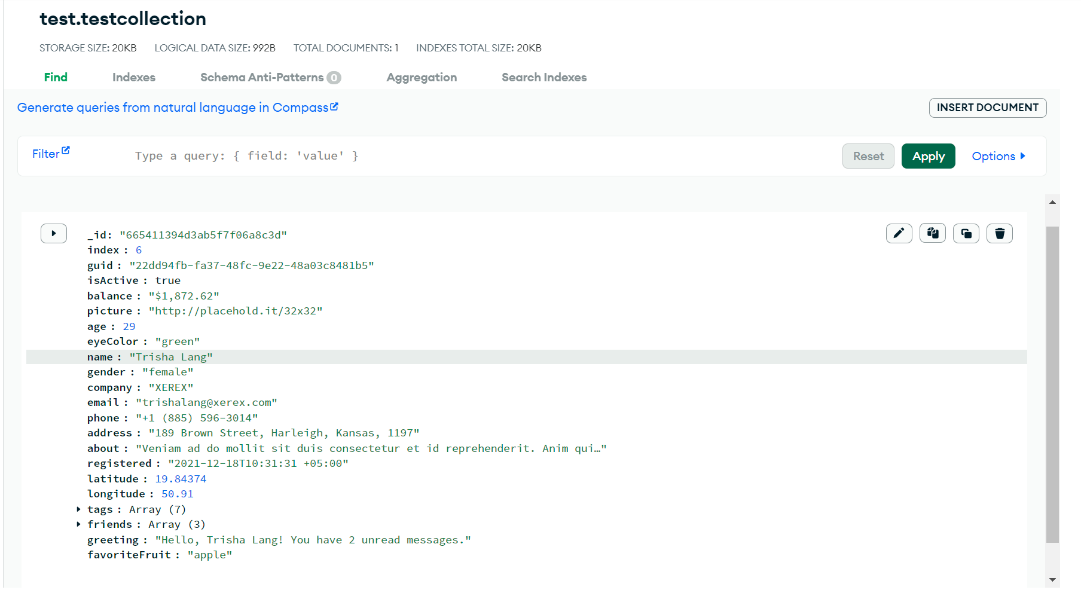

* + *Generate a single record and insert using the insert method*

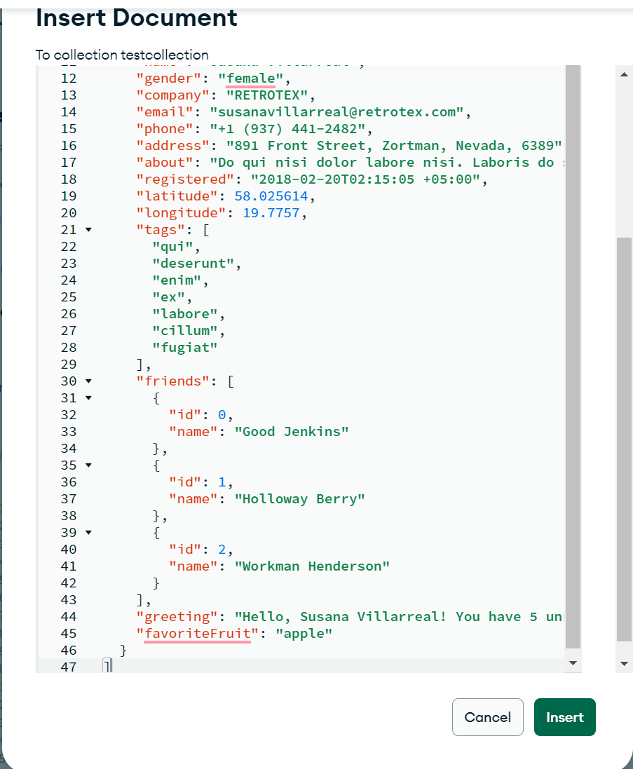

* + *Update the first document name field to "Tim Allen"*

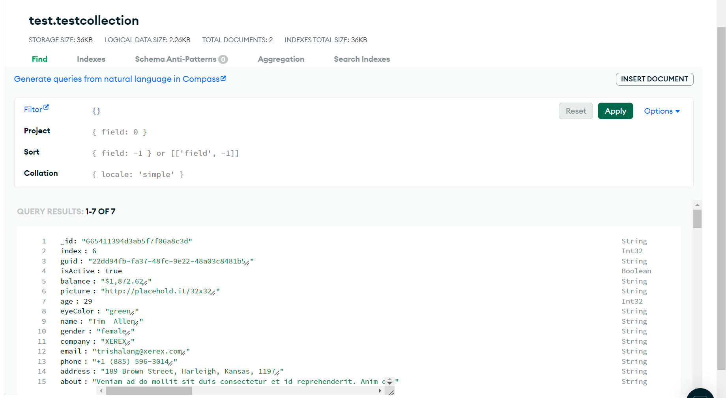

* + *Find the 7th document in the collection and delete that record*

