PROOF OF USABILITY

# User context

You've found this App on the play-store, the app page was the following:

Perm'App Culture, the brand new app that's will help you to begin in permaculture! Find information about theory made by the greatest name of this domain and learn the practical side with tutorials from professionals! Manage your garden for having a virtual assistant which remind you some important events of your plant’s life

For each question you will be free to say what you think about the App or image show to you.

*Please complete the information before:*

|  |  |
| --- | --- |
| Sexe | Male |
| Age | 65 |
| Level of gardening | Bad |
| Level of Technology | Normal |

Instruction for the test helper: Don’t give any information helpful for the user, be more possible neutral. Helping the user is like a defeat of usability for us. Read one time fully the document before starting the test to understand it’s structure!

Ok! Let’s Start the Test!

First Step: Opening

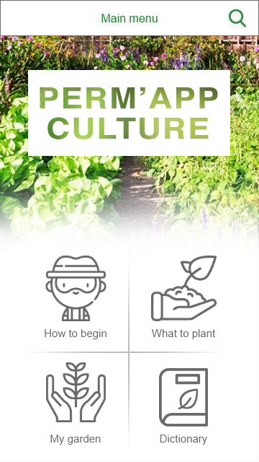

Q1. Which section will you go first naturally after opening the app?

How to Begin

Q2. Intuitively this menu, in order to transmit information to the users is:

* Too rich
* Well balance
* Too poor

Change the color of the answer

Q3. Describe what you type of information you attend to find behind:

|  |  |
| --- | --- |
| “How to begin” section? | “What to plant” section? |
| Instructions, materials, maybe plants | I expect conditions for the place, land, climatologically |
| My garden | Dictionary |
| How the plants develop, plague control | Terminology that I don’t understand |

# Action to do: *Find information about StrawBerry Plant*

**Before interacting**

Q4. To which section you will go?

|  |  |  |  |
| --- | --- | --- | --- |
| How to begin? | What to plant? | My garden | Dictionary |

Change the color of the answer

↓GO NEXT PAGE ↓

*For each menu choose an answer:*

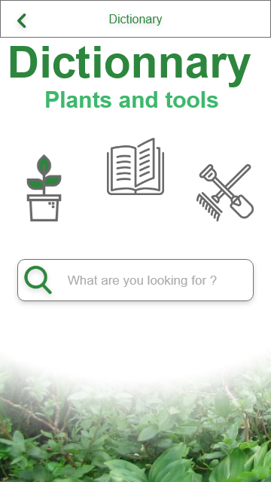

Q6. How many interactions do you think there is in this menu? No idea, maybe a lot

Q7. Intuitively this menu, in order to transmit information to the users is:

* Too rich
* Well balance
* Too poor

Change the color of the answer

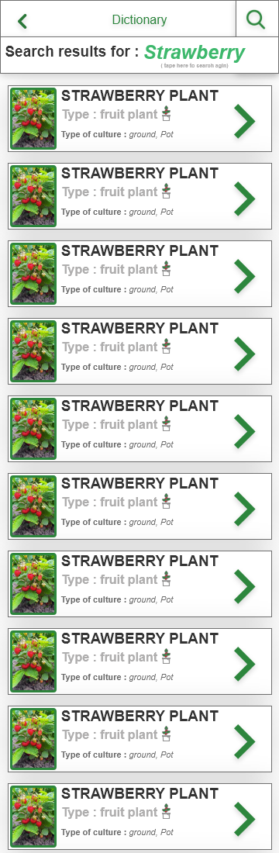

Q7. How many interactions do you think there is in this menu? No idea

Q8. Intuitively this menu, in order to transmit information to the users is:

* Too rich
* Well balance
* Too poor

Change the color of the answer

Q9. How many interaction do you think there is in this menu? No idea

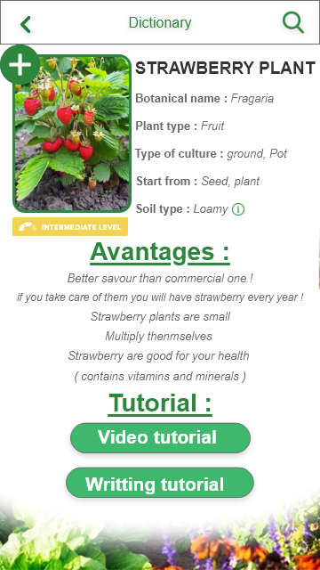

Q10. This page give the information you want?

|  |  |  |
| --- | --- | --- |
| Not at all | Yes | Too many |

Change the color of the answer

**After interacting**

Q5. Did you have any difficulties to find the information?

|  |  |  |
| --- | --- | --- |
| Yes many | Just a little | No one |

Change the color of the answer

Q6. If you had some difficulties can you describe the reason(s):

|  |  |
| --- | --- |
| Element of the ui not readable | Navigation system bad designing |

Change the color of the answer

# Action to do: *Find an article about the permaculture story!*

**Before interacting**

Q4. To which section you will go?

|  |  |  |  |
| --- | --- | --- | --- |
| How to begin? | What to plant? | My garden | Dictionary |

Change the color of the answer

↓GO NEXT PAGE ↓

*For each menu choose an answer:*

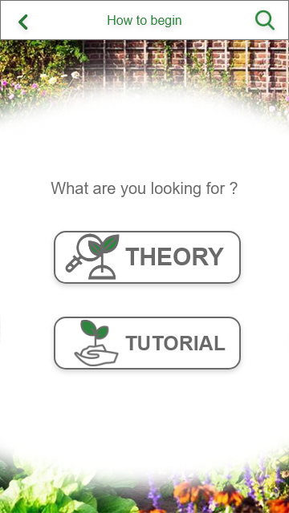Q9. How many interaction do you think there is in this menu? No idea

Q10. This page give the information you want?

|  |  |
| --- | --- |
| No | Yes |

Change the color of the answer

Q11. What type of information is behind “Theory”?

Write your answer here . .

Q. 12 What type of information is behind

“Tutorial”?

Write your answer here . .

Q13. How many interaction do you think there is in this menu? No idea

Q14. The navigation system of this menu is:

|  |  |
| --- | --- |
| Bad | Good |

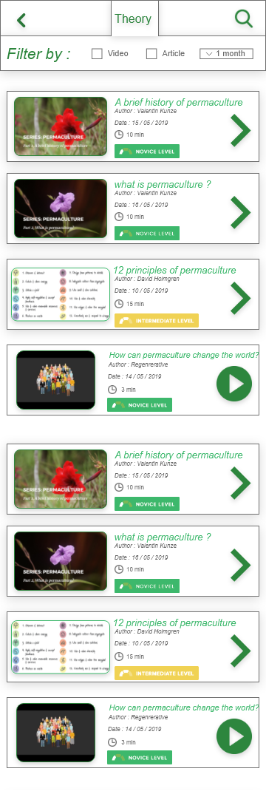

Q15: For you this menu gives you enough information about the article?

|  |  |
| --- | --- |
| Yes | No |

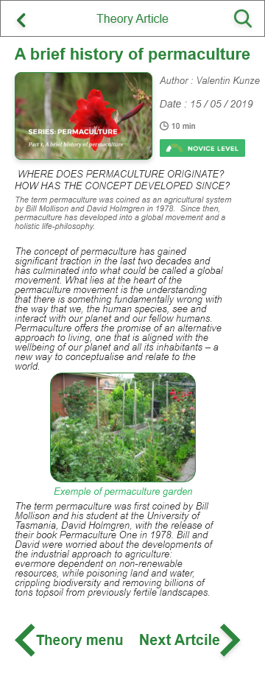

Q16. The design of this page is helpful for the lecture?

|  |  |
| --- | --- |
| Yes | No |

Change the color of the answer

Q17. Have you any difficulties to read?

|  |  |
| --- | --- |
| Yes | No |

Change the color of the answer

Q17.b. If you have some difficulty what type it is?

|  |  |  |
| --- | --- | --- |
| Bad contrast to read | To small | Disorganized |

Change the color of the answer

**After interacting**

Q18. Did you have any difficulties to find the information?

|  |  |  |
| --- | --- | --- |
| Yes many | Just a little | No one |

Change the color of the answer

Q19. If you had some difficulties can you describe the reason(s):

|  |  |
| --- | --- |
| Element of the ui not readable | Navigation system bad designing |

Change the color of the answer

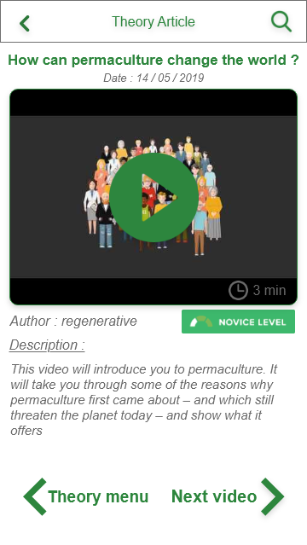

Q20. The design of this page is helpful for the lecture?

|  |  |
| --- | --- |
| Yes | No |

Change the color of the answer

Q21. Have you any difficulties to find how to start the video?

|  |  |
| --- | --- |
| Yes | No |

Change the color of the answer

Q21.b. If you have some difficulty what type it is?

|  |  |
| --- | --- |
| Not intuitive | Disorganized |

Change the color of the answer

# Action to do : *Add a Strawberry plant in my garden section!*

**Before Interacting with this menu:**

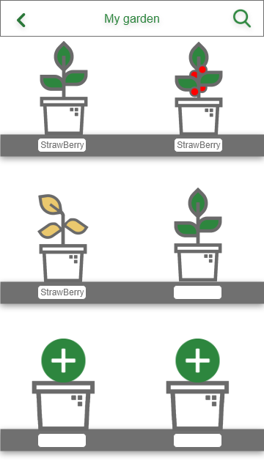Q22. How many interaction do you think there is in this menu? No idea.

Q23. This page give the information you want?

|  |  |
| --- | --- |
| No | Yes |

Change the color of the answer

Q24. Can you tell us what is the different status of the plant? (1 or 2 words)

Green one: Healthy

Orange one: Dry, dead

↓GO NEXT PAGE ↓

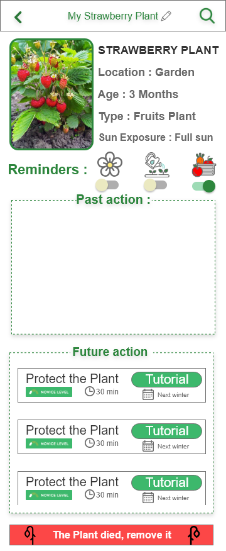Q25. The design of this page is helpful for the lecture?

|  |  |
| --- | --- |
| Yes | No |

Change the color of the answer

Q26. For you what function has the reminders?

|  |  |
| --- | --- |
| Blue One | If they have flowered |
| Orange One | If the plants have been showered |
| Purple One | Collect the fruits |

Q27. The design of the future action is?

|  |  |
| --- | --- |
| good | Bad |

Change the color of the answer

Q28. For you the comprehension of the working if this page is?

|  |  |
| --- | --- |
| good | Bad |

Change the color of the answer

**Open the two other plant with special status in the main menu before responding.**

↓GO NEXT PAGE ↓

Q29. For you the design of the plant who need an action is?

|  |  |
| --- | --- |
| Adequate | Inadequate |

Change the color of the answer

Q30. For you the design of the plant who have it fruits is?

|  |  |
| --- | --- |
| Adequate | Inadequate |

Change the color of the answer

# Action to do: Find a plant you can start growing today!

**Before interacting**

Q31. To which section you will go?

|  |  |  |  |
| --- | --- | --- | --- |
| How to begin? | What to plant? | My garden | Dictionary |

Change the color of the answer

↓GO NEXT PAGE ↓

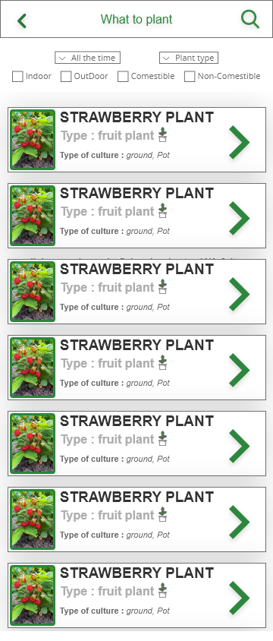Q32. The design of this page is helpful for the selection?

|  |  |
| --- | --- |
| Yes | No |

Change the color of the answer

Q33. Do you think the different filter is?

|  |  |  |
| --- | --- | --- |
| Too Few | Enough | Too much |

Change the color of the answer

**After interacting**

Q34. Did you have any difficulties to find the information?

|  |  |  |
| --- | --- | --- |
| Yes many | Just a little | No one |

Change the color of the answer

Q35. If you had some difficulties can you describe the reason(s):

|  |  |
| --- | --- |
| Element of the ui not readable | Navigation system bad designing |

Change the color of the answer

# Conclusion Feeling about the App :

*Q.36 What is your feeling about the navigation in the App:*

|  |  |  |  |  |
| --- | --- | --- | --- | --- |
| Very Bad | Bad | Pretty intuitive | Very well | Perfect |

*Q.37 What is your feeling about the iconography of the App:*

|  |  |  |
| --- | --- | --- |
| Inadequate | Pretty Adequate | Adequate |

*Q38. What is your feeling about the Reading quality of the text in the App:*

|  |  |  |
| --- | --- | --- |
| Too small | Not small Not big | Too big |

Size:

|  |  |  |
| --- | --- | --- |
| Inadequate | Pretty Adequate | Adequate |

Font:

|  |  |
| --- | --- |
| Bad contrast | Good visibility |

Color:

Q39.What is your feeling about the functionality off the Apps:

|  |  |  |
| --- | --- | --- |
| Too few | Good number | Too much |

Number:

|  |  |
| --- | --- |
| Useless | Useful |

Utility:

|  |  |
| --- | --- |
| Bad | Good |

Q40. Finally, in your mind this app How is the usability of the App?

# Analysis:

For him the interaction with the app was straightforward only whit a little of troubles with certain windows, specifically the dictionary one, where the information wasn’t what he expected it to be.

Referring to the plants’ icons in “My Garden” window, he felt that the icons don’t really represented the plant state at all, they gave an idea but weren’t as clear as they could possibly be.

In the dictionary window he expected to find terminology and such things, however the tutoring part was a good point and he pretty much like the idea.

Overall, he felt the app was good and very useful, but it could be polished a little more, having some additional kind of information in the plants dictionary, such as type of ground needed, plague control, conditions for the plant to growth and so on.