**Final Project Pre-Lab**

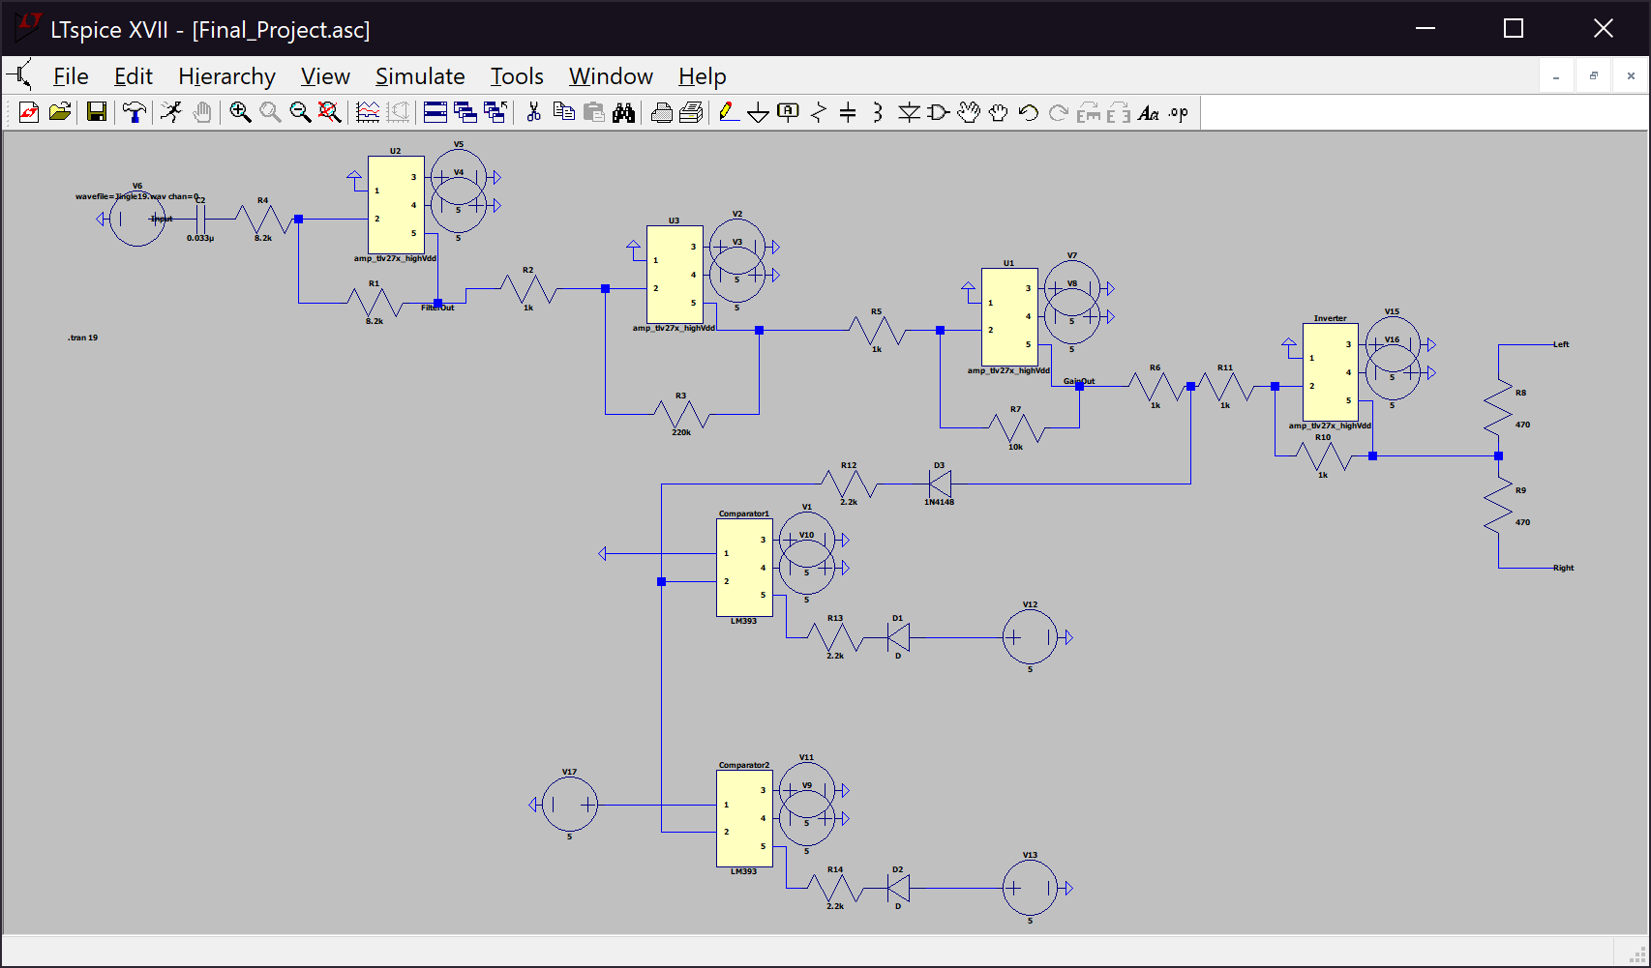Fran Luka Antoljak

*Figure 1. Circuit diagram*

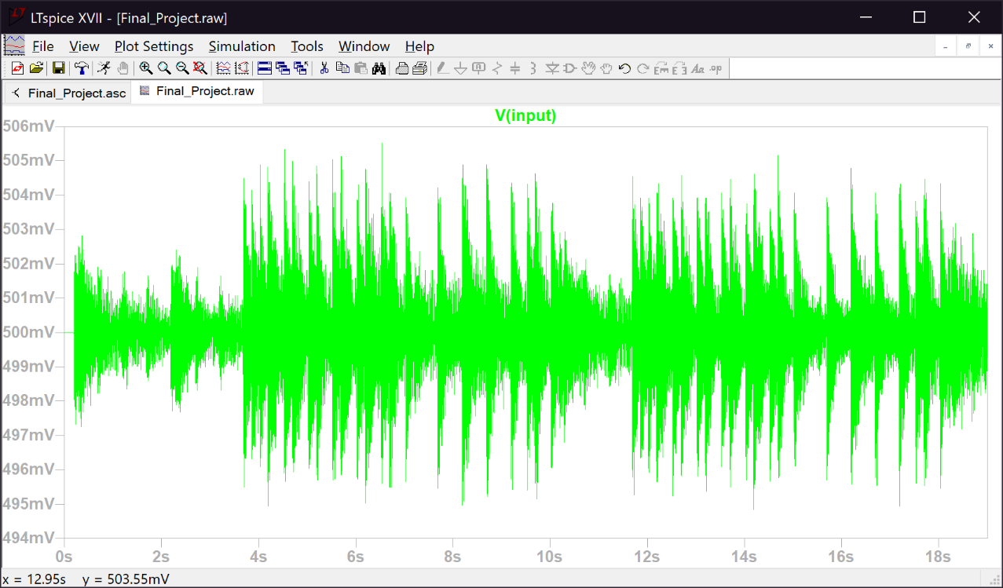

*Figure 2. Input voltage*

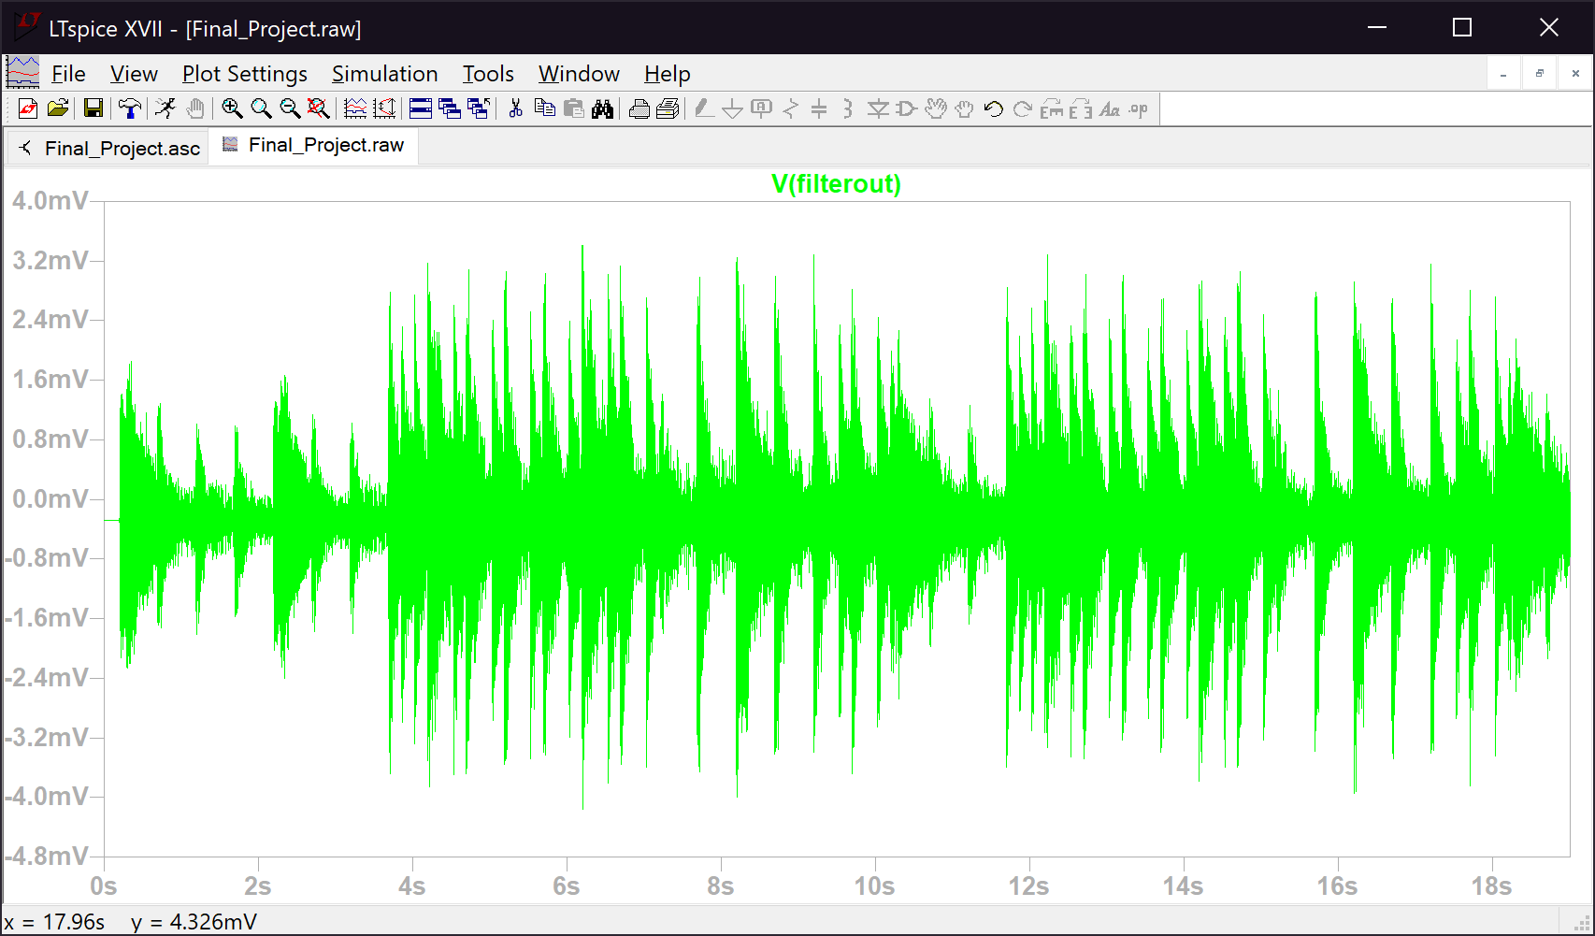*Figure 3. Output voltage of the high pass filter*

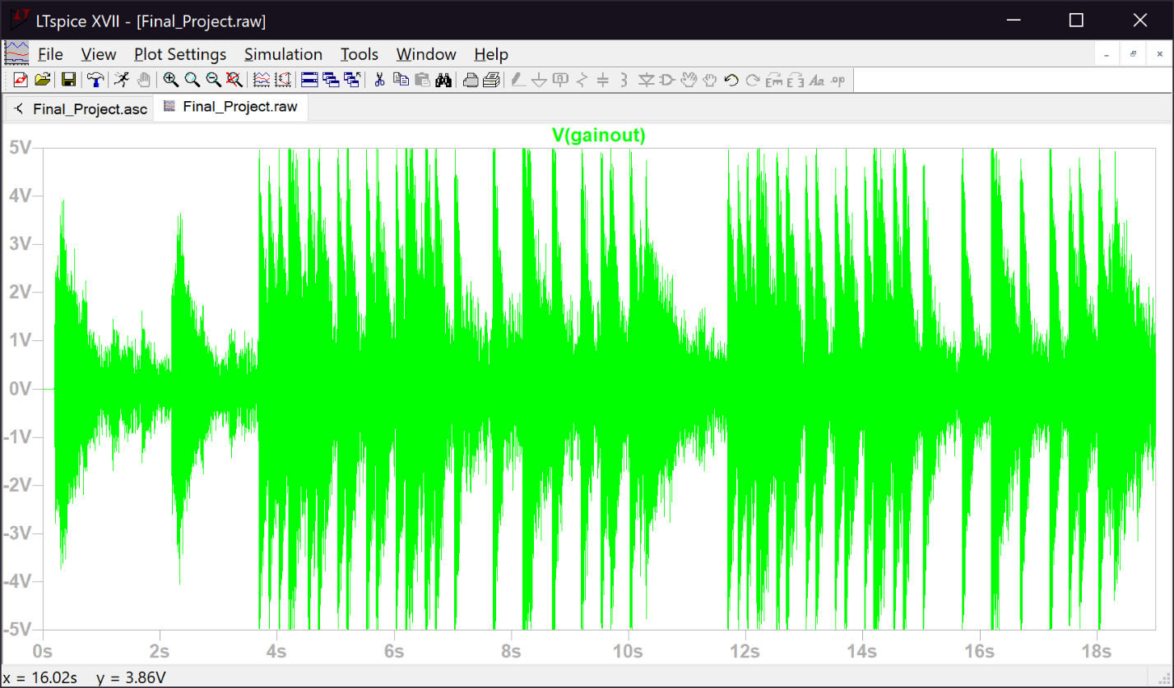

*Figure 4. Output voltage of the variable gain amplifier*

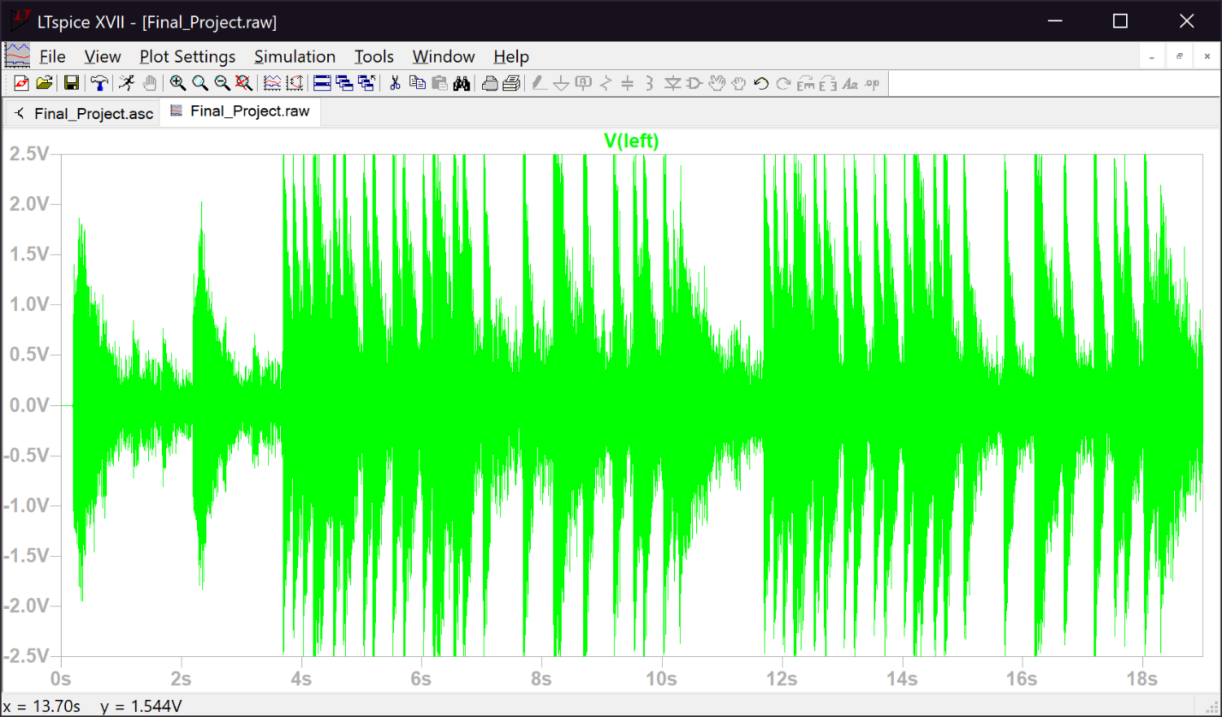*Figure 5. Output voltage (left speaker)*

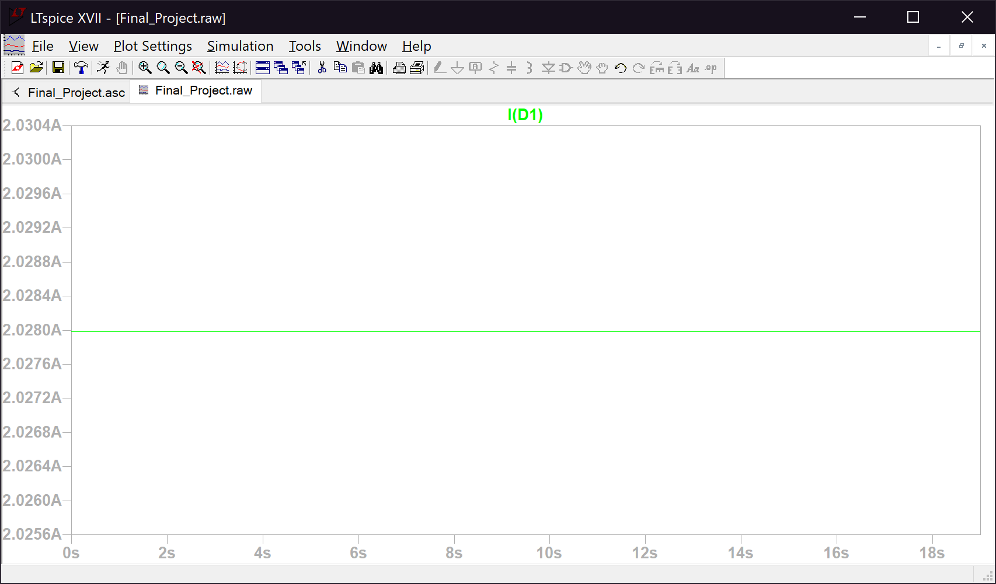

*Figure 6. Current of diode 1 (represents if threshold 1 was met; Table 10.1, lab manual)*

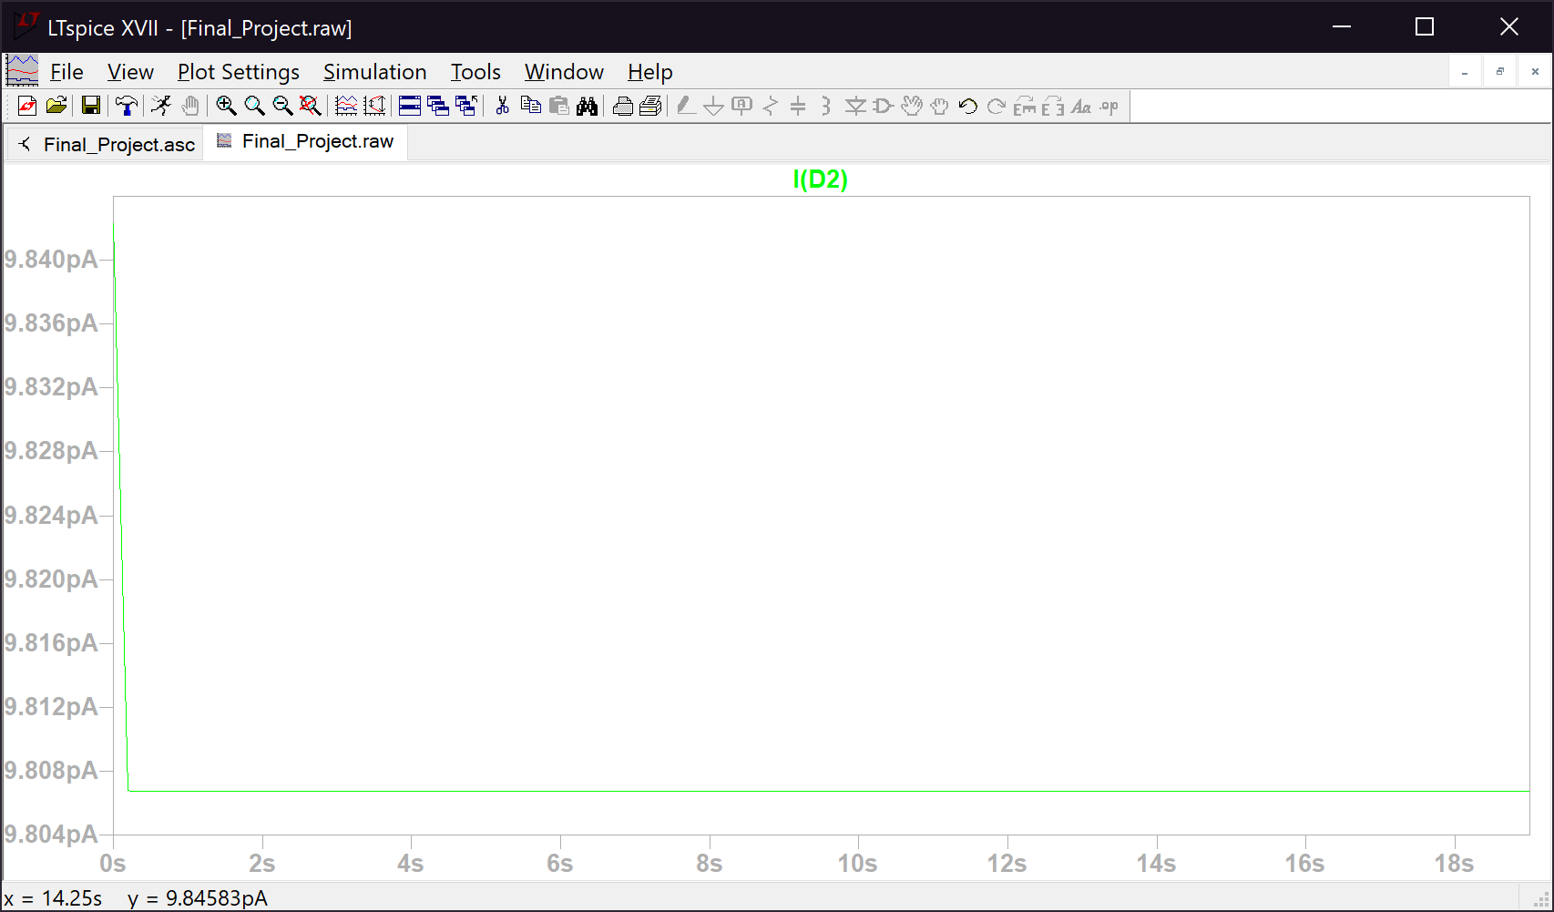*Figure 7. Current of diode 2 (represents if threshold 2 was met; Table 10.1, lab manual)``*