Final Project

Abstract

The circuit built for the final project is an audio amplifier. The input audio has a small offset and a low amplitude. The audio amplifier circuit, built for the final project, removes the offset and gains the input; a variable gain amplifier is also added. The circuit consists of four parts. The first part is an active high pass filter which also acts as a gain amplifier. Since the active filter is built with an op amp, we can also use the op amp to amplify the input. The second part is a variable gain amplifier, which is built using a potentiometer at the (negative) terminal of the op amp; the potentiometer’s resistance can be changed at will to vary the amplification. The third part is a clip detector which consists of 2 LEDs; one LED checks if there is an input in the circuit, and the second LED checks if the input is clipping. The final part is the output stage which consist of two inverting amplifiers for both left and right speaker.

Procedure

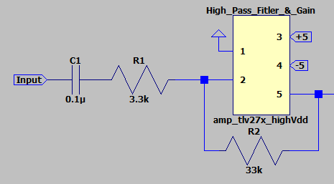

*Figure 1. High Pass Filter and Gain Amplifier*

The first part of the circuit is an active high pass filter and gain amplifier. The high pass filter removes the DC offset from the input. It is also important to pick a fitting 3 dB frequency to not attenuate the input (3 dB frequency should not be in the kHz). With this setup the 3 dB frequency is ~48.23 Hz; using the formula:

$$f_{0}=\frac{1}{2μ*C_{1}*R_{2}}$$

Additionally, there is a gain amplifier that amplifies the input by a factor of 10; using the formula (the negative sign signifies that it is an inverting amplifier):

$$V_{out}=-\frac{R_{2}}{R_{1}}V_{in}$$

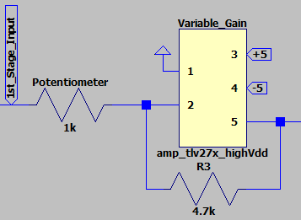

*Figure 2. Variable Gain Amplifier*

The second part of the circuit is a variable gain amplifier. Using a potentiometer, we can vary the gain of the input by changing the resistance of the potentiometer; using the formula:

$$V_{out}=-\frac{R_{3}}{R_{pot}}V_{in}$$

With this variable gain amplifier, we can control the volume of the input by changing its resistance. We can also test the peak detector for clipping by lowering the resistance of the potentiometer by too much.

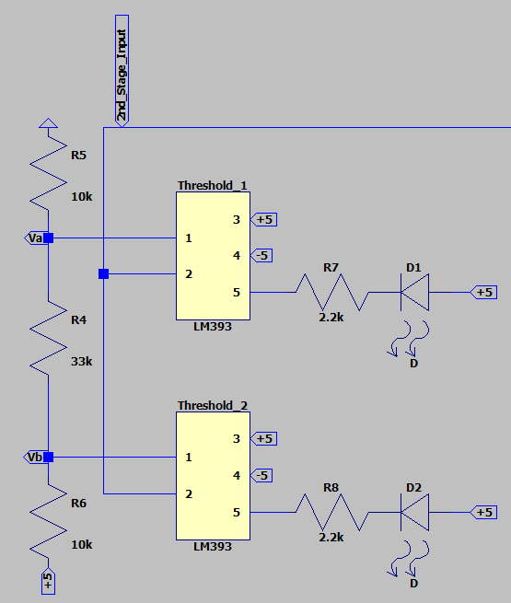

*Figure 3. Peak Detector*

The third part of the circuit is the peak detector. The peak detector consists of two comparators and two LEDs. The comparators compare the positive and negative terminals, if the positive terminal (1) is greater than the negative terminal (2), then the comparator outputs a voltage of +5 V, which turns off the LED. Both LEDs turn on when their respective threshold has been met. D1 turns on when there is an input present, its comparator compares Va (~ 0.94 V, positive terminal) with the input (negative terminal), and since the input is strictly greater than 0.94 V, the comparator will stop outputting +5 V which will turn on the LED, D1. D2 turns on when the input is clipping, this would occur if the input is greater than 5 V, its comparator compares Vb (~ 4.06 V, positive terminal) with the input (negative terminal), and if the input is greater than 4.06 V (almost/surely clipping), the comparator will stop outputting +5 V which will turn on the LED, D2.

The formula for calculating Va and Vb, using node voltage:

$$\frac{V_{a}-0}{10,000}+\frac{V_{a}-V_{b}}{33,000}=0$$

$$\frac{V_{b}-V_{a}}{33,000}-\frac{V_{b}-5}{10,000}=0$$

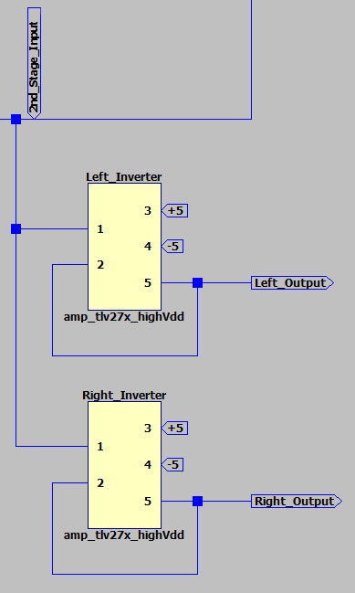

*Figure 4. Output Buffer*

The final part of the circuit is the output buffer. The output buffer consists of two non-inverting amplifiers which buffers the output to the left and right speakers. We use one amplifier for each speaker to reduce unnecessary noise to produce a cleaner output. The reason the amplifiers are non-inverting is because in the first and second part of the circuit we already used two inverting amplifiers which canceled each other out.

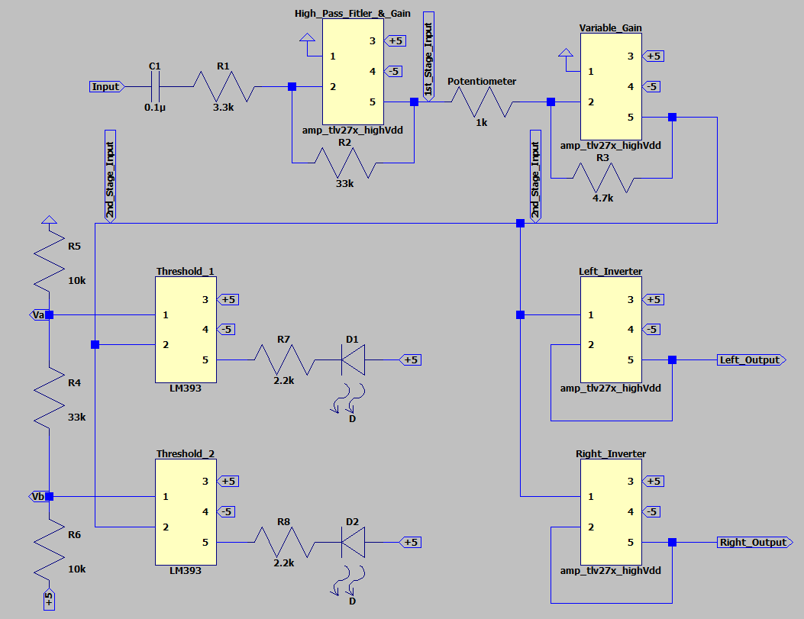Results

*Figure 5. Circuit Diagram*

*Table 1. Parts list*

|  |  |  |  |
| --- | --- | --- | --- |
| Parts | Values | Quantity | Price |
| Resistors | 2,200 Ω | 2 | $0.10 |
|  | 3,300 Ω | 1 | $0.10 |
|  | 4,700 Ω | 1 | $0.10 |
|  | 10,000 Ω | 2 | $0.10 |
|  | 33,000 Ω | 2 | $0.10 |
| Potentiometer |  | 1 | $0.85 |
| Capacitors | 0.1 µF | 1 | $0.16 |
| Op-amps, TLV272 |  | 2 | $1.33 |
| Comparators, LM393 |  | 1 | $0.45 |
| LEDs |  | 2 | $0.39 |
|  |  | Total Price: | $5.70 |

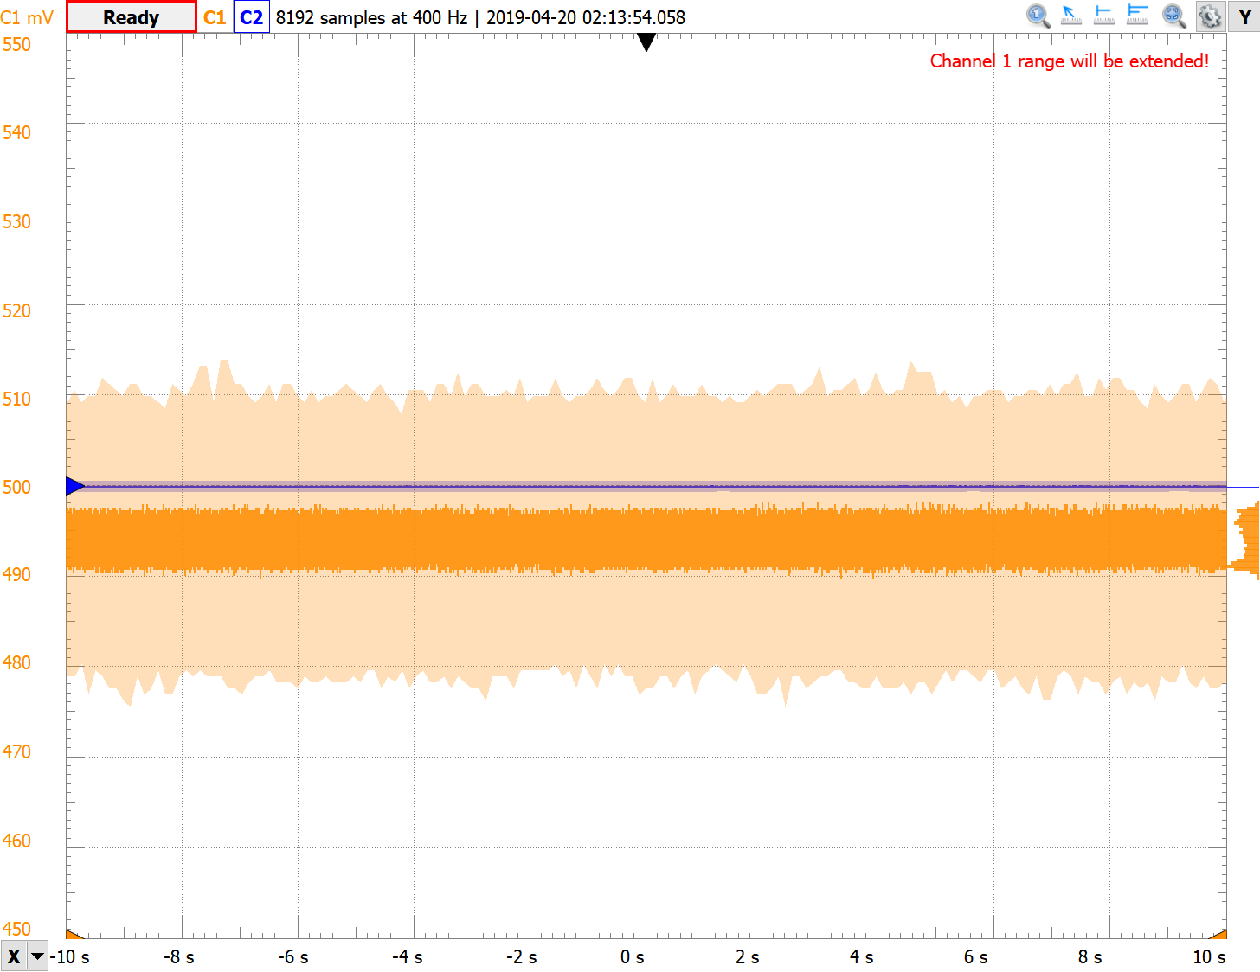*Figure 6. Input (orange) and Output of the Variable Gain Amplifier (blue)*

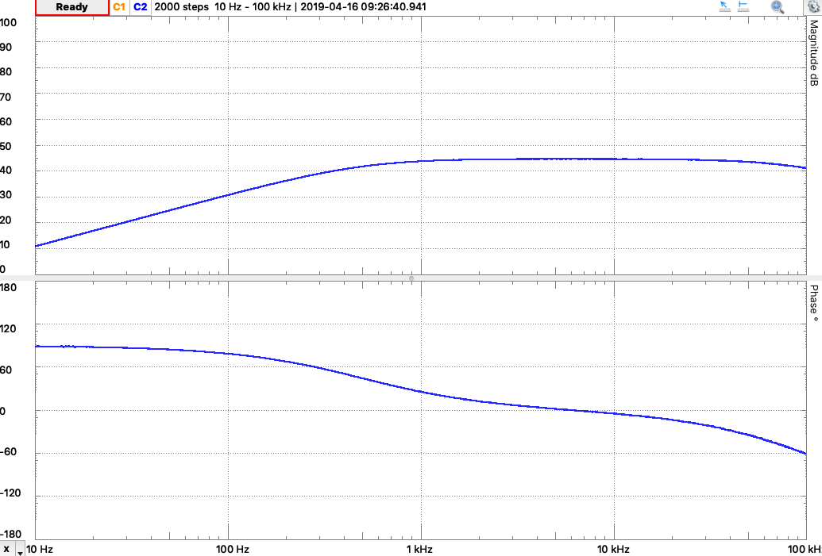

*Figure 7. Network Response of the Output of the Variable Gain Amplifier*

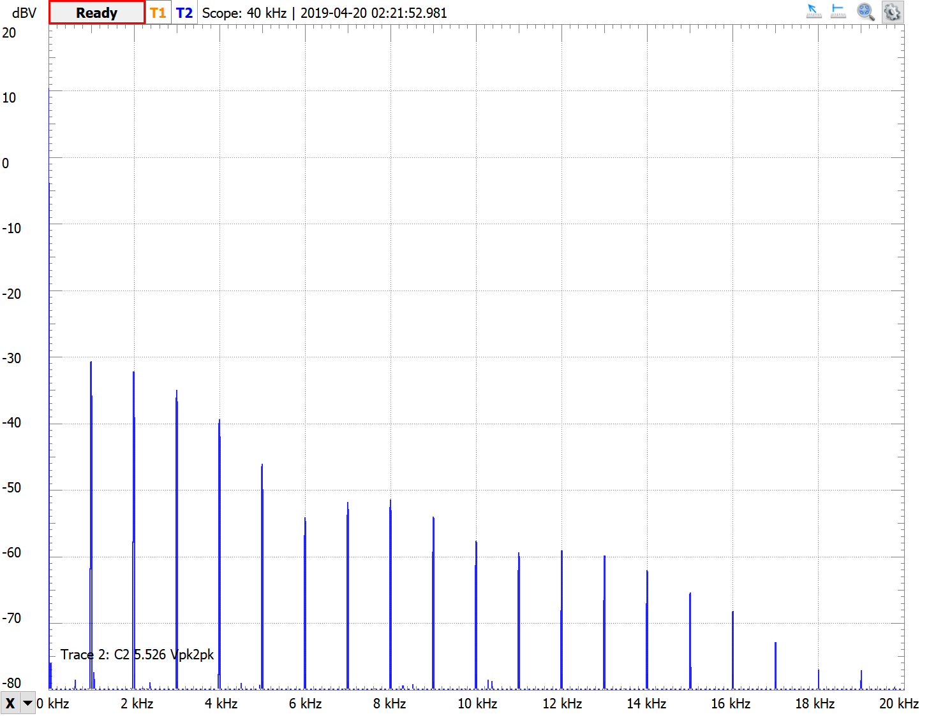

*Figure 8. Spectrum of the Output of the Variable Gain Amplifier*

Conclusion

The circuit we built is an audio amplifier which modifies the input to create a working output. The circuit consists of four parts, a high pass filter/gain amplifier, variable gain amplifier, peak detector, and output buffer. The filter removes the offset of the input, the gain amplifiers amplify the input, additionally allowing variation, the peak detectors detect if and input is present and if the input is clipping, and, finally, the output buffer buffers the input to be ready for the speakers. On the scope we can see how the input is being filtered to remove the offset. The network response shows a graph that resembles a high pass filter, which is what we are looking for. The spectrum graph shows the magnitude of the input sinusoidal wave with varying frequency. Due to the uncertainty factors that come with real-world circuit parts and breadboards we cannot expect ideal outcomes in certain situations. With more stable equipment, uncertainty and performance can be improved.