**Prelab**

Fran Luka Antoljak

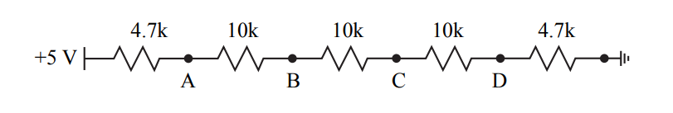3.5.1 - Resistor Ladders

|  |  |  |
| --- | --- | --- |
|  | *3.5.1* |  |
| Nodes | **Calculated Voltage [V]** | **Measured Voltage [V]** |
| A | 4.404 | 4.390 |
| B | 3.135 | 3.107 |
| C | 1.865 | 1.846 |
| D | 0.596 | 0.598 |

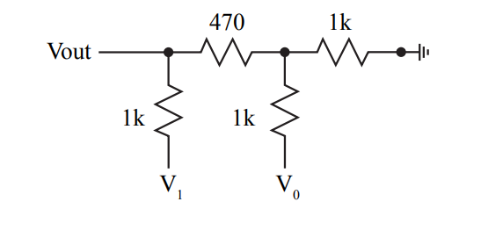3.5.2 - R-2R Ladder

|  |  |  |
| --- | --- | --- |
|  | *3.5.2* |  |
| Node V1, V0 [V] | **Calculated Voltage [V]** | **Measured Voltage [V]** |
| 0, 0 | 0.000 | -0.011 |
| 0, 5 | 1.269 | 1.253 |
| 5, 0 | 2.462 | 2.463 |
| 5, 5 | 3.731 | 3.727 |