**Lab 3**

**Introduction**

In this lab we explored the effect resistor tolerances on their actual, real-world resistance. In two different resistor ladders we got to see the effect of how the error in resistors changes the value of voltages at nodes.

**Discussion**

*3.6.1 Resistor Tolerances*

For *Figure 3.5*, we measured the actual values for each resistor in the resistor ladder. They are all within their promised 5% tolerance which was denoted by the gold band each one had. In this case, all of them had a smaller resistance than their theorical resistance.

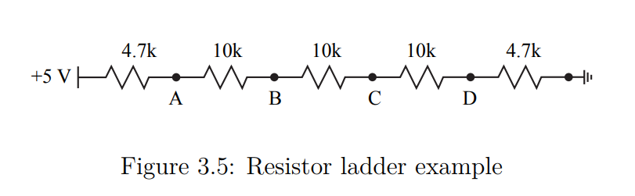

|  |  |
| --- | --- |
| Theoretical Resistance | Actual Resistance |
| 4,700 Ω [+5 V – Node A] | 4,600 Ω |
| 10,000 Ω [Node A – Node B] | 9,810 Ω |
| 10,000 Ω [Node B – Node C] | 9,770 Ω |
| 10,000 Ω [Node C – Node D] | 9,720 Ω |
| 4,700 Ω [Node D – GND] | 4,610 Ω |

*Table 1. Theoretical vs. Real-world resistor values for the resistors used in Figure 3.5*

In *Table 2*, we can see three values for the voltage at nodes A, B, C, and D; calculated with theoretical resistance, measured and calculated with actual resistor values, and an additional column for percent error.

*Table 2. Node voltages calculated with theoretical resistance, calculated and measured with actual resistance, and percent error between calculated and measured voltage*

|  |  |  |  |  |
| --- | --- | --- | --- | --- |
| Node | Theoretical Voltage | Calculated Voltage | Measured Voltage | Percent Error (δ) |
| A | 4.404 V | 4.403 V | 4.390 V | 0.2953% |
| B | 3.135 V | 3.129 V | 3.107 V | 0.7031% |
| C | 1.865 V | 1.861 V | 1.846 V | 0.8060% |
| D | 0.5964 V | 0.5985 V | 0.5980 V | 0.0835% |

The node voltages were solved using a system of equations.

$$\frac{V_{A}-5}{4,600}+\frac{V_{A}-V_{B}}{9,810}=0$$

$$\frac{V_{B}-V_{A}}{9,810}+\frac{V_{B}-V_{C}}{9,770}=0$$

$$\frac{V_{C}-V_{B}}{9,770}+\frac{V_{C}-V_{D}}{9,720}=0$$

$$\frac{V_{D}-V_{C}}{9,720}+\frac{V_{D}}{4,610}=0$$

And the percent error was calculated using the formula:

$$δ=\left|\frac{Theoretical-Experimental}{Theoretical}\right|*100\%$$

From *Table 2* we can see that the theoretical voltage is higher than the measured voltage, with an exception at node D; this is the effect of resistor tolerance. That is because in the system of equations the relation between resistance and voltage is inverse proportional, the higher the resistance, the lower the voltage, and vice versa. The reason for the exception at node D is because of the final fraction in which it is alone in the numerator, which creates a specific case for it when using different resistance values. Furthermore, we can see that each measured voltage is lower than its calculated pair. Because of many imperfections of real-life circuits, such as imperfect wires or not exact voltage sources, the measured voltage differs from the calculated voltage. Finally, we see that the percent error for each measurement is extremely low, all of them fall under 1%.

For *Figure 3.6*, we measured the actual values for each resistor in another resistor ladder.

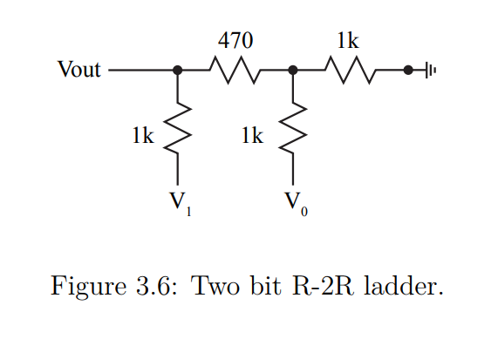

V­x

*Table 3. Theoretical vs. Real-world resistor values for the resistors used in Figure 3.6*

|  |  |
| --- | --- |
| Theoretical Resistance | Actual Resistance |
| 470 Ω [V­out - Vx] | 464Ω |
| 1,000 Ω [Vx - GND] | 979 Ω |
| 1,000 Ω [V0 - Vx] | 977 Ω |
| 1,000 Ω [V1­ – V­out] | 977 Ω |

In *Table 4*, we can see three values for the voltage at Vout when V1 and V0 are 0 V and 0 V, 0 V and 5 V, 5 V and 0 V, and 5 V and 5 V, respectively; calculated with theoretical resistance, measured and calculated with actual resistor values, and an additional column for percent error.

*Table 4. Node voltages calculated with theoretical resistance, calculated and measured with actual resistance, and percent error between calculated and measured voltage*

|  |  |  |  |  |
| --- | --- | --- | --- | --- |
| V1, V0 | Theoretical Voltage | Calculated Voltage | Measured Voltage | Percent Error (δ) |
| 0 V, 0 V | 0.000 V | 0.000 V | -0.01129 V | N/A |
| 0 V, 5 V | 1.269 V | 1.267 V | 1.253 V | 1.105% |
| 5 V, 0 V | 2.462 V | 2.469 V | 2.463 V | 0.2430% |
| 5 V, 5 V | 3.731 V | 3.736 V | 3.727 V | 0.2409% |

The voltage at Vout was solved using a system of equations.

$$\frac{V_{x}-V_{out}}{464}+\frac{V_{x}-V_{0}}{977}+\frac{V_{x}}{979}=0$$

$$\frac{V_{out}-V_{1}}{977}+\frac{V_{out}-V_{x}}{464}=0$$

In this system of equations, we are not interested in what Vx is, only V­out. Also, the values for V0 and V1 change based on the combination selected, (0/0, 0/5 etc.)

From *Table 4* we can see that the theoretical and calculated voltages are almost equal and follow no trend. They are equal in when V1 and V0 are 0 V and 0 V, theoretical is larger than calculated when V1 and V0 are 0 V and 5 V, and calculated is larger than theoretical when V1 and V0 are 5 V and 0 V, and 5 V and 5 V. Since the second circuit is more complex than the first, no real conclusion can be concluded from the effect of tolerance unlike the first linear ladder. Similarly, in *Table 2*, the measured voltage values in *Table 4* are all lower than their calculated counterpart because of real-world imperfections that affect the circuit. Finally, the percent errors are relatively low, <1.2%, however the error for the first row cannot be easily calculated using the percent error formula due to dividing by 0. Taking the limit to 0 would not work, as it would result in an error of ∞%.

**Conclusion**

In this lab we got to see how tolerance affect two different resistor ladders, in a simple linear resistor ladder the relation is clearer than when taking a more complex circuit such as the one in *Figure 3.6*. Due to the resistors having less resistance than promised, the voltage for the first circuit was larger at every node expect node D, because of node D’s standalone fraction due to the right resistor being connected to ground. However, in the second circuit no clear pattern could have been concluded as the theoretical and calculated values switch in relative sizes. For the measured voltage, it was always lower than the calculated voltage because of imperfections in real-world circuits such as faulty wires or unbalanced voltage sources; additionally, the percent error in each case was reasonable as they were all below 1.2%.