Prelab 4

Fran Luka Antoljak

4.4.1 Simulating a Controlled Source

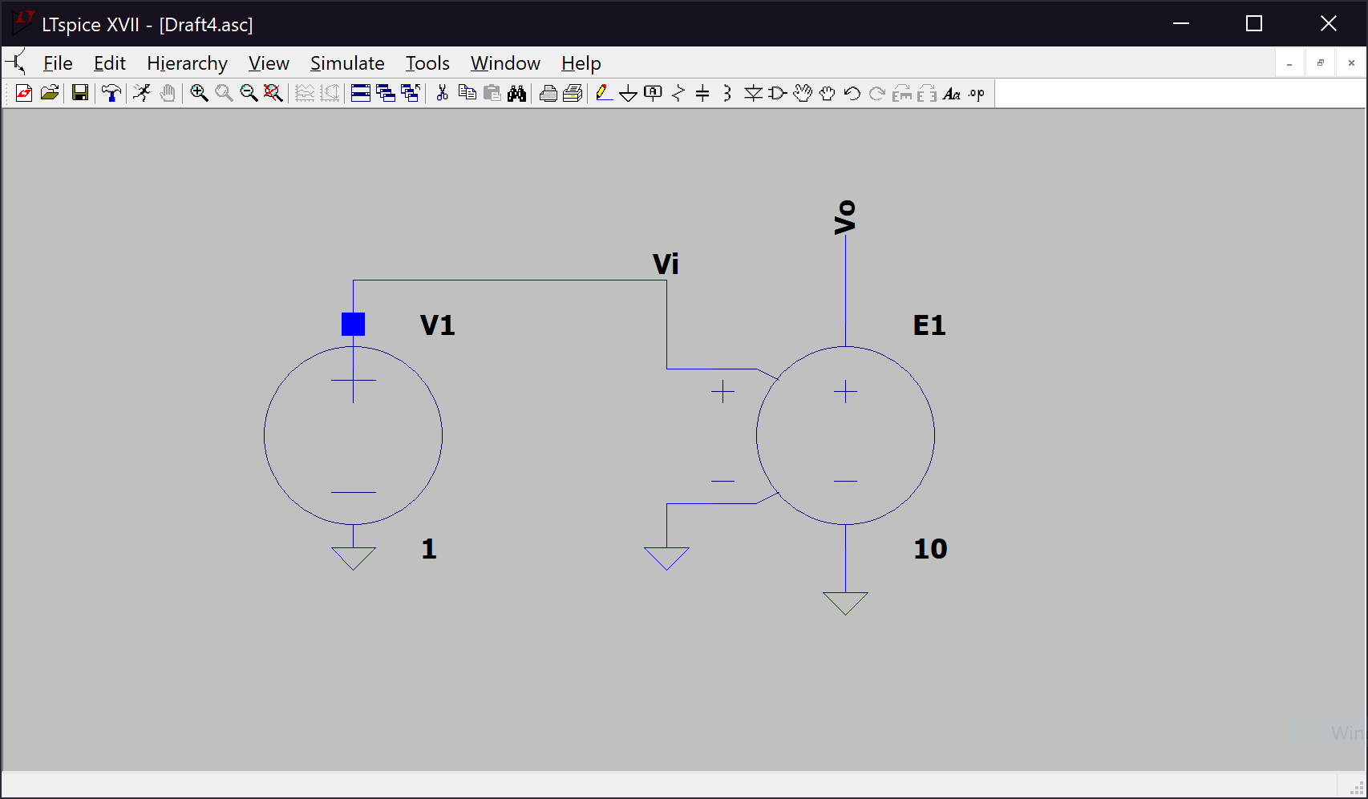a)

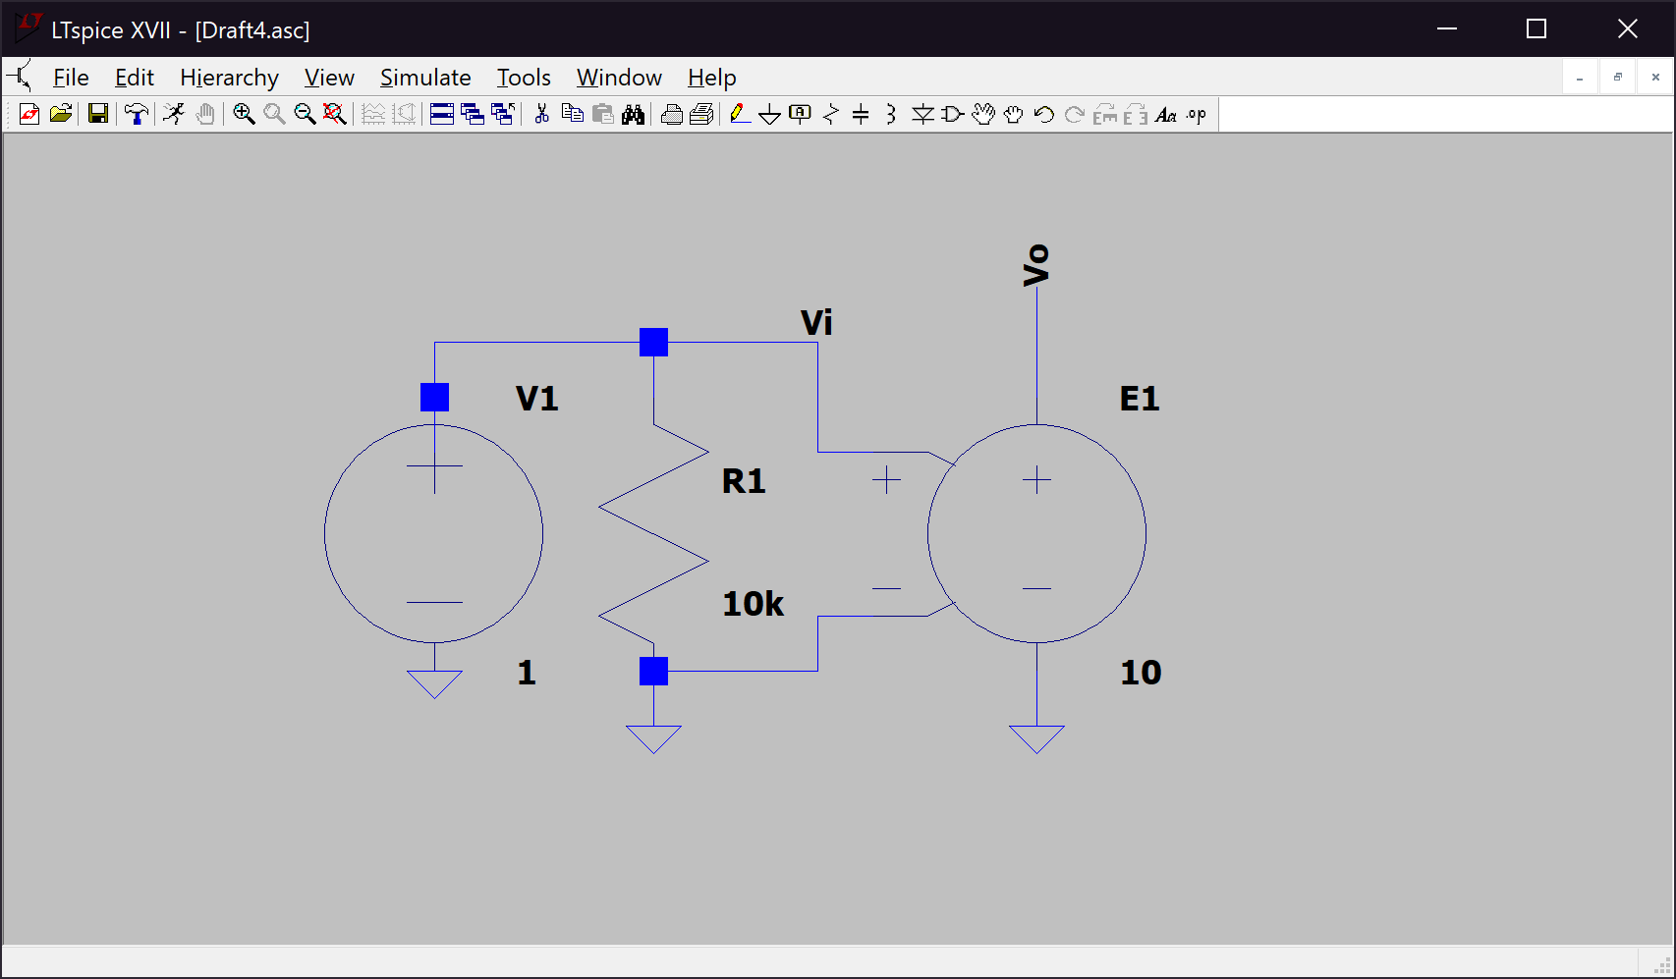b)

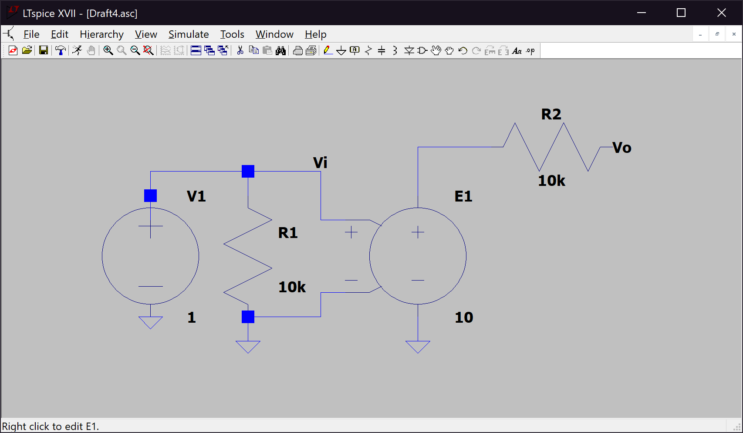c)

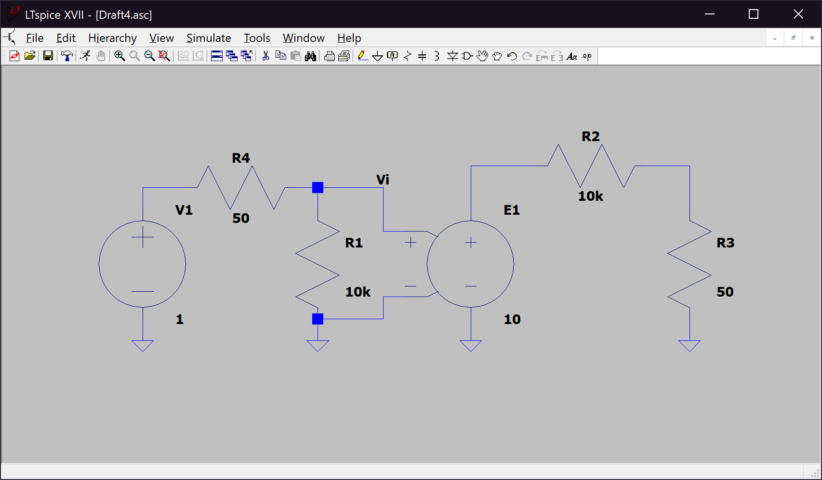d)

|  |  |  |
| --- | --- | --- |
| 4.4.1 | Vo | Vi |
| a) | 10 V | 1 V |
| b) | 10 V | 1 V |
| c) | 10 V | 1 V |
| d) | 0.0495037 V | 0.99502 V |

Best Ri value: 1Meg Ω

Best Ro value: 0.1 Ω

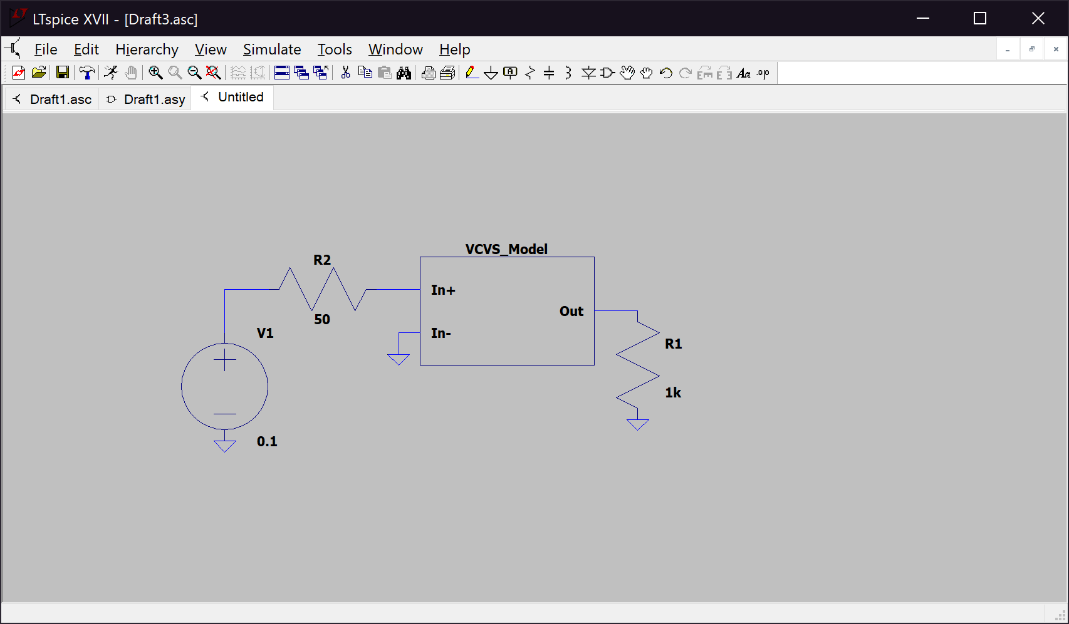4.4.2 Monte Carlo SimulationsCircuit:

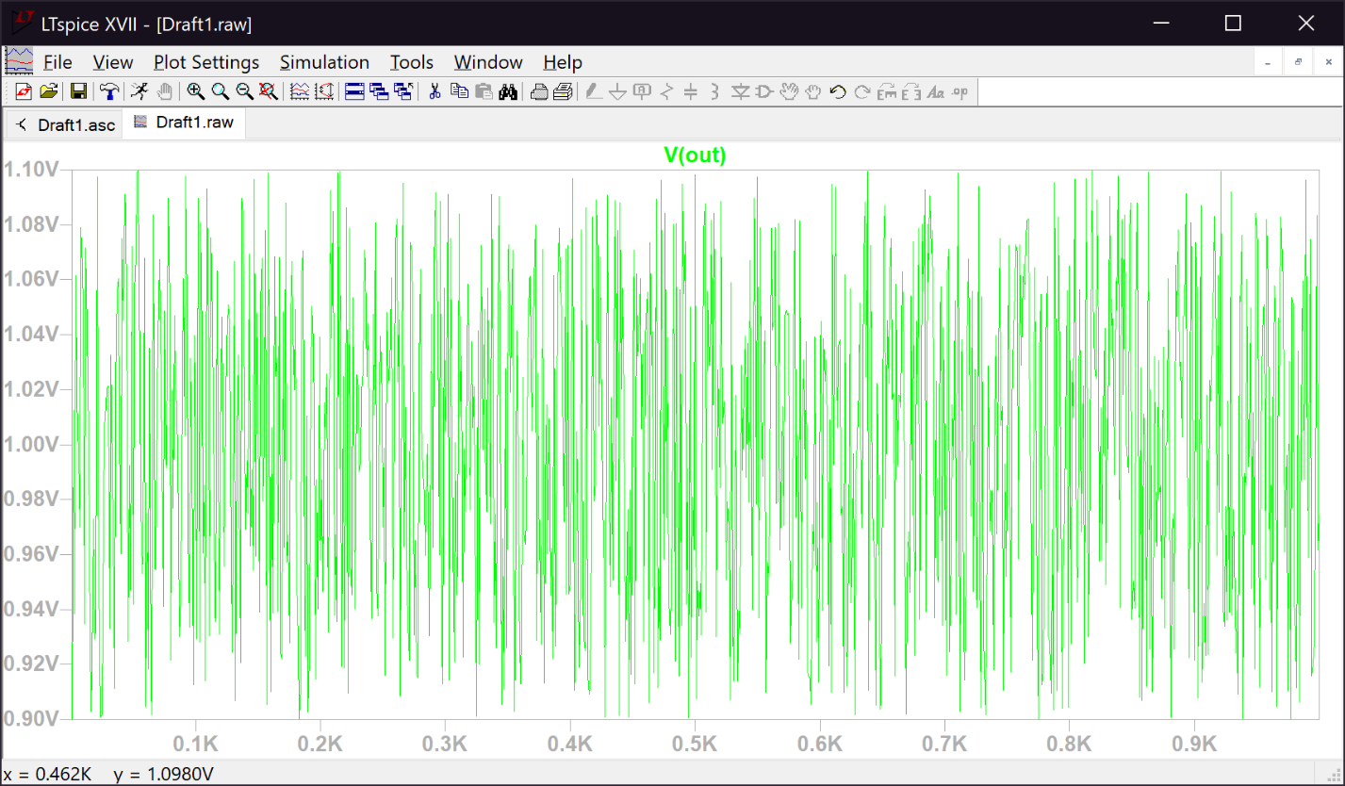Monte Carlo simulation for gain, E:

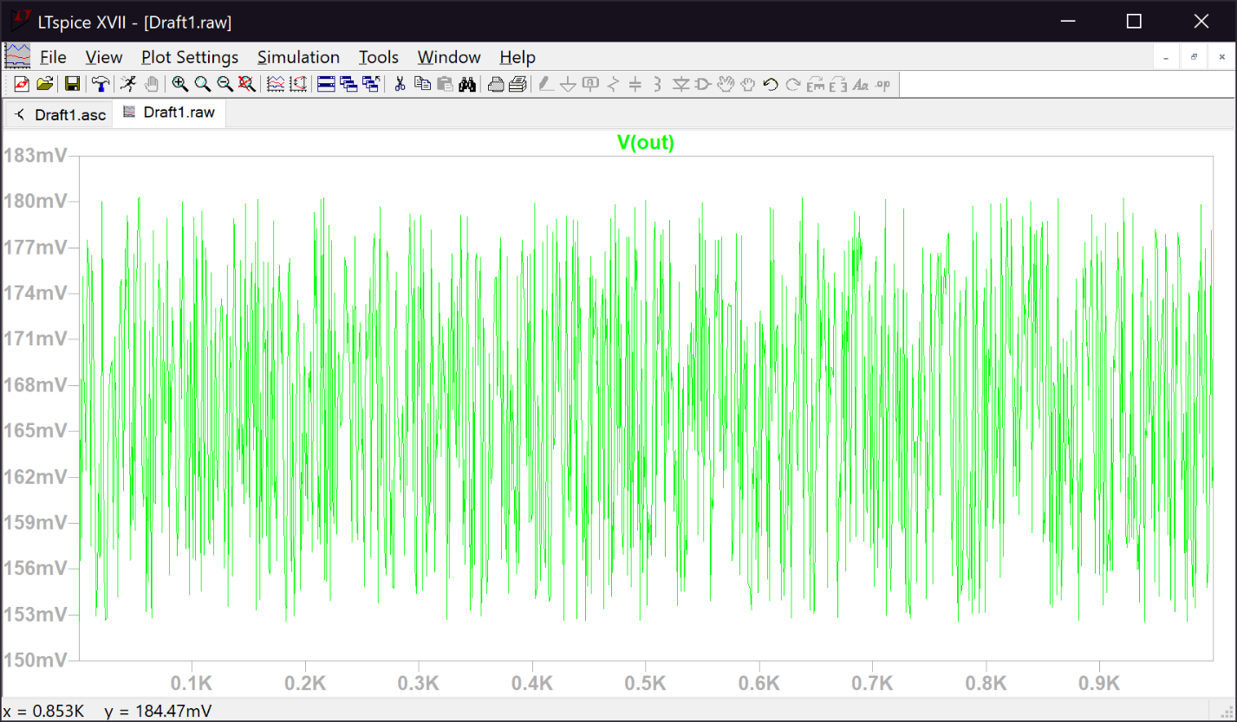Monte Carlo Simulation for input resistance, Ri:

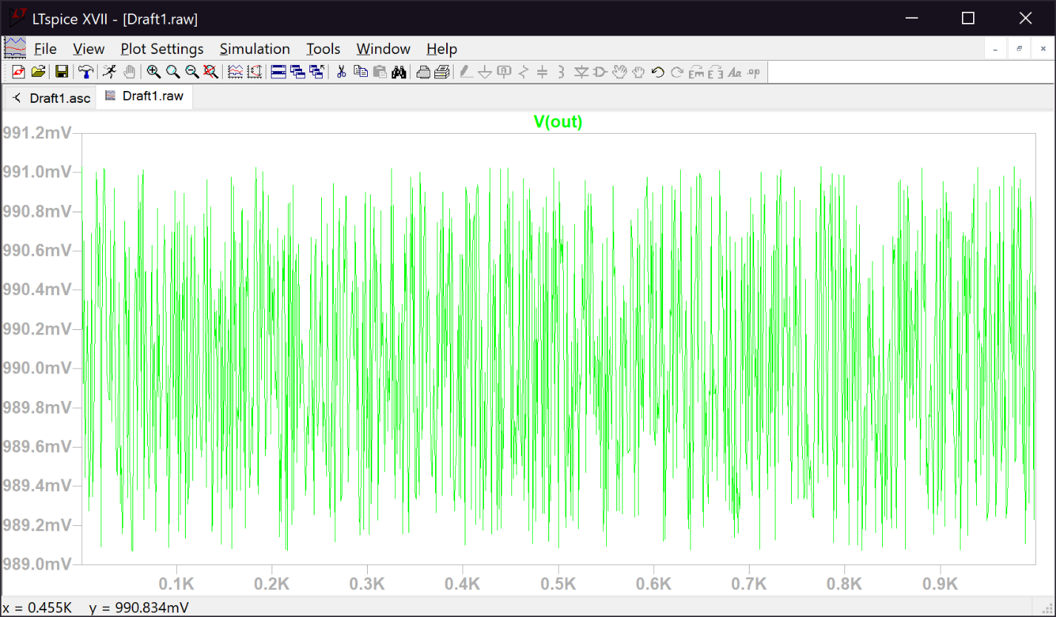Monte Carlo simulation for output resistance, Ro:

4.4.3 Feedback

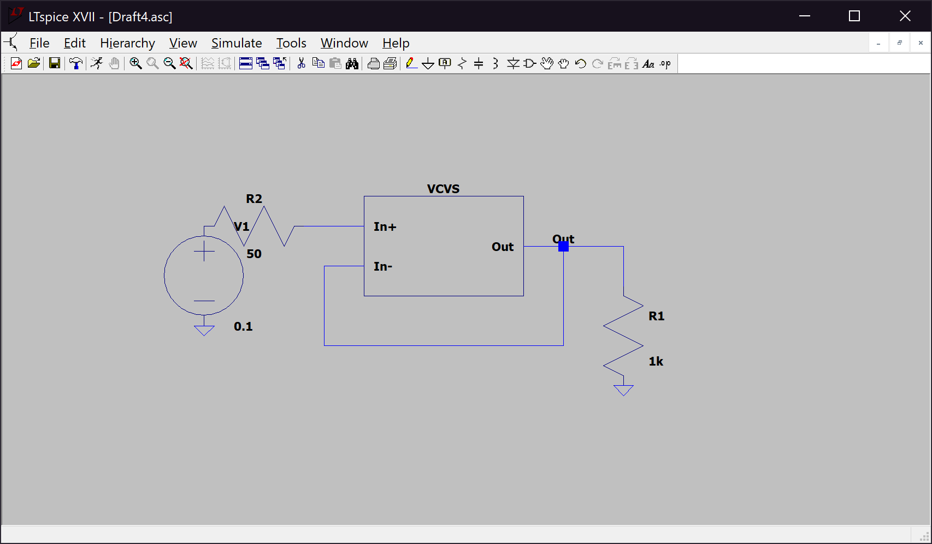Monte Carlo simulation for figure b):

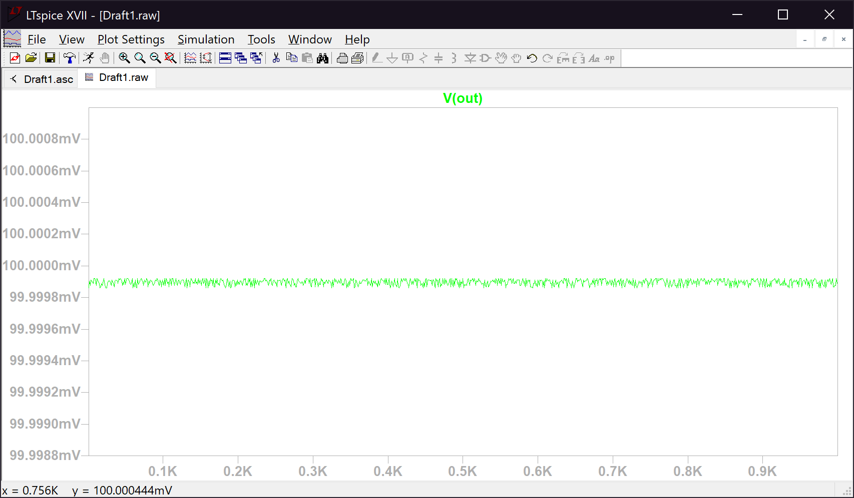

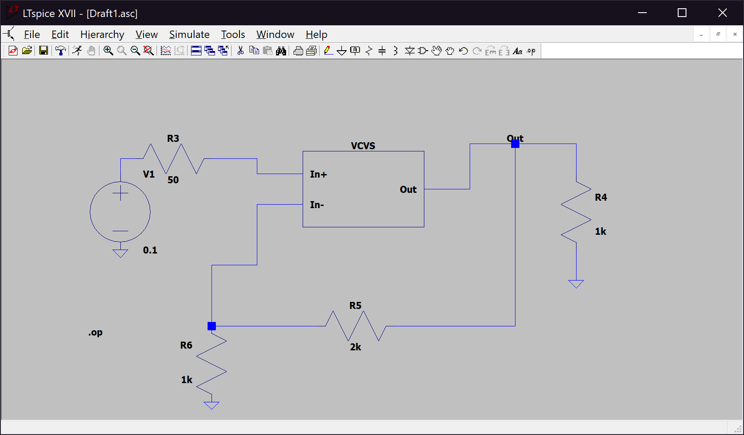Monte Carlo simulation for figure c):

