**Lab 4**

**Introduction**

In this lab we explored the effect of resistor tolerance when dealing with op amps. We researched the worst-case scenarios of the output voltage by testing the various extremes of resistors within their tolerance. Additionally, we explored the relation between tolerance and resistor price.

**Discussion**

*4.5.1 Worst Case Analysis*

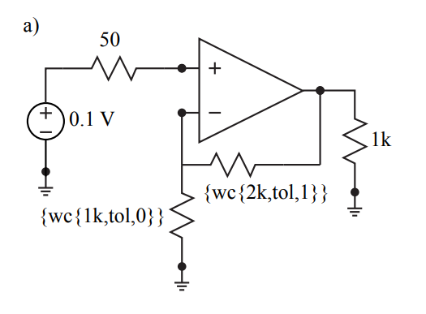

R3

R2

*Figure 1. Non-inverting configuration with the necessary resistor values for a worst-case simulation*

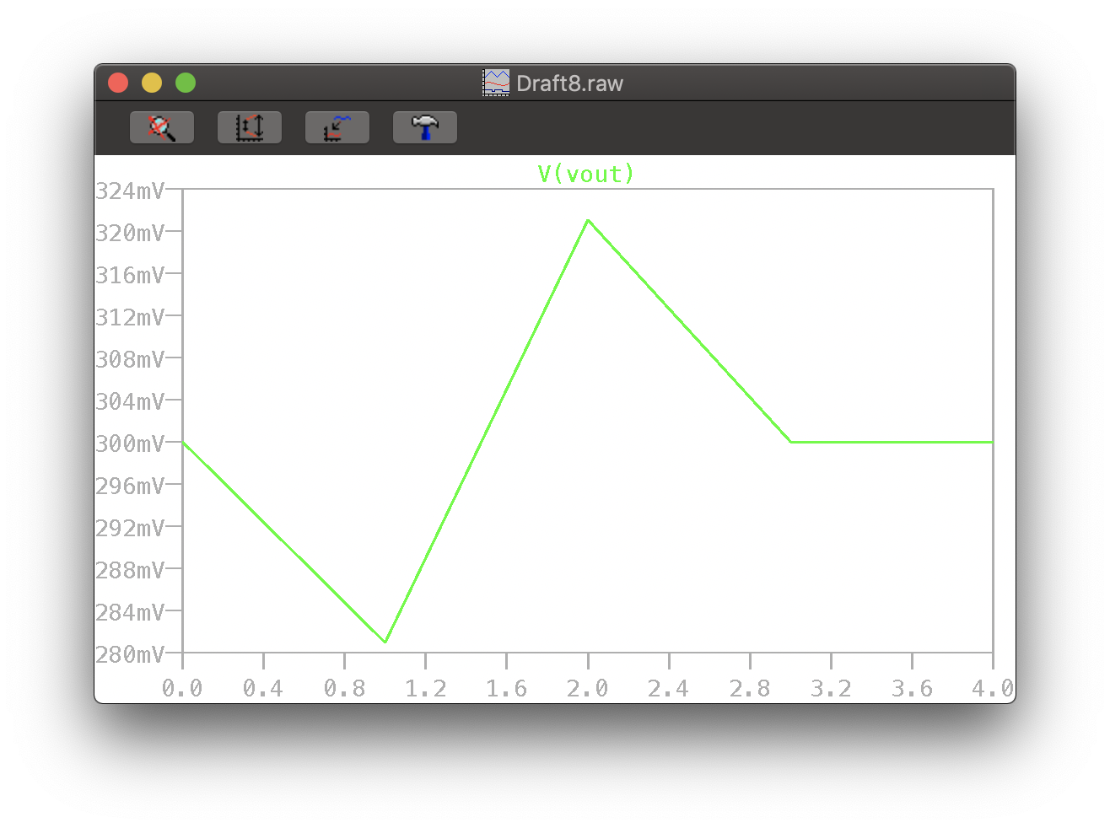

*Figure 2. Output voltage plot for a 5% tolerance for Figure 1*

*Table 1. The highest and lowest output voltage cases for Figure 1*

|  |  |
| --- | --- |
| Tolerance | 0.05 |
| Voltage max | 321.05 mV |
| Voltage min | 280.95 mV |

*Table 2. Output voltage range for different resistor tolerances for Figure 1*

|  |  |  |  |  |  |
| --- | --- | --- | --- | --- | --- |
| Tolerance | 0.01 | 0.005 | 0.001 | 0.0005 | 0.0001 |
| Voltage max | 304.04 mV | 302.01 mV | 300.40 mV | 300.20 mV | 300.04 mV |
| Voltage min | 296.04 mV | 298.01 mV | 299.60 mV | 299.80 mV | 299.96 mV |

We can see from *Figure 1* how the voltage changes when the extremes of the resistance changes. The 1,000 Ω resistor’s range is 950 Ω to 1050 Ω, and the 2,000 Ω resistor’s range is 1900 Ω to 2100 Ω. From *Table 2* we can see that with lower tolerance the less difference there is between the maximum and minimum voltage which is to be expected as lower tolerance means lower resistor error.

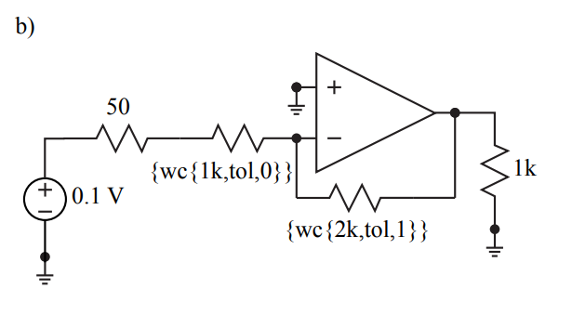*Figure 3. Inverting configuration with the necessary resistor values for a worst-case simulation*

R3

R2

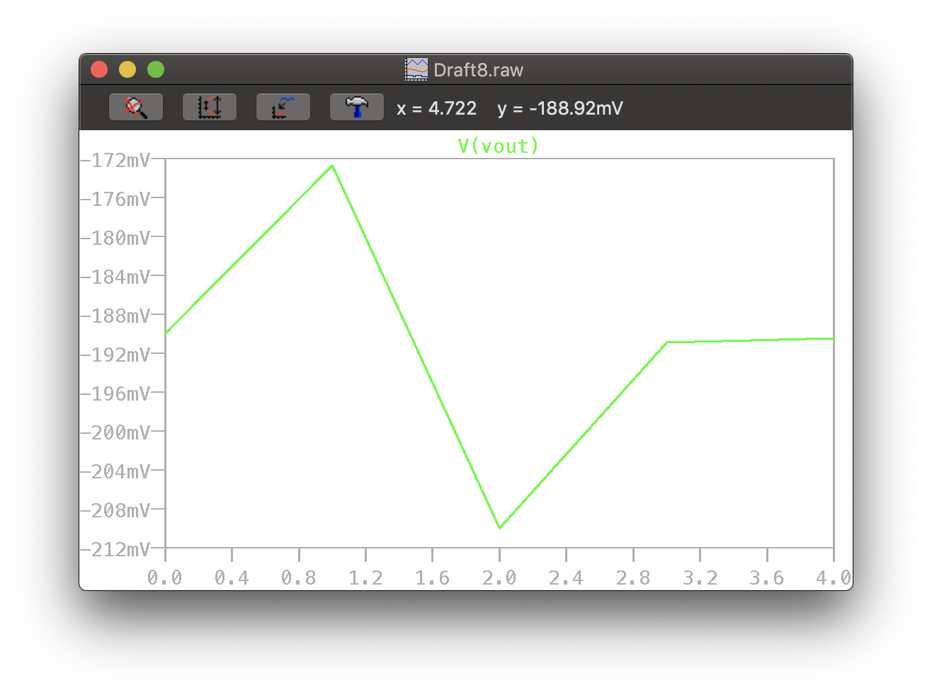

*Figure 4. Output voltage plot for a 5% tolerance for Figure 3*

*Table 3. The highest and lowest output voltage cases for Figure 3*

|  |  |
| --- | --- |
| Tolerance | 0.05 |
| Voltage max | -172.73 mV |
| Voltage min | -209.99 mV |

*Table 4. Output voltage range for different resistor tolerances for Figure 3*

|  |  |  |  |  |  |  |
| --- | --- | --- | --- | --- | --- | --- |
| Tolerance | 0.05 | 0.01 | 0.005 | 0.001 | 0.0005 | 0.0001 |
| Voltage max | -172.73 mV | -186.79 mV | -188.63 mV | -190.10 mV | -190.29 mV | -190.44 mV |
| Voltage min | -209.99 mV | -194.23 mV | -192.34 mV | -190.85 mV | -190.66 mV | -190.51 mV |

We have a similar conclusion for *Figure 3* as we do for *Figure 1*, the lower the tolerance, the more precise.

*Table 5. Pricing for different resistor tolerances.*

|  |  |  |
| --- | --- | --- |
| Tolerance | Max Price | Min Price |
| 5% | $0.65 | $0.10 |
| 1% | $7.68 | $0.10 |
| 0.5% | $0.66 | $0.11 |
| 0.1% | $9.01 | $0.36 |
| 0.05% | $4.27 | $0.77 |
| 0.01% | $22.90 | $2.15 |

To no surprise, resistors with lower tolerance, meaning more precise, are more expensive than resistors with higher tolerance. This is because lower tolerance allows for more precise measurements and gives a circuit environment close to ideal.

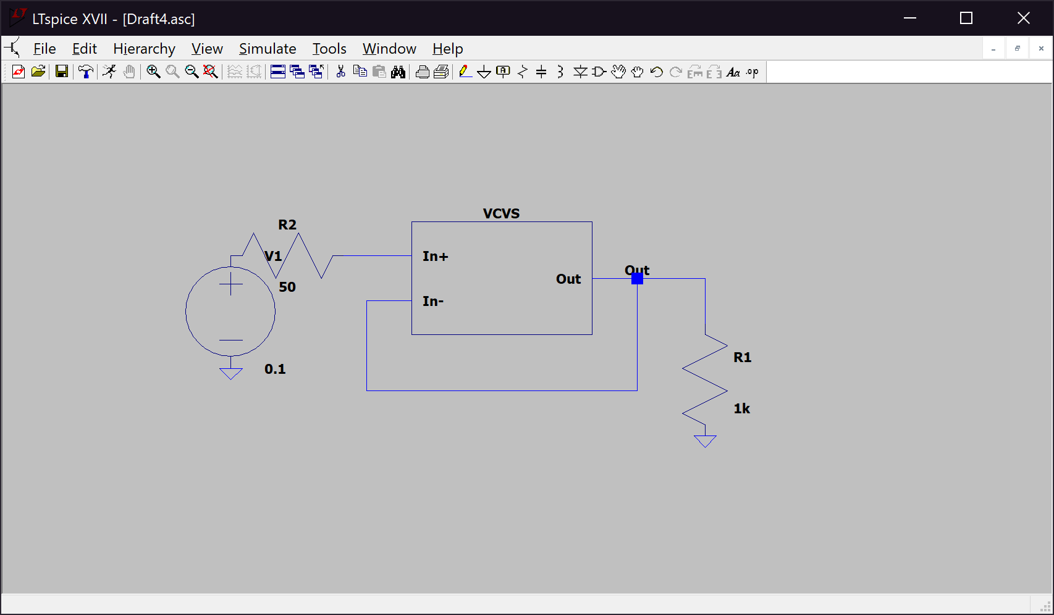*Figure 5. Unity gain configuration*

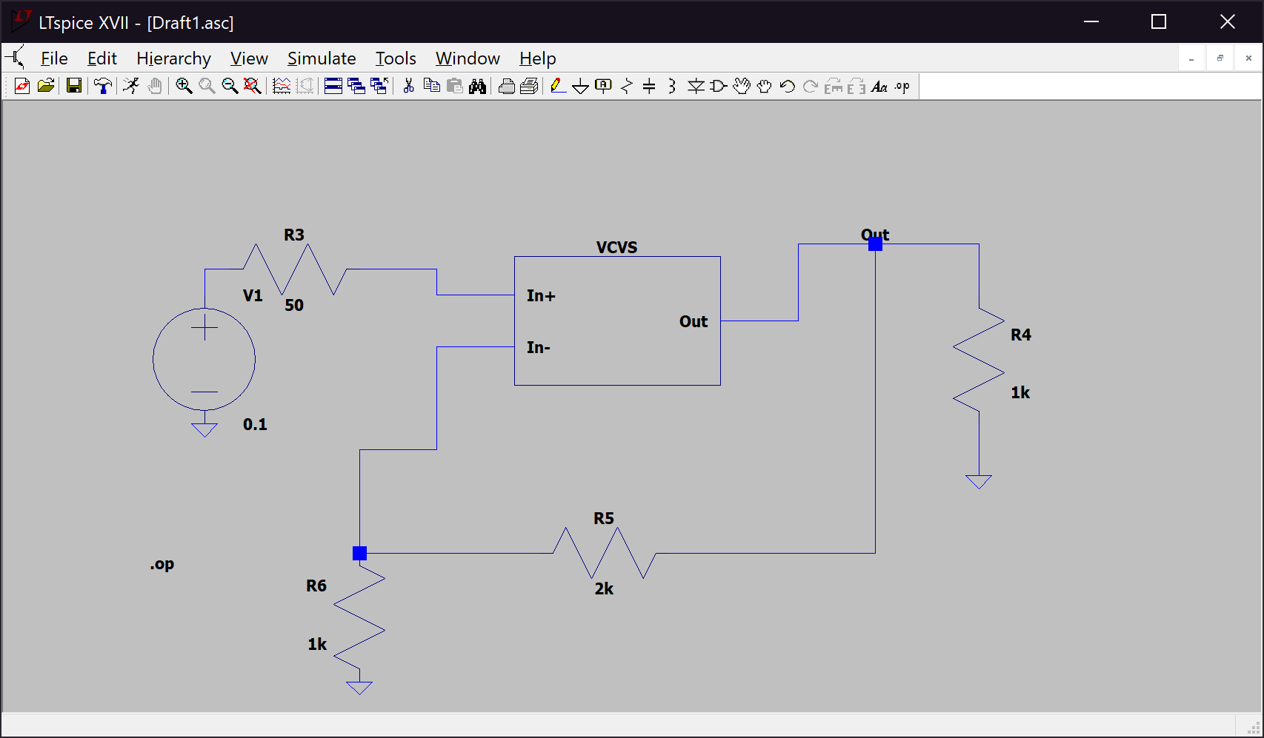

*Figure 6. N*on-inverting gain configuration

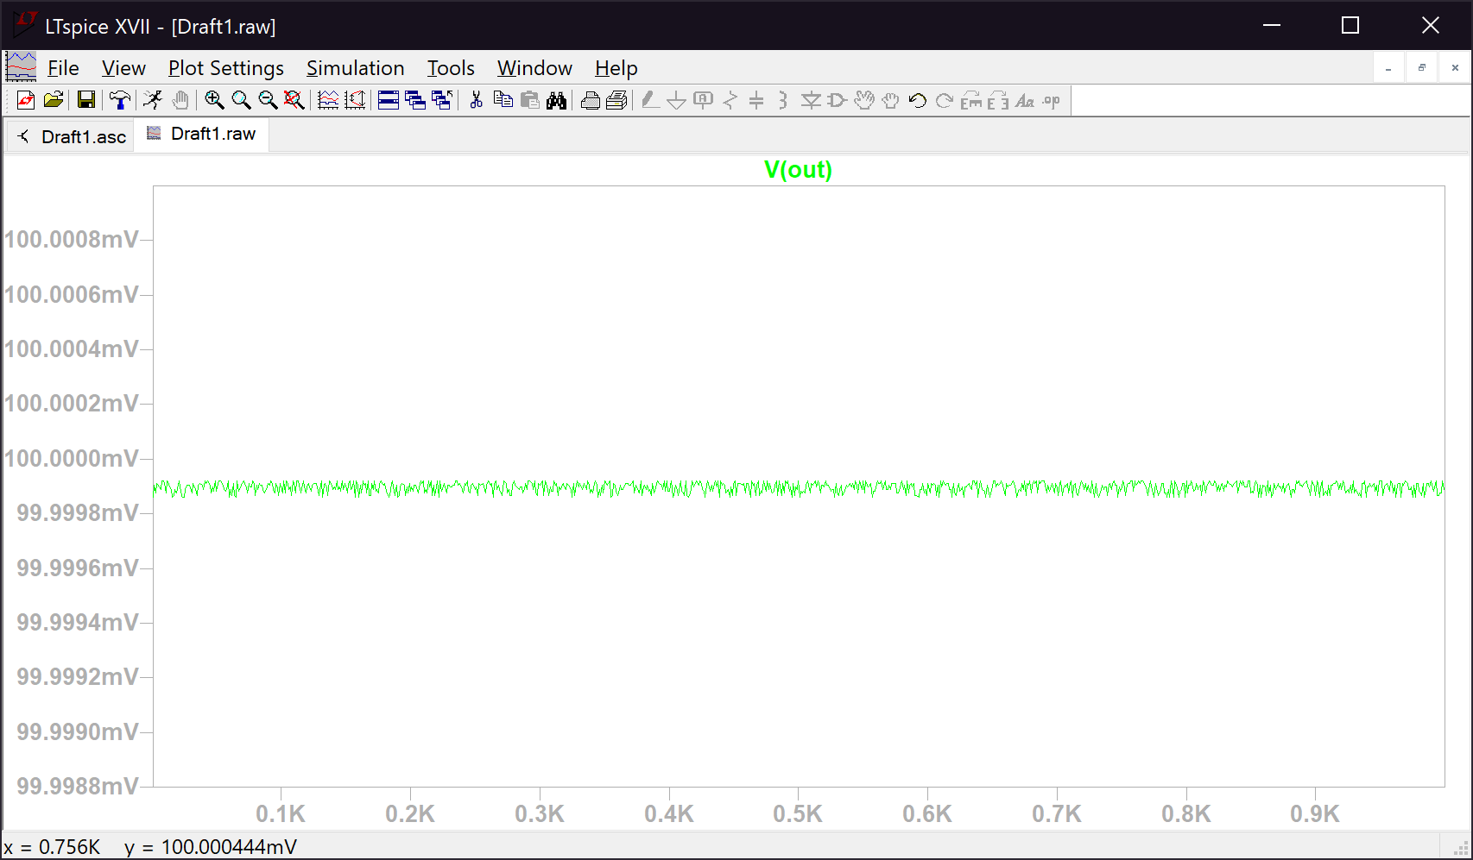*Figure 7. Output voltage plot for Figure 5*

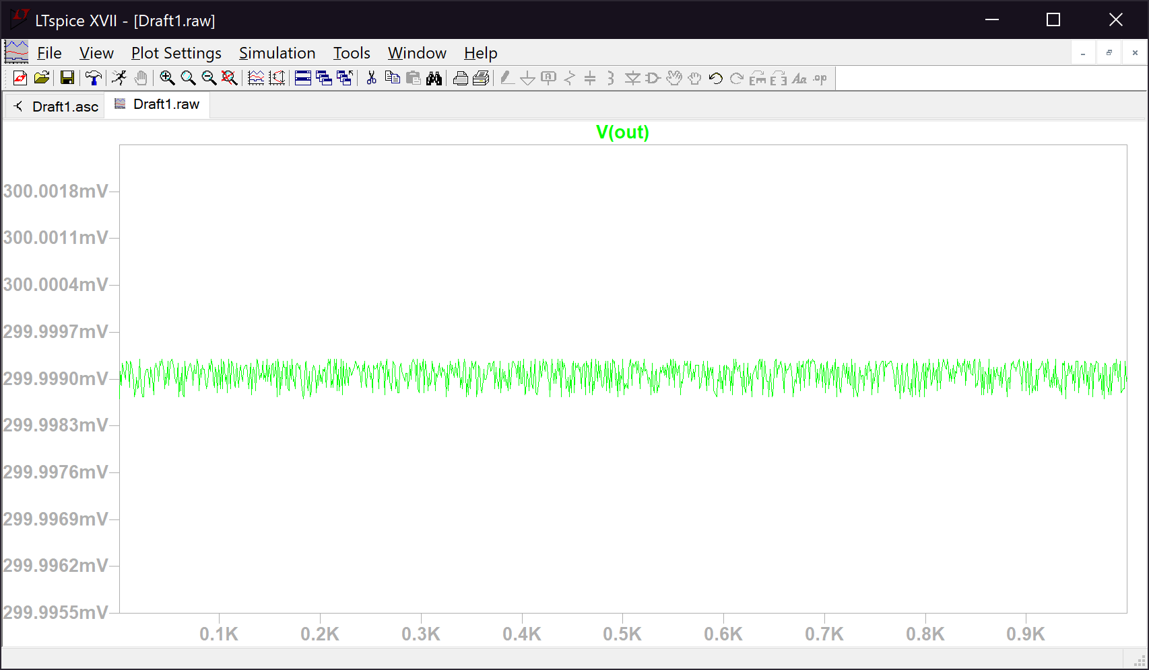

*Figure 8. Output voltage plot for Figure 6*

Negative feedback greatly improves the functionality of the op amp. Voltage gain stabilizes with negative feedback which we can see in *Figure 7* and *Figure 8*. When the feedback route is simply a wire, we equate Vin and Vout and the difference between the maximum and minimum voltage is insignificantly small. However, when the route is crowded with a couple of resistors than a difference occurs. Such as in *Figure 6*, the output voltage is not equal to its input and its range of values are visible larger than those *Figure 5*.

In *Figure 1*, the lowest output voltages were achieved when R2 was the largest in its tolerance range (i.e. 1050 Ω) and R3 was the smallest (i.e. 1900 Ω). This applies vice versa, the highest output voltages were achieved when R2 was the smallest in its tolerance range (i.e. 950 Ω) and R3 was the largest (i.e. 2100 Ω). In *Figure 3* it is just the opposite when R2 is its lowest (i.e. 950 Ω) and R3 is its highest (i.e. 2100 Ω) then the output voltage is the lowest, and when R2 is its highest (i.e. 1050 Ω) and R3 is its lowest (i.e. 1900 Ω) then the output voltage is the highest.

**Conclusion**

We concluded that feedback in an op amp circuit is very beneficial when measuring voltage; it produces more accurate readings. When looking at inverting and non-inverting setups, the worst-case voltage values happen when the resistors are at opposite sides of their tolerance ranges, i.e. R2 is 5% above its nominal values and R3 is 5% below is nominal value. For the inverting setup, the maximum voltage happened with R2 was minimum resistance and R3 was maximum resistance, while for the non-inverting setup it was just the opposite, R2 was maximum resistance and R3 was minimum resistance; to read the minimum voltage just flip the minimum/maximums of R2 and R3. Finally, we saw the correlation between tolerance and price, with lower tolerance the price rises because lower tolerance means lower resistance error making for more precise readings.