Prelab 4

Fran Luka Antoljak

5.5.1 LTspice TLV272 Op Amp Model

*Table 1. Tabled values for 5.5.1*

|  |  |
| --- | --- |
| *5.5.1* |  |
| Offset Voltage | -0.000280429 V |
| Time taken to reach 1 V | 3.23948 µs |
| Slew rate | 0.30869 V/µs |
| Max value of V­­out | 5 V |
| Min value of Vmin | -5 V |
| -Vout/Vin | 10.028126 |

Slew rate was calculated by the formula:

$$Slew rate=\frac{1 V}{3.23948 μs}=0.30869 \frac{V}{μs}$$

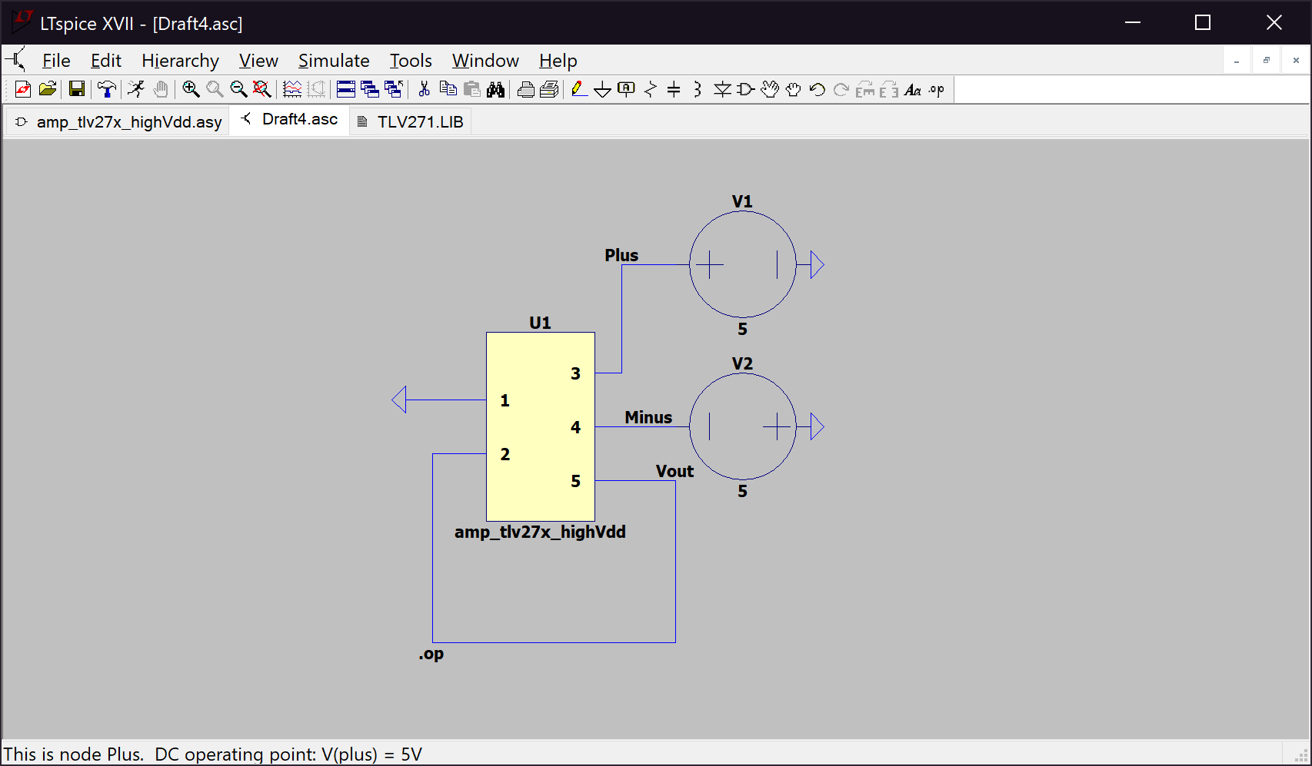

*Figure 1. Measuring Offset Voltage*

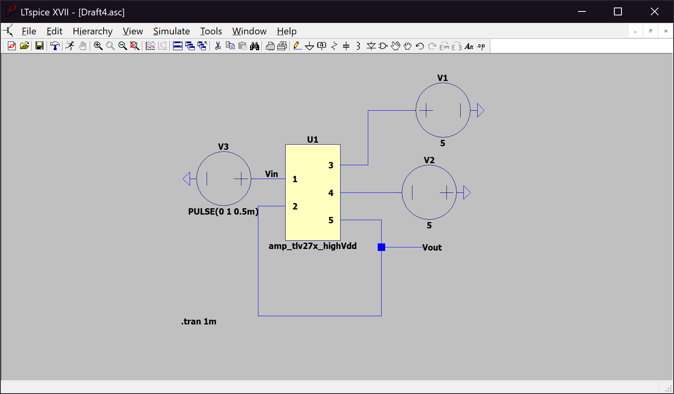*Figure 2. Circuit for step 5*

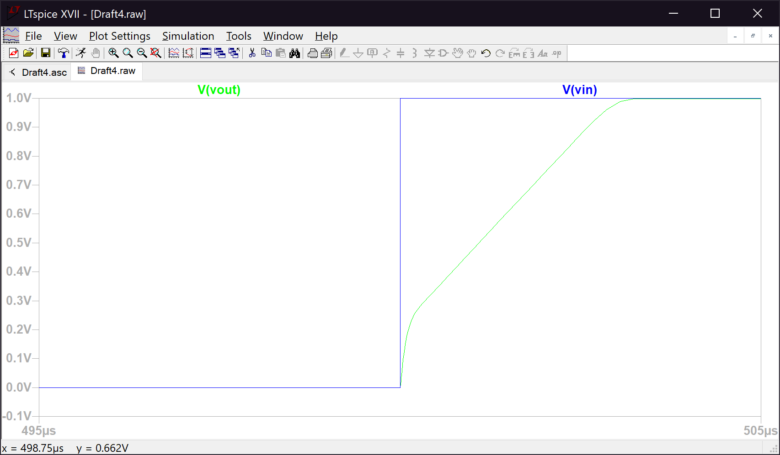

*Figure 3. Graph for step 5*

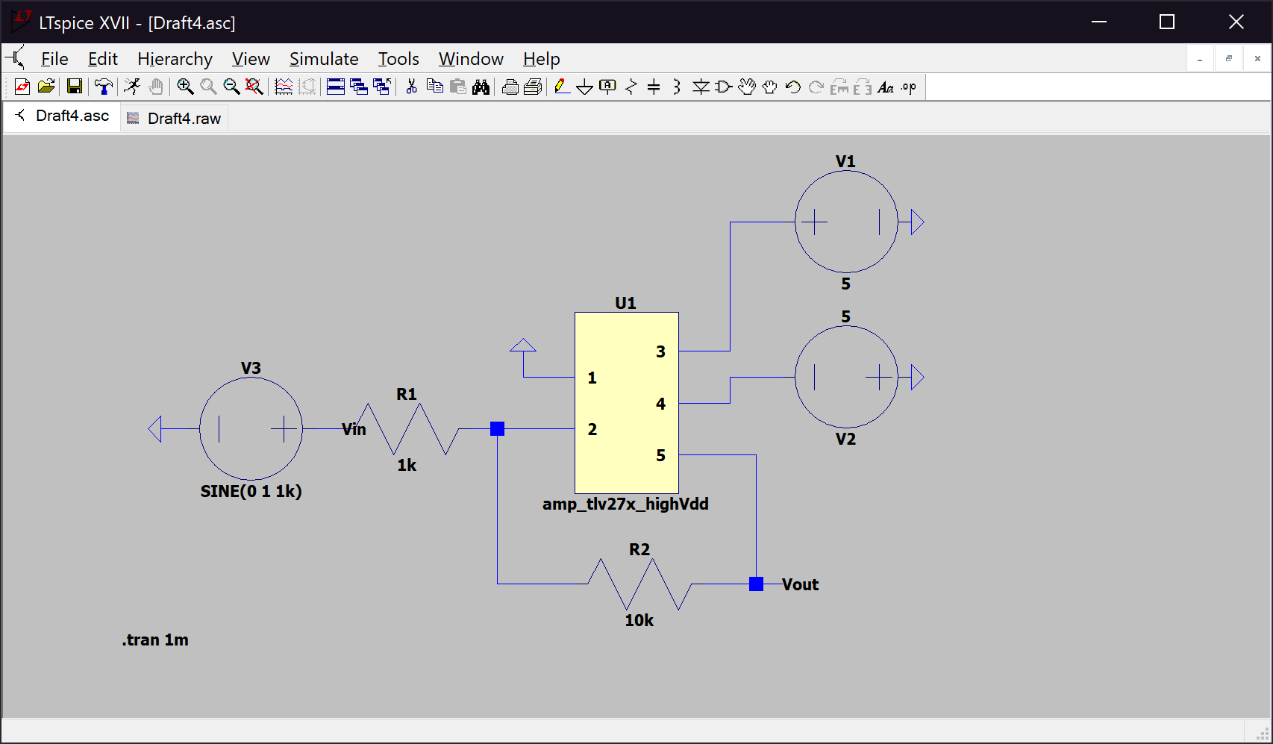*Figure 4. Circuit for step 6*

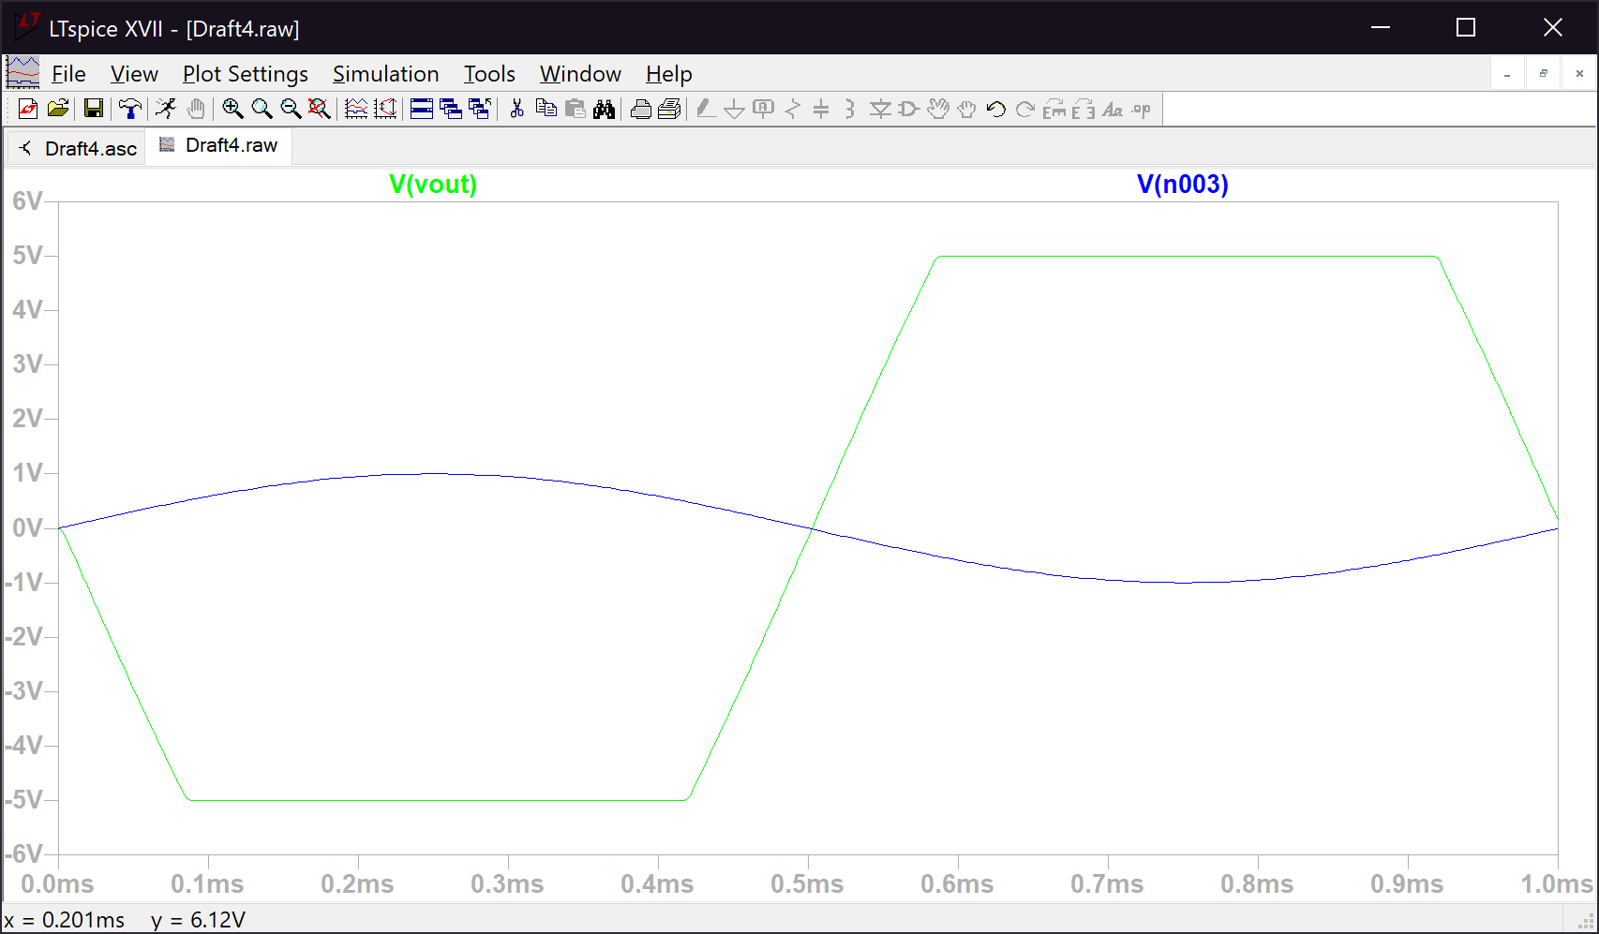

*Figure 5. Graph for step 6*

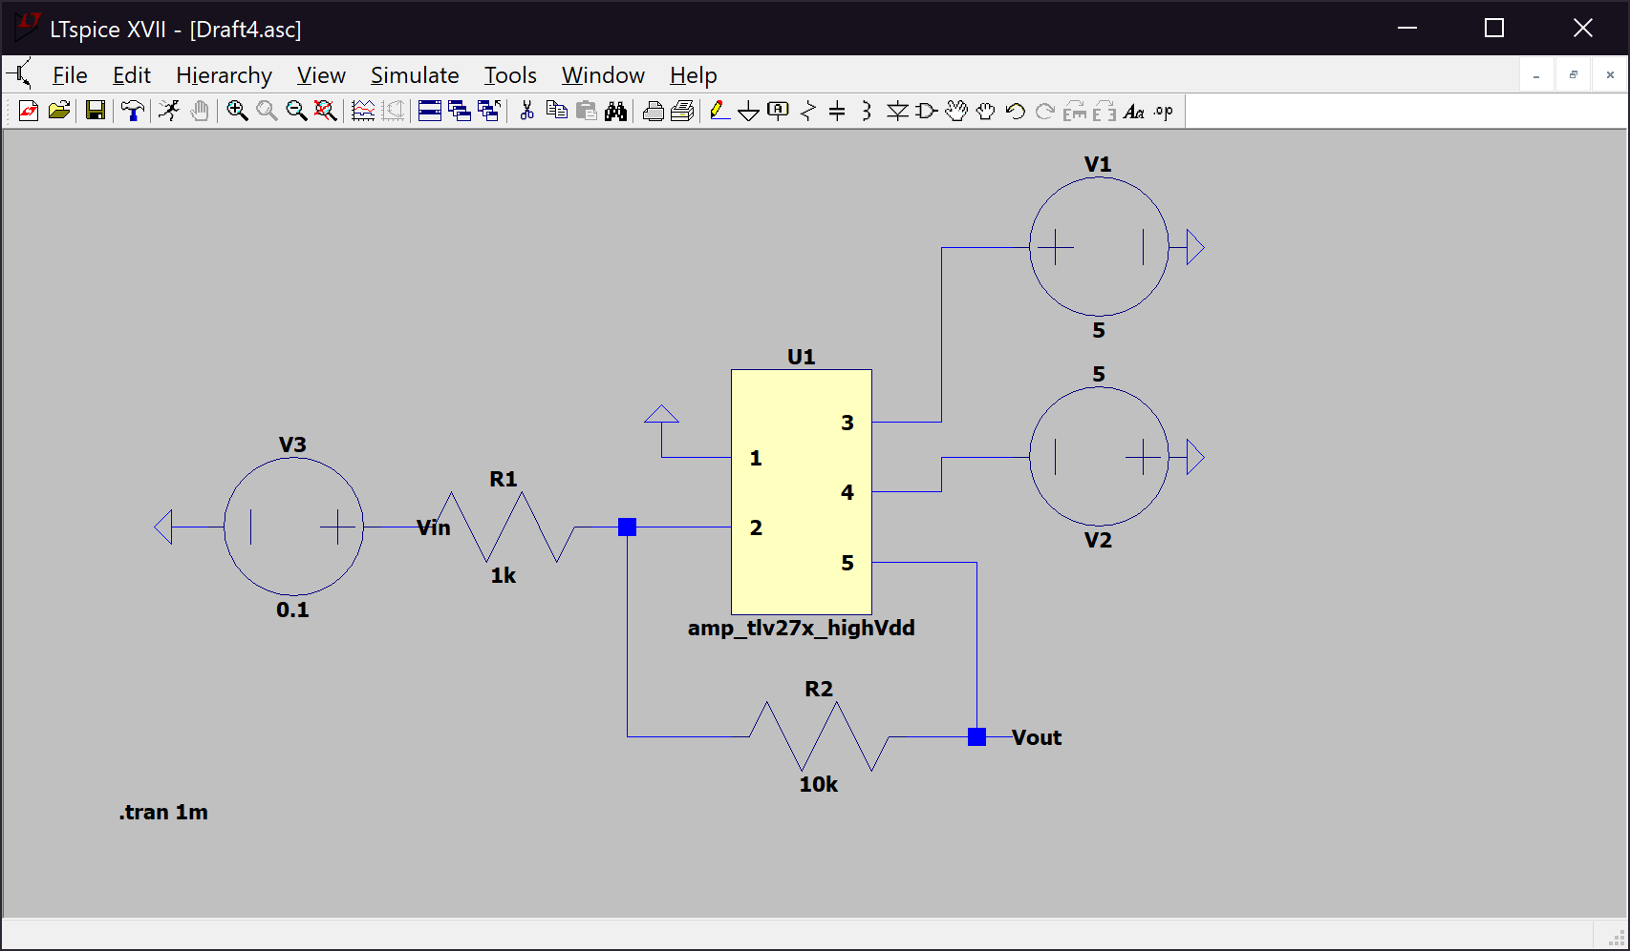*Figure 6. Circuit for step 7*

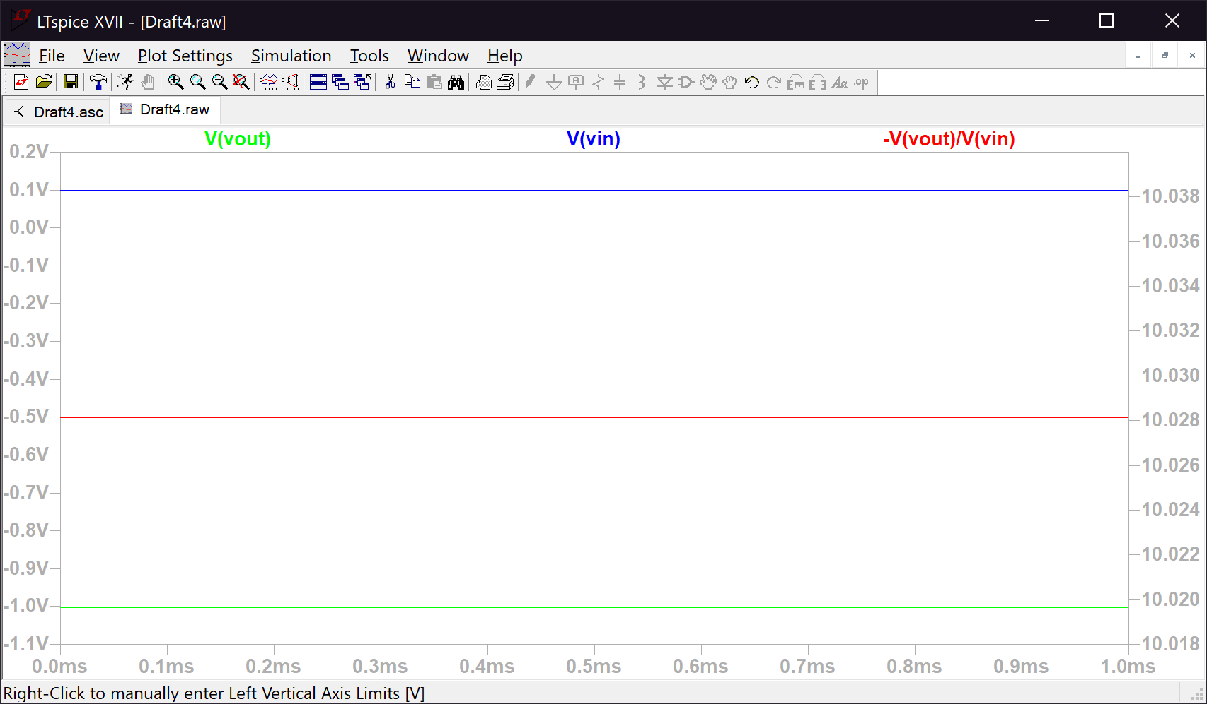

*Figure 7. Graph for step 7*