**Lab 5**

**Introduction**

In this lab we explored the offset voltage, slew rate, output voltage range, and effective gain of a physical op amp. We than compared three different models of op amps, an ideal op amp, spice TLV272 model, and the physical op amp.

**Discussion**

*Table 1. Table of experimental parameters*

|  |  |
| --- | --- |
| Offset voltage | 370 µV |
| Slew rate | 2.7 V/µs |
| Maximum output voltage swing | 9.9611 V |
| Effective gain | 10.253 |

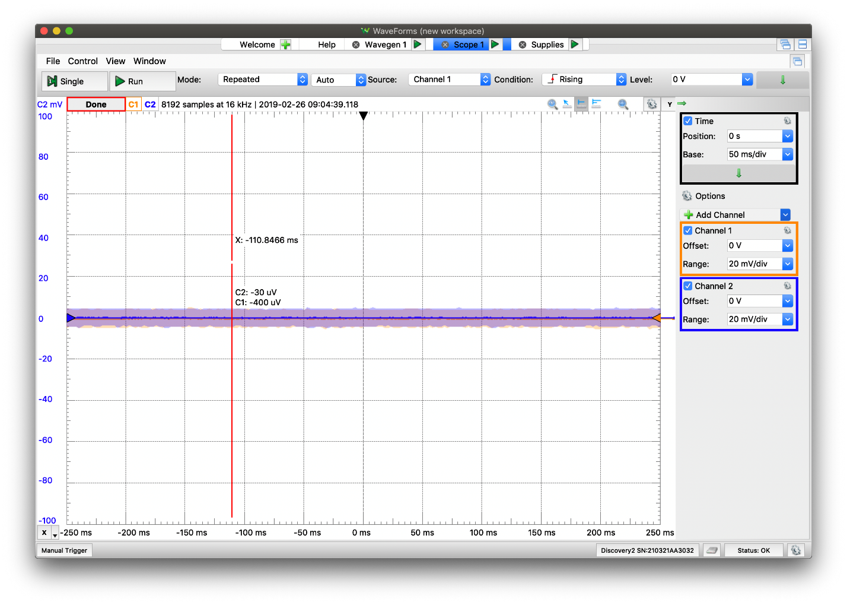

*Figure 1. Graphical representation of offset voltage (C2 – C1)*

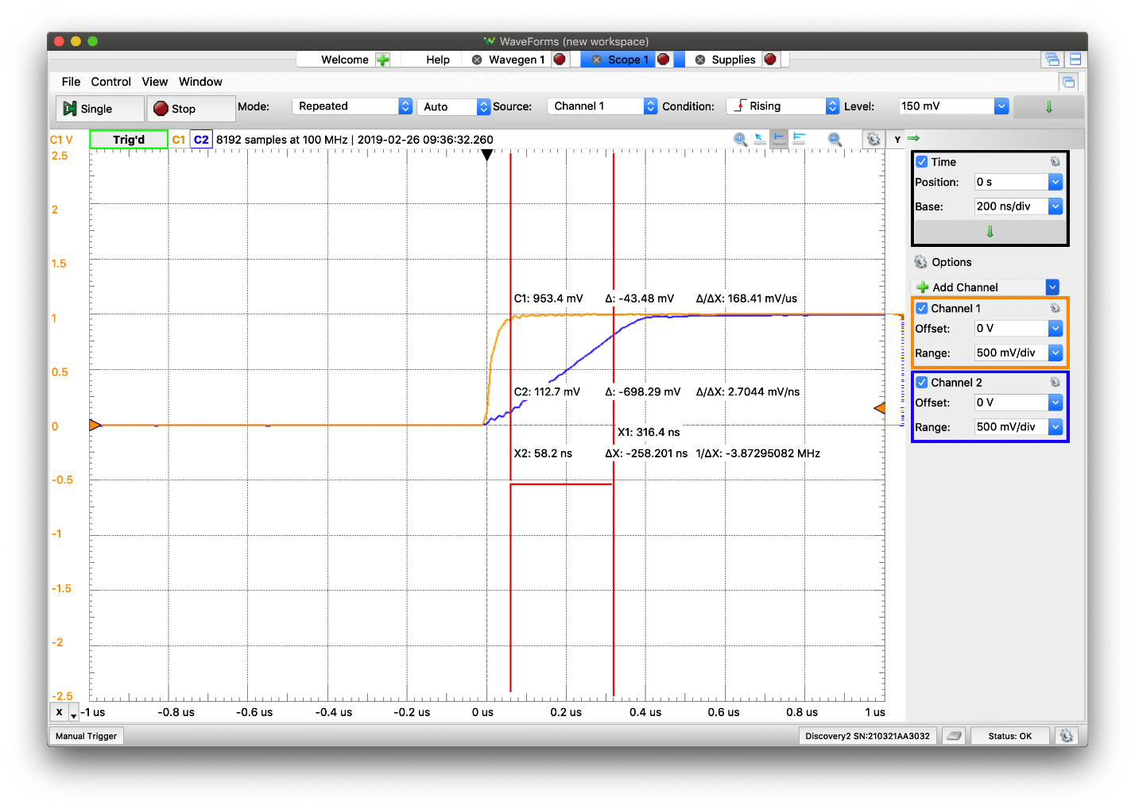*Figure 2. Graphical representation of slew rate (C2: Δ/ΔX)*

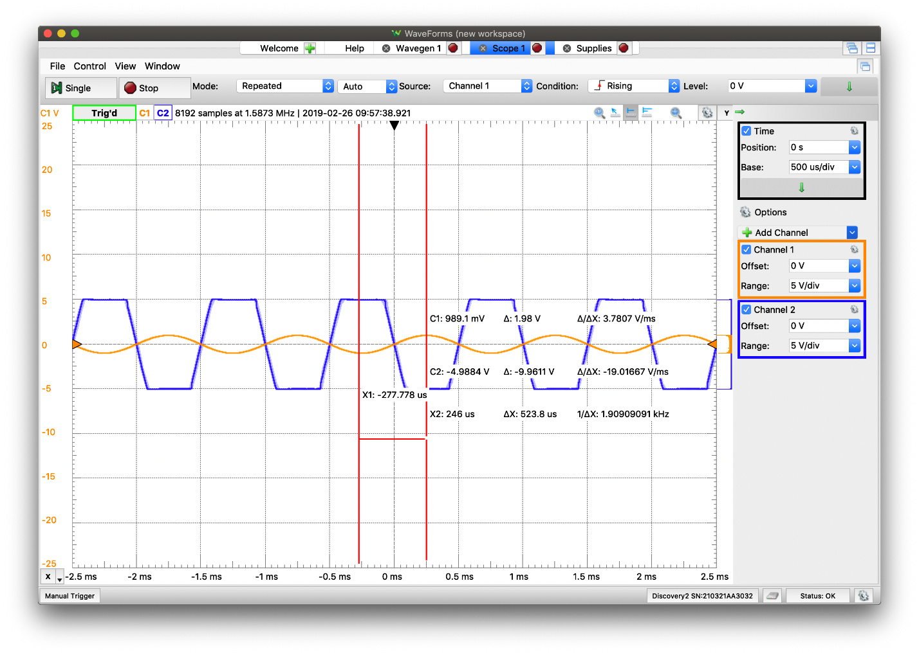*Figure 3. Graphical representation of maximum output voltage swing (C2: |Δ|)*

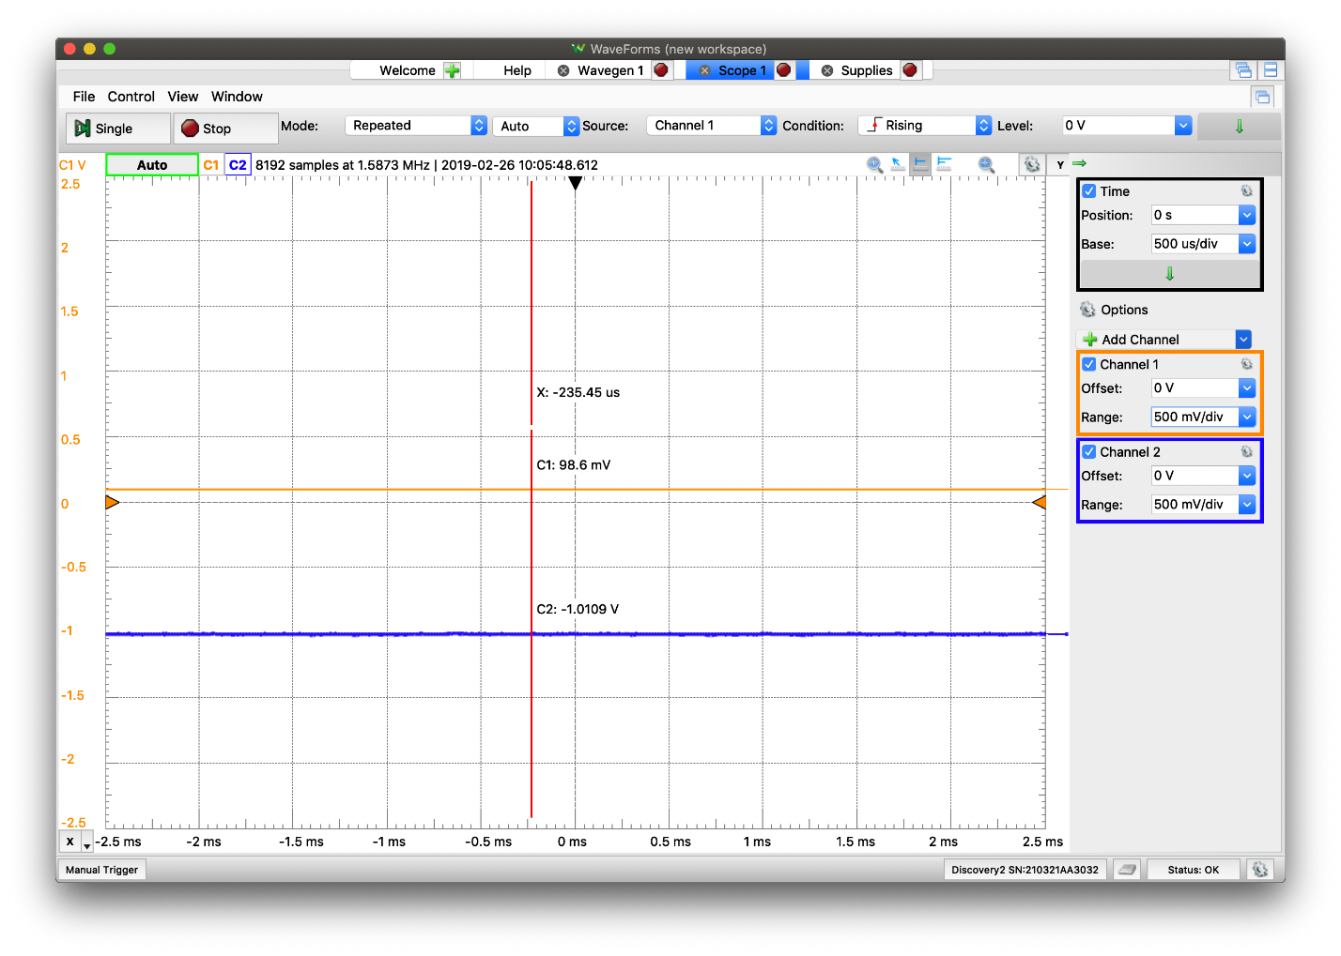*Figure 4. Graphical representation of effective gain (-C2 / C1)*

*Table 2. Percent error of experimental parameters*

|  |  |  |  |
| --- | --- | --- | --- |
|  | Theoretical values | Experimental values | Percent Error |
| Offset voltage | 280.429 µV | 370 µV | 31.9 % |
| Slew rate | 0.30869 V/µs | 2.7 V/µs | 770 % |
| Maximum output voltage swing | 10 V | 9.9611 V | 0.39 % |
| Effective gain | 10.028126 | 10.253 | 2.2424 % |

The ideal op amp model should be used when you do not need to account for real world imperfections; when you do not need realistic values and would rather see what the ideal case would be. The spice TLV272 model should be used when you want a circuit that impersonates a real-world case, but do not have the tools necessary to build a real circuit. Even though the spice TLV272 model was made to impersonate a real-world op amp, you will always get more realistic results building a real circuit, however if that is not possible the spice TLV272 model can be a sufficient replacement. Finally the physical op amp should be used when you have the tool needed to build the circuit and want realistic values associated with it.

**Conclusion**

From the percent error we can see how much the real world op amp differs from the spice TLV272 model; the offset voltage and slew rate have exceptionally large errors (especially the slew rate), however the maximum output voltage range swing and effective gain have quite low errors. All three of the op amp models have their own uses. The ideal op amp is useful when you need an ideal case for the op amp circuit, the spice TLV272 is useful when you need a more realistic op amp circuit but do not have the tool to build a real one, and the physical op amp should be used when you need a realistic op amp circuit and have the tool necessary to build one.