Prelab 6

Fran Luka Antoljak

6.5.1 Buffering

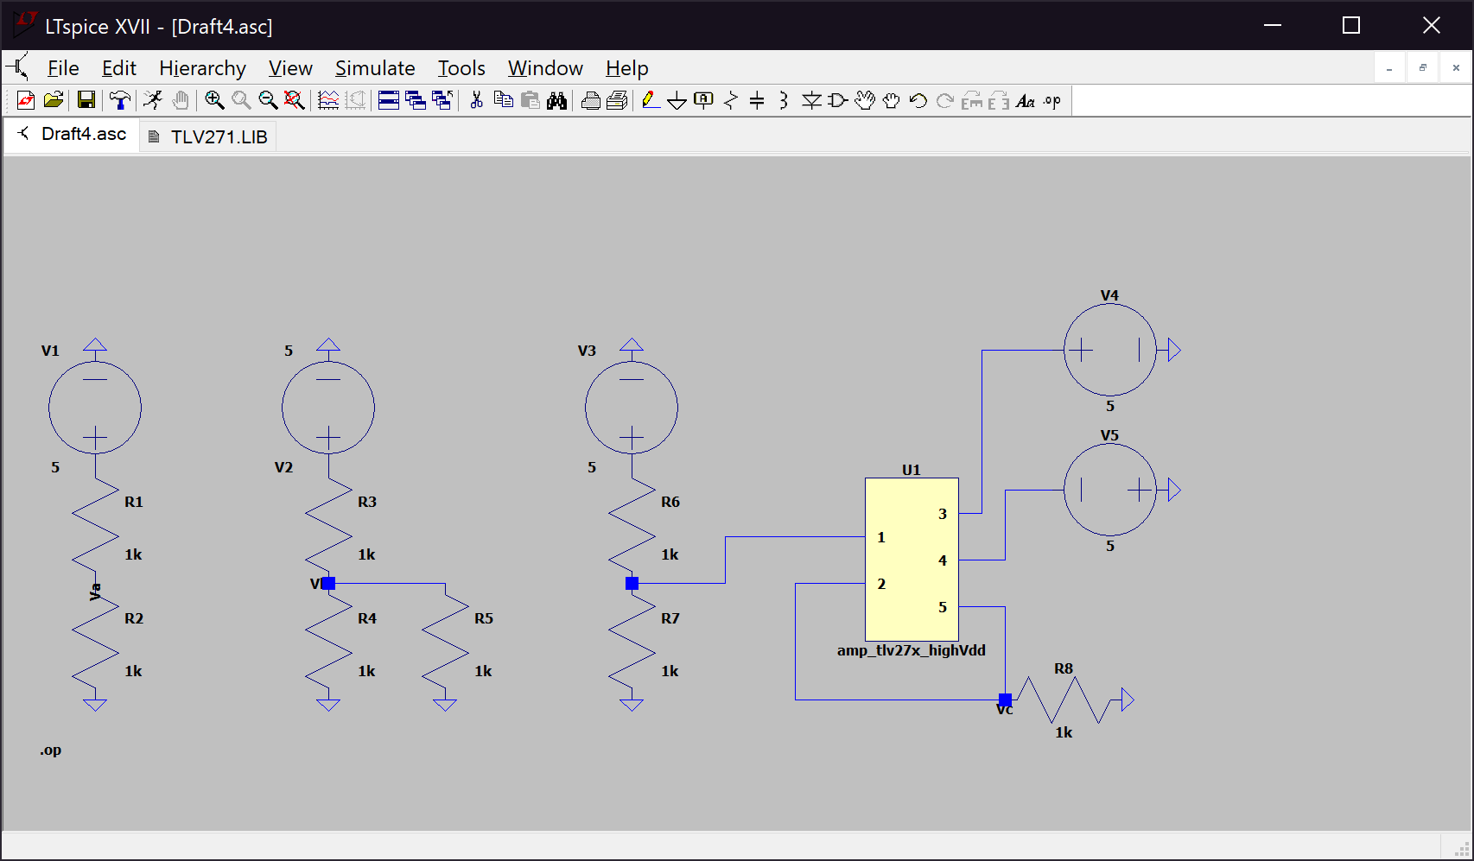*Table 1. Voltages VA, VB, VC*

V-

V+

|  |  |
| --- | --- |
| V­A | 2.5 V |
| VB | 1.66667 V |
| VC | 2.49892 V |

*Figure 1. Circuit for 6.5.1*

Voltages VA and VC are approximately 2.5V because their respective circuits simulate a voltage divider between two equal resistors with an independent source of 5V. VA is exactly 2.5V because it is an ideal situation, however V+ is slightly lower than 2.5V because in its respective circuit, we introduced an op amp, TLV272, which tries to simulate a real world op amp. Since the left side of the right most circuit is identical to the left most circuit V+ is equal to 2.5V, and with op amps we assume that V+ = V-, but since TLV272 simulates a real-world situation V- is slightly lower than V+ due to real world conditions, (not infinite input impedance). VB is 1.667V because its voltage divider introduced an additional 1,000 Ω resistor which equates to a 500 Ω resistor below VB.

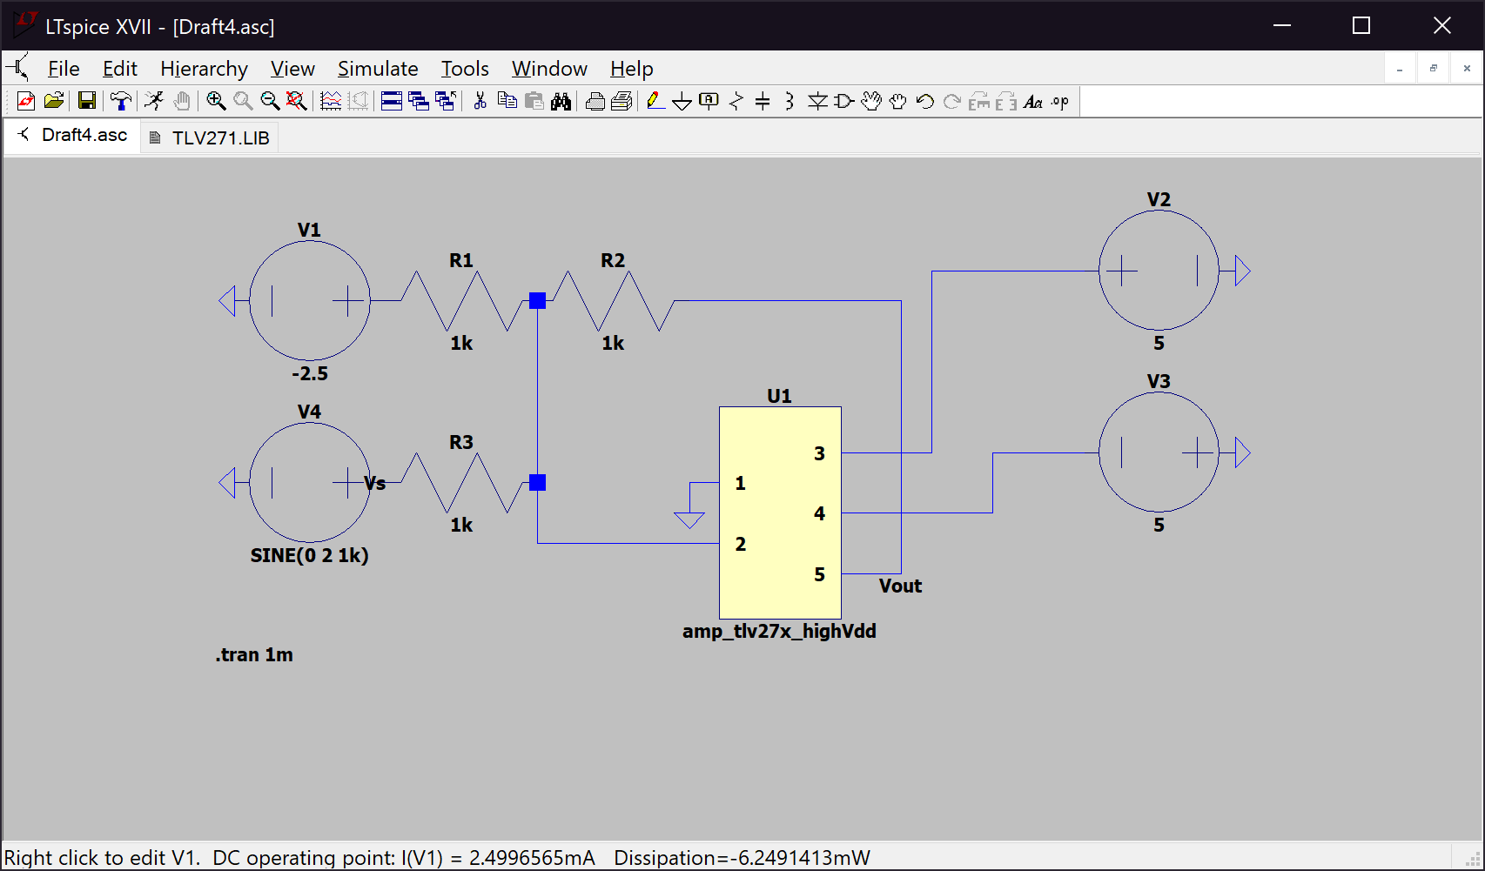6.5.2 Level Shifting

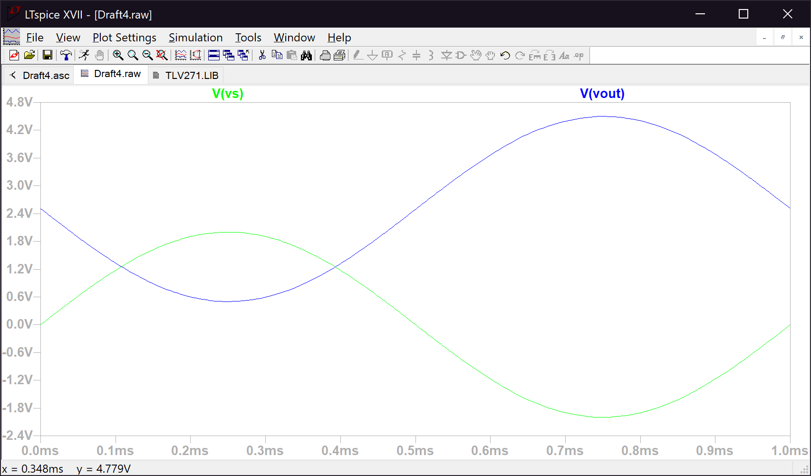*Figure 2. Circuit a) in 6.5.2*

*Figure 3. The input and output voltages for step 1 in 6.5.2*

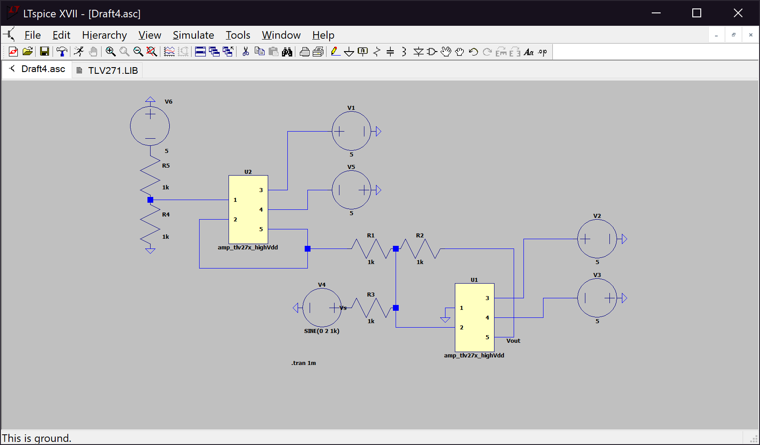The reason the resistor divider uses -5V instead of 5V is because we need to use a voltage of -2.5V, so we use a voltage divider to split the -5V into two equal voltages for further use. If we needed 2.5V than we would have used a source of 5V.

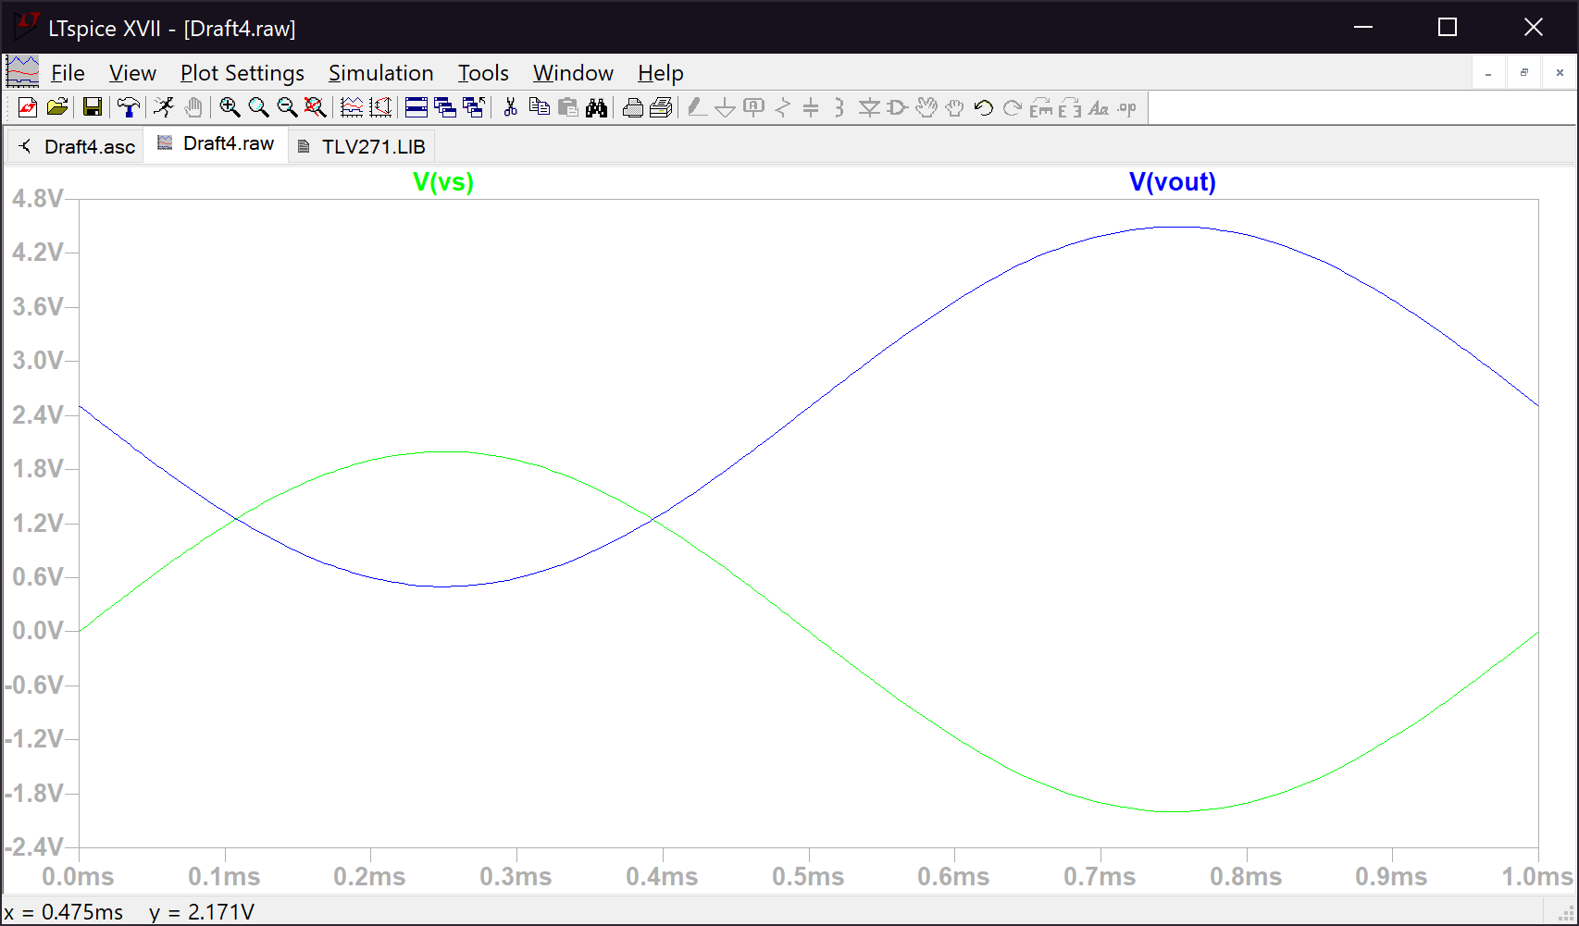*Figure 4. Circuit b) in 6.5.2*

*Figure 5. The input and output voltages for step 3 in 6.5.2*

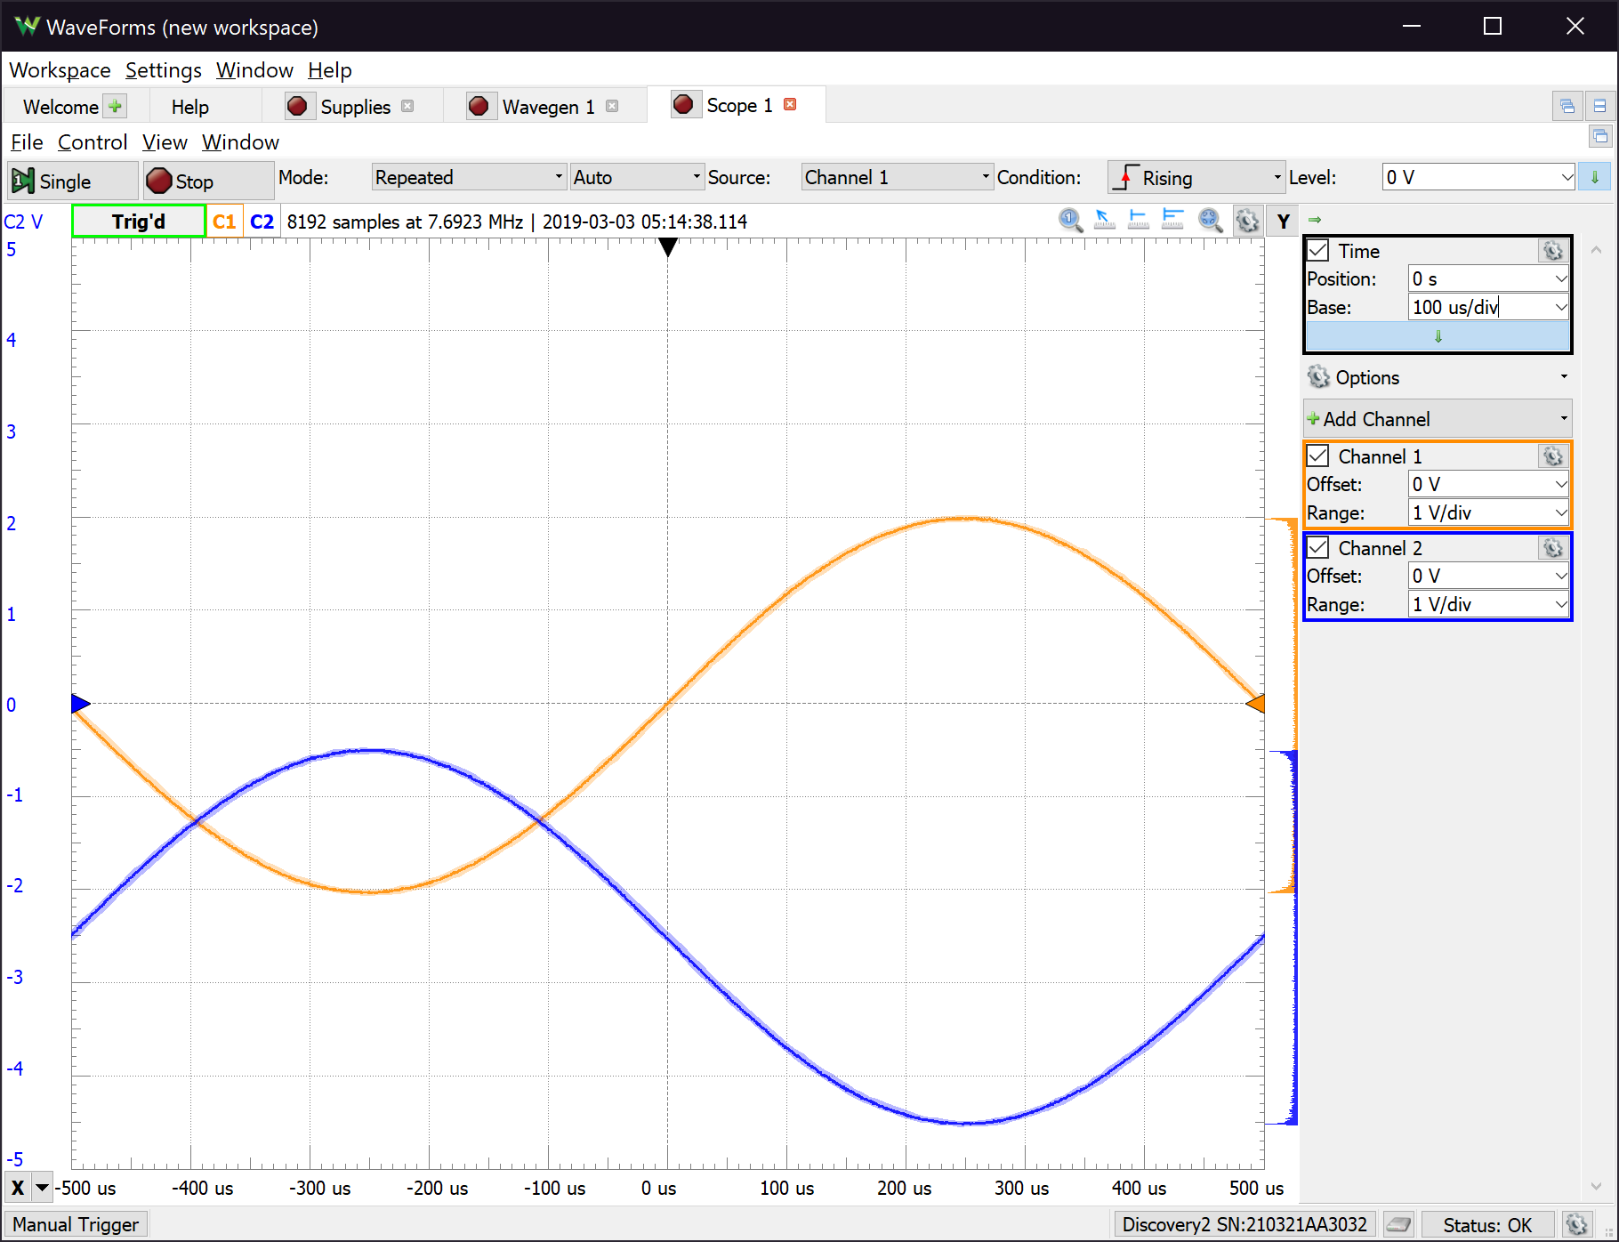*Figure 6. The input and output voltage for circuit b) on the breadboard*

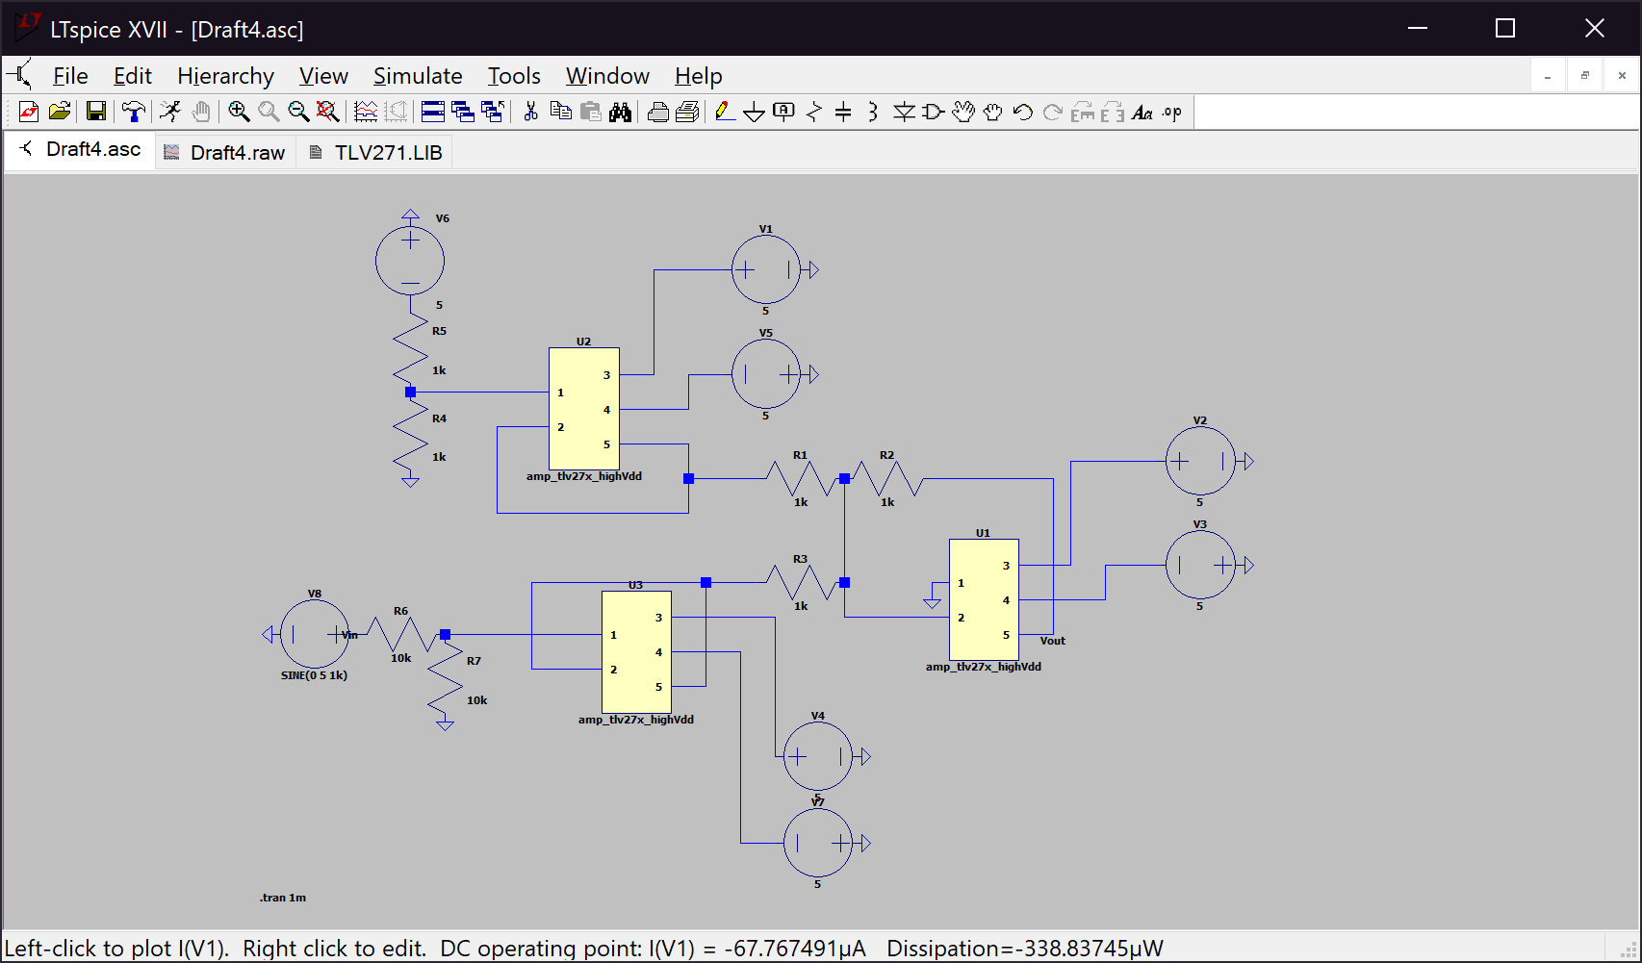*Figure 7. Circuit for step 5*

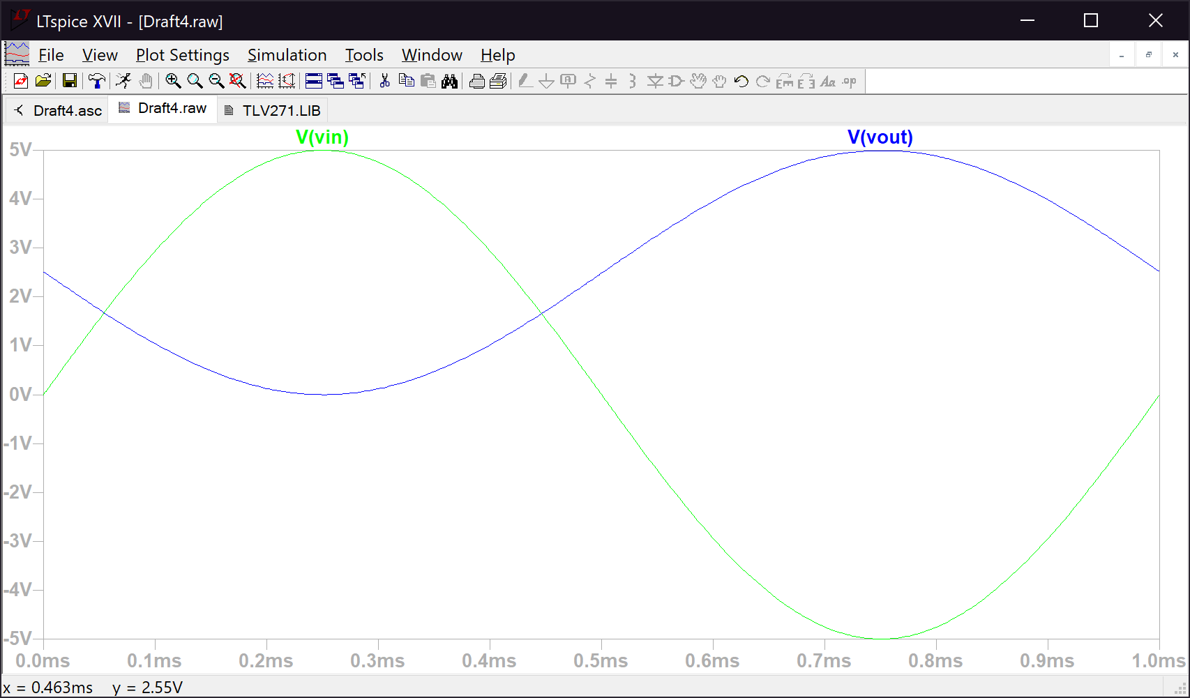

*Figure 8. The input and output voltages for step 5 in 6.5.2*

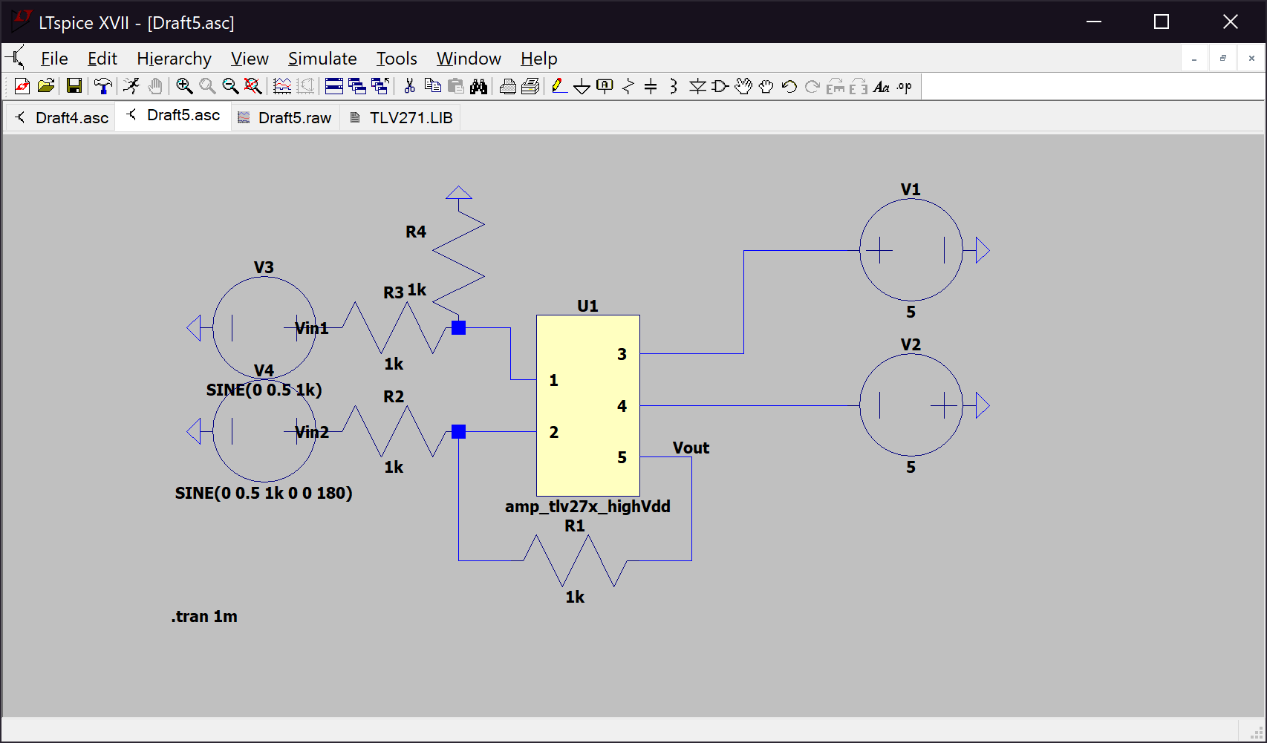6.5.3 Differential to Single Ended Conversion

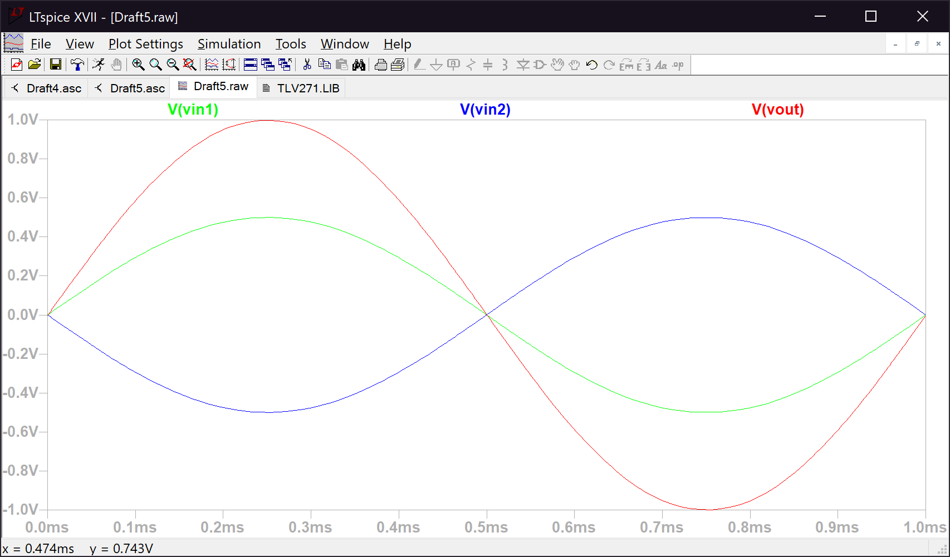*Figure 9. Circuit a) in 6.5.3*

*Figure 10. Both input voltages and output voltage for step 1 in 6.5.3*

*Table 2. The resistor values for circuit b) in 6.5.3*

|  |  |
| --- | --- |
| R1 | 1,000 Ω |
| R2 | 1,000 Ω |
| R3 | 1,000 Ω |
| R4 | 1,000 Ω |
| R5 | 1,000 Ω |
| R6 | 10,000 Ω |
| R7 | 10,000 Ω |

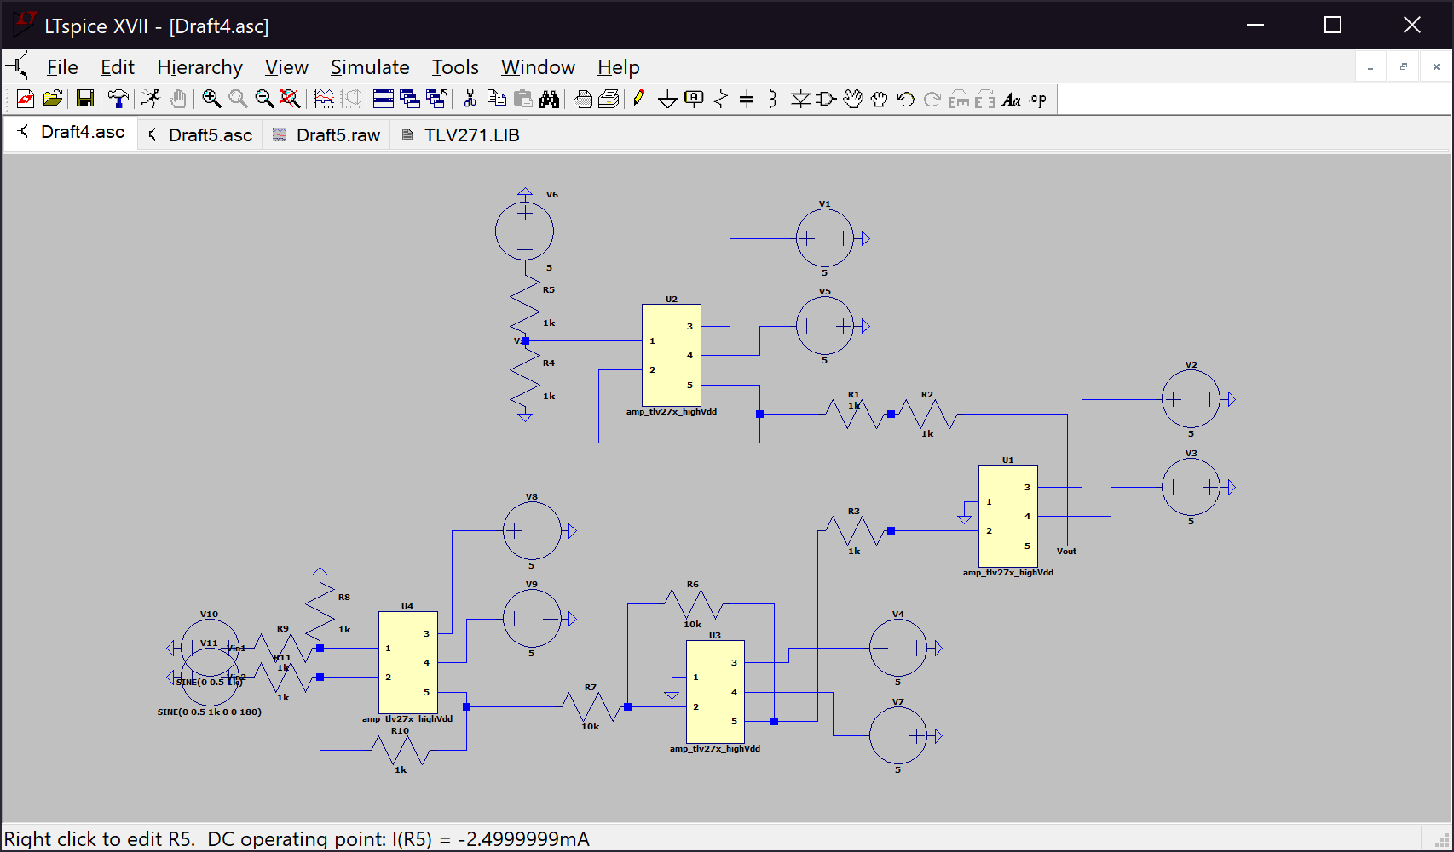

Bottom

Right

Top

Bottom left

*Figure 11. Circuit b) in 6.5.3*

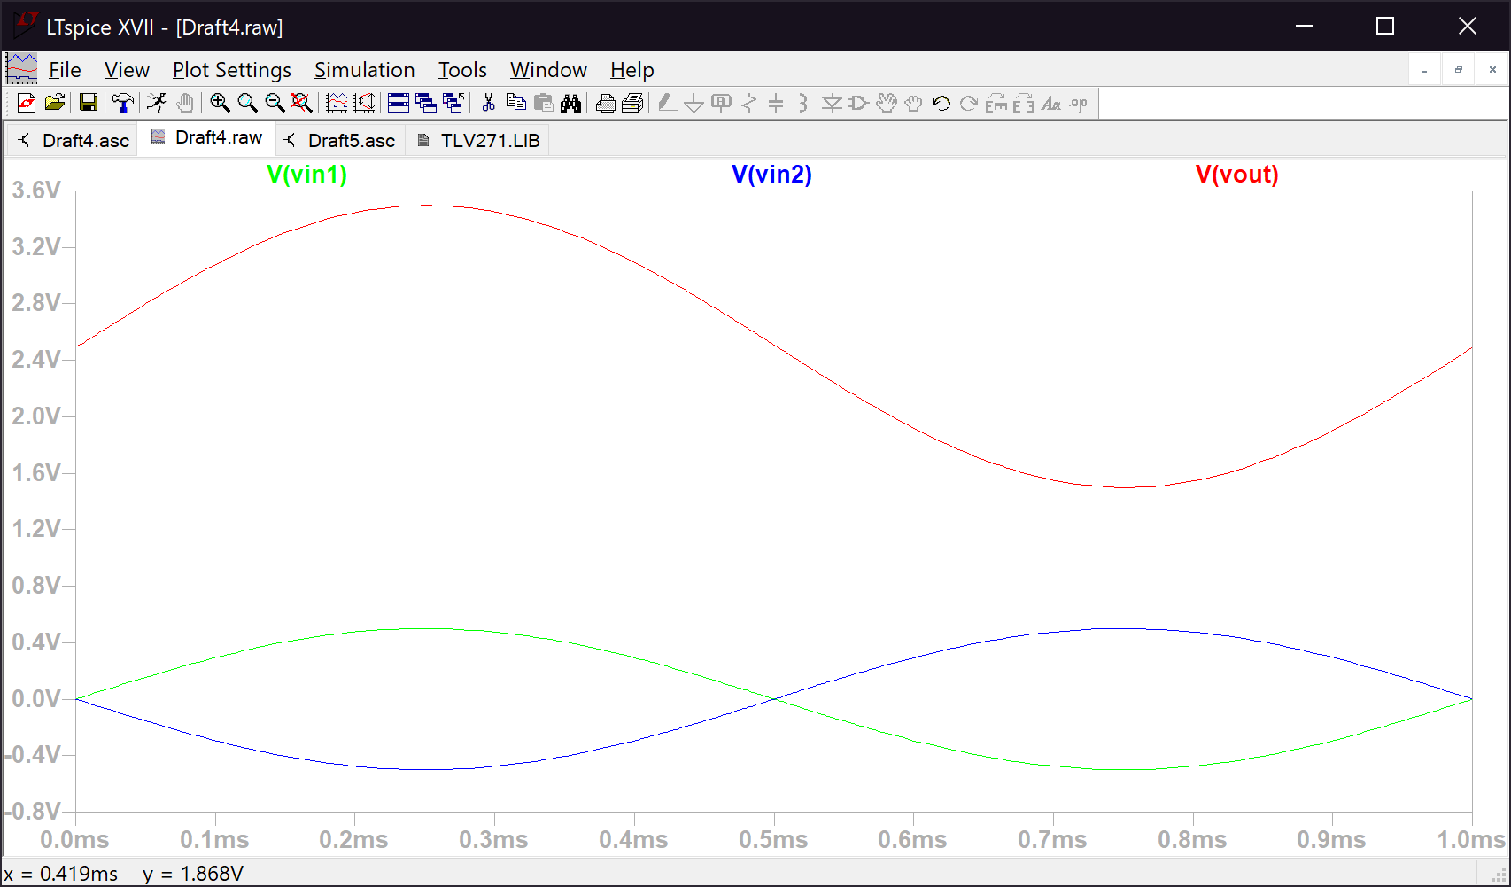*Figure 12. Both input voltages and output voltage for step 3 in 6.5.3*

The circuit in *Figure 11.* has 4 parts (op amps). The first part is a difference amplifier that converts a differential signal to single ended which is the bottom left TLV272. Differential signal is used because it has increased noise performance. The differential signal can be easily converted to a single ended signal using a difference amplifier. The second part is a DC level shifter configured to convert the full range of +/-5 to +5/0, which is the bottom TLV272. With this we can account for the full range of the input. The third part is a voltage divider with a voltage follower between the output and the load, with the top TLV272. Sometimes we cannot get the voltage we desire so we need to derive it from a different voltage source. With the voltage divider we can use the desired -2.5V by dividing a -5V voltage source into two equal voltages. The final part is an inverting summing amplifier used to add 2.5V to -Vin (The single ended signal of Vin1 and Vin2). This is the right TLV272.