**Lab 6**

**Introduction**

In this lab we analyzed two complex op amp circuits. One circuit was a DC level shifter configured to convert the full range of +/-5 to +5/0. The other circuit was a combination of the level shifter and differential to single ended converter.

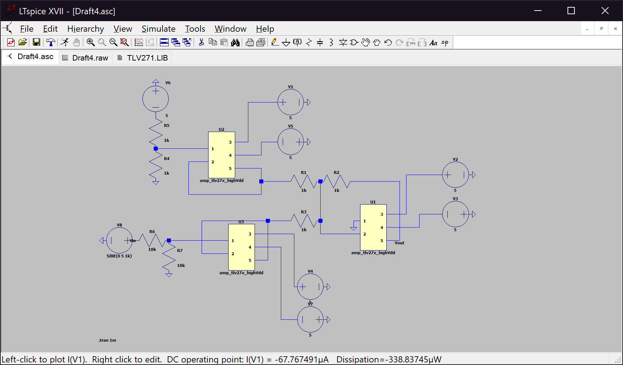**Discussion**

Right

Top

Bottom

*Figure 1. Schematic of the circuit from Section 6.5.2 Item 5*

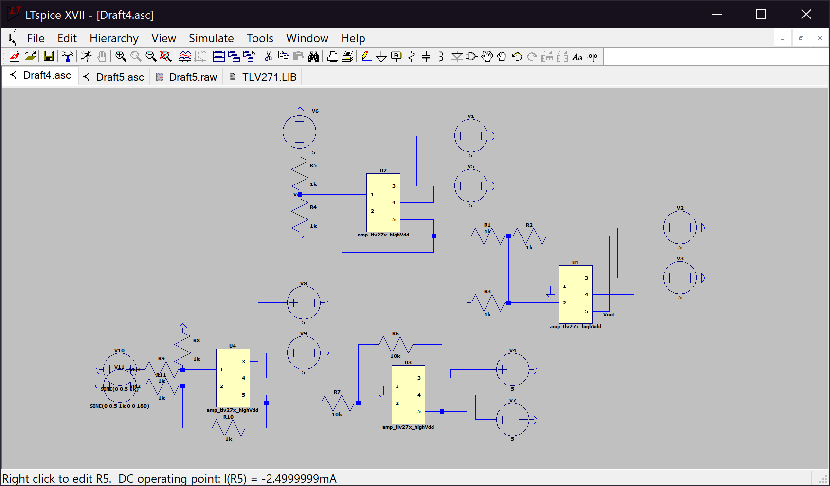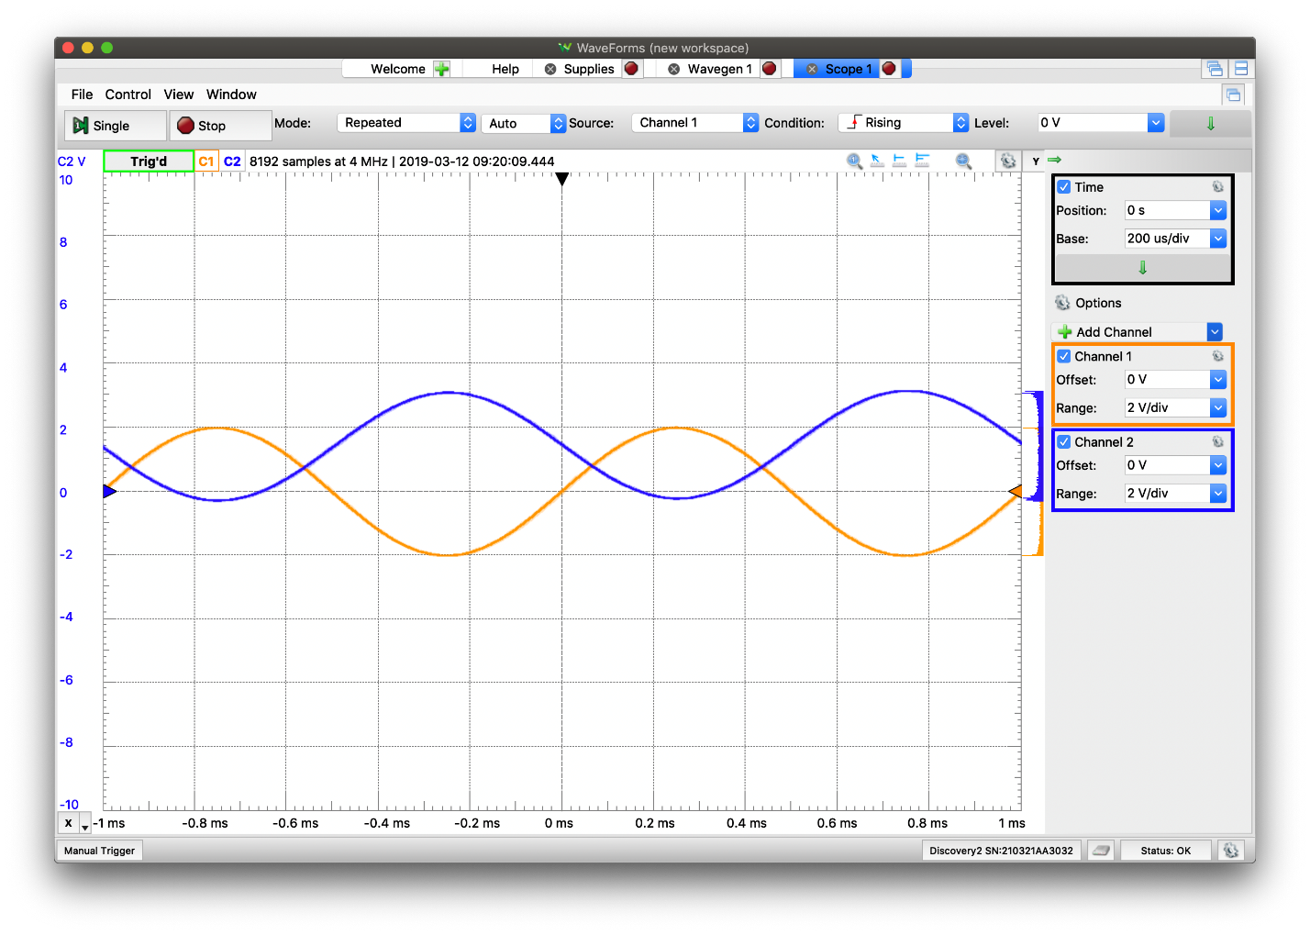*Figure 2.* *Plot of the input and output voltages for Figure 1*

Right

Top

Left

Bottom

*Figure 3. Schematic of the circuit from Section 6.5.3 Item 3*

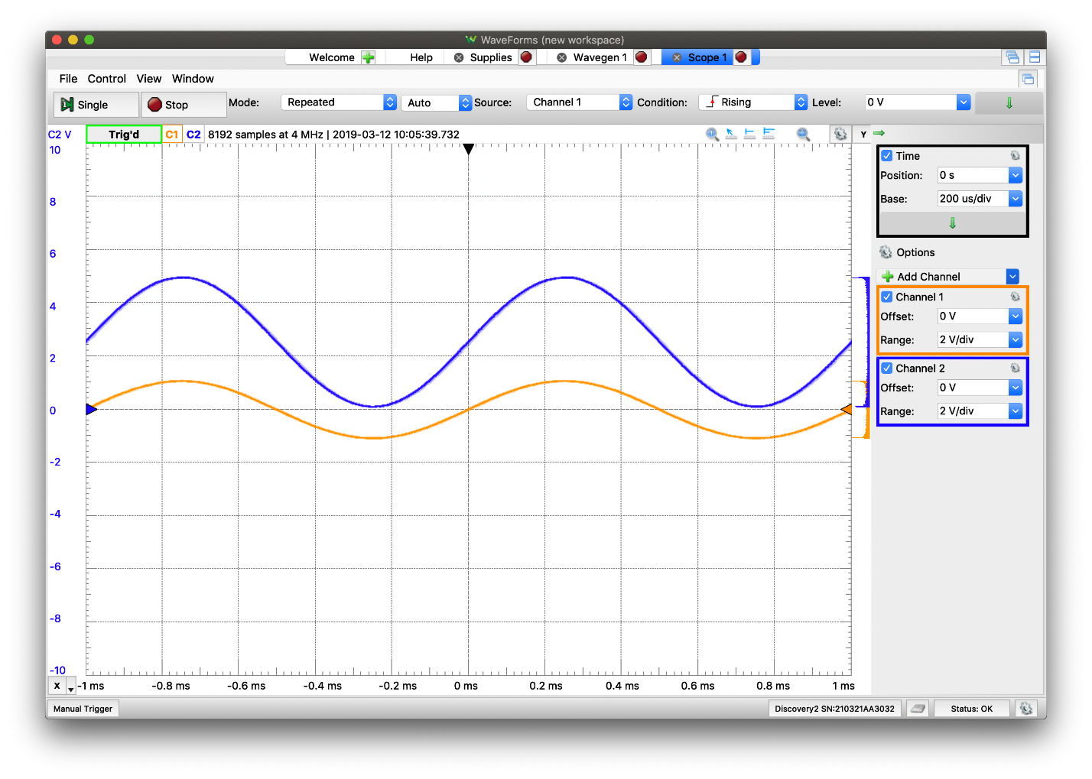*Figure 4. Plot of the input and output voltages for Figure 3*

The circuit in *Figure 1.* has 3 parts (op amps). The first part is a DC level shifter configured to convert the full range of +/-5 to +5/0, which is the bottom TLV272. With this we can account for the full range of the input. The second part is a voltage divider with a voltage follower between the output and the load, with the top TLV272. Sometimes we cannot get the voltage we desire so we need to derive it from a different voltage source. With the voltage divider we can use the desired -2.5V by dividing a -5V voltage source into two equal voltages. The final part is an inverting summing amplifier used to add 2.5V to -Vin (The single ended signal of Vin1 and Vin2). This is the right TLV272. The circuit in *Figure 3.* is the exact same as the previous circuit, only it has an additional part. The left op amp is a difference amplifier that converts a differential signal to single ended. Differential signal is used because it has increased noise performance. The differential signal can be easily converted to a single ended signal using a difference amplifier.

The accuracy of the resistors is very important when dealing with op amps. If the resistor values are too low or too high, this messes up the ratios between the resistor value which may lead to oversaturation in the op amp, and the plot of the output voltage would plateau at the highest and lowest points of the curve. Because of this, lower tolerance is almost necessary.

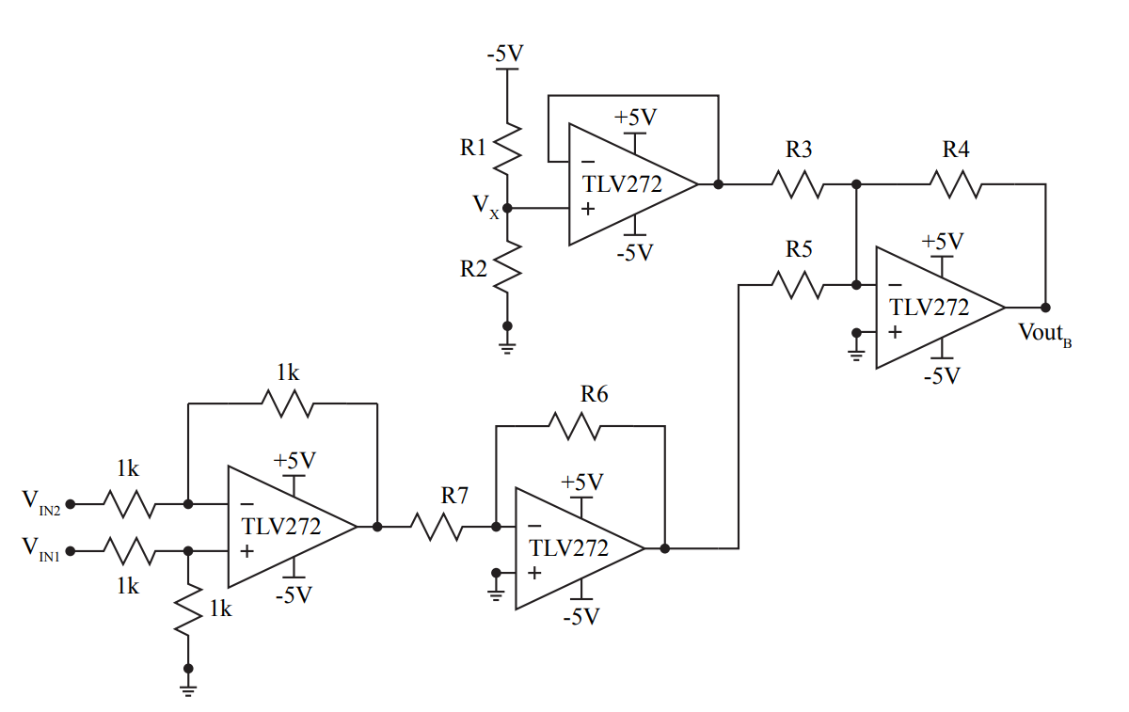*Figure 5. Schematic of the circuit from Section 6.5.3 Item 3*

For the circuit in Section 6.5.3 Item 3, we needed to choose appropriate values for R1-R7 to meet certain criteria. Choose R1 and R2 so that V­X is 2.5V, R3, R4, and R5 so that both voltages are added equally, and R6 and R7 so that the output, VoutB utilizes as much of the full range, 0 to 5V, as possible without clipping. It is also important to keep track of the number of resistor there are in the lab kit. For my circuit, I chose 4.7kΩ resistors for R1 and R2. The exact value for these resistors does not matter much, it is important however that they are equal in value. For R3, R4, and R5 I chose the 10kΩ resistors. For these resistors it is important that they are equal, but also it was also important that their resistor value was greater than 470Ω. Since they deal with an op amp, unlike R1 and R2, it is important that the op amp does not saturate, which it would with resistors lower than 470Ω. The resistor value I chose was 10kΩ.

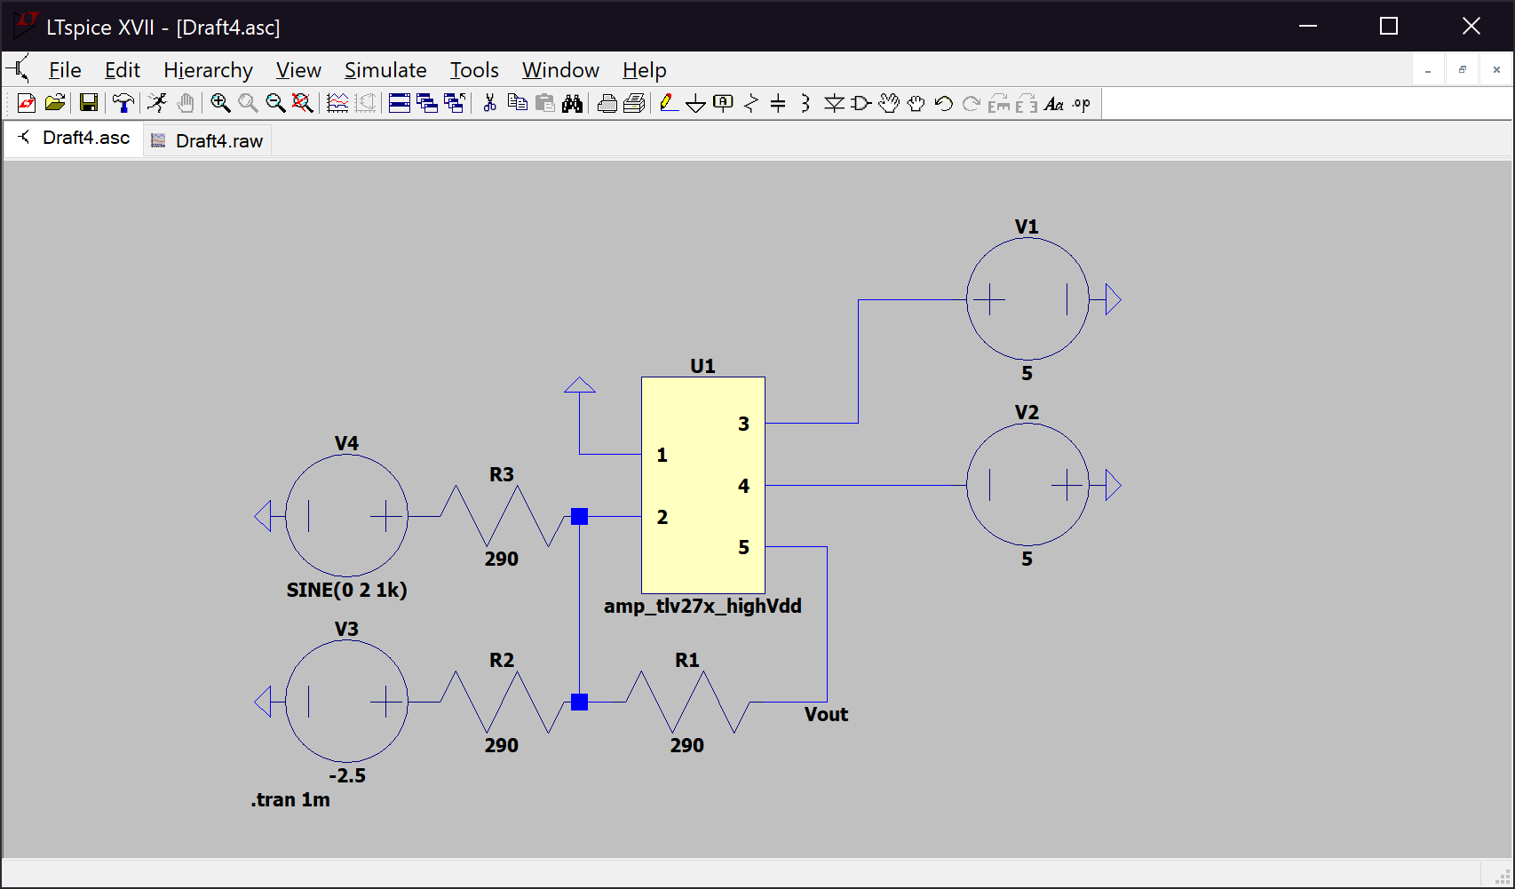E.g.

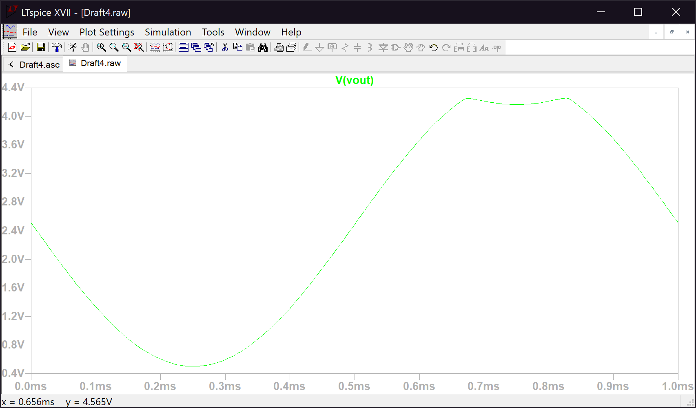*Figure 6. The right op amp from Figure 5 with R3, R4, and R5 equal to 290Ω*

*Figure 7. The plot of the output voltage, visibly showing the oversaturation at 0.65ms ≤ t ≤ 0.85ms*

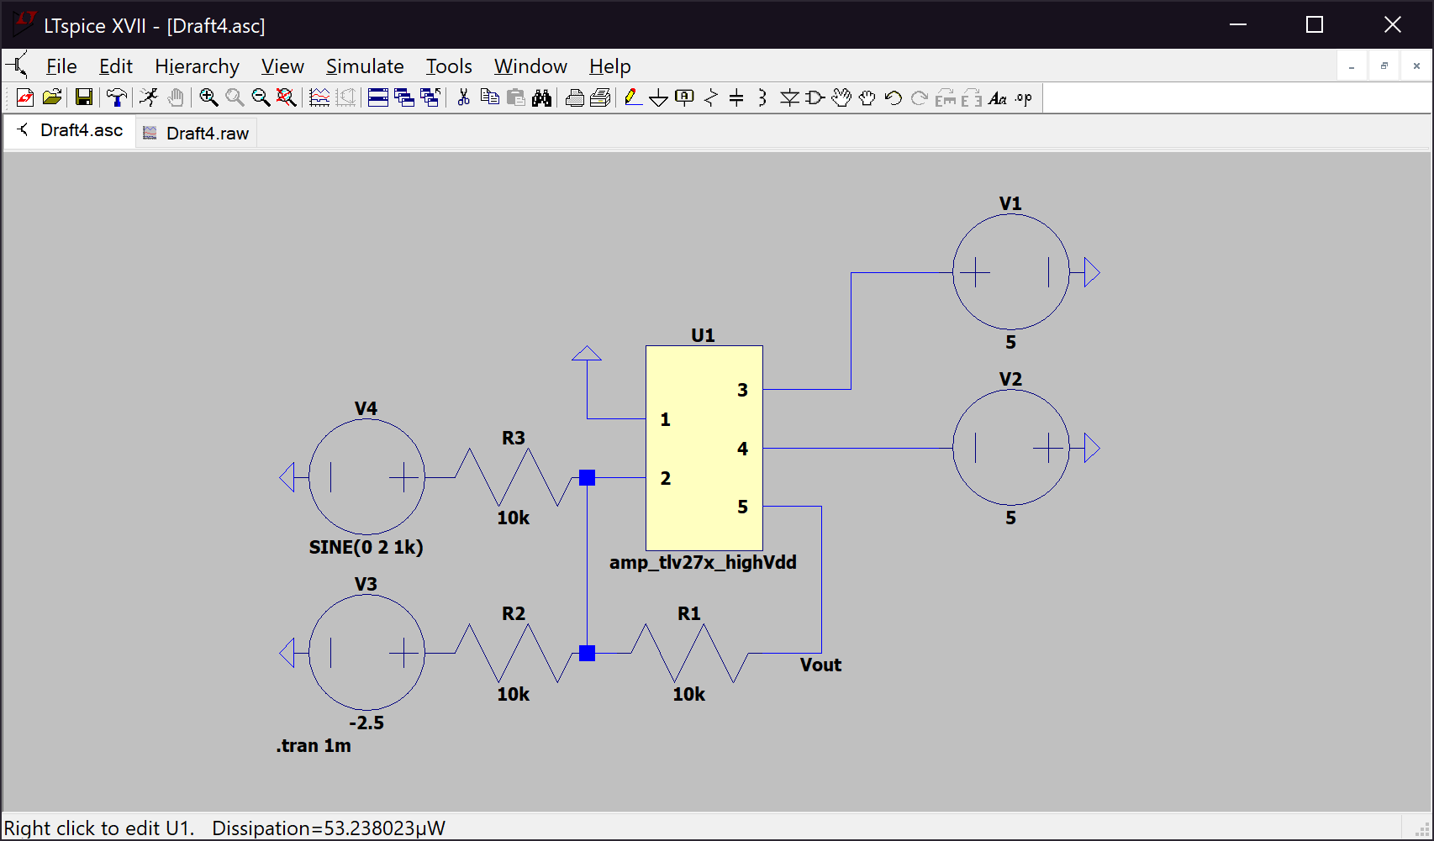*Figure 8. The right op amp from Figure 5 with R3, R4, and R5 equal to 10kΩ*

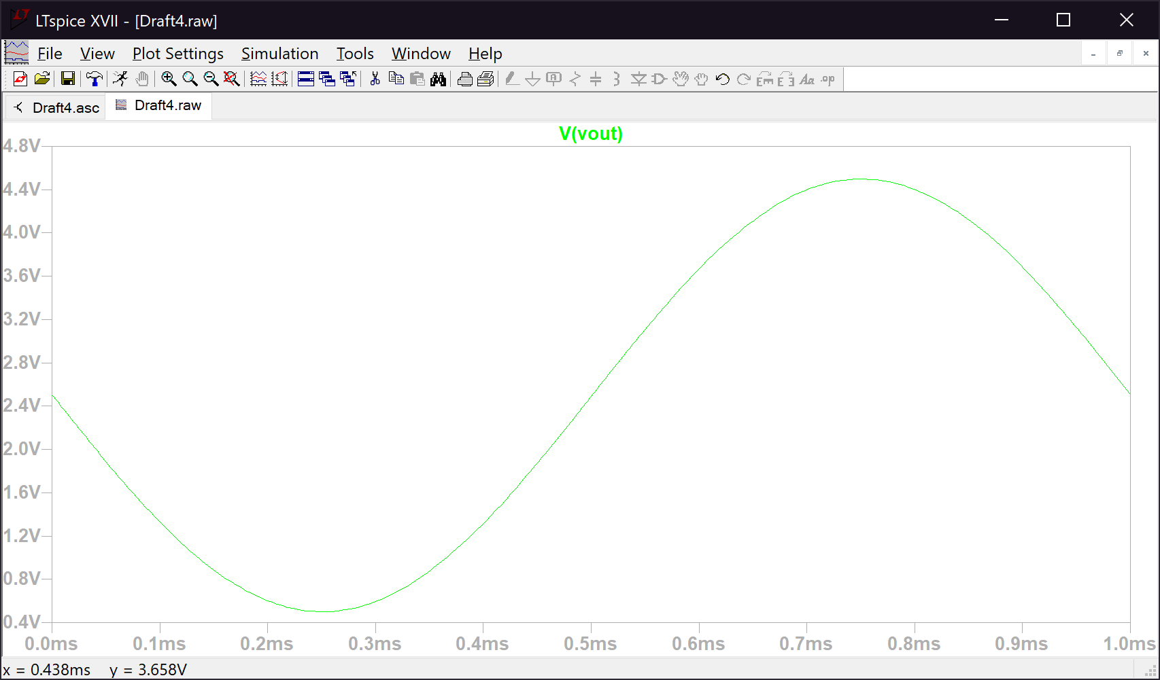

*Figure 7. The plot of the output voltage, showing no oversaturation*

The values of R6 and R7 had to follow the relation R6 = 2.5 * R7. Using this relation, the output voltage utilizes as much of the full range, 0 to 5V. If the value of R6 was too high the op amp would oversaturate. The resistor values I chose were 2.2kΩ for R6 (since there is no 2.5kΩ resistor, however 2.2kΩ is satisfactory as it does not differ a significant amount from the output voltage) and 1kΩ for R7.

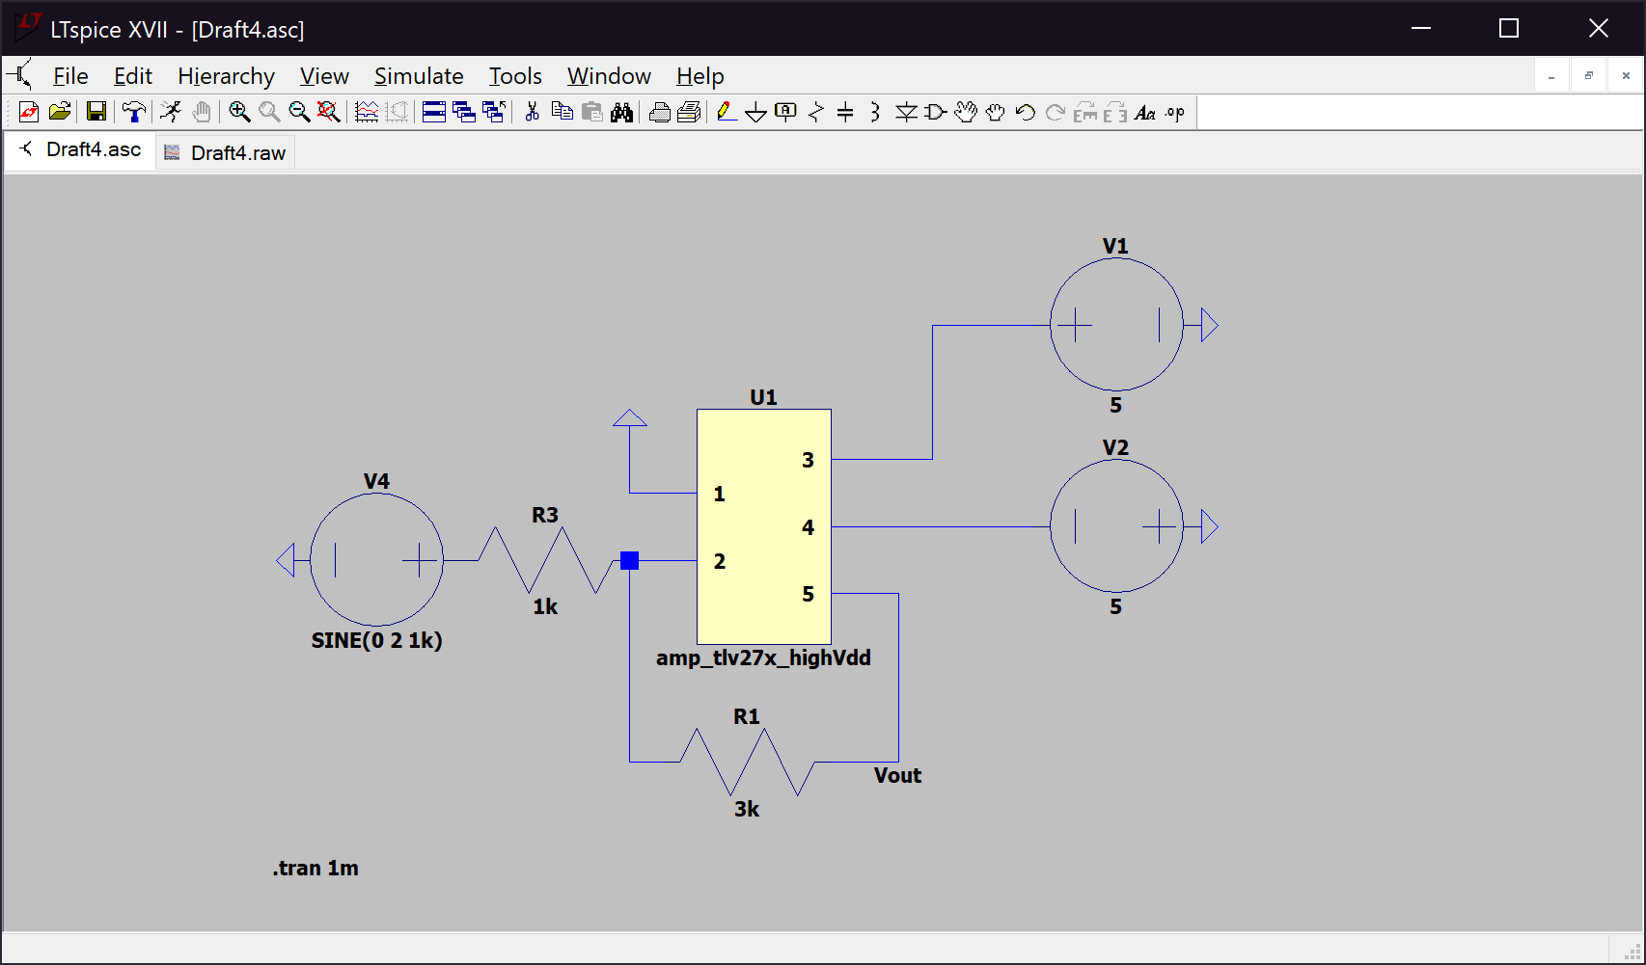E.g. (Both of these examples of the output voltage is not yet shifted from +/-5 to +5/0)

*Figure 8. The bottom op amp from Figure 5 with R6 equal to 3kΩ and R7 equal to 1kΩ*

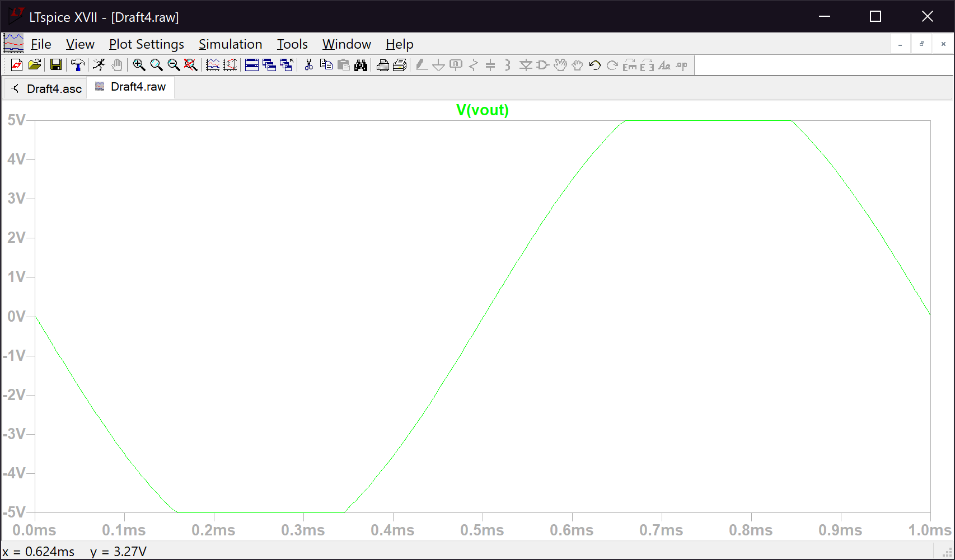*Figure 9. The plot of the output voltage, visible showing oversaturation at -5V and 5V*

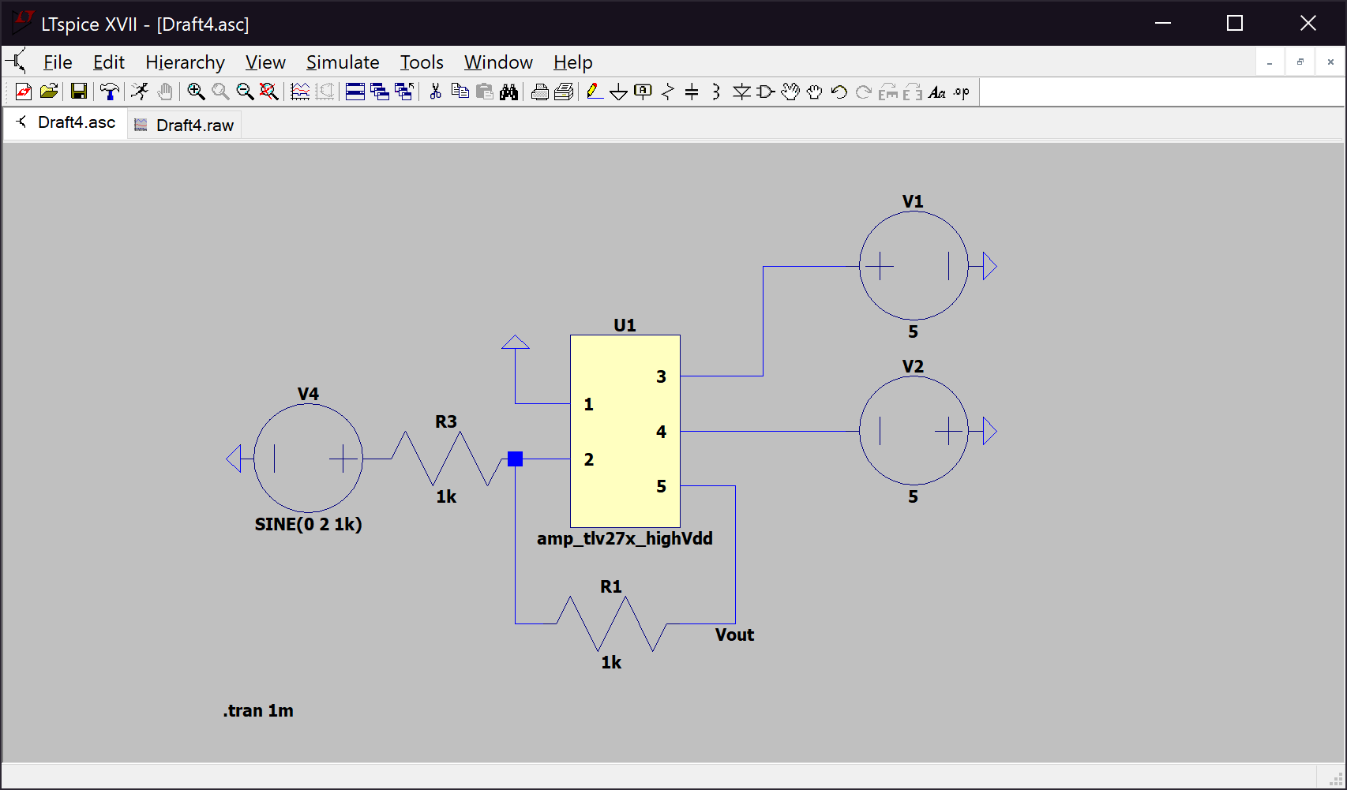

*Figure 10. The bottom op amp from Figure 5 with R6 equal to 1kΩ and R7 equal to 1kΩ*

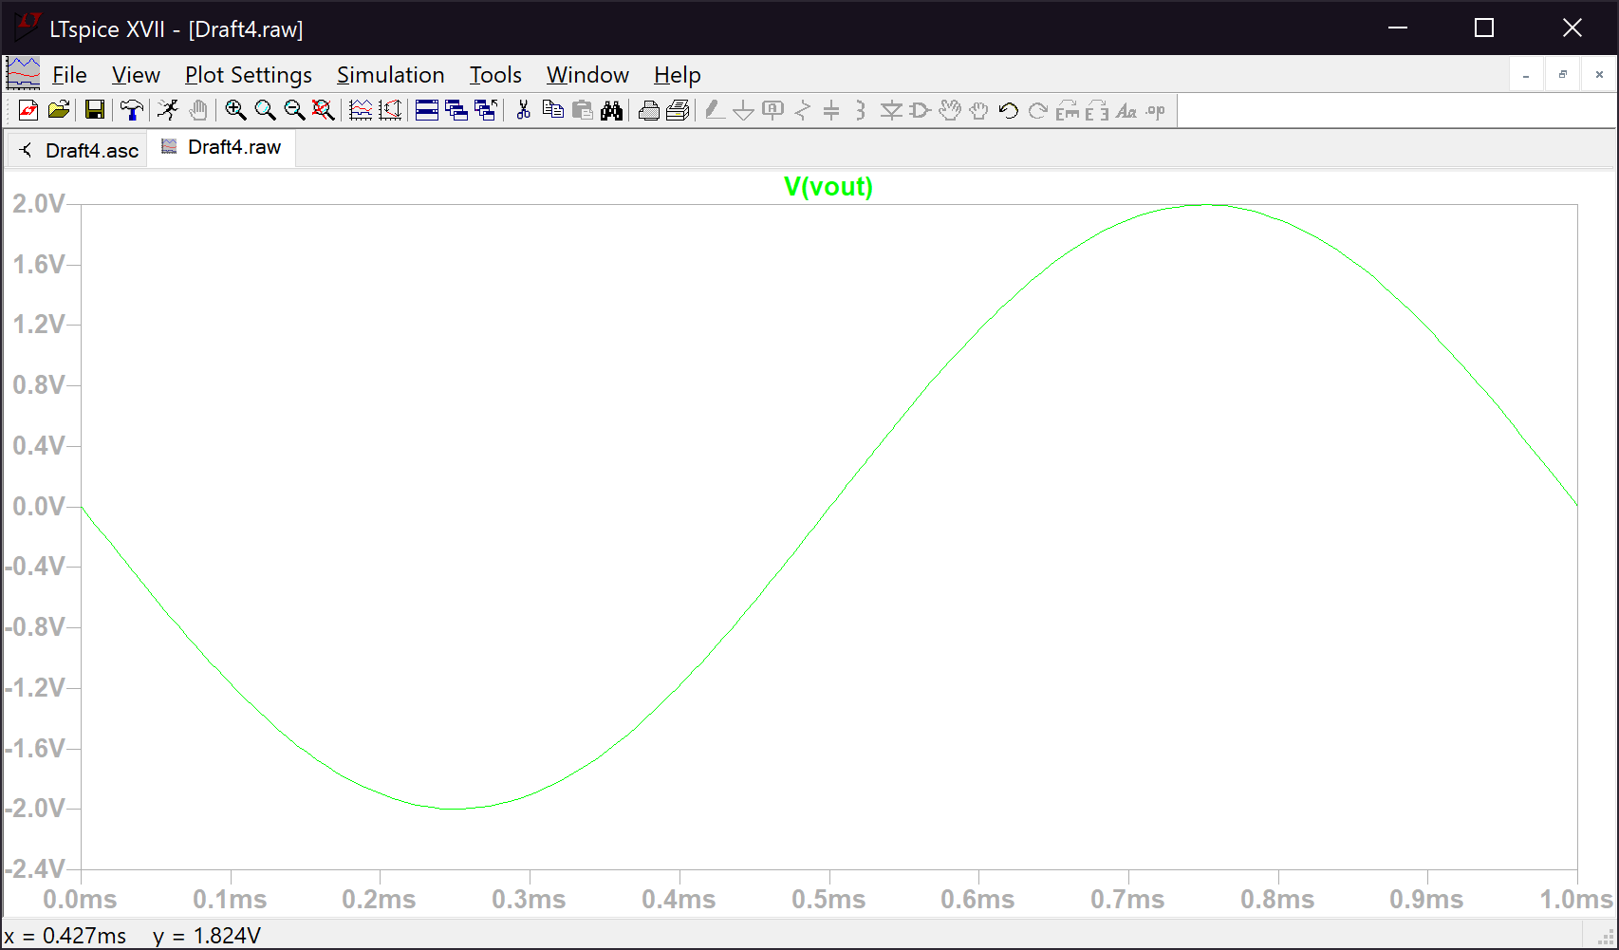*Figure 11. The plot of the output voltage, showing how it is not using the full range +/-5, but rather +/-2*

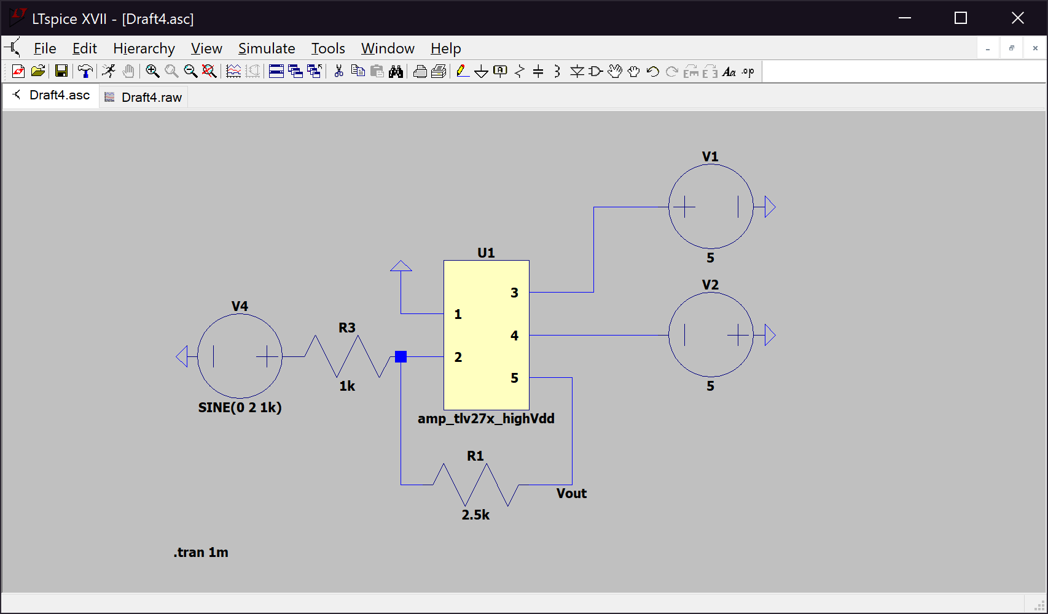

*Figure 12. The bottom op amp from Figure 5 with R6 equal to 2.5kΩ and R7 equal to 1kΩ*

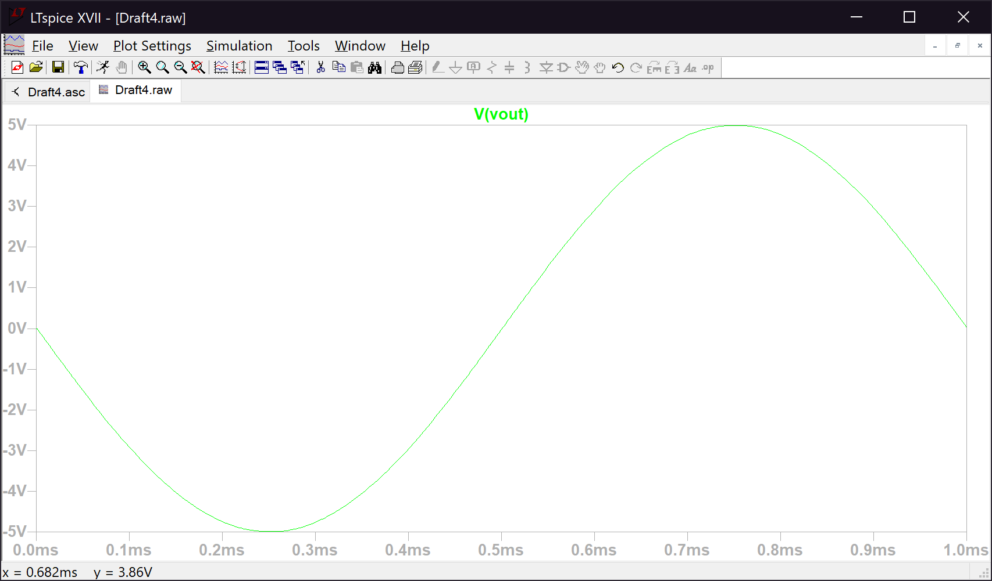*Figure 13. The plot of the output voltage, showing the correct usage of the full range, +/-5*

**Conclusion**

In this lab we found the output voltage for the DC level shifter and the combination between a level shifter and a differential to single ended converter. We also found the appropriate values for R1-R7 so that we had a desired voltage divider, sum of voltages, and output voltage range. These values were: R1 = R2 = 4.7kΩ, R3 = R4 = R5 = 10kΩ, R6 = 2.2kΩ, and R7 = 1kΩ.