**Pre-Lab 7**

Fran Luka Antoljak

*7.5.1 LTspice Simulations*

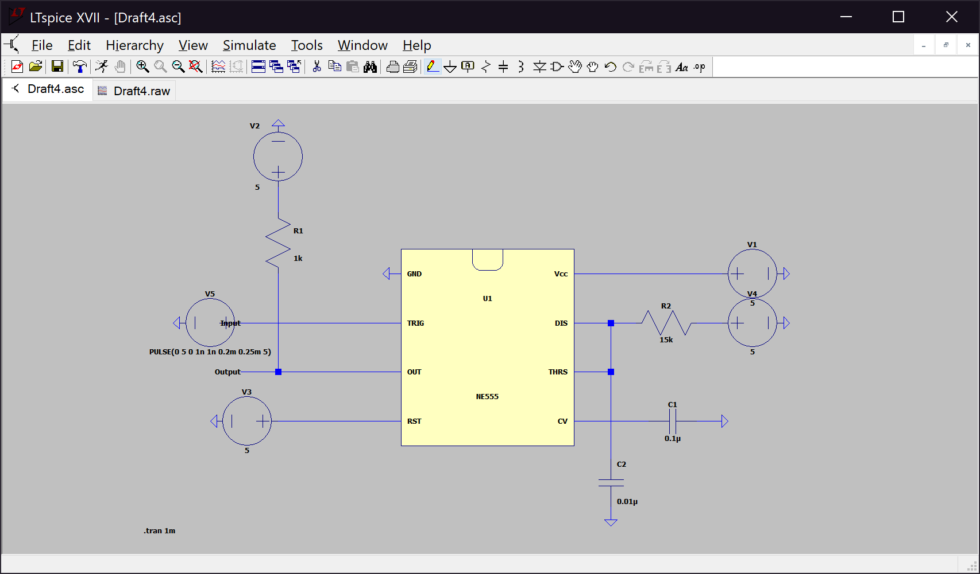Item 2:

Voltage Pulse Duration:

|  |  |
| --- | --- |
| Pulse Start | 200 µs |
| Pulse End | 365 µs |
| Pulse Duration | 165 µs |

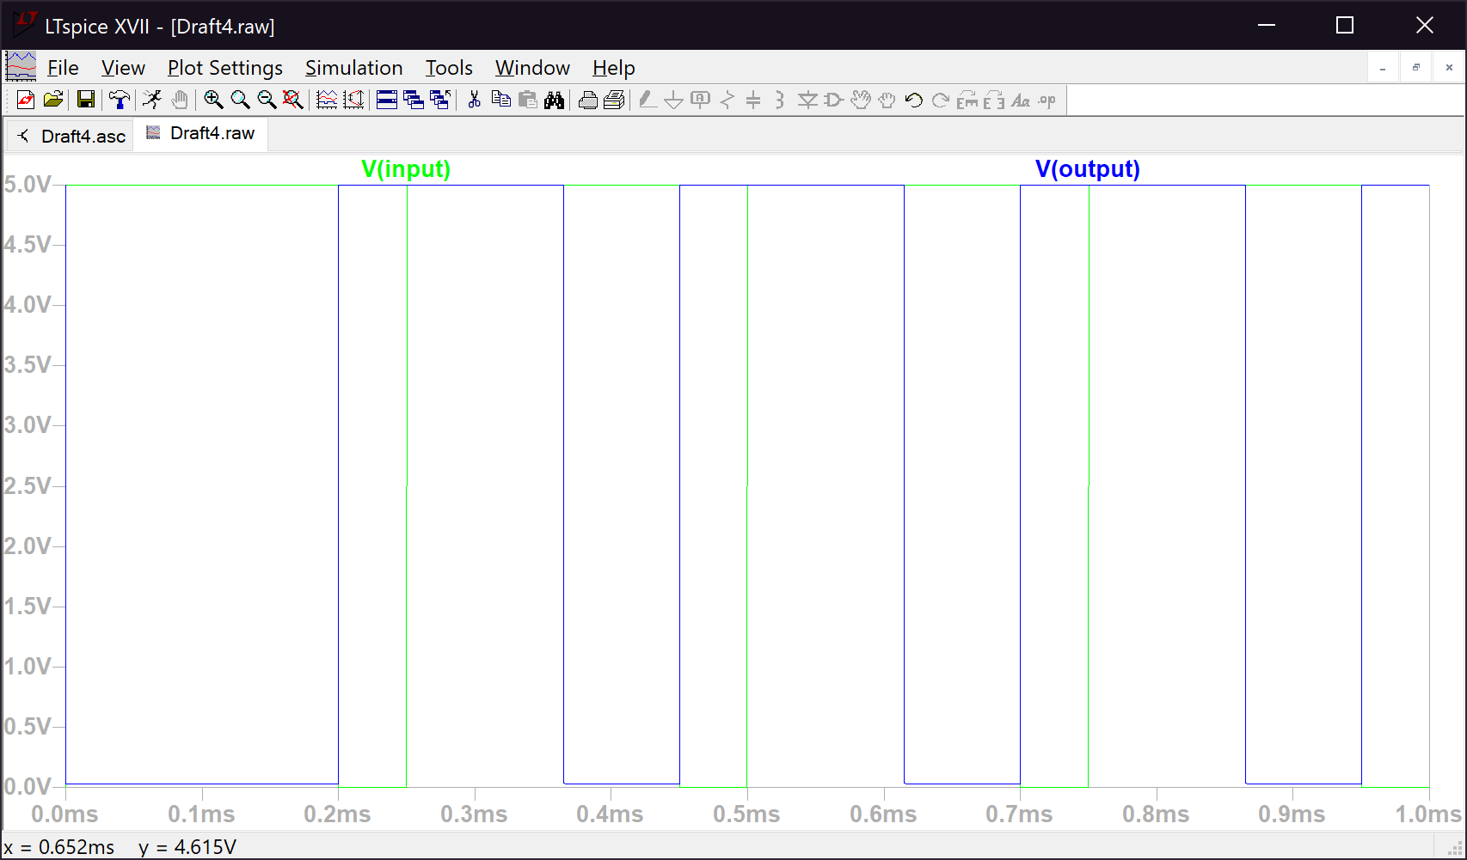Item 2 Plots:

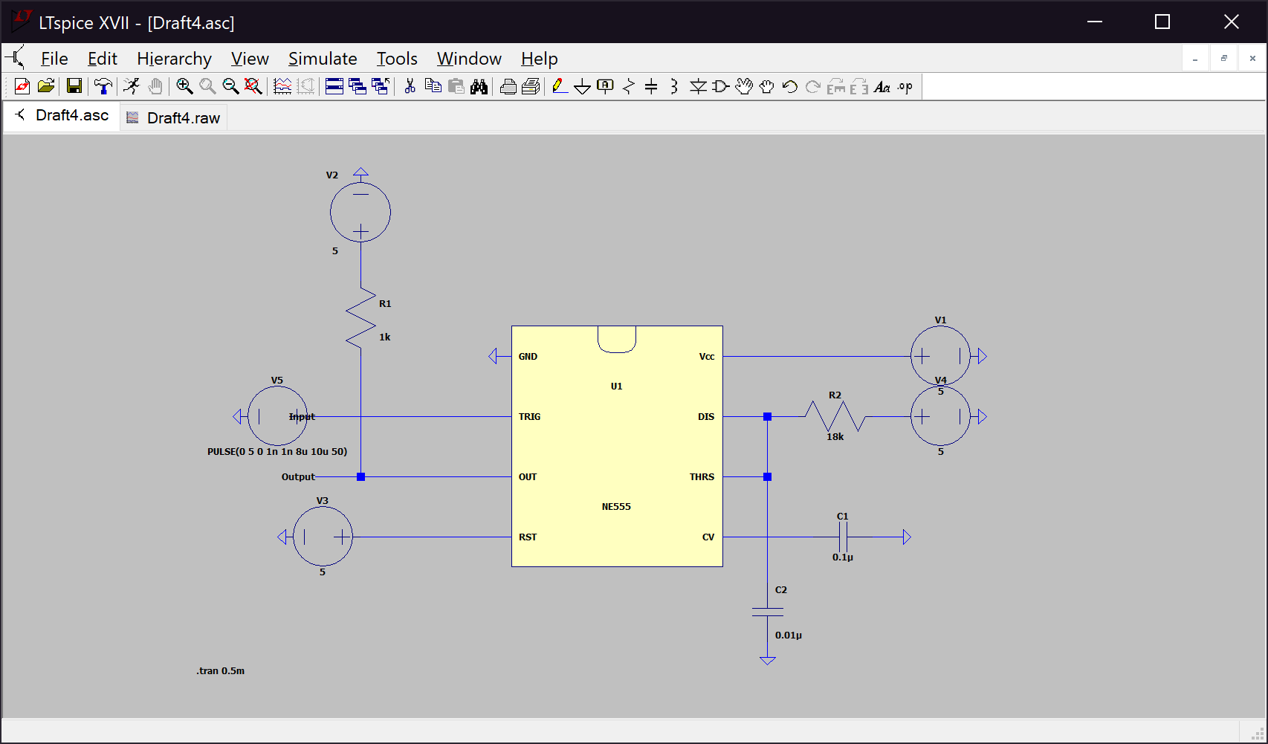Item 3:

Resistor, Capacitor and Voltage Pulse Duration Values:

|  |  |
| --- | --- |
| Resistor Value (RA) | 18kΩ |
| Capacitor Value (CL) | 0.01µF |
| Pulse Start | 8.0547 µs |
| Pulse End | 206.16 µs |
| Pulse Duration | 198.11 µs |

Resistor and Capacitor values were determined with the formula:

$$t=1.1*R_{A}*C_{L}$$

where t = 200 µs.

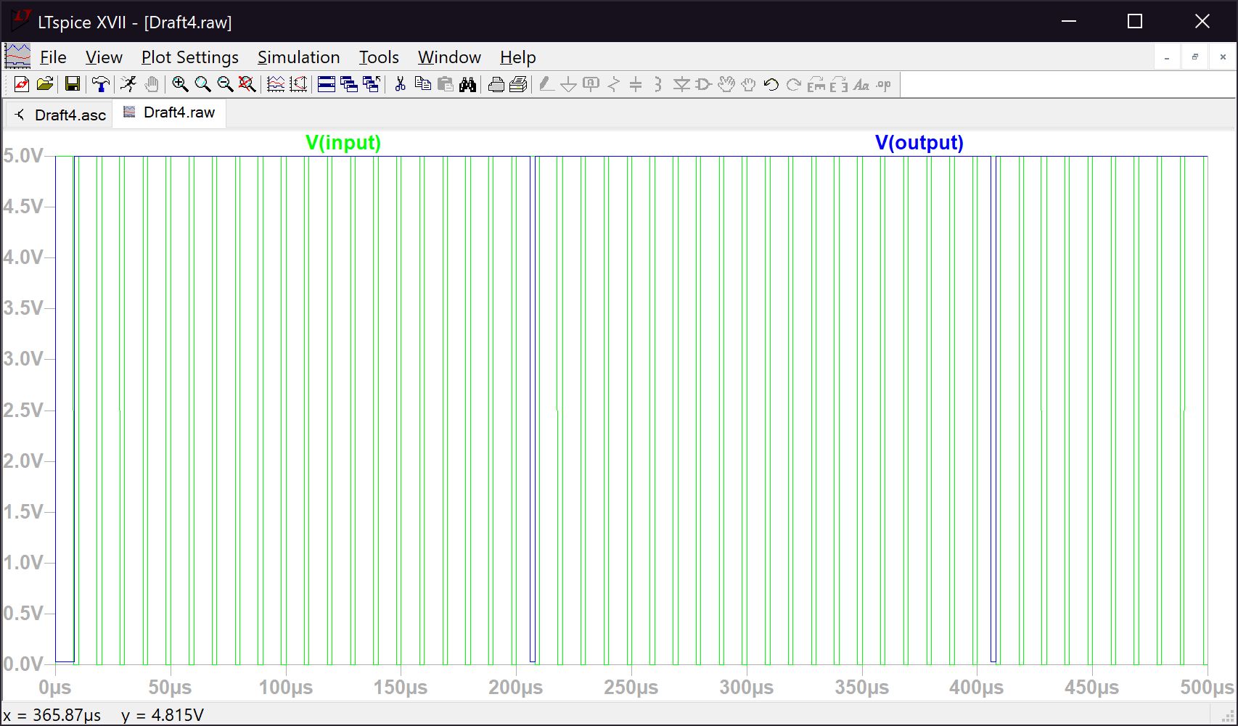Item 3 Plots:

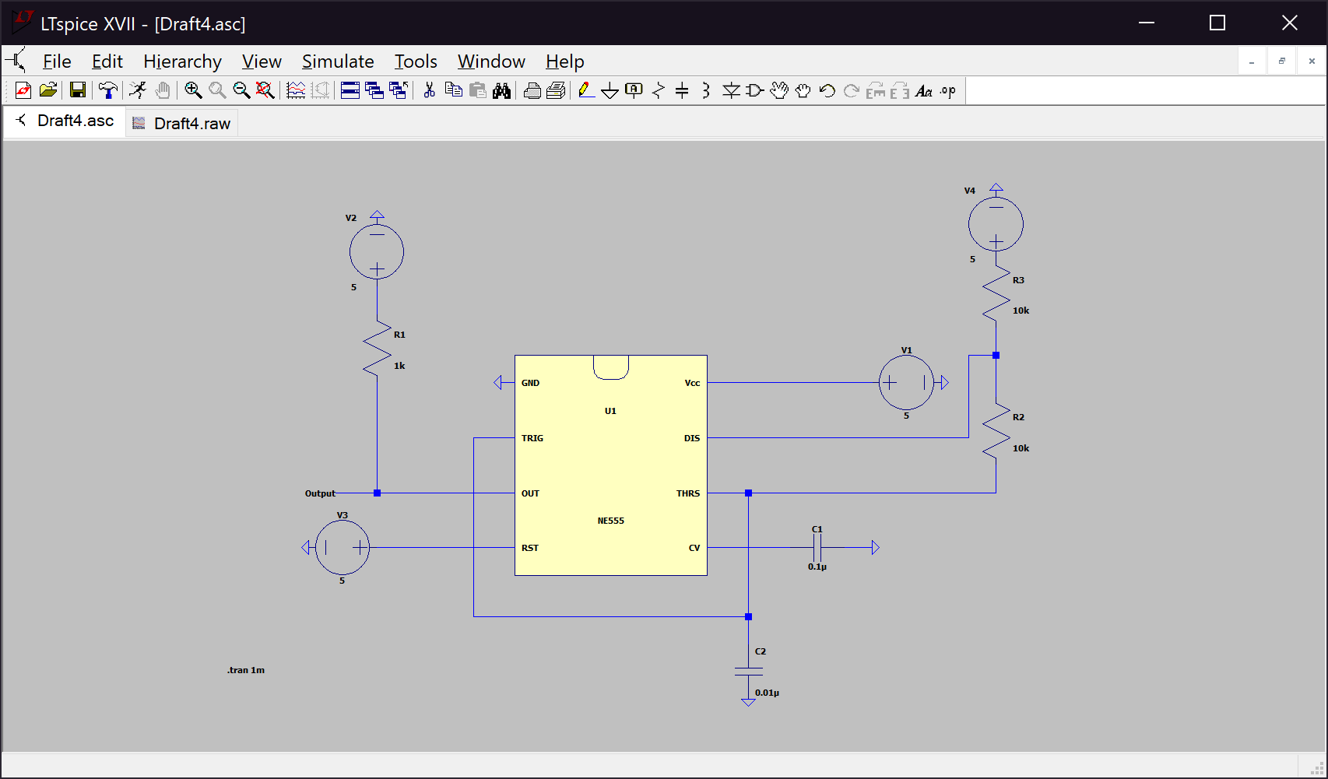Item 4:

Voltage Period:

|  |  |
| --- | --- |
| Period Start | 110.28 µs |
| Period End | 318.93 µs |
| Period | 208.65 µs |

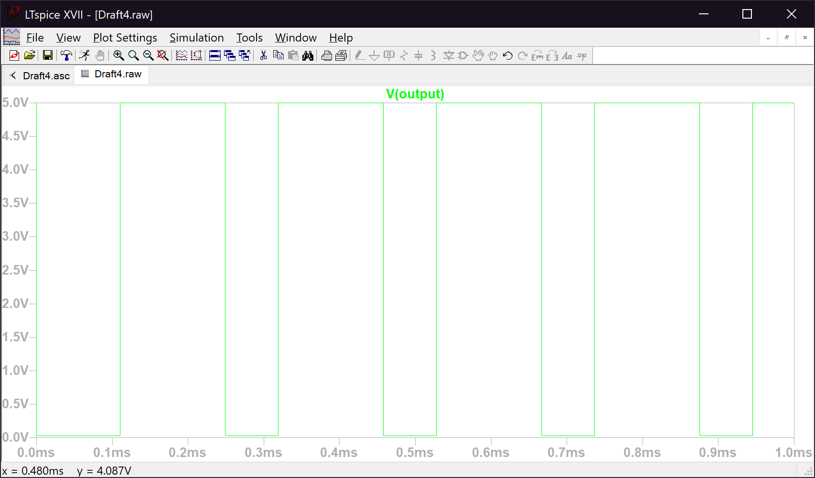Item 4 Plot:

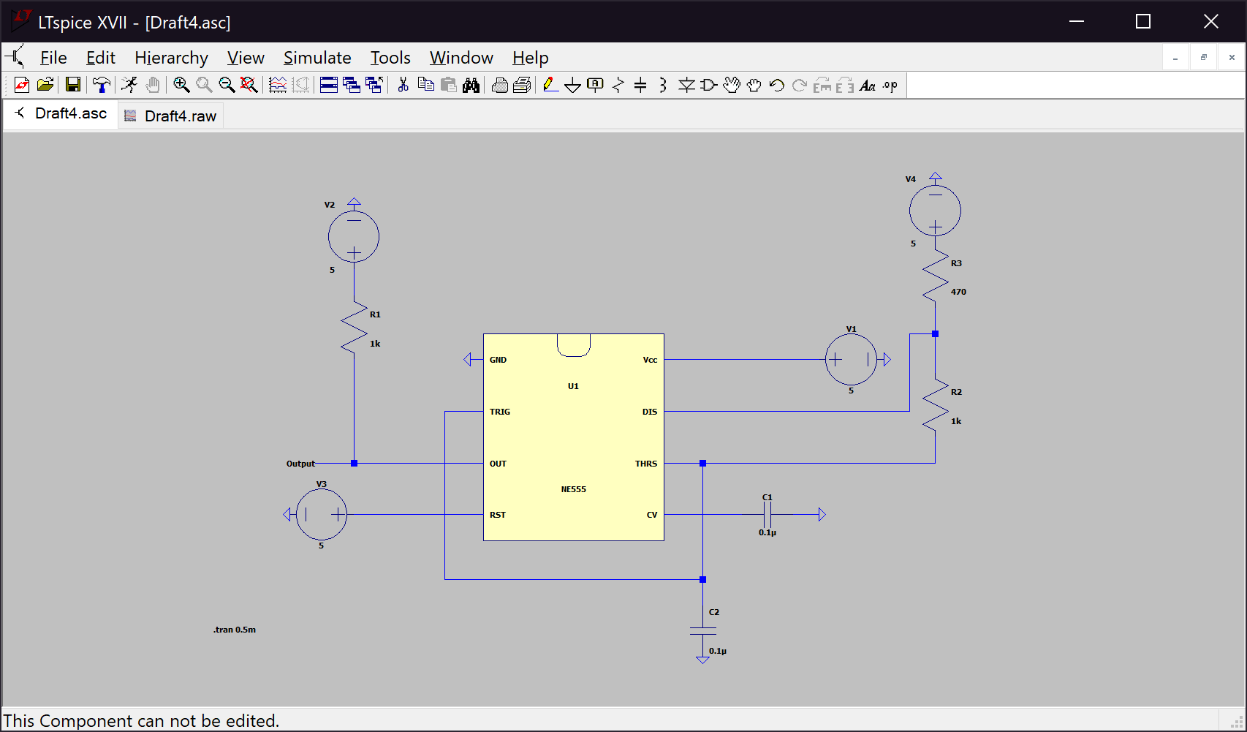Item 5:

Resistor, Capacitor, Voltage Period, and Frequency Values:

|  |  |
| --- | --- |
| Resistor A (RA) | 470Ω |
| Resistor B (RB) | 1kΩ |
| Capacitor (CL) | 0.1µF |
| Period Start | 113.36 µs |
| Period End | 215.60 µs |
| Period | 102.24 µs |
| Frequency | 9.78 kHz |

Resistor and Capacitor values were determined with the formula:

$$t_{High}=0.693*(R_{A}+R_{B})C_{L}$$

where t = 100 µs.

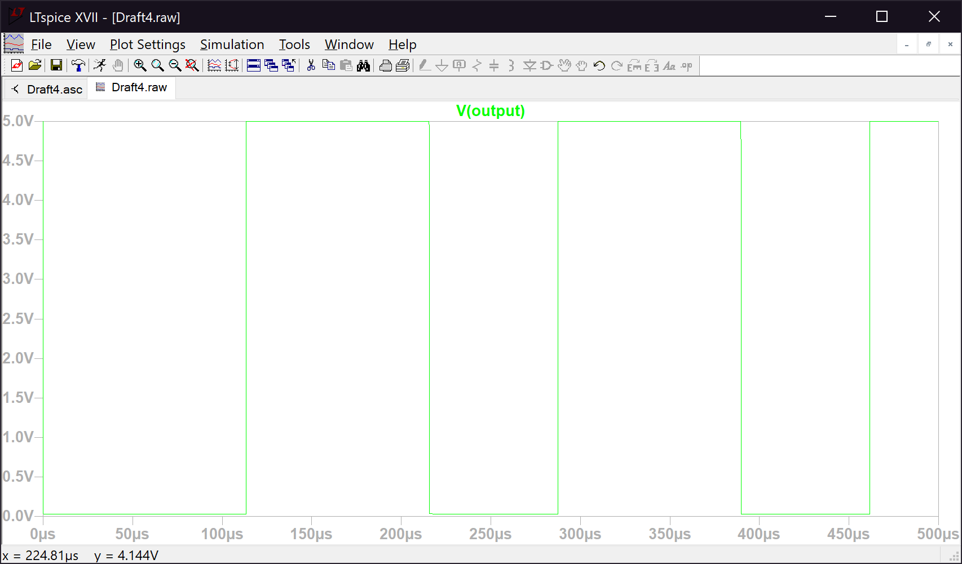Item 5 Plot:

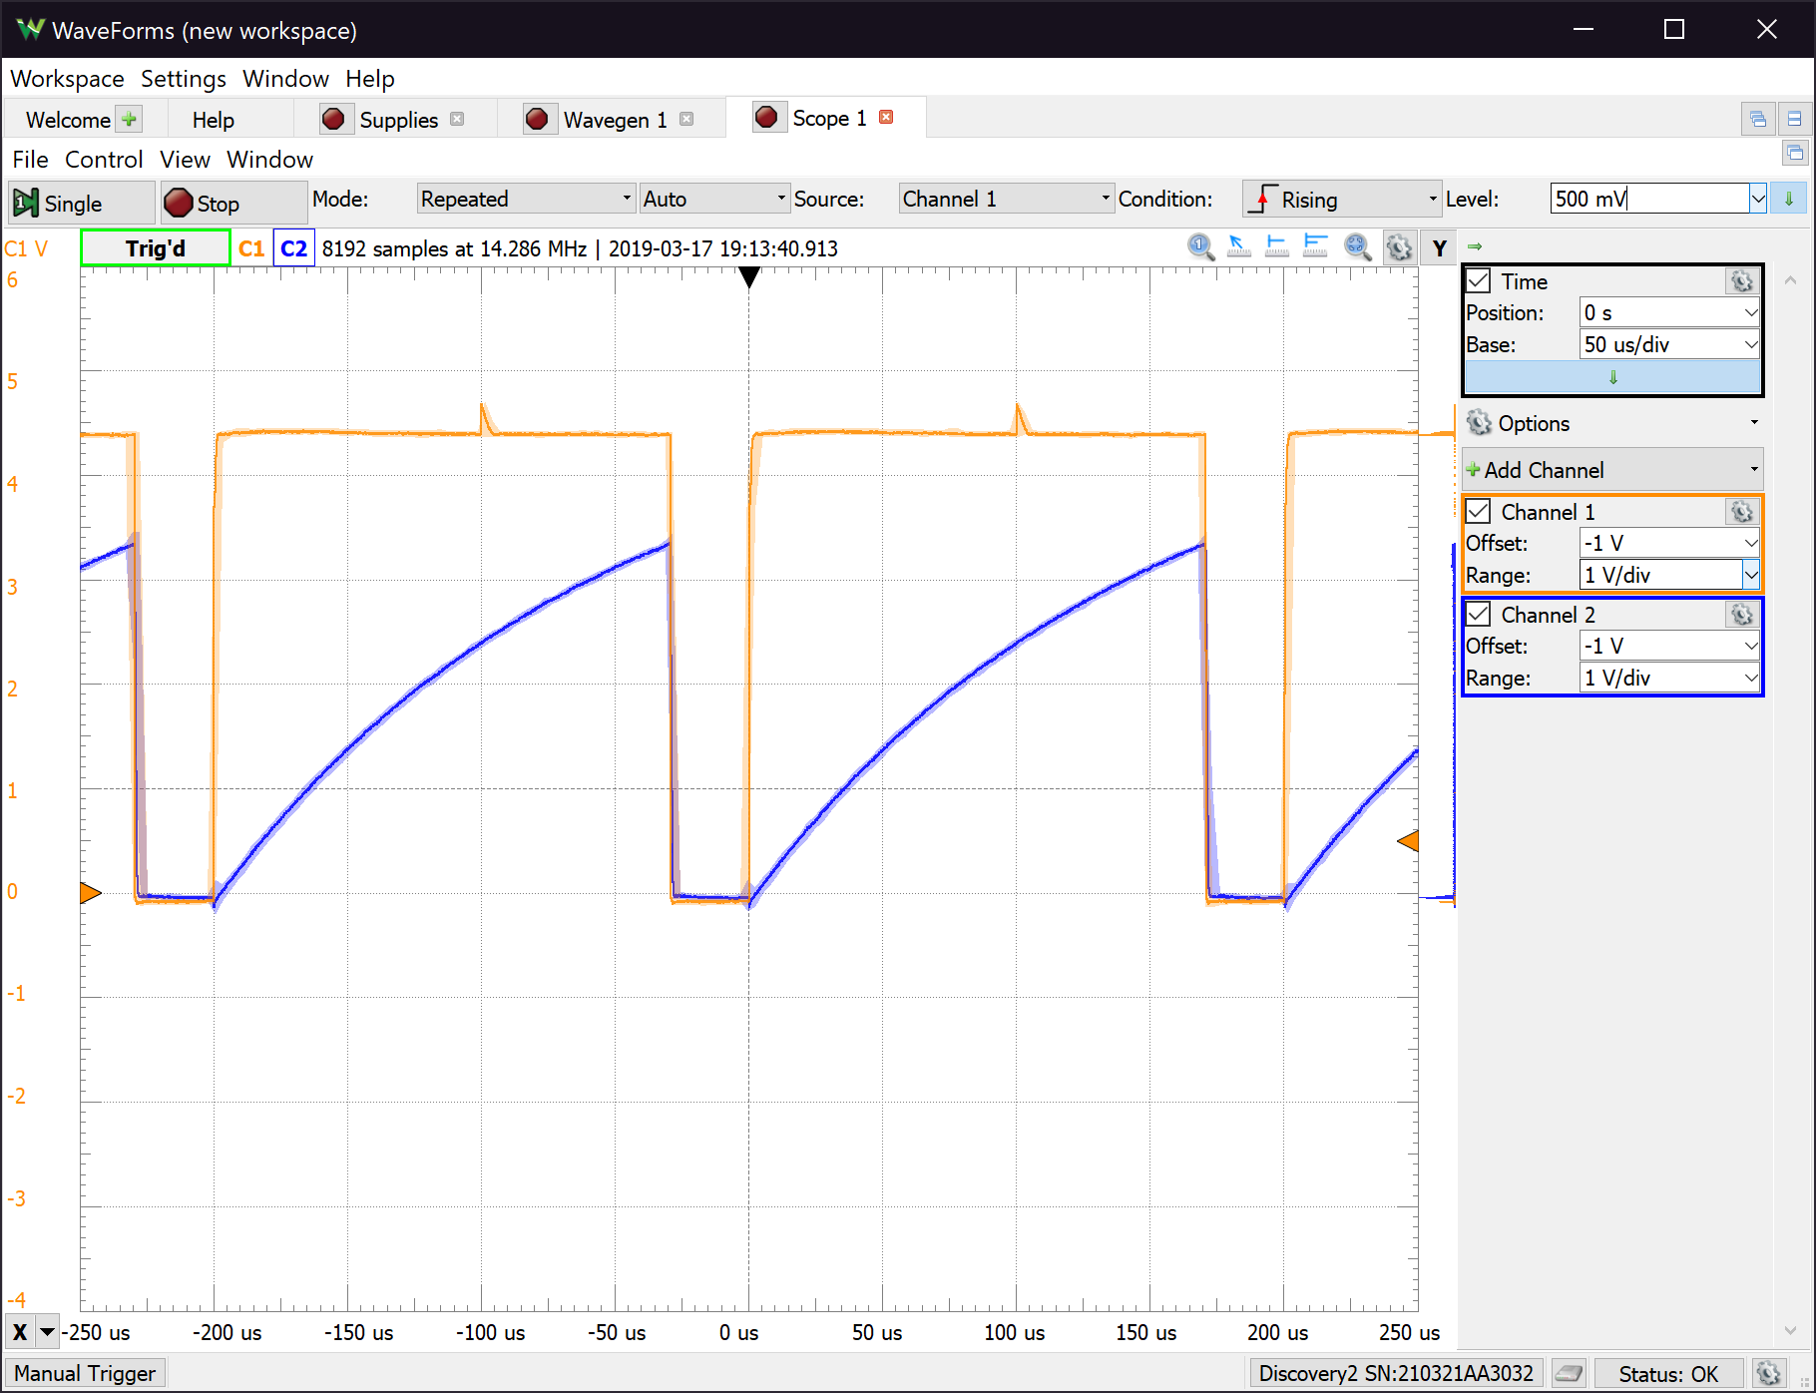*7.5.2 Breadboard Implementation*

Output and Capacitor Voltage for the Breadboard Implementation