**Lab 7**

**Introduction**

In this lab we focused on RC circuits. More specifically, we explored the use of a capacitor and its time constant with a 555 timer.

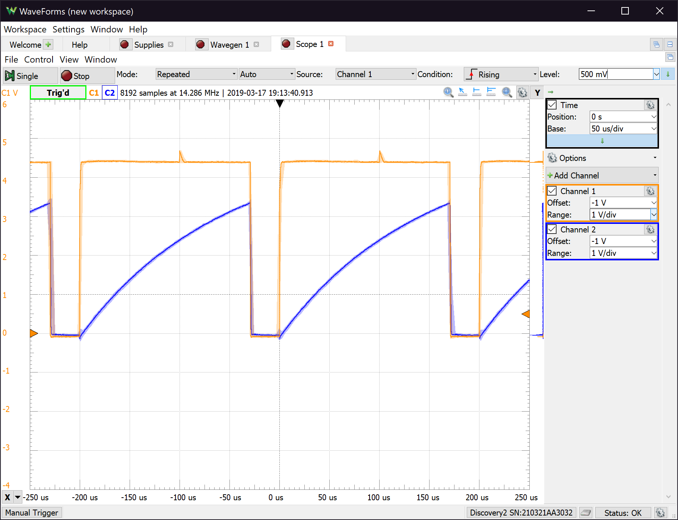**Discussion**

*Figure 1. Plots of the output voltage and capacitor voltage on the o-scope for the circuit from Subsection 7.5.2*

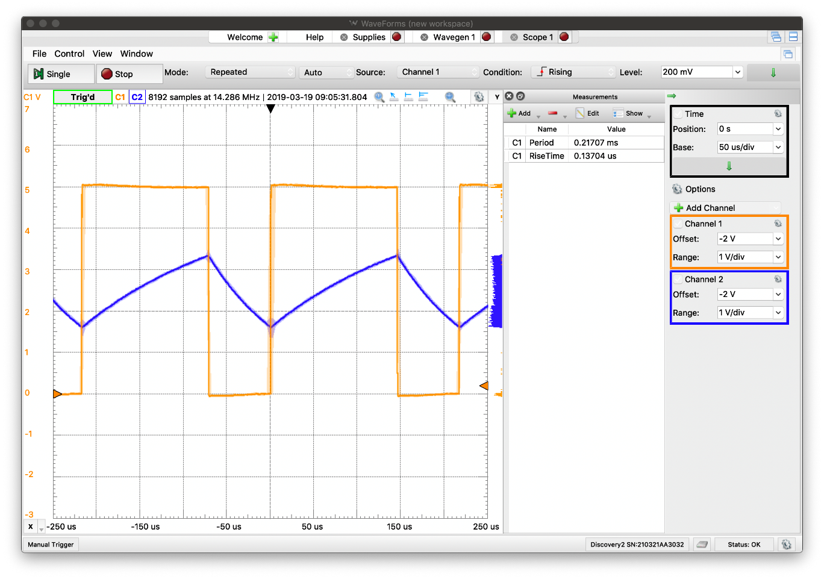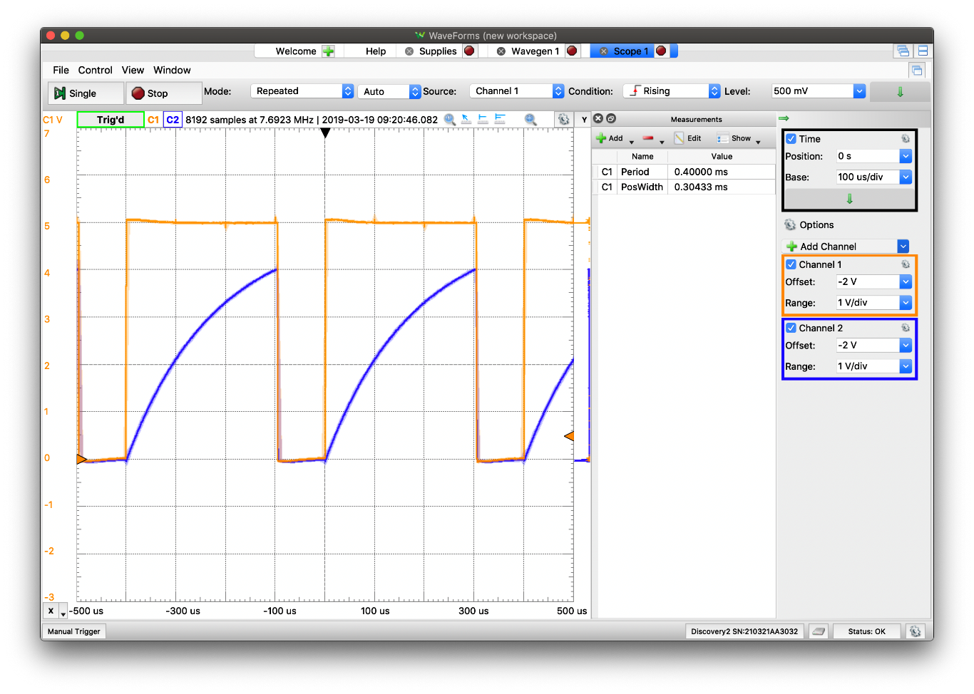*Figure 2. Plots of the output voltage and capacitor voltage on the o-scope for the circuit from Section 7.5.1 Item 3*

*Figure 3. Plots of the output voltage and capacitor voltage on the o-scope for the circuit from Section 7.5.1 Item 4*

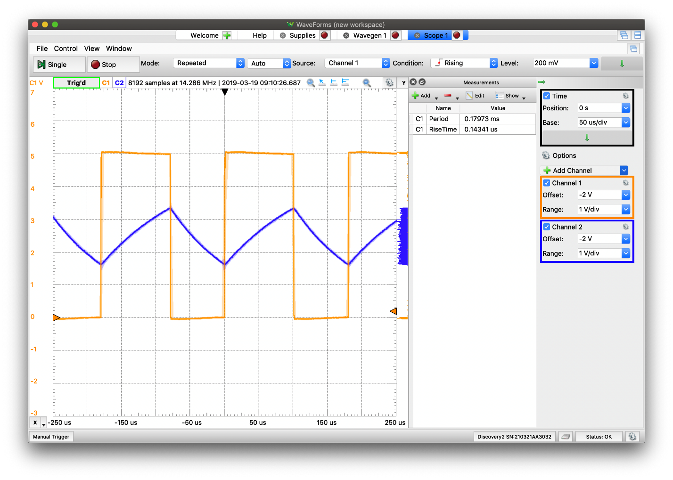*Figure 4. Plots of the output voltage and capacitor voltage on the o-scope for the circuit from Section 7.5.1 Item 5*

*Table 1. Theoretical and Experimental Values for the Pulse Duration (Item 2 & Item 3) and Period (Item 4 & Item 5)*

|  |  |  |  |
| --- | --- | --- | --- |
| 7.5.2 | Theoretical Values | Experimental Values | Percent Error |
| Pulse Duration - Item 2 | 165 µs | 170 µs | 3.03% |
| Pulse Duration - Item 3 | 198.11 µs | 304.33 µs | 53.616% |
| Period Item - 4 | 208.65 µs | 217.07 µs | 4.0355% |
| Period Item - 5 | 102.24 µs | 143.41 µs | 40.268% |

The experimental values are exclusively greater than the theoretical values. There are multiple reasons to why the two values are not equal. Since LTSpice simulates a best-case scenario, it is unreasonable to expect the same results in a real-world circuit. The oscilloscope itself has imperfections that may affect the results. More importantly, the scope probes do not have infinite resistance as it should in a textbook example. Because of this, some current is “stolen” by the oscilloscope which may adversely affect the results. The wires and breadboard may also alter the result if they are slightly faulty or damaged. Also, the resistors influence the results because of their tolerance which is 5%, while the tolerance of the resistors in LTSpice is 0%, and the capacitors used may not have been 100% reliable.

**Conclusion**

In this lab we concluded the many imperfections that exist in real-world circuits. In more complex circuits these imperfections have greater effects on the voltages and current in the circuit, which is why Item 3 and Item 5 have such great errors. They followed the formulas, t = 1.1*R­­ACL and tH = 0.693(RA+RB)CL, respectively, however the formulas hold for textbook circuits and not exactly for real-world ones.