**Pre-Lab 8**

Fran Luka Antoljak

*8.5.1 LTspice Simulations*

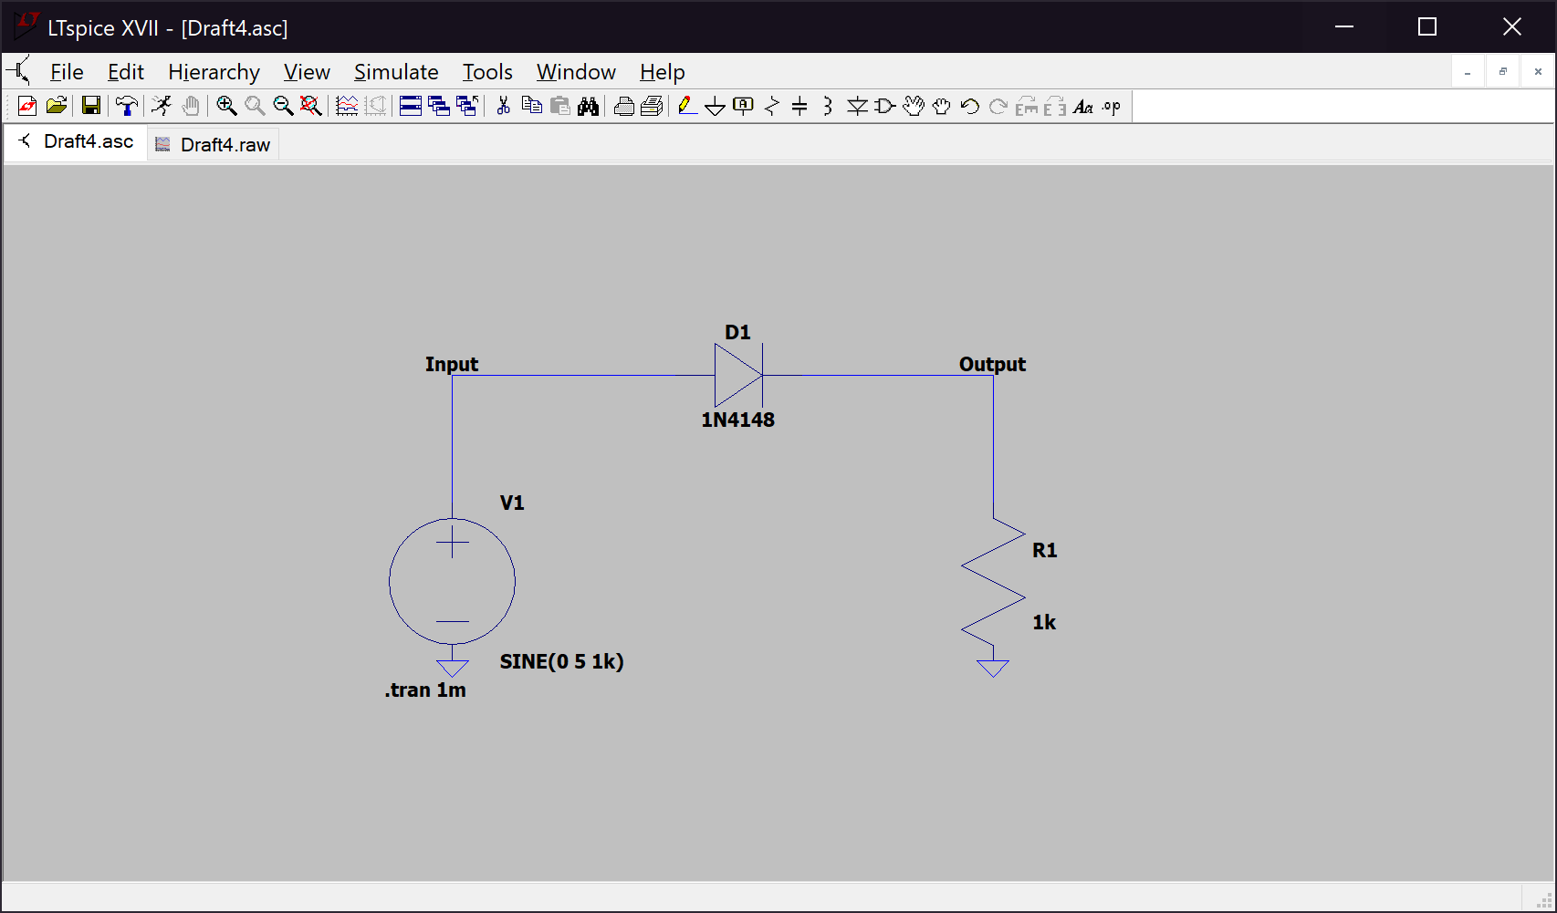Item 1:

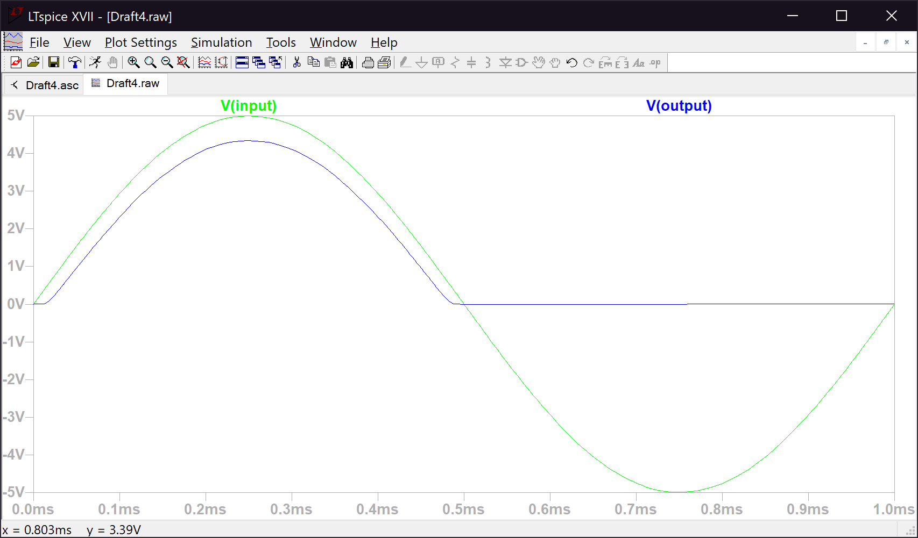Item 1 Plots:

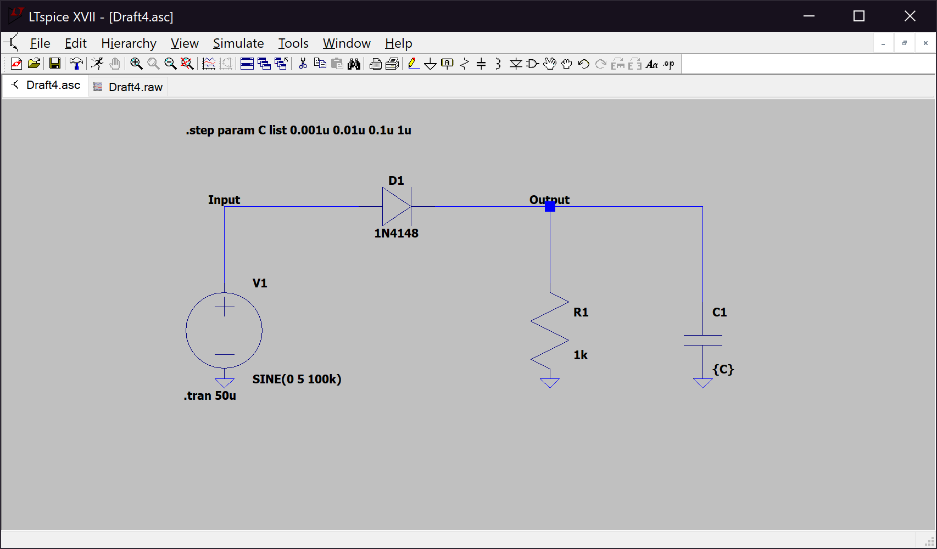Item 2:

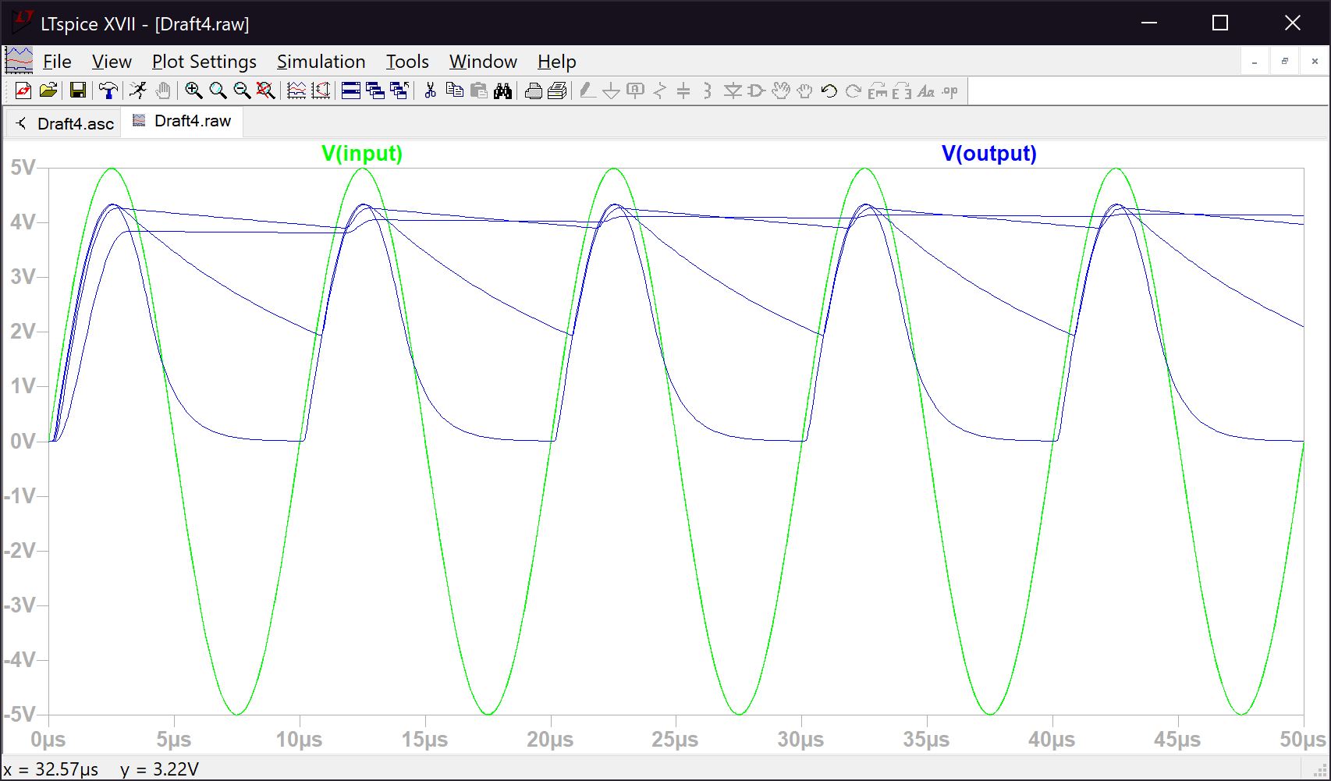Item 2 Plots:

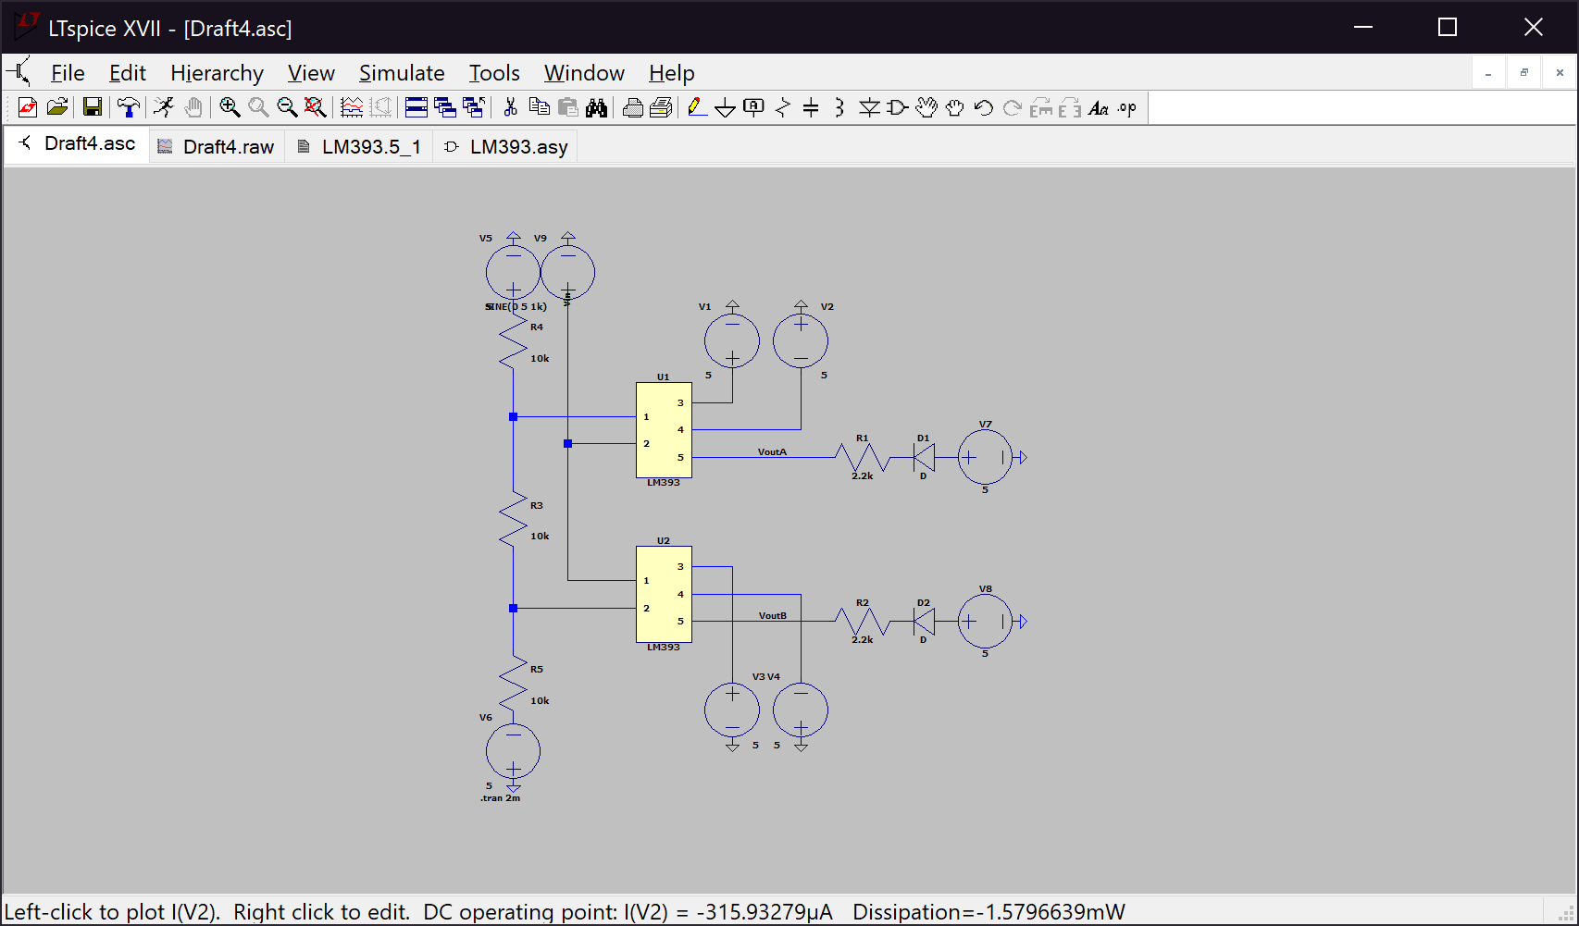Item 3:

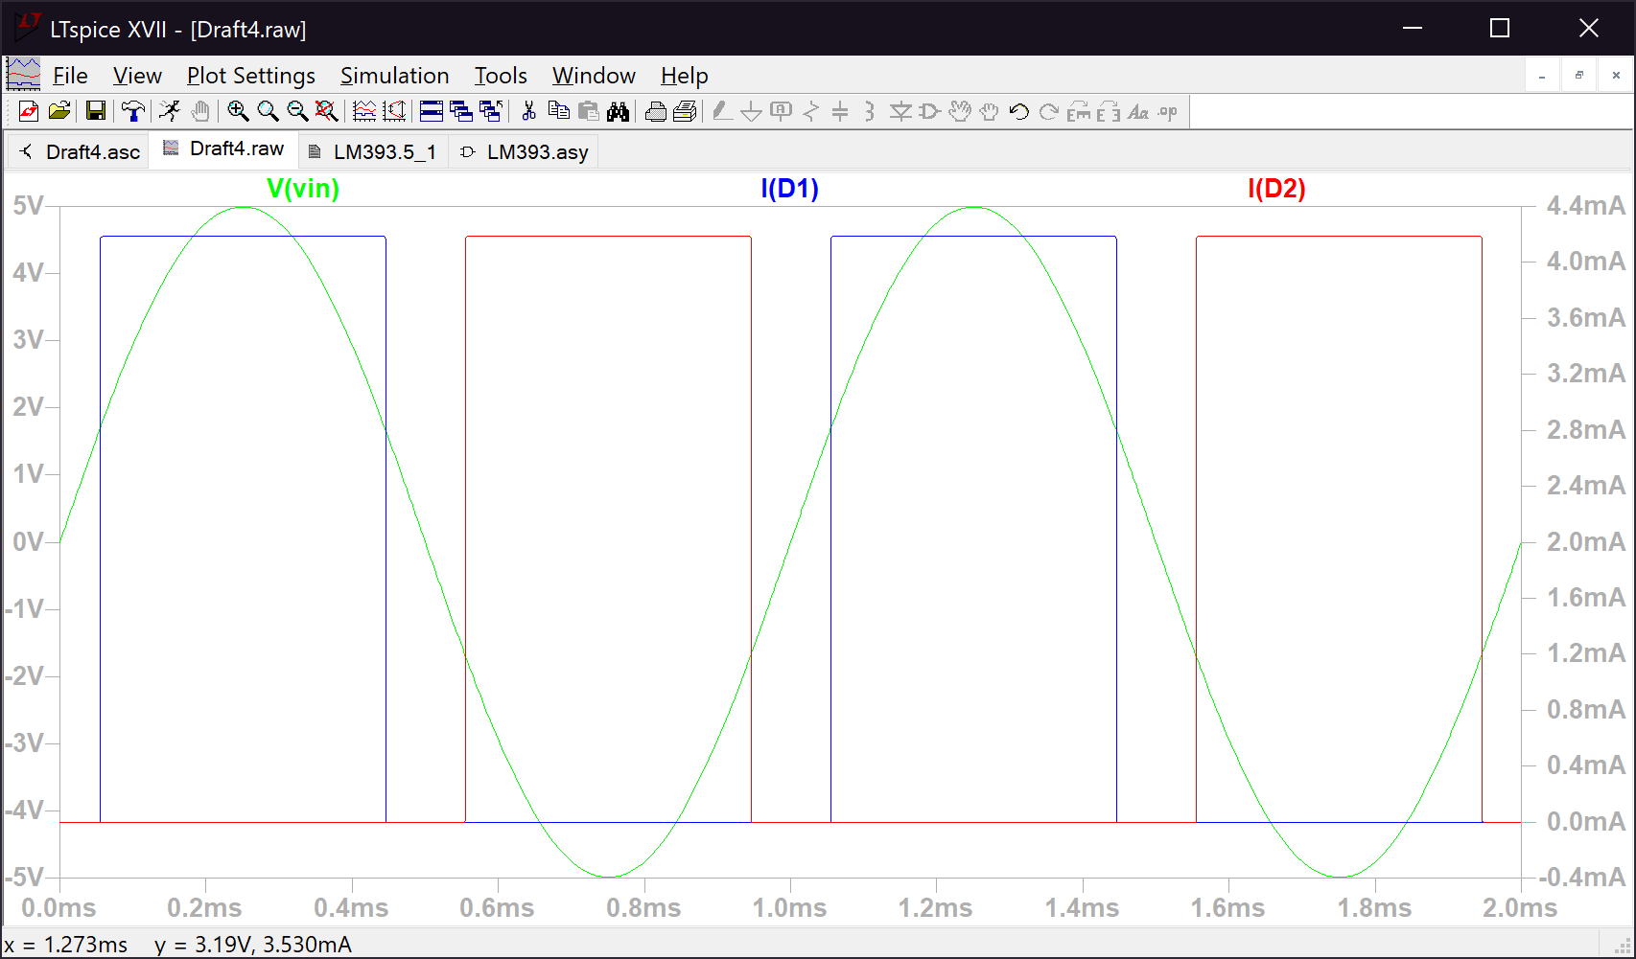Item 3 Plots:

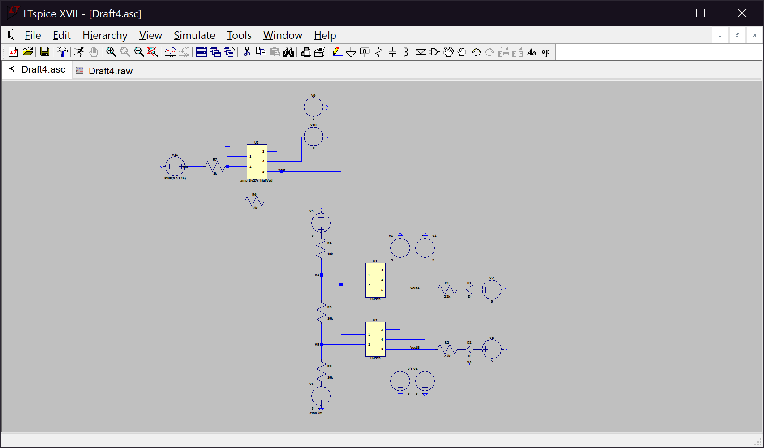Item 4 (R = 1kΩ):

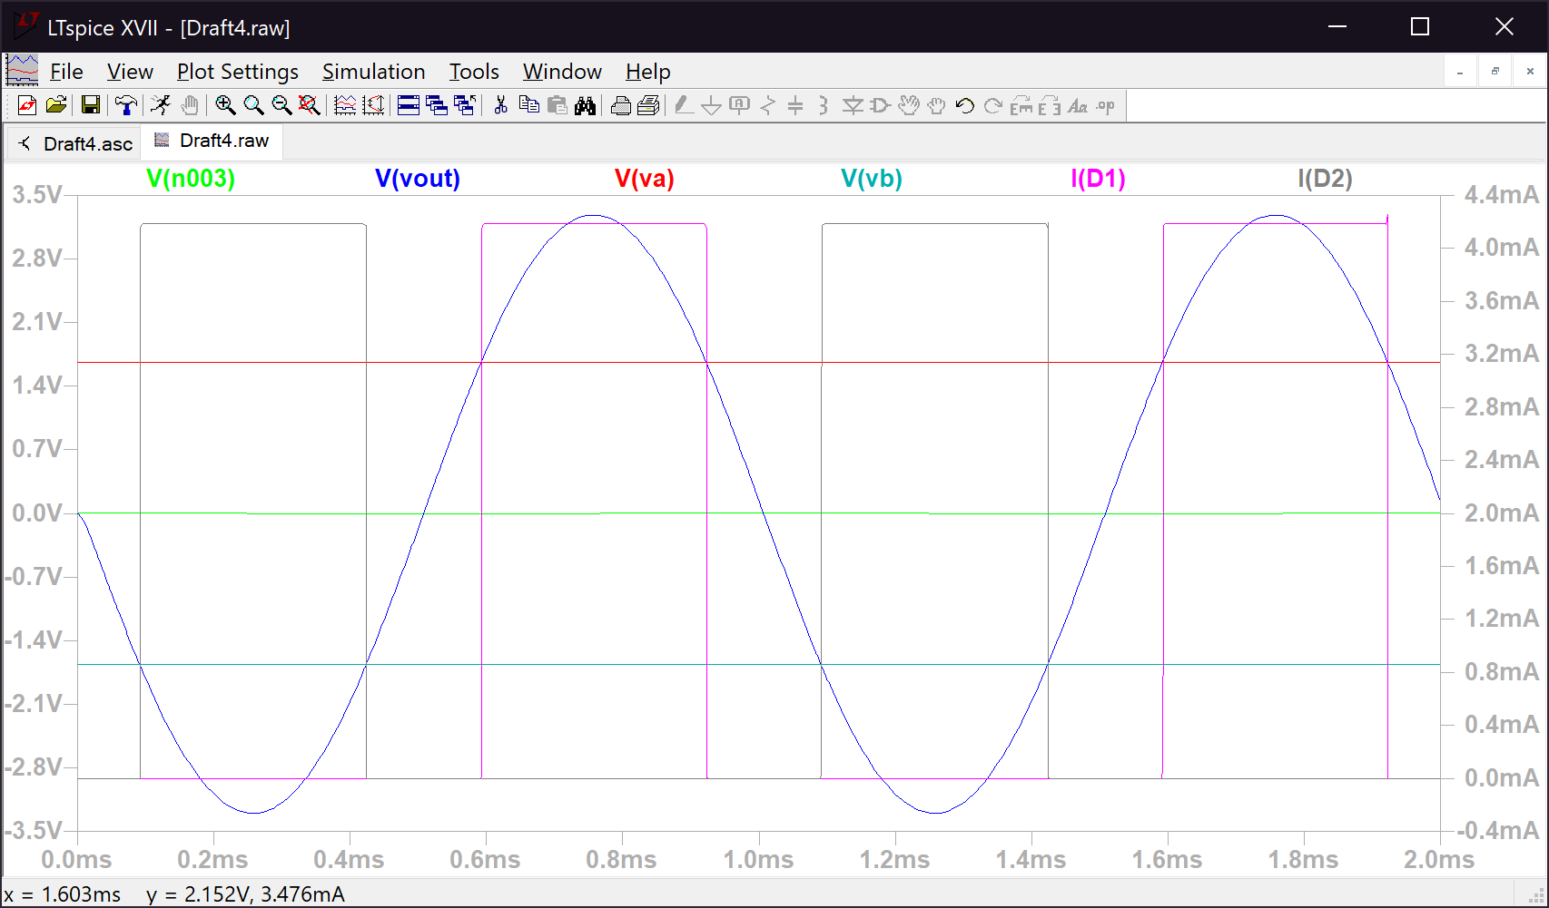Item 4 Plots (R = 1kΩ):