**Lab 8**

**Introduction**

In this lab we focused on diodes. We saw a few of their applications in various circuits.

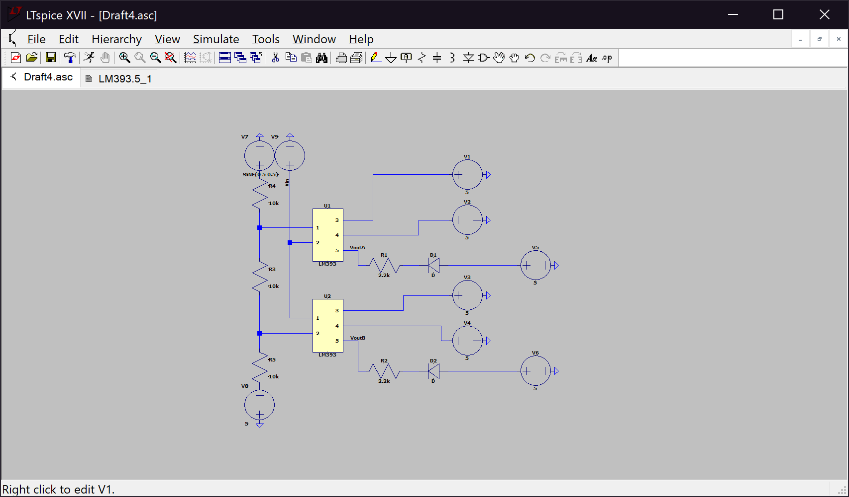**Discussion**

U1B

U1A

VB

VA

*Figure 1. Item 1 circuit diagram*

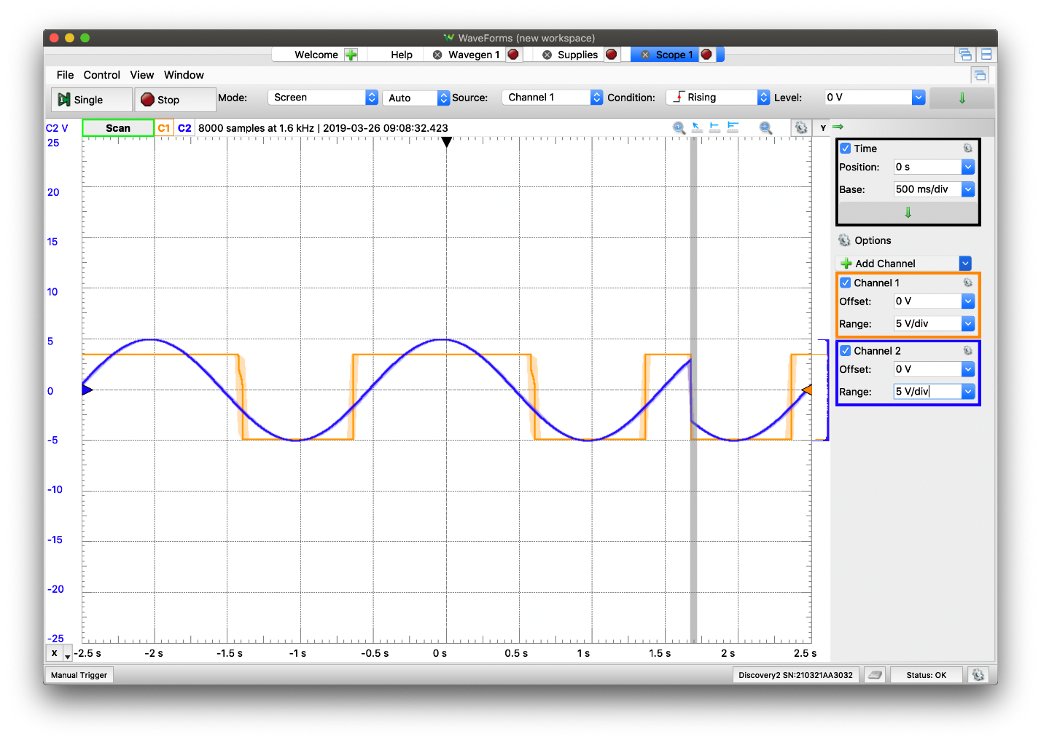*Figure 2. Input (blue) and one of the output voltages (orange) of Item 1*

The purpose of this circuit is to detect clipping. We compare the input with voltages VA and VB by using the comparators U1A and U1B. Depending on if the input voltage is greater than or less than VA/VB the LED is lights up. The limitation to this circuit is that the forward voltage limits how much of the signal can be rectified.

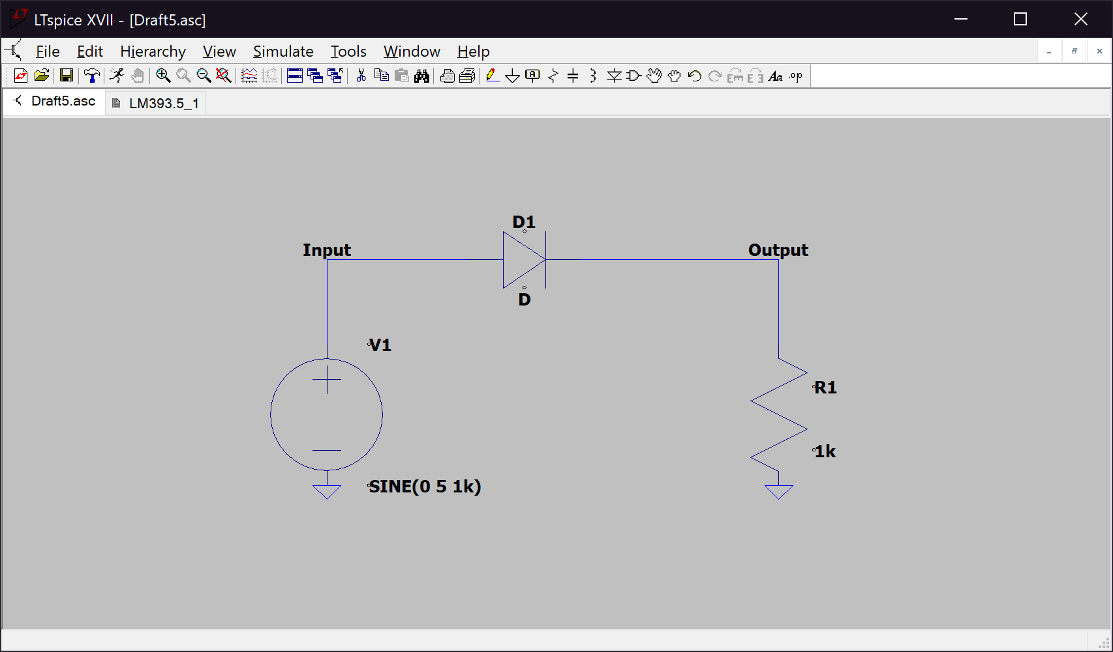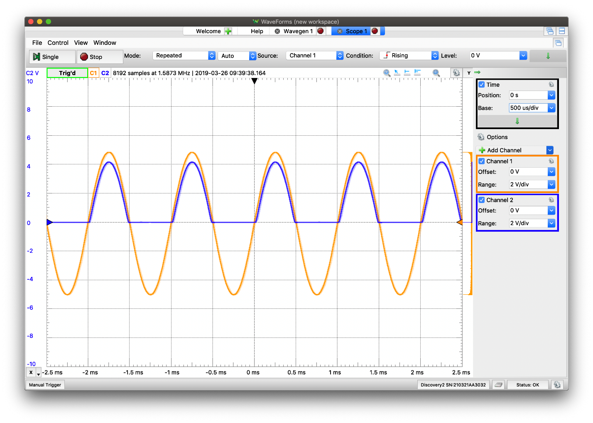*Figure 3. Item 2 circuit diagram*

*Figure 4. Input (orange) and output (blue) voltages for Item 2*

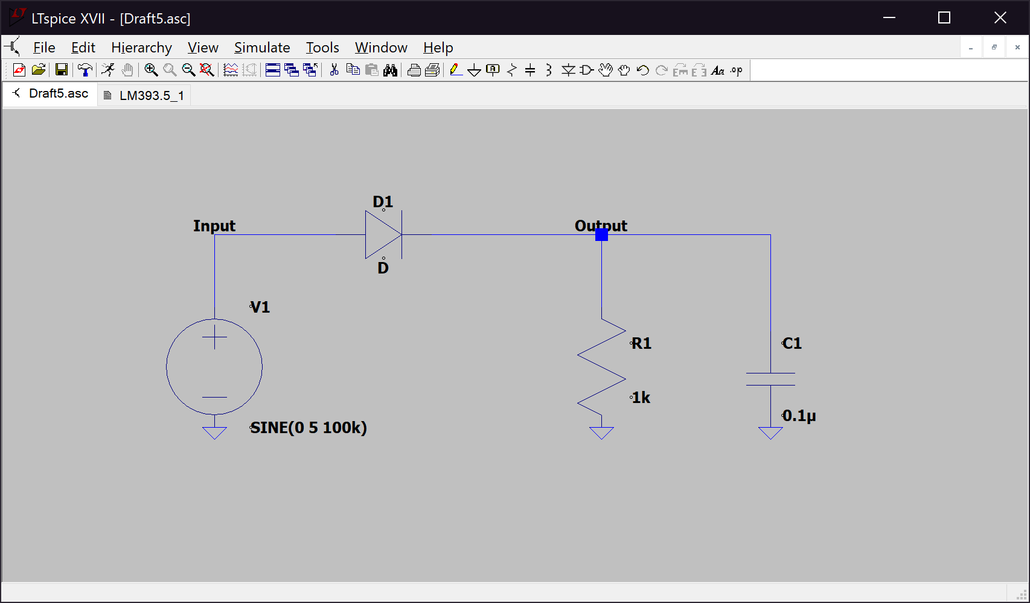 Item 2 is a half wave rectifier. The limitations to this circuit are its low power output and rectification frequency (because power is delivered for one half-cycle).

*Figure 5. Item 3 circuit diagram*

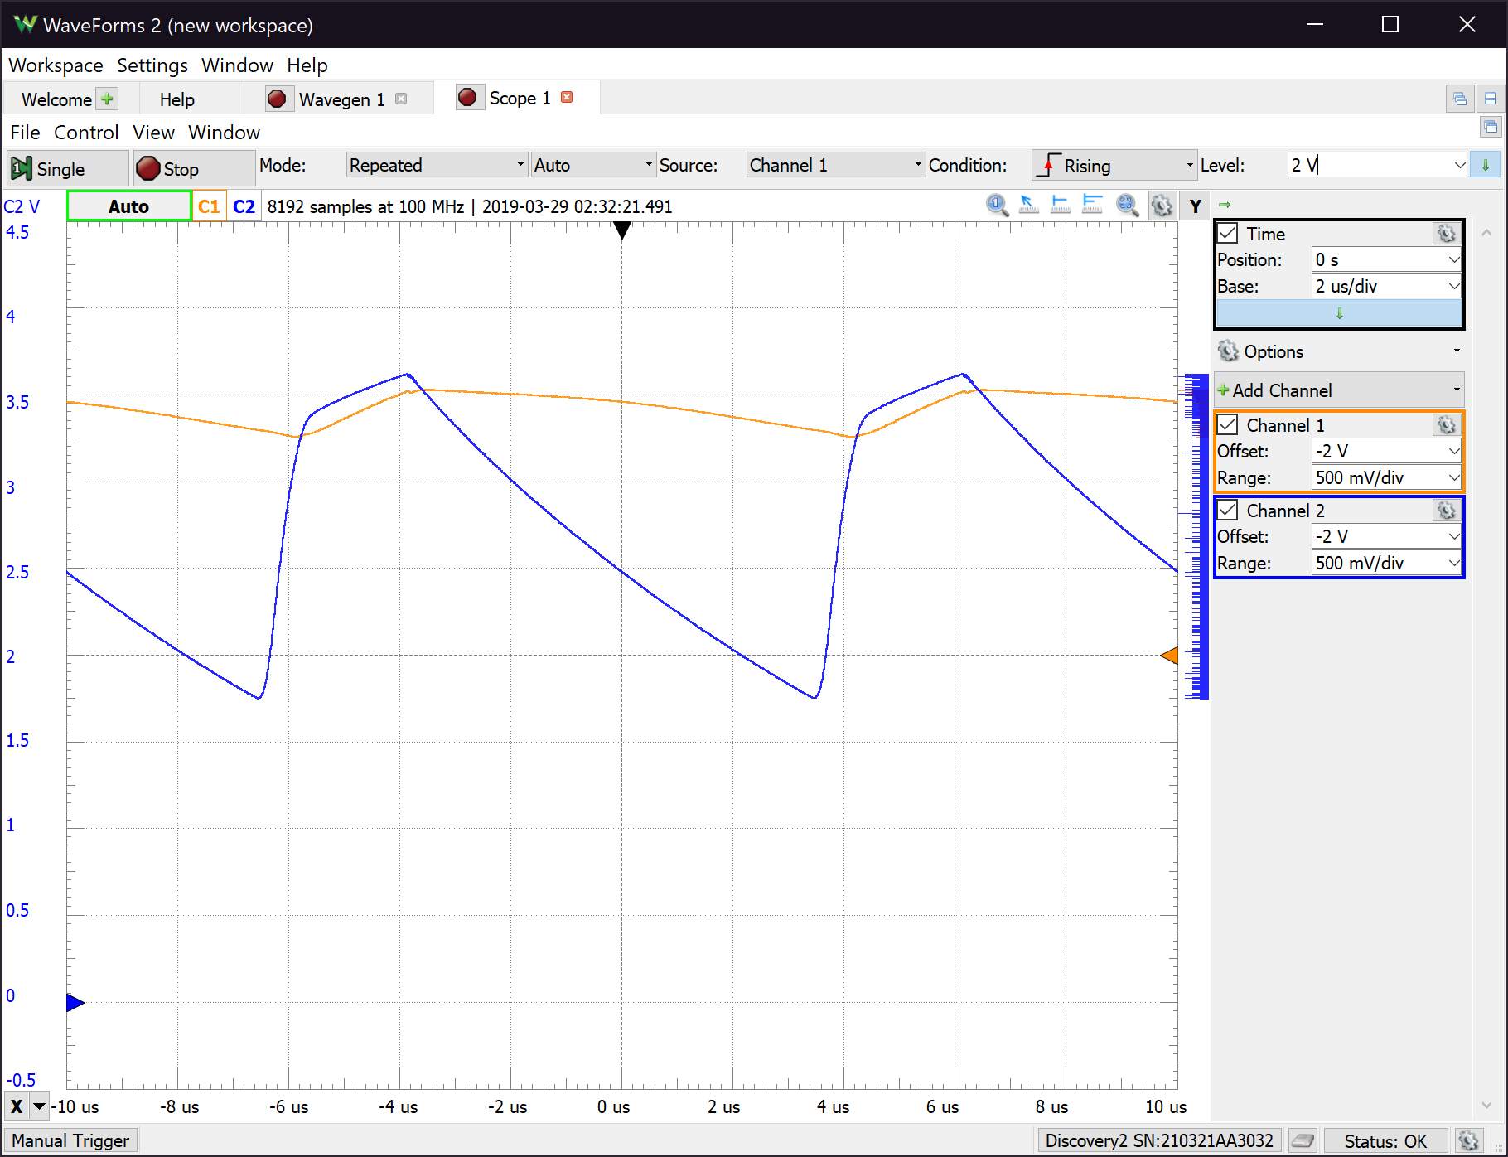

*Figure 6. Both output voltages for Item 3 (orange - 0.1 µF, blue - 0.01 µF)*

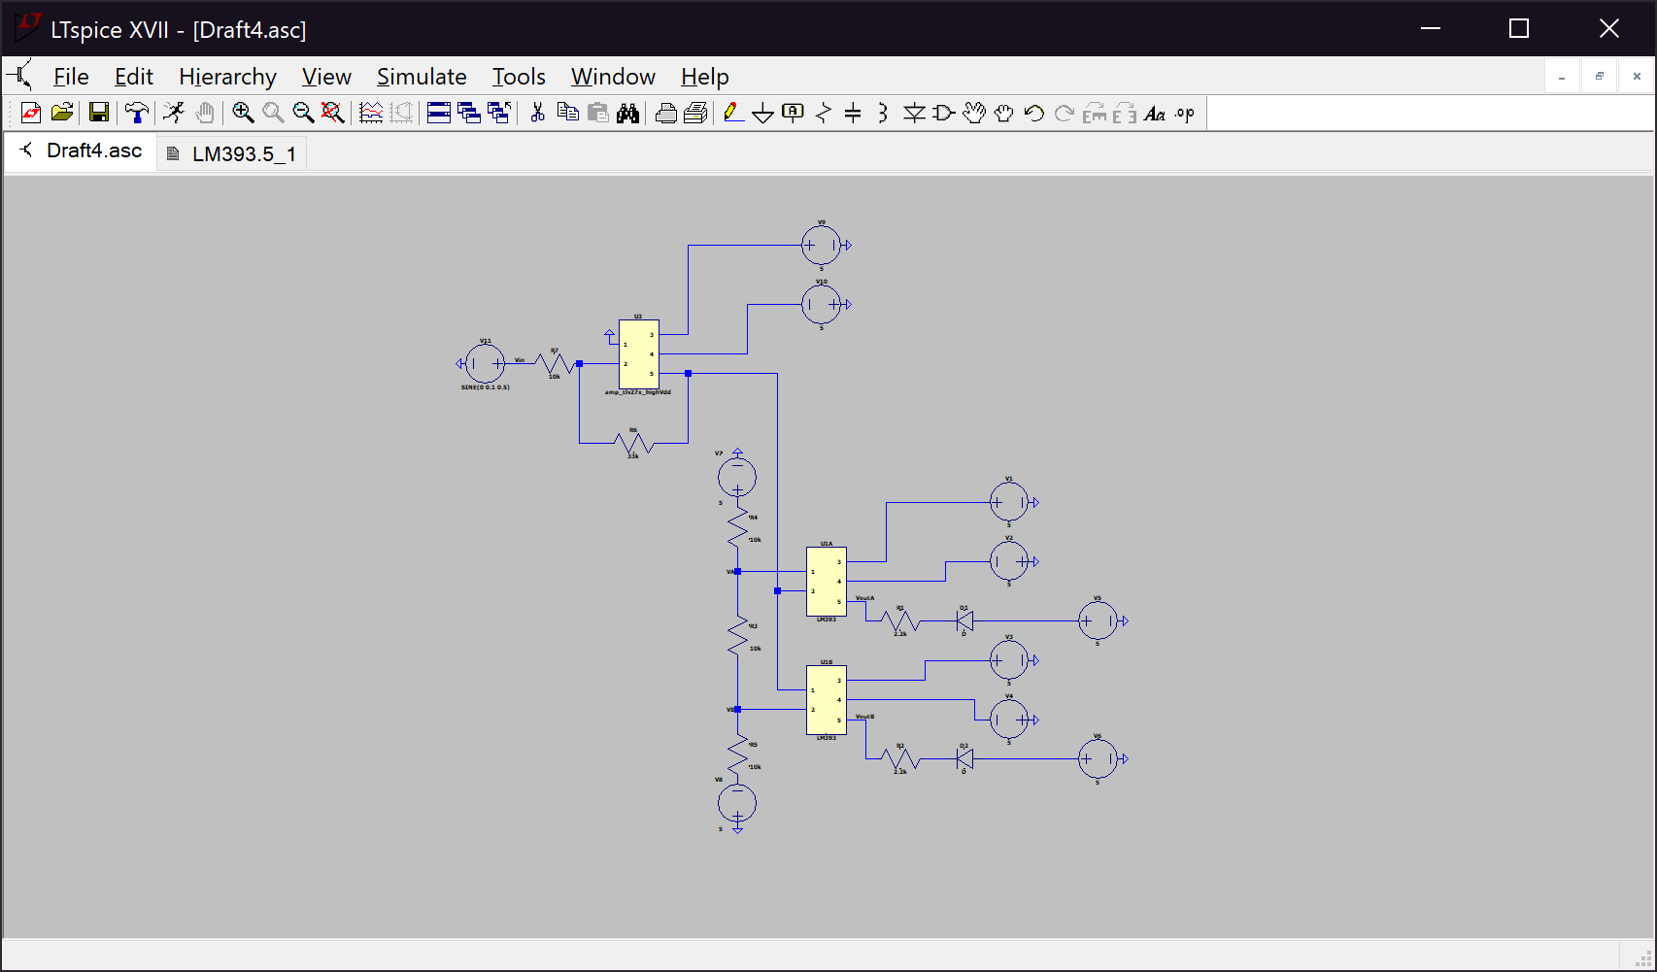 Item 3 is also a half wave rectifier but with a capacitor at the output. As seen on the plots of the output voltages, the capacitors do not allow the voltage change as quick as in Item 2. The limitations to Item 3 are similar to those of Item 2, however with the added capacitor, the reliability of the capacitor adds an additional limitation to Item 3.

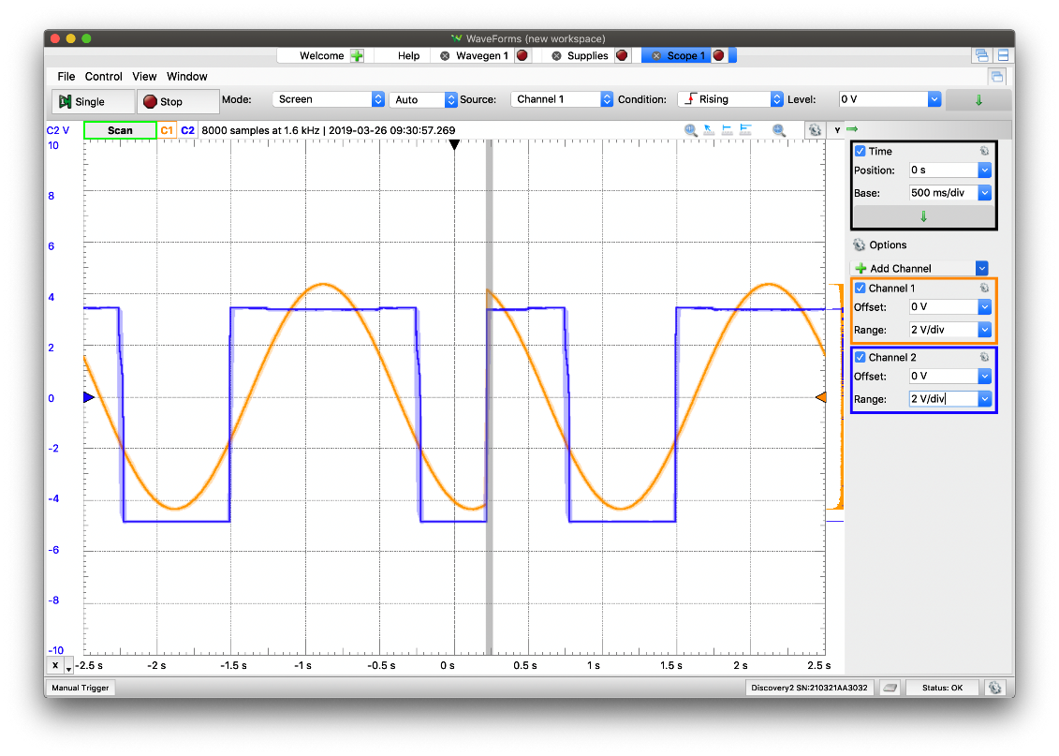*Figure 7. Item 4 circuit diagram*

*Figure 8. Output voltage of the amplifier (orange) and output of one comparator (blue)*

Item 4 is a variable gain amplifier where the output is checked for clipping. The limitations to Item 4 are the same as Item 1, with added limitations due to the added op-amp. The limitations added are that the input current of the op-amp is not equal to zero, the input impedance is not infinite, the output impedance is not equal to zero, and there is not infinite gain.

**Conclusion**

In this lab we explored the various limitations of the diode and reviewed the limitations of the op-amp. The diode is limited by its forward voltage which limits signal rectification. The limitations of the op-amp are familiar as we explored them in the past. Its input current is not equal to zero, input impedance is not infinite, output impedance is not zero, and its gain is not infinite.