**Pre-Lab 9**

Fran Luka Antoljak

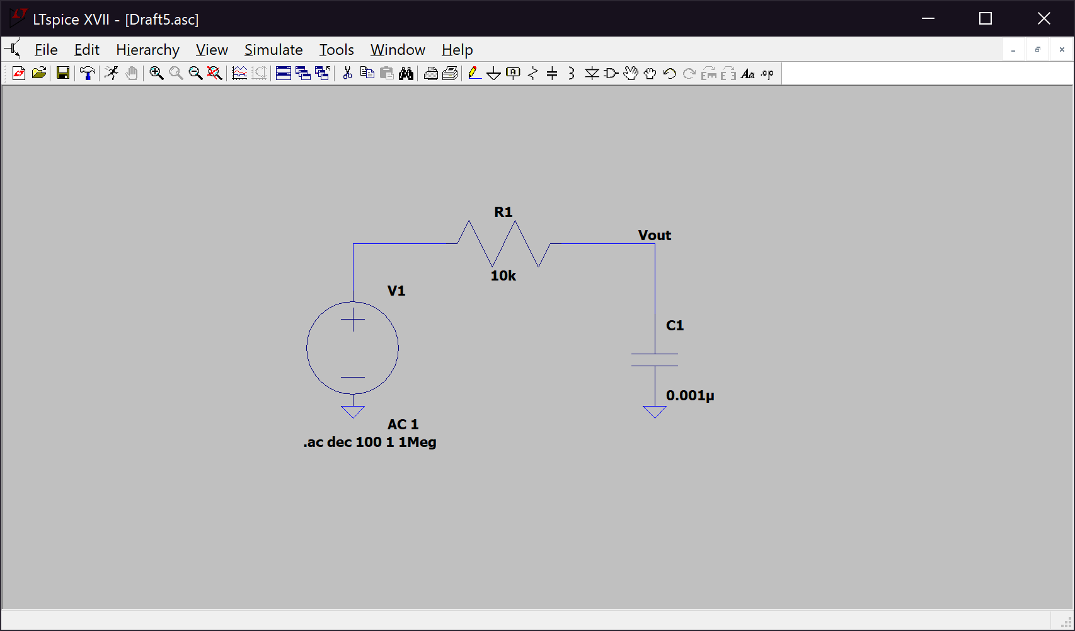*9.5.1 LTspice Simulations*

­*Figure 1. Circuit for Item 2*

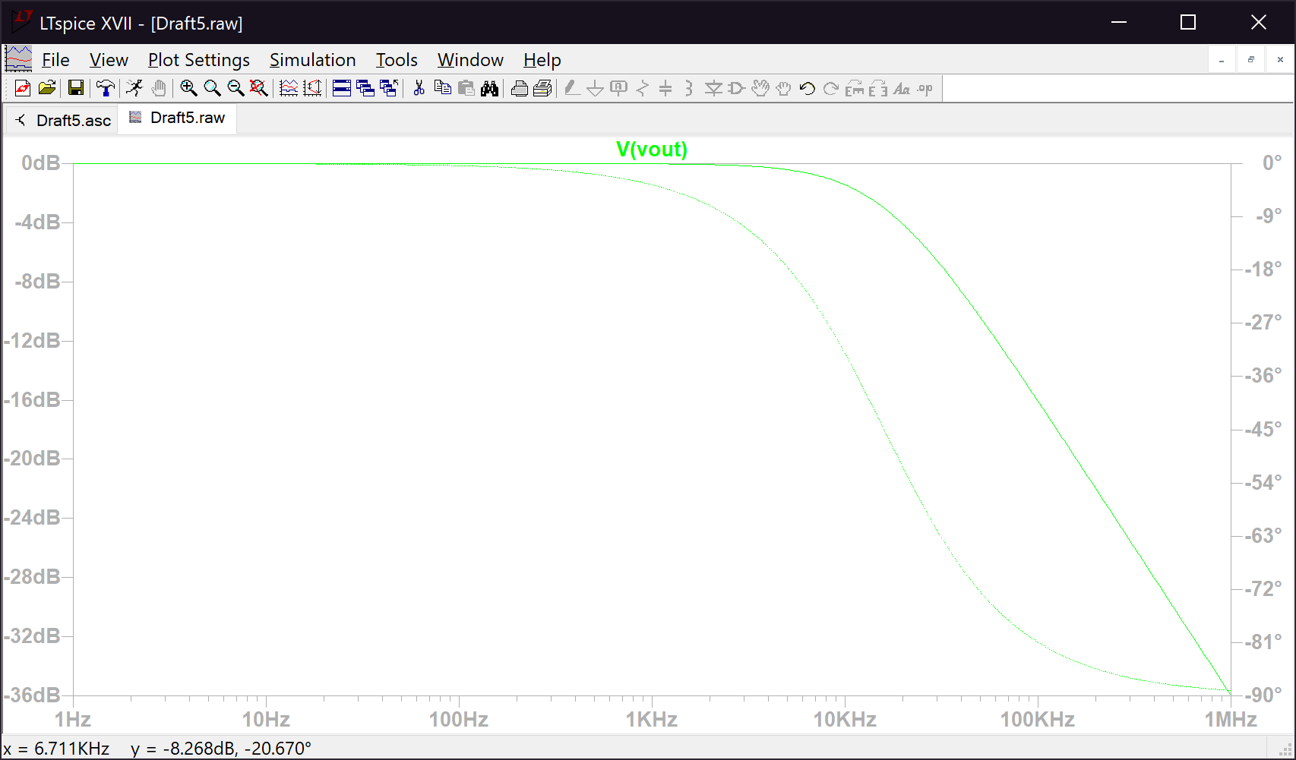

*Figure 2. Output for Item 2*

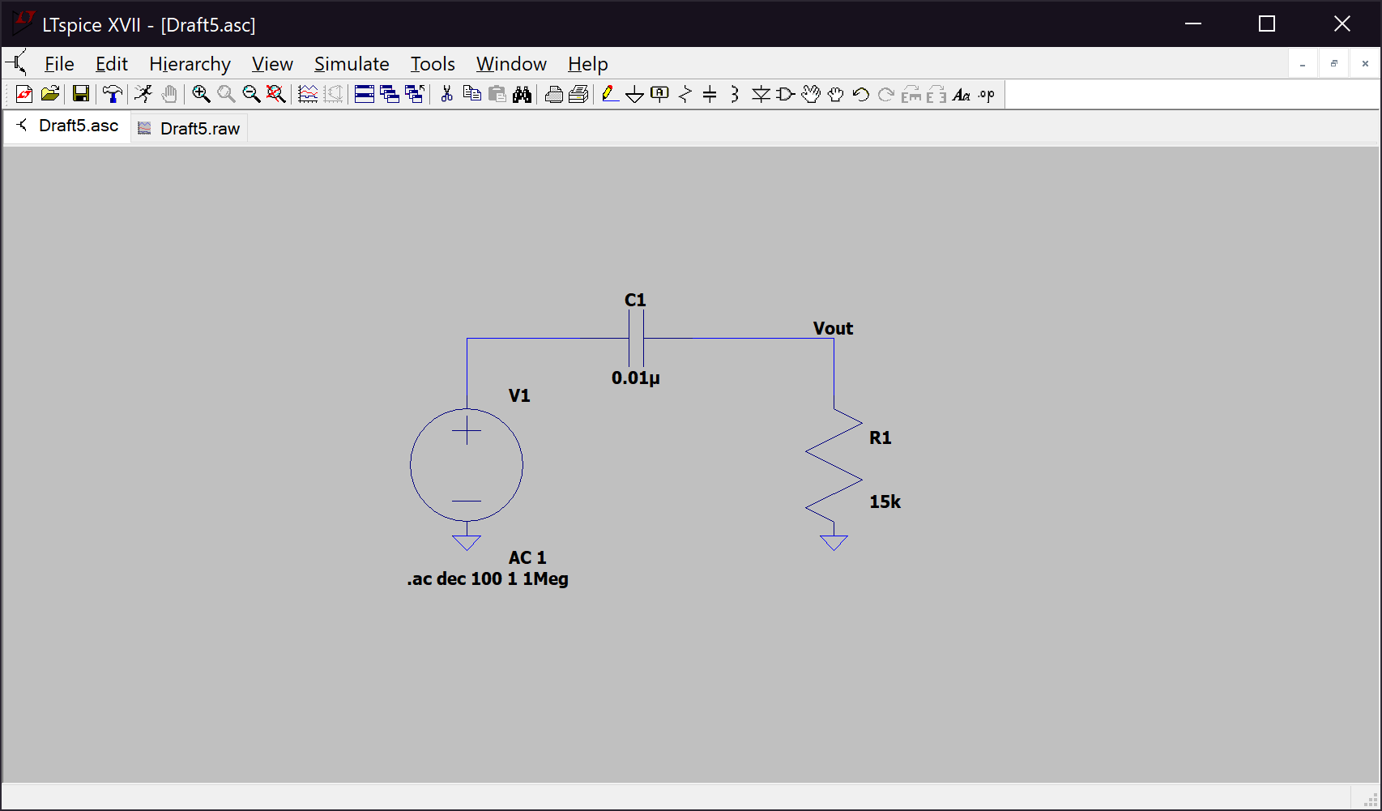*Figure 3. Circuit for Item 3*

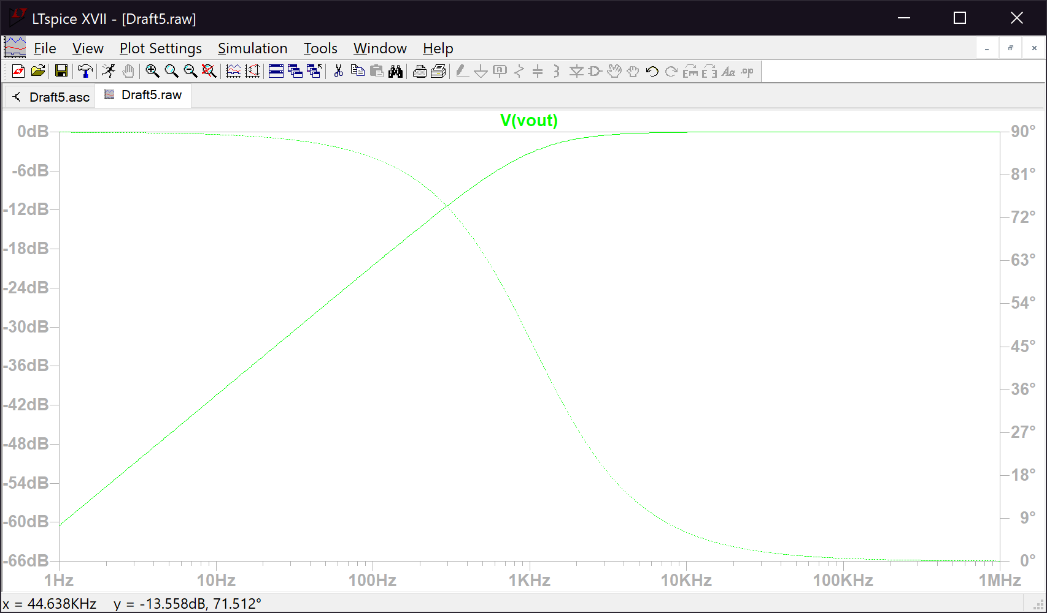

*Figure 4. Output for Item 3*

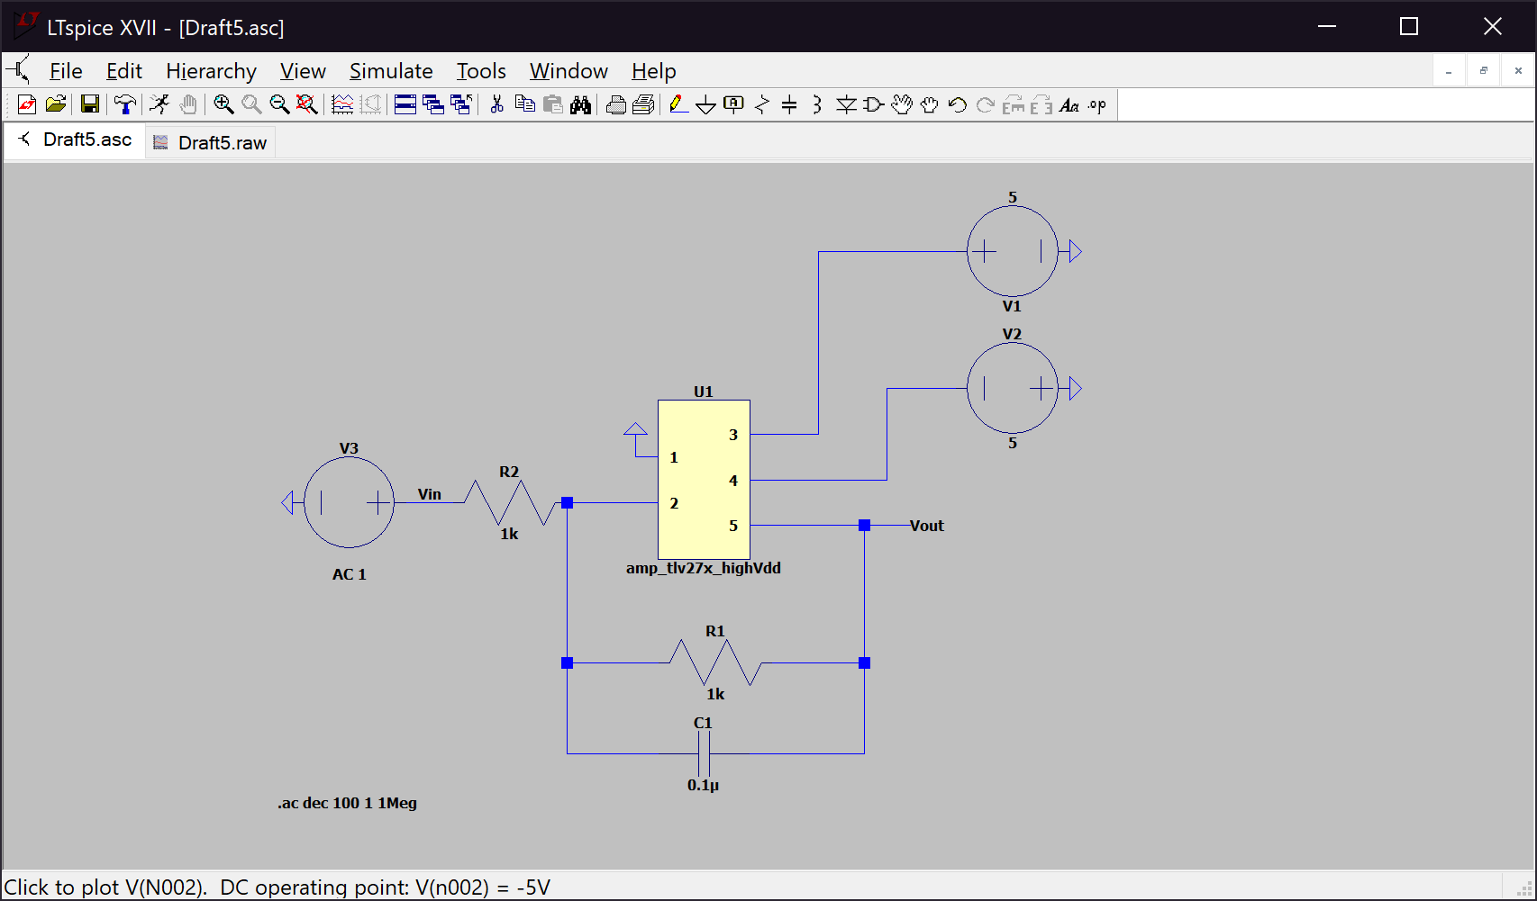*Figure 5. Circuit for Item 4*

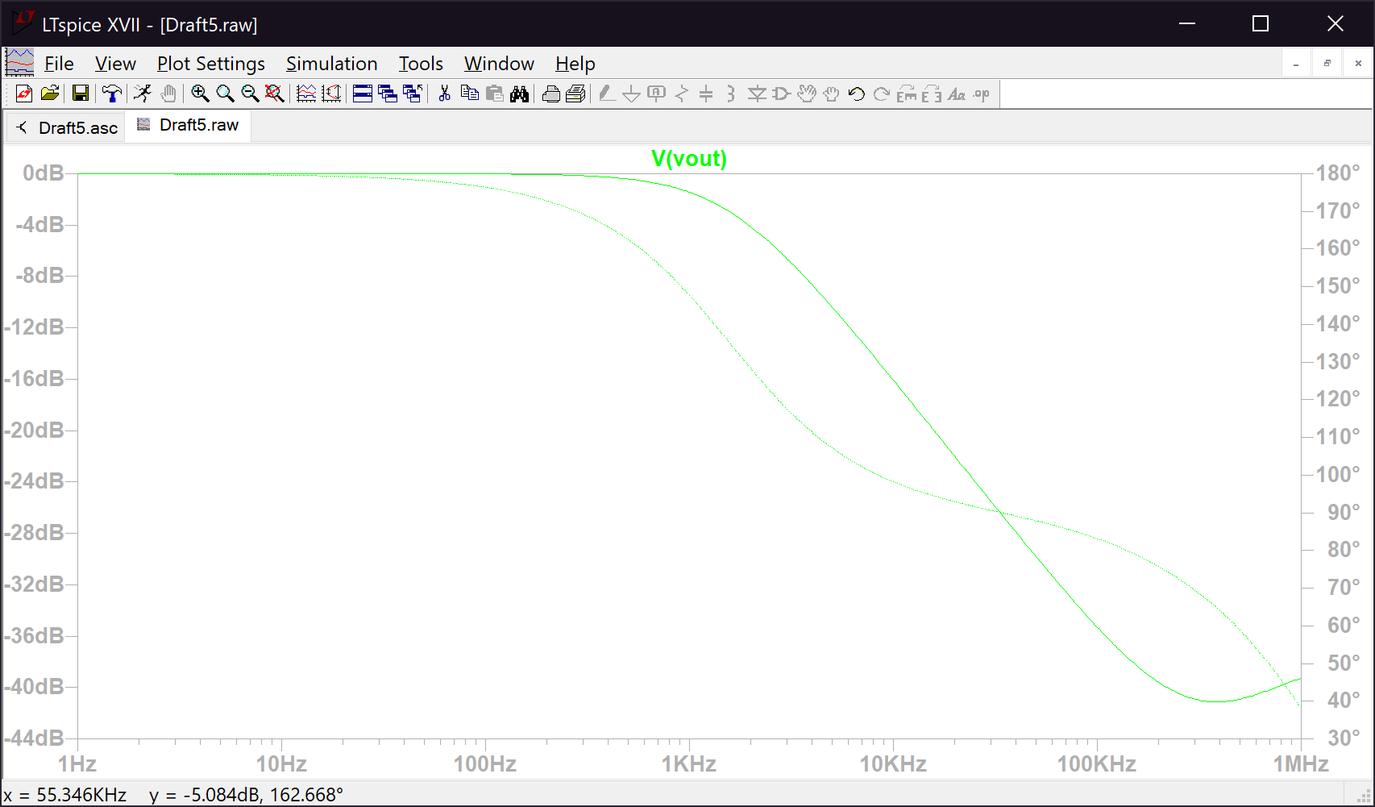

*Figure 6. Output for Item 4*

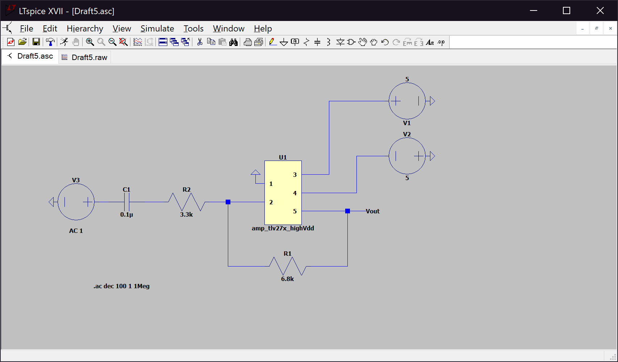*Figure 7. Circuit for Item 5*

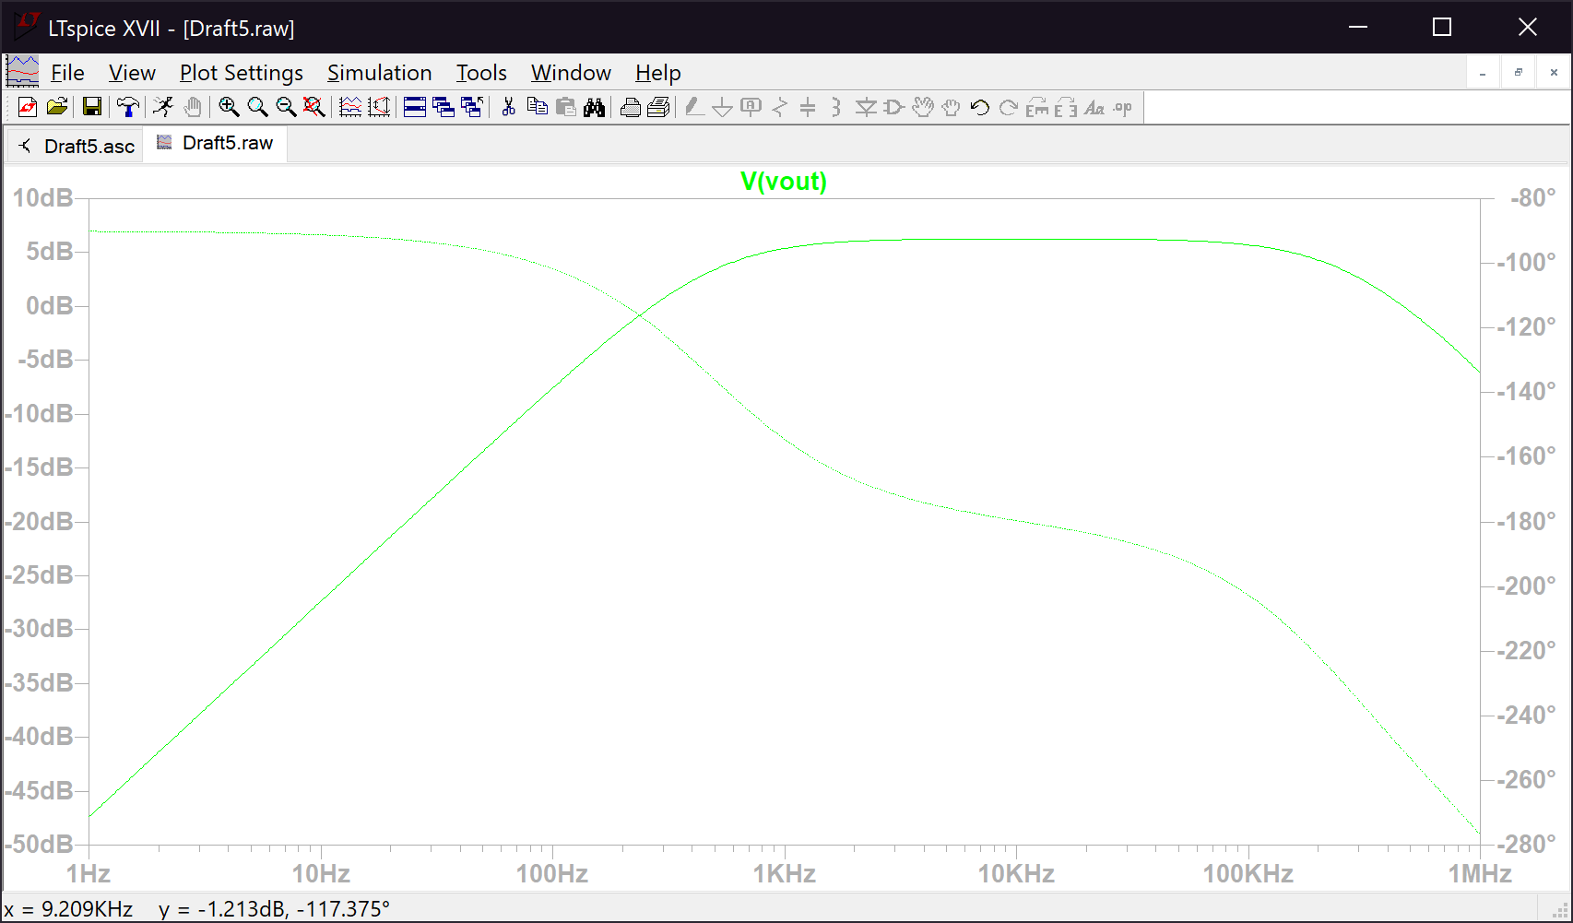

*Figure 8. Output for Item 5*

*Table 1. Tabled values for Items 2-5*

|  |  |  |
| --- | --- | --- |
| Item 2 | 3 dB frequency | 15895.9 Hz |
| Item 3 | 3 dB frequency | 1063.29 Hz |
| Item 4 | R1 | 1kΩ |
|  | R2 | 1kΩ |
|  | 3 dB frequency | 1585 Hz |
| Item 5 | R1 | 3.3kΩ |
|  | R2 | 6.8kΩ |
|  | 3 dB frequency | 454 Hz |