**Lab 9**

**Introduction**

In this lab we focused on filters. We saw how high pass and low pass filters work with different values of frequencies. We built both the active and passive versions of both filters.

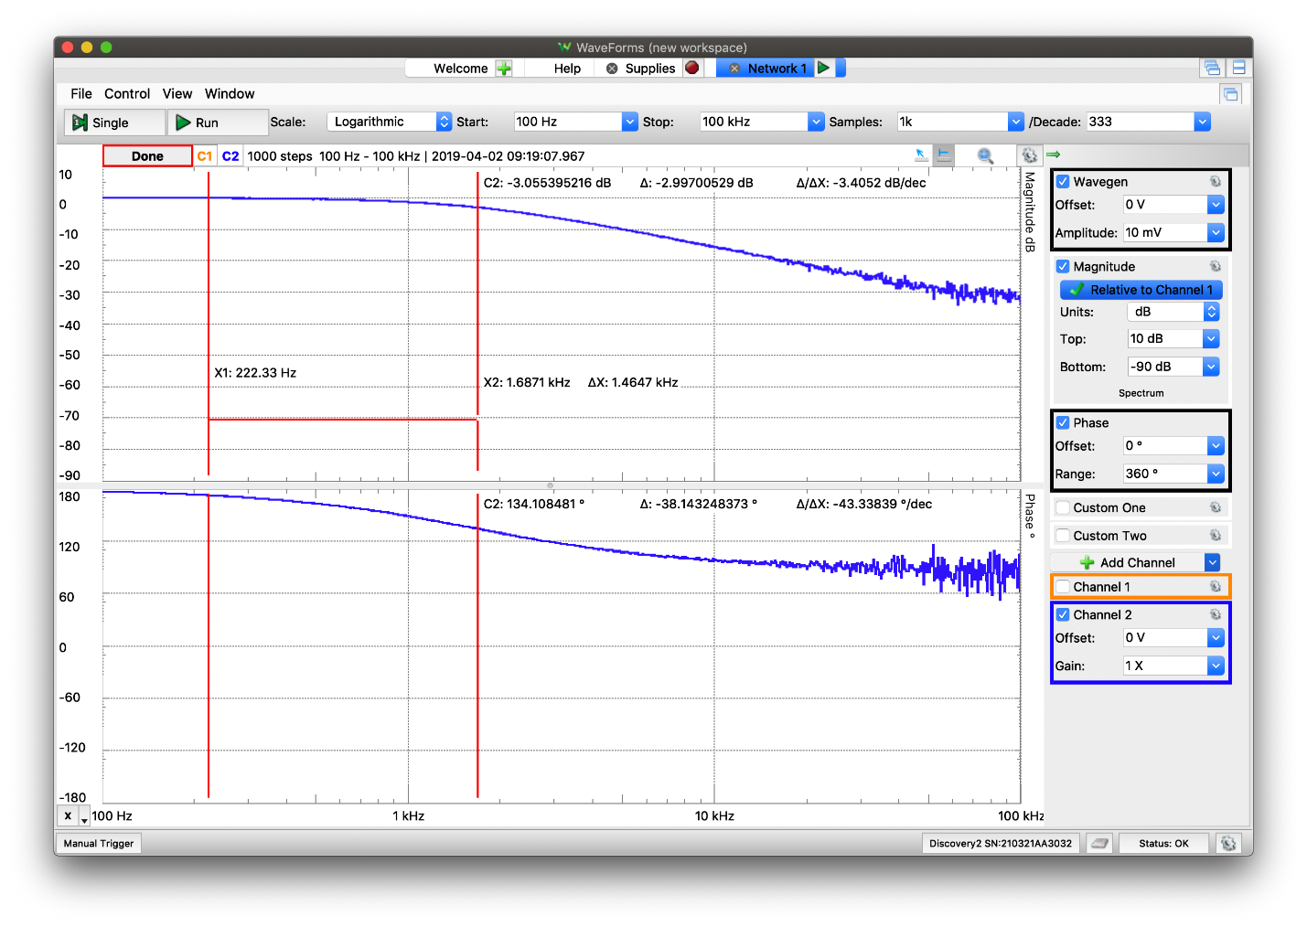**Discussion**

*Figure 1. Output voltage of an active low pass filter*

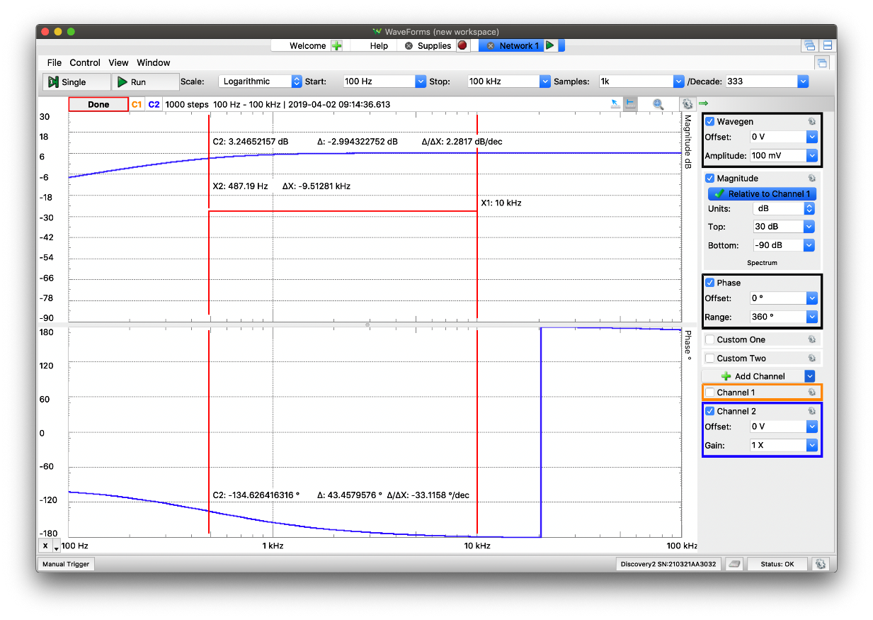

*Figure 2. Output voltage of an active high pass filter*

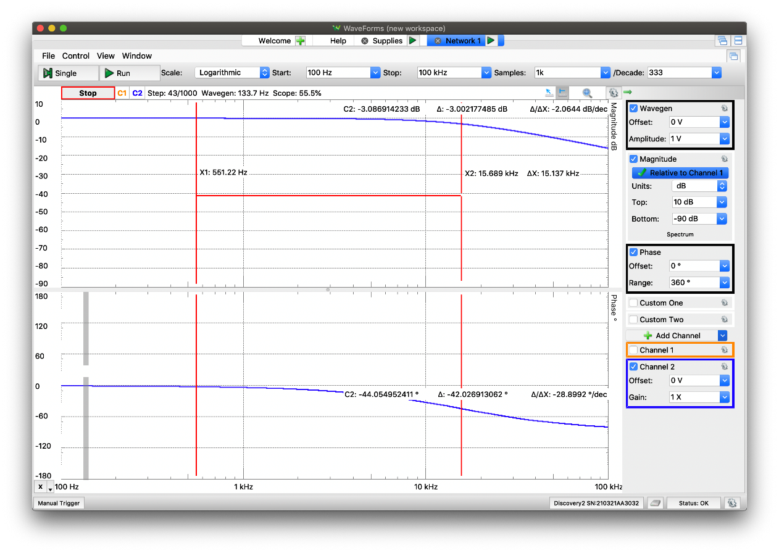

*Figure 3. Output voltage of a passive low pass filter*

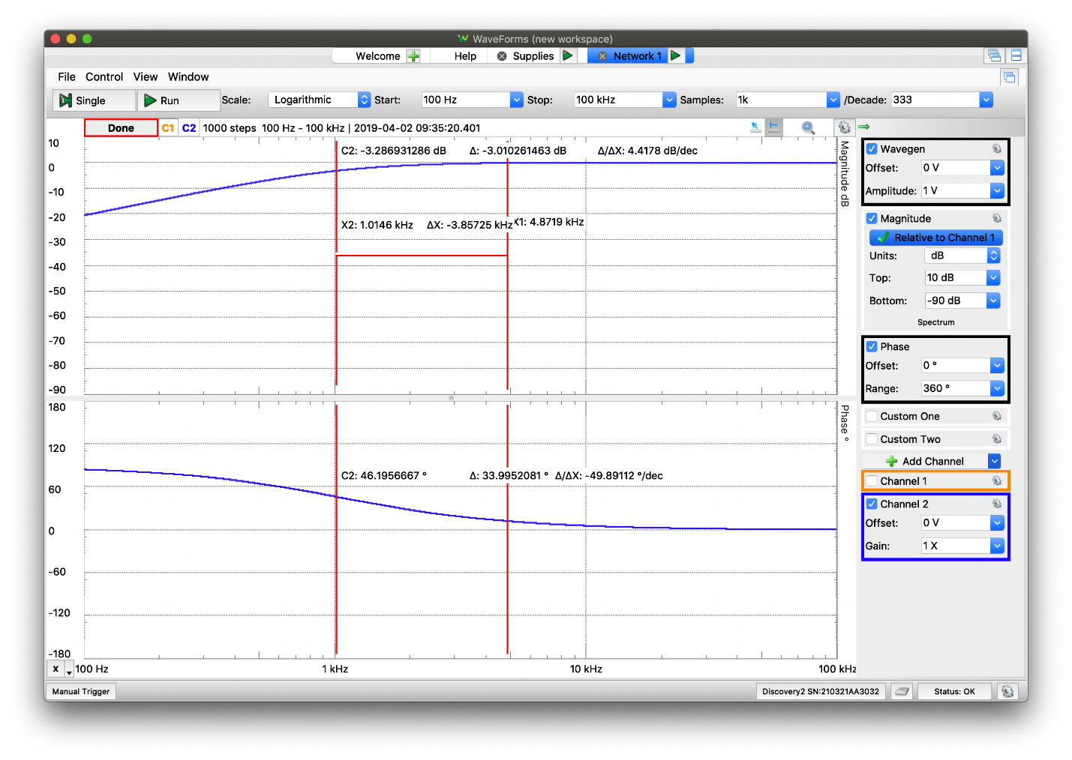*Figure 4. Output voltage of a passive high pass filter*

*Table 1. Theoretical and experimental values for 3dB frequencies, and percent error of output voltage for each filter*

|  |  |  |  |
| --- | --- | --- | --- |
|  | Theoretical value | Experimental value | Percent error |
| Active low pass | 1585.0 Hz | 1687.1 Hz | 6.44% |
| Active high pass | 454.00 Hz | 487.19 Hz | 7.31% |
| Passive low pass | 15895.9 Hz | 15689.0 Hz | 1.30% |
| Passive high pass | 1063.29 Hz | 1014.60 Hz | 4.58% |

From the figures we can see that high pass filters do not allow low frequencies to pass, while higher frequencies can. Similarly, low pass filter does not allow high frequencies to pass, but low frequencies can. The experimental values all have errors less than 10%, which some may declare satisfactory. It is also interesting to note that both experimental values for the active filters are higher than their theoretical pair, while both experimental values for the passive filter are lower than their theoretical pair.

When dealing with op-amps in the active filters, you always must be aware of saturation. One of the things that can shift the 3dB frequency from its ideal value is saturation. If the op-amp saturations, we can no longer assume its functioning in its linear region, which will result in an altered 3dB frequency.

The advantages of the active filters are that, with the op-amp, you can gain your output; in parallel with filtering it. Additionally, if it is an inverting circuit, you can invert the signal if needed. The downside with respect to passive filters is that active filter is more expensive since it uses an additional resistor and an amplifier. Passive filters are also easier to deal with in circuit analysis, as it is just a capacitor and resistor in series, while active filters force you to add additional equations, that the presence of the op-amp carries, to fully analyze the circuit.

**Conclusion**

In this lab we saw how high pass and low pass filters reacted to different frequencies. As expected, low pass filters only allow low frequencies to pass to the output, while high pass filters only allow high frequencies to pass to the output. Limitations to the active filters include the saturation level of the op-amp, which can shift the 3dB frequency from its ideal value. Finally, we concluded that active filters are good for adding gain or inverting, while passive filters are less expensive and easier to deal with.