

|  |
| --- |
| , RD Dep.  **Oracle DB for DWH and ETL building** |
| Python Task 01 by Anton Gridushko |

Contents

**Oracle DB for DWH and ETL building** 1

1. Python introduction. 3

2. Installation. 3

3. IDE. 3

4.1 Task 1 3

4.1.1 TASK 1.1 3

4.2 Task 2 4

4.2.1 TASK 2.1 4

4.2.2 TASK 2.2 5

4.2.3 TASK 2.3* 5

4.3 Task 3 5

4.3.1 TASK 3.1 5

4.3.2 TASK 3.2 6

4.3.3 TASK 3.3* 6

# 

# Python introduction.

Python is an open-source language.

# Installation.

Installed anaconda:

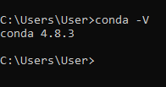

# IDE.

1. Used previously investigated Spyder IDE.



2. Have installed libraries avro, pyarrow and pandavro

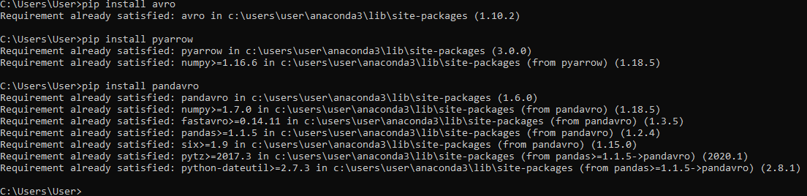



## Task 1

Asset:

**1_generate_random_arr.py** script will help you to generated csv file with random numbers from between 1-100, read this array, order it in thread mode, and write result back to csv file.

### TASK 1.1

Task:

In the function write_dict_to_csv_file header for csv as is a parameter, but it easily could be retrieved from the array arr_dict_tofile itself. Could you please retrieve headerRow from array arr_dict_tofile and use it instead?

Implementation:



TASK 1.2

Please insert bubble sorting algorithm in the bubble_sorting function

Implementation:

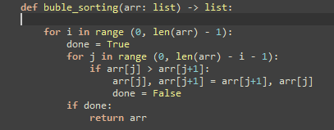

Proof in line to asset:

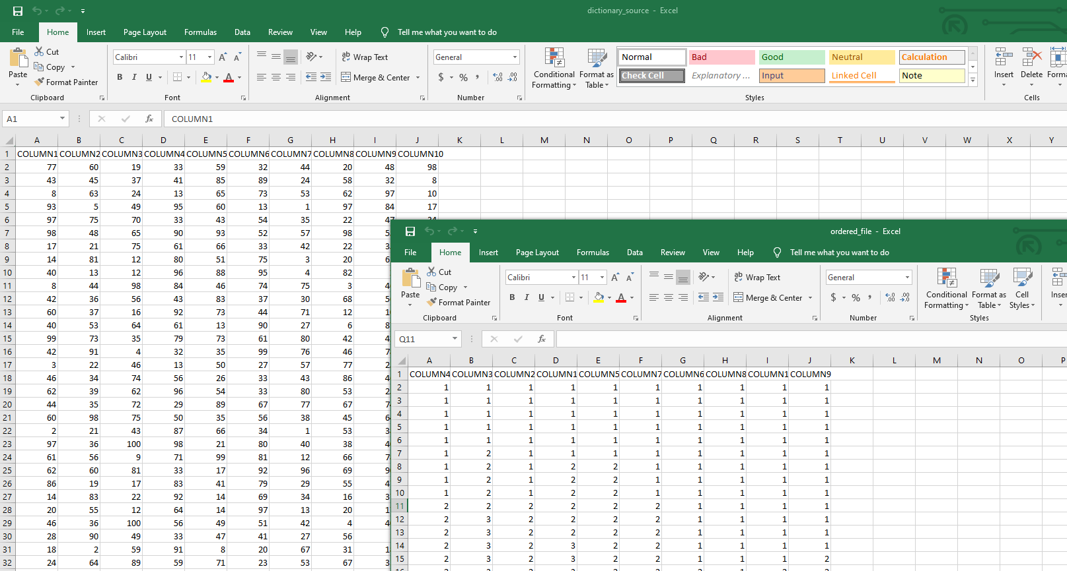

## Task 2

Asset:

**2_sqlite_database_utilies.py** script will read ordered numbers from the created csv file and loaded these values into the sqlite db file (this file with appropriate table will be created if not exists).

### TASK 2.1

You have to add procedure which will count rows inserted today. LOG this count.

Implementation:

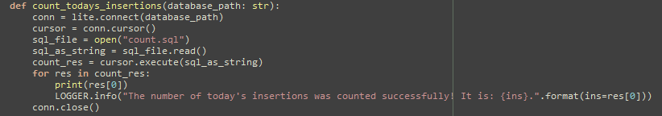

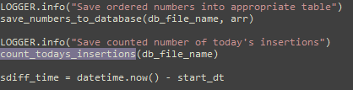

Proof in line to asset:

LOG:



### TASK 2.2

You have only inserts into your table. What is the reason of no updates?

**Answer:**

The reason is: every time we create database and the table in it - we use drop command for table **("drop table if exists t_ordered_items") that nulls table and all values in it.**

In **save_numbers_to_database** method we have condition **if count > 0**, that checks if ORDERED_ITEMS_SURR_ID exists. If exists - we will update, if not - we insert.

### TASK 2.3*

Create sql queries as separate files ( *.sql) and run them from files ( read file -> execute ) instead of hardcoding queries in code.

One of parts of implementation of the task:

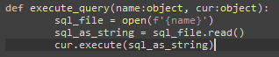

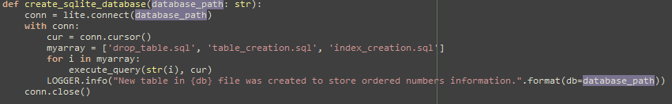

Others scripts you can see in special folder named “scripts”. And implementation process in code from atomic commits on GitLab.

## Task 3

Assets:

**3_write_to_utilities.py** will read table information from sqlite db file and write this data into the files with different formats.

### TASK 3.1

Please use Pandas Dataframe ordered_numbers_df instead of using hardcoded column names. Column names could be easily taken from dataframe itself.

Optionally you could retrieve column types from dataframe as well. *

Implementation:

I think, one of the approaches to avoid hardcode could be:

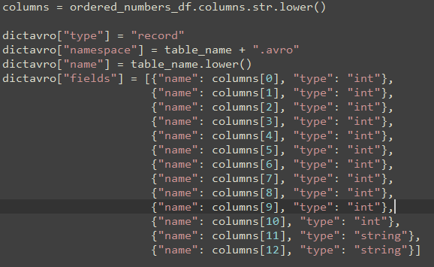

### TASK 3.2

In the method write_dataframe_to_json please add code to export dataframe into JSON file

(example you could see in the provided folder)

Implementation:



### TASK 3.3*

After you get dataframe from the sqlite database please leave in it only rows with all values > 20 and use this cut dataframe for further exporting.

Implementation:



One of numerous decisions is:

Take this one – because in my mind this one better to be understood.

