
EXXX - Data Engineering 1 – Cloud Computing and Managed AI Solutions
Homework I - Public-Key Encryption Homework
(CEU and Visitor Simulation)

Prepared by:
Agnes Kandera – ID:
Anton Shestakov – ID: 2403362

- Key generation

The content of key_generation.sh for running in consol terminal (aka Git bash or others)


Extracting keys (file public_key_exercise.ipynb):

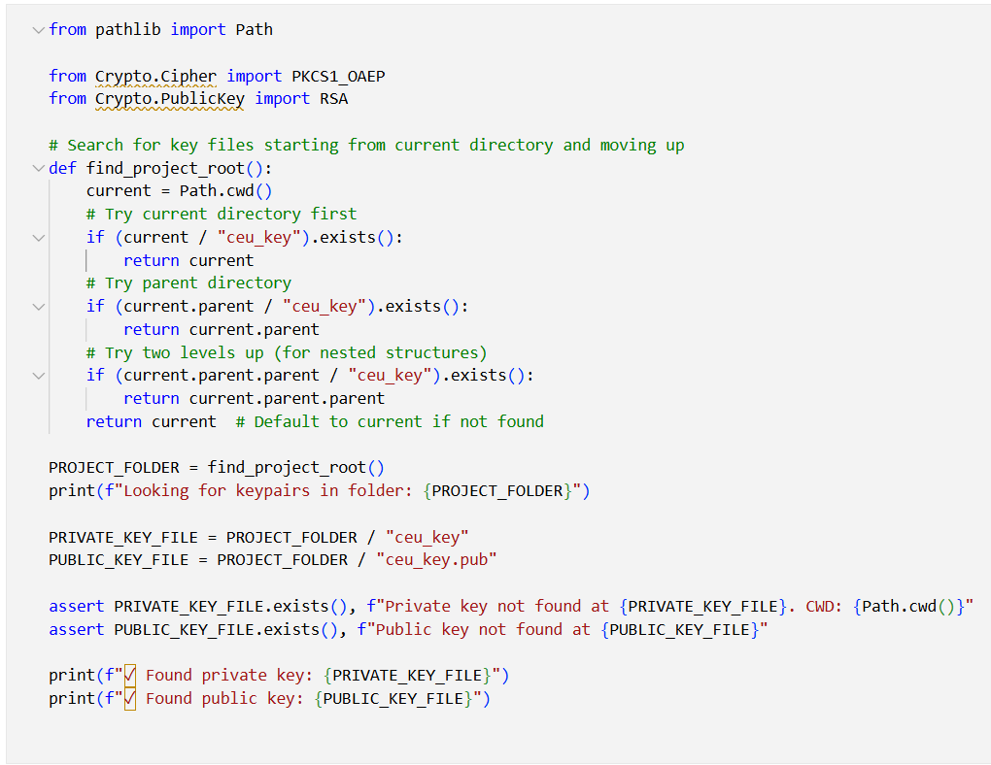

- Public key

Placed in ceu.key.pub
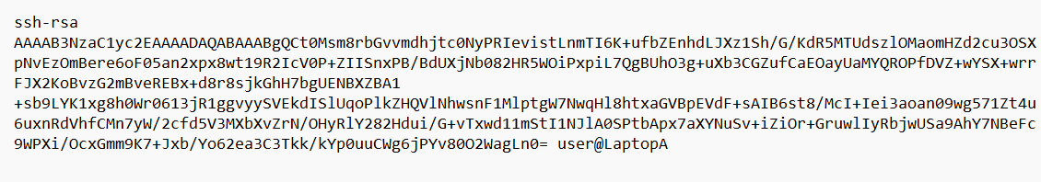
- Private key
Placed in ceu.key
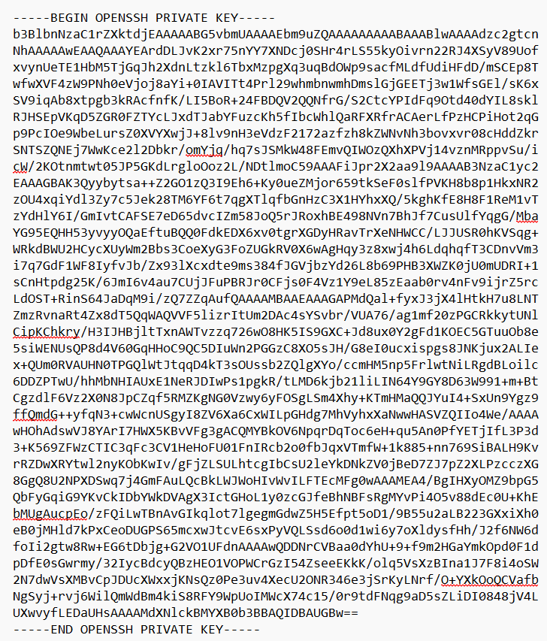

- Message request (ipynb)

Placed message_request.ipynb
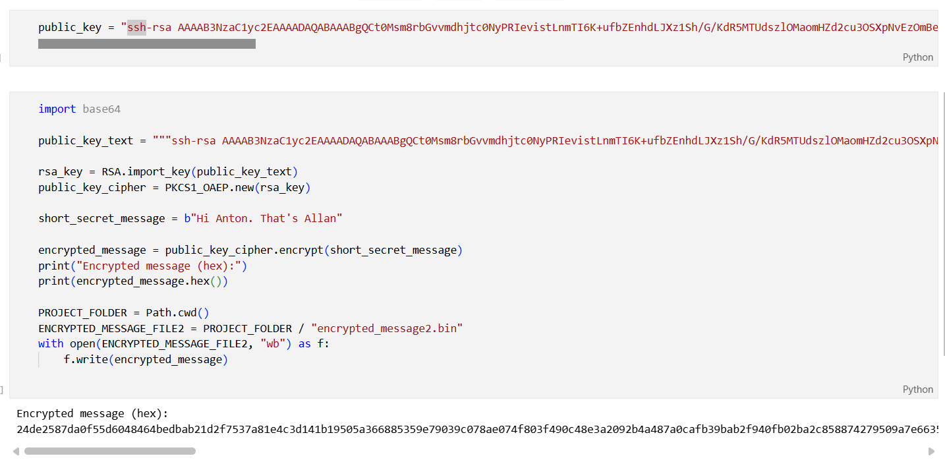

- Decoding the message

Placed in public_key_exercise.ipynb
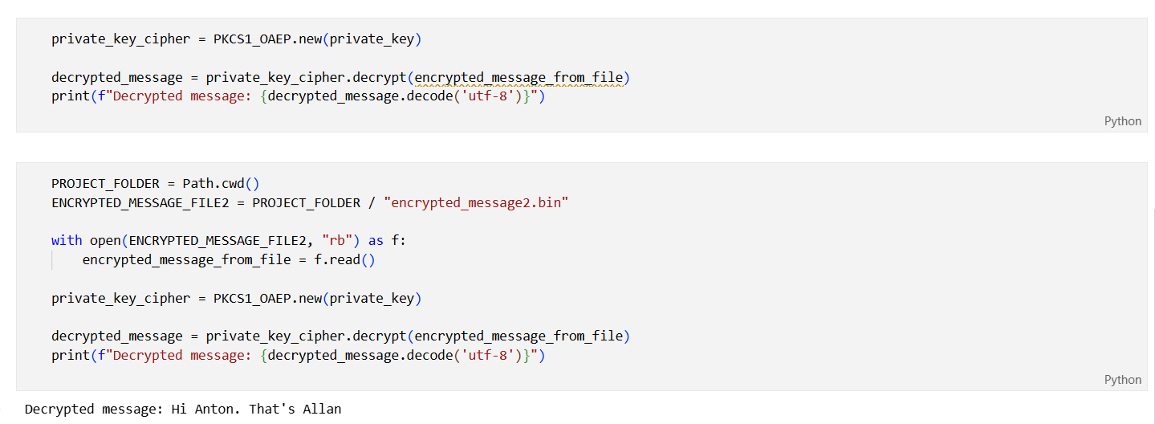

- Encrypted message

A part of message_request.ipynb by creating encrypted_messages2.bin that later is decoded

