Discipline: Coding for Economists

Student: **Anton Shestakov**

Work Stages:

1. Initially, I set up automation for remotely accessing the GitHub repository via the command line in the GitBash interface. To do this, I created a .sh script that includes git add and git commit commands to automatically stage and commit any new files that should be added to the GitHub repository.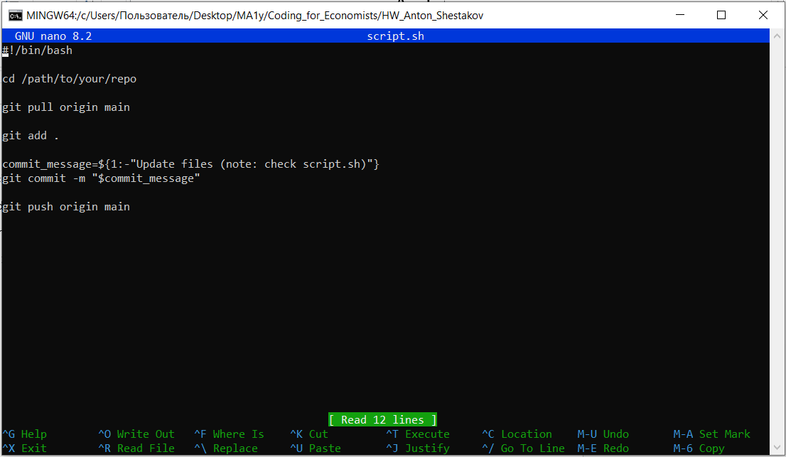
2. Then I proceeded my work with Python. The results can be found in data.ipynb file. I employed epl-games_p.csv. There I did data exploration within standard functions of descriptive statistics output (and also functions from skim package). Keeping my coding part on, I modified data by creating new variables and filtering. Then I turned my attention on loops including “for” one. That was useful for creating specific data sets that were used for next step of graph building.
3. Final step of my work was Stata. I employed epl_totalpoints.dta to describe the data and make some modification with the given variables. Basically, I did aggregate data and created new vars which I used in graph building as well. All stata results are placed in [STATA_part/dataHW](https://github.com/Anton21a/HW_Anton_Shestakov/tree/main/STATA_part/dataHW) path in GitHub repository.