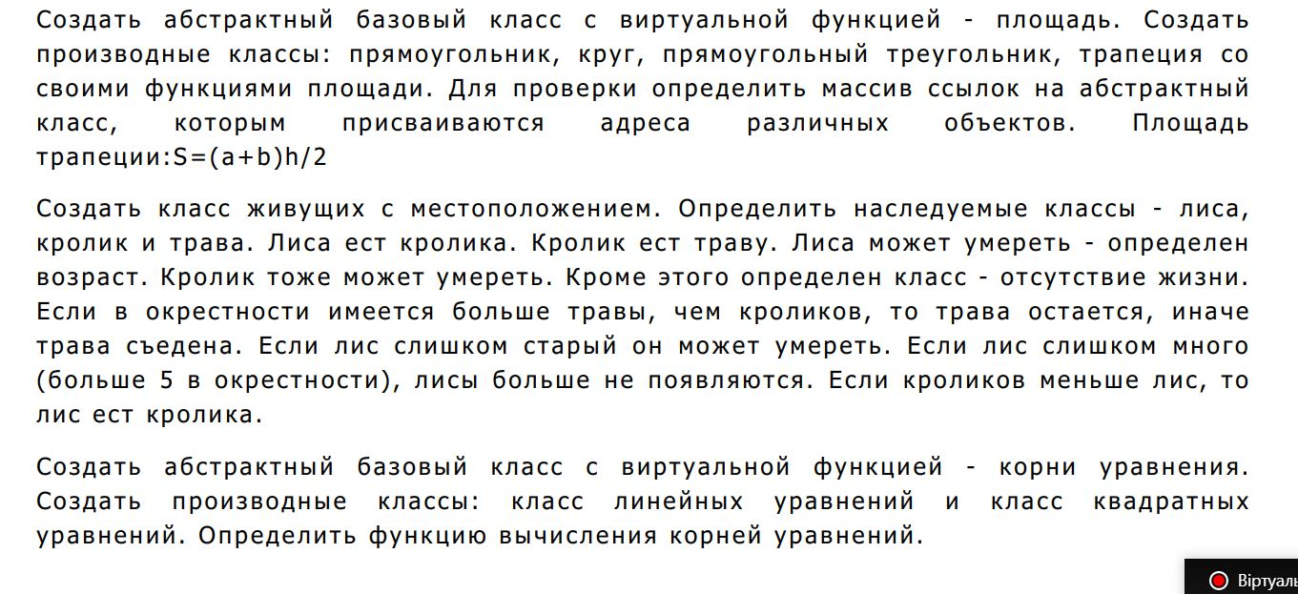
Завдання 1
#define _CRT_SECURE_NO_WARNINGS
#include<Windows.h>
#include <iostream>
#include<conio.h>
#include<time.h>
using namespace std;

class Geometry_element
{
public:
Geometry_element()
{

}
virtual float Square() = 0;
};
class Rectangles:public Geometry_element
{
private:
float a;
float b;
public:
Rectangles()
{
this->a = 0;
this->b = 0;
}
Rectangles(float a, float b)
{
this->a = a;
this->b = b;
}
float Square()
{
return a * b;
}
};
class Circle :public Geometry_element
{
private:
float r;
public:
Circle()
{
this->r = 0;
}
Circle(float r)
{
this->r = r;
}
float Square()
{
return r*r*3.14;
}
};
class Right_Triangle :public Geometry_element
{
private:
float a;
float b;
public:
Right_Triangle()
{
this->a = 0;
this->b = 0;
}
Right_Triangle(float a, float b)
{
this->a = a;
this->b = b;
}
float Square()
{
return a * b*0.5;
}
};
class Trapeze :public Geometry_element
{
private:
float a;
float b;
float h;
public:
Trapeze()
{
this->a = 0;
this->b = 0;
this->h = 0;
}
Trapeze(float a, float b, float h)
{
this->a = a;
this->b = b;
this->h = h;
}
float Square()
{
return ((a + b) * h)/2;
}
};

int main()
{
SetConsoleCP(1251);
SetConsoleOutputCP(1251);
srand(time(0));
Geometry_element** arr = new Geometry_element * [4];
arr[0] = new Rectangles(10,10);
arr[1] = new Circle(10);
arr[2] = new Right_Triangle(10,10);
arr[3] = new Trapeze(10,10,10);
for (int i = 0; i < 4; i++)
{
cout << "Площа фігури: "<<arr[i]->Square() << endl;
}
for (int i = 0; i < 4; i++)
{
delete arr[i];
}
delete[] arr;
return 0;
}
Завдання 2
#define _CRT_SECURE_NO_WARNINGS
#include<Windows.h>
#include <iostream>
#include<conio.h>
#include<time.h>
using namespace std;

class Element_of_life
{
protected:
int year;
int x;
int y;
public:
Element_of_life()
{
year = 0;
x = 0;
y = 0;
}
int& Year()
{
return year;
}
int& GetX()
{
return x;
}
int& GetY()
{
return y;
}
virtual int Type()=0;
};
class Fox:public Element_of_life
{

public:
int Type()
{
return 3;
}

};
class Rabbit :public Element_of_life
{

public:
int Type()
{
return 2;
}
};
class Grass :public Element_of_life
{

public:
int Type()
{
return 1;
}
};
class Empty :public Element_of_life
{
public:
int Type()
{
return 0;
}

};
void Add(Element_of_life*** arr, int a, int b, int k, int* fox_count, int* grass_count, int* rabbit_count)
{
int y;
bool c = false;
int x = rand() % a;
while (!c)
{
for (int i = 0; i < b; i++)
{
if (arr[x][i]->GetX() == 0)
{
y = rand()%b;
while (arr[x][y]->GetX() != 0)
{
y = rand() % b;
}

delete arr[x][y];
switch (k)
{
case 1:
arr[x][y] = new Grass;
arr[x][y]->Year() = -1;
(*grass_count)++;
break;
case 2:
arr[x][y] = new Rabbit;
arr[x][y]->Year() = rand() % 7;
(*rabbit_count)++;
break;
case 3:
arr[x][y] = new Fox;
arr[x][y]->Year() = rand() % 10;
(*fox_count)++;
break;
}

arr[x][i]->GetX() = x;
arr[x][i]->GetX() = i;
c = true;
break;
}

}
x = rand() % a;
}
}
void Show_before(Element_of_life*** arr, int a, int b)
{
for (int i = 0; i < a; i++)
{
for (int j = 0; j < b; j++)
{
switch (arr[i][j]->Type())
{
case 0:
cout << "X";
break;
case 1:
cout << "Т";
break;
case 2:
cout << "З";
break;
case 3:
cout << "Л";
break;
}
}
cout << endl;
}
}
void Show_after(Element_of_life*** arr, int a, int b, int* fox_count, int* grass_count, int* rabbit_count)
{
bool g=true, r=true;
for (int i = 0; i < a; i++)
{
for (int j = 0; j < b; j++)
{
if (*grass_count < *rabbit_count)
{
g = false;
if (arr[i][j]->Type() == 1)
{
delete arr[i][j];
arr[i][j] = new Empty;
arr[i][j]->Year() = -1;
}
}
if (*rabbit_count < *fox_count)
{
r = false;
if (arr[i][j]->Type() == 2)
{
delete arr[i][j];
arr[i][j] = new Empty;
arr[i][j]->Year() = -1;
}
}
if (arr[i][j]->Year() != -1)
{
switch (arr[i][j]->Type())
{
case 2:
if (rand() % (7 - arr[i][j]->Year()) == 0)
{
delete arr[i][j];
arr[i][j] = new Empty;
arr[i][j]->Year() = -1;
}
break;
case 3:
if (rand() % (11 - arr[i][j]->Year()) == 0|| rand() % (11 - arr[i][j]->Year()) == 1)
{
delete arr[i][j];
arr[i][j] = new Empty;
arr[i][j]->Year() = -1;
}
break;
}
}
}

}
if (!g)
*grass_count = 0;
if (!r)
*rabbit_count = 0;
Show_before(arr,a,b);
}

int main()
{
SetConsoleCP(1251);
SetConsoleOutputCP(1251);
srand(time(0));
int a, b;
int elem, fox_count=0, grass_count=0, rabbit_count=0;
cout << "Введіть розмір поля(а x b):\n";
cout << "a->";
cin >> a;
cout << "b->";
cin >> b;

Element_of_life*** arr = new Element_of_life ** [a];
for (int i = 0; i < a; i++)
{
arr[i] = new Element_of_life*[b];
}
for (int i = 0; i < a; i++)
{
for (int j = 0; j < b; j++)
{
arr[i][j] = new Empty;
arr[i][j]->Year() = -1;

}
}
for (int i = 0; i < a * b; i++)
{
if (fox_count < 5)
{
elem = rand() % 2;
switch (elem)
{
case 0:
Add(arr, a, b, 3, &fox_count, &grass_count, &rabbit_count);

break;
case 1:
break;
}
}
elem = rand() % 2;
switch (elem)
{
case 0:
Add(arr, a, b, 2, &fox_count, &grass_count, &rabbit_count);

break;
case 1:
break;
}
elem = rand() % 2;
switch (elem)
{
case 0:
Add(arr, a, b, 1, &fox_count, &grass_count, &rabbit_count);

break;
case 1:
break;
}
}
Show_before(arr, a, b);
cout << "----------------------------\n";
Show_after(arr, a, b, &fox_count, &grass_count, &rabbit_count);
for (int i = 0; i < a; i++)
{
for (int j = 0; j < b; j++)
{
delete arr[i][j];

}
}
delete[]arr;
return 0;
}

Завдання 3
#define _CRT_SECURE_NO_WARNINGS
#include<Windows.h>
#include <iostream>
#include<conio.h>
#include<time.h>
using namespace std;

class Root
{
public:
Root()
{
}
virtual void Find_the_root() = 0;
};
class Linear_equation:public Root
{
private:
float ax;
float b;
float c;
public:
Linear_equation()
{
ax=0;
b=0;
c=0;
}
Linear_equation(float ax, float b, float c)
{
this->ax = ax;
this->b = b;
this->c = c;
}
void Find_the_root()
{
c = c + (-b);
cout <<"Корінь рівняння: "<< (c / ax) << endl;
}
};
class Quadratic_equation :public Root
{
private:
float a;
float b;
float c;
public:
Quadratic_equation()
{
a = 0;
b = 0;
c = 0;
}
Quadratic_equation(float a, float b, float c)
{
this->a = a;
this->b = b;
this->c = c;
}
void Find_the_root()
{

float d, x1, x2;
if (a == 0 && b == 0 && c == 0)
cout << "Коренів нескінченна кількість\n";
else if (a == 0 && b == 0 && c != 0)
cout << "Коренів немає\n";
else if (a != 0 && b == 0 && c == 0)
{
cout << "Корінь: " << 0<<endl;
}
else if (a != 0 && b == 0 && c != 0)
{
if (c > 0)
cout << "Коренів немає\n";
else if (c < 0)
{
d = -4 * a * c;
if (d > 0)
{
x1 = (-sqrt(d)) / (2 * a);
x2 = sqrt(d) / (2 * a);
cout << "Два корені: x1=" << x1 << " x2=" << x2<<endl;
}
else if (d == 0)
{
cout << "Один корінь: " << 0<<endl;
}
else if (d < 0)
cout << "Коренів немає\n";
}
}
else if (a != 0 && b == 0 && c == 0)
cout << "Один корінь: " << 0<<endl;

else if (a != 0 && b != 0 && c == 0)
{
d = b * b;
x1 = (-b + sqrt(d)) / (2 * a);
x2 = (-b - sqrt(d)) / (2 * a);
if (x1 < x2)
cout << "Два корені: x1=" << x1 << " x2=" << x2<<endl;
else
cout << "Два корені: x1=" << x2 << " x2=" << x1<<endl;

}
else if (a != 0 && b != 0 && c != 0)
{
d = (b * b) - (4 * a * c);
if (d < 0)
cout << "Коренів немає\n";
else if (d == 0)
{
x1 = -b / (2 * a);
cout << "Один корінь: " << x1<<endl;
}
else if (d > 0)
{
x1 = (-b + sqrt(d)) / (2 * a);
x2 = (-b - sqrt(d)) / (2 * a);
if (x1 < x2)
cout << "Два корені: x1=" << x1 << " x2=" << x2 << endl;
else
cout << "Два корені: x1=" << x2 << " x2=" << x1 << endl;
}
}

else if (a == 0 && b != 0 && c != 0)
{
x1 = -c / b;
cout << "Один корінь: " << x1 << endl;
}
else if (a == 0 && b != 0 && c == 0)
{
cout << "Один корінь: " << 0 << endl;
}
}
};

int main()
{
SetConsoleCP(1251);
SetConsoleOutputCP(1251);
srand(time(0));
Root** arr = new Root*[2];
arr[0] = new Linear_equation(2,4,2);
arr[1] = new Quadratic_equation(2, 4, 2);
for (int i = 0; i < 2; i++)
{
arr[i]->Find_the_root();
}
for (int i = 0; i < 2; i++)
{
delete arr[i];
}
delete arr;

return 0;
}

