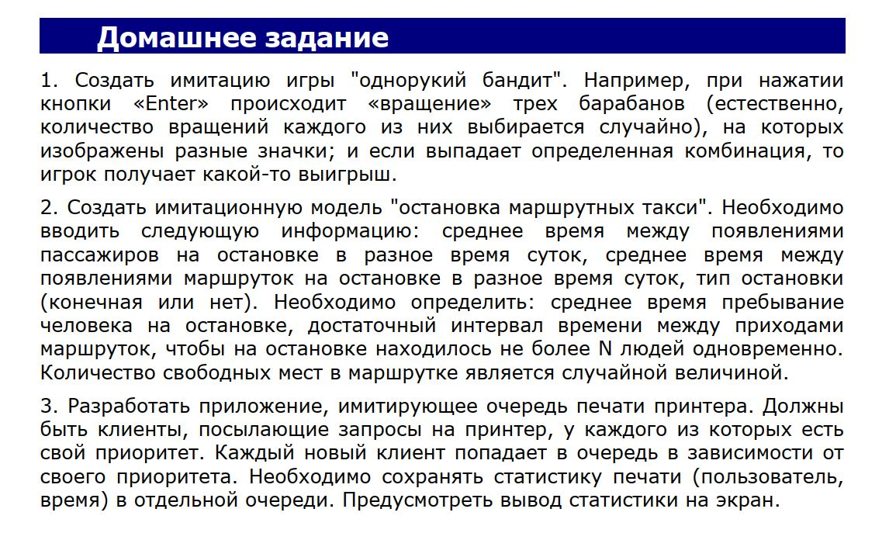
Завдання 1
#define _CRT_SECURE_NO_WARNINGS
#include<Windows.h>
#include <iostream>
#include<conio.h>
#include<time.h>
using namespace std;

class QueueRing
{
char* symbol;
int QueueRingLength;
public:
QueueRing();
~QueueRing();
void Clear();
void Add(char c);
char Extract();
bool IsEmpty();
int GetCount();
void Show();
};
bool QueueRing::IsEmpty()
{
return this->QueueRingLength == 0;
}
int QueueRing::GetCount()
{
return QueueRingLength;
}
void QueueRing::Show()
{
cout << "-----------------------\n";
cout << "|";
for (int i = 0; i < this->QueueRingLength; i++)
{
cout << symbol[i] << "|";
}
cout << endl;
cout << "-----------------------\n";
}
QueueRing::QueueRing()
{
QueueRingLength = 5;
symbol = new char[QueueRingLength];
symbol[0] = '$';
symbol[1] = '#';
symbol[2] = '7';
symbol[3] = '6';
symbol[4] = 'G';

}
QueueRing::~QueueRing()
{
if (this->QueueRingLength > 0)
delete[] this->symbol;
}
void QueueRing::Clear()
{
if (this->QueueRingLength > 0)
delete[] this->symbol;
}
void QueueRing::Add(char c)
{
symbol = (char*)realloc(symbol, sizeof(char) * (QueueRingLength + 1));
symbol[QueueRingLength] = c;
QueueRingLength++;
}
char QueueRing::Extract()
{
char tmp = this->symbol[0];
for (int i = 1; i < QueueRingLength; i++)
symbol[i - 1] = symbol[i];
symbol[QueueRingLength - 1] = tmp;
return tmp;
}
class Game
{
QueueRing first_ring;
QueueRing second_ring;
QueueRing third_ring;
public:
void Start_Game(int* money, int stavka);
};
void Game::Start_Game(int* money, int stavka)
{
char a, b, c;
int random = rand() % 101;
cout << "-------\n";
cout << "|";
for (int i = -1; i < random; i++)
{
if (i == random - 1)
{
a = this->first_ring.Extract();
cout << a << "|";
}
else
this->first_ring.Extract();
}
random = rand() % 101;
for (int i = -1; i < random; i++)
{
if (i == random - 1)
{
b = this->second_ring.Extract();
cout << b << "|";
}
else
this->second_ring.Extract();
}
random = rand() % 101;
for (int i = -1; i < random; i++)
{
if (i == random - 1)
{
c = this->third_ring.Extract();
cout << c << "|";
}
else
this->third_ring.Extract();
}
cout << endl;
cout << "-------\n";
if (a == '7' && b == '7' && c == '7')
{
cout << "ДЖЕКПОТ!!!\n";
cout << "X100\n";
*money += stavka * 100;
}
else if (a == b && a == c && b == c)
{
cout << "Ви зірвали куш!\n";
cout << "X10\n";
*money += stavka * 10;
}
else if (a == b || a == c || b == c)
{
cout << "Ви виграли!\n";
cout << "X2\n";
*money += stavka * 2;
}
else
{
cout << "Ви програли:(\n";
*money -= stavka;
}
cout << "Ваш банк: " << *money << endl;
}
int main()
{
SetConsoleCP(1251);
SetConsoleOutputCP(1251);
srand(time(0));
Game game;
int money, stavka;
char s;
cout << "Введіть ваш банк->";
cin >> money;
cout << "Введіть вашу ставку->";
cin >> stavka;
while (money != 0)
{
if (stavka > money||stavka<1)
{
while (stavka > money || stavka < 1)
{
cout << "Не правильна ставка\n";
cout << "Введіть ще раз->";
cin >> stavka;
}
}
cout << "Крутити барабани ->Enter\n";
while (true)
{

s = _getch();
if (s == 13)
break;
}
game.Start_Game(&money, stavka);
if (money == 0)
{
cout << "Банк пустий:(\n";
break;
}
cout << "Продовжити грати ->Enter, вихід->будь-яка інша клавіша\n";
cout << "->";
s = _getch();
if (s != 13)
break;
cout << "Введіть вашу ставку->";
cin >> stavka;
}
return 0;
}
Завдання 3
#define _CRT_SECURE_NO_WARNINGS
#include<Windows.h>
#include <iostream>
#include<conio.h>
#include<time.h>
using namespace std;
struct Client
{
char* PIB;
int number_of_paper;
int time_for_print;
int priority;
Client* next;
Client* prev;

Client& operator=(const Client& obj)
{
this->number_of_paper = obj.number_of_paper;
this->priority = obj.priority;
this->PIB = new char[strlen(obj.PIB) + 1];
strcpy(PIB, obj.PIB);
return *this;
}
Client()
{

}
Client(const Client& obj)
{
this->number_of_paper = obj.number_of_paper;
this->priority = obj.priority;
this->PIB = new char[strlen(obj.PIB) + 1];
strcpy(PIB, obj.PIB);
}
};
class Queue
{
Client* head;
Client* tail;
int QueueLength;
public:
void Add(Client client);
void Show();
void Delete_From_Head();
~Queue();
Queue();
};
Queue::Queue()
{
head = tail = NULL;
}
void Queue::Delete_From_Head()
{
Client* tmp = head;
head = head->next;
delete[] tmp->PIB;
delete tmp;
this->QueueLength--;
}
Queue::~Queue()
{
while (this->QueueLength > 0)
Delete_From_Head();
}
void Queue::Add(Client client)
{
Client* tmp = new Client;
tmp->next = NULL;
tmp->number_of_paper = rand() % 30 + 1;
tmp->time_for_print = tmp->number_of_paper / 2;
tmp->PIB = new char[strlen(client.PIB) + 1];
strcpy(tmp->PIB, client.PIB);
tmp->priority = rand() % 10 + 1;
tmp->prev = tail;
if (tail != NULL)
{
tail->next = tmp;
tail = tmp;
}
else
head = tail = tmp;
this->QueueLength++;
}
void Queue::Show()
{
Client* tmp = head;
cout << "--------------------------------------\n";
while (tmp != NULL)
{

cout << tmp->PIB << endl;
cout << "Кількість аркушів для друку ->" << tmp->number_of_paper << endl;
cout << "Час для друку ->" << tmp->time_for_print << endl;
tmp = tmp->next;
cout << "--------------------------------------\n";
}
}

class QueuePriority
{
Client* head;
Client* tail;
int QueueLength;
void Delete_From_Head();
void Delete_From_Tail();
public:
QueuePriority();
~QueuePriority();
void Add(const char* pib);
Client Extract();
void Clear();
bool IsEmpty();
int GetCount();
void Show();
};
void QueuePriority::Show()
{
Client* tmp = head;
cout << "--------------------------------------\n";
while (tmp != NULL)
{

cout << tmp->PIB << endl;
cout << "Кількість аркушів для друку ->" << tmp->number_of_paper << endl;
cout << "Час для друку ->" << tmp->time_for_print << endl;
cout << "Пріоритет ->" << tmp->priority << endl;
tmp = tmp->next;
cout << "--------------------------------------\n";
}
}
QueuePriority::~QueuePriority()
{
while (this->QueueLength != 0)
Extract();
}
QueuePriority::QueuePriority()
{
head = tail = NULL;
QueueLength = 0;
}
void QueuePriority::Clear()
{
while (QueueLength > 0)
Extract();
}
bool QueuePriority::IsEmpty()
{
return QueueLength == 0;
}
int QueuePriority::GetCount()
{
return QueueLength;
}
void QueuePriority::Add(const char* pib)
{
Client* tmp = new Client;
tmp->next = NULL;
tmp->number_of_paper = rand() % 30+1;
tmp->time_for_print = tmp->number_of_paper / 2;
tmp->PIB = new char[strlen(pib) + 1];
strcpy(tmp->PIB, pib);
tmp->priority = rand() % 10 + 1;
tmp->prev = tail;
if (tail != NULL)
{
tail->next = tmp;
tail = tmp;
}
else
head = tail = tmp;
this->QueueLength++;
}
void QueuePriority::Delete_From_Head()
{
Client* tmp = head;
head = head->next;
delete[] tmp->PIB;
delete tmp;
this->QueueLength--;
}
void QueuePriority::Delete_From_Tail()
{
Client* tmp = tail;
tail->prev->next = NULL;
delete[] tmp->PIB;
delete tmp;
this->QueueLength--;
}
Client QueuePriority::Extract()
{
if (!IsEmpty())
{
Client* tmp = head;
Client* look_for = head;
int max_pri = 0;
while (tmp != NULL)
{
if (look_for->priority < tmp->priority)
look_for = tmp;
tmp = tmp->next;
}
Client for_return = *look_for;
if (look_for == head)
Delete_From_Head();
else if (look_for == tail)
Delete_From_Tail();
else
{
look_for->prev->next = look_for->next;
look_for->next->prev = look_for->prev;
delete look_for;
QueueLength--;
}
return for_return;
}

}
int main()
{
SetConsoleCP(1251);
SetConsoleOutputCP(1251);
srand(time(0));
QueuePriority a;
Queue b;
a.Add("Vasia");
a.Add("Dima");
a.Add("Kolia");
a.Show();
cout << "\\\\\\\\\\\\\\\\\\\\\\\\\\\\\\\\\\\\\\\\\\\\\\\\\\\\\\\\\\\\\\\\\\\\\\\\\\\\\\\n";
b.Add(a.Extract());
b.Add(a.Extract());
b.Add(a.Extract());
b.Show();
return 0;
}

