Demo 7 Report

Original Timing Analysis

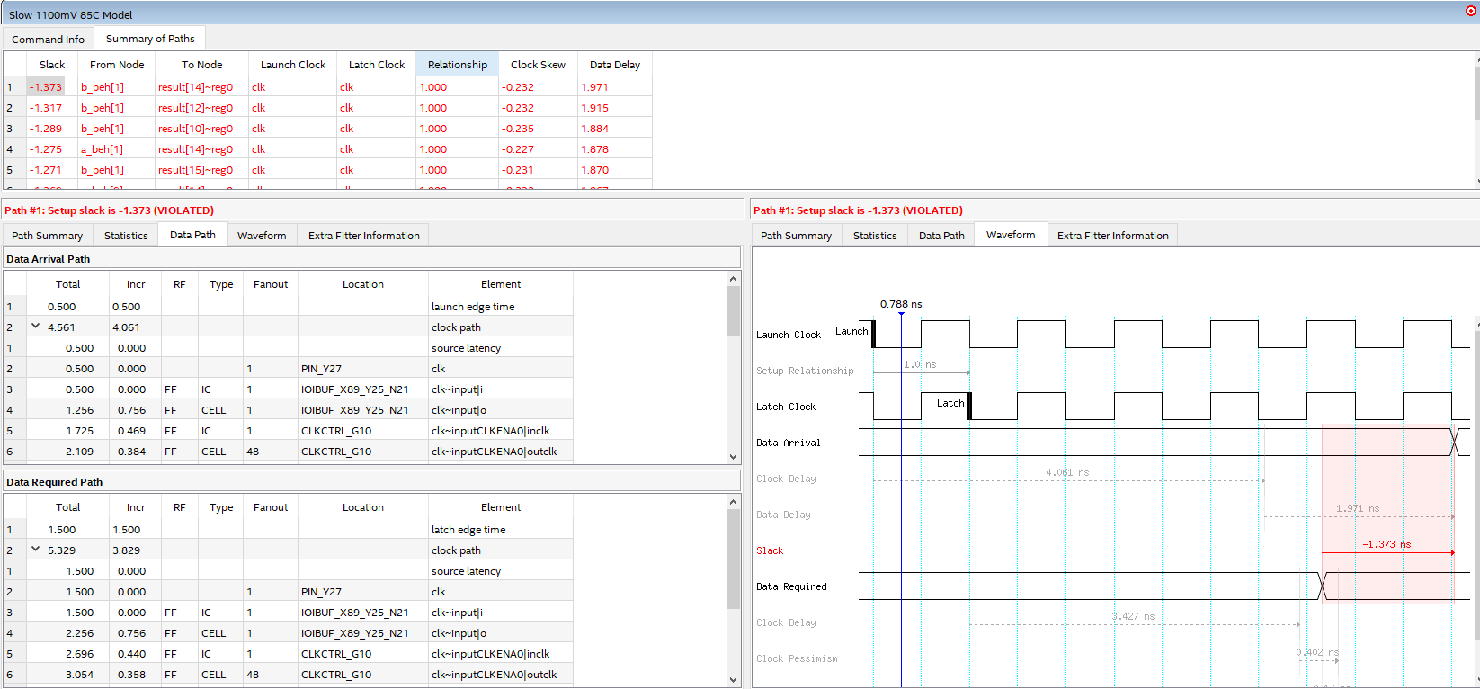

Slack = - 1.373 ns because clock is not constrained and Fmax 1000 MHz

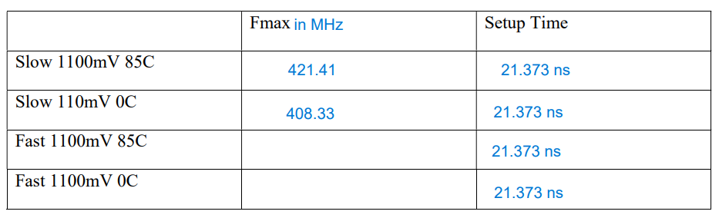

Slack = 17.197 ns

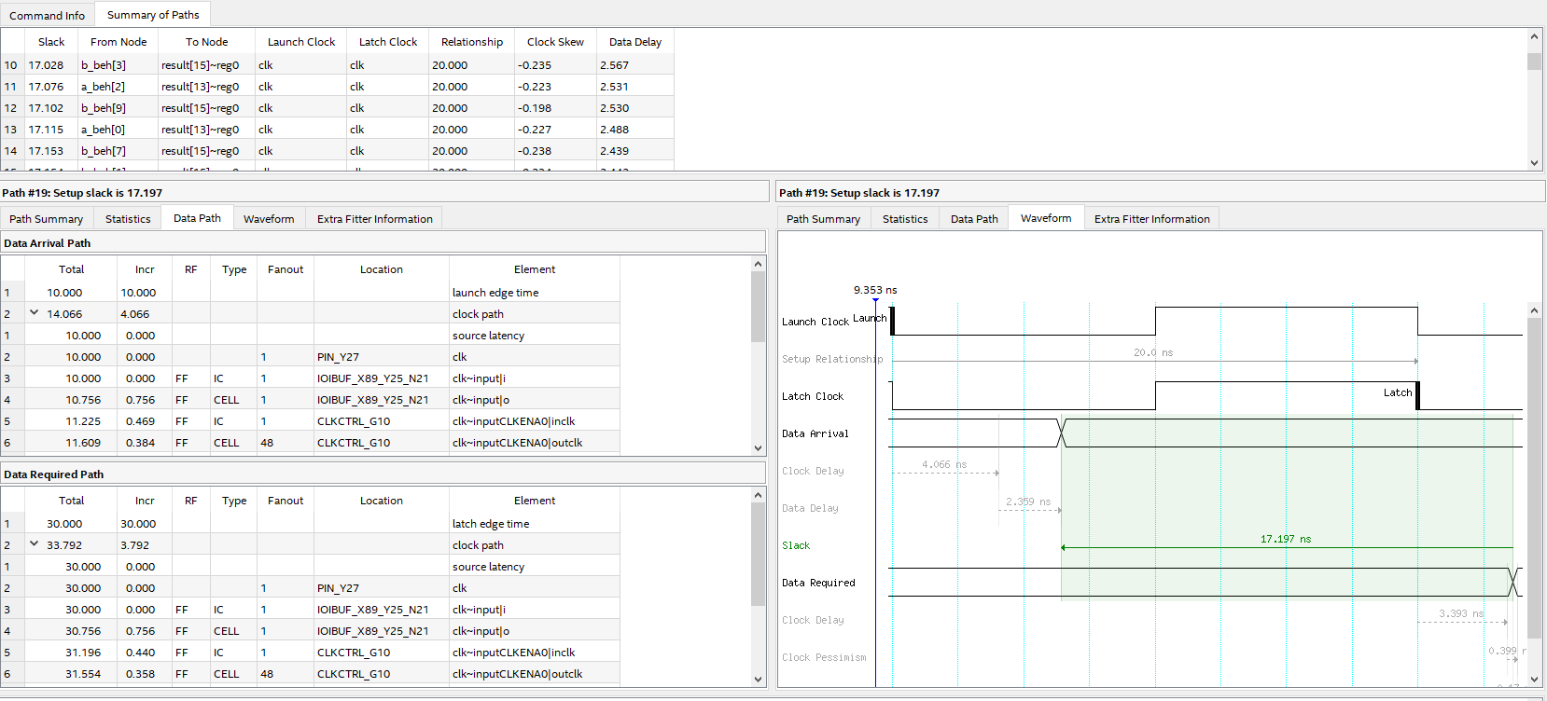

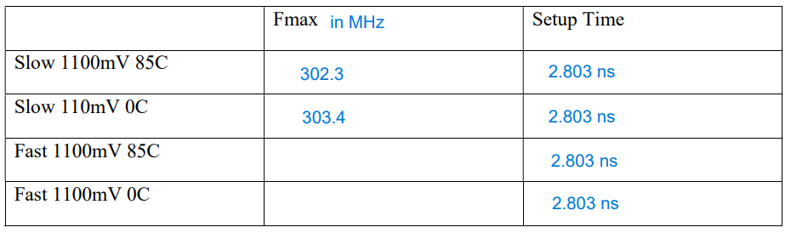

The slack has increased and system passed the timing because I have scaled the clock down to 50 MHz.