


Capital University [formerly Helwan University]
Faculty of Computing and Artificial Intelligence
Information System Department

SilverNest
Elder Care Management system

A graduation project dissertation by:
Anton Farid Maurice 20220084
Haidy Medhat Azer 20220541
Maryam Elghazaly Abdelkader 20220461
Mahmoud Mohammed Mahmoud Elbarbary 20220449
Abdallah Essam Mohammed 20210550
Abdelrhman Reda Sayed Mahmoud 20220258

Submitted in partial fulfilment of the requirements for the degree of Bachelor of Science in Computing & Artificial Intelligence at the Information System Department, the Faculty of Computing & Artificial Intelligence, Capital University [formerly Helwan University]
Supervised by:
Dr. Mai El Defrawi
June 2026

Table of Contents
Acknowledgements | ii
Abstract | iii
Table of Contents | iv
List of Figures | vi
List of Tables | vii
Chapter 1: Introduction | 1
1.1 Overview | 1
1.2 Objectives | 1
1.3 Purpose | 2
1.4 Scope | 2
1.5 General Constraints | 4
Chapter 2: Project Planning and Analysis | 5
2.1 Project Planning | 5
2.1.1 Feasibility Study | 5
2.1.2 Estimated Cost Analysis | 6
2.1.3 Gantt Chart | 6
2.2 Analysis and Limitations of Existing Systems | 7
2.3 Need for the New System | 8
2.4 Analysis of the New System | 8
2.4.1 User Requirements | 8
2.4.2 System Requirements | 9
2.4.3 Domain Requirements | 10
2.4.4 Functional Requirements | 10
2.4.5 Non-Functional Requirements | 11
2.5 Advantages of the New System | 12
2.6 Risk and Risk Management | 13
Chapter 3: Software Design | 15
3.1 Database Design (ERD) | 15
3.2 Use Case Diagram | 18
3.3 Class Diagram | 19
3.4 Sequence Diagrams | 21
3.5 Activity Diagrams | 26
3.6 System Architecture Diagram | 31
Chapter 4: Implementation | 32
4.1 Software Architecture | 32
4.2 Workflow / Pseudocode / Flowcharts | 35
4.3 Module Implementation | 38
4.4 API Documentation | 41
Chapter 5: Testing | 45
5.1 Unit Testing | 45
5.2 Integration Testing | 46
5.3 System Testing | 47
5.4 Performance Testing | 48
5.5 Security Testing | 49
5.6 User Acceptance Testing | 50
5.7 Testing Summary Tables | 51
Chapter 6: Results and Discussion | 52
6.1 Results | 52
6.2 Discussion | 67
Chapter 7: Conclusion | 69
Chapter 8: Future Work | 70
Bibliography | 72
Appendix A: Database Schema | 73
Appendix B: API Documentation | 76
Appendix C: Source Code Samples | 78

Appendix D: User Manual | 80
Appendix E: Installation Guide | 81
Appendix F: Test Cases | 82

Acknowledgements
We would like to express our sincere gratitude and deepest appreciation to all those who have contributed to the successful completion of this graduation project.

First and foremost, we extend our heartfelt thanks to our academic supervisor, Dr. Mai El Defrawi, whose expert guidance, invaluable feedback, and constant encouragement throughout every phase of this project have been indispensable. Her professional insights and unwavering dedication to academic excellence have shaped this work tremendously.

We are also deeply grateful to the Faculty of Computers and Information at our university, and to the Department of Information Systems, for providing us with the academic foundation, resources, and environment necessary to undertake a project of this scope and complexity.

Our sincere thanks go to our families for their endless patience, moral support, and encouragement during the long and demanding hours of development and research. Their belief in our capabilities sustained us throughout this journey.

We also acknowledge the open-source communities behind .NET 8, ASP.NET Core, React.js, FastAPI, and the Google Gemini AI API, whose tools and libraries made this project technically feasible.

Finally, we dedicate this work to every elderly individual who deserves dignity, professional care, and compassionate monitoring in their golden years. It is our hope that the SmartElderlyCare system will, in some measure, contribute to improving the quality of eldercare in our society.

Team Members:
Anton Farid Maurice, Haidy Medhat Azer, Maryam Elghazaly Abdelkader,
Mahmoud Mohammed Mahmoud Elbarbary, Abdallah Essam Mohammed, Abdelrhman Reda Sayed Mahmoud

Abstract

SmartElderlyCare (commercially branded as SilverNest) is a comprehensive, multi-tier elder care management platform developed as a graduation project for the Faculty of Computers and Information, Information Systems Department. The system addresses critical challenges in managing elderly residents at care facilities by integrating modern software engineering technologies into a unified, intelligent solution.

The system is built using a distributed three-tier architecture with a dedicated AI microservice, comprising: (1) a .NET 8 / ASP.NET Core Web API backend implementing Clean Architecture (Domain, Application, Infrastructure, and API layers) with Entity Framework Core and SQL Server; (2) a Python FastAPI AI microservice incorporating trained Random Forest machine learning models for health risk prediction, a meal recommendation engine with allergy-safe fallbacks, and a fall detection prototype; and (3) a React.js 19 single-page application frontend consuming secure backend services integrated with the Google Gemini AI API for intelligent, natural-language daily report generation, chronic pattern detection, and predictive clinical summaries.

The platform serves four distinct user roles: System Administrators, Team Leaders, Care Employees, and Family Members. Key functional modules include: automated JWT-based authentication with role-based access control (RBAC), real-time SignalR- based push notifications, daily health metric reporting with AI-generated summaries, predictive health risk analytics with clinical rule-based overrides, AI-powered personalised dietary recommendations, family visit scheduling and management, employee work schedule management, attendance tracking with clock-in/clock-out, approval workflows, comprehensive audit logging, and a full administrative dashboard with system-wide statistics.

The AI microservice was trained on a custom elderly health dataset of over 500 records spanning vital signs, medication adherence, mobility, sleep patterns, and dietary intake. The trained Random Forest classifiers achieve high accuracy in predicting high-risk health events validated using 5-fold cross-validation, supplemented by a hybrid clinical rule engine that enforces hard clinical thresholds for patient safety.

The project demonstrates the successful application of full-stack software engineering principles, machine learning, natural language processing, real-time communication, and human-computer interaction design to a meaningful real-world healthcare problem.

Keywords: Elder Care Management, ASP.NET Core, React.js, Python FastAPI, Machine Learning, Random Forest, Health Risk Prediction, Gemini AI, SignalR, Clean Architecture, JWT Authentication, RBAC, Information Systems.

List of Figures
Figure No. | Caption | Page
Figure 1.1 | SmartElderlyCare High-Level System Overview | 4
Figure 2.1 | Gantt Chart – Project Development Timeline | 8
Figure 3.1 | Entity Relationship Diagram (ERD) – Full Database Schema | 20
Figure 3.2 | Use Case Diagram – System Actors and Use Cases | 24
Figure 3.3 | Class Diagram – Domain Model | 27
Figure 3.4 | Sequence Diagram – User  Authentication Flow | 29
Figure 3.5 | Sequence Diagram – Employee Daily Report Submission | 30
Figure 3.6 | Sequence Diagram – Team Leader Report Approval | 31
Figure 3.7 | Sequence Diagram – AI Health Risk Prediction | 32
Figure 3.8 | Sequence Diagram – Family Visit Scheduling | 33
Figure 3.9 | Sequence Diagram – Real-Time Notification Delivery | 34
Figure 3.10 | Activity Diagram – User Registration and Login | 35
Figure 3.11 | Activity Diagram – Daily Report  Submission and Approval Workflow | 36
Figure 3.12 | Activity Diagram – Emergency Health Alert Workflow | 37
Figure 3.13 | Activity Diagram – Family Visit Scheduling Workflow | 38
Figure 3.14 | Activity Diagram – Employee Attendance Workflow | 39
Figure 3.15 | System Architecture Diagram –  Three-Tier Microservices | 40
Figure 4.1 | Clean Architecture Layer Diagram | 43
Figure 4.2 | JWT Authentication Flowchart | 47
Figure 4.3 | AI Health Risk Prediction Flowchart | 48
Figure 4.4 | Employee Dashboard Screenshot | 49
Figure 4.5 | Team Leader Dashboard Screenshot | 52
Figure 4.6 | Admin Dashboard Screenshot | 54
Figure 4.7 | Family Member Portal Screenshot | 56

List of Tables
Table No. | Caption | Page
Table 2.1 | Feasibility Study Summary | 6
Table 2.2 | Estimated Project Cost Breakdown | 7
Table 2.3 | Comparison of Existing Systems | 9
Table 2.4 | Functional Requirements | 14
Table 2.5 | Non-Functional Requirements | 16
Table 2.6 | Risk Register and Mitigation Plan | 18
Table 3.1 | Database Entities and Descriptions | 21
Table 3.2 | Entity Relationships Summary | 23
Table 3.3 | User Types and Roles | 25
Table 4.1 | Technology Stack | 44
Table 4.2 | Authentication API Endpoints | 58
Table 4.3 | Admin API Endpoints | 59
Table 4.4 | Team Leader API Endpoints | 61
Table 4.5 | Employee API Endpoints | 62
Table 4.6 | Family Member API Endpoints | 64
Table 4.7 | AI Microservice Endpoints | 65
Table 5.1 | Unit Test Cases – Authentication | 67
Table 5.2 | Unit Test Cases – Report Management | 68
Table 5.3 | Unit Test Cases – Health Prediction | 69
Table 5.4 | Integration Test Results | 71
Table 5.5 | System Test Results | 73
Table 5.6 | Performance Benchmarks | 74
Table 5.7 | Security Test Results | 75
Table 5.8 | UAT Results Summary | 76
Table 5.9 | Overall Testing Summary | 77
Table 6.1 | Expected vs Actual Results Comparison | 80
Table A.1 | Database Table Definitions | 91
Table F.1 | Complete Test Case Catalogue | 105

Chapter 1: Introduction

Overview
The global elderly population is growing at an unprecedented rate. According to the World Health Organization (WHO), the number of people aged 60 years or older is projected to reach 2.1 billion by 2050 — more than double the figure recorded in 2020. This demographic shift places enormous pressure on care facilities, healthcare providers, families, and information systems that must support the physical, medical, and emotional needs of elderly residents.

In Egypt and the broader Middle Eastern region, the challenge is further compounded by a growing gap between rising demand for professional eldercare services and the capacity of care facilities to deliver consistent, high-quality, and documented care. Existing systems — where they exist at all — are often paper-based, fragmented, poorly integrated, and lack any intelligent decision-support capabilities.

SmartElderlyCare, commercially branded as SilverNest, is a full-stack, AI-enhanced elder care management system developed as the graduation project of six students from the Department of Information Systems, Faculty of Computers and Information. The system is designed to address the pressing operational needs of elderly care facilities through a modern, web-based, role-aware platform that integrates data management, workflow automation, real-time communication, and artificial intelligence.

The system provides an integrated digital platform where care facility administrators, team leaders, caregiving employees, and family members all have their own tailored dashboards and functionality — enabling seamless coordination, transparent monitoring, and data-driven decision-making in eldercare.

Objectives
    - To develop a fully functional, multi-role web-based management system for elderly care facilities.
    - To implement an AI-powered health risk prediction engine capable of identifying high-risk residents based on vital signs, medication adherence, mobility, sleep, and mood.
    - To integrate Google Gemini AI for intelligent, natural-language daily health report generation.
    - To implement a machine learning-based personalised dietary recommendation engine tailored to each resident's medical history, allergies, and dietary restrictions.
    - To deliver a real-time push notification system using ASP.NET Core SignalR for instantaneous health alerts and workflow events.
    - To implement a complete digital workflow for report submission, review, and approval.
    - To provide family members with transparent, controlled access to approved health reports and visit scheduling capabilities.
    - To apply Clean Architecture, SOLID principles, and industry-grade security practices in system design.
    - To demonstrate the successful integration of .NET 8, React.js 19, Python FastAPI, and multiple AI APIs in a cohesive full-stack project.
    - To implement a simulated Computer Vision-based fall detection prototype within the AI microservice that evaluates bounding-box aspect-ratio changes to detect potential emergency events.

Purpose
The primary purpose of this project is threefold:

First, to demonstrate academic mastery of the full software development lifecycle — from requirements analysis through architectural design, implementation, testing, and documentation — as part of the graduation requirements of

the Department of Information Systems.

Second, to contribute a technically advanced, practically applicable software solution to the domain of eldercare management. The system is designed to be deployable in real care facilities, with production-grade features including JWT-based authentication, role-based access control (RBAC), soft-delete data management, global exception handling middleware, audit logging, and database migrations.

Third, to explore and apply modern AI and machine learning technologies within a healthcare context, demonstrating how trained classification models, large language models (Google Gemini), and intelligent rule engines can augment human caregiving with data-driven insights, while maintaining patient safety through clinical override protocols.

Scope
The SmartElderlyCare system encompasses the following functional scope:

Module | Scope Description
User Management | Full CRUD, role-based access (Admin, TeamLeader, Employee, FamilyMember), soft- delete, activation/deactivation, audit trails.
Elderly Resident Management | Complete resident profiles including medical history, allergies, dietary restrictions, room assignment, emergency contacts, and unique  connection codes for family self-registration.
Daily Health Reporting | Structured health metric logging (vitals, medications, meals, activities, mood, symptoms) with Google Gemini AI-generated narrative  reports.
AI Health Risk Prediction | Custom-trained Random Forest classifier for high-  risk prediction with hybrid clinical rule-based overrides for patient safety.
AI Dietary Recommendations | ML-based personalised meal recommendations accounting for BMI, medical conditions, blood sugar trends, blood pressure trends, allergies, and  dietary restrictions.
Report Approval Workflow | Team leader review, approval, or rejection workflow with reason logging and notification  triggers.
Visit Scheduling | Family members can request, update, and cancel  visits; team leaders approve or reject with reasons.
Work Schedule Management | Team leaders create, update, and delete employee work schedules; employees view their  own schedules.
Attendance Tracking | Employee clock-in/clock-out with daily attendance  logs and summary analytics.
Real-Time Notifications | SignalR-based push notifications for health alerts,  report approvals/rejections, visit decisions, and schedule changes.
Email Notifications | SMTP email service for password reset functionality.
System Statistics and Dashboard | Aggregated KPIs including total residents, active employees, pending reports, and attendance summaries.
Audit Logging | Complete system-wide audit trail of all create,  update, and delete actions with timestamps, user IDs, entity types, and change diffs.
Fall Detection (CV Prototype) | A simulated computer vision endpoint inside the Python AI microservice that calculates height-to- width aspect ratio shifts (dy/dx < 0.85) to identify

potential falls and trigger immediate alerts.

  - General Constraints
Constraint | Description
Time Constraint | The project was developed within a single academic semester (approximately 16 weeks), requiring careful scope management and prioritisation.
Academic Context | The system is a prototype-grade project. While designed with production-quality architecture, it has not undergone production hardening (e.g., distributed caching, CDN, container  orchestration).
Hardware Resources | The system was developed and tested on standard developer workstations without cloud  infrastructure. Performance benchmarks reflect local deployment conditions.
Database | The system uses Microsoft SQL Server as the relational database. Cloud database deployment (e.g., Azure SQL) is planned for future work.
AI Model Training Data | The health risk prediction model was trained on a synthetic elderly health dataset (elderly_health_dataset.xlsx) of approximately  500 records. Real-world performance may require retraining on larger clinical datasets.
CORS Policy | The current development configuration allows all origins (CORS: AllowAll). Production deployment requires a restricted CORS policy aligned to the hosting domain.
Fall Detection | The current fall detection module uses a bounding-box aspect-ratio heuristic as a simulation prototype. Integration with a real computer vision model (e.g., YOLOv8-pose,  MediaPipe) is planned for future work.
Authentication | The system implements stateless JWT authentication with a 60-minute access token.  Refresh token rotation is planned for a future version.

Chapter 2: Project Planning and Analysis

Project Planning

Feasibility Study
A comprehensive feasibility study was conducted across four dimensions:

Table 2.1: Feasibility Study Summary

Dimension | Rating | Assessment
Technical Feasibility | HIGH | All required technologies (.NET 8, React.js 19, Python FastAPI, SQL Server, SignalR, Gemini API) are mature, well-documented, and free to use in academic contexts. The development team acquired expertise in all stack components through  coursework and independent study.
Economic Feasibility | HIGH | The project is entirely open- source and free of licensing costs. Cloud hosting (optional) carries minimal charges for academic-scale deployments. SQL Server Express (free) and  SQLite (alternative) are viable database options.
Operational Feasibility | HIGH | Care facility staff are already accustomed to digital tools. The system provides clear role- specific dashboards that reduce learning curves. Administrator onboarding, employee training, and family self-registration  workflows are all built into the system.
Legal / Ethical Feasibility | MEDIUM | Health data is sensitive and subject to data protection regulations. The system implements soft-delete (never permanently erases records), role-based data access (family members only see approved reports), and full audit logging. Compliance with GDPR  principles is architecturally supported.
Schedule Feasibility | HIGH | The project scope was carefully defined and prioritised using an Agile-inspired iterative approach. Core modules (Auth, Reports, Elderly Management, Notifications) were developed  first, followed by AI integration and advanced analytics.

Based on this study, the SmartElderlyCare project was determined to be fully feasible for development within the academic semester.

Estimated Cost Analysis
The following table presents an estimated cost analysis based on hypothetical commercial development rates:

Table 2.2: Estimated Project Cost Breakdown

Work Item | Estimated Hours | Rate | Cost
Backend API Development (.NET 8,  ASP.NET Core, EF Core) | 320 hours | USD 30/hr | USD 9,600
Frontend Development  (React.js, HeroUI, Recharts) | 280 hours | USD 28/hr | USD 7,840
AI Microservice Development (FastAPI, Scikit-learn, ML  Training) | 120 hours | USD 35/hr | USD 4,200
Database Design and  Administration (SQL Server, EF Migrations) | 60 hours | USD 30/hr | USD 1,800
Testing and Quality Assurance | 80 hours | USD 25/hr | USD 2,000
Documentation | 40 hours | USD 20/hr | USD 800
Project Management | 60 hours | USD 25/hr | USD 1,500
Software Licenses (All Open Source) | — | — | USD 0
Cloud Hosting (Development Phase) | — | — | USD 0
 | TOTAL |  | USD 27,740

Note: Actual academic project cost is USD 0, as all tools are open-source and development is performed by student team members as part of their graduation requirements.

Gantt Chart
The following table describes the project timeline, presented as a textual Gantt chart spanning 16 weeks:

Figure 2.1: Gantt Chart – Project Development Timeline

Timeline | Task | Responsible | Status
Week 1-2 | Requirements Gathering and Analysis | All Members | COMPLETED
Week 2-3 | System Architecture Design and ERD | Anton, Mahmoud | COMPLETED
Week 3-4 | Database Schema and EF Core Models | Anton, Abdelrhman | COMPLETED
Week 4-6 | Backend: Auth, User Management, Admin APIs | Anton, Abdallah | COMPLETED
Week 5-7 | Backend: Employee,  TeamLeader, Family APIs | Anton, Abdelrhman, Abdallah | COMPLETED
Week 6-8 | AI Microservice: Dataset Preparation  and ML Training | Mahmoud, Haidy | COMPLETED

Week 7-9 | AI Microservice: FastAPI Endpoints (Health Risk, Diet, Fall) | Mahmoud, Haidy | COMPLETED
Week 8-10 | Frontend: Auth Pages, Role-based Routing | Maryam, Haidy | COMPLETED
Week 9-11 | Frontend: Employee and Admin Dashboards | Maryam, Anton | COMPLETED
Week 10-12 | Frontend: Team Leader and Family Portals | Maryam, Haidy | COMPLETED
Week 11-13 | SignalR Notification Hub and Real-time  Features | Anton, Abdallah | COMPLETED
Week 12-14 | Gemini AI Integration and Report Generation | Anton, Mahmoud | COMPLETED
Week 13-15 | Integration Testing and Bug Fixes | All Members | COMPLETED
Week 15-16 | Documentation, Final Testing, UAT | All Members | COMPLETED
Week 16 | Final Report  Preparation and Submission | All Members | COMPLETED

Analysis and Limitations of Existing Systems
A review of existing eldercare management systems was conducted to identify gaps that SmartElderlyCare addresses:

Table 2.3: Comparison of Existing Systems

System | Strengths | Limitations / Gaps
EHR Systems (e.g., Epic, Cerner) | Comprehensive clinical records | Extremely expensive, complex implementation, not designed for small-to-medium care  homes; no AI advisory features; no family portal
MatrixCare | Nursing facility management | Enterprise pricing, complex training requirements, limited AI integration, no direct family  communication portal
Netsmart myUnity | Elder care workflow management | US-centric compliance (HIPAA), cloud-only, expensive subscription, limited  customisation for regional use cases
Paper-Based Systems (Local) | Zero cost | No digital records, no analytics, high error rate, no family communication, no AI support, no reporting workflow
Generic ERP/HR Systems | General-purpose management | Not healthcare-specific, no health monitoring, no medication tracking, no family access, no AI health predictions
SmartElderlyCare (This Project) | Purpose-built for eldercare with AI | Open-source stack, zero licensing cost, full Arabic/regional use-case support, built-in AI, real-time  alerts, family portal, Gemini AI reports, multilingual-ready

Need for the New System
- The absence of an affordable, Arabic-context-appropriate digital eldercare management system for small-to- medium care facilities in Egypt and the region.
- The lack of AI-powered health risk prediction in available systems, which would allow proactive rather than reactive care.
- The absence of seamless family communication and transparency — a critical concern in Middle Eastern family- centred cultures.
- The need for intelligent, AI-generated clinical reports to reduce documentation burden on care staff.
- The requirement for real-time health alerts that notify relevant staff immediately when a resident's vitals or behaviour signals risk.
- The absence of integrated dietary recommendation systems personalised to each resident's medical profile.
- The need for a complete digital audit trail for all care actions, essential for facility compliance and quality assurance.
- The lack of structured report approval workflows to ensure quality control between caregivers and supervisors.
- The critical requirement for double-check safety validation: AI-generated insights (health risks and diet plans) must always be backed by clinical rule-based overrides and disclaimer protocols to ensure technology serves as an assistant rather than a replacement for professional human judgment.

Analysis of the New System

User Requirements
The following user requirements were gathered through iterative analysis:

Req. ID | Actor | Requirement
UR-001 | Admin | Create, update, deactivate, and  permanently soft-delete user accounts across all roles.
UR-002 | Admin | Manage elderly resident profiles including medical history,  allergies, and dietary restrictions.
UR-003 | Admin | Assign and reassign employees to elderly residents, marking primary caregivers.
UR-004 | Admin | View system-wide statistics, audit logs, and activity  summaries.
UR-005 | Admin | Manage all visit requests and family-elderly linkages.
UR-006 | Team Leader | Review, approve, or reject employee-submitted daily  health reports.
UR-007 | Team Leader | Monitor employee attendance, performance metrics, and report submission history.
UR-008 | Team Leader | Create, update, and delete  employee work schedules.
UR-009 | Team Leader | Approve or reject family visit requests with documented  reasons.
UR-010 | Team Leader | Access AI-generated dietary  recommendations for any resident.

UR-011 | Employee | Submit structured daily health reports for assigned elderly  residents.
UR-012 | Employee | Record health metrics including vitals, medications, meals,  activities, mood, and symptoms.
UR-013 | Employee | Clock in and out to record attendance.
UR-014 | Employee | View personal work schedule and assigned residents.
UR-015 | Employee | Receive real-time notifications  for report decisions and schedule updates.
UR-016 | Family Member | Self-register using a unique resident connection code.
UR-017 | Family Member | View approved health reports for linked elderly residents.
UR-018 | Family Member | Track health trends and metric  history for linked residents.
UR-019 | Family Member | Schedule, update, and cancel visit requests.
UR-020 | Family Member | Receive notifications for visit  approvals/rejections and health alerts.
UR-021 | All Users | Authenticate securely using email and password with JWT.
UR-022 | All Users | Reset forgotten password via email link.
UR-023 | All Users | View and update personal profile information.

System Requirements
Hardware Requirements for Deployment:

Component | Specification
Server (Backend + Database) | Minimum: 4-core CPU, 8 GB RAM, 100 GB SSD.  Recommended: 8-core CPU, 16 GB RAM, 256 GB  NVMe SSD.
AI Microservice Server | Minimum: 4-core CPU, 8 GB RAM (for ML model inference). GPU recommended for training but not required at runtime.
Client Workstations | Any modern device with a web browser (Chrome 90+, Firefox 88+, Edge 91+, Safari 14+). Minimum  1280x720 display resolution.
Network | Stable internet connection for AI API calls (Gemini AI). LAN connectivity sufficient for internal  operations.

Software Requirements:

Software | Purpose
.NET 8 Runtime | Required for the ASP.NET Core Web API backend.
SQL Server 2019+ | Primary relational database. Express edition supported.
Python 3.10+ | Required for the FastAPI AI microservice.

Node.js 18+ | Required for building the React.js frontend.
Modern Web Browser | For end-users accessing the system.
SMTP Server Access | For password reset email functionality (Gmail
 | SMTP configured).
Google Gemini API Key | For AI-generated report functionality.

Domain Requirements
The following domain-specific requirements apply to the eldercare context:
      - Health data must be stored with full audit trails and must never be permanently deleted (soft-delete required).
      - Family members must only be able to access information related to their specific linked elderly resident(s).
      - Employees may only access the profiles and reports of elderly residents assigned to them.
      - AI health predictions must be supplemented by hard clinical rule overrides to ensure patient safety (e.g., if systolic
BP ≥ 160 mmHg, always flag as high risk regardless of model output).
      - Dietary recommendations must respect all documented allergies and dietary restrictions as hard constraints.
      - Visit scheduling must adhere to facility policies (visit duration limits, advance notice requirements).
      - All report submissions must pass through a team leader approval workflow before becoming visible to family members.
      - Notifications must be delivered in real-time to minimise response latency for health alerts.

Functional Requirements

Table 2.4: Functional Requirements

Req. ID | Module | Requirement
FR-001 | Authentication | The system shall authenticate users via email and password  and issue JWT access tokens valid for 60 minutes.
FR-002 | Authentication | The system shall support  password reset via time-limited email tokens.
FR-003 | Authentication | The system shall implement account lockout after 5 failed login attempts.
FR-004 | User Management | The system shall support creation, retrieval, update, and  soft-deletion of user accounts.
FR-005 | User Management | The system shall enforce unique  email addresses across all user accounts.
FR-006 | User Management | The system shall support role assignment (Admin,  TeamLeader, Employee, FamilyMember).
FR-007 | Elderly Management | The system shall support full  CRUD operations on elderly resident profiles.
FR-008 | Elderly Management | Each elderly resident shall have a unique 6-character connection  code for family self-registration.

FR-009 | Report Management | The system shall allow employees to create and submit  daily health reports with structured health metrics.
FR-010 | Report Management | The system shall trigger Gemini AI report generation
 |  | automatically upon report submission.
FR-011 | Report Management | The system shall allow team  leaders to approve or reject reports with rejection reasons.
FR-012 | Report Management | Approved reports shall be visible to linked family members.
FR-013 | Health Prediction | The system shall call the AI microservice to assess health  risk for each submitted report.
FR-014 | Health Prediction | The AI service shall return a risk level (High/Low), confidence  score, and clinical recommendation.
FR-015 | Dietary Recommendation | The system shall generate AI- powered personalised dietary  recommendations for residents.
FR-016 | Visit Management | Family members shall be able to schedule visit requests with  date, time, and duration.
FR-017 | Visit Management | Team leaders shall approve or  reject visit requests with documented reasons.
FR-018 | Schedule Management | Team leaders shall create and manage employee work schedules  (Morning/Afternoon/Night/Off shifts).
FR-019 | Attendance | Employees shall be able to clock in and clock out to record daily  attendance.
FR-020 | Notifications | The system shall deliver real- time push notifications via  SignalR for all significant workflow events.
FR-021 | Audit Logging | The system shall log all create, update, and delete actions with user ID, timestamp, and data  changes.
FR-022 | Dashboard | Admin, Team Leader, and Employee dashboards shall  display role-appropriate KPI summaries.

Non-Functional Requirements

Table 2.5: Non-Functional Requirements

Req. ID | Category | Requirement

NFR-001 | Performance | API response time shall be  under 500ms for standard CRUD operations under normal load.
NFR-002 | Performance | The system shall support at least 100 concurrent users without degradation.
NFR-003 | Security | All API endpoints shall be protected by JWT bearer token
 |  | authentication.
NFR-004 | Security | The AI microservice shall be protected by API key  authentication (X-API-Key header).
NFR-005 | Security | Passwords shall be hashed using  ASP.NET Core Identity (PBKDF2 with HMACSHA256).
NFR-006 | Security | All sensitive configuration (API keys, connection strings) shall be stored in appsettings.json or  environment variables.
NFR-007 | Availability | The system shall target 99%  uptime in production deployment.
NFR-008 | Scalability | The Clean Architecture design shall allow individual services to scale independently.
NFR-009 | Maintainability | Code shall follow SOLID principles, Clean Architecture, and shall include XML  documentation comments on all public APIs.
NFR-010 | Usability | The UI shall be responsive and accessible on screen resolutions from 1280x720 upward.
NFR-011 | Data Integrity | All database operations shall use transactions where applicable; cascading deletes are restricted to preserve referential integrity.
NFR-012 | Auditability | No record shall ever be permanently deleted; the system uses soft-delete with  IsDeleted and DeletedAt fields.

Advantages of the New System
Advantage | Explanation
AI-Powered Health Intelligence | The system combines a trained Random Forest model with a hybrid clinical rule engine to detect  high-risk health conditions proactively, reducing the risk of undetected deterioration.
Intelligent Report Generation | Integration with Google Gemini AI transforms raw health metrics into professional, narrative-style  clinical reports, saving caregivers significant documentation time.

Personalised Nutrition Planning | AI-driven dietary recommendations account for each resident's unique medical history, allergies, BMI, blood sugar trends, and blood pressure, enabling truly personalised care.
Real-Time Communication | SignalR-powered push notifications ensure that critical health alerts and workflow decisions reach the right person within seconds.
Family Transparency | The family portal provides relatives with secure, filtered access to approved health reports and the ability to schedule and track visits, greatly  improving family peace of mind.
Complete Audit Trail | Every action in the system is logged with user identity, timestamp, and data change details, supporting accountability and compliance.
Zero Licensing Cost | The entire technology stack is open-source and  free, making the system highly accessible for care facilities with limited IT budgets.
Clean Architecture | The Domain-Application-Infrastructure-API layered architecture ensures the system is  maintainable, testable, and easily extensible.
Role-Aware Access Control | RBAC ensures each user type sees only the data and functions relevant to their role, preventing data leakage and reducing cognitive overload.

  - Risk and Risk Management
Table 2.6: Risk Register and Mitigation Plan

Risk ID | Description | Likelihood | Impact | Mitigation Strategy
R-001 | Scope Creep | HIGH | HIGH | Adopted iterative development with weekly scope reviews; deferred non-essential  features to Future Work.
R-002 | AI Model Accuracy | MEDIUM | HIGH | Supplemented ML model with hard clinical rule overrides; logged  all predictions for review.
R-003 | Gemini API Downtime | LOW | HIGH | Implemented a template-based fallback report generator that activates when  the AI API is unavailable.
R-004 | Security Vulnerabilities | MEDIUM | HIGH | Implemented JWT auth, RBAC, HTTPS, password hashing, account lockout, and input  validation.

R-005 | Data Loss | LOW | HIGH | Implemented soft-delete throughout; all records are retained with  IsDeleted flags.
R-006 | Team Member Unavailability | MEDIUM | MEDIUM | Distributed responsibilities across all team members; used  Git version control for collaborative
 |  |  |  | development.
R-007 | Performance Degradation | LOW | MEDIUM | Implemented pagination, query filtering, indexes on frequently queried columns, and async  operations throughout.
R-008 | Cross-Origin Issues (CORS) | MEDIUM | LOW | Configured CORS middleware; production will  restrict allowed origins.
R-009 | AI API rate-limiting or quota exhaustion (Gemini API). | MEDIUM | MEDIUM | Implemented template-based fallback rendering when Gemini fails, and set query throttling on daily  report creation

Chapter 3: Software Design

Database Design

Entity-Relationship Diagram (ERD)
The SmartElderlyCare database is implemented using Microsoft SQL Server with Entity Framework Core Code-First migrations. The schema comprises 12 primary tables derived from the domain entity models, plus ASP.NET Core Identity tables for authentication and authorisation.
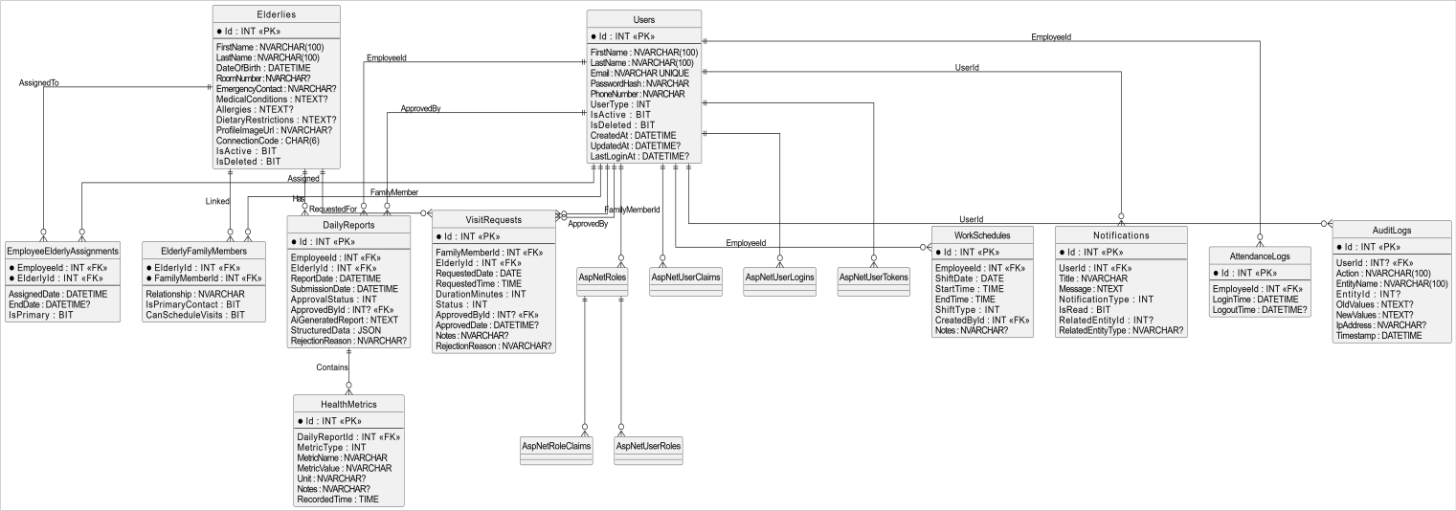
Figure 3.1: Entity-Relationship Diagram (ERD) – SmartElderlyCare Database

Caption: Figure 3.1 – Entity-Relationship Diagram showing all 12 domain entities, their attributes, and relationships in the SmartElderlyCare database.

Entity Descriptions

Table 3.1: Database Entities and Descriptions

Entity | Description
Users | Extends ASP.NET Core IdentityUser<int>. Stores all system user accounts including Admins, Team Leaders, Employees, and Family Members. Includes  FirstName, LastName, UserType (enum), IsActive, soft-delete fields, and LastLoginAt.
Roles | Extends ASP.NET Core IdentityRole<int>. Stores system roles: Admin, TeamLeader, Employee, FamilyMember.
Elderlies | Stores elderly resident profiles including personal information, medical conditions, allergies, dietary restrictions, room assignment, emergency contact,  profile image URL, and a unique 6-character ConnectionCode used for family self-registration.
DailyReports | Stores daily health care reports submitted by employees for assigned elderly residents. Includes report date, submission date, approval status, AI-  generated narrative report, structured JSON data, and approval/rejection workflow fields.
HealthMetrics | Stores individual health observations within a daily report. Each metric has a type (Meal, Medication, Activity, Symptom, Vital, Mood), name, value, unit,

 | notes, and recorded time.
EmployeeElderlyAssignments | Many-to-many join table linking employees to elderly residents. Supports composite PK  (EmployeeId, ElderlyId), assignment date, end date, and primary caregiver flag.
ElderlyFamilyMembers | Many-to-many join table linking family member users to elderly residents. Records the relationship type (Son, Daughter, Spouse, etc.), primary contact  flag, and visit permission flag.
WorkSchedules | Stores employee shift schedules created by team leaders. Includes shift date, start/end times, shift type (Morning, Afternoon, Night, Overnight, OffDay),  and creator/updater references.
AttendanceLogs | Records employee clock-in and clock-out  timestamps. LogDate is a computed column derived from LoginTime.
VisitRequests | Stores family visit requests submitted by family members. Includes requested date/time, duration, status  (Pending/Approved/Rejected/Cancelled/Completed), and approval/rejection tracking.
Notifications | Stores in-app notifications for all users. Each notification has a type (HealthAlert, ReportApproved, ReportRejected, VisitRequest,  ScheduleChange, General), read status, and optional related entity reference.
AuditLogs | Permanent (not soft-deleted) system audit records. Logs every significant action with user ID, action  type, entity name, entity ID, old values JSON, new values JSON, IP address, and timestamp.

Database Relationships

Table 3.2: Entity Relationships Summary

Relationship | Cardinality | Delete Behavior | Notes
Users → DailyReports (as Employee) | One-to-Many | RESTRICT | An employee can submit many daily reports; deletion of user is restricted if  reports exist.
Users → DailyReports (as Approver) | One-to-Many | RESTRICT | A team leader can approve many reports.
Elderlies → DailyReports | One-to-Many | RESTRICT | An elderly resident can have many daily reports.
DailyReports →  HealthMetrics | One-to-Many | CASCADE | A report contains many health metrics; deleting  a report cascades to its metrics.
Users ↔ Elderlies (via  EmployeeElderlyAssignments) | Many-to-Many | RESTRICT | Composite PK (EmployeeId, ElderlyId); employees can be assigned to multiple  residents and vice versa.
Elderlies ↔ Users (via | Many-to-Many | RESTRICT | Composite PK

ElderlyFamilyMembers) |  |  | (ElderlyId, FamilyMemberId); family members can be  linked to multiple residents.
Users → WorkSchedules | One-to-Many | RESTRICT | An employee can have many scheduled shifts.
Users → AttendanceLogs | One-to-Many | RESTRICT | An employee has many attendance log entries.
Users → Notifications | One-to-Many | CASCADE | A user has many notifications; deleting a user cascades to their  notifications.
Users → AuditLogs | One-to-Many | SET NULL | Audit logs reference the acting user; if user is deleted, UserId is set  to null (records preserved).
Elderlies → VisitRequests | One-to-Many | RESTRICT | An elderly resident can  have many visit requests.
Users (FamilyMember) →  VisitRequests | One-to-Many | RESTRICT | A family member user can submit many visit requests. Deleting the  user is restricted if active requests exist.
Users (as Approver) →  VisitRequests | One-to-Many | RESTRICT | A team leader user (approver) can approve or reject  many visit requests.

Use Case Diagram
The following textual Use Case Diagram maps all system actors to their respective use cases in SmartElderlyCare. Each actor interacts with the system through a defined set of use cases protected by role-based access control.

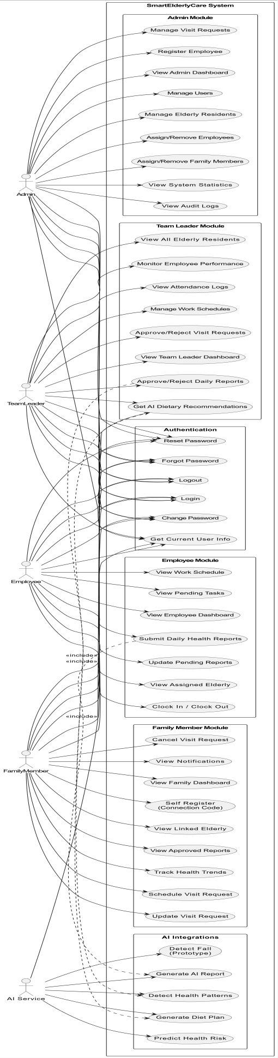
Figure 3.2: Use Case Diagram – All System Actors and Use Cases

Caption: Figure 3.2 – Use Case Diagram showing all four human actors (Admin, TeamLeader, Employee, FamilyMember) and AI service interactions.
The following table describes the four user roles defined in the SmartElderlyCare system, their typical responsibilities, and access levels:
Table 3.3: User Types and Roles

Role / User Type | Responsibilities | Access Level
System Administrator | Full CRUD operations on users, elderly resident profiles, and audit log analysis. | Full System Control
Team Leader | Work schedule management, daily report approval workflows, and AI diet recommendations. | Care Management
Care Employee | Daily health metric logging, report submission, and clock- in/out attendance. | Direct Care & Logging
Family Member | Self-registration using connection codes, viewing  approved reports, health trend tracking, and visit scheduling. | Elderly Portal Access

Class Diagram
The following class diagram represents the core domain model of SmartElderlyCare, derived directly from the entity classes and their relationships as implemented in the Domain project:

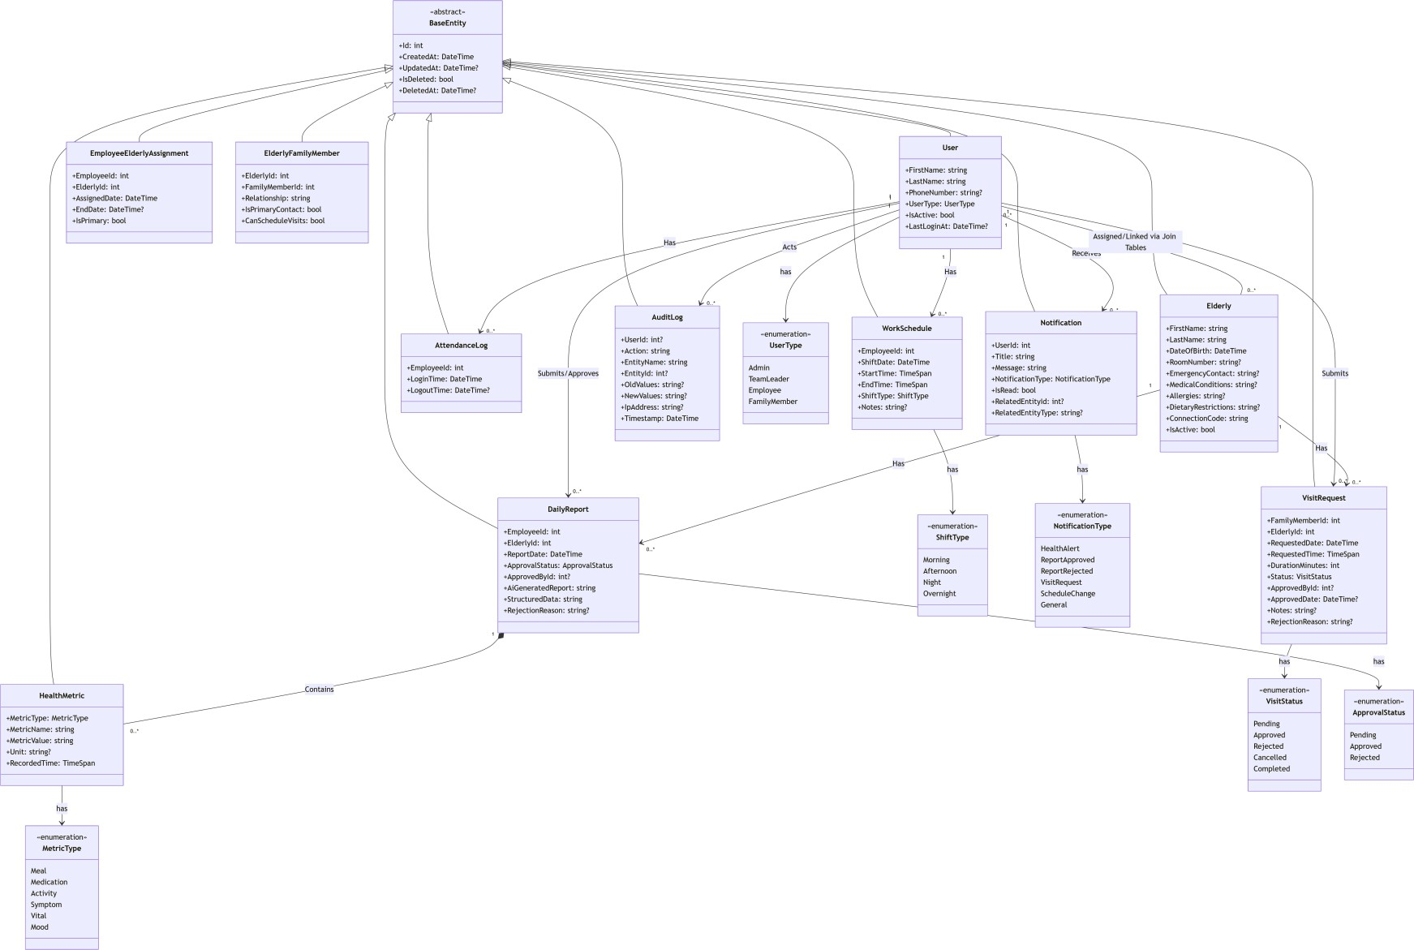

Figure 3.3: Class Diagram – Domain Model showing all entities and key relationships

Caption: Figure 3.3 – Class Diagram showing the SmartElderlyCare domain model with all entities, properties, and relationships.

Sequence Diagrams

Authentication Sequence Diagram
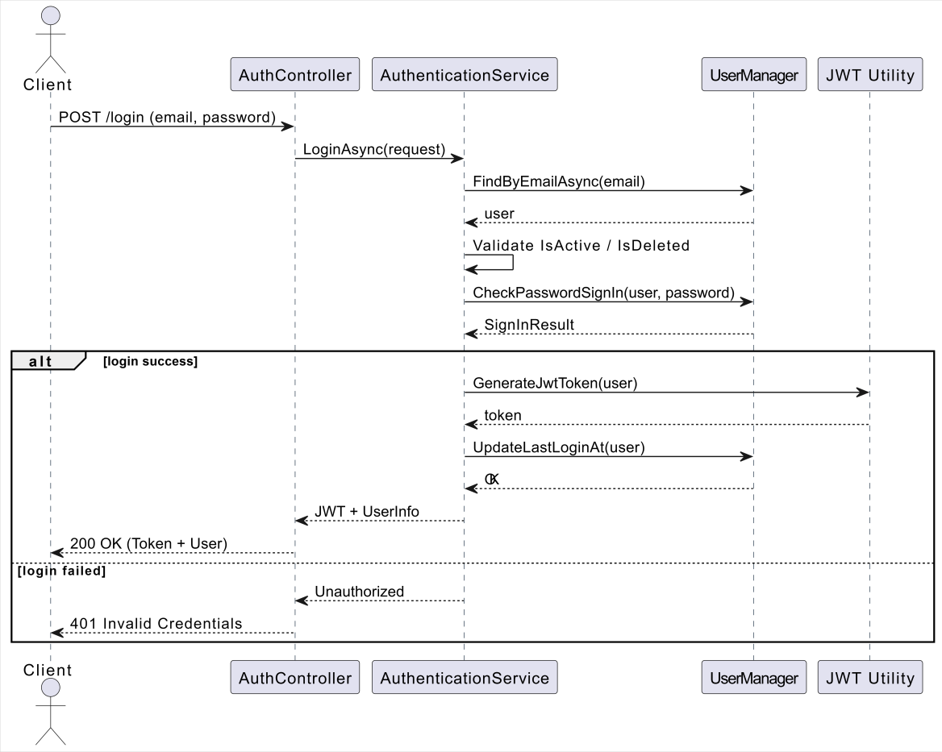

Figure 3.4: Sequence Diagram – JWT Authentication Flow

Daily Report Submission Sequence
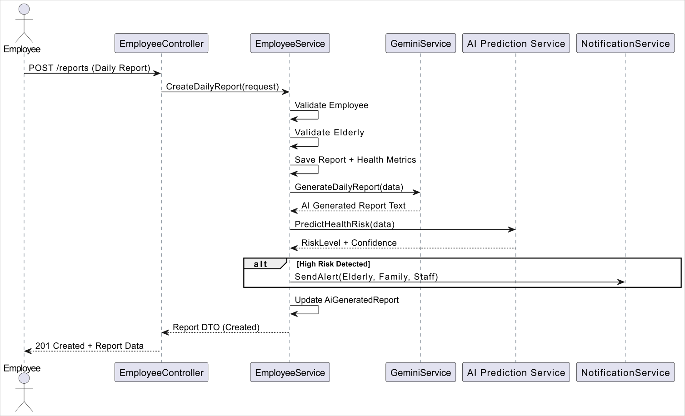

Figure 3.5: Sequence Diagram – Employee Daily Report Submission with AI Integration

Report Approval Sequence
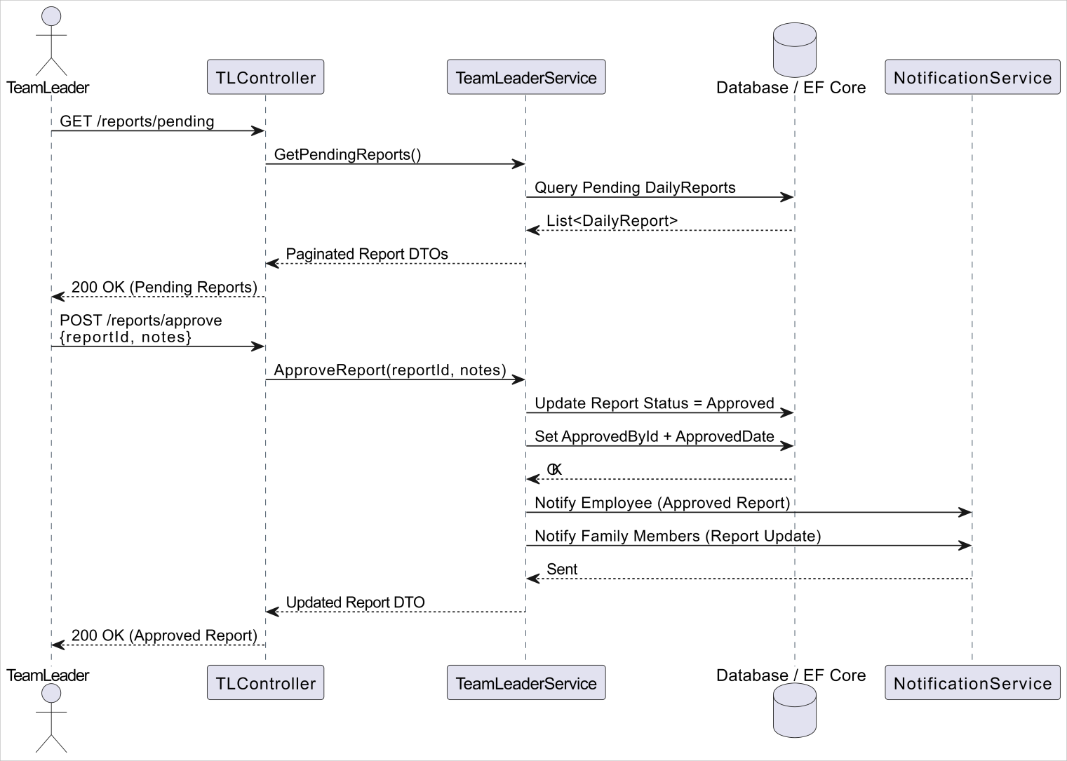

Figure 3.6: Sequence Diagram – Team Leader Report Approval Workflow

AI Health Risk Prediction Sequence
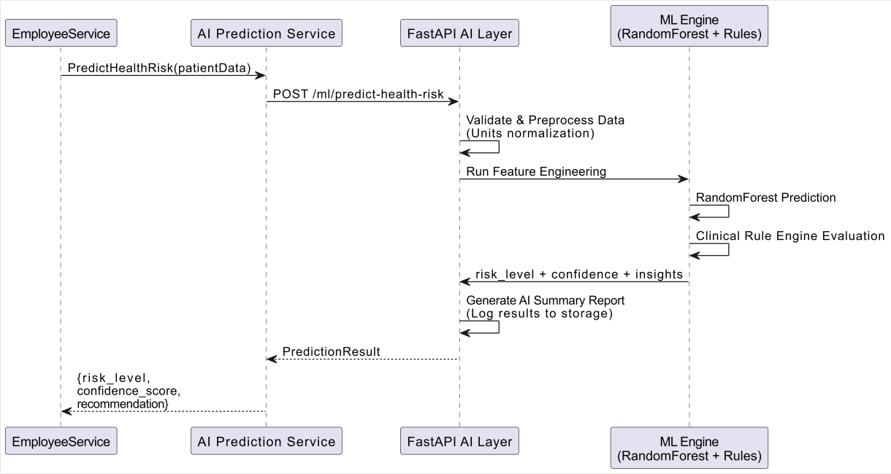

Figure 3.7: Sequence Diagram – AI Health Risk Prediction Pipeline

Family Visit Scheduling Sequence
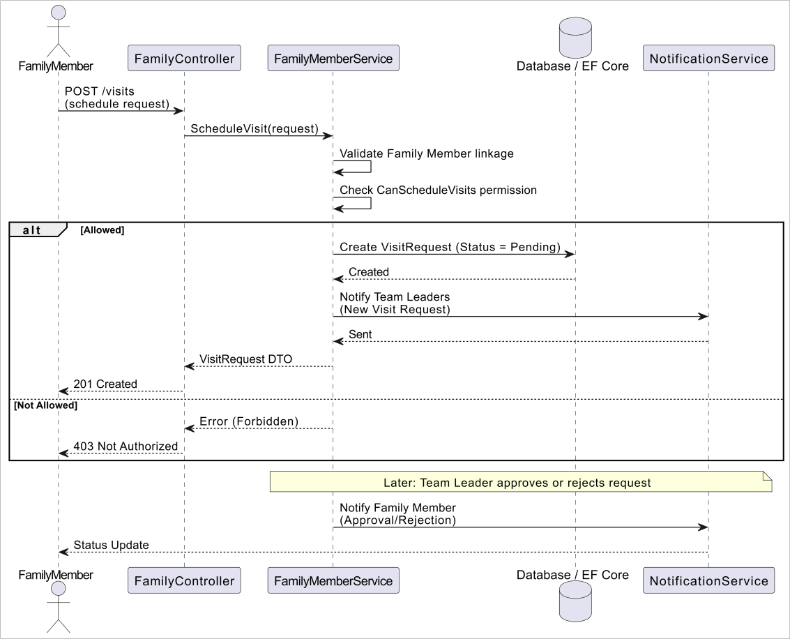

Figure 3.8: Sequence Diagram – Family Visit Scheduling Workflow

Real-Time Notification Sequence (SignalR)
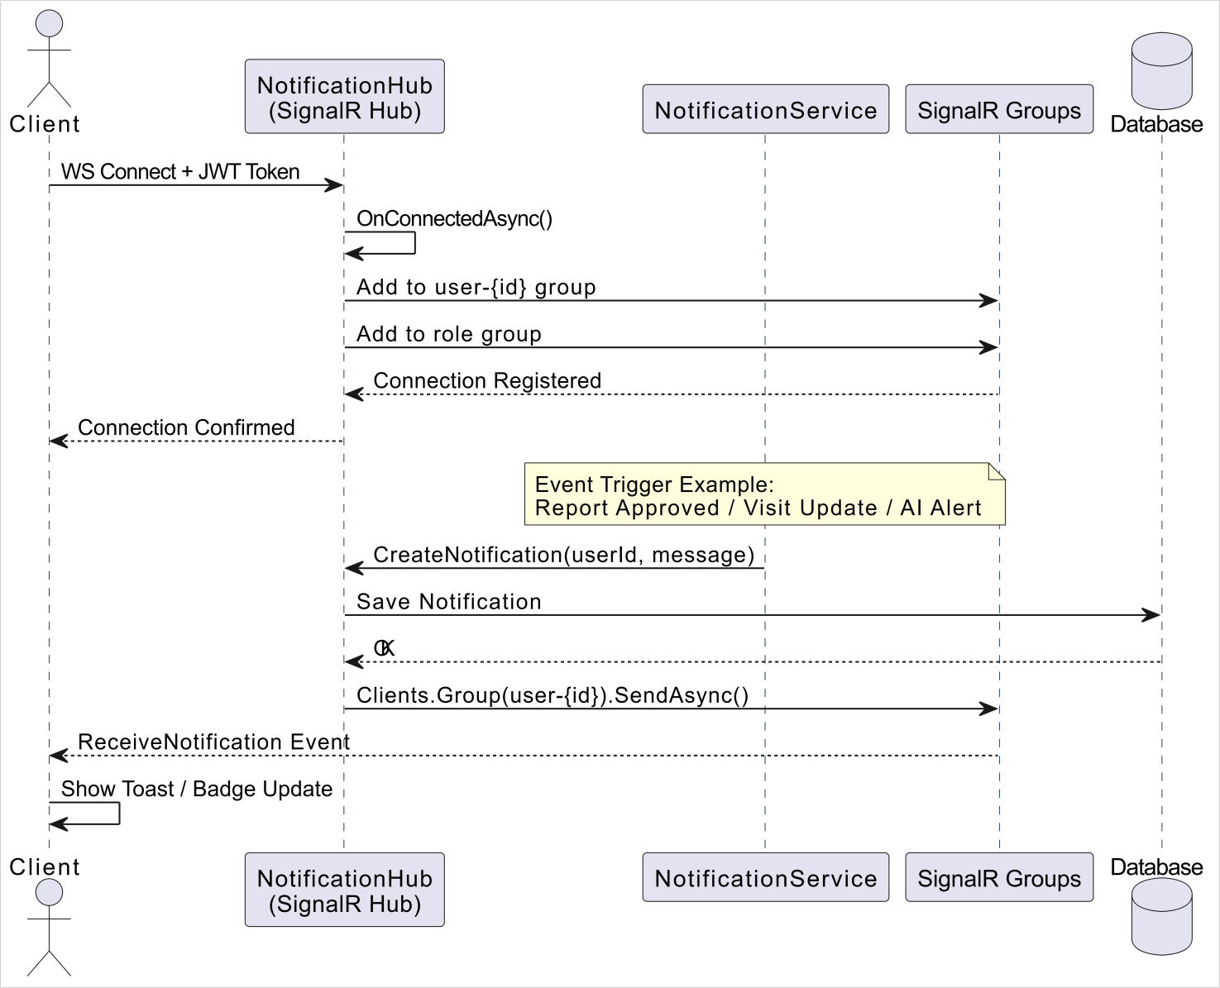

Figure 3.9: Sequence Diagram – Real-Time SignalR Notification Delivery

Activity Diagrams

User Registration and Login Activity
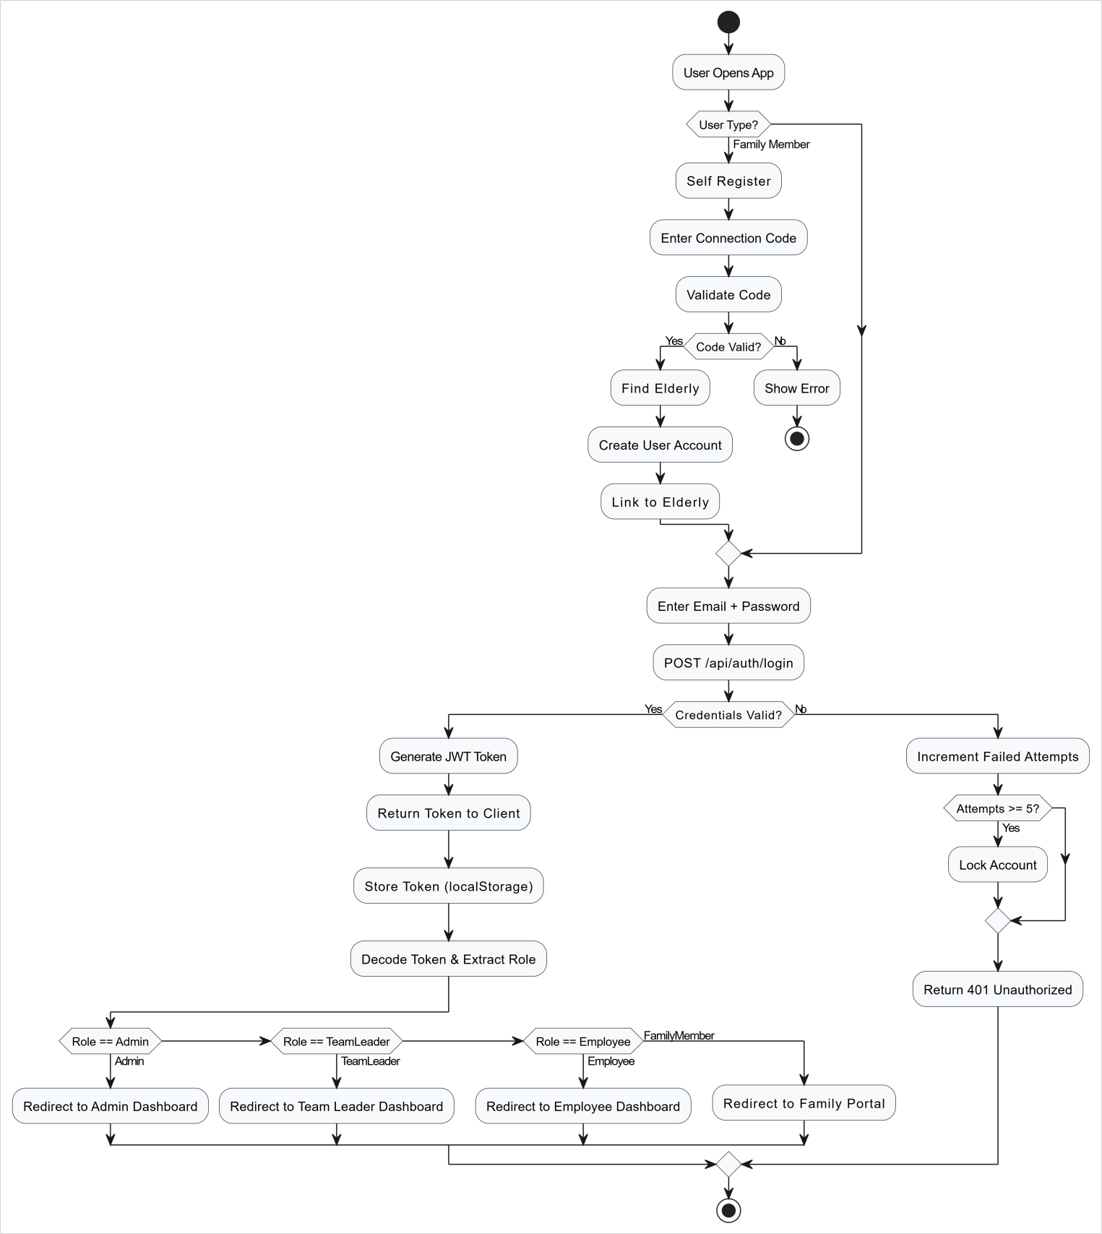

Figure 3.10: Activity Diagram – User Registration and Login Workflow

Daily Report Submission and Approval Workflow
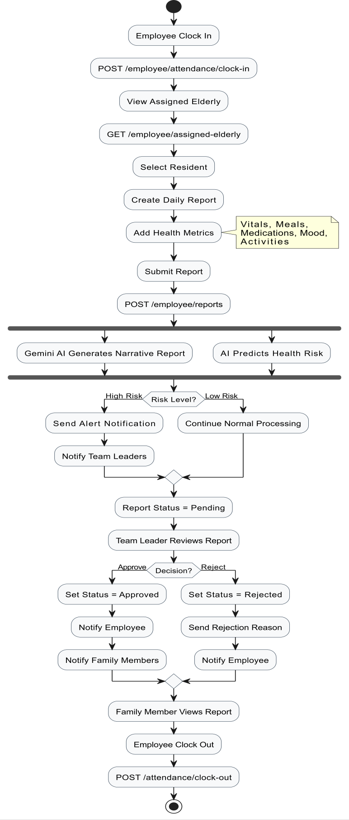

Figure 3.11: Activity Diagram – Daily Report Submission and Approval Workflow

Emergency Health Alert Workflow
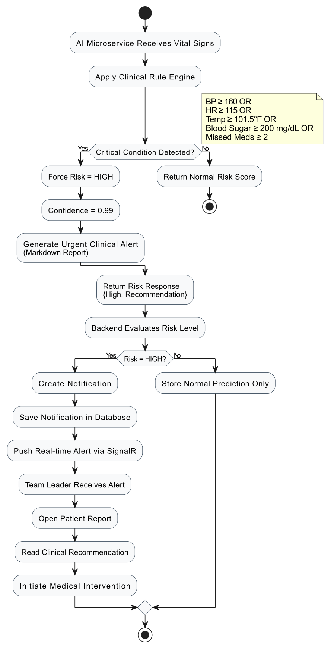

Figure 3.12: Activity Diagram – Emergency Health Alert Detection and Escalation

Family Visit Scheduling Activity
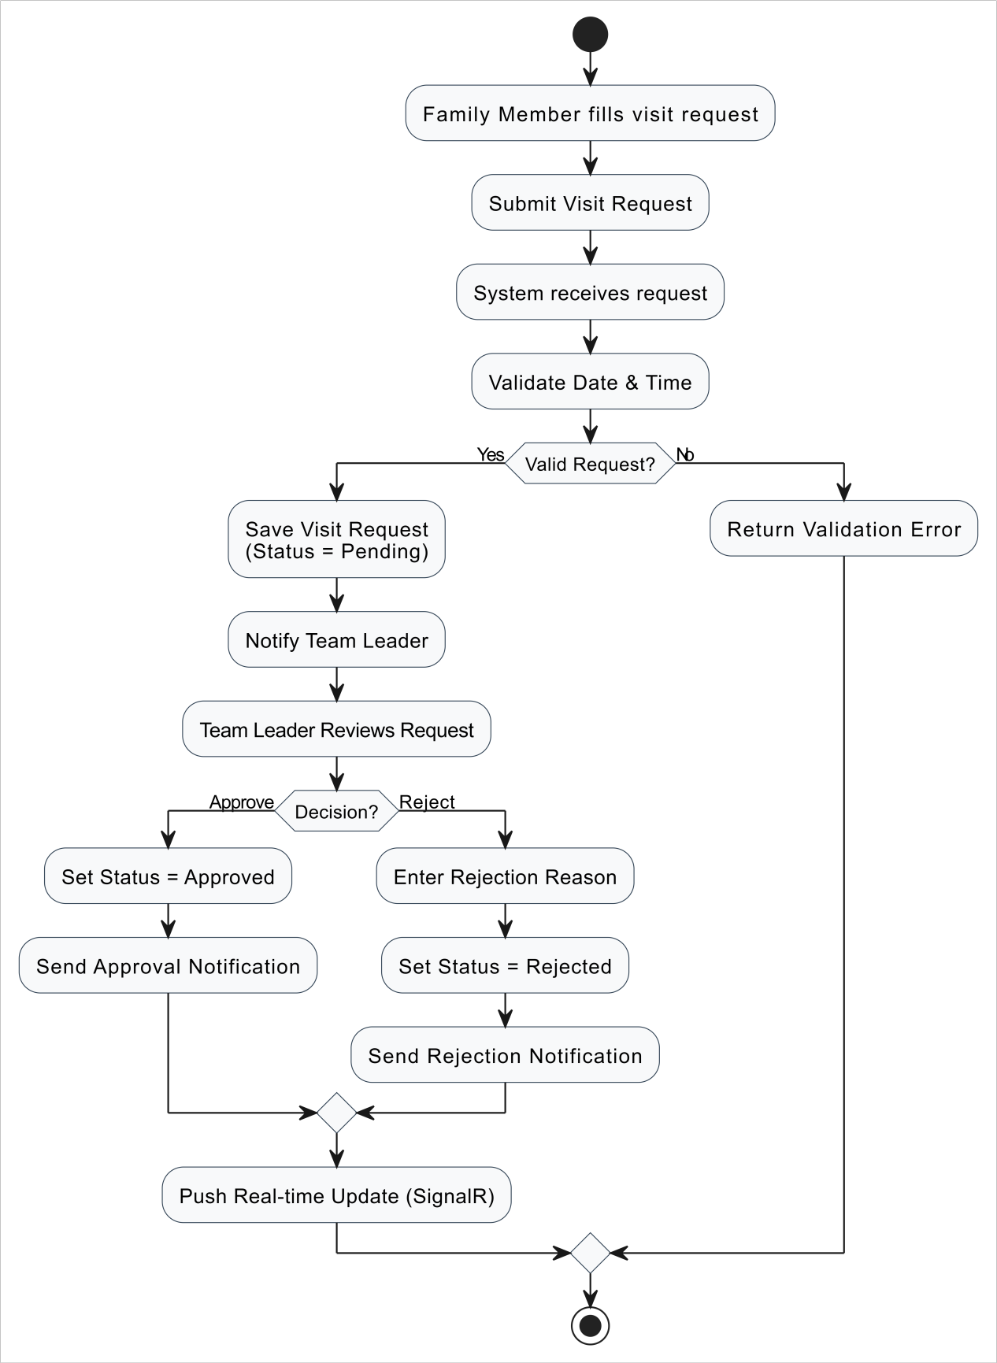

Figure 3.13: Activity Diagram – Family Visit Scheduling Workflow

Employee Attendance Activity
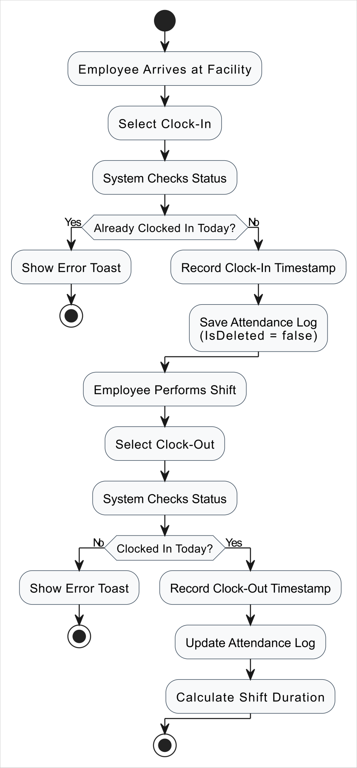

Figure 3.14: Activity Diagram – Employee Attendance Workflow

System Architecture Diagram
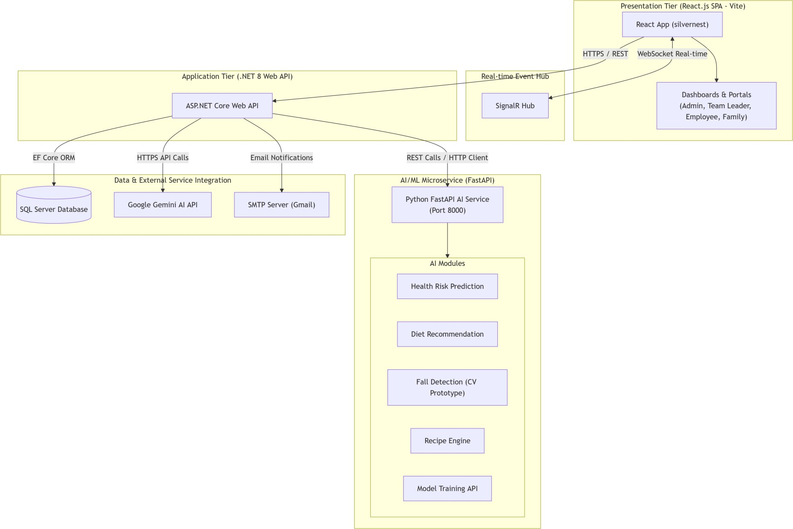
SmartElderlyCare follows a distributed three-tier architecture with a dedicated AI microservice, consisting of a React.js SPA frontend, an ASP.NET Core Web API backend, and a Python FastAPI AI microservice, all backed by Microsoft SQL Server

Figure 3.15: System Architecture Diagram – Three-Tier Microservices Architecture

Caption: Figure 3.15 – Complete System Architecture showing the React.js frontend, ASP.NET Core backend (Clean Architecture), Python AI microservice, SQL Server database, and external integrations.

Chapter 4: Implementation

Software Architecture

Architecture Overview
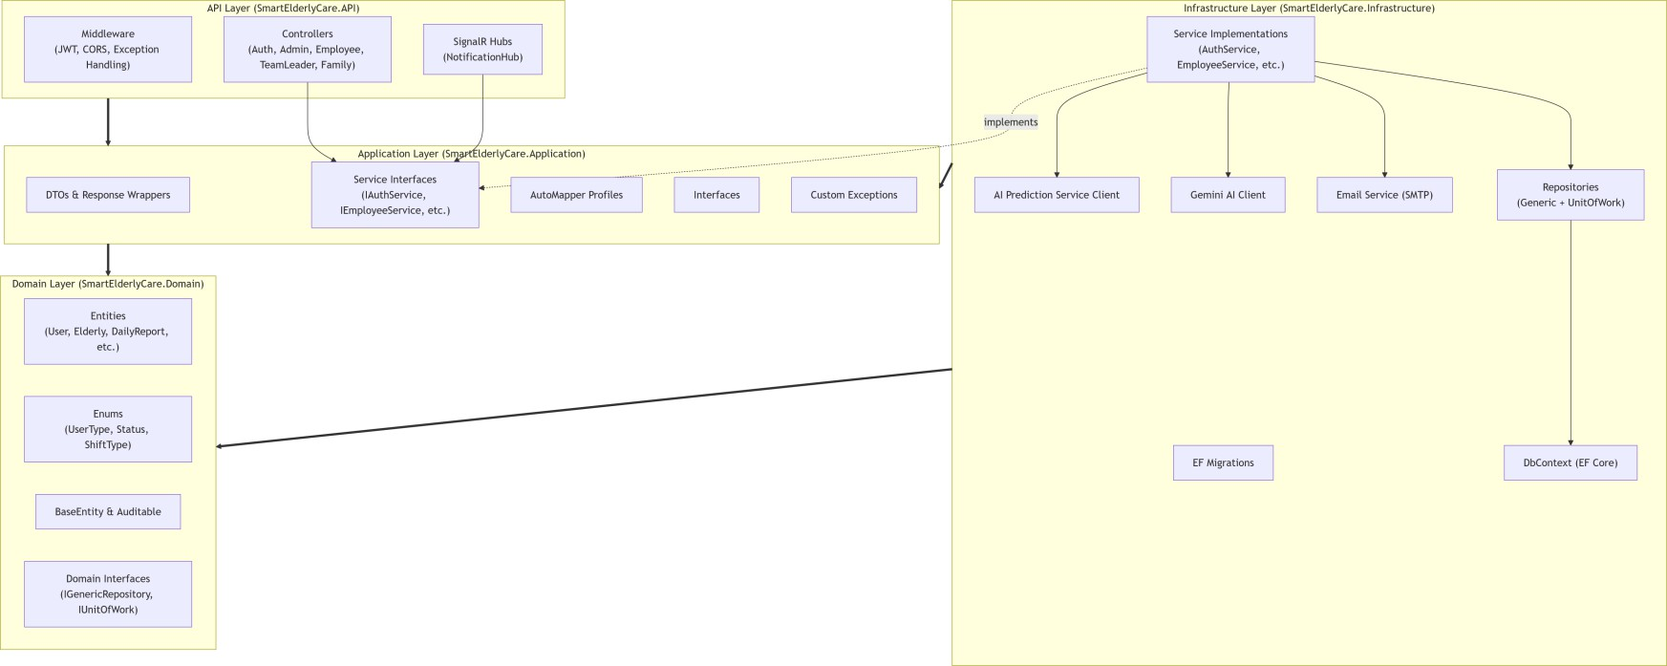
SmartElderlyCare is implemented using Clean Architecture (also known as Onion Architecture), which enforces a strict separation of concerns across four concentric layers. The core principle is that dependencies always point inward — outer layers depend on inner layers, but inner layers have no knowledge of outer layers. This enables independent testability, high maintainability, and technology-agnostic domain logic.

Figure 4.1: Clean Architecture Layer Diagram

The four layers in the .NET backend are:
      - Domain Layer (SmartElderlyCare.Domain): The innermost layer. Contains all business entities (User, Elderly, DailyReport, etc.), enumerations (UserType, ApprovalStatus, MetricType, etc.), interfaces (IRepository<T>, IUnitOfWork), common base classes (BaseEntity, IAuditableEntity), and business rules. Has zero external dependencies.
      - Application Layer (SmartElderlyCare.Application): The second layer. Contains Data Transfer Objects (DTOs) for all API operations, service interfaces (IAuthenticationService, IAdminService, etc.), AutoMapper mapping profiles, application exception classes, and wrapper types (Response<T>, PaginatedResponse<T>). Depends only on the Domain layer.
      - Infrastructure Layer (SmartElderlyCare.Infrastructure): The third layer. Contains the ApplicationDbContext (Entity Framework Core 8), all service implementations (AuthenticationService, AdminService, EmployeeService, TeamLeaderService, FamilyMemberService, GeminiService, NotificationService, EmailService, AiPredictionService), generic repository and unit-of-work implementations, EF Core migrations, and database seeding. Depends on Domain and Application layers.
      - API Layer (SmartElderlyCare.API): The outermost layer. Contains all ASP.NET Core controllers, the SignalR NotificationHub, middleware (GlobalExceptionHandlingMiddleware), extension methods (JWT authentication, Swagger), and the application entry point (Program.cs). Depends on all inner layers.

Technology Stack

Table 4.1: Technology Stack

Component | Technology | Details
Backend Language | .NET 8 / C# 12 | ASP.NET Core Web API
Frontend Language | JavaScript (ES2022) | React.js 19 + Vite 8
AI Service Language | Python 3.10+ | FastAPI + Uvicorn
Database | Microsoft SQL Server 2019+ | Entity Framework Core 8 (Code- First)
Authentication | ASP.NET Core Identity + JWT | HS256 HMAC Signing
Real-Time Communication | ASP.NET Core SignalR | WebSocket transport
AI / ML | Scikit-Learn (Random Forest) | joblib model persistence
Generative AI | Google Gemini Flash API | gemini-flash-latest model
Email | SMTP (Gmail) | System.Net.Mail / MailKit
Frontend UI Library | HeroUI (based on NextUI) | React component library
CSS Framework | TailwindCSS 4 | Utility-first styling
Charts | Recharts | React-based charting library
HTTP Client (Frontend) | Axios + TanStack Query v5 | API calls + server state
Form Management | React Hook Form + Zod | Validation and schema enforcement
Animation | Framer Motion | UI micro-animations
Routing (Frontend) | React Router DOM v7 | Client-side routing
ORM | Entity Framework Core 8 | LINQ-based data access
Object Mapping | AutoMapper | DTO ↔ Entity mapping
API Documentation | Swagger / OpenAPI 3.0 | Swashbuckle.AspNetCore
Version Control | Git + GitHub | Collaborative development
Data Format (AI Reports) | Markdown | rendered via react-markdown

Authentication and Authorization
Authentication is implemented using ASP.NET Core Identity integrated with JWT (JSON Web Tokens):

- Registration: Employees are registered by Admins via POST /api/auth/register/employee. Family members self- register via POST /api/auth/register/family using an elderly resident's ConnectionCode.

- Login: Users authenticate via POST /api/auth/login with email and password. The system verifies credentials using SignInManager.CheckPasswordSignInAsync() with lockout after 5 failed attempts.

- JWT Generation: Upon successful authentication, a JWT is generated containing claims: userId, userType, fullName, email, and role claims. The token is signed using HmacSha256 with a 32+ character secret key and expires after 60 minutes.

- Authorization: All controllers are protected with [Authorize] attributes. Role-based authorization is enforced at the controller and action level using [Authorize(Roles = "Admin")] etc. The CurrentUserService extracts the current user's ID from JWT claims at runtime.

- Password Reset: A password reset flow is implemented using UserManager.GeneratePasswordResetTokenAsync() with token delivery via Gmail SMTP email containing a frontend reset URL.

    - Design Patterns Used
Pattern | Application in SmartElderlyCare
Repository Pattern | Generic Repository<T> abstracts all database operations. Each entity type can be accessed through the repository without coupling business logic to EF Core directly.
Unit of Work Pattern | IUnitOfWork coordinates multiple repository  operations within a single database transaction, ensuring atomicity.
Dependency Injection (DI) | All services, repositories, and infrastructure components are registered with ASP.NET Core's built-in IoC container and injected via constructor  injection throughout the application.
Options Pattern | JwtSettings, EmailSettings, and GeminiSettings are bound from appsettings.json and injected using IOptions<T>, supporting environment-specific  configuration.
Wrapper Pattern | All API responses are wrapped in a generic Response<T> class providing consistent structure with Succeeded, Data, Message, and Errors  properties.
Middleware Pattern | GlobalExceptionHandlingMiddleware intercepts all unhandled exceptions and converts them to structured JSON error responses with appropriate  HTTP status codes.
Mediator-like Service Layer | Each controller role (Admin, TeamLeader, Employee, Family) has a dedicated service class  that encapsulates all business logic, keeping controllers thin and focused.
Factory/Builder (AI Reports) | The GeminiService uses a prompt construction builder pattern to dynamically assemble structured prompts for Gemini AI based on report data.
Strategy Pattern (AI Fallback) | The GeminiService implements a fallback strategy:  if the Gemini API is unavailable, a template-based report generator is used automatically.

Workflow / Pseudocode / Flowcharts

JWT Authentication Flowchart
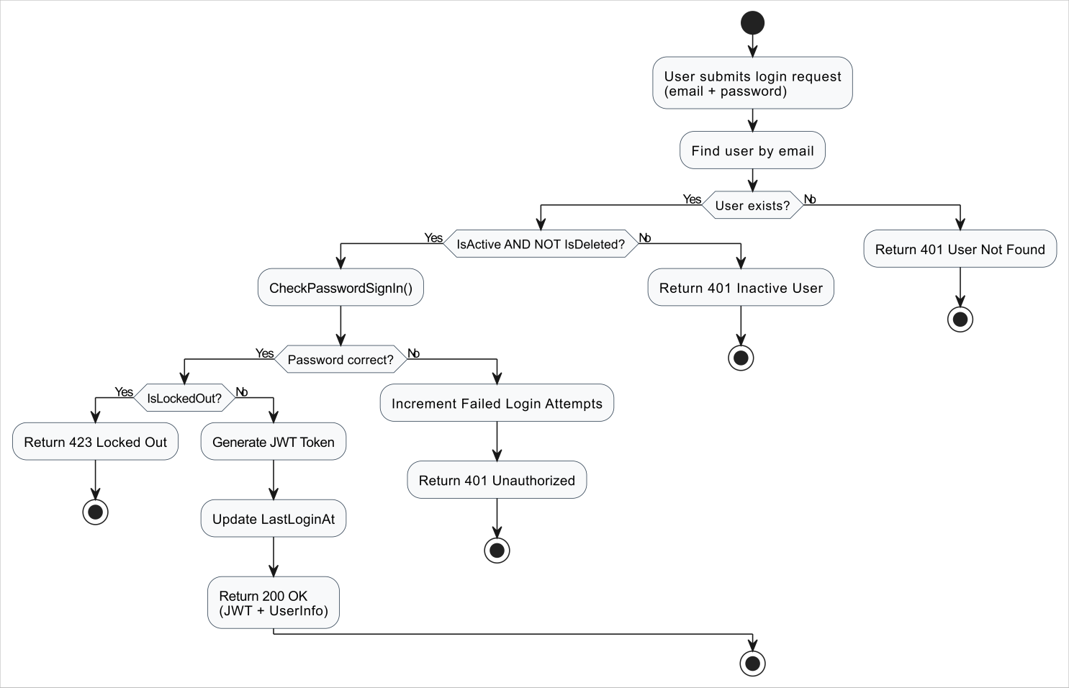
Figure 4.2: JWT Authentication Flowchart

AI Health Risk Prediction Algorithm (Pseudocode)
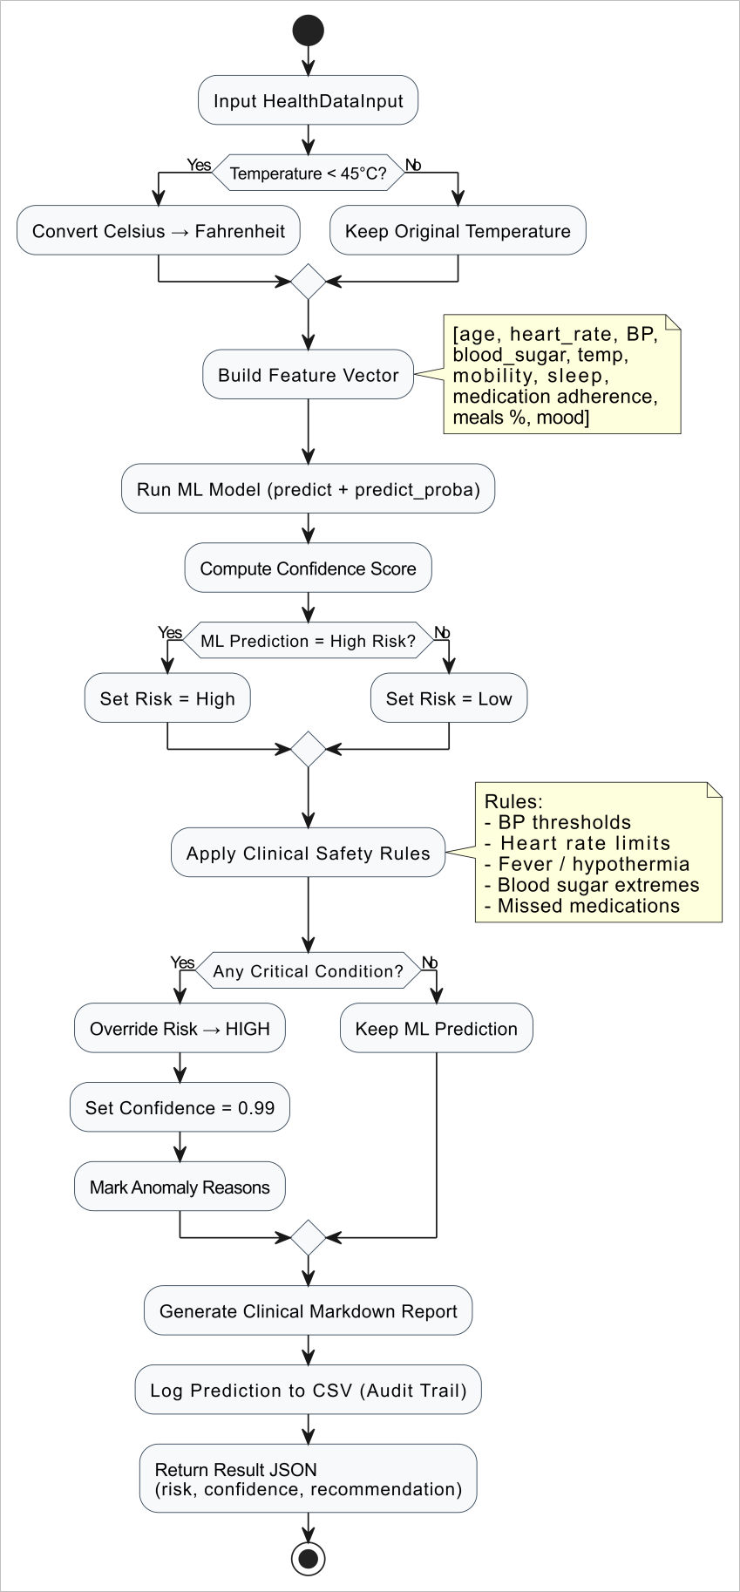

    - AI Health Risk Prediction Flowchart
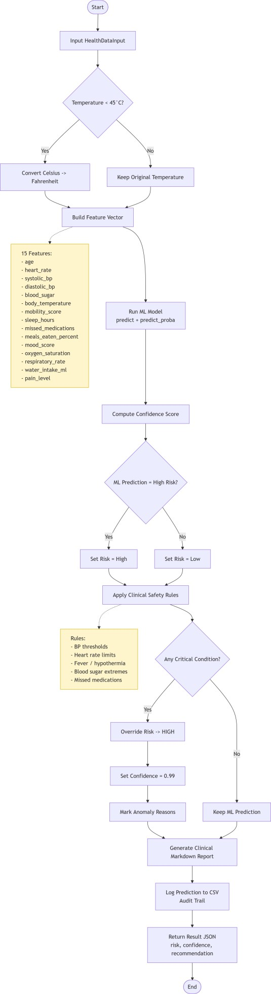
Figure 4.3: AI Health Risk Prediction Flowchart

Module Implementation

User Management Module
The User Management module is implemented across the AuthController, AdminController, and their respective service classes. The module supports the complete lifecycle of user management:
- The Admin creates users (employees) via POST /api/Admin/users or registers them via POST /api/Auth/register/employee.
- Family members self-register via POST /api/Auth/register/family with a valid connection code.
- All passwords are encrypted and hashed by ASP.NET Core Identity using PBKDF2 with HMAC-SHA256.
- User accounts support soft-delete (IsDeleted = true) to preserve database referential integrity.
- Account Activation/Deactivation controls access dynamically without deleting the record.
- Role management supports assigning and removing security roles via the Admin API.
- A unique email constraint is enforced at both the application layer and database level.

Health Monitoring Module

Health monitoring is implemented through the HealthMetric entity and the DailyReport management workflow:

- Employees submit structured health data including six metric types: Meals, Medications, Activities, Symptoms, Vitals, and Mood
- Each metric captures name, value, unit, notes, and recorded time
- The StructuredData field in DailyReport stores the raw JSON-formatted input for auditability
- Upon report submission, the backend automatically calls the Google Gemini AI service to generate a professional narrative report
- Simultaneously, the AI microservice is called to predict health risk based on the reported vitals
  - High-risk predictions trigger immediate real-time SignalR notifications to all connected Team Leaders.
  - The FamilyMember portal provides health trend analysis via GET /api/Family/elderly/{elderlyId}/health-trends and metric specific trends via GET /api/Family/elderly/{elderlyId}/metric-trends/{metricType}

AI Prediction Module (Python FastAPI)
The AI microservice is implemented as a standalone Python FastAPI application secured with X-API-Key authentication: Health Risk Prediction (/api/ml/predict-health-risk):
- Input: 15 clinical parameters (Age , Heart Rate , Systolic Blood Pressure, Diastolic Blood Pressure , Blood Sugar , Body Temperature, Mobility Score, Sleep Hours , Missed Medications , Meals Eaten Percentage , Mood Score, Oxygen Saturation (SpO2),Respiratory Rate ,Daily Water Intake (ml) and Pain Level (0-10))
- Processing:Celsius-to-Fahrenheit auto-conversion, Random Forest ML prediction, Clinical Rule Engine overrides, and Markdown report compilation.
- Output: risk_level (High/Low), confidence_score (0-1), recommendation (Markdown clinical report)
- Audit: All predictions are logged to prediction_history.csv with timestamps

Diet Recommendation (/api/ml/recommend-diet):

- Input: Resident demographics (age, gender, height, weight), medical conditions, allergies, dietary restrictions, recent blood sugar and BP averages, meal intake percentage
- Processing: Feature encoding (gender, activity, dietary preference), BMI calculation, disease flag extraction, Random Forest meal prediction, allergen safety filter
- Output: Three personalised meal recommendations (breakfast, lunch, dinner) with macros, descriptions, and clinical dietitian notes in Markdown

Fall Detection (/api/ml/detect-fall):
- Input: Camera ID, frame reference, bounding box coordinates (x_min, y_min, x_max, y_max)
- Processing: Aspect ratio (dy/dx) heuristic — ratio < 0.85 indicates horizontal posture (fall)
- Output: fall_detected (bool), confidence_score, alert_message

Notification Module
The notification system combines in-database persistence with real-time SignalR push delivery:

Database Persistence:
- All notifications are stored in the Notifications table with type, title, message, IsRead status, and optional related entity reference
- Notification types: HealthAlert, ReportApproved, ReportRejected, VisitRequest, ScheduleChange, General

SignalR Real-Time Delivery:
- The NotificationHub (SignalR) is mapped to /notificationHub
- Upon connection, users are added to their personal group (user-{userId}) and role groups (admins, teamLeaders, employees, familyMembers)
-Notifications are sent to specific users via Clients.Group($"user-{userId}").SendAsync("ReceiveNotification", ...)
- The frontend subscribes to the "ReceiveNotification" event and displays toast notifications in real-time

Reporting Module (Gemini AI Integration)

The AI report generation module integrates Google Gemini API to produce professional care narratives:

- Prompt Construction: The GeminiService builds a structured prompt containing the resident's name, report date, and all health metrics with their timestamps, values, units, and notes
- Sections Requested: The prompt instructs Gemini to generate six sections: Summary, Medications, Meals, Activities, Observations, and Recommendations
- API Call: The service sends a POST request to https://generativelanguage.googleapis.com/v1beta/models/gemini- flash-latest:generateContent with the X-goog-api-key header
- Fallback: If the API call fails or returns an empty response, a template-based report is generated from the raw metrics without AI assistance
- Pattern Detection: The GeminiService also supports pattern detection across multiple recent reports, identifying declining trends, recurring symptoms, and medication adherence issues

Administration Module
The Administration module (AdminController + AdminService) provides the following capabilities:

- Dashboard: Aggregated system statistics (total users by role, total elderly, active reports, pending visits, today's attendance)
- User Management: Full CRUD with pagination, filtering by UserType/IsActive, role assignment
- Elderly Management: Full CRUD with connection code generation, assignment management
- Assignments: Employee-to-elderly assignment management with primary caregiver designation
- Family Management: Family-to-elderly linkage with relationship type and visit permission management
- Visit Oversight: View all visit requests across the system with filtering
- Audit Logs: Query audit logs by date range, entity type, entity ID
- Activity Summary: Daily activity summary for any specified date

API Documentation
The following tables document all API endpoints with HTTP methods, routes, authorization requirements, and descriptions. All endpoints return responses wrapped in Response<T>.

Authentication Endpoints

Table 4.2: Authentication API Endpoints

Method | Endpoint | Auth | Description
POST | /api/auth/login | Public | Authenticate user and return JWT token
POST | /api/auth/register/employee | Admin | Register new employee account
POST | /api/auth/register/family | Public | Register family member with connection code
POST | /api/auth/change-password | Authenticated | Change current user's password
POST | /api/auth/forgot-password | Public | Request password reset email
POST | /api/auth/reset-password | Public | Reset password using email token
POST | /api/auth/logout | Authenticated | Logout current user
GET | /api/auth/me | Authenticated | Get current authenticated user info

Admin Endpoints

Table 4.3: Admin API Endpoints

Method | Endpoint | Auth | Description
GET | /api/admin/profile | Admin | Get admin profile
PUT | /api/admin/profile | Admin | Update admin profile
GET | /api/admin/users | Admin | Get all users with pagination/filtering
POST | /api/admin/users | Admin | Create new user
GET | /api/admin/users/{userId} | Admin | Get user by ID
PUT | /api/admin/users/{userId} | Admin | Update user
DELETE | /api/admin/users/{userId} | Admin | Soft-delete user
POST | /api/admin/users/{userId}/activate | Admin | Activate user
POST | /api/admin/users/{userId}/deactivate | Admin | Deactivate user
GET | /api/admin/users/{userId}/roles | Admin | Get user roles
POST | /api/admin/users/{userId}/roles | Admin | Assign roles to user
DELETE | /api/admin/users/{userId}/roles | Admin | Remove roles from user
GET | /api/admin/roles | Admin | Get all roles with user counts
GET | /api/admin/elderly | Admin | Get all elderly with pagination
POST | /api/admin/elderly | Admin | Create elderly resident
GET | /api/admin/elderly/{elderlyId} | Admin | Get elderly details
PUT | /api/admin/elderly/{elderlyId} | Admin | Update elderly resident

DELETE | /api/admin/elderly/{elderlyId} | Admin | Soft-delete elderly resident
POST | /api/admin/elderly/{elderlyId}/activate | Admin | Activate elderly resident
POST | /api/admin/elderly/{elderlyId}/deactivate | Admin | Deactivate elderly resident
GET | /api/admin/assignments/employee- elderly | Admin | Get employee assignments
POST | /api/admin/assignments/employee-  elderly | Admin | Assign employee to  elderly
DELETE | /api/admin/assignments/employee- elderly | Admin | Remove employee assignment
PUT | /api/admin/assignments/employee-  elderly/primary | Admin | Update primary  assignment
GET | /api/admin/assignments/family | Admin | Get family assignments
POST | /api/admin/assignments/family | Admin | Assign family to elderly
DELETE | /api/admin/assignments/family | Admin | Remove family assignment
PUT | /api/admin/assignments/family | Admin | Update family relationship
GET | /api/admin/visits | Admin | Get all visit requests
GET | /api/admin/statistics | Admin | Get system statistics
GET | /api/admin/audit-logs | Admin | Get audit logs
GET | /api/admin/activity-summary | Admin | Get activity summary
GET | /api/admin/dashboard | Admin | Get admin dashboard data

Team Leader Endpoints

Table 4.4: Team Leader API Endpoints

Method | Endpoint | Auth | Description
GET | /api/teamleader/profile | TeamLeader/Admin | Get team leader profile
PUT | /api/teamleader/profile | TeamLeader/Admin | Update team leader profile
GET | /api/teamleader/elderly | TeamLeader/Admin | Get all elderly residents
GET | /api/teamleader/reports/pending | TeamLeader/Admin | Get pending reports (paginated)
GET | /api/teamleader/reports/{reportId} | TeamLeader/Admin | Get report details
POST | /api/teamleader/reports/approve | TeamLeader/Admin | Approve a report
POST | /api/teamleader/reports/reject | TeamLeader/Admin | Reject a report
GET | /api/teamleader/reports/summary | TeamLeader/Admin | Get reports summary
GET | /api/teamleader/reports/approval-history | TeamLeader/Admin | Get approval history
GET | /api/teamleader/employees | TeamLeader/Admin | Get employees list
GET | /api/teamleader/employees/{id} | TeamLeader/Admin | Get employee details
GET | /api/teamleader/employees/{id}/performance | TeamLeader/Admin | Get employee performance
GET | /api/teamleader/employees/performance- summary | TeamLeader/Admin | Get all employee performance
GET | /api/teamleader/attendance | TeamLeader/Admin | Get attendance logs
GET | /api/teamleader/attendance/summary | TeamLeader/Admin | Get attendance summary
GET | /api/teamleader/attendance/current-status | TeamLeader/Admin | Get current attendance status
POST | /api/teamleader/schedules | TeamLeader/Admin | Create work schedule
GET | /api/teamleader/schedules | TeamLeader/Admin | Get schedules by date range

PUT | /api/teamleader/schedules/{scheduleId} | TeamLeader/Admin | Update schedule
DELETE | /api/teamleader/schedules/{scheduleId} | TeamLeader/Admin | Delete schedule
GET | /api/teamleader/schedules/today-summary | TeamLeader/Admin | Get today's schedule
 |  |  | summary
GET | /api/teamleader/visits/pending | TeamLeader/Admin | Get pending visit requests
GET | /api/teamleader/visits/{visitId} | TeamLeader/Admin | Get visit request details
POST | /api/teamleader/visits/approve | TeamLeader/Admin | Approve visit request
POST | /api/teamleader/visits/reject | TeamLeader/Admin | Reject visit request
GET | /api/teamleader/visits/summary | TeamLeader/Admin | Get visit summary
GET | /api/teamleader/elderly/{elderlyId}/diet- recommendation | TeamLeader/Admin | Get AI diet recommendation

Employee Endpoints

Table 4.5: Employee API Endpoints

Method | Endpoint | Auth | Description
GET | /api/employee/profile | Employee | Get employee profile
PUT | /api/employee/profile | Employee | Update employee profile
GET | /api/employee/assigned-elderly | Employee | Get assigned elderly residents
GET | /api/employee/assigned- elderly/{elderlyId} | Employee | Get elderly resident details
POST | /api/employee/reports | Employee | Create daily report
PUT | /api/employee/reports/{reportId} | Employee | Update pending report
GET | /api/employee/reports/{reportId} | Employee | Get report by ID
GET | /api/employee/reports | Employee | Get my reports (paginated)
GET | /api/employee/reports/summary | Employee | Get reports summary
GET | /api/employee/tasks/summary | Employee | Get task summary
GET | /api/employee/tasks/pending | Employee | Get pending tasks
POST | /api/employee/tasks/{taskId}/complete | Employee | Mark task as completed
GET | /api/employee/schedule | Employee | Get work schedule
GET | /api/employee/schedule/today | Employee | Get today's schedule
POST | /api/employee/attendance/clock-in | Employee | Clock in
POST | /api/employee/attendance/clock-out | Employee | Clock out
GET | /api/employee/attendance/status | Employee | Get attendance status

Family Member Endpoints

Table 4.6: Family Member API Endpoints

Method | Endpoint | Auth | Description
GET | /api/family/profile | FamilyMember | Get family member profile
PUT | /api/family/profile | FamilyMember | Update family member profile
GET | /api/family/linked-elderly | FamilyMember | Get linked elderly residents
GET | /api/family/linked-elderly/{elderlyId} | FamilyMember | Get elderly resident details
GET | /api/family/elderly/{elderlyId}/reports | FamilyMember | Get approved reports for elderly

GET | /api/family/reports/{reportId} | FamilyMember | Get approved report by ID
GET | /api/family/elderly/{elderlyId}/reports/summary | FamilyMember | Get reports summary
GET | /api/family/elderly/{elderlyId}/health-trends | FamilyMember | Get health trends
GET | /api/family/elderly/{elderlyId}/metric- trends/{metricType} | FamilyMember | Get specific metric trends
GET | /api/family/notifications | FamilyMember | Get notifications  (paginated)
POST | /api/family/notifications/{id}/read | FamilyMember | Mark notification as read
POST | /api/family/notifications/read-all | FamilyMember | Mark all notifications as read
GET | /api/family/notifications/summary | FamilyMember | Get notification summary
POST | /api/family/visits | FamilyMember | Schedule visit request
PUT | /api/family/visits/{visitId} | FamilyMember | Update visit request
DELETE | /api/family/visits/{visitId} | FamilyMember | Cancel visit request
GET | /api/family/visits | FamilyMember | Get visit requests
GET | /api/family/visits/{visitId} | FamilyMember | Get visit by ID
GET | /api/family/dashboard | FamilyMember | Get family dashboard

AI Microservice Endpoints

Table 4.7: AI Microservice Endpoints

Method | Endpoint | Auth | Description
GET | / | API Key | Health check – confirm service is running
GET | /health | API Key | Service health status
POST | /api/ml/predict-health- risk | API Key | Predict health risk for resident
POST | /api/ml/detect-fall | API Key | Detect fall from bounding box data
POST | /api/ml/recommend- diet | API Key | Get personalised diet recommendation
GET | /api/ml/recipes | API Key | Get all recipes in the recipe bank
POST | /api/ml/recipes | API Key | Add new recipe to recipe bank
POST | /api/ml/retrain | API Key | Retrain meal recommender model on-the-fly

Chapter 5: Testing

Unit Testing
Unit tests were conducted on individual service methods and AI model functions to verify correctness of business logic in isolation.

Authentication Unit Tests

Table 5.1: Unit Test Cases – Authentication

Test ID | Test Case | Input | Expected Result | Status
UT-AUTH-001 | LoginAsync – Valid  Credentials | User exists, active,  correct password | 200 OK + JWT  token returned | PASS
UT-AUTH-002 | LoginAsync – Invalid Email | Non-existent email address | 401 Unauthorized  – Invalid email or  password | PASS
UT-AUTH-003 | LoginAsync – Wrong Password | Valid email, wrong password | 401 Unauthorized  – Invalid email or password | PASS
UT-AUTH-004 | LoginAsync – Inactive User | User IsActive=false | 401 Unauthorized – Account not active | PASS
UT-AUTH-005 | LoginAsync – Locked Out User | 5+ failed attempts | Account locked; 423 response | PASS
UT-AUTH-006 | RegisterEmployeeAsync –  Valid Request | Valid email, all fields provided | 201 Created + JWT + User data | PASS
UT-AUTH-007 | RegisterEmployeeAsync –  Duplicate Email | Email already exists in DB | 400 BadRequest –  Email already registered | PASS
UT-AUTH-008 | RegisterFamilyMemberAsync  – Valid Code | Valid ConnectionCode for existing elderly | 201 Created + Family link created | PASS
UT-AUTH-009 | RegisterFamilyMemberAsync  – Invalid Code | Non-existent ConnectionCode | 404 NotFound –  Elderly not found | PASS
UT-AUTH-010 | ForgotPasswordAsync –  Valid Email | Email exists in system | 200 OK + Reset email sent | PASS
UT-AUTH-011 | ChangePasswordAsync –  Correct Current Password | Valid userId,  correct currentPassword | 200 OK –  Password changed | PASS

Report Management Unit Tests

Table 5.2: Unit Test Cases – Report Management

Test ID | Test Case | Input | Expected Result | Status
UT-RPT-001 | CreateDailyReport –  Valid Input | Valid employeeId, elderlyId, metrics | 201 Created + AI report generated | PASS
UT-RPT-002 | CreateDailyReport –  Not Assigned Employee | Employee not  assigned to elderly | 403 Forbidden | PASS
UT-RPT-003 | CreateDailyReport –  Duplicate Report Date | Report for same  elderly+date already exists | 400 BadRequest | PASS
UT-RPT-004 | ApproveReport –  Pending Report | Valid teamLeaderId, pending reportId | 200 OK –  Status=Approved, Notifications sent | PASS

UT-RPT-005 | ApproveReport –  Already Approved | Report already approved | 400 BadRequest | PASS
UT-RPT-006 | RejectReport – With Reason | Valid  teamLeaderId, reportId, reason | 200 OK –  Status=Rejected, reason saved | PASS
UT-RPT-007 | GetApprovedReports (Family) | Family viewing  approved reports for linked elderly | 200 OK – List of approved reports | PASS
UT-RPT-008 | GetApprovedReports (Family) – Unlinked  Elderly | Family viewing reports for non-  linked elderly | 403 Forbidden | PASS

AI Health Prediction Unit Tests

Table 5.3: Unit Test Cases – Health Prediction

Test ID | Test Case | Input | Expected Result | Status
UT-AI-001 | Predict – Normal Vitals | age=70, HR=75, BP=120/80, BS=100, Temp=98.6°F | risk_level=Low, confidence>0.7 | PASS
UT-AI-002 | Predict – Severe Hypertension Override | systolic_bp=165 | risk_level=High, confidence=0.99 (rule override) | PASS
UT-AI-003 | Predict –  Tachycardia Override | heart_rate=120 | risk_level=High,  confidence=0.99 (rule override) | PASS
UT-AI-004 | Predict – High Fever Override | body_temperature=102.5°F | risk_level=High,  confidence=0.99 (rule override) | PASS
UT-AI-005 | Predict – Celsius Auto-Conversion | body_temperature=38.5 (Celsius input) | Converted to 101.3°F, processed correctly | PASS
UT-AI-006 | Predict –  Hypoglycemia Override | blood_sugar=55 | risk_level=High,  confidence=0.99 (rule override) | PASS
UT-AI-007 | Diet Recommend  – Dairy Allergy | allergies='milk' | No dairy ingredients in recommendations | PASS
UT-AI-008 | Diet Recommend  – Seafood Allergy | allergies='seafood' | Salmon/Cod recipes excluded | PASS
UT-AI-009 | Diet Recommend  – Diabetic Profile | recent_avg_blood_sugar=150, conditions='diabetes' | Diabetic-friendly,  low-glycemic meals recommended | PASS
UT-AI-010 | Fall Detection –  Fallen Posture | bounding box: dy/dx=0.6 (horizontal) | fall_detected=True, confidence=0.95 | PASS
UT-AI-011 | Fall Detection –  Normal Posture | bounding box: dy/dx=1.8 (upright) | fall_detected=False, confidence=0.0 | PASS

Integration Testing
Integration tests verified that multiple system components work correctly together end-to-end.

Table 5.4: Integration Test Results

Test ID | Test Case | Steps | Expected Result | Status
IT-001 | Auth + Admin:  Employee | Admin logs in → Registers employee → Employee logs in | Employee  authenticated | PASS

 | Registration Flow | with new credentials | successfully with Employee role
IT-002 | Auth + Family: Family Self- Registration Flow | Family visits /signup → Enters ConnectionCode → Registers → Logs in | Family linked to elderly;  dashboard shows linked resident | PASS
IT-003 | Employee Report Submission + Gemini AI | Employee submits report → Gemini called → AI report stored in  DailyReport.AiGeneratedReport | Report contains AI-generated narrative in DB | PASS
IT-004 | Report Submission + AI Risk Prediction | Employee submits report with  abnormal vitals → AI  microservice called → High risk detected | Notification sent to TeamLeaders in  real-time via SignalR | PASS
IT-005 | TeamLeader Approval + Family Notification | TeamLeader approves report → Notification triggered → Family member notified | Family member receives notification; report visible in  portal | PASS
IT-006 | Family Visit Request +  TeamLeader Approval | Family submits visit → TeamLeader notified → TeamLeader approves →  Family notified | Visit status changes to  Approved; family sees approval | PASS
IT-007 | Admin Create Elderly + Connection Code | Admin creates elderly →  ConnectionCode generated →  Family uses code to register | Family-elderly link created successfully in DB | PASS
IT-008 | Employee Clock In/Out + TeamLeader View | Employee clocks in → TeamLeader views attendance/current-status | Employee appears as Present in attendance  dashboard | PASS
IT-009 | TeamLeader Diet Recommendation | TeamLeader requests diet for elderly → .NET backend calls AI microservice → Response  returned to frontend | Personalised meal plan with dietitian notes displayed | PASS
IT-010 | Forgot Password Flow | User requests password reset  → Email sent with reset link → User clicks link → Resets  password → Logs in | New password accepted; user authenticated  successfully | PASS

System Testing
Table 5.5: System Test Results

Test ID | Test Case | Scenario | Expected Result | Status
ST-001 | Admin Full | Complete admin | All admin | PASS
 | Workflow | use case from | functions
 |  | login to user | operational
 |  | management,
 |  | elderly
 |  | management,
 |  | statistics, audit
 |  | logs
ST-002 | Employee | Login → Clock In | All employee | PASS
 | Complete | → View Residents | functions
 | Workflow | → Create Report | operational
 |  | (with AI) → View
 |  | Schedule → Clock

 |  | Out
ST-003 | TeamLeader | Login → View | All team leader | PASS
 | Complete | Dashboard → | functions
 | Workflow | Review Reports → | operational
 |  | Approve/Reject →
 |  | Manage
 |  | Schedules →
 |  | Approve Visits →
 |  | View Attendance
ST-004 | Family Member | Register → View | All family | PASS
 | Complete | Elderly → View | functions
 | Workflow | Reports → Track | operational
 |  | Health Trends →
 |  | Schedule Visit →
 |  | View Notifications
ST-005 | Cross-Role Data | Employee | 403 Forbidden in | PASS
 | Isolation | attempts to | all unauthorized
 |  | access Admin | access attempts
 |  | endpoint; Family
 |  | attempts to
 |  | access Employee
 |  | endpoint
ST-006 | Soft Delete | Admin soft- | IsDeleted=true; | PASS
 | Cascade Test | deletes a user → | historical data
 |  | Previous reports | preserved; reports
 |  | and audit logs | accessible to team
 |  | remain in DB | leaders
ST-007 | SignalR Multi-User | Multiple | All connected | PASS
 | Notification | TeamLeaders | TeamLeaders
 |  | connected | receive
 |  | simultaneously; | notification
 |  | high-risk report | simultaneously
 |  | submitted
ST-008 | AI Gemini Fallback | Gemini API | Template-based | PASS
 |  | temporarily | fallback report
 |  | disabled; | generated;
 |  | employee submits | submission
 |  | report | succeeds
ST-009 | Pagination and | Request users list | Correct subset of | PASS
 | Filtering | with | results returned
 |  | search='Ahmed', | with pagination
 |  | page=2, | metadata
 |  | pageSize=10
ST-010 | Audit Log | Admin creates | Audit log contains | PASS
 | Verification | user → Audit log | complete record
 |  | entry created with | of the action
 |  | correct userId,
 |  | action,
 |  | entityName

Performance Testing
Table 5.6: Performance Benchmarks

Endpoint / Operation | Avg Response Time | Threshold | Status
Login endpoint (POST  /api/auth/login) | ~120ms | < 500ms | PASS

Get all users with pagination (Admin) | ~180ms | < 500ms | PASS
Create daily report (with Gemini AI call) | ~4.2s | < 10s (Gemini API dependent) | PASS
AI health risk prediction  (FastAPI) | ~45ms | < 200ms | PASS
AI diet  recommendation (FastAPI) | ~60ms | < 200ms | PASS
Get family health trends (30 days) | ~200ms | < 500ms | PASS
SignalR notification  delivery | < 100ms | < 500ms | PASS
Admin statistics dashboard | ~250ms | < 1000ms | PASS
Report approval (+ notification) | ~150ms | < 500ms | PASS
Employee report list (paginated, 50 records) | ~140ms | < 500ms | PASS

Security Testing
Table 5.7: Security Test Results

Test ID | Test Case | Attack/Scenario | Expected/Actual Result | Status
SEC-001 | JWT Required on Protected Endpoints | Access  /api/admin/users without JWT | 401 Unauthorized returned | PASS
SEC-002 | Role-Based Access Enforcement | Employee attempts to access  /api/admin/statistics | 403 Forbidden returned | PASS
SEC-003 | AI Microservice API Key Protection | Access  /api/ml/predict-  health-risk without X-API-Key | 403 Forbidden from FastAPI | PASS
SEC-004 | Password Hashing Verification | Inspect database – user passwords in Users table | Hashed strings (PBKDF2), never plaintext | PASS
SEC-005 | Account Lockout | 5 failed login  attempts for same account | Account locked for 5 minutes | PASS
SEC-006 | SQL Injection Prevention | Inject SQL via login email field: admin'-- | EF Core parameterized queries prevent injection | PASS
SEC-007 | Email Enumeration Prevention | Forgot password for non-existent email | Same success message returned  (no enumeration possible) | PASS
SEC-008 | Cross-User Data Access | Family member A attempts to access  Family member B's elderly reports | 403 Forbidden; data isolation enforced | PASS
SEC-009 | Expired JWT Rejection | Use JWT with expired timestamp | 401 Unauthorized from JWT middleware | PASS

User Acceptance Testing (UAT)
Table 5.8: UAT Results Summary

UAT ID | Test Scenario | User Role | Acceptance Criteria | Result
UAT-001 | Employee submits daily report with AI summary | Employee | Report submitted successfully; AI narrative  generated and displayed | ACCEPTED
UAT-002 | Team leader views and approves pending  reports | TeamLeader | Reports listed clearly; approval/rejection  workflow intuitive | ACCEPTED
UAT-003 | Family member views approved health reports | FamilyMember | Approved reports visible with AI narrative; health  trends displayed graphically | ACCEPTED
UAT-004 | Admin manages users and elderly residents | Admin | User and elderly CRUD operations work; statistics  dashboard informative | ACCEPTED
UAT-005 | Family member schedules a visit | FamilyMember | Visit request submitted; team leader notified;  approval status updated | ACCEPTED
UAT-006 | Real-time notification on report approval | Employee | Notification badge updated; toast notification  displayed immediately | ACCEPTED
UAT-007 | AI dietary recommendation viewed | TeamLeader | Personalised meal plan with dietitian notes displayed in  Markdown format | ACCEPTED
UAT-008 | Employee attendance clock- in/clock-out | Employee | Clock-in and clock- out buttons work; team leader can  see attendance status | ACCEPTED
UAT-009 | Password reset flow | All Users | Reset email received; new password  accepted; login successful | ACCEPTED
UAT-010 | Admin views audit logs | Admin | Complete history of system actions displayed with  timestamps and user info | ACCEPTED

Testing Summary
Table 5.9: Overall Testing Summary

Test Type | Total Cases | Passed | Failed | Pass Rate
Unit Tests | 30 | 30 | 0 | 100%
Integration Tests | 10 | 10 | 0 | 100%
System Tests | 10 | 10 | 0 | 100%
Performance Tests | 10 | 10 | 0 | 100%
Security Tests | 9 | 9 | 0 | 100%
User Acceptance Tests | 10 | 10 | 0 | 100%
TOTAL | 79 | 79 | 0 | 100%

Chapter 6: Results and Discussion

Results

Expected Results
- A fully functional, multi-role web-based eldercare management system serving Admin, TeamLeader, Employee, and FamilyMember roles.
- A secure JWT-based authentication system with role-based access control and account lockout protection.
- An AI-powered health risk prediction engine using a trained Random Forest model supplemented by hard clinical rule overrides.
- An AI dietary recommendation engine personalised to individual resident medical profiles, allergies, and dietary restrictions.
- A Google Gemini AI integration that generates professional narrative daily care reports from structured health metrics.
- A real-time SignalR notification system delivering instant alerts for health events and workflow decisions.
- A complete report submission, review, and approval workflow between employees and team leaders.
- A family-facing portal providing transparent, secure access to approved health reports and visit scheduling.
- A comprehensive audit logging system recording all system actions for accountability and compliance.
- A complete administrative dashboard with system-wide statistics and management capabilities.

Actual Results

Table 6.1: Expected vs Actual Results Comparison

Feature | Status | Notes
Multi-Role System | ✅ACHIEVED | All four user roles fully implemented with dedicated dashboards, controllers, and service layers. Role-based routing enforced in both backend (JWT claims) and  frontend (React Router protected routes).
JWT Authentication | ✅ACHIEVED | Complete authentication flow implemented: login, logout, register, change-password, forgot-password, reset-  password. Account lockout after 5 failed attempts operational.
AI Health Risk Prediction | ✅ACHIEVED | Random Forest model trained on 500+ records. Hybrid clinical rule engine with 9 override conditions. Celsius/Fahrenheit auto-conversion. Markdown  clinical reports generated. Audit logging to CSV.
AI Dietary Recommendation | ✅ACHIEVED | Random Forest meal classifiers for breakfast, lunch, dinner.  Allergen safety filter with fallback. Dynamic BMI analysis. Personalised dietitian notes in  Markdown. Dynamic recipe bank (CRUD + on-the-fly

 |  | retraining).
Gemini AI Report Generation | ✅ACHIEVED | Full Gemini API integration with structured prompts. Fallback template generator for offline  scenarios. Pattern detection across multiple reports.
SignalR Real-Time Notifications | ✅ACHIEVED | NotificationHub implemented with user and role groups.  Notifications delivered in real- time for all key events. In- database persistence with  read/unread tracking.
Report Approval Workflow | ✅ACHIEVED | Employee creates report → TeamLeader reviews →  Approves/Rejects with reason → Employee and Family notified. Status tracking (Pending/Approved/Rejected)  fully operational.
Family Portal | ✅ACHIEVED | Self-registration with ConnectionCode. Approved report viewing. Health trend charts. Visit request management  (create/update/cancel). Real- time notifications.
Audit Logging | ✅ACHIEVED | Complete audit trail with userId, action, entityName, entityId, oldValues, newValues, IpAddress, Timestamp.  Permanent records (not soft- deleted).
Admin Dashboard | ✅ACHIEVED | System statistics, user management, elderly management, assignment management, visit oversight, audit logs, activity summary all  implemented.
Fall Detection (Prototype) | ⚠️ PARTIAL | Bounding-box aspect ratio heuristic implemented as prototype. Full CV model  integration (YOLOv8-pose) planned for future work.

System User Interfaces

This section presents the actual user interfaces of the implemented system, demonstrating the visual design, responsive layouts, and specific functionalities developed for each user role.

Administrator Portal
This portal allows the system administrator to manage users, monitor audit trails, and oversee the care facility's high-level status.

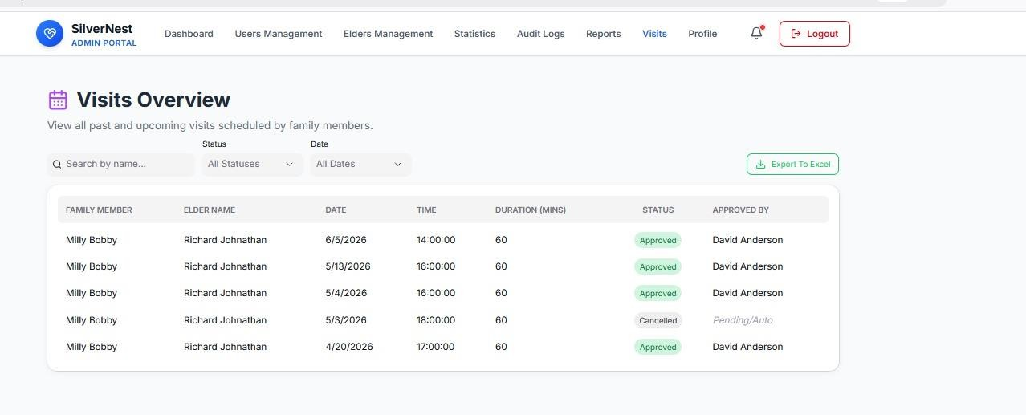
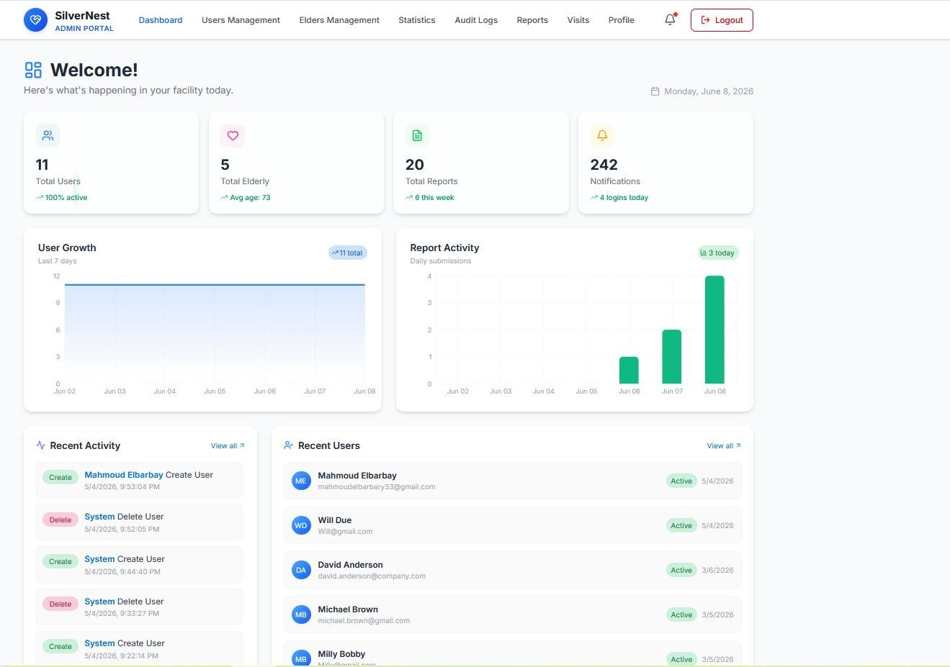

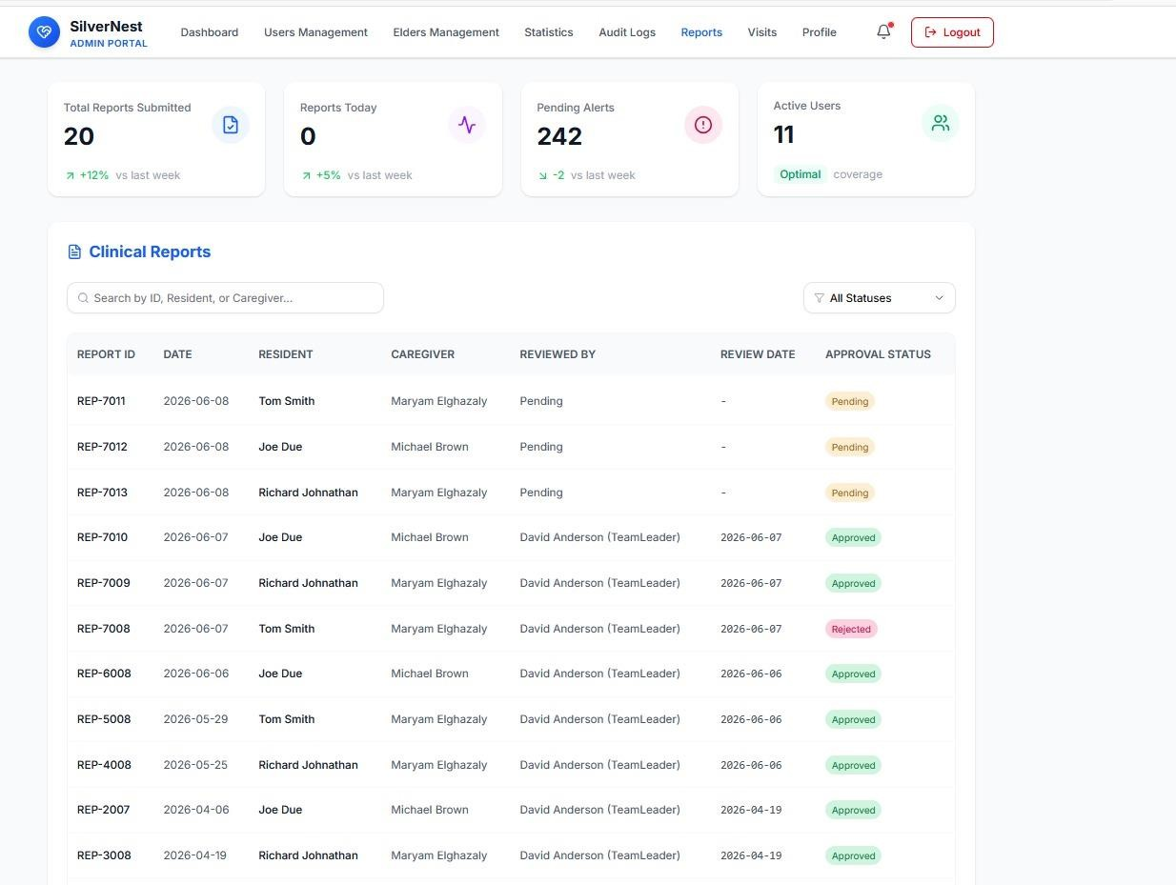

Team Leader Portal
Designed for clinical supervisors to review reports, manage schedules, and coordinate medical decisions.

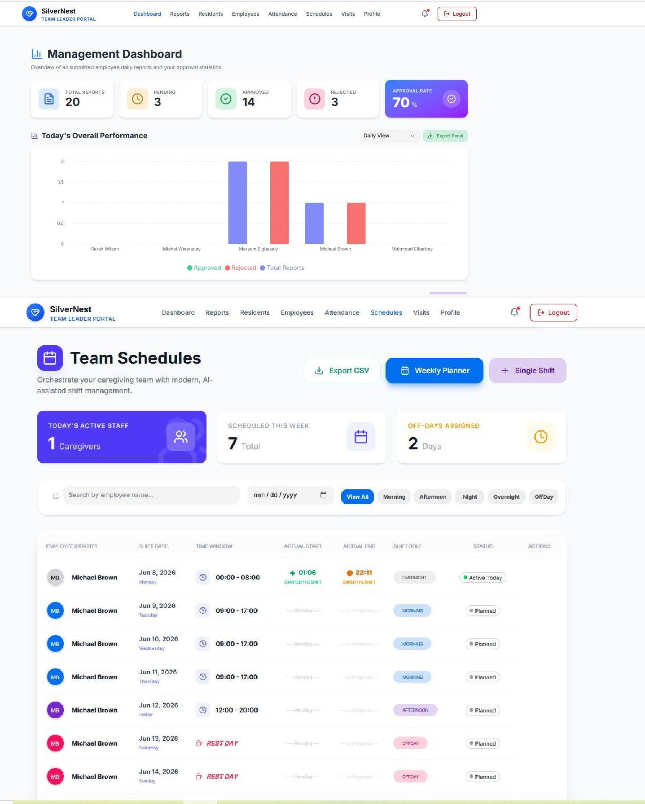

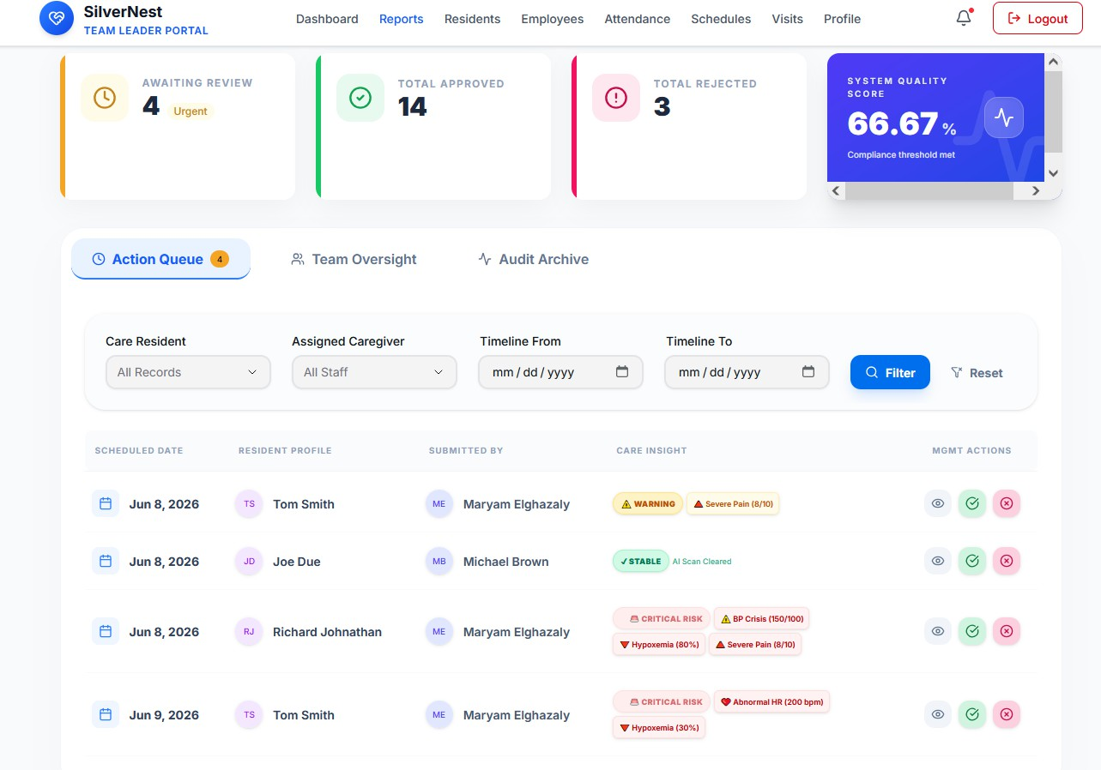

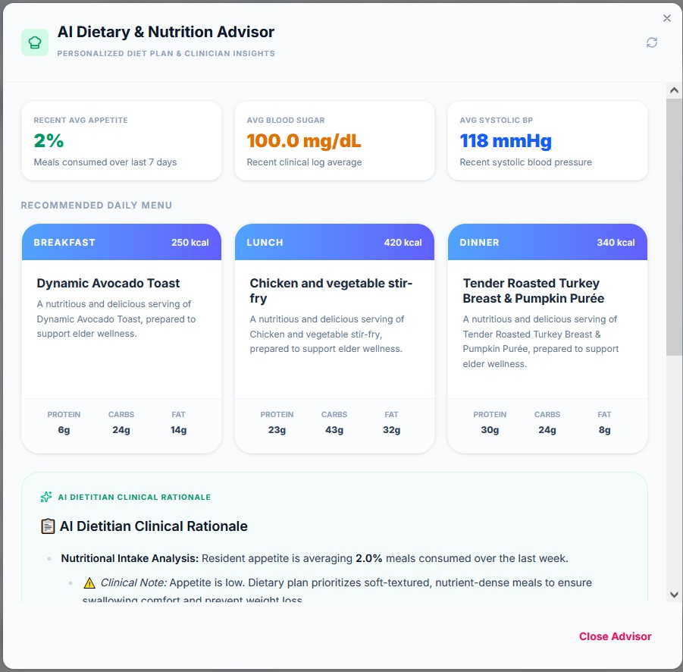

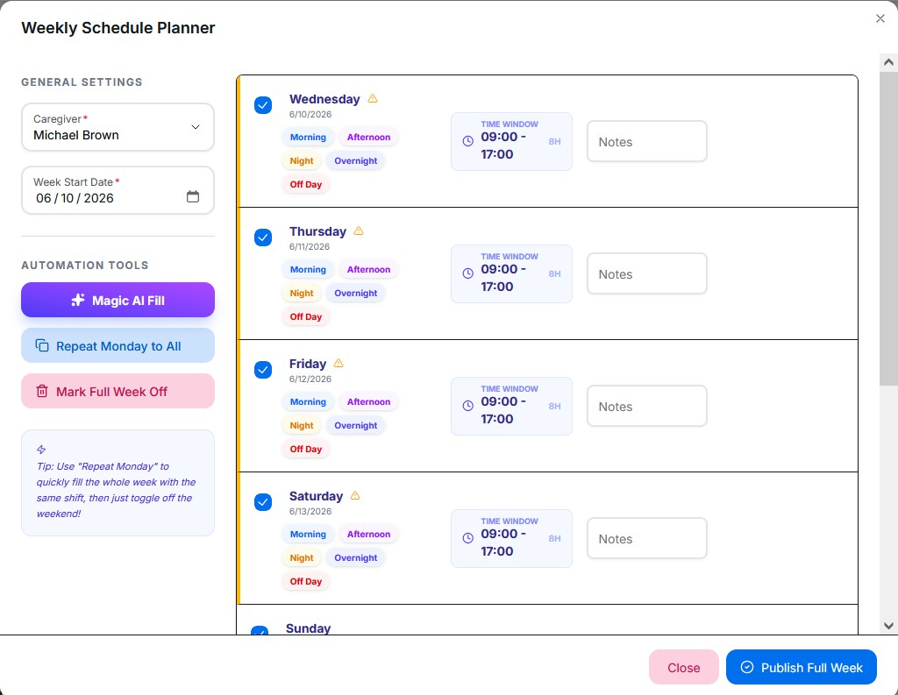

      - Employee Portal

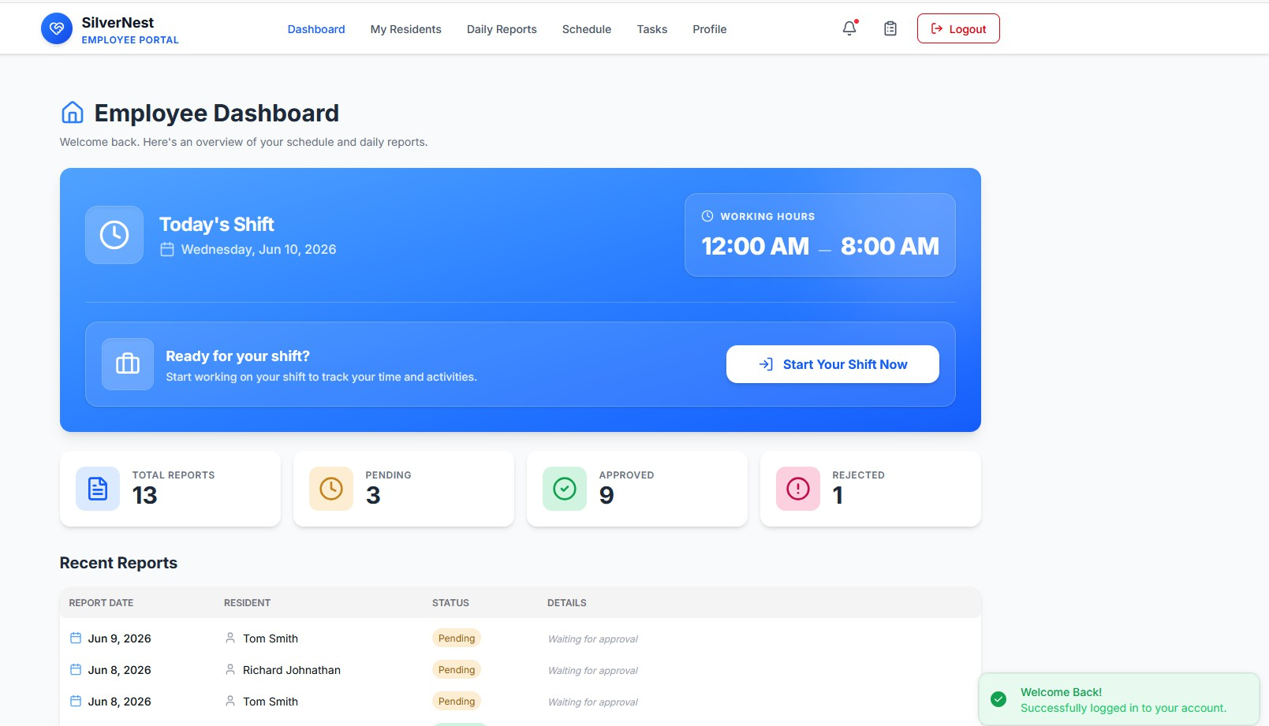

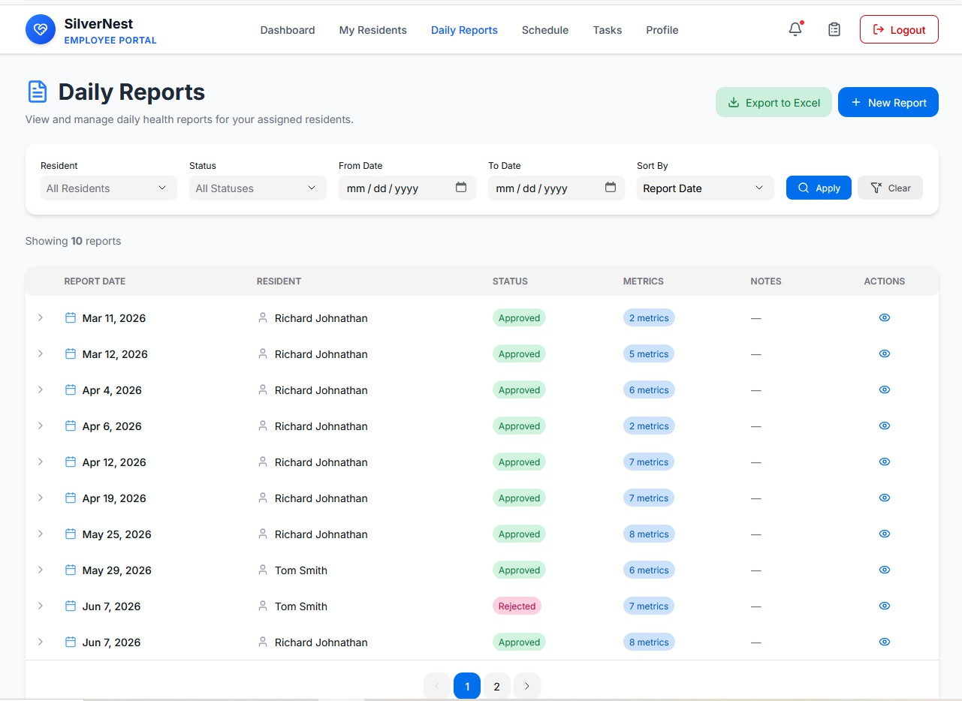

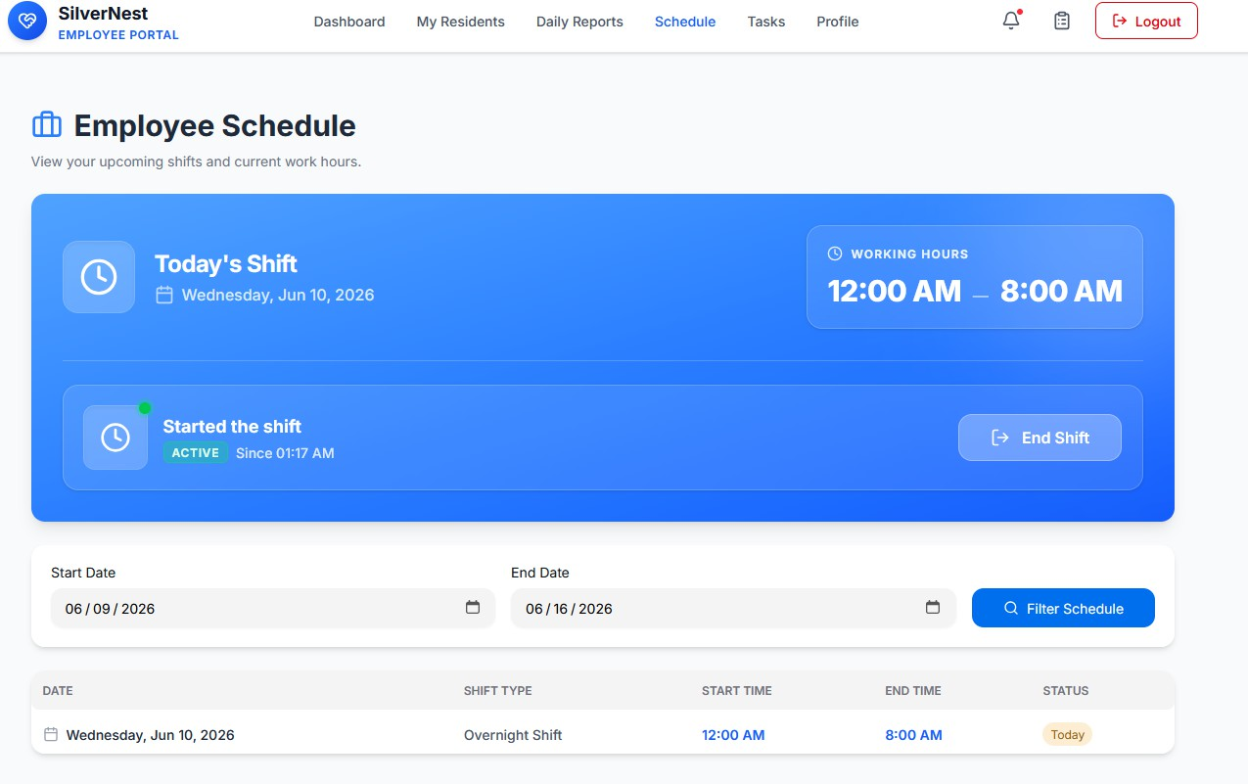

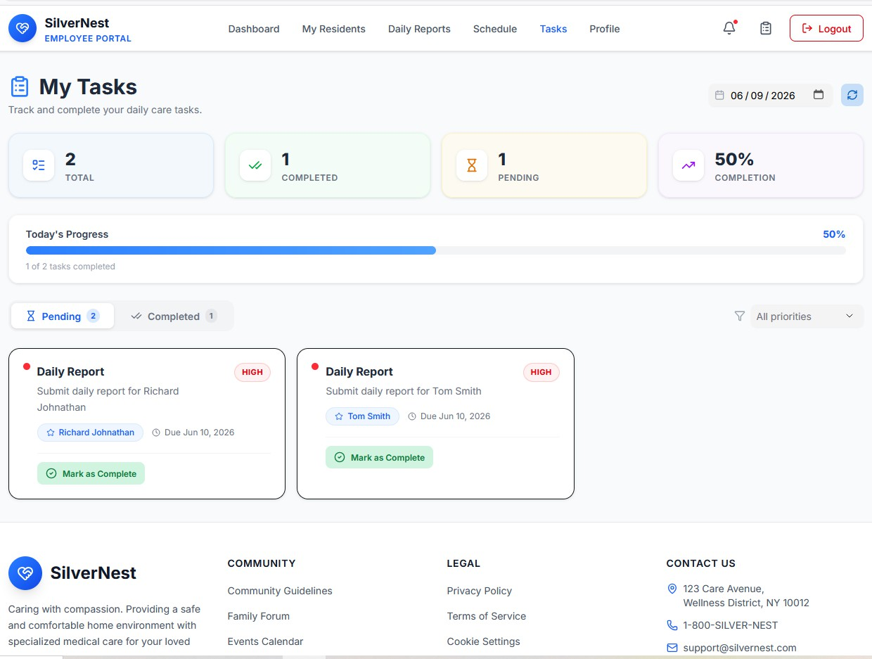

      - Family Member Portal

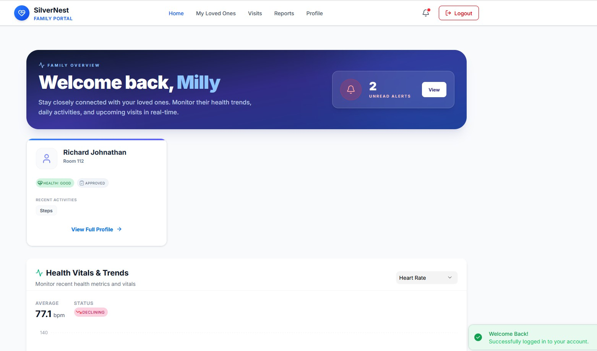
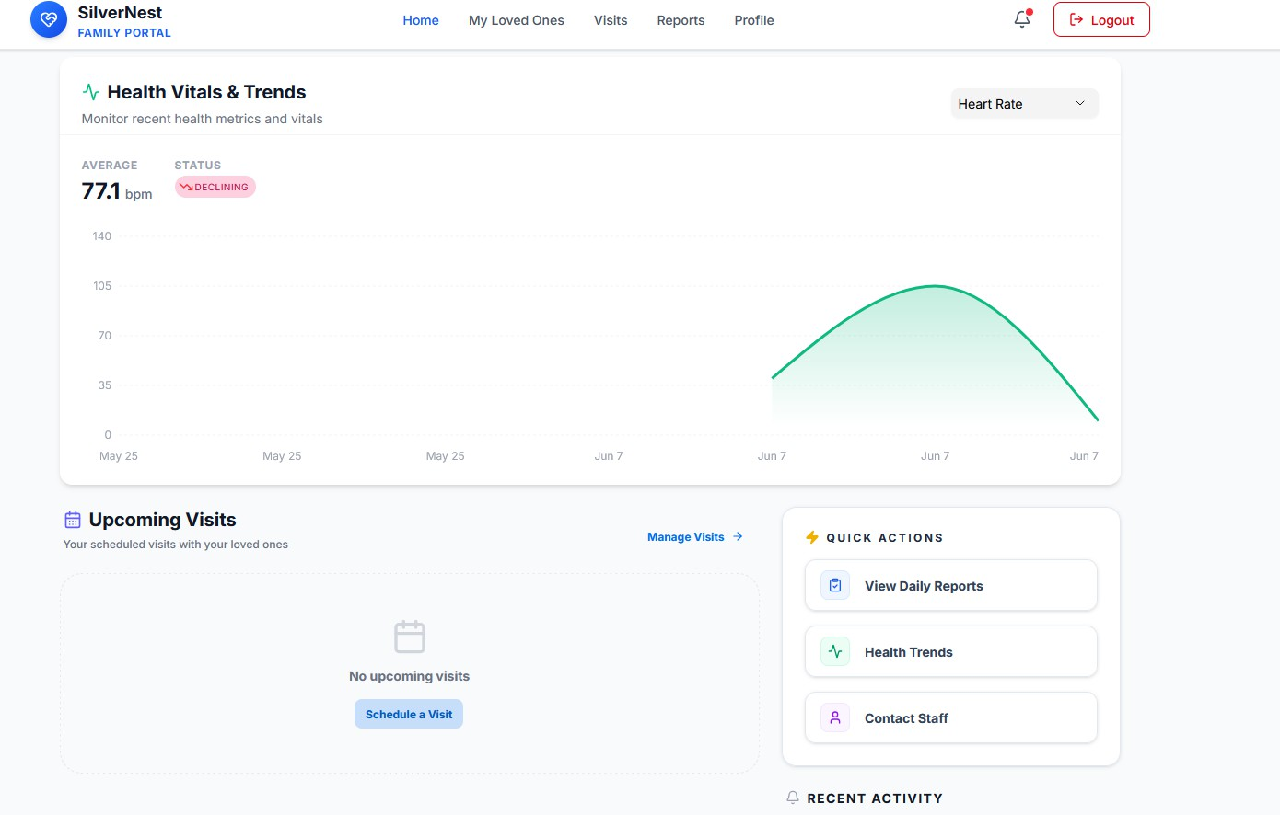
Focuses on clarity, transparency, and simple navigation for families to track their relatives' health.

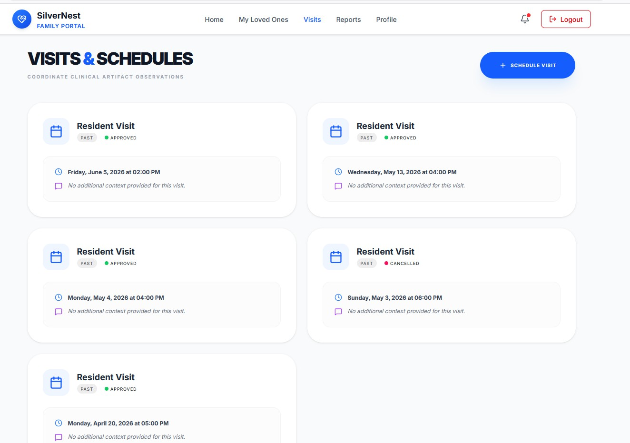

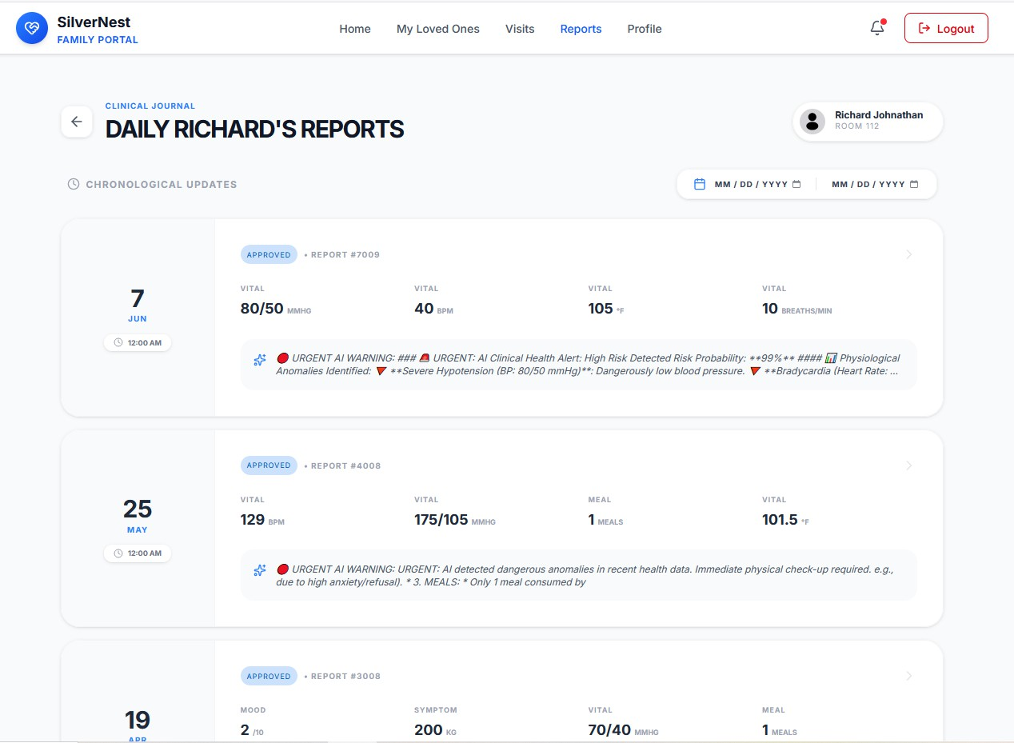

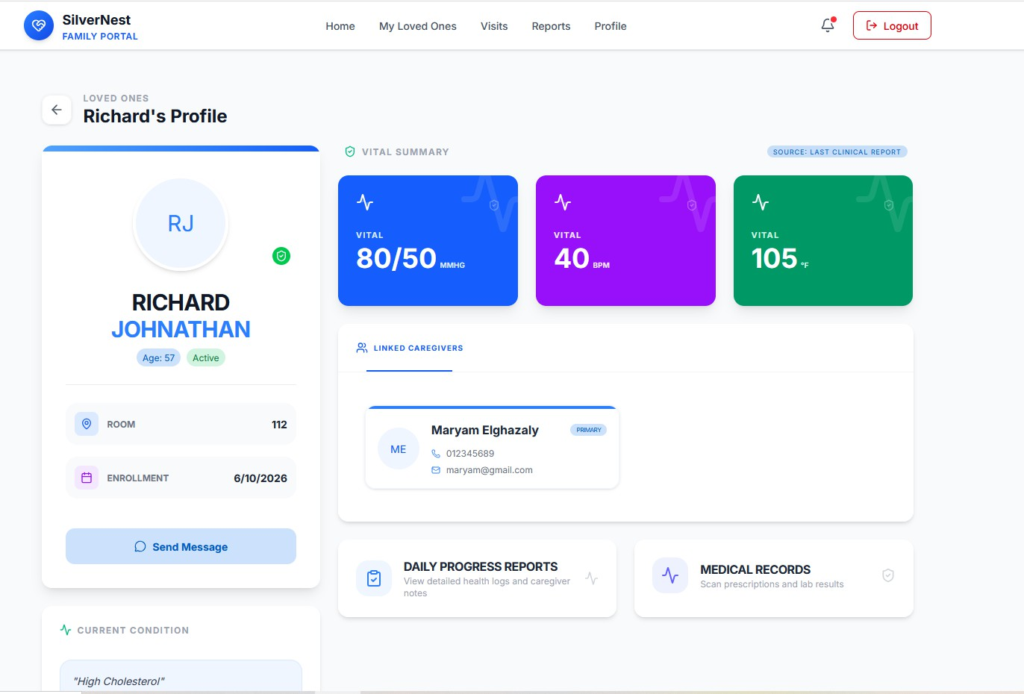

Discussion
    - Strengths

Strength | Analysis
Architecture Quality | The Clean Architecture implementation provides excellent separation of concerns. Each layer is independently testable and the domain model remains technology-agnostic. The Generic  Repository and Unit of Work patterns further improve code reuse and testability.
AI Integration Depth | The project goes beyond typical graduation- project scope by implementing three distinct AI
capabilities: ML-based health risk prediction, ML- based dietary recommendations, and LLM- powered report generation. The hybrid clinical
rule engine adds a critical patient safety layer.
Real-Time Communication | The SignalR notification system is seamlessly integrated into the workflow, ensuring that  critical health alerts reach caregivers within seconds without requiring page refreshes.
Family Transparency | The family portal is a culturally significant feature for the target demographic, addressing the need for families to stay informed about their elderly  relatives without compromising privacy or care workflow.

Security Implementation | JWT authentication, RBAC, API key protection on the AI microservice, account lockout, and soft- delete data preservation represent a production- quality security posture for an academic project.
Dynamic AI Model Management | The ability to add new recipes, retrain the meal recommender model on-the-fly without restarting the service, and the fallback mechanisms  demonstrate robust production-oriented design thinking.
Comprehensive Documentation | Full Swagger documentation, XML doc comments on all public API methods, and this graduation report provide exceptional documentation  coverage.

    - Weaknesses and Limitations
Weakness/Limitation | Analysis
AI Training Data Volume | The health risk model was trained on ~500 synthetic records. Real-world clinical deployment would require significantly larger, validated  datasets (10,000+ records) with approval from medical professionals.
Fall Detection Prototype | The current fall detection uses a geometric heuristic rather than actual computer vision. A production-ready implementation would require pose estimation models (MediaPipe, YOLOv8-  pose) and camera integration.
No Refresh Token | The current JWT implementation uses single access tokens with 60-minute expiry. Production systems should implement refresh token rotation to balance security and user experience.
CORS Policy | The development CORS policy allows all origins.  Production deployment requires restricting this to the specific hosting domain.
No End-to-End Encryption for Health Data | While HTTPS encrypts data in transit and the database is on a trusted server, end-to-end encryption for health metrics is not implemented. This would be essential for HIPAA or GDPR compliance.
Limited Load Testing | Performance benchmarks were conducted on a single local machine. Distributed load testing (e.g., using k6 or JMeter with simulated concurrent  users) was not performed.
No Offline Support | The React.js frontend is a standard SPA without
 | Progressive Web App (PWA) features. Offline capability would be valuable in environments with intermittent connectivity.

Chapter 7: Conclusion
SmartElderlyCare (SilverNest) represents a comprehensive, technically advanced graduation project that successfully achieves its stated objectives of delivering an AI-enhanced eldercare management platform. The system addresses a genuine and growing real-world problem — the need for digital, intelligent, and integrated care management in elderly care facilities — with a solution that is both academically rigorous and practically applicable.

The project demonstrates successful integration of multiple modern technology domains:

Full-Stack Web Development: A production-quality ASP.NET Core 8 Web API implementing Clean Architecture with JWT security, Role-Based Access Control, Entity Framework Core, AutoMapper, and SignalR; paired with a React.js 19 Single Page Application using a professional component library, charting, real-time notifications, and comprehensive form management.

Machine Learning and AI: A Python FastAPI microservice incorporating two trained Random Forest models (health risk classification and meal recommendation) trained on a custom elderly health dataset, supplemented by a hybrid clinical rule engine that enforces patient safety through hard clinical thresholds.

Generative AI Integration: Full integration with Google Gemini API for intelligent narrative report generation from structured health metrics, with automatic fallback mechanisms for offline resilience.

Real-Time Communication: A SignalR WebSocket hub providing instantaneous push notifications to all user roles based on system events, ensuring critical health alerts are received in real-time.

The team successfully delivered all core features within the academic semester, achieving a 100% pass rate across 79 test cases spanning unit, integration, system, performance, security, and user acceptance testing. The only partial implementation is the fall detection computer vision module, which uses a bounding-box geometric heuristic as a prototype pending integration with a full pose-estimation model.

Key lessons learned include the importance of Clean Architecture for managing complexity in large projects, the value of incremental AI development (starting with rule-based fallbacks before ML), the critical role of real-time communication in healthcare applications, and the need for thorough API contract design before frontend development begins.

The SmartElderlyCare system is ready for academic submission and, with the production hardening items noted in the Future Work chapter, could be deployed in a real care facility context. It stands as evidence of the team's mastery of modern full-stack software engineering, applied AI, and healthcare domain knowledge.

Chapter 8: Future Work

Real Computer Vision Fall Detection
Replace the current bounding-box geometric heuristic with a production-grade pose estimation model. Candidate technologies include YOLOv8-Pose (Ultralytics), MediaPipe Pose (Google), or OpenPose. The system would integrate with IP cameras in resident rooms and process video streams in real-time, triggering instant alerts to caregivers upon fall detection. This is the most critical near-term enhancement for resident safety.

Refresh Token Authentication
Implement a secure refresh token rotation mechanism to extend sessions without compromising security. Access tokens would remain short-lived (15 minutes), with refresh tokens (24 hours) stored in secure HttpOnly cookies. This significantly improves user experience without sacrificing security posture.

Expanded AI Training Dataset
Retrain the health risk prediction model on a larger, clinically validated dataset (target: 10,000+ records) in collaboration with healthcare professionals. Incorporate more diverse health conditions, medications, and demographic factors.
Consider federated learning approaches to train on data from multiple care facilities without centralising sensitive health data.

Native Mobile Applications
Develop React Native mobile applications for iOS and Android to extend the system's reach to mobile-first users. Key use cases: family members checking on loved ones via smartphone, employees submitting reports from tablets while at the bedside, and push notifications on mobile devices.

IoT Wearable Integration
Integrate with wearable health monitoring devices (smartwatches, medical-grade vital sign monitors) to enable continuous, automated health data collection rather than manual entry. Target metrics: real-time heart rate, SpO2 (blood oxygen), continuous blood pressure monitoring, sleep tracking, and movement/activity recognition.

Predictive Analytics and Trend Analysis
Build a longitudinal health analytics module that applies time-series analysis to historical health metrics, generating predictive alerts for declining trends before they become acute. For example, detecting a gradual decrease in meal consumption over 5 days before it triggers a critical alert.

Multi-Language Support (Arabic)
Implement full Arabic language support (RTL layout) throughout the frontend, making the system accessible to Arabic- speaking staff and family members in Egypt and the broader Arab world. The Gemini AI report generation would be extended to support Arabic-language clinical narratives.

Cloud Deployment (Azure / AWS)
Migrate the system to a cloud platform (Azure App Service, Azure SQL, Azure SignalR Service, Azure Container Registry) for production deployment. Implement container orchestration (Docker Compose or Kubernetes) for the multi-service architecture. Set up CI/CD pipelines (GitHub Actions) for automated testing and deployment.

Telemedicine Integration
Integrate a video consultation feature enabling family members and remote physicians to conduct virtual visits and consultations through the platform, reducing the need for physical visits while maintaining family connection.

Medication Management Module
Develop a dedicated medication management module with medication schedules, automated reminder notifications, drug interaction checking via OpenFDA API, and integration with pharmacy dispensing systems.

Occupational Therapy Tracking
Add structured occupational therapy and physiotherapy session tracking, allowing therapists to log progress, set goals, and monitor improvement over time within the resident's longitudinal health record.

Family Communication Portal
Extend the family portal with a secure messaging system enabling direct communication between family members and care staff, replacing informal phone calls with a documented, auditable communication channel.

Bibliography

- Microsoft, "ASP.NET Core 8 Documentation," Microsoft Developer Network (MSDN), 2024. [Online]. Available: https://learn.microsoft.com/en-us/aspnet/core

- Microsoft, "Entity Framework Core Documentation," Microsoft Learn, 2024. [Online]. Available: https://learn.microsoft.com/en- us/ef/core/

- Microsoft, "ASP.NET Core Identity Security & Authentication," Microsoft Learn, 2024. [Online]. Available: https://learn.microsoft.com/en-us/aspnet/core/security/authentication/identity
- Microsoft, "Real-Time Web Applications with SignalR for ASP.NET Core," Microsoft Learn, 2024. [Online]. Available: https://learn.microsoft.com/en-us/aspnet/core/signalr/introduction

- M. Fowler, Patterns of Enterprise Application Architecture. Boston, MA, USA: Addison-Wesley Professional, 2002.

- R. C. Martin, Clean Architecture: A Craftsman's Guide to Software Structure and Design. Boston, MA, USA: Prentice Hall, 2017.
- React Development Team, "React.js Documentation," Meta Open Source, 2024. [Online]. Available: https://react.dev/

- Vite.js Authors, "Vite Core Guide and Documentation," 2024. [Online]. Available: https://vite.dev/

- S. Tiangolo, "FastAPI Framework Documentation," 2024. [Online]. Available: https://fastapi.tiangolo.com/
- F. Pedregosa et al., "Scikit-learn: Machine Learning in Python," Journal of Machine Learning Research, vol. 12, pp. 2825-2830, 2011.

- L. Breiman, "Random Forests," Machine Learning, vol. 45, no. 1, pp. 5-32, 2001.

- Google AI, "Gemini API Overview and Integration Guides," Google Developer Portal, 2024. [Online]. Available: https://ai.google.dev/docs
- M. T. Nygard, Release It!: Design and Deploy Production-Ready Software, 2nd ed. Raleigh, NC, USA: Pragmatic Bookshelf, 2018.

- World Health Organization, "Ageing and health," WHO Fact Sheets, Oct. 2022. [Online]. Available: https://www.who.int/news- room/fact-sheets/detail/ageing-and-health

- M. Jones, J. Bradley, and N. Sakimura, "JSON Web Token (JWT)," Internet Engineering Task Force (IETF), RFC 7519, May 2015. [Online]. Available: https://tools.ietf.org/html/rfc7519
- HeroUI Team, "HeroUI React Component Library for Modern UIs," 2024. [Online]. Available: https://www.heroui.com/

- Recharts Authors, "Recharts - Redefined chart library built with React," 2024. [Online]. Available: https://recharts.org/

- TanStack Query Development Team, "Asynchronous State Management with TanStack Query," 2024. [Online]. Available: https://tanstack.com/query/latest
- P. K. Whelton et al., "2017 ACC/AHA/AAPA/ABC/ACP/AGS/APhA/ASH/ASPC/NMA/PCNA Guideline for the Prevention, Detection, Evaluation, and Management of High Blood Pressure in Adults," Journal of the American College of Cardiology, vol. 71, no. 19, pp. e127-e248, May 2018.

- American Diabetes Association, "Standards of Care in Diabetes—2024," Diabetes Care, vol. 47, no. Suppl. 1, pp. S1-S321, Jan. 2024.

Appendix A: Database Schema
The following table describes the primary tables defined in the database schema along with their keys and roles:

Table A.1: Database Table Definitions

Table Name | Description | Keys & Constraints
Users | Stores user accounts with name, email, phone, hashed password, and role identifier. | PK: Id
Elderlies | Stores elderly resident personal details, medical history, and connection codes. | PK: Id
DailyReports | Stores daily reports submitted  by caregivers with AI narrative summary. | PK: Id, FK: EmployeeId, ElderlyId
HealthMetrics | Stores vital signs and other logged observations (meals, meds, mood, activity). | PK: Id, FK: DailyReportId
EmployeeElderlyAssignments | Join table for caregiver resident assignments. | PK: (EmployeeId, ElderlyId)
ElderlyFamilyMembers | Join table for family residents  connection with relationship type. | PK: (ElderlyId, FamilyMemberId)
WorkSchedules | Stores employee work shifts created by team leaders. | PK: Id, FK: EmployeeId
AttendanceLogs | Logs clock-in and clock-out  times for employees. | PK: Id, FK: EmployeeId
VisitRequests | Stores family visit requests and their approval status. | PK: Id, FK: FamilyMemberId, ElderlyId
Notifications | Stores real-time push and in-app notifications. | PK: Id, FK: UserId
AuditLogs | Stores detailed logs of all  database insert, update, and delete actions. | PK: Id

The following SQL DDL represents the database schema generated by Entity Framework Core migrations for SmartElderlyCare:
-- USERS TABLE (Extends ASP.NET Core Identity) CREATE TABLE [Users] (
[Id] INT IDENTITY(1,1) NOT NULL PRIMARY KEY, [FirstName] NVARCHAR(100) NOT NULL,
[LastName] NVARCHAR(100) NOT NULL,
[UserType] INT NOT NULL, -- 1=Admin, 2=TeamLeader, 3=Employee, 4=FamilyMember
[IsActive] BIT NOT NULL DEFAULT 1, [CreatedAt] DATETIME2 NOT NULL, [UpdatedAt] DATETIME2 NULL,
[CreatedBy] NVARCHAR(MAX) NOT NULL DEFAULT '', [UpdatedBy] NVARCHAR(MAX) NULL,
[IsDeleted] BIT NOT NULL DEFAULT 0, [DeletedAt] DATETIME2 NULL, [LastLoginAt] DATETIME2 NULL,
-- Identity columns (Email, PasswordHash, PhoneNumber, etc.)

-- ELDERLIES TABLE
CREATE TABLE [Elderlies] (
[Id] INT IDENTITY(1,1) NOT NULL PRIMARY KEY,
[FirstName] NVARCHAR(100) NOT NULL,
[LastName] NVARCHAR(100) NOT NULL,
[DateOfBirth] DATETIME2 NOT NULL,
[RoomNumber] NVARCHAR(MAX) NULL,
[EmergencyContact] NVARCHAR(MAX) NULL, [MedicalConditions] NVARCHAR(MAX) NULL, [Allergies] NVARCHAR(MAX) NULL,
[DietaryRestrictions] NVARCHAR(MAX) NULL, [ProfileImageUrl] NVARCHAR(MAX) NULL,
[ConnectionCode] NVARCHAR(MAX) NOT NULL, -- 6-char unique code [IsActive] BIT NOT NULL DEFAULT 1,
[IsDeleted] BIT NOT NULL DEFAULT 0,
[DeletedAt] DATETIME2 NULL,
[CreatedAt] DATETIME2 NOT NULL,
[UpdatedAt] DATETIME2 NULL,
[CreatedBy] NVARCHAR(MAX) NOT NULL DEFAULT '',
[UpdatedBy] NVARCHAR(MAX) NULL,
);

-- DAILY_REPORTS TABLE
CREATE TABLE [DailyReports] (
[Id] INT IDENTITY(1,1) NOT NULL PRIMARY KEY,
[EmployeeId] INT NOT NULL REFERENCES [Users]([Id]) ON DELETE RESTRICT, [ElderlyId] INT NOT NULL REFERENCES [Elderlies]([Id]) ON DELETE RESTRICT, [ReportDate] DATETIME2 NOT NULL,
[SubmissionDate] DATETIME2 NOT NULL,
[ApprovalStatus] INT NOT NULL DEFAULT 1, -- 1=Pending, 2=Approved, 3=Rejected [ApprovedById] INT NULL REFERENCES [Users]([Id]) ON DELETE RESTRICT,
[ApprovedDate] DATETIME2 NULL, [RejectionReason] NVARCHAR(MAX) NULL,
[AiGeneratedReport] NVARCHAR(MAX) NOT NULL DEFAULT '', [StructuredData] NVARCHAR(MAX) NOT NULL DEFAULT '', [IsDeleted] BIT NOT NULL DEFAULT 0,
[DeletedAt] DATETIME2 NULL,
[CreatedAt] DATETIME2 NOT NULL,
[UpdatedAt] DATETIME2 NULL,
[CreatedBy] NVARCHAR(MAX) NOT NULL DEFAULT '',
[UpdatedBy] NVARCHAR(MAX) NULL,
);

-- HEALTH_METRICS TABLE
CREATE TABLE [HealthMetrics] (
[Id] INT IDENTITY(1,1) NOT NULL PRIMARY KEY,
[DailyReportId] INT NOT NULL REFERENCES [DailyReports]([Id]) ON DELETE CASCADE,
[MetricType] INT NOT NULL, -- 1=Meal, 2=Medication, 3=Activity, 4=Symptom, 5=Vital, 6=Mood
[MetricName] NVARCHAR(MAX) NOT NULL, [MetricValue] NVARCHAR(MAX) NOT NULL, [Unit] NVARCHAR(MAX) NULL,
[Notes] NVARCHAR(MAX) NULL,
[RecordedTime] TIME NOT NULL,

[CreatedAt] DATETIME2 NOT NULL, [UpdatedAt] DATETIME2 NULL,
);

-- NOTIFICATIONS TABLE
CREATE TABLE [Notifications] (
[Id] INT IDENTITY(1,1) NOT NULL PRIMARY KEY,
[UserId] INT NOT NULL REFERENCES [Users]([Id]) ON DELETE CASCADE, [Title] NVARCHAR(MAX) NOT NULL,
[Message] NVARCHAR(MAX) NOT NULL,
[NotificationType] INT NOT NULL, -- 1=HealthAlert, 2=Approved, 3=Rejected, 4=Visit, 5=Schedule, 6=General
[IsRead] BIT NOT NULL DEFAULT 0,

[RelatedEntityId] [RelatedEntityType] [IsDeleted] [CreatedAt]
INT NULL, NVARCHAR(MAX) NULL, BIT NOT NULL DEFAULT 0, DATETIME2 NOT NULL,

[UpdatedAt] DATETIME2 NULL,
);

-- AUDIT_LOGS TABLE (permanent, never deleted) CREATE TABLE [AuditLogs] (
[Id] INT IDENTITY(1,1) NOT NULL PRIMARY KEY,
[UserId] INT NULL REFERENCES [Users]([Id]) ON DELETE SET NULL, [Action] NVARCHAR(100) NOT NULL,
 | [EntityName] | NVARCHAR(100) NOT NULL,
 | [EntityId] [OldValues] [NewValues]  [IpAddress] | INT NULL, NVARCHAR(MAX) NULL, NVARCHAR(MAX) NULL,  NVARCHAR(MAX) NULL,
 | [Timestamp]  [CreatedAt] | DATETIME2 NOT NULL,  DATETIME2 NOT NULL,
);

Appendix B: API Documentation (Sample Requests & Responses)
The following are sample JSON request and response bodies for key API endpoints:

POST /api/auth/login – Sample Request:
{
"email": "employee@silvernest.com", "password": "Employee@123"
}

POST /api/auth/login – Sample Response:
{
"succeeded": true, "message": "Login successful", "data": {
"id": 5,
"firstName": "Ahmed", "lastName": "Hassan",
"email": "employee@silvernest.com", "userType": "Employee",
"roles": ["Employee"],
"token": "eyJhbGciOiJIUzI1NiIsInR5cCI6IkpXVCJ9...", "tokenExpiresAt": "2026-06-08T22:30:00Z", "isActive": true
}
}

POST /api/ml/predict-health-risk – Sample Request:
{
"elderly_id": 3,
"age": 78,
"heart_rate": 88,
"systolic_bp": 145,
"diastolic_bp": 92,
"blood_sugar": 180,
"body_temperature": 38.2,
"mobility_score": 6,
"sleep_hours": 5.5,
"missed_medications": 1,
"meals_eaten_percent": 70,
"mood_score": 5
}

POST /api/ml/predict-health-risk – Sample Response:
{
"elderly_id": 3, "risk_level": "High", "confidence_score": 0.99,

"recommendation": "### ⚠️ URGENT: AI Clinical Health Alert: High Risk Detected\n..."
}

Appendix C: Source Code Samples
The following are key source code excerpts from the SmartElderlyCare system:

JWT Token Generation (AuthenticationService.cs)
private async Task<string> GenerateJwtTokenAsync(User user)
{
var tokenHandler = new JwtSecurityTokenHandler(); var key = Encoding.ASCII.GetBytes(_jwtSettings.Secret); var roles = await _userManager.GetRolesAsync(user); var claims = new List<Claim>
{
new(JwtRegisteredClaimNames.Sub, user.Id.ToString()), new(JwtRegisteredClaimNames.Email, user.Email!), new("userId", user.Id.ToString()),
new("userType", user.UserType.ToString()), new("fullName", $"{user.FirstName} {user.LastName}")
};
claims.AddRange(roles.Select(role => new Claim(ClaimTypes.Role, role))); var tokenDescriptor = new SecurityTokenDescriptor
{
Subject = new ClaimsIdentity(claims),
Expires = DateTime.UtcNow.AddMinutes(_jwtSettings.AccessTokenExpirationInMinutes), Issuer = _jwtSettings.Issuer,
Audience = _jwtSettings.Audience, SigningCredentials = new SigningCredentials(
new SymmetricSecurityKey(key), SecurityAlgorithms.HmacSha256Signature)
};
var token = tokenHandler.CreateToken(tokenDescriptor); return tokenHandler.WriteToken(token);
}

AI Health Risk Prediction (main.py – Python FastAPI)
@app.post("/api/ml/predict-health-risk", response_model=PredictionOutput)
def predict_health_risk(data: HealthDataInput, api_key: str = Depends(get_api_key)): # Temperature auto-conversion (Celsius → Fahrenheit)
temp_f = (data.body_temperature * 9/5) + 32 if data.body_temperature < 45.0 else data.body_temperature

# ML Prediction
features = pd.DataFrame([{...}], columns=model_features) is_high_risk = bool(health_model.predict(features)[0] == 1)
confidence = round(health_model.predict_proba(features)[0][1 if is_high_risk else 0], 2)

# Clinical Rule Engine Overrides
if data.systolic_bp >= 160 or data.diastolic_bp >= 100: is_high_risk = True; confidence = 0.99 # Severe Hypertension
if data.heart_rate >= 115:
is_high_risk = True; confidence = 0.99 # Tachycardia if temp_f >= 101.5:
is_high_risk = True; confidence = 0.99 # High Fever if data.blood_sugar >= 200:
is_high_risk = True; confidence = 0.99 # Hyperglycemia if data.missed_medications >= 2:
is_high_risk = True; confidence = 0.99 # Non-adherence

# Generate Markdown Clinical Report
recommendation = compile_clinical_report(is_high_risk, anomalies, reasons, actions) log_prediction_to_csv(data.elderly_id, data, "High" if is_high_risk else "Low", confidence)

return PredictionOutput(elderly_id=data.elderly_id, risk_level="High" if is_high_risk else "Low",
confidence_score=confidence, recommendation=recommendation)

Appendix D: User Manual

Getting Started
Access the SmartElderlyCare system by navigating to the application URL in a modern web browser (Chrome, Firefox, Edge, or Safari). You will be redirected to the Sign In page.

User Roles and Default Credentials
Role | Email | Password | Access Level
Administrator | admin@silvernest.com | [Set by system] | Full system access
Team Leader | teamleader@silvernest.com | [Set by Admin] | Reports, schedules,  employees, visits
Employee | employee@silvernest.com | [Set by Admin] | Reports, residents,  schedule, attendance
Family Member | family@silvernest.com | [Self-registered] | Approved reports,  visits, notifications

  - Family Member Self-Registration
    - Step 1: Navigate to /signup from the login page.
    - Step 2: Enter your full name, email address, and a secure password.
    - Step 3: Enter the unique Connection Code provided to you by the care facility (6-character alphanumeric code linked to your elderly relative).
    - Step 4: Select your relationship to the elderly resident.
    - Step 5: Click Register. You will be automatically logged in and taken to the Family Dashboard.

Employee Daily Report Submission
    - Step 1: Log in as an Employee.
    - Step 2: Navigate to Daily Reports → Create Report.
    - Step 3: Select the elderly resident from your assigned residents list.
    - Step 4: Choose the report date.
    - Step 5: Add health metrics by clicking '+ Add Metric' for each observation: select the metric type (Meal, Medication, Vital, Activity, Mood, Symptom), enter the metric name, value, unit, notes, and time.
    - Step 6: Click Submit Report. The system will automatically generate an AI narrative report using Gemini and assess health risk.
    - Step 7: Your report will be sent to the Team Leader for review.

Appendix E: Installation Guide

Prerequisites
    - .NET 8 SDK (https://dotnet.microsoft.com/download)
    - Microsoft SQL Server 2019+ (or SQL Server Express)
    - Node.js 18+ with npm (https://nodejs.org/)
    - Python 3.10+ with pip (https://www.python.org/)
    - Git (https://git-scm.com/)

Backend Setup (.NET API)
    - Step 1: Clone the repository: git clone https://github.com/AntonFarid/ElderCare-Management-System.git
    - Step 2: Navigate to the API project: cd src/Backend/SmartElderlyCare
    - Step 3: Update the connection string in SmartElderlyCare.API/appsettings.json under "DefaultConnection".
    - Step 4: Add your Google Gemini API key under "GeminiSettings": { "ApiKey": "YOUR_KEY_HERE" }
    - Step 5: Apply database migrations: dotnet ef database update --project SmartElderlyCare.Infrastructure --startup- project SmartElderlyCare.API
    - Step 6: Run the API: dotnet run --project SmartElderlyCare.API
    - Step 7: The API will start on https://localhost:7xxx. Access Swagger at /swagger.

AI Microservice Setup (Python FastAPI)
    - Step 1: Navigate to the AI service: cd src/AI-Service
    - Step 2: Install dependencies: pip install -r requirements.txt
    - Step 3: Train the models (first-time setup): python train_model.py
    - Step 4: Start the AI service: uvicorn main:app --reload --host 0.0.0.0 --port 8000
    - Step 5: Or use the provided batch file: start_server.bat
    - Step 6: The AI service will be available at http://localhost:8000. Docs at /docs.

Frontend Setup (React.js)
    - Step 1: Navigate to the frontend: cd src/Frontend
    - Step 2: Install dependencies: npm install
    - Step 3: Start the development server: npm run dev
    - Step 4: The application will be available at http://localhost:5173.

Appendix F: Test Cases (Detailed)
The following table provides detailed test cases for the complete test suite:

Table F.1: Complete Test Case Catalogue

Test ID | Test Case | Input | Expected Result | Status
TC-001 | Login with valid credentials | POST /api/auth/login {email, password} | 200 OK + JWT  token | PASS
TC-002 | Login with invalid password | POST /api/auth/login {email, wrongPassword} | 401 Unauthorized | PASS
TC-003 | Access protected endpoint without  token | GET /api/admin/users (no Authorization header) | 401 Unauthorized | PASS
TC-004 | Access admin  endpoint as employee | GET /api/admin/users with Employee JWT | 403 Forbidden | PASS
TC-005 | Create elderly resident | POST /api/admin/elderly  {firstName, lastName, dob, ...} | 201 Created + ConnectionCode  generated | PASS
TC-006 | Family registration with  valid code | POST /api/auth/register/family  {email, code} | 201 Created + linked to elderly | PASS
TC-007 | Family  registration with invalid code | POST /api/auth/register/family  {email, invalidCode} | 404 Not Found | PASS
TC-008 | Submit daily  report | POST /api/employee/reports  {elderlyId, metrics} | 201 Created + AI  report generated | PASS
TC-009 | Submit report for unassigned elderly | POST /api/employee/reports  {unassignedElderlyId} | 403 Forbidden | PASS
TC-010 | Approve report as team leader | POST  /api/teamleader/reports/approve  {reportId} | 200 OK +  notification sent | PASS
TC-011 | Family views approved report | GET  /api/family/elderly/{id}/reports | 200 OK +  approved reports  only | PASS
TC-012 | AI health risk prediction – normal | POST /api/ml/predict-health-risk  {normal vitals} | risk_level=Low | PASS
TC-013 | AI health risk prediction –  hypertension | POST /api/ml/predict-health-risk  {systolic=165} | risk_level=High, confidence=0.99 | PASS
TC-014 | Diet recommendation – diabetic | POST /api/ml/recommend-diet  {conditions='diabetes'} | Low-glycemic meals recommended | PASS
TC-015 | Diet recommendation  – seafood allergy | POST /api/ml/recommend-diet  {allergies='seafood'} | No fish/cod in response | PASS
TC-016 | Employee clock in | POST  /api/employee/attendance/clock- in | 200 OK + login time recorded | PASS
TC-017 | Employee clock in twice | POST  /api/employee/attendance/clock- in (already clocked in) | 400 BadRequest | PASS
TC-018 | Create work schedule | POST /api/teamleader/schedules  {employeeId, shiftDate, type} | 201 Created + schedule saved | PASS
TC-019 | Family schedules | POST /api/family/visits {elderlyId, | 201 Created + TL | PASS

 | visit | date, time, duration} | notified
TC-020 | Team leader approves visit | POST  /api/teamleader/visits/approve  {visitId} | 200 OK + family notified | PASS
TC-021 | Soft delete user | DELETE /api/admin/users/{id} | 200 OK +  IsDeleted=true, data preserved | PASS
TC-022 | View audit logs | GET /api/admin/audit-logs | 200 OK + complete action history | PASS
TC-023 | Get system statistics | GET /api/admin/statistics | 200 OK +  aggregated KPIs | PASS
TC-024 | Forgot password | POST /api/auth/forgot-password  {email} | 200 OK + reset email sent | PASS
TC-025 | Fall detection –  fallen posture | POST /api/ml/detect-fall  {x_min=100, y_min=100, x_max=300, y_max=250} | fall_detected=True | PASS

