**Mini instruction**

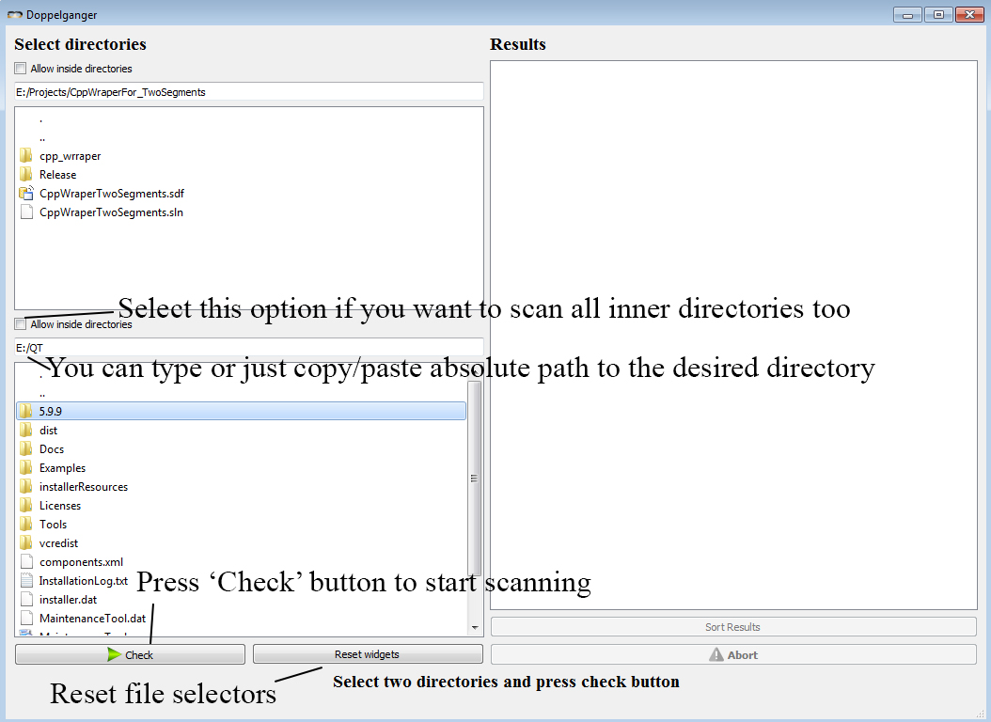

**Select two directories in which you would like to search for duplicates. When start the searching:**

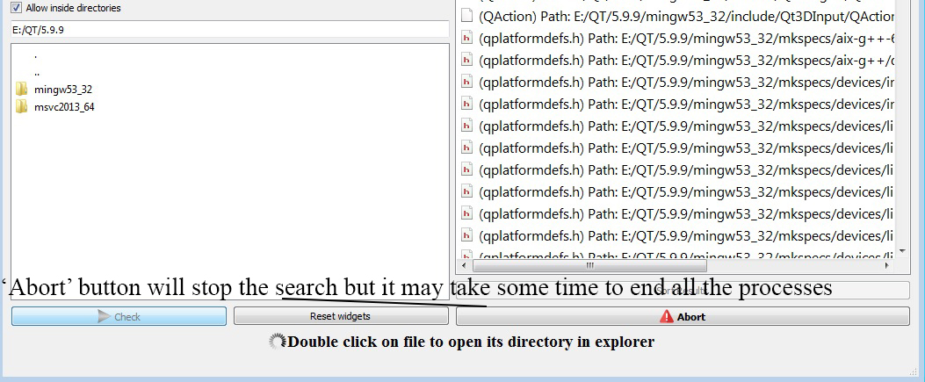

**After the algorithm starts 'Abort' button will be enabled. When the algorithm finishes its work you can sort files by their names in the 'Results' widget:**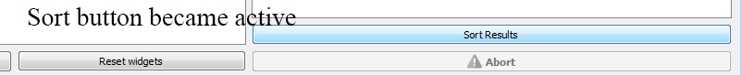

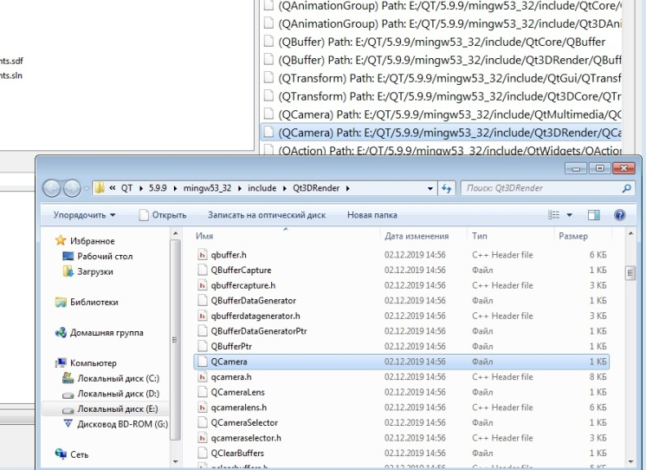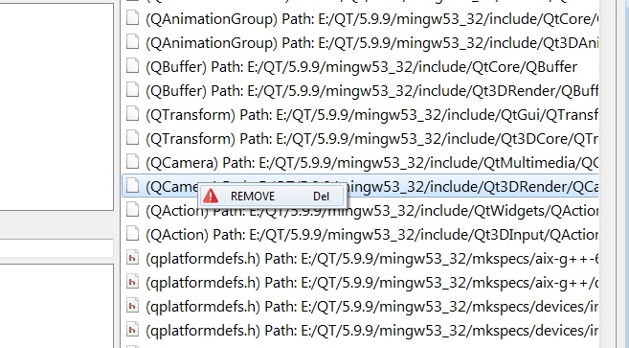

**You can open distanation folder of each file in the explorer. You can also delete every file from your computer directly from the widget.**