1. **Source file structure:**

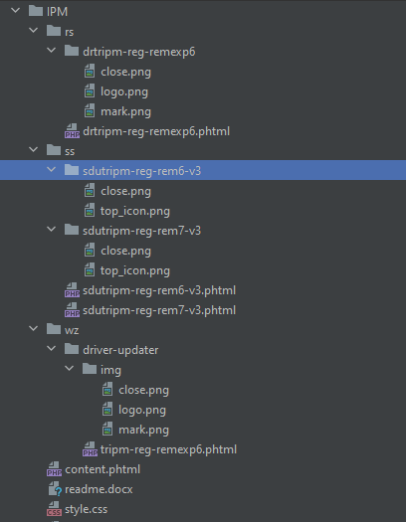

1. **Phtml tamplates:**

For including parts into layout with parameters use next command:

@@include('../content.phtml', {  
 "countdown": "<?php include 'templates/timers/48hour-countdown.phtml'; ?>"  
})

For applicating parameters in the part use next command:

@@countdown