**Final Project Part 2**

Kovalyov Anton

0431945

**Screenshot of program run:**

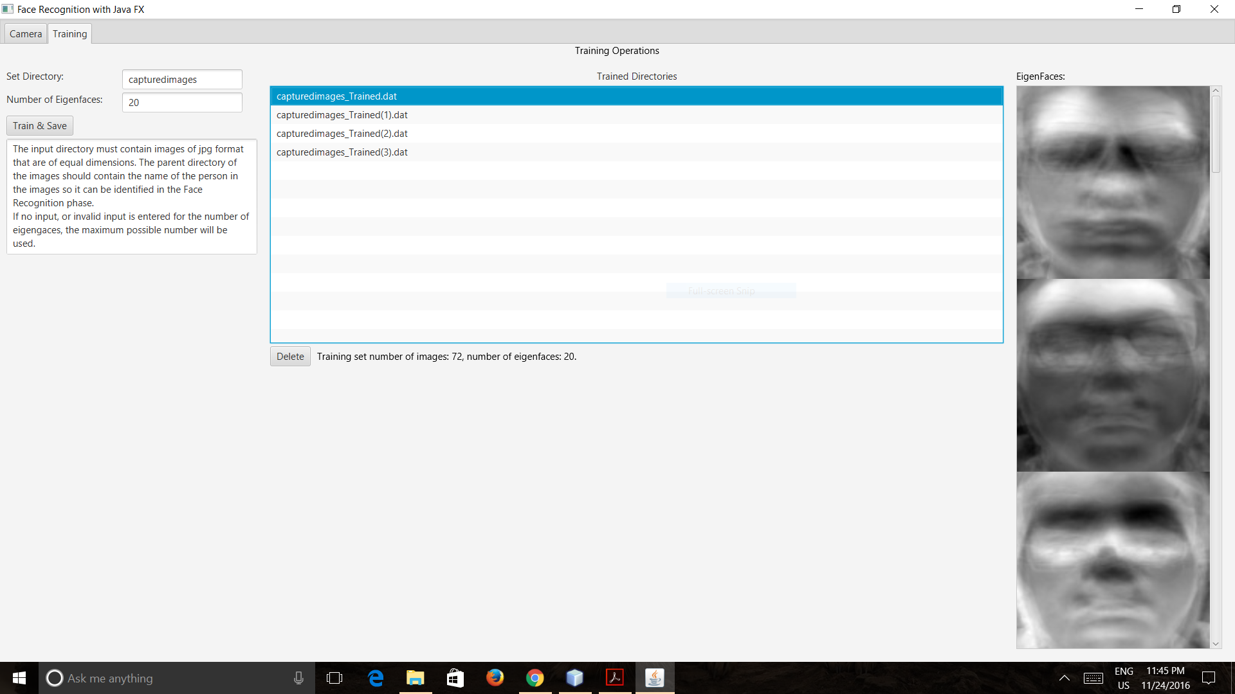

**Note:**

The program follows all of the steps provided in the FaceRecog PDF and use the Colt library for the matrix operations.

I separated the camera and training tabs into two FXML documents and then united them in the class FinalProjectGUI which extends a stage.

I did my best to get rid of any bug the program might have by handling several input exceptions and adding some extra functionalities.

The FXMLTrainingController class has a method to get the selected EigenDecomposition object. This object contains all the necessary information for Face Recognition (The EigenFaces double and scaled byte 2D arrays and a list of Faces objects that have the names, locations and weights of all the used images).

The trained files list is serialized and saved in the trainingLocations.dat file in the project folder.

Each new training set is saved as an EigenDecomposition object and serialized to <name_of_images_directory + _[(n)]Trained.dat> file for later use.