**SoftConsole installers:**

ftp://ftp.actel.com/incoming/tommy/softconsole

Use

Microsemi-SoftConsole-v5.2.0.13-Linux-x86-Installer

Or

Microsemi-SoftConsole-v5.2.0.13-Windows-Installer.exe

**How to use SoftConsole:**

After installing, open SoftConsole. It will ask for the Workspace path.

Provide path: <path on your machine>\microsemi-liteos\mscc-huawei-wsp

After you sync microsemi-liteos repo to your machine,

you will have <path on your machine>\microsemi-liteos\mscc-huawei-wsp on your machine.

You will find that the project sc-gd450i-iot-ocf-server is open in workspace.

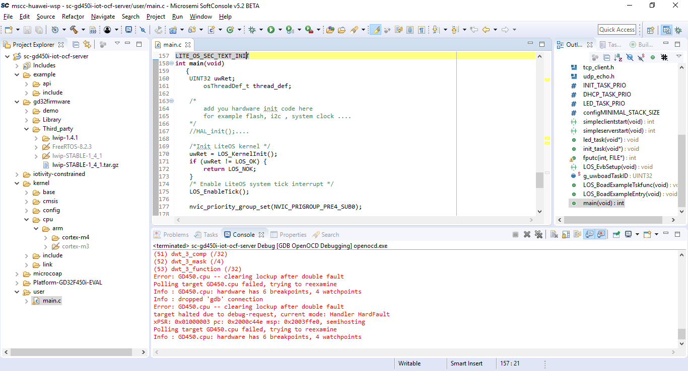

The Miscellaneous/microsemi-cortex-m3.cfg must be copied into SoftConsole

installation path on your machine. e.g. path

C:\Microsemi\SoftConsole_v5.2.0.12\openocd\share\openocd\scripts\target

**In this file the support for Cortex-M4 processor is created.**

**Note: Flash downloading is not yet supported.**

In your CM4 project, following values should be provided in debugger config options

in debug configuration.

--command "set JTAG_KHZ 4000"

--command "set FPGA_TAP N"

--command "set DEVICE GD450"

--file board/microsemi-cortex-m3.cfg

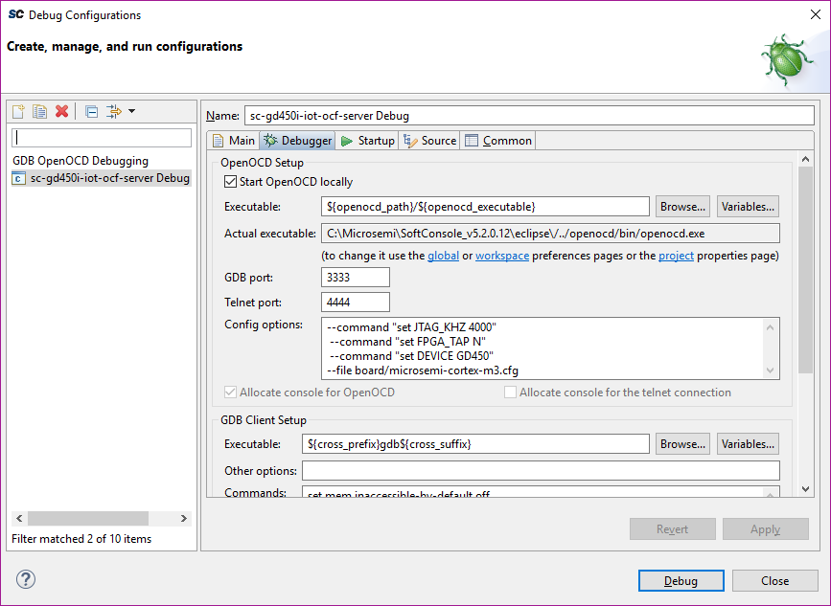

**Linker script:**

The linker script used to run the project from RAM is located

\microsemi-liteos\microsemi-liteos\mscc-huawei-wsp\sc-gd450i-iot-ocf-server\Platform-GD32F450i-EVAL\ debug-in-gd450-ram.ld

The startup code required with GCC for the GD450 processor is added in

startup_gd32f4xx.S

newlib_stubs.c

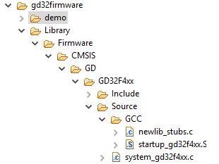

Not all files in the project are compiled. The files those are not required for this project are avoided using “resource configuration --> Exclude from build” option. As example, cortex-m3 folder is excluded from the build.

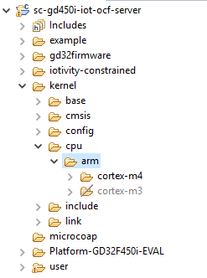

Right click on the project name and select “project properties” in the “Project Explorer” to view all the properties of the project

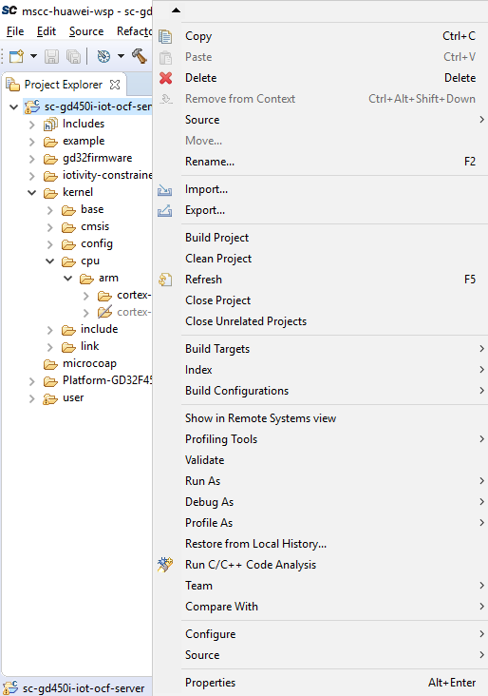

Screenshot of the properties is given below as an example

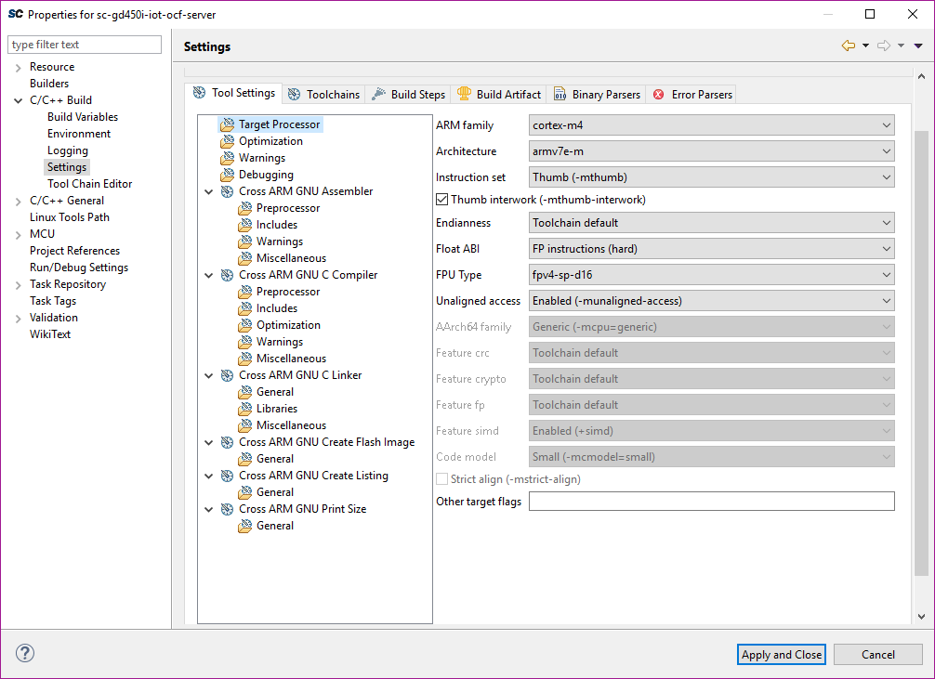

**Downloading and step debug:**

Use Flashpro debugger to connect to the board using USB cable.

FLashpro debugger has 10Pin JTAG. GD450 has 20pin Jtag. Use the add-on card to covert from 10opin to 20 pin Jtag.

In absence of add-on card below are the pin connection details which can be manually done using jumper wires.

