**COMP1231: Assignment 4 Test Exhibit**

Anton Nikitenko (T00622037)

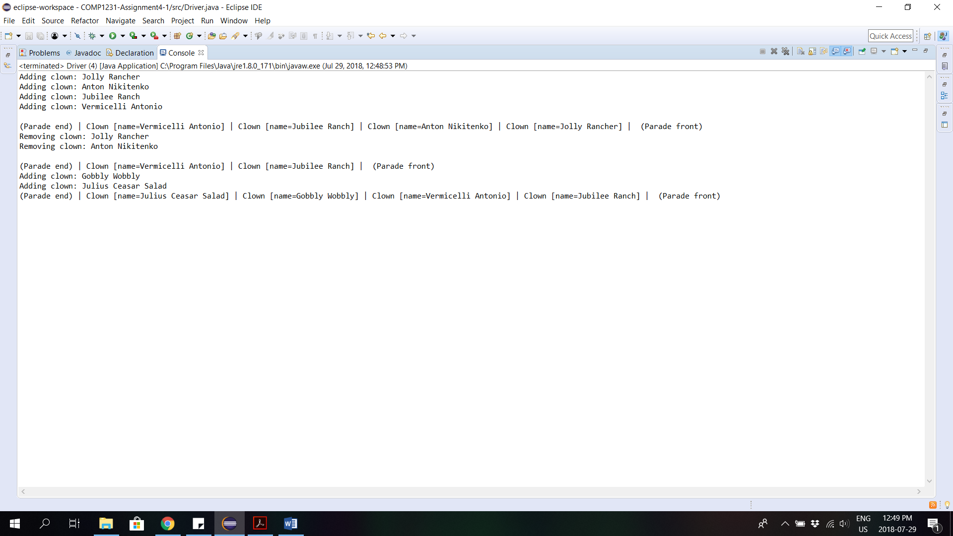Part 1 – Clown Parade

Part 2 – Box Drawer

Trial 1:

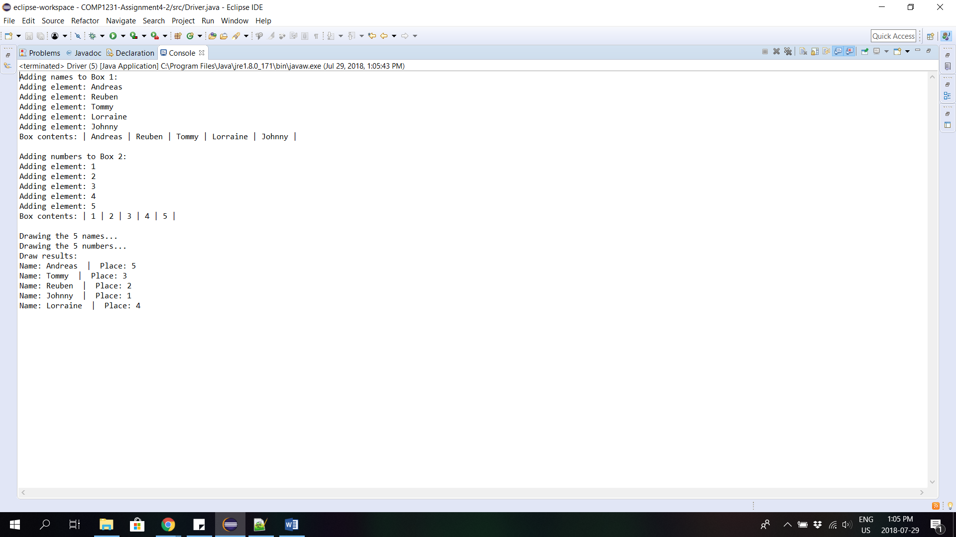

Trial 2:

