VCF parsing results report

# Overview

This report describes the data that was collected from the following VCF file:

chr20.variants_20072022.vcf

The parsed VCF file is of VCFv4.3 format and includes genotype information on 3 samples and 8749 variants on 1 chromosome.

The reference sequence that was used for variant calling is ftp://ftp.1000genomes.ebi.ac.uk/vol1/ftp/technical/reference/GRCh38_reference_genome/GRCh38_full_analysis_set_plus_decoy_hla.fa.

# Variants summary

The parsed VCF file contains information on 8749 variants on 1 chromosome.

Figures below demonstrate variants distribution across each of the chromosomes in the VCF.

### Distribution of variants for chr20

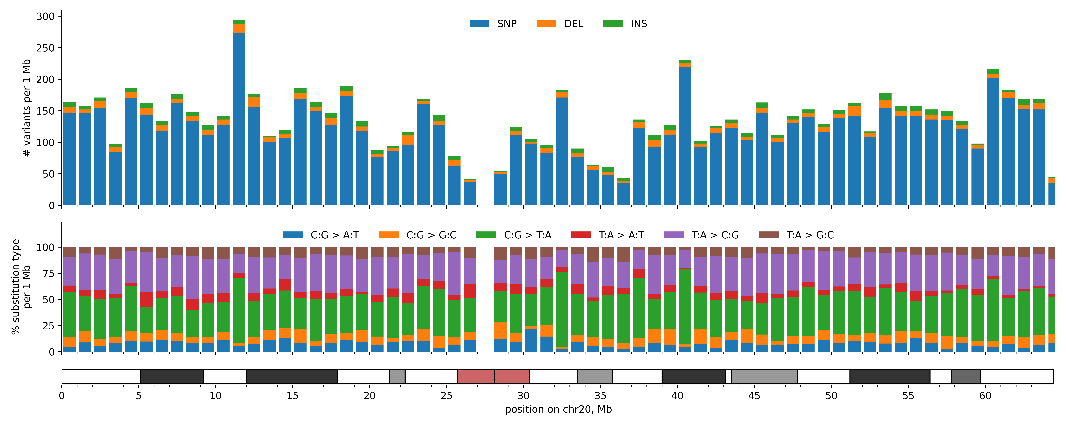

# Samples variant profiles summary

The parsed VCF file contains genotype information on 3 samples.

Figures below show each sample genetic variants profiles across all chromosomes in the VCF parsed.

### sample1's genetic variants profile for chr20



### sample2's genetic variants profile for chr20



### sample3's genetic variants profile for chr20

