Tool to create Microsoft Word docx from abap.

Installation

Install package via ABAPGIT <https://docs.abapgit.org/guide-install.html>



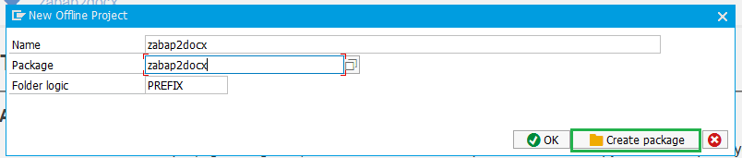





I don’t know why, but some times you have errors, just click Pull_zip twice.

For example we would like to create document like this

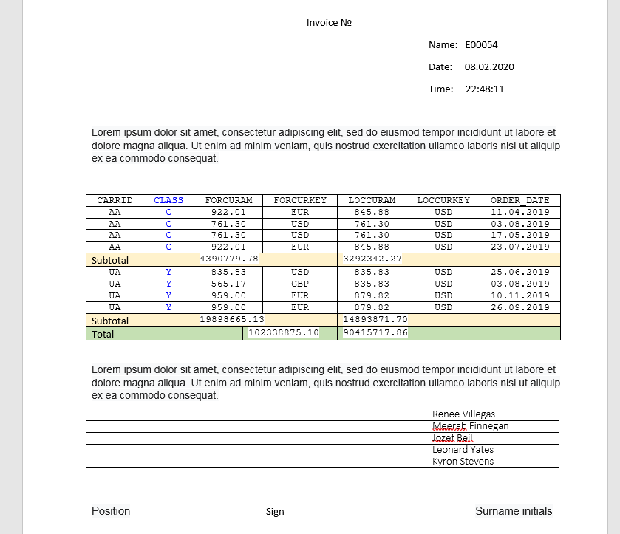

At first detect variable and repeated parts

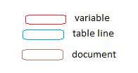

Variable – simple text.

Table line – contain table row that may contain several or zero variables and text.

Document – contain several or zero texts, variables, table row

And we have something like this

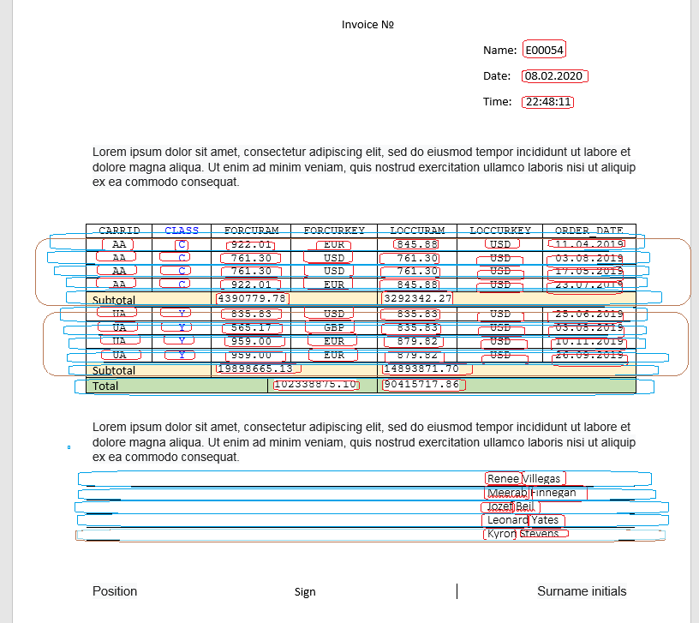

Let reduce our document

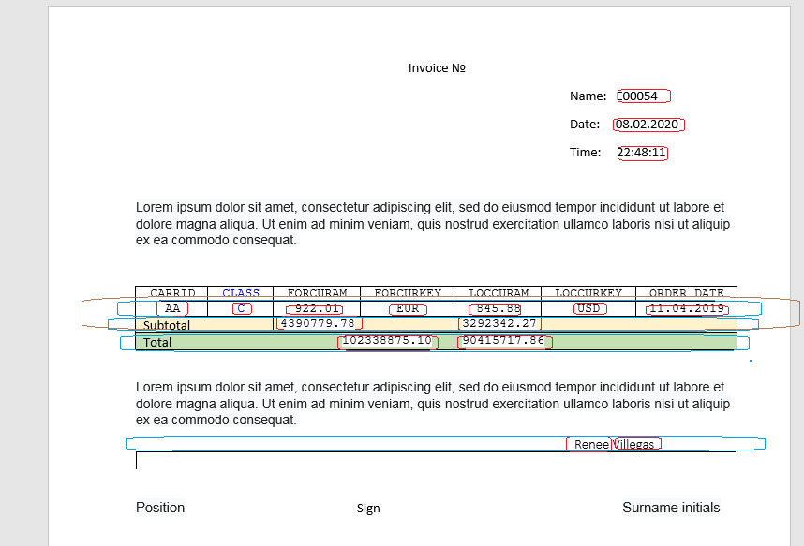

Structure of data for our document be like

├── name

├── date

├── time

├── document1

│   ├── data_row

│   │ ├── CARRID

│   │ ├── CLASS

│   │ ├── FORCURAM

│   │ ├── LOCCURAM

│   │ ├── LOCCURKEY

│   │ └── ORDER_DATE

│   │ .

│   │ .

│   ├── data_row

│   │ ├── CARRID

│   │ ├── CLASS

│   │ ├── FORCURAM

│   │ ├── LOCCURAM

│   │ ├── LOCCURKEY

│   │ └── ORDER_DATE

│   └── subtotal

│   ├── FORCURKEY

│   └── LOCCURAM

│   .

│   .

├── document1

│   ├── data_row

│   │ ├── CARRID

│   │ ├── CLASS

│   │ ├── FORCURAM

│   │ ├── LOCCURAM

│   │ ├── LOCCURKEY

│   │ └── ORDER_DATE

│   │ .

│   │ .

│   ├── data_row

│   │ ├── CARRID

│   │ ├── CLASS

│   │ ├── FORCURAM

│   │ ├── LOCCURAM

│   │ ├── LOCCURKEY

│   │ └── ORDER_DATE

│   └── subtotal

│   ├── FORCURKEY

│   └── LOCCURAM

├── total

│   ├── FORCURKEY

│   └── LOCCURAM

├── sign

│   ├── NAME_FIRST

│   └── NAME_LAST

│ .

│ .

└── sign

    ├── NAME_FIRST

    └── NAME_LAST

Or simple

├── name (value)

├── date (value)

├── time (value)

├── document1 (document repeated)

│   ├── data_row (table repeated)

│   │ ├── CARRID

│   │ ├── CLASS

│   │ ├── FORCURAM

│   │ ├── LOCCURAM

│   │ ├── LOCCURKEY

│   │ └── ORDER_DATE

│   └── subtotal (table of 1 row)

│   ├── FORCURKEY

│   └── LOCCURAM

├── total (table of 1 row)

│   ├── FORCURKEY

│   └── LOCCURAM

└── sign (table repeated)

    ├── NAME_FIRST

    └── NAME_LAST

Let sign variable placeholder.

At first toggle developer toolbar. <https://www.google.com/search?q=microsoft+office+16+toggle+developer+toolbar>

Select



Make tag

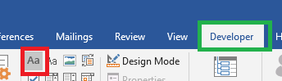

Click properties

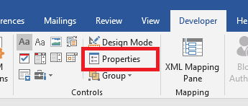

Enter tag name

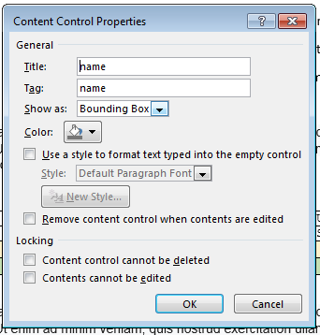

Tag name case insensitive all the way it will be convert to uppercase

Value can have any tag name, value inside table row must have name of field of row structure

For example tag name for sign row

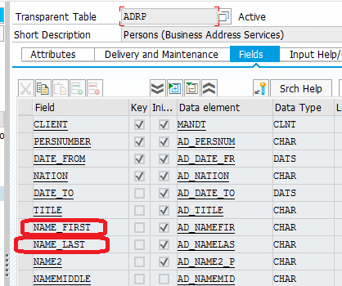

Name all variable placeholder

In design time it must look like this

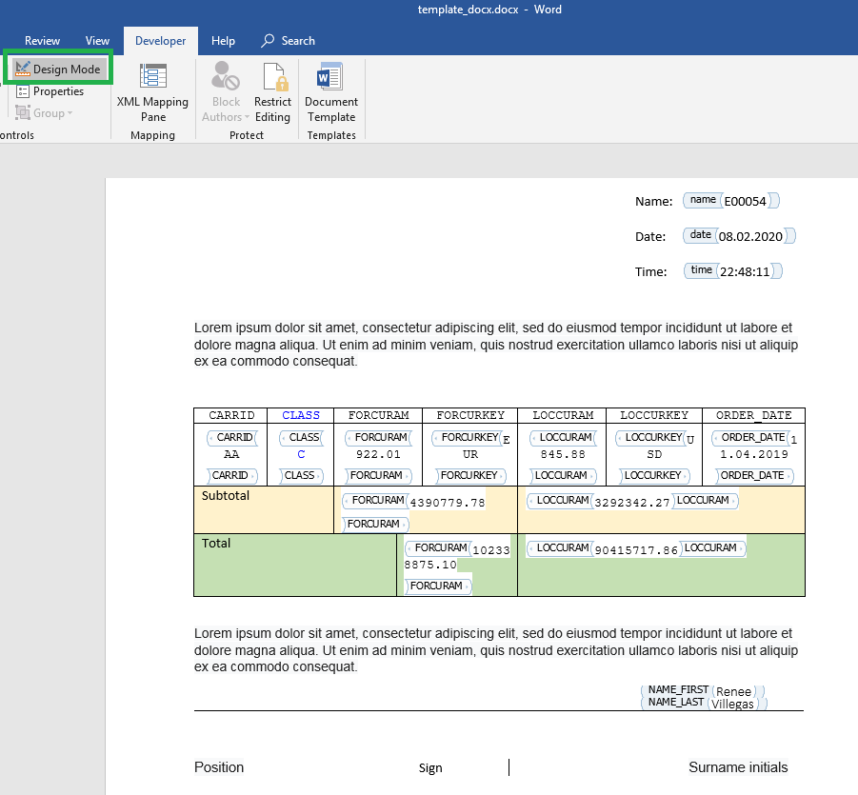

At second we mark placeholder for table row(data_row, subtotal, total, sign)

Place mouse cursor to the left of row

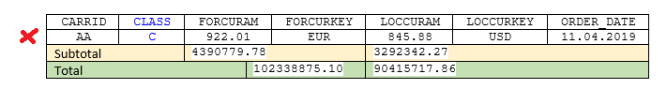

Click

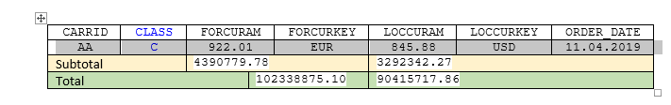

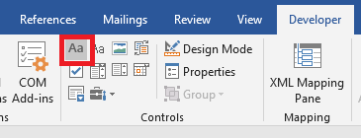

Properties, data_row

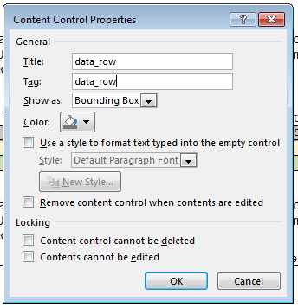

Subtotal

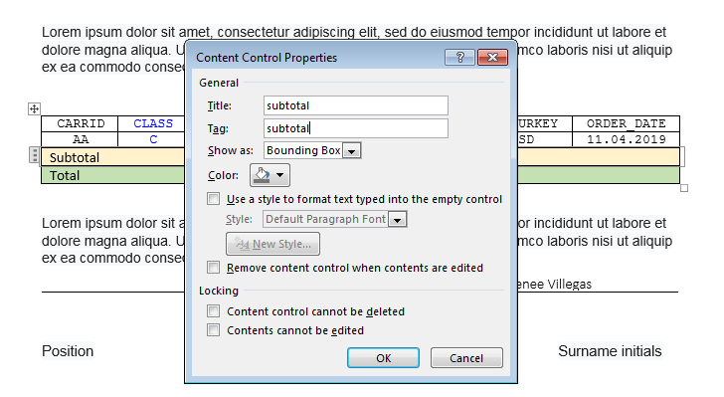

Total

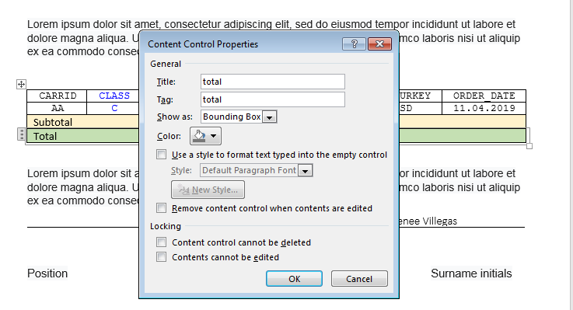

Sign

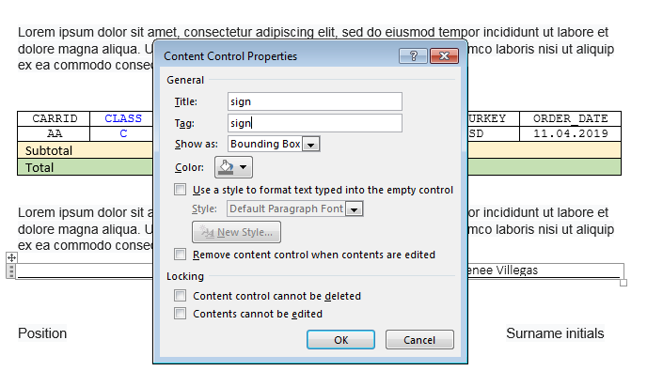

Then template in design mode must look like

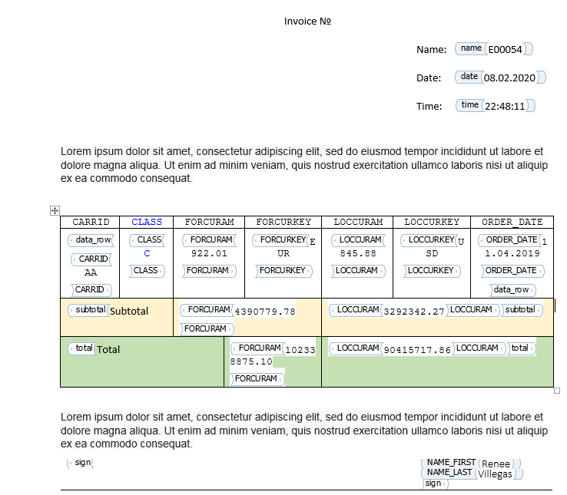

And now we move on to the task with an asterisk. In 99% cases you do not need this. I just show opportunity how to make more complex document.

If you want you can make infinity depth of your document.

We need join 2 rows in one placeholder. Unfortunately, Microsoft Office cannot make placeholder for 2 rows. It can make placeholder for one row or for a whole table.

There we have 2 way:

1. Cheap and wrong
2. More complex and True

First way:

Copy your table 3 times

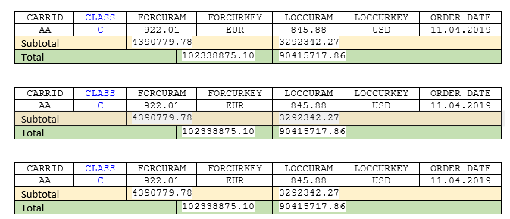

Cut unnecessary part from each table

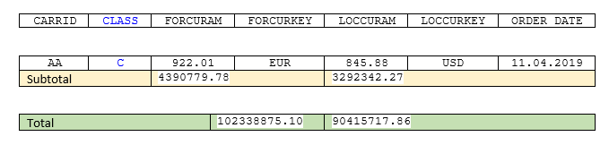

Make placeholder for whole second table

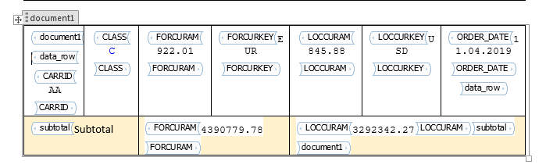

Remove spaces between tables

In my case it look like

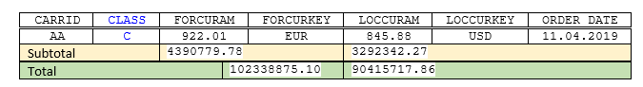

I don’t like this, maybe I cannot work with tables.

Second way I prefer:

Select 2 rows, make place holder. Office create place holder for first row. It is ok.

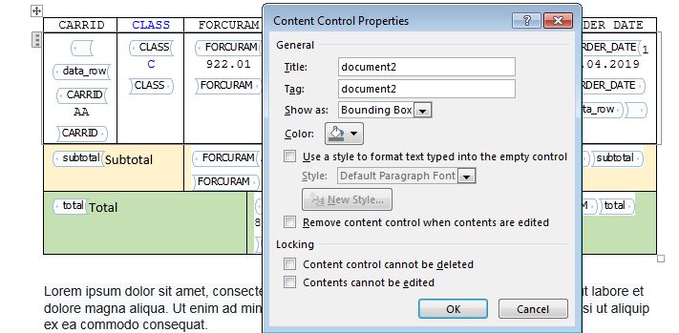

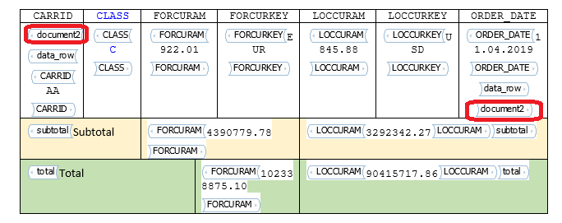

Now save template, close office.

Rename template.docx to template.zip





Unpack to subfolder



Navigate inside, then in subfolder ‘word’

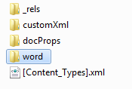

We need notepad++ <https://notepad-plus-plus.org/downloads/>

Open document.xml with notepad++

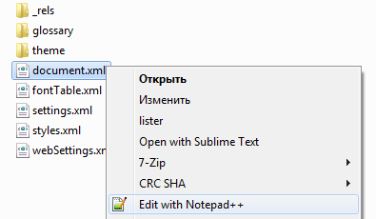

Navigate plugin->plugins admin..

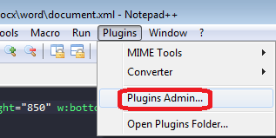

Search “Xml tools”

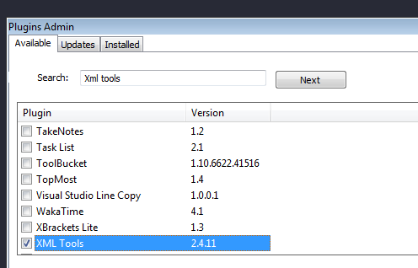

Install

Now you can pretty print xml document

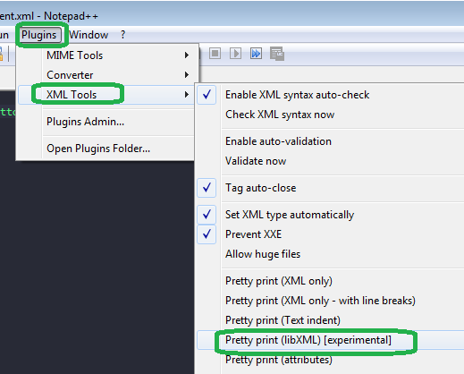

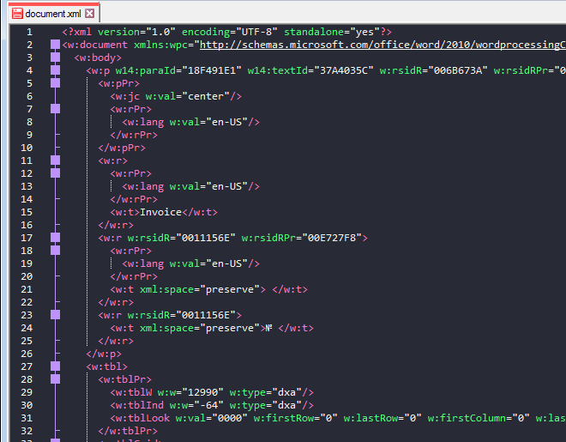

Find placeholder we created. In our case it document2

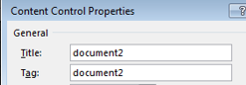

Ctrl+f

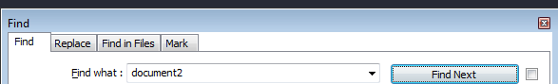

We can see our placeholder

<w:tag w:val="document2"/>

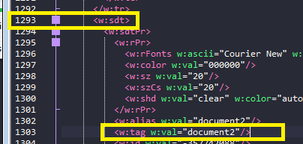

It strat in line 1293 with tag <w:sdt>

Collapse tree to see where it end

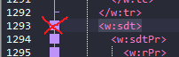

It end near line 1621



Now collapse next placeholder to see where it end

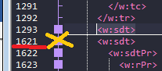

It end near line 1757

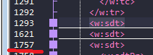

Expand all.

Go to line 1621

Cut 2 lines 1619, 1620



</w:sdtContent>

</w:sdt>

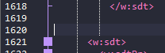

Navigate to line 1757

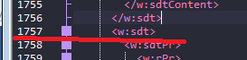

Insert 2 lines before line 1757

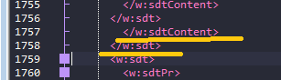

Yellow – inserted lines.

Save, close.

Navigate 1 level up

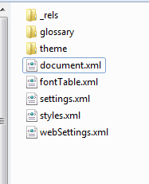

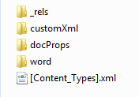

Select all file at this level, add to zip archive

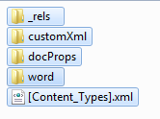

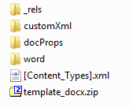

Rename template_docx.zip to template_docx.docx

Now we can see placeholder hold 2 rows

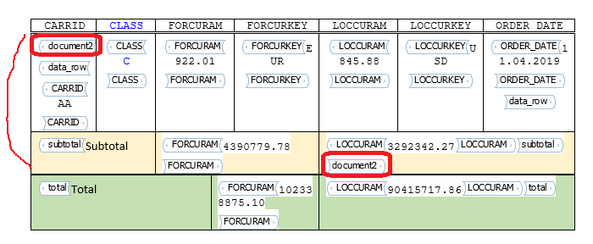

Go to transaction smw0

Select Binary data, enter

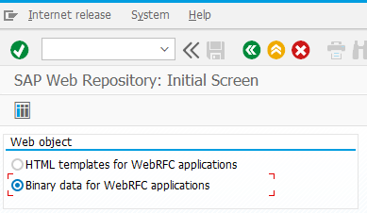

Object name Z_TEST_DOCX2

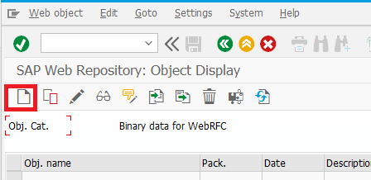

Create

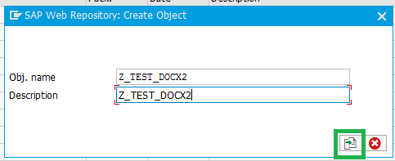

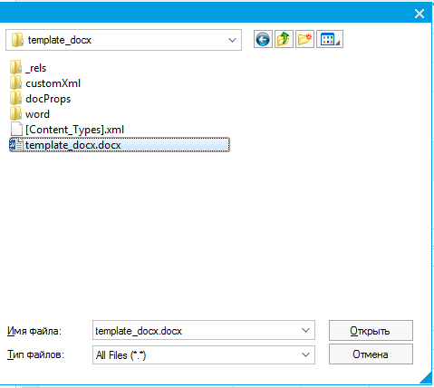

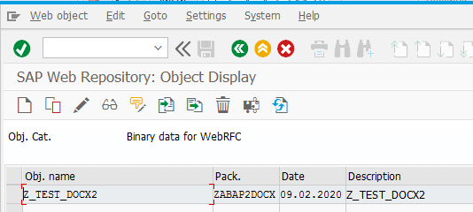

Now lets program something.

You can read this program with comments or see program Z_TEST_DOCX2 that already exists in package.

Template Z_TEST_DOCX2 also exist in package

*\*&---------------------------------------------------------------------\**  
*\*& Report Z_TEST_DOCX_2*  
*\*&---------------------------------------------------------------------\**  
*\*--------------------------------------------------------------------\**  
*\*  Autor: Anton.Sikidin@gmail.com*  
*\*--------------------------------------------------------------------\**  
  
REPORT z_test_docx_2.  
  
START-OF-SELECTION.  
  
  
  TYPES  
*"  structure to hold our data*  
  : BEGIN OF t_data  
  ,   carrid  TYPE s_carr_id  
  ,   class  TYPE s_class  
  ,   forcuram  TYPE s_f_cur_pr  
  ,   forcurkey  TYPE s_curr  
  ,   loccuram  TYPE s_l_cur_pr  
  ,   loccurkey  TYPE s_currcode  
  ,   order_date  TYPE s_bdate  
  , END OF t_data  
  .  
  
  
  
  DATA  
        : lt_carrid TYPE TABLE OF s_carr_id  
        , lt_total TYPE TABLE OF t_data  
        , lt_sub_total TYPE TABLE OF t_data  
        , lt_sub_total_tmp TYPE TABLE OF t_data  
        , lt_data TYPE TABLE OF t_data  
        , lt_tmp TYPE TABLE OF t_data  
  
        , lt_adrp TYPE TABLE OF adrp  
  
        .  
  
  *" select data for "sign" placeholder*  
  SELECT * INTO TABLE lt_adrp FROM adrp UP TO 5 ROWS.  
  
*\*  REFRESH lt_adrp.*  
*\**  
*\**  
*\*  APPEND INITIAL LINE TO lt_adrp ASSIGNING FIELD-SYMBOL(<fs_adrp>).*  
*\*  <fs_adrp>-name_first = 'Renee'.*  
*\*  <fs_adrp>-name_last = 'Villegas'.*  
*\*  APPEND INITIAL LINE TO lt_adrp ASSIGNING <fs_adrp>.*  
*\**  
*\*  <fs_adrp>-name_first = 'Meerab'.*  
*\*  <fs_adrp>-name_last = 'Finnegan'.*  
*\*  APPEND INITIAL LINE TO lt_adrp ASSIGNING <fs_adrp>.*  
*\**  
*\*  <fs_adrp>-name_first = 'Jozef'.*  
*\*  <fs_adrp>-name_last = 'Beil'.*  
*\*  APPEND INITIAL LINE TO lt_adrp ASSIGNING <fs_adrp>.*  
*\**  
*\*  <fs_adrp>-name_first = 'Leonard'.*  
*\*  <fs_adrp>-name_last = 'Yates'.*  
*\*  APPEND INITIAL LINE TO lt_adrp ASSIGNING <fs_adrp>.*  
*\**  
*\*  <fs_adrp>-name_first = 'Kyron'.*  
*\*  <fs_adrp>-name_last = 'Stevens'.*  
  
  
  
  
  
  *" select data to display in main table,*  
  *" may be it may create in easy and in proper way,*  
  *" but now it just data for proof of concept*  
  
  SELECT *  
    INTO CORRESPONDING FIELDS OF TABLE lt_tmp  
    FROM sbook  
    .  
  
  lt_data = lt_tmp. *"make backup, because our data corrupted, while calculate total and subtotal*  
  
  LOOP AT lt_tmp ASSIGNING FIELD-SYMBOL(<fs_tmp>).  
    COLLECT <fs_tmp>-carrid INTO lt_carrid.  *" every document1 or document2 hold data by single carrid*  
  
    CLEAR  
    : <fs_tmp>-class  
    , <fs_tmp>-forcurkey  
    , <fs_tmp>-loccurkey  
    , <fs_tmp>-order_date  
    .  
  
    COLLECT <fs_tmp> INTO lt_sub_total . *"calculate  subtotal*  
  
    CLEAR  
    : <fs_tmp>-carrid  
    .  
  
    COLLECT <fs_tmp> INTO lt_total. *" calculate total.*  
  
  ENDLOOP.  
  
  
  lt_tmp = lt_data.  
  
  REFRESH lt_data.  
  
  LOOP AT lt_sub_total ASSIGNING FIELD-SYMBOL(<fs_sub_total>).  
  
    DATA  
          : lv_i TYPE i  
          .  
    CLEAR lv_i.  
  
    LOOP AT lt_tmp ASSIGNING <fs_tmp> WHERE carrid = <fs_sub_total>-carrid.  
      ADD 1 TO lv_i.  
  
      IF lv_i > 4 . *" four row for proof of concept is enought*  
        EXIT.  
      ENDIF.  
  
      APPEND <fs_tmp> TO lt_data.  
  
    ENDLOOP.  
  
  ENDLOOP.  
  
  
  *" craete main wariable to hold our data*  
  DATA(lr_data) = zcl_docx2=>create_data( ).  
  
  
  *" fill place holder for simple variable, iv_key case insensitive*  
  lr_data->append_key_value(  iv_key = 'name' iv_value = sy-uname ).  
  lr_data->append_key_value(  iv_key = 'date' iv_value = |{ sy-datum DATE = ENVIRONMENT }| ).  
  lr_data->append_key_value(  iv_key = 'time' iv_value = |{ sy-uzeit TIME = ENVIRONMENT }| ).  
  
  *" fill place holder for total ( table of 1 row)*  
  lr_data->append_key_table( iv_key = 'total' iv_table = lt_total ).  
  
  *"fill  placeholder for sign, iv_key always case insensitive*  
  lr_data->append_key_table( iv_key = 'sign' iv_table = lt_adrp ).  
  
  
  *" fill our main table*  
  
  LOOP AT lt_sub_total ASSIGNING <fs_sub_total>.  
  
    REFRESH  
    : lt_tmp  
    , lt_sub_total_tmp  
    .  
  
    APPEND <fs_sub_total> TO lt_sub_total_tmp. *" subtotal table of 1 row*  
    LOOP AT lt_data ASSIGNING FIELD-SYMBOL(<fs_data>) WHERE carrid = <fs_sub_total>-carrid.  
      APPEND <fs_data> TO lt_tmp.  *" table for placeholder "data_row"*  
    ENDLOOP.  
  
  
    *" create  variable to hold data as subchild of our main variable*  
  
    DATA(lr_document1) = lr_data->create_document( 'document1' ).  
  
    *" fill placeholder "data_row" in document "document1"*  
    lr_document1->append_key_table( iv_key = 'data_row' iv_table = lt_tmp ).  
  
    *" fill placeholder "subtotal" in document "document1"*  
    lr_document1->append_key_table( iv_key = 'subtotal' iv_table = lt_sub_total_tmp ).  
  
  
    *" our temlate contain 2 variant of main table: easy and wrong, more complex and true*  
  
    *"create variable to hold data for document2*  
    DATA(lr_document2) = lr_data->create_document( 'document2' ).  
  
    *" fill placeholder "data_row" in document "document2"*  
    lr_document2->append_key_table( iv_key = 'data_row' iv_table = lt_tmp ).  
  
    *" fill placeholder "subtotal" in document "document2"*  
    lr_document2->append_key_table( iv_key = 'subtotal' iv_table = lt_sub_total_tmp ).  
  
  ENDLOOP.  
  
  
  
*\*final moment get document*  
  
  DATA  
        : lv_document TYPE xstring  *" variable to hold generated document, can be omitted*  
        .  
  
  
  
  lv_document = zcl_docx2=>get_document(  
      iv_w3objid    = 'Z_TEST_DOCX2' *" name of our template, obligatory*  
*\*      iv_on_desktop = 'X'           " by default save document on desktop*  
*\*      iv_folder     = 'report'      " in folder by default 'report'*  
*\*      iv_path       = ''            " IF iv_path IS INITIAL  save on desctop or sap_tmp folder*  
*\*      iv_file_name  = 'report.docx' " file name by default*  
*\*      iv_no_execute = ''            " if filled -- just get document no run office*  
*\*      iv_protect    = ''            " if filled protect document from editing, but not protect from sequence*  
                                     *" ctrl+a, ctrl+c, ctrl+n, ctrl+v, edit*  
      ir_data       = lr_data        *" root of our data, obligatory*  
*\*      iv_no_save    = ''            " just get binary data not save on disk*  
      ).

Run program and get something like this

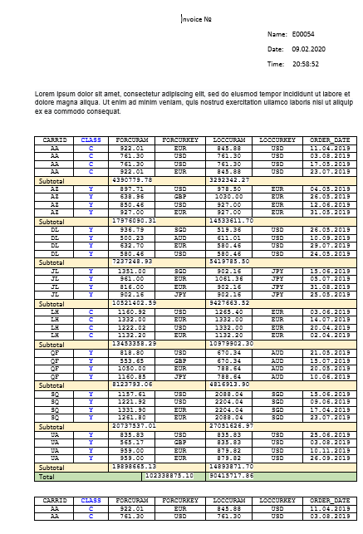

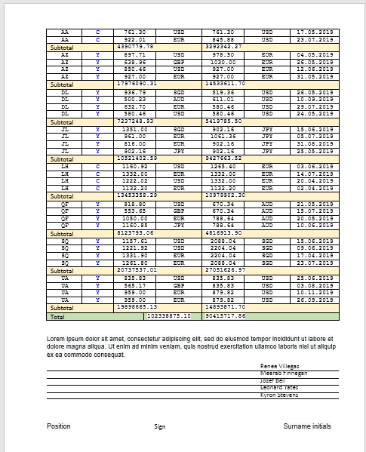

Both variants seem legit. Second give you more power, just for your information.

Also, you can do what you want.